**Clustering Results Report**

**Clustering Algorithm Used - K-Means Clustering**

**Number of Clusters Formed - 3 cluster**

**Clustering Metrics**

1. **Davies-Bouldin Index (DB Index)**:
   * **Value**: **0.6862**
   * **Interpretation**:  
     A lower DB Index indicates that the clusters are well-separated and compact. The achieved value of 0.6862 reflects that the clusters have good separation and minimal overlap.
2. **Silhouette Score**:
   * **Value**: **0.4315**
   * **Interpretation**:  
     A score of 0.4315 indicates moderate clustering quality, with clusters being distinguishable but having some overlap.

**Cluster Descriptions**

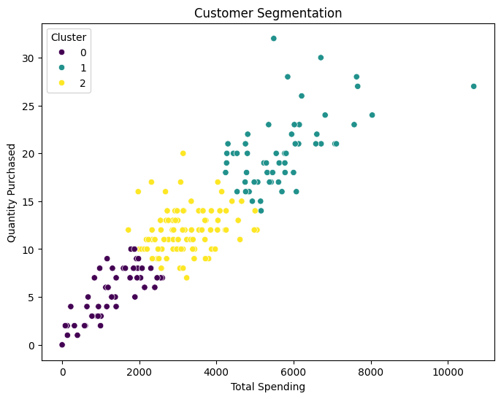

**The scatter plot visualizes the clustering results based on Total Spending and Quantity Purchased, segmented into three clusters:**

1. **Cluster 0 (Purple):**
   * **Characteristics:  
     Customers with the lowest total spending and small purchase quantities.**
   * **Strategy:  
     Target these customers with incentives, promotions, or discounts to increase both spending and purchase volume.**
2. **Cluster 1 (Yellow):**
   * **Characteristics:  
     Customers with medium total spending and moderate purchase quantities.**
   * **Strategy:  
     Focus on loyalty programs or bundle offers to encourage higher spending and quantity.**
3. **Cluster 2 (Teal):**
   * **Characteristics:  
     Customers with high total spending and large purchase quantities.**
   * **Strategy:  
     Concentrate on upselling premium products or exclusive memberships to maintain and expand this profitable segment.**
4. **ific Strategies**:
   * Focus on **Cluster 1** customers to maximize revenue by upselling premium products.
   * For **Cluster 2**, promote bulk-purchase discounts.
   * For **Cluster 3**, provide incentives or discounts to increase spending.
5. **Future Improvements**:
   * Experiment with semi-supervised techniques or hybrid clustering approaches to enhance results.
   * Incorporate additional customer features, such as demographics or shopping frequency, for better segmentation.