Verification-:

1. Using info pci in qemu

Bus 0, device 2, function 0:

Display controller: PCI device 1af4:1050

PCI subsystem 1af4:1100

IRQ 11, pin A

BAR1: 32 bit memory at 0xfebd5000 [0xfebd5fff].

BAR2: 64 bit prefetchable memory at 0x7010000000 [0x7010003fff].

BAR4: 64 bit prefetchable memory at 0x7000000000 [0x700fffffff].

id ""

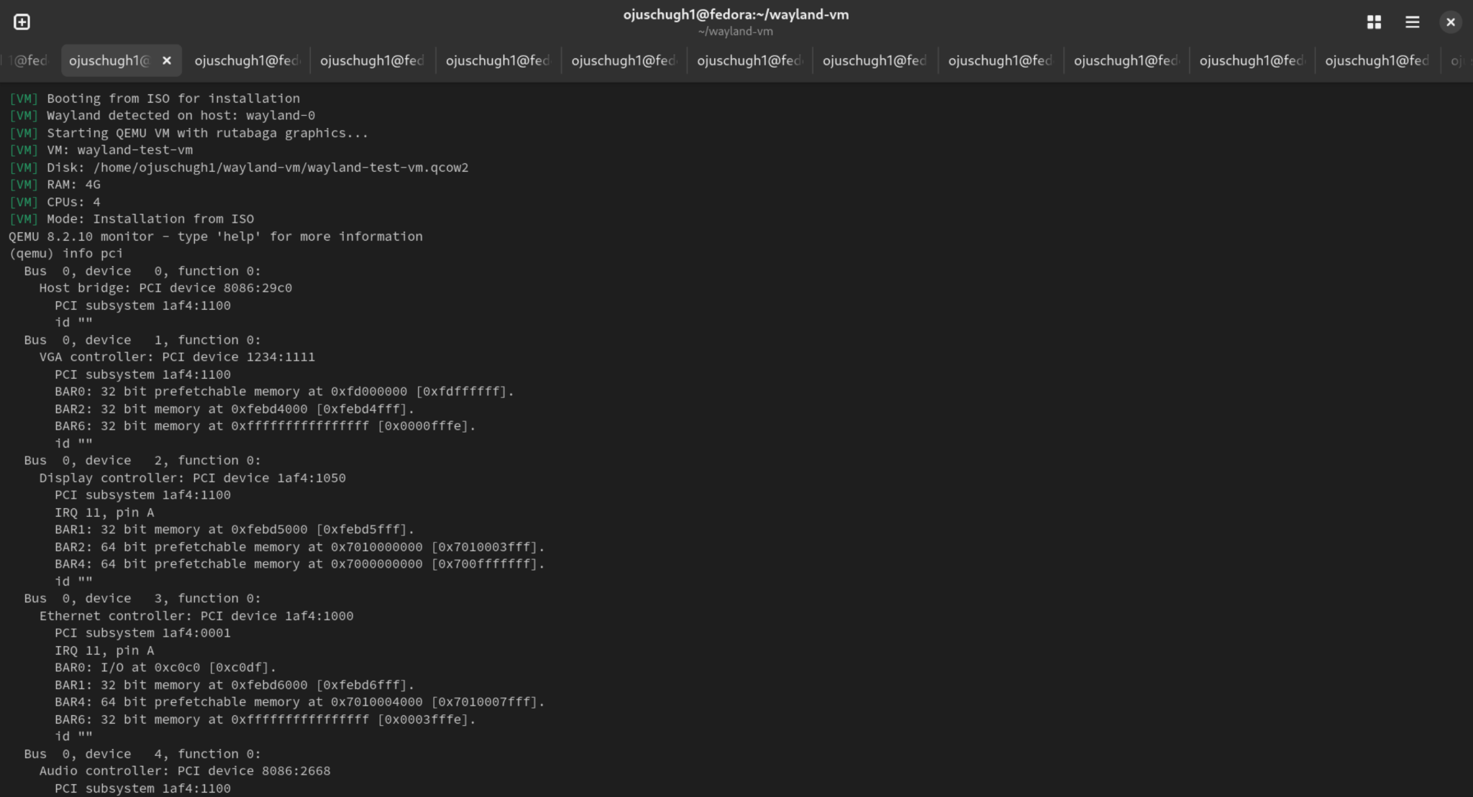

1. Using Info Tree-:   
     
   (qemu) info qtree
2. bus: main-system-bus
3. type System
4. dev: ps2-mouse, id ""
5. gpio-out "" 1
6. dev: ps2-kbd, id ""
7. gpio-out "" 1
8. dev: hpet, id ""
9. gpio-in "" 2
10. gpio-out "" 1
11. gpio-out "sysbus-irq" 32
12. timers = 3 (0x3)
13. msi = false
14. hpet-intcap = 16711940 (0xff0104)
15. hpet-offset-saved = true
16. mmio 00000000fed00000/0000000000000400
17. dev: kvm-ioapic, id ""
18. gpio-in "" 24
19. gsi_base = 0 (0x0)
20. mmio 00000000fec00000/0000000000001000
21. dev: q35-pcihost, id ""
22. MCFG = 2952790016 (0xb0000000)
23. pci-hole64-size = 34359738368 (32 GiB)
24. below-4g-mem-size = 2147483648 (2 GiB)
25. above-4g-mem-size = 2147483648 (2 GiB)
26. x-pci-hole64-fix = true
27. x-config-reg-migration-enabled = true
28. bypass-iommu = false
29. bus: pcie.0
30. type PCIE
31. dev: virtio-blk-pci, id ""
32. disable-legacy = "off"
33. disable-modern = false
34. class = 0 (0x0)
35. ioeventfd = true
36. vectors = 5 (0x5)
37. virtio-pci-bus-master-bug-migration = false
38. migrate-extra = true
39. modern-pio-notify = false
40. x-disable-pcie = false
41. page-per-vq = false
42. x-ignore-backend-features = false
43. ats = false
44. x-ats-page-aligned = true
45. x-pcie-deverr-init = true
46. x-pcie-lnkctl-init = true
47. x-pcie-pm-init = true
48. x-pcie-flr-init = true
49. aer = false
50. addr = 07.0
51. romfile = ""
52. romsize = 4294967295 (0xffffffff)
53. rombar = 1 (0x1)
54. multifunction = false
55. x-pcie-lnksta-dllla = true
56. x-pcie-extcap-init = true
57. failover_pair_id = ""
58. acpi-index = 0 (0x0)
59. x-pcie-err-unc-mask = true
60. x-pcie-ari-nextfn-1 = false
61. class SCSI controller, addr 00:07.0, pci id 1af4:1001 (sub 1af4:0002)
62. bar 0: i/o at 0xc000 [0xc07f]
63. bar 1: mem at 0xfebd9000 [0xfebd9fff]
64. bar 4: mem at 0x7010010000 [0x7010013fff]
65. bus: virtio-bus
66. type virtio-pci-bus
67. dev: virtio-blk-device, id ""
68. drive = "virtio0"
69. backend_defaults = "auto"
70. logical_block_size = 512 (512 B)
71. physical_block_size = 512 (512 B)
72. min_io_size = 0 (0 B)
73. opt_io_size = 0 (0 B)
74. discard_granularity = 4294967295 (4 GiB)
75. write-cache = "auto"
76. share-rw = false
77. account-invalid = "auto"
78. account-failed = "auto"
79. rerror = "auto"
80. werror = "auto"
81. cyls = 16383 (0x3fff)
82. heads = 16 (0x10)
83. secs = 63 (0x3f)
84. lcyls = 0 (0x0)
85. lheads = 0 (0x0)
86. lsecs = 0 (0x0)
87. serial = ""
88. config-wce = true
89. scsi = false
90. request-merging = true
91. num-queues = 4 (0x4)
92. queue-size = 256 (0x100)
93. seg-max-adjust = true
94. discard = true
95. report-discard-granularity = true
96. write-zeroes = true
97. max-discard-sectors = 4194303 (0x3fffff)
98. max-write-zeroes-sectors = 4194303 (0x3fffff)
99. x-enable-wce-if-config-wce = true
100. indirect_desc = true
101. event_idx = true
102. notify_on_empty = true
103. any_layout = true
104. iommu_platform = false
105. packed = false
106. queue_reset = true
107. use-started = true
108. use-disabled-flag = true
109. x-disable-legacy-check = false
110. dev: virtio-mouse-pci, id ""
111. disable-legacy = "on"
112. disable-modern = false
113. vectors = 2 (0x2)
114. virtio-pci-bus-master-bug-migration = false
115. migrate-extra = true
116. modern-pio-notify = false
117. x-disable-pcie = false
118. page-per-vq = false
119. x-ignore-backend-features = false
120. ats = false
121. x-ats-page-aligned = true
122. x-pcie-deverr-init = true
123. x-pcie-lnkctl-init = true
124. x-pcie-pm-init = true
125. x-pcie-flr-init = true
126. aer = false
127. addr = 06.0
128. romfile = ""
129. romsize = 4294967295 (0xffffffff)
130. rombar = 1 (0x1)
131. multifunction = false
132. x-pcie-lnksta-dllla = true
133. x-pcie-extcap-init = true
134. failover_pair_id = ""
135. acpi-index = 0 (0x0)
136. x-pcie-err-unc-mask = true
137. x-pcie-ari-nextfn-1 = false
138. class Mouse, addr 00:06.0, pci id 1af4:1052 (sub 1af4:1100)
139. bar 1: mem at 0xfebd8000 [0xfebd8fff]
140. bar 4: mem at 0x701000c000 [0x701000ffff]
141. bus: virtio-bus
142. type virtio-pci-bus
143. dev: virtio-mouse-device, id ""
144. wheel-axis = true
145. display = ""
146. head = 0 (0x0)
147. serial = ""
148. indirect_desc = true
149. event_idx = true
150. notify_on_empty = true
151. any_layout = true
152. iommu_platform = false
153. packed = false
154. queue_reset = true
155. use-started = true
156. use-disabled-flag = true
157. x-disable-legacy-check = false
158. dev: virtio-keyboard-pci, id ""
159. disable-legacy = "on"
160. disable-modern = false
161. vectors = 2 (0x2)
162. virtio-pci-bus-master-bug-migration = false
163. migrate-extra = true
164. modern-pio-notify = false
165. x-disable-pcie = false
166. page-per-vq = false
167. x-ignore-backend-features = false
168. ats = false
169. x-ats-page-aligned = true
170. x-pcie-deverr-init = true
171. x-pcie-lnkctl-init = true
172. x-pcie-pm-init = true
173. x-pcie-flr-init = true
174. aer = false
175. addr = 05.0
176. romfile = ""
177. romsize = 4294967295 (0xffffffff)
178. rombar = 1 (0x1)
179. multifunction = false
180. x-pcie-lnksta-dllla = true
181. x-pcie-extcap-init = true
182. failover_pair_id = ""
183. acpi-index = 0 (0x0)
184. x-pcie-err-unc-mask = true
185. x-pcie-ari-nextfn-1 = false
186. class Keyboard, addr 00:05.0, pci id 1af4:1052 (sub 1af4:1100)
187. bar 1: mem at 0xfebd7000 [0xfebd7fff]
188. bar 4: mem at 0x7010008000 [0x701000bfff]
189. bus: virtio-bus
190. type virtio-pci-bus
191. dev: virtio-keyboard-device, id ""
192. display = ""
193. head = 0 (0x0)
194. serial = ""
195. indirect_desc = true
196. event_idx = true
197. notify_on_empty = true
198. any_layout = true
199. iommu_platform = false
200. packed = false
201. queue_reset = true
202. use-started = true
203. use-disabled-flag = true
204. x-disable-legacy-check = false
205. dev: intel-hda, id ""
206. debug = 0 (0x0)
207. msi = "auto"
208. old_msi_addr = false
209. addr = 04.0
210. romfile = ""
211. romsize = 4294967295 (0xffffffff)
212. rombar = 1 (0x1)
213. multifunction = false
214. x-pcie-lnksta-dllla = true
215. x-pcie-extcap-init = true
216. failover_pair_id = ""
217. acpi-index = 0 (0x0)
218. x-pcie-err-unc-mask = true
219. x-pcie-ari-nextfn-1 = false
220. class Audio controller, addr 00:04.0, pci id 8086:2668 (sub 1af4:1100)
221. bar 0: mem at 0xfebd0000 [0xfebd3fff]
222. bus: hda.0
223. type HDA
224. dev: hda-duplex, id ""
225. audiodev = "audio0"
226. debug = 0 (0x0)
227. mixer = true
228. use-timer = true
229. cad = 0 (0x0)
230. dev: virtio-net-pci, id ""
231. disable-legacy = "off"
232. disable-modern = false
233. ioeventfd = true
234. vectors = 4 (0x4)
235. virtio-pci-bus-master-bug-migration = false
236. migrate-extra = true
237. modern-pio-notify = false
238. x-disable-pcie = false
239. page-per-vq = false
240. x-ignore-backend-features = false
241. ats = false
242. x-ats-page-aligned = true
243. x-pcie-deverr-init = true
244. x-pcie-lnkctl-init = true
245. x-pcie-pm-init = true
246. x-pcie-flr-init = true
247. aer = false
248. addr = 03.0
249. romfile = "efi-virtio.rom"
250. romsize = 262144 (0x40000)
251. rombar = 1 (0x1)
252. multifunction = false
253. x-pcie-lnksta-dllla = true
254. x-pcie-extcap-init = true
255. failover_pair_id = ""
256. acpi-index = 0 (0x0)
257. x-pcie-err-unc-mask = true
258. x-pcie-ari-nextfn-1 = false
259. class Ethernet controller, addr 00:03.0, pci id 1af4:1000 (sub 1af4:0001)
260. bar 0: i/o at 0xc0c0 [0xc0df]
261. bar 1: mem at 0xfebd6000 [0xfebd6fff]
262. bar 4: mem at 0x7010004000 [0x7010007fff]
263. bar 6: mem at 0xffffffffffffffff [0x3fffe]
264. bus: virtio-bus
265. type virtio-pci-bus
266. dev: virtio-net-device, id ""
267. csum = true
268. guest_csum = true
269. gso = true
270. guest_tso4 = true
271. guest_tso6 = true
272. guest_ecn = true
273. guest_ufo = true
274. guest_announce = true
275. host_tso4 = true
276. host_tso6 = true
277. host_ecn = true
278. host_ufo = true
279. mrg_rxbuf = true
280. status = true
281. ctrl_vq = true
282. ctrl_rx = true
283. ctrl_vlan = true
284. ctrl_rx_extra = true
285. ctrl_mac_addr = true
286. ctrl_guest_offloads = true
287. mq = false
288. rss = false
289. hash = false
290. guest_rsc_ext = false
291. rsc_interval = 300000 (0x493e0)
292. mac = "52:54:00:12:34:56"
293. netdev = "net0"
294. x-txtimer = 150000 (0x249f0)
295. x-txburst = 256 (0x100)
296. tx = ""
297. rx_queue_size = 256 (0x100)
298. tx_queue_size = 256 (0x100)
299. host_mtu = 0 (0x0)
300. x-mtu-bypass-backend = true
301. speed = -1 (0xffffffffffffffff)
302. duplex = ""
303. failover = false
304. guest_uso4 = true
305. guest_uso6 = true
306. host_uso = true
307. indirect_desc = true
308. event_idx = true
309. notify_on_empty = true
310. any_layout = true
311. iommu_platform = false
312. packed = false
313. queue_reset = true
314. use-started = true
315. use-disabled-flag = true
316. x-disable-legacy-check = false
317. dev: virtio-gpu-rutabaga-pci, id ""
318. ioeventfd = false
319. vectors = 3 (0x3)
320. virtio-pci-bus-master-bug-migration = false
321. migrate-extra = true
322. modern-pio-notify = false
323. x-disable-pcie = false
324. page-per-vq = false
325. x-ignore-backend-features = false
326. ats = false
327. x-ats-page-aligned = true
328. x-pcie-deverr-init = true
329. x-pcie-lnkctl-init = true
330. x-pcie-pm-init = true
331. x-pcie-flr-init = true
332. aer = false
333. addr = 02.0
334. romfile = ""
335. romsize = 4294967295 (0xffffffff)
336. rombar = 1 (0x1)
337. multifunction = false
338. x-pcie-lnksta-dllla = true
339. x-pcie-extcap-init = true
340. failover_pair_id = ""
341. acpi-index = 0 (0x0)
342. x-pcie-err-unc-mask = true
343. x-pcie-ari-nextfn-1 = false
344. class Display controller, addr 00:02.0, pci id 1af4:1050 (sub 1af4:1100)
345. bar 1: mem at 0xfebd5000 [0xfebd5fff]
346. bar 2: mem at 0x7010000000 [0x7010003fff]
347. bar 4: mem at 0x7000000000 [0x700fffffff]
348. bus: virtio-bus
349. type virtio-pci-bus
350. dev: virtio-gpu-rutabaga-device, id ""
351. gfxstream-vulkan = false
352. cross-domain = true
353. x-gfxstream-gles = false
354. x-gfxstream-composer = false
355. wayland-socket-path = ""
356. wsi = "surfaceless"
357. max_outputs = 1 (0x1)
358. edid = true
359. xres = 1280 (0x500)
360. yres = 800 (0x320)
361. max_hostmem = 268435456 (256 MiB)
362. blob = true
363. hostmem = 268435456 (256 MiB)
364. indirect_desc = true
365. event_idx = true
366. notify_on_empty = true
367. any_layout = true
368. iommu_platform = false
369. packed = false
370. queue_reset = true
371. use-started = true
372. use-disabled-flag = true
373. x-disable-legacy-check = false
374. dev: VGA, id ""
375. vgamem_mb = 16 (0x10)
376. mmio = true
377. qemu-extended-regs = true
378. edid = true
379. xres = 1280 (0x500)
380. yres = 800 (0x320)
381. xmax = 0 (0x0)
382. ymax = 0 (0x0)
383. refresh_rate = 0 (0x0)
384. global-vmstate = false
385. addr = 01.0
386. romfile = "vgabios-stdvga.bin"
387. romsize = 65536 (0x10000)
388. rombar = 1 (0x1)
389. multifunction = false
390. x-pcie-lnksta-dllla = true
391. x-pcie-extcap-init = true
392. failover_pair_id = ""
393. acpi-index = 0 (0x0)
394. x-pcie-err-unc-mask = true
395. x-pcie-ari-nextfn-1 = false
396. class VGA controller, addr 00:01.0, pci id 1234:1111 (sub 1af4:1100)
397. bar 0: mem at 0xfd000000 [0xfdffffff]
398. bar 2: mem at 0xfebd4000 [0xfebd4fff]
399. bar 6: mem at 0xffffffffffffffff [0xfffe]
400. dev: ICH9-SMB, id ""
401. addr = 1f.3
402. romfile = ""
403. romsize = 4294967295 (0xffffffff)
404. rombar = 1 (0x1)
405. multifunction = true
406. x-pcie-lnksta-dllla = true
407. x-pcie-extcap-init = true
408. failover_pair_id = ""
409. acpi-index = 0 (0x0)
410. x-pcie-err-unc-mask = true
411. x-pcie-ari-nextfn-1 = false
412. class SMBus, addr 00:1f.3, pci id 8086:2930 (sub 1af4:1100)
413. bar 4: i/o at 0x700 [0x73f]
414. bus: i2c
415. type i2c-bus
416. dev: smbus-eeprom, id ""
417. address = 87 (0x57)
418. dev: smbus-eeprom, id ""
419. address = 86 (0x56)
420. dev: smbus-eeprom, id ""
421. address = 85 (0x55)
422. dev: smbus-eeprom, id ""
423. address = 84 (0x54)
424. dev: smbus-eeprom, id ""
425. address = 83 (0x53)
426. dev: smbus-eeprom, id ""
427. address = 82 (0x52)
428. dev: smbus-eeprom, id ""
429. address = 81 (0x51)
430. dev: smbus-eeprom, id ""
431. address = 80 (0x50)
432. dev: ich9-usb-uhci3, id ""
433. masterbus = "usb-bus.0"
434. firstport = 4 (0x4)
435. bandwidth = 1280 (0x500)
436. maxframes = 128 (0x80)
437. addr = 1d.2
438. romfile = ""
439. romsize = 4294967295 (0xffffffff)
440. rombar = 1 (0x1)
441. multifunction = true
442. x-pcie-lnksta-dllla = true
443. x-pcie-extcap-init = true
444. failover_pair_id = ""
445. acpi-index = 0 (0x0)
446. x-pcie-err-unc-mask = true
447. x-pcie-ari-nextfn-1 = false
448. class USB controller, addr 00:1d.2, pci id 8086:2936 (sub 1af4:1100)
449. bar 4: i/o at 0xc120 [0xc13f]
450. dev: ich9-usb-uhci2, id ""
451. masterbus = "usb-bus.0"
452. firstport = 2 (0x2)
453. bandwidth = 1280 (0x500)
454. maxframes = 128 (0x80)
455. addr = 1d.1
456. romfile = ""
457. romsize = 4294967295 (0xffffffff)
458. rombar = 1 (0x1)
459. multifunction = true
460. x-pcie-lnksta-dllla = true
461. x-pcie-extcap-init = true
462. failover_pair_id = ""
463. acpi-index = 0 (0x0)
464. x-pcie-err-unc-mask = true
465. x-pcie-ari-nextfn-1 = false
466. class USB controller, addr 00:1d.1, pci id 8086:2935 (sub 1af4:1100)
467. bar 4: i/o at 0xc100 [0xc11f]
468. dev: ich9-usb-uhci1, id ""
469. masterbus = "usb-bus.0"
470. firstport = 0 (0x0)
471. bandwidth = 1280 (0x500)
472. maxframes = 128 (0x80)
473. addr = 1d.0
474. romfile = ""
475. romsize = 4294967295 (0xffffffff)
476. rombar = 1 (0x1)
477. multifunction = true
478. x-pcie-lnksta-dllla = true
479. x-pcie-extcap-init = true
480. failover_pair_id = ""
481. acpi-index = 0 (0x0)
482. x-pcie-err-unc-mask = true
483. x-pcie-ari-nextfn-1 = false
484. class USB controller, addr 00:1d.0, pci id 8086:2934 (sub 1af4:1100)
485. bar 4: i/o at 0xc0e0 [0xc0ff]
486. dev: ich9-usb-ehci1, id ""
487. maxframes = 128 (0x80)
488. addr = 1d.7
489. romfile = ""
490. romsize = 4294967295 (0xffffffff)
491. rombar = 1 (0x1)
492. multifunction = true
493. x-pcie-lnksta-dllla = true
494. x-pcie-extcap-init = true
495. failover_pair_id = ""
496. acpi-index = 0 (0x0)
497. x-pcie-err-unc-mask = true
498. x-pcie-ari-nextfn-1 = false
499. class USB controller, addr 00:1d.7, pci id 8086:293a (sub 1af4:1100)
500. bar 0: mem at 0xfebda000 [0xfebdafff]
501. bus: usb-bus.0
502. type usb-bus
503. dev: usb-tablet, id ""
504. usb_version = 2 (0x2)
505. display = ""
506. head = 0 (0x0)
507. port = ""
508. serial = ""
509. msos-desc = true
510. pcap = ""
511. addr 0.2, port 1, speed 480, name QEMU USB Tablet, attached
512. dev: ich9-ahci, id ""
513. addr = 1f.2
514. romfile = ""
515. romsize = 4294967295 (0xffffffff)
516. rombar = 1 (0x1)
517. multifunction = true
518. x-pcie-lnksta-dllla = true
519. x-pcie-extcap-init = true
520. failover_pair_id = ""
521. acpi-index = 0 (0x0)
522. x-pcie-err-unc-mask = true
523. x-pcie-ari-nextfn-1 = false
524. class SATA controller, addr 00:1f.2, pci id 8086:2922 (sub 1af4:1100)
525. bar 4: i/o at 0xc140 [0xc15f]
526. bar 5: mem at 0xfebdb000 [0xfebdbfff]
527. bus: ide.5
528. type IDE
529. bus: ide.4
530. type IDE
531. bus: ide.3
532. type IDE
533. bus: ide.2
534. type IDE
535. dev: ide-cd, id ""
536. drive = "ide2-cd0"
537. backend_defaults = "auto"
538. logical_block_size = 512 (512 B)
539. physical_block_size = 512 (512 B)
540. min_io_size = 0 (0 B)
541. opt_io_size = 0 (0 B)
542. discard_granularity = 512 (512 B)
543. write-cache = "auto"
544. share-rw = false
545. account-invalid = "auto"
546. account-failed = "auto"
547. rerror = "auto"
548. werror = "auto"
549. ver = "2.5+"
550. wwn = 0 (0x0)
551. serial = "QM00005"
552. model = ""
553. unit = 0 (0x0)
554. bus: ide.1
555. type IDE
556. bus: ide.0
557. type IDE
558. dev: ICH9-LPC, id ""
559. gpio-out "gsi" 24
560. noreboot = false
561. smm-compat = false
562. smm-enabled = true
563. x-smi-broadcast = true
564. x-smi-cpu-hotplug = true
565. x-smi-cpu-hotunplug = true
566. addr = 1f.0
567. romfile = ""
568. romsize = 4294967295 (0xffffffff)
569. rombar = 1 (0x1)
570. multifunction = true
571. x-pcie-lnksta-dllla = true
572. x-pcie-extcap-init = true
573. failover_pair_id = ""
574. acpi-index = 0 (0x0)
575. x-pcie-err-unc-mask = true
576. x-pcie-ari-nextfn-1 = false
577. class ISA bridge, addr 00:1f.0, pci id 8086:2918 (sub 1af4:1100)
578. bus: isa.0
579. type ISA
580. dev: port92, id ""
581. gpio-out "a20" 1
582. dev: vmmouse, id ""
583. dev: vmport, id ""
584. x-read-set-eax = true
585. x-signal-unsupported-cmd = true
586. x-report-vmx-type = true
587. x-cmds-v2 = true
588. vmware-vmx-version = 6 (0x6)
589. vmware-vmx-type = 2 (0x2)
590. dev: i8042, id ""
591. gpio-in "ps2-mouse-input-irq" 1
592. gpio-in "ps2-kbd-input-irq" 1
593. gpio-out "" 2
594. gpio-out "a20" 1
595. extended-state = true
596. kbd-throttle = false
597. kbd-irq = 1 (0x1)
598. mouse-irq = 12 (0xc)
599. dev: isa-parallel, id ""
600. index = 0 (0x0)
601. iobase = 888 (0x378)
602. irq = 7 (0x7)
603. chardev = "parallel0"
604. dev: isa-serial, id ""
605. index = 0 (0x0)
606. iobase = 1016 (0x3f8)
607. irq = 4 (0x4)
608. dev: isa-pcspk, id ""
609. audiodev = ""
610. iobase = 97 (0x61)
611. migrate = true
612. dev: kvm-pit, id ""
613. gpio-in "" 1
614. lost_tick_policy = "delay"
615. iobase = 64 (0x40)
616. dev: kvm-i8259, id ""
617. iobase = 160 (0xa0)
618. elcr_addr = 1233 (0x4d1)
619. elcr_mask = 222 (0xde)
620. master = false
621. dev: kvm-i8259, id ""
622. iobase = 32 (0x20)
623. elcr_addr = 1232 (0x4d0)
624. elcr_mask = 248 (0xf8)
625. master = true
626. dev: mc146818rtc, id ""
627. gpio-out "" 1
628. base_year = 0 (0x0)
629. iobase = 112 (0x70)
630. irq = 8 (0x8)
631. lost_tick_policy = "discard"
632. dev: i8257, id ""
633. base = 192 (0xc0)
634. page-base = 136 (0x88)
635. pageh-base = -1 (0xffffffffffffffff)
636. dshift = 1 (0x1)
637. dev: i8257, id ""
638. base = 0 (0x0)
639. page-base = 128 (0x80)
640. pageh-base = -1 (0xffffffffffffffff)
641. dshift = 0 (0x0)
642. dev: mch, id ""
643. extended-tseg-mbytes = 16 (0x10)
644. smbase-smram = true
645. addr = 00.0
646. romfile = ""
647. romsize = 4294967295 (0xffffffff)
648. rombar = 1 (0x1)
649. multifunction = false
650. x-pcie-lnksta-dllla = true
651. x-pcie-extcap-init = true
652. failover_pair_id = ""
653. acpi-index = 0 (0x0)
654. x-pcie-err-unc-mask = true
655. x-pcie-ari-nextfn-1 = false
656. class Host bridge, addr 00:00.0, pci id 8086:29c0 (sub 1af4:1100)
657. dev: fw_cfg_io, id ""
658. dma_enabled = true
659. x-file-slots = 32 (0x20)
660. acpi-mr-restore = true
661. dev: kvmclock, id ""
662. x-mach-use-reliable-get-clock = true
663. dev: kvmvapic, id ""
664. (qemu)

3)

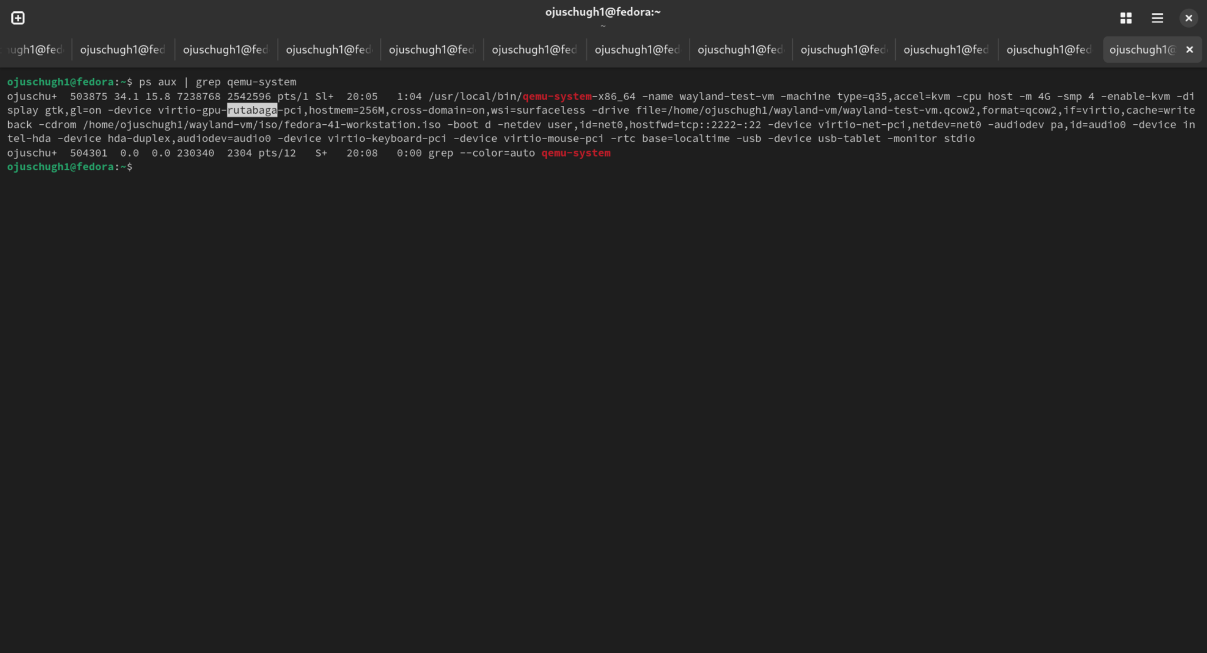

4th

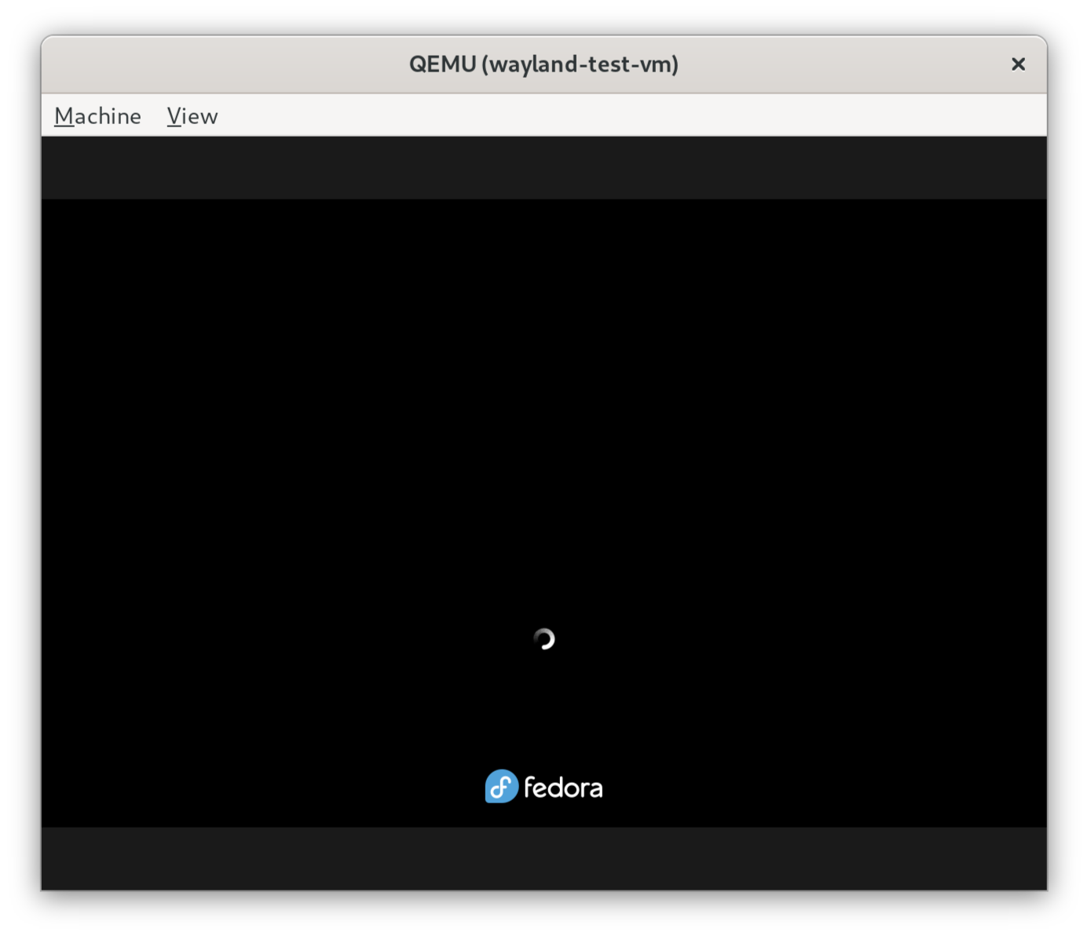

5th verification-:   
  
