**NOISE POLLUTION MONITORING**

PROJECT DEFINITION

The project involves an IoT-based noise monitoring system, consisting of a noise sensor to monitor the noise level, an application to show people the real-time noise level so as to create awareness about noise pollution, and an interface between the sensor and application.

DESIGN THINKING

1. Project objective

The main objective of this project is to create awareness among people about the increasing noise pollution by using a real-time noise monitoring system and to improve the quality of life.

1. IoT sensor design

Noise sensors can be used to monitor noise levels in public areas such as traffic signals, marketplaces, preaching areas, theatres and so on.

1. Noise pollution interface platform

Blynk IoT is an application to prototype, deploy, and remotely manage connected electronic devices at any scale. Blynk IoT can be used to personalize an application for a noise monitoring system based on our preferences.

1. Integration approach

The sensor and application can be interfaced using microcontrollers such as ESP-32 which provides Wi-Fi facility to interact with the mobile application.

Steps involved in noise monitoring:

1. Data Collection:
   * Installing noise monitoring sensors or devices in the target area. These could be sound level meters, microphones, or IoT devices designed for noise monitoring.
   * Ensuring that the sensors are properly calibrated and placed strategically to capture relevant data.
   * Collecting continuous or periodic noise measurements over time. This can be done in real-time or at specific intervals.
2. Data Preprocessing:
   * Cleaning the collected data to remove outliers, errors, or missing values.
   * Time-aligning the data if we have multiple sensors recording at different times.
   * Converting data into a structured format for analysis.
3. Data Analysis:
   * Temporal Analysis: Analyzing how noise levels change over time. Identify patterns, trends, and peak noise events.
   * Spatial Analysis: If we have multiple sensors in different locations, analyze spatial variations in noise levels.
   * Frequency Analysis: Performing spectral analysis to understand the frequency components of noise, especially for different sources (e.g., traffic, industrial machinery).
4. Visualization:
   * Creating visualizations such as line charts, histograms, heatmaps, and spectrograms to help interpret the data.
   * Using geospatial mapping to represent noise levels across different locations.
5. Noise Source Identification:
   * Trying to identify and differentiate noise sources. For instance, using clustering techniques to group similar noise patterns.
   * Utilizing domain knowledge or information about local activities to identify potential sources.
6. Alarm and Reporting:
   * Seting up alarms and notifications for noise level thresholds to alert relevant stakeholders if noise levels exceed certain limits.
   * Generating reports and summaries of noise monitoring data for decision-making and compliance purposes.
7. Continuous Improvement:
   * Periodically reviewing and refining our noise monitoring and analytics processes based on the insights gained from the data.

Top of Form

**CODE FOR SIMULATION:**

from machine import Pin, ADC

from time import sleep

import math

micc = ADC(Pin(2))

micc.atten(ADC.ATTN_11DB)

calib_cons = 1.0

threshold = 80

while True:

mic_level = micc.read()

mic_level_db = 20 * math.log10(mic_level / calib_cons)

if mic_level_db > threshold:

print("Warning: Noise pollution!!! ")

print("dB: {:.2f}".format(mic_level_db))

sleep(0.3)

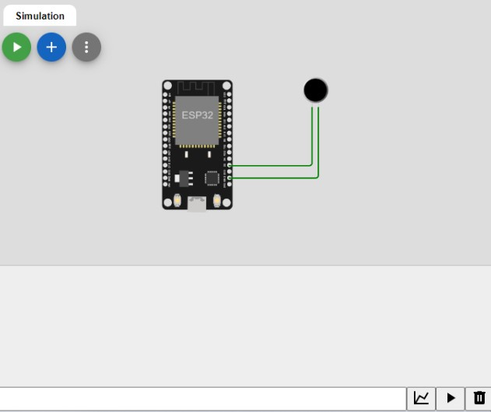

**HTML CODE FOR WEBSITE:**

<!DOCTYPE html>

<html>

<head>

<title>Noise Pollution Platform</title>

</head>

<body>

<header>

<h1>Real-Time Noise Levels</h1>

</header>

<main>

<!-- Noise level data will be displayed here -->

</main>

</body>

</html>

<!DOCTYPE html>

<html lang="en">

<head>

<meta charset="UTF-8">

<meta name="viewport" content="width=device-width, initial-scale=1.0">

<title>Noise Pollution Monitoring</title>

<style>

body {

font-family: Arial, sans-serif;

background-color: #f0f0f031;

margin: 0;

padding: 0;

}

header {

background-color: #3453db;

color: rgba(255, 255, 255, 0.986);

text-align: center;

padding: 20px;

}

h1 {

font-size: 28px;

}

.noise-level {

text-align: center;

font-size: 24px;

margin-top: 20px;

}

</style>

</head>

<body>

<header>

<h1>Noise Pollution Monitoring</h1>

</header>

<div class="noise-level">

<p>Current Noise Level: <span id="noise-value">60</span> dB</p>

</div>

</body>

</html>

**MOBILE APP:**

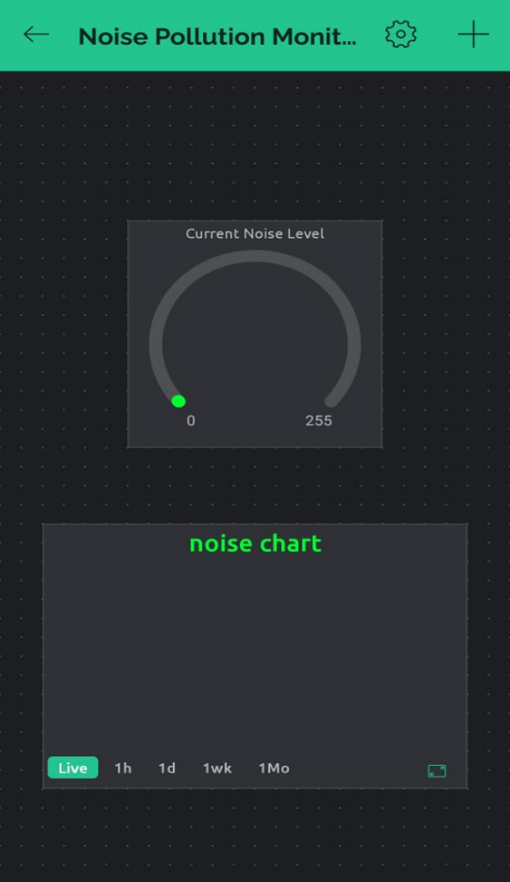

**How the real-time noise level monitoring system promote public awareness and contributes to noise pollution mitigation?**

A real-time noise level monitoring system can play a significant role in promoting public awareness and contributing to noise pollution mitigation by providing accurate and accessible information about noise levels in an area. Real-time monitoring systems can provide notifications and alerts when noise levels exceed acceptable limits. This empowers local authorities to respond quickly and address noise disturbances, and it encourages individuals and businesses to reduce noise levels when notified.

Access to real-time noise data can help the public better understand the sources and patterns of noise pollution in their communities. This knowledge can lead to increased awareness of the impact of noise on health and well-being.

Real-time monitoring systems can incorporate feedback from the public, allowing for continuous improvement in data accuracy and coverage. This iterative process can lead to more effective noise pollution mitigation strategies over time.

In summary, a real-time noise level monitoring system promotes public awareness by making people more conscious of noise pollution, empowers authorities to take timely action, informs data-driven decision-making, engages the community in noise reduction efforts, supports research and policy development, and enables continuous improvement in noise mitigation strategies. By providing transparent and accessible noise data, such systems are valuable tools in the collective effort to reduce noise pollution and improve the quality of life in urban areas.