# Lambdas

* Lambdas enable functional programming
* Allows to write readable anche concise code
* Enable support for parallel processing

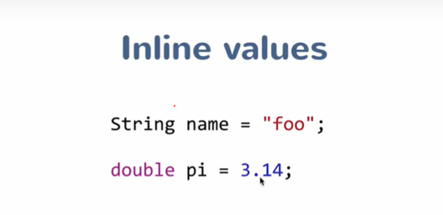

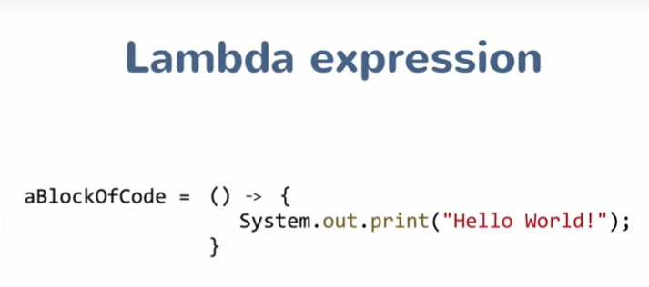

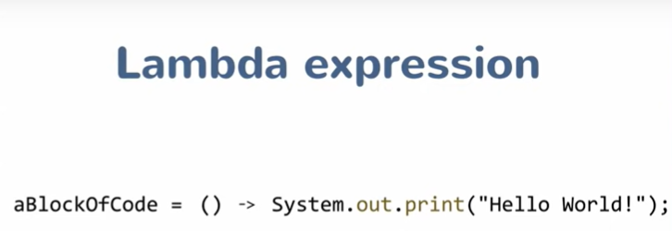

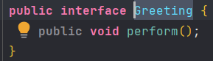





## Type inference

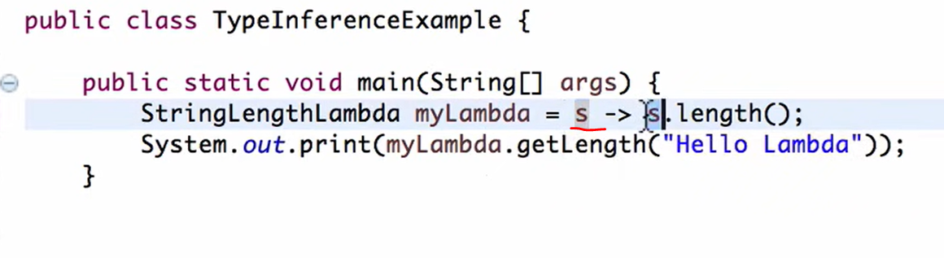

It not necessary to specify the type of input arguments.

If there is only one argument, parenthesis can be removed.

## Functional interface

A functional interface has only one abstract method.

