# Docker for Java and Spring Boot developers

Github: <https://github.com/PacktPublishing/Docker-for-Java-and-Spring-Boot-Developers>

## AWS account

“free aws tier”

[https://aws.amazon.com/it/free/?all-free-tier.sort-by=item.additionalFields.SortRank&all-free-tier.sort-order=asc&awsf.Free%20Tier%20Types=*all&awsf.Free%20Tier%20Categories=*all](https://aws.amazon.com/it/free/?all-free-tier.sort-by=item.additionalFields.SortRank&all-free-tier.sort-order=asc&awsf.Free%20Tier%20Types=*all&awsf.Free%20Tier%20Categories=*all)

## EC2 Elastic Compute Cloud

**AMI** stands for **Amazon Machine Image**.

## Linux

### Checking resources

**top**

### ls /

1. **ls /** shows folders in root folder
2. **ls /bin**  in /bin all command line are stored
3. **ls /etc**  in /etc all configuration files are stored
4. **ls /dev** /dev is the folder in which all hardware devices are mapped
5. **ls /home** /home contains users
6. **ls /lib** /libraries kernel and programs
7. **ls /mnt** /mnt contains the removable mounted devices
8. **ls /opt** /opt contains application binaries
9. **ls /proc** kernel related processes
10. **ls /root** home directory of root user
11. **ls /sbin** system administration commands
12. **ls /tmp** temporary directory
13. **ls /usr** all small programs accessible from users and some command line administration tools
14. **ls /var** variables data

## SSH

## Vi

**i** – insert mode

**ESC** – to pass to command mode

In command mode – **SHIFT – $** goes to the end of the line

In command mode – **SHIFT – ^** goes to the beginning of the line

In command mode – **o** – inserts a new line

In command mode – **dd**  - removes a line

In command mode – **2dd**  - removes two lines

In command mode – **yy** – copies a line

In command mode – **p** – paste a line copied with **yy**

In command mode – **ESC :/ STRING-TO SEARCH** – searches a string

## Usecase

## Build a Dockerfile

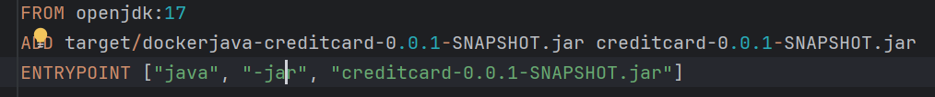

**docker build -f Dockerfile -t creditscore-app** .

The --link flag in Docker was previously used to **establish a connection** between different containers. It essentially created a **symbolic link** between the source container (the one providing the service) and the target container (the one needing the service). This allowed the target container to access the source container using a specific alias, simplifying communication.  
In **--link mysql-db:mysql**  mysql  is the alias of mysql-db

**docker run -t --name=crediscore-app --link mysql-db:mysql -p 10555:8080 creditscore-app**

## Docker compose

**docker-compose.yaml**  is used to define services that compose an application.

**docker compose up** (searches for docker-compose.yaml)

or

**docker compose up -f docker-compose.yaml**

## Yaml

### Networks

### Volumes

