# Java functional programming

Github repo: <https://github.com/in28minutes/functional-programming-with-java>

## Method reference

## .stream().filter

## Lambda expressions

## Streams

### reduce()

Performs an **accumulation operation** on all elements in the stream, reducing them to a single value.

### distinct(), sorted()

### collect()

## Intermediate and terminal operations

### Intermediate

* Transform or filter the elements of a stream without producing a final result.
* They create a new stream based on the original one.
* i.e. filter(), sorted(), distinct(), map()

### Terminal

* Produce a final result from the elements in a stream.
* They consume the entire stream and do not return a new stream.
* i.e. forEach(), collect(), reduce()

## Behaviour parametrization

## Method reference

## allMatch(), noneMatch(), anyMatch()

## sorted()

## limit()

## skip()

## takeWhile()

takeWhile is a method available in Java Streams that extracts elements from a stream until a certain condition is no longer met. It's like a filter, but it stops processing the stream the moment the first element doesn't satisfy the condition.

## dropWhile()

## max(), min()

## findFirst()

## findAny()

## sum()

## average()

## count()

## max()

## groupingBy()

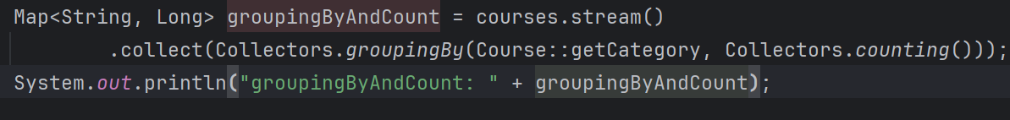

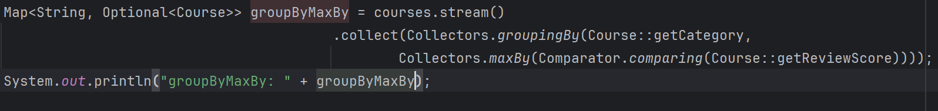

## Streams

