[Type the company name]
Trolley
(Version One)
Omar Khalid Ali
6/16/2024

[Type the abstract of the document here. The abstract is typically a short summary of the contents of the document. Type the abstract of the document here. The abstract is typically a short summary of the contents of the document.]

Contents | Page
Introduction | 3
Scope | 3
Purpose:- | 4
System architecture:- | 4
System requirements specification:- | 6
User Stories:- | 7
Work backlog:- | 0
Project duration:- | 0
Use case diagram:- | 0
Actor Description:- | 0
Use Case Description:- | 0
Traceability matrix:- | 0
Activity Diagram:- | 0
Sequence Diagram:- | 0
Non-Functional Requirements:- | 0
System Design:- | 0
Component Diagram:- | 0
Class Diagram:- | 0
Contents:- | Page
Entity Relationship Diagram (ERD):- | 0
Mapping:- | 0
Testing (User Acceptance test):- | 0
Test cases:- | 0
User Stories:- | 0
Work backlog:- | 0
Project duration:- | 0
Use case diagram:- | 0
Actor Description:- | 0
Use Case Description:- | 0
Traceability matrix:- | 0
Activity Diagram:- | 0
Sequence Diagram:- | 0
Non-Functional Requirements:- | 0
System Design:- | 0
Component Diagram:- | 0
Class Diagram:- | 0
Entity Relationship Diagram (ERD):- | 0
Mapping:- | 0
Testing (User Acceptance test):- | 0
Test cases:- | 0

Introduction:-

In our time, the Progress become use in trade and transports and booking hotels ,rooms and anything as it reduce time and effort that it did goals to computer industry but we have problem with communicate between clients and Transport driver so we will develop app use communicate between clients and Transport driver

Scope:-

This project works within the scope of Transport driver , company and individual because It aims to communication between transport driver and clients as facilitate the transportation process, through A reliable application that guarantees you transportation tracking, competitive prices, and quality transportation

Cases:-
- We have a problem in Egypt that transport drivers cannot be reached easily, and you must search for them on the roads or know someone to transport your goods. Therefore, we provide an application through which you can request a transport vehicle to transport goods, in which the cost of transport is indicated.
- The customer requests a car that suits the size of the goods, and the starting and arrival point are determined, and the price is determined accordingly
- If the customer cancels a car order, he will be fined 100 pounds based on the terms and policy that the customer signs while registering the order and informing the driver that the order has been cancelled.
- When the customer changes the destination before or during transportation, the cost changes based on the distance, and it is a relative increase if it is during transportation.
- If the driver cancels more than 4 orders during the day, the driver will be fined 100 pounds, but if he is in busy or parked mode, orders will not be sent to him.
- A car that is not within the area in which the order is made does not appear except in cases of extreme pressure. Orders are from neighboring areas, and in that case 10% is added, which is made clear to the customer before ordering.
- If driver don't drive in custom route or the specified path, the application stop and send notification to admin and we following with client.
- Client and driver location must clear on map
- It display transportation cost for customer, he have multi choice between drivers and different cost

Purpose:-

It is to create an application to serve individuals, company as we provide them with an easy way to connect with transport drivers when they need to transport anything from anywhere to anywhere and follow transport your goods and expected arrival time on app, also we provide more tasks for transport drivers

- System architecture:-
- The client do logs in or creates a new email, choose her location, after that choose where he is going, choose the type of transportational and choose type of pay. The client can follow driver on map
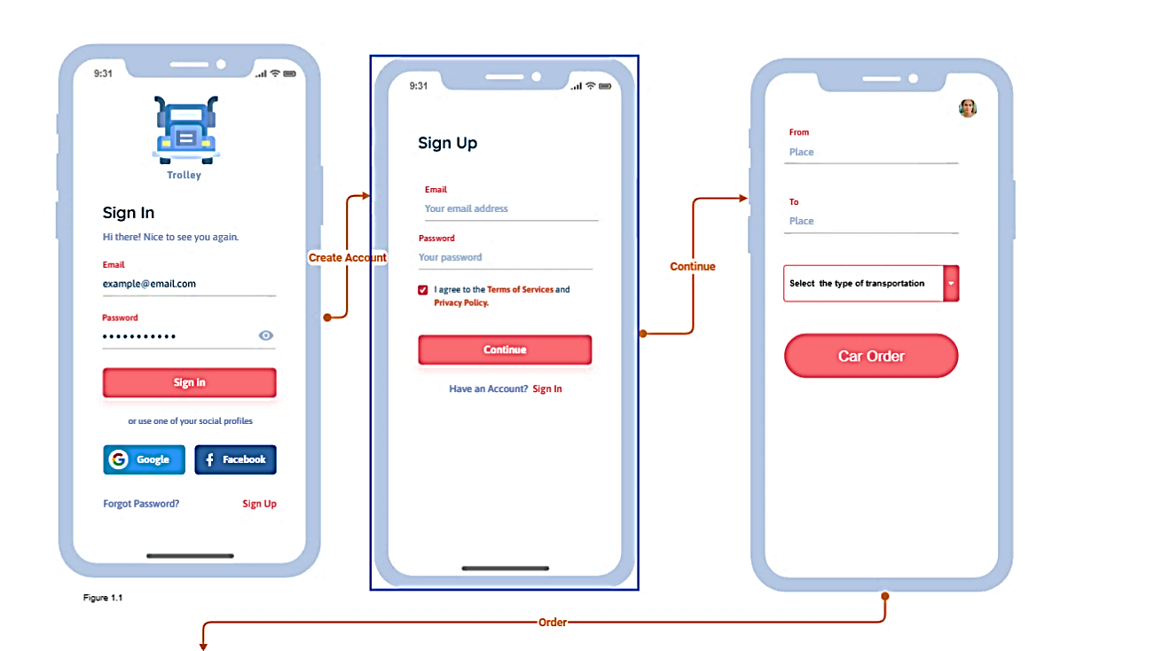
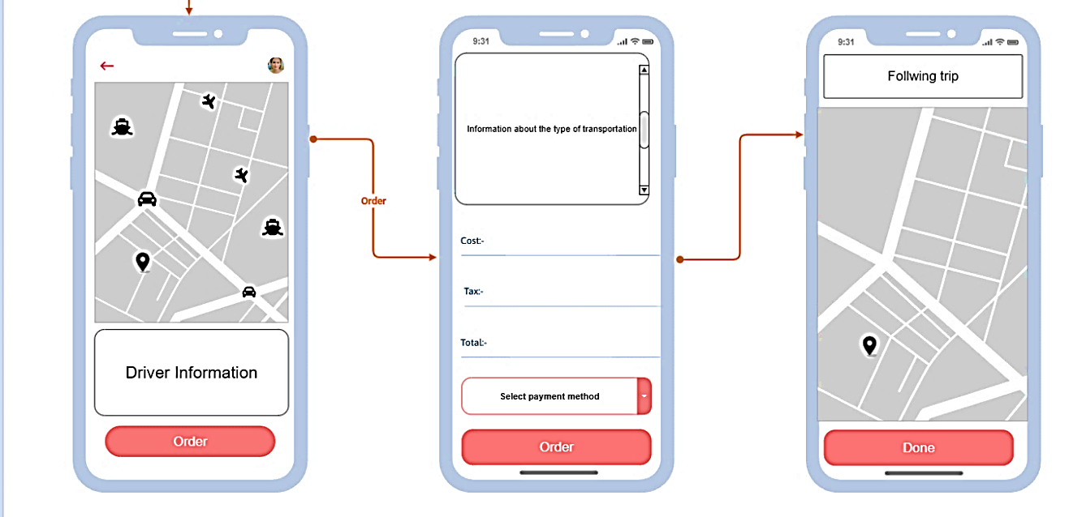
Figure 1.1 Clint Interface

- The driver login or create account and upload national ID, driving license and criminal record. He is receiving order from client; he can accept order or cancel. so when client accepts to deal with the driver send notification to driver, also the driver can accept or cancel order

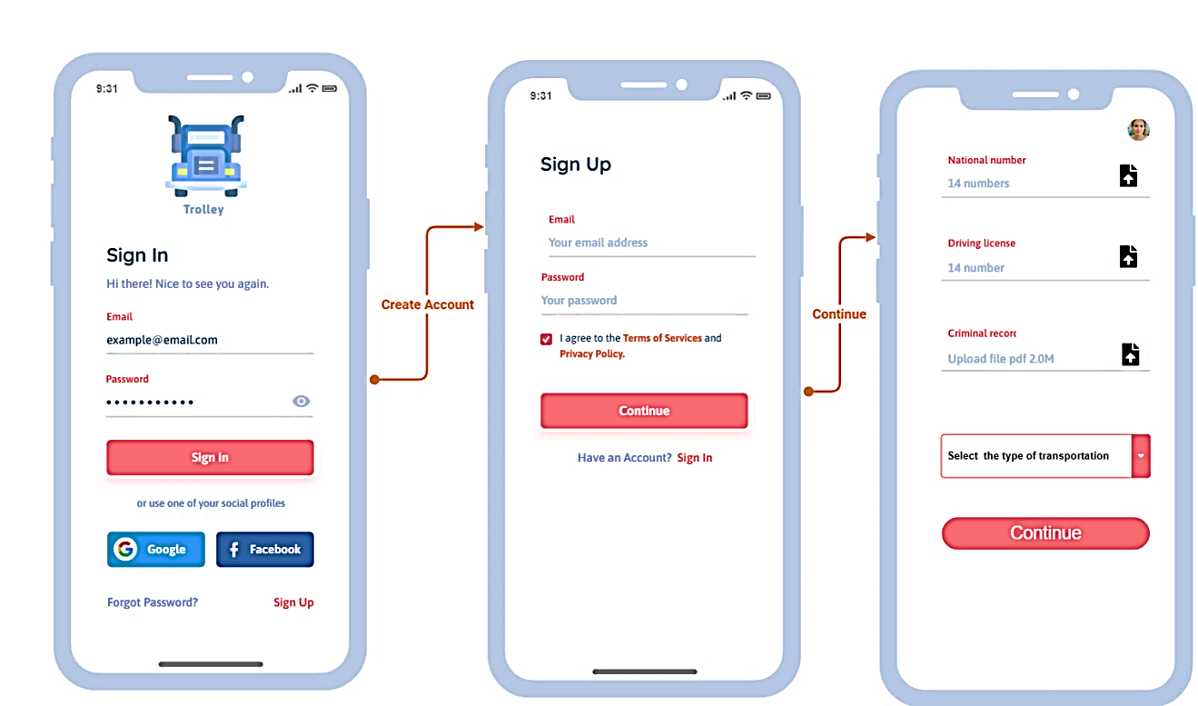

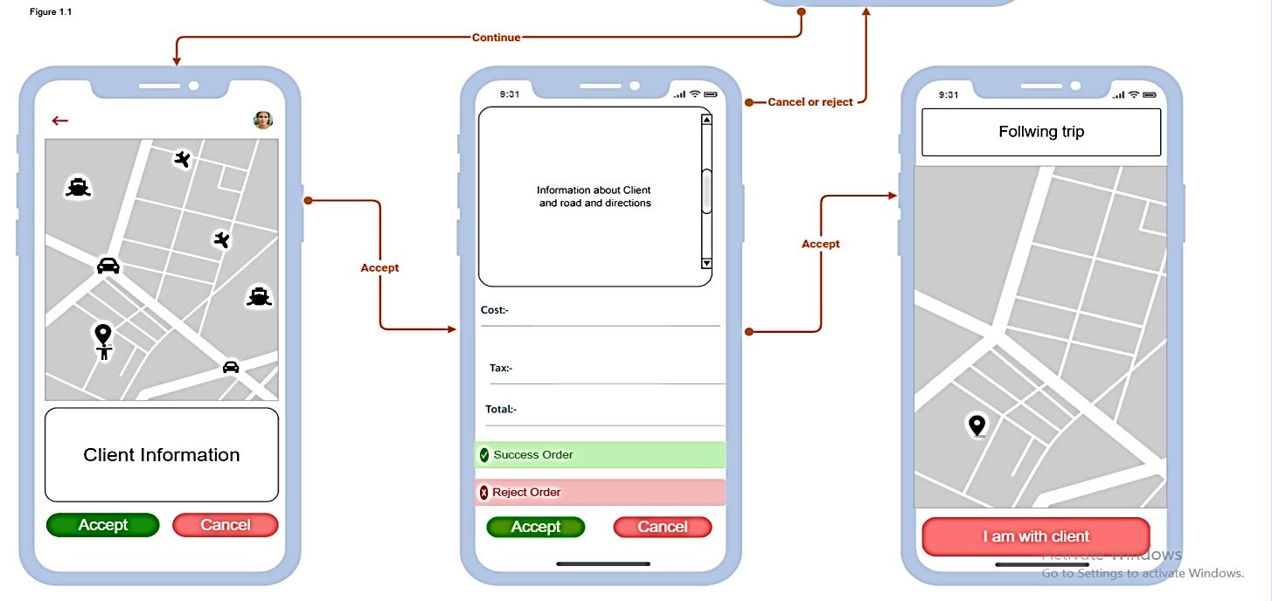

Figure 1.2 Driver Interface

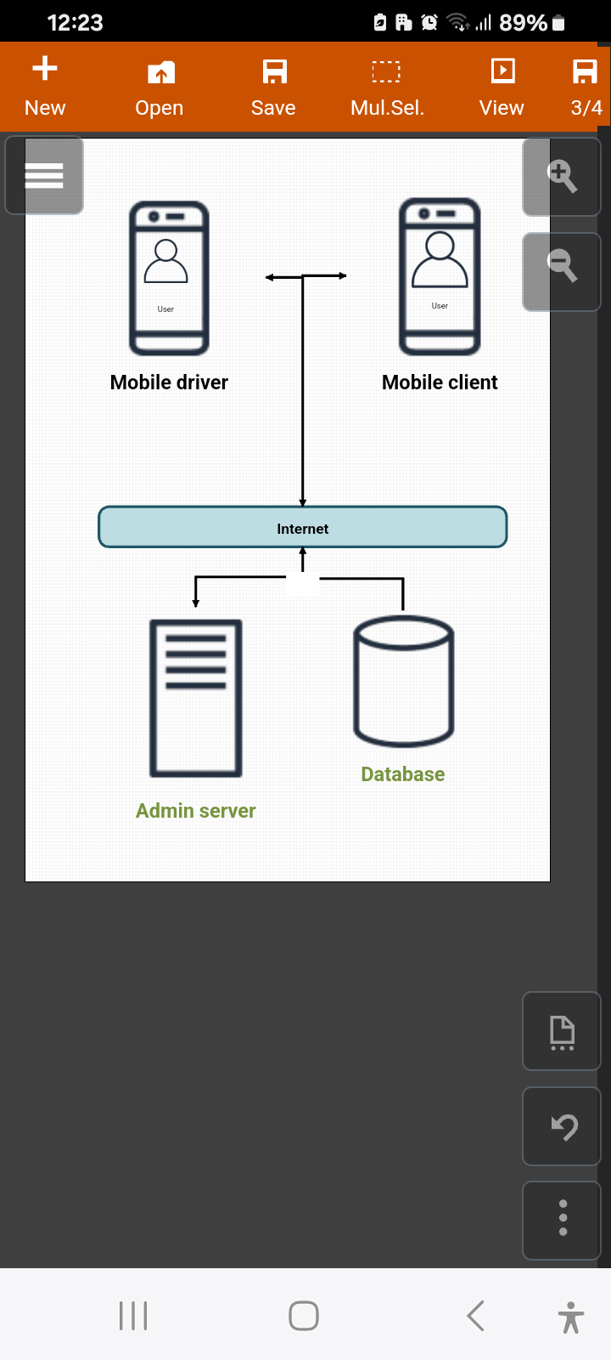

Figure 1.3 Map connections between
driver, client, admin and database

- System requirements specification:-
  - Functional Requirements:-
      - Requirement specifications:-
- Includes all system features requested by the customer

- Specific Requirements:-

- Create page login and create account. Client can register or login on app where create account include full name, national ID, phone number, email, password. Because we can follow with customer when any problem occurs.
but driver account include full name, national ID, phone number, email, password, driving license, driver's license, type of car, car model and car brand. Because we can follow driver through drive or transport
- When we make order, must find starting location and arrival Location and type of movables.

- Must locate the driver and locate the client and arrival point on map and display appropriate path to arrival point and costs transport

- Send notification to admin and client when the driver does not adhere to a specific route

- Send a notification to the driver when the customer makes a transportation request

- D

Identifier | Priority | Requirement
 | 5 | Login and register account on app and configuration new account
 | 4 | Starting location and arrival Location and type of movables.
 | 4 | Display locate the driver, the client and arrival point on map
 | 5 | Display appropriate path to arrival point and costs transport
 | 6 | Send notification to admin and client when the driver does not adhere to a specific route
 | 6 | Send a notification to the driver when the customer makes a transportation request

  - User Stories:-
- Focus on user benefits

Identifier | User Stories | Size
 | As registered customer, you can request car | 6pt
 | As registered customer, you can select Starting and arrival Location | 4pt
 | As registered customer, you can select type of movables | 3pt

Time and effort estimation:-

- Team velocity: how much points they can do per day.
- Assume that our team can do 2 points per 1 day. Then:
- 6point=3day
- 4point=2day
- 3point=1.5day

  - Work backlog “prioritized by customer”:-

Work  Items | User Stories | Iteration no. | Estimated work duration

  - Project duration:-
  - Use case diagram:-
  - Actor Description:-
  - Use Case Description:-
  - Traceability matrix:-
  - Activity Diagram:-
  - Sequence Diagram:-
  - Non-Functional Requirements:-
- System Design:-
  - Component Diagram:-
  - Class Diagram:-
  - Entity Relationship Diagram (ERD):-
  - Mapping:-
- Testing (User Acceptance test):-
  - Test cases:-

