Supplementary Material for Curation, inference, and assessment of a globally reconstructed gene regulatory network for Streptomyces coelicolor
Andrea Zorro-Aranda^{1,3}, Juan Miguel Escorcia-Rodríguez¹, José Kenyi González-Kise^{1,2}, and Julio Augusto Freyre-González^{1,}*
¹Regulatory Systems Biology Research Group, Laboratory of Systems and Synthetic Biology, and ²Undergraduate Program in Genomic Sciences, Center for Genomics Sciences, Universidad Nacional Autónoma de México. Av. Universidad s/n, Col. Chamilpa, 62210. Cuernavaca, Morelos, México. ³Bioprocess Research Group, Department of Chemical Engineering, Universidad de Antioquia, Calle 70 No. 52-21, Medellín, Colombia.
*Corresponding author: jfreyre@ccg.unam.mx (J.A.F.-G.)

Supplementary results 3
Supplementary Figure 1 3
The functional architecture of the S. coelicolor GRN 4
Supplementary Figure 2 4
Global regulators 4
Intermodular genes 5
Network inference 7
Quantitative assessment and cross-validation 7
Supplementary Figure 3 7
Supplementary Figure 4 7
Supplementary Figure 5 8
Supplementary Figure 6 9
Topological assessment 10
Supplementary Figure 7 10
Supplementary Figure 8 11
Supplementary Figure 9 11
Supplementary Figure 10 12
Supplementary Figure 11 12
Supplementary Figure 12 13
Assessment of the global regulators' inference 14
Supplementary Figure 13 14
Supplementary Figure 14 14
Putative transcription factors for actII-orf4 15
Supplementary Figure 15 15
Supplementary Figure 16 15
Supplementary methods 16
Details collected in the curation of the regulatory interactions 16
Transcriptomic Data 17
Friedman 17
Statmodel 17
The Natural Decomposition Approach 18
Supplementary references 18

Supplementary results

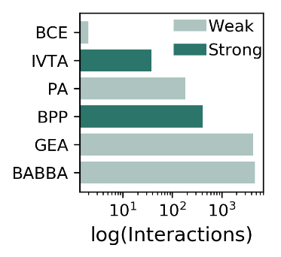

Supplementary Figure 1
The number of interactions supported by each type of experimental evidence. BCE, binding of cellular extracts; IVTA, in-vitro transcription assay; PA, proteomic analysis; BPP, binding of purified proteins; GEA, gene expression analysis; BABBA, binding affinity by bead-based assays.

The most studied TFs were the ones encoded by phoP (SCO4230) ¹⁻⁹, glnR (SCO4159) ¹⁰⁻¹⁶, and the sigma factor encoded by sigR (SCO5216) ¹⁷⁻²³. The interactions more studied are among the TF encoded by phoP (SCO4230) and its TGs pstS (SCO4142), phoU (SCO4228), phoR (SCO4229), and itself ^{1,2,4,9}; and the sigma factor encoded by sigR (SCO5216) and its TGs trxC (SCO0885) ^{19,20,22,23}, trxB (SCO3890), and itself ^{18,20,22,23} (Supplementary Table 3).

The functional architecture of the S. coelicolor GRN
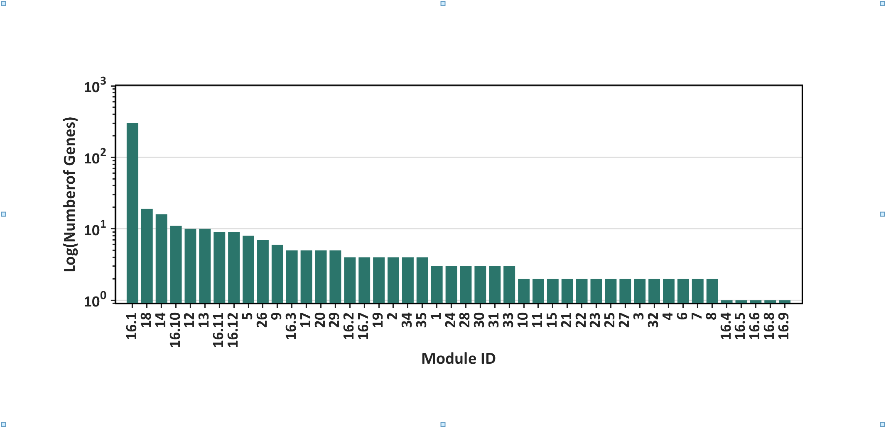
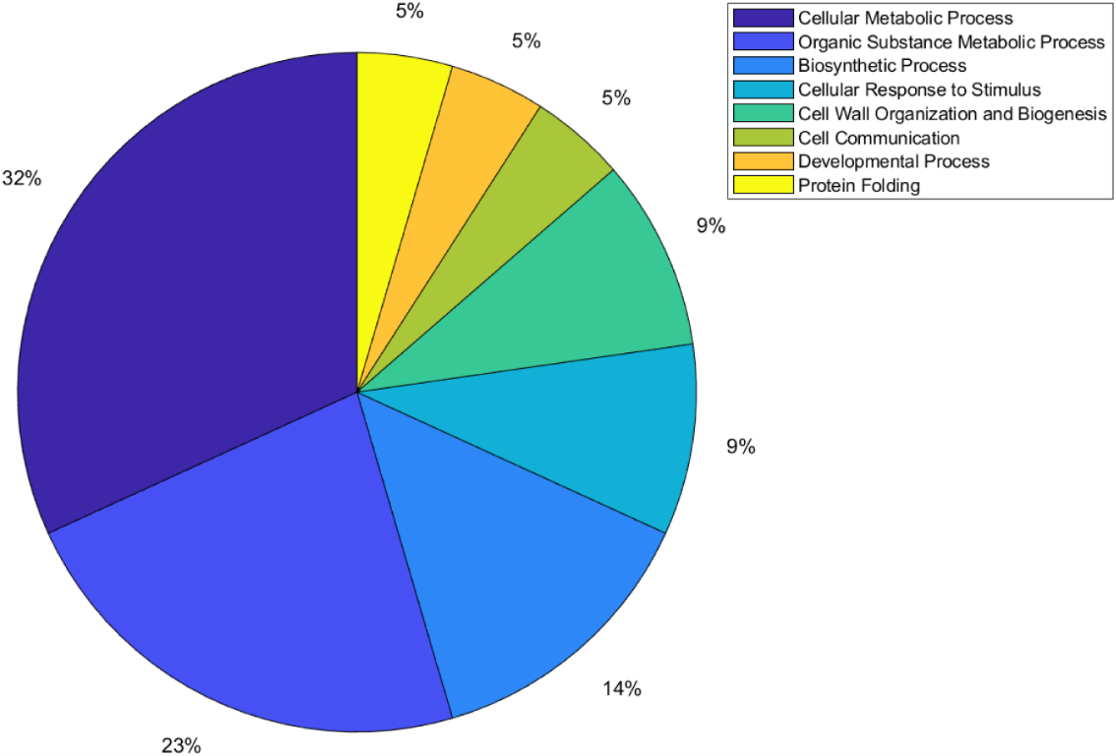
a

b

Supplementary Figure 2
a) Number of genes per module of the meta-curated network Curated_RTB-FL-DBSCR. b) Distribution of modules per function for the meta-curated network Curated_FL-DBSCR-RTB.

Global regulators
The nine GR previously reported in Martín et. Al.²⁴ are argR (SCO1576), absA2 (SCO3226), phoP (SCO4230), afsS (SCO4425), abrC3 (SCO4596), dasR (SCO5231), absC (SCO5405), ndgR (SCO5552), and scbR (SCO6265). phoP is the gene with the highest out-connectivity in the meta-curated network Curated_FL-DBSCR-RTB. PhoP is a response regulator from the TCS PhoR–PhoP. It has been experimentally identified to act as GR in vivo controlling phosphate scavenging systems and cell wall/extracellular polymer biosynthesis ⁹. The other 10 genes that were classified as GRs by Martín et. al, were not identified as such by the NDA. The reason for these false negatives is the criteria used by the author to their classification since it is done by their capability to regulate genes from multiple pathways (wide domain regulators) or the regulation of hundreds of genes. Therefore, in an incomplete GRN, TFs controlling genes from multiple pathways but with a few TGs will not be identified as GRs by the NDA, where a high out-connectivity and low clustering coefficient of the gene are, by definition, features required to be classified as GR. Moreover, the classification by Martín et. al considers GRs for Streptomyces in general, not only for S. coelicolor. Therefore, genes labeled as false negatives could be acting as local regulators in S. coelicolor while being GRs in another Streptomyces.
Following, we describe the GRs or pleiotropic regulators that were reported individually (Supplementary Table 4). The sigma factor SigR (SCO5216) was recently reported as GR controlling DNA repair, protein quality control, thiol homeostasis, sulfur metabolism, ribosome modulation, and DNA repair²⁵. ScbR2 (SCO6286) has been identified to regulate morphological differentiation and stress response through a plethora of genes across the S. coelicolor genome, suggesting a global-level regulation²⁶. The ECF sigma factor SCO4117 has been previously reported as a pleiotropic regulator that controls secondary metabolism and morphogenesis ²⁷. The gene SCO5283 has just been described to encode the cognate response regulator of the TCS SCO5282/SCO5283, having a pleiotropic effect in glycolysis, gluconeogenesis, stress-signaling pathways, proteins secretion, and cell envelope metabolism²⁸. Rok7B7 (SCO6008) has been found to control carbon catabolite repression, antibiotic biosynthesis, xylose utilization, and morphological development²⁹. The TF encoded by SCO7173 has been reported as pleiotropic regulators of phosphate starvation response and actinorhodin biosynthesis³⁰. The TF encoded by SCO5785 is a response regulator related to antibiotic synthesis, sporulation, and several ribosomal genes ³¹. Aor1 (SCO2281) has been recently described as a global regulator, orphan RR containing REC and HTH domains, which act as a positive regulator of antibiotic production of ACT, RED, and CDA; and of the genes involved in morphological differentiation³². WblA (SCO3579) has been reported as a pleiotropic regulator of various antibiotic pathways, the formation of aerial hyphae, and response to oxidative stress³³. HrdB (SCO5820) is known to be the housekeeping sigma factor of S. coelicolor and to be essential for its survival, thus it affects a great number of biological processes and genes³⁴. The only gene predicted as GR that has not been reported as such is SCO3356, which codes for the ECF sigma factor SigE and has only been reported as a coordinator of the cell wall integrity system^{35,36}. Nevertheless, the maintenance of the wall integrity carries diverse biological functions, which might imply a pleiotropic effect on the cell.

Intermodular genes
Intermodular genes integrate the regulatory response of different modules, which means they coordinate different biological processes in the cell. Among all the curated networks, the meta-curated network Curated_RTB-FL-DBSCR has the largest number of intermodular genes, 18 (0.33% of the 5386 network genes). Some of the genes found as intermodular are: ssgB (SCO1541) a homolog of the sporulation gene ssgA, and its product has been suggested as a key regulator of the process of growth cessation before sporulation-specific cell division, affecting cell sporulation along with actinorhodin production³⁷. Five genes are predicted as intermodular genes. Two genes glnA (SCO2198) and glnII (SCO2210) encode glutamine synthase and the amount operon, amtB-glnK-glnD (SCO5583-85), encodes an ammonium transporter, a PII protein, and an adenylyltransferase. These five genes are involved in nitrogen metabolism and are directed regulated by GlnR (SCO4159), the major regulator of nitrogen metabolism^{6,38}. Moreover, they are also regulated by PhoP (SCO4230) the principal regulator of phosphate metabolism^{6,38}. Moreover, glnII is also involved in the onset of mycelial differentiation, which might suggest a role in the regulation of secondary metabolism³⁹. Additionally, an intrinsic role of glutamine synthetase in secondary metabolism has been also suggested in S. lividans⁴⁰. This suggests that both genes might have in role in the coordination of nitrogen and phosphate metabolism, along with the secondary metabolism. Regarding another gene cluster agl3EFG (SCO7165-67) classified as intermodular, Hillerich and Westpheling suggested it have the function of carbohydrate transport⁴¹. This cluster appears to be regulated by GlnR (SCO4159) and Agl3R (SCO7168), a GntR family transcriptional regulator. While GlnR is known to regulate the genes involved in nitrogen metabolism¹⁰, many GntR family regulators have been proved to have a role of repression in carbon metabolism⁴¹. This might suggest that this cluster has a role in coordinating nitrogen and carbon metabolism, as it has been shown for other processes such as nitrogen and phosphate metabolism⁴². Other intermodular genes are the actII-orf2 and actII-orf3 (SCO5083-84), which are part of the BCG of ACT antibiotic. Both genes are regulated by actII-orf4 (SCO5085) — the SARP of ACT —, AfsS (SCO4425) and SCO7173. -The two latter TFs are involved in phosphate metabolism and SCO7173 also affects the biosynthesis of ACT, which might be achieving through these intermodular genes³⁰.

Network inference

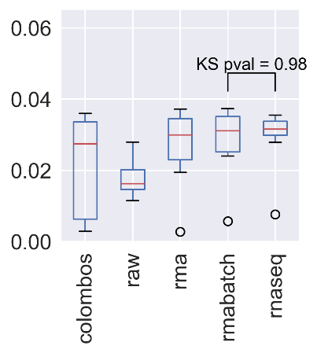
Quantitative assessment and cross-validation
a b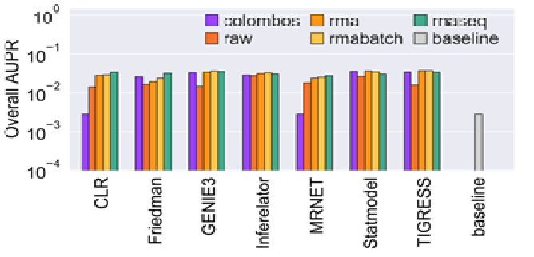

Supplementary Figure 3
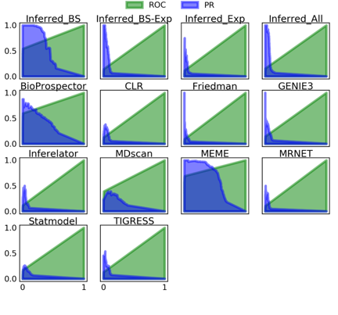
a) AUPR for the inferences from transcriptomic data. b) Distribution of the AUPR scores obtained with different datasets. KS = Kolmogorov-Smirnov between the distributions of the AUPR scores for batch-corrected RMA and RNA-seq datasets used as input for the GRNs prediction tools.

Supplementary Figure 4
ROC and PR curves for each of the inference methods and the community networks using the curated networks as GS.
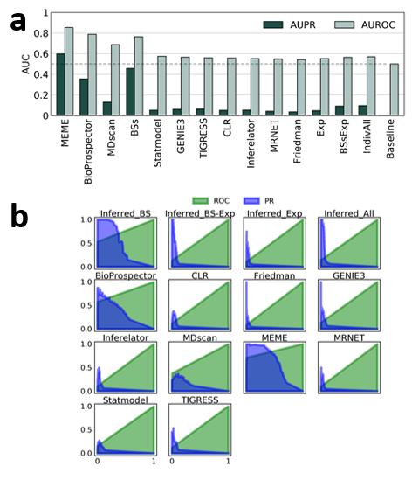

Supplementary Figure 5
a) AUCs for the inference methods and the community networks using the curated networks plus the statistically validated interactions as GS. b)ROC y PR curves for each of the inference methods and the community networks using the curated networks plus the statistically validated interactions as GS.

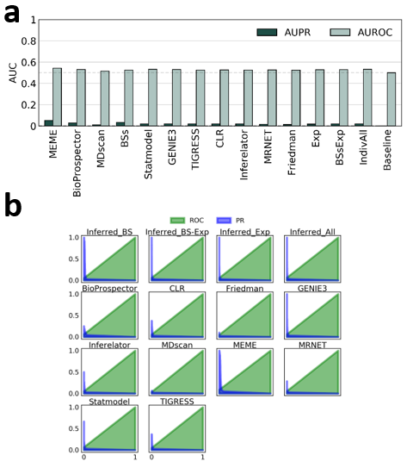

Supplementary Figure 6
- AUCs for the inference methods and the community networks using every curated interaction as the GS (Curated_FL-DBSCR15-RTB13). Note that the tools based on binding sites prediction are the most affected ones wrt. Supplementary Figure 5. This is because the predictions based on binding sites were only for the experimentally supported DNA-binding proteins. Namely, the TFs in Curated_FL(S)-DBSCR(S). Curated_FL(S)-DBSCR(S) has only 72 TFs, while Curated_FL-DBSCR15-RTB13 has 137. This results in a poor recall by the predictions based on binding sites (b), as interactions for 65 TFs are not predictable. Even though the precision increased for most of the tools based on gene expression data, they also showed a poor recall.

Topological assessment

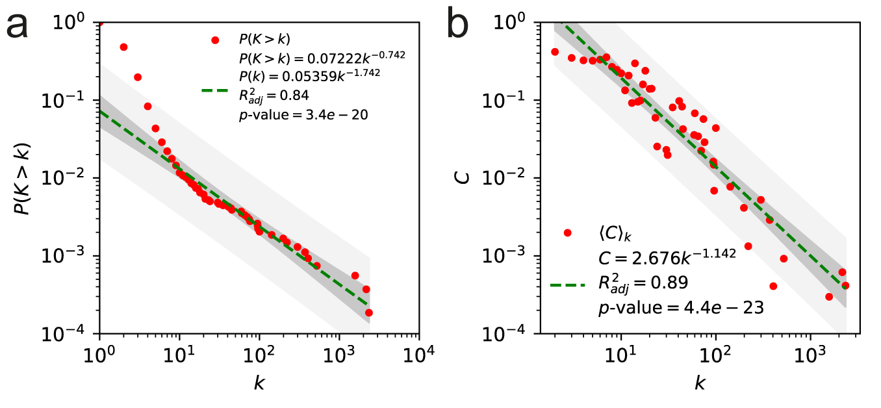

Supplementary Figure 7
a) Cumulative distribution of node connectivity and b) clustering coefficient distribution for the meta-curated network Curated_FL-DBSCR-RTB.

Some of the most relevant structural properties of the curated networks are described following. The curated networks have low network density (<1%), as have been previously reported for other bacterial regulatory networks ⁴³. Their average path lengths are smaller than the logarithm of the network size, $\ln{(ln(N))}$, which indicates that they are ultra-small world networks, as scale-free networks ⁴⁴. From the robust linear regression over the log-log data, the degree distributions ($P(k)$) follow a power-law, suggesting that they are scale-free (Supplementary Figure 7). Regarding the clustering coefficient distribution ($C(k)$), the networks seemed to be hierarchical modular. Both characteristics were previously observed in diverse bacterial networks ⁴⁵. We computed the Kolmogorov-Smirnov distance between the networks’ degree distribution and several probability functions, and a maximum likelihood estimation for their α to corroborate that the curated networks are scale-free. Except for Curated_DBSCR(S) that has a similar distance between its degree distribution to a power law and a log-normal, the degree distributions of all the curated networks have the smallest distance to a power law distribution (Supplementary Table 7a). For the α estimation values between two and three for the curated networks (Supplementary Table 7b), we can corroborate that the curated networks are scale-free as other bacterial GRNs ⁴³

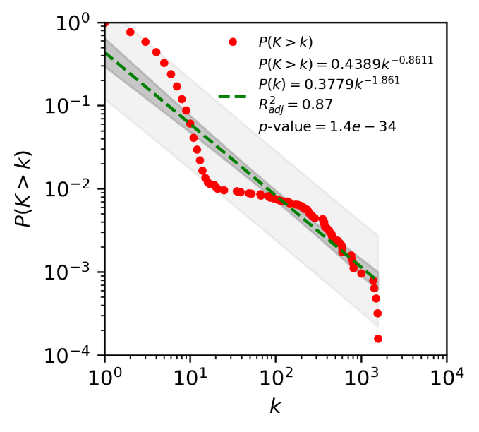
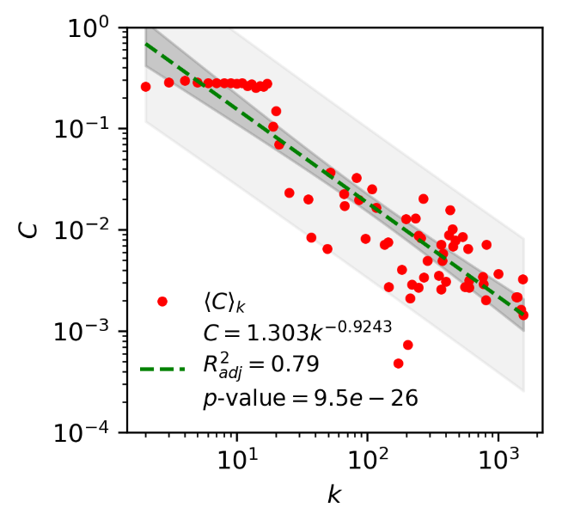

Supplementary Figure 8
Cumulative distribution of node connectivity and distribution of node clustering coefficient of community network Inferred_BS.

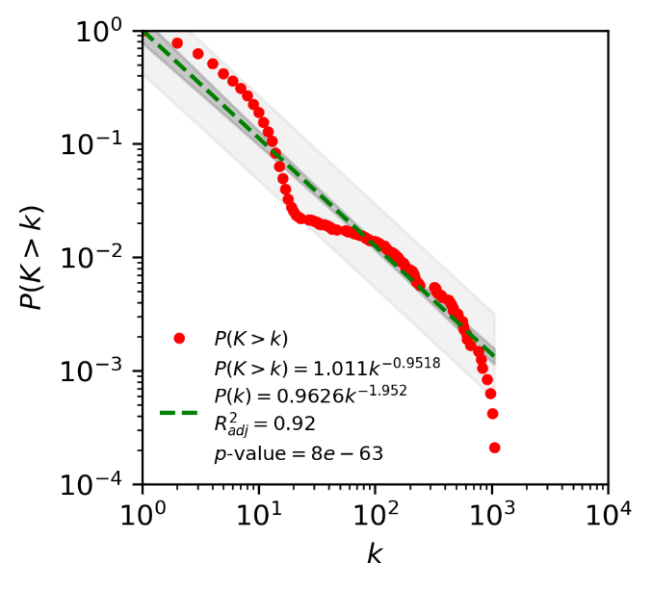
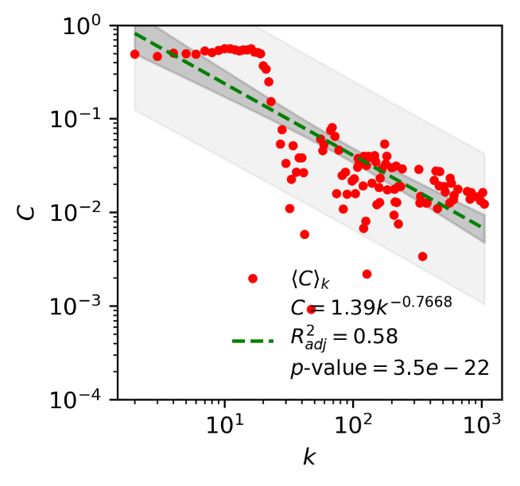

Supplementary Figure 9
Cumulative distribution of node connectivity and distribution of node clustering coefficient of community network Inferred_Exp.

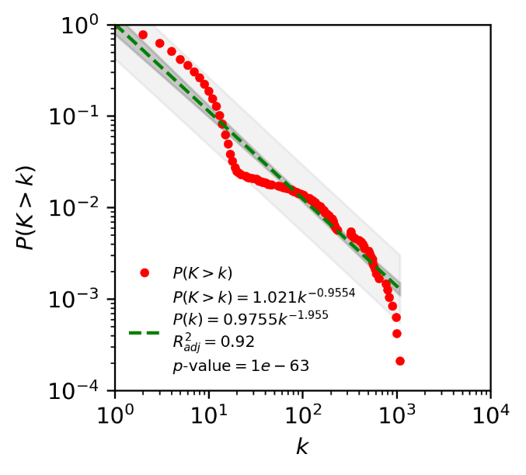
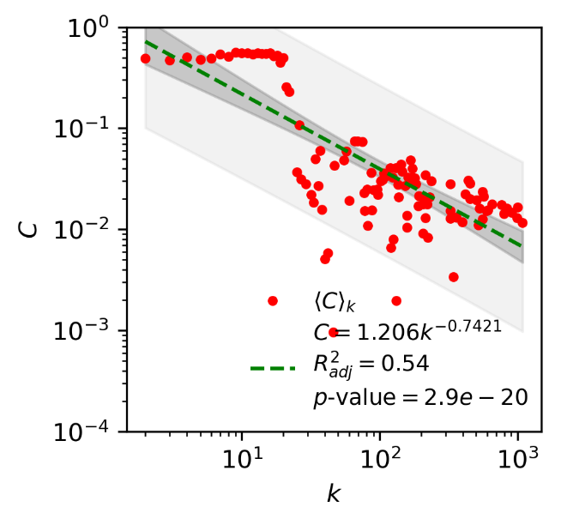

Supplementary Figure 10
Cumulative distribution of node connectivity and distribution of node clustering coefficient of community network Inferred_BS-Exp.

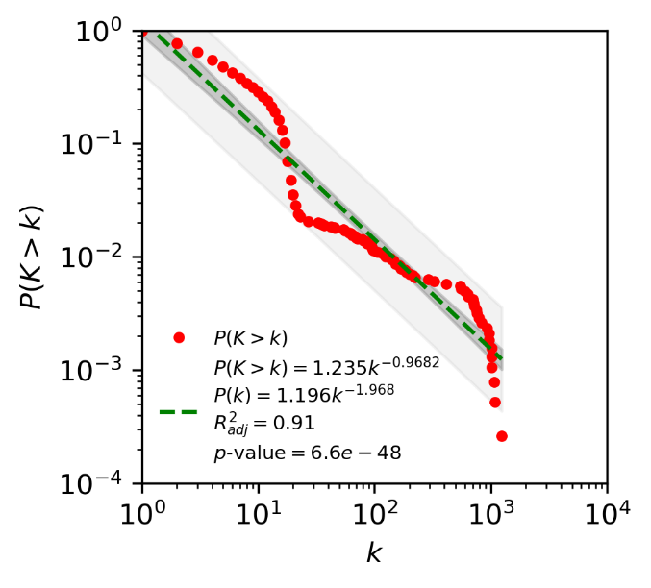
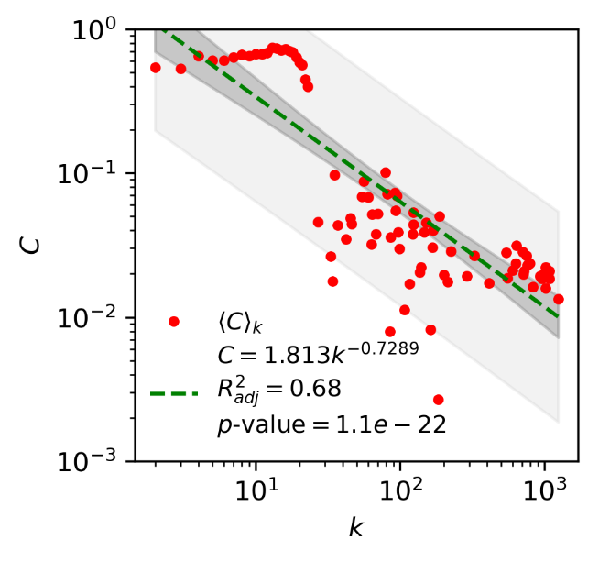

Supplementary Figure 11
Cumulative distribution of node connectivity and distribution of node clustering coefficient of community network Inferred_All.

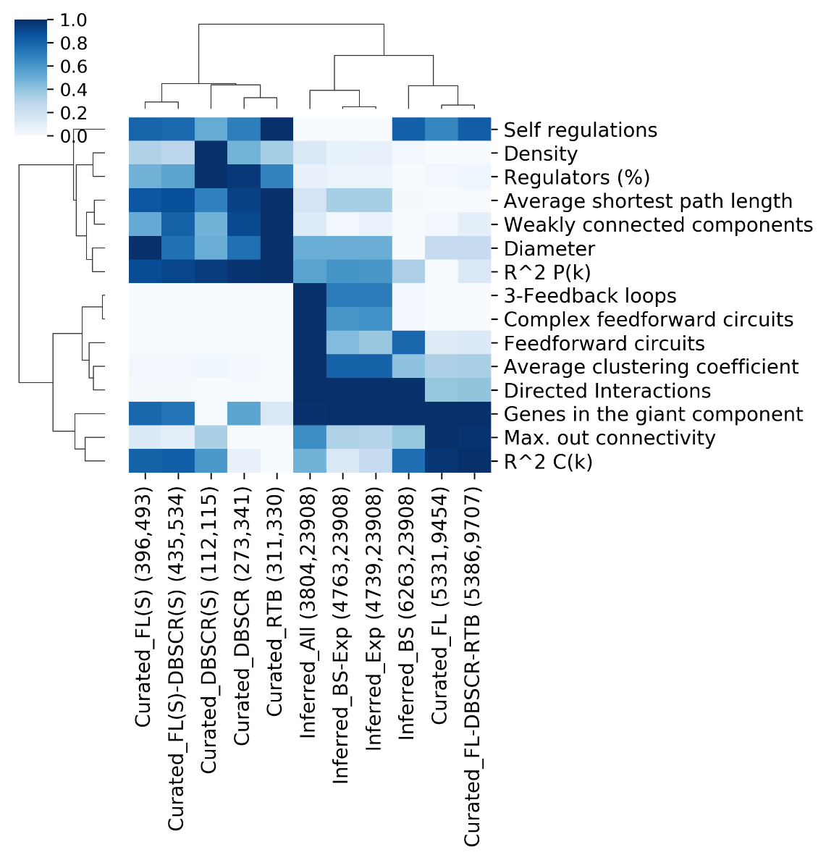

Supplementary Figure 12

Comparative of network properties. Min-max normalization was applied for each property across networks. Aside from each network is their cognate number of nodes and interactions are displayed.

Assessment of the global regulators' inference
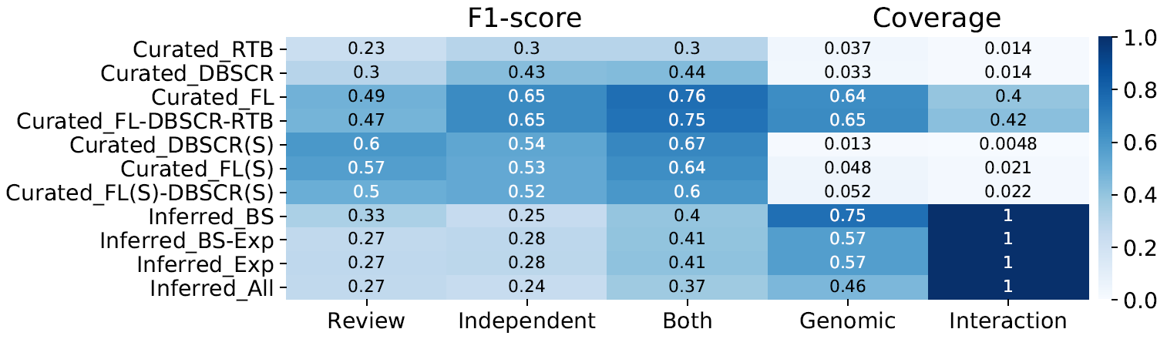

Supplementary Figure 13
F1-score for global regulators predicted by NDA for each of the curated and inferred networks. Scores ≥ 0.5 are represented in white numbers.

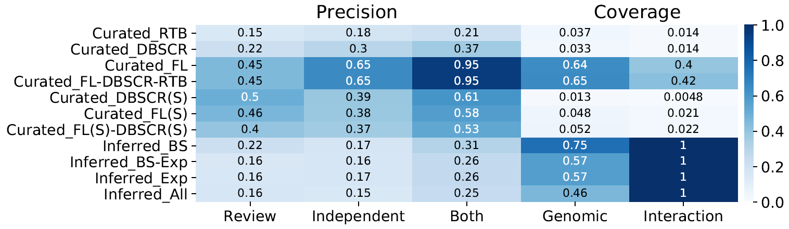

Supplementary Figure 14
Precision for global regulators predicted by NDA for each of the curated and inferred networks. Scores ≥ 0.5 are represented in white numbers.

Putative transcription factors for actII-orf4

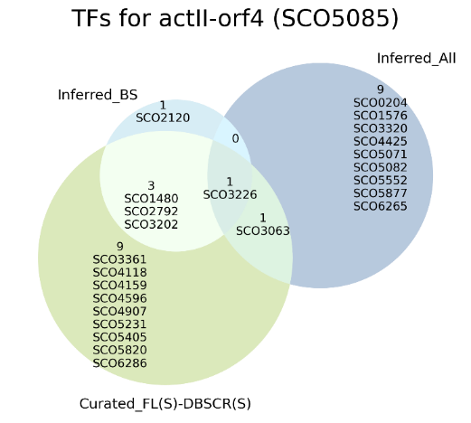

Supplementary Figure 15. Potential transcription factors for actII-orf4 suggested by Inferred_BS and Inferred_All, and the overlap of their predictions with the strong meta-curation.
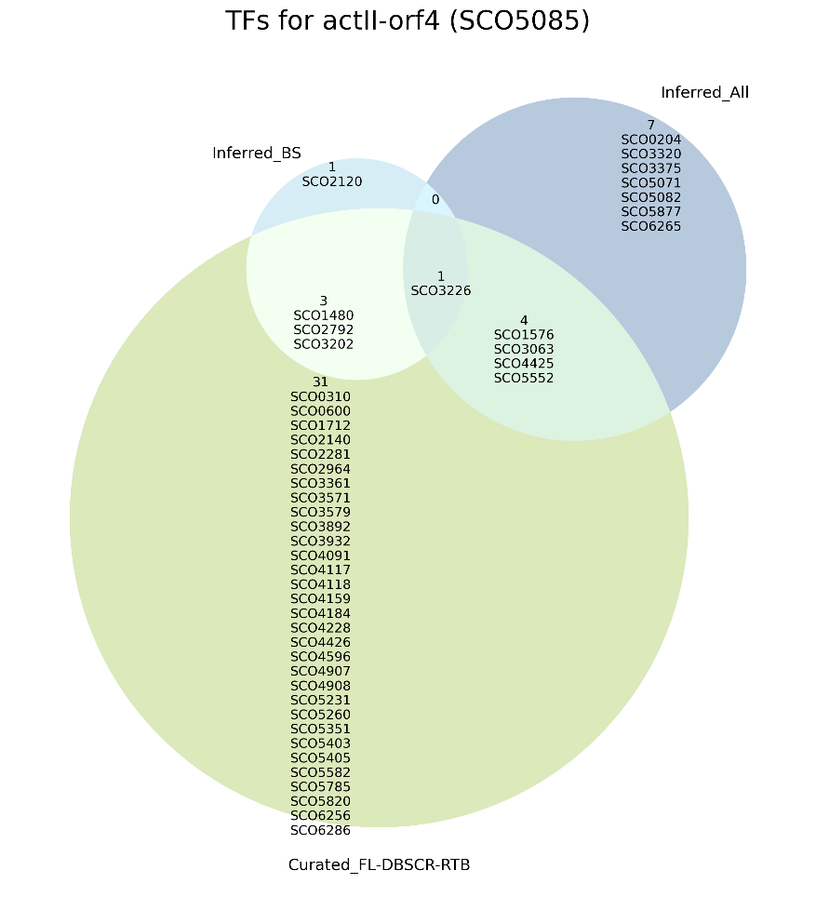

Supplementary Figure 16. Potential transcription factors for actII-orf4 suggested by Inferred_BS and Inferred_All, and the overlap of their predictions with the meta-curation including all types of experimental evidence.

- Besides SCO3226 and SCO3063, 3 more TFs have been already reported as regulators of SCO5085 and are included in the network Curated_FL-DBSCR-RTB. Namely, SCO1576, SCO4425, and SCO5552.
- SCO0204 (osdR) regulates genes involved in the control of stress and development⁴⁶. The authors characterized the OsdR regulon using predictions based on regulatory binding sites and verify them with EMSA. However, SCO5085 was not a putative target in their prediction. It was not part of our prediction based on binding sites (Inferred_BS) neither, only of predictions based on gene expression.
- SCO3320. Previous work suggested the regulation of SCO5085 by SCO3320 through a LexA-like motif in E. coli⁴⁷. However, no experimental evidence has been performed to confirm such regulation.
- SCO3375 codes a putative Lsr2-like protein regulated by PhoP and regulates the transcription of SCO1541, a gene involved in sporulation-specific cell division.
- SCO5071 codes a putative hydroxylacyl-CoA dehydrogenase and has been found its expression to be regulated by SCO5351⁴⁸, a regulator of SCO5085. Noteworthy, SCO5071 has been reported as a TG for SCO5085 itself ⁴⁹. SCO5071 is included as a regulator of several genes in Curated_RTB, however, it might be an indirect effect such as the feedback expected to happen with SCO5085.
- SCO5082 codes ActII-orf1, a repressor of actII-orf2 and actII-orf3⁵⁰. The genes actII-orf2 and actII-orf3 are divergently transcribed, therefore, it is likely for actII-orf4 to also be regulated by ActII-orf1.
- SCO5877 codes RedD, a regulator of the RED biosynthesis⁵¹. Suggesting cross-regulation between gene clusters encoding biosynthesis of individual antibiotics⁵².
- SCO6265 codes ScbR, a protein involved in γ-butyrolactone (SCB1) synthesis that has been previously suggested to regulate Act and Red synthesis through orfB (SCO6268)⁵³.

Supplementary methods

Details collected in the curation of the regulatory interactions
- TF
- TF locus tag
- TF description
- TG
- TG locus tag
- Experiment
- evidence (methodology applied for the identification of the interaction)
- regulatory function (repression, activation, unknown)
- evidence classification, interactions were classified according to the weight of the experimental evidence supporting them as “strong” (evidence of direct TF binding) or “weak” (no evidence of direct TF binding), following the RegulonDB scheme ^{54,55} (Supplementary Figure 1)
- reference PubMed ID and DOI of the paper curated; xi) year of publication; xii) notes.
- The same information is presented in Supplementary Table 1.

Transcriptomic Data
First, we used the microarray data consisting of 371 samples available from the COLOMBOS Database⁵⁶. Second, we obtain microarray and RNA-Seq data from NCBI GEO⁵⁷. As there is not a consensus method for microarray data integration from different platforms, we decide to take the platform with the largest dataset (137 samples), which was an Affymetrix platform. This data was taken raw, then Robust Multi-chip Averaging (RMA) normalization was performed⁵⁸, and finally, it was batch-effect corrected⁵⁹. For the case of RNA-Seq, the data is available with different types of normalization for each series. Therefore, we decided to take the largest dataset as well (54 samples). The inference from expression data was performed over the 5 datasets available: i) COLOMBOS (colombos), ii) RNA-Seq (rnaseq), iii) Affymetrix raw (raw), iv) Affymetrix with RMA normalization (rma), and v) Affimetrix with batch-effect correction (rmabatch). To provide insights on the quality of the predictions, the inferred GRNs were assessed using the network Curated_FL(cS)-DBSCR(S) as GS, and the AUPR were computed for each one of the networks. We assessed the inferred GRN based mostly on the AUPR since it is more informative for imbalanced datasets⁶⁰ as it is the case of GRNs inference⁶¹ (Supplementary Figure 3). From the evaluation, despite a large amount of data, the prediction with colombos performs poorly regarding the other data sets. From the Affymetrix data, the rmabatch set performed the best with a very similar result to the rnaseq dataset. However, the latter comes from one unique study, while the Affymetrix data comes from different studies with more diverse data. Then, we selected the Affymetrix rmabatch as our dataset for the final inference from transcriptomic data. This, since we believe a more diverse data will allow us to identify a higher quantity of regulatory interactions.

Friedman
We proposed a modification of the method ANOVA for GRN inference. In this method, the likelihood of an interaction between a transcription factor (TF) and a target gene (TG) is given by a non-linear correlation coefficient, which is derived from an analysis of variance (two-way ANOVA). The correlation coefficient measures association as the fraction of the total variance that is explained by the differential expression across experimental conditions ⁶². ANOVA has some requirements for its proper application, one of them is a normal distribution. This might not be accurate for the distributions of gene expression. Thus, we proposed a variation, deriving the non-linear correlation coefficient from a Friedman test. This is the non–parametric alternative of ANOVA since it does not make assumptions of normality ⁶³. A Matlab implementation for the original method (Anova) and the modification (Friedman), along with their documentation can be found at https://github.com/andreazorro/Anova. The algorithm takes as input a matrix of expression data and a list of TFs, and the output is the list of TF - TG correlation coefficients.

Statmodel
We proposed a modification for GRN inference of the method Statmodel proposed by Hernandez⁶⁴. This method is an alternative tool for statistical modeling and analysis of experiments than ANOVA. Since this methodology allows us to determine the influence of independent factors (TFs expression) over a response variable (TG expression), we found it as a proper tool for GRN inference. For this purpose, we proposed a modification of the methodology initially presented and a suggested score for the interaction reliability. Statmodel presents some advantages concerning ANOVA, such as no assumption of the data distributions and the minimization of the variance of the residual error probability model, reducing the chances of over-fitting. Moreover, this methodology reduces the spurious effects minimizing the number of predictor variables, which is mainly what we look for in GRN inference.
To obtain a parsimonious model, we should reduce the number of parameters of the model. This can be done through a hypothesis test to find the coefficients that are significantly different from zero. To perform the hypothesis test, first, we find the probability distribution that better adjusts to the response variable. Then, we evaluate if the data for the smallest subgroup is adjusted to this probability distribution (See Hernandez⁶⁴ for further details). To evaluate this, we applied a Chi-square test in Matlab. The coefficient is considered to be significantly different from zero If the alternative hypothesis cannot be rejected. This means that the null hypothesis Is rejected by the Chi-square test.
In this case, we are evaluating the influence of a TF's expression on a gene’s expression. We proposed a score for the reliability of the interaction as the $-\log{ \left(\text{p-value}\right)}$ of Chi-square test. Its Matlab implementation along with its documentation can be found at https://github.com/andreazorro/Statmodel. The algorithm takes as input a matrix of expression data and a list of TFs, and the output is the list of TF-TG reliability scores.

The Natural Decomposition Approach
First, the NDA identifies the global regulators (GRs) as genes with higher out connectivity than the κ value, the equilibrium point from the $C(k)$ distribution where the variation of the clustering coefficient is equal to the variation of the connectivity but with the opposite sign dC(k)/dk = -1. Then, the genes from the basal machinery are revealed as those regulated only by GRs. After the removal of the GRs and the genes from the basal machinery, as well as their interactions, the structural genes are removed, leaving isolated subnetworks (modules). Then, the structural genes are re-integrated as intermodular genes if their regulators belong to different modules, otherwise as modular genes belonging to the same module as their regulators.

Supplementary references
1 Sola-Landa, A., Rodriguez-Garcia, A., Franco-Dominguez, E. & Martin, J. F. Binding of PhoP to promoters of phosphate-regulated genes in Streptomyces coelicolor: identification of PHO boxes. Mol Microbiol 56, 1373-1385, doi:10.1111/j.1365-2958.2005.04631.x (2005).
2 Rodriguez-Garcia, A., Barreiro, C., Santos-Beneit, F., Sola-Landa, A. & Martin, J. F. Genome-wide transcriptomic and proteomic analysis of the primary response to phosphate limitation in Streptomyces coelicolor M145 and in a DeltaphoP mutant. Proteomics 7, 2410-2429, doi:10.1002/pmic.200600883 (2007).
3 Apel, A. K., Sola-Landa, A., Rodriguez-Garcia, A. & Martin, J. F. Phosphate control of phoA, phoC and phoD gene expression in Streptomyces coelicolor reveals significant differences in binding of PhoP to their promoter regions. Microbiology (Reading) 153, 3527-3537, doi:10.1099/mic.0.2007/007070-0 (2007).
4 Sola-Landa, A., Rodriguez-Garcia, A., Apel, A. K. & Martin, J. F. Target genes and structure of the direct repeats in the DNA-binding sequences of the response regulator PhoP in Streptomyces coelicolor. Nucleic Acids Res 36, 1358-1368, doi:10.1093/nar/gkm1150 (2008).
5 Santos-Beneit, F., Rodriguez-Garcia, A., Sola-Landa, A. & Martin, J. F. Cross-talk between two global regulators in Streptomyces: PhoP and AfsR interact in the control of afsS, pstS and phoRP transcription. Mol Microbiol 72, 53-68, doi:10.1111/j.1365-2958.2009.06624.x (2009).
6 Rodriguez-Garcia, A., Sola-Landa, A., Apel, K., Santos-Beneit, F. & Martin, J. F. Phosphate control over nitrogen metabolism in Streptomyces coelicolor: direct and indirect negative control of glnR, glnA, glnII and amtB expression by the response regulator PhoP. Nucleic Acids Res 37, 3230-3242, doi:10.1093/nar/gkp162 (2009).
7 Santos-Beneit, F., Rodriguez-Garcia, A., Apel, A. K. & Martin, J. F. Phosphate and carbon source regulation of two PhoP-dependent glycerophosphodiester phosphodiesterase genes of Streptomyces coelicolor. Microbiology (Reading) 155, 1800-1811, doi:10.1099/mic.0.026799-0 (2009).
8 Santos-Beneit, F. et al. The RNA polymerase omega factor RpoZ is regulated by PhoP and has an important role in antibiotic biosynthesis and morphological differentiation in Streptomyces coelicolor. Appl Environ Microbiol 77, 7586-7594, doi:10.1128/AEM.00465-11 (2011).
9 Allenby, N. E., Laing, E., Bucca, G., Kierzek, A. M. & Smith, C. P. Diverse control of metabolism and other cellular processes in Streptomyces coelicolor by the PhoP transcription factor: genome-wide identification of in vivo targets. Nucleic Acids Res 40, 9543-9556, doi:10.1093/nar/gks766 (2012).
10 Tiffert, Y. et al. The Streptomyces coelicolor GlnR regulon: identification of new GlnR targets and evidence for a central role of GlnR in nitrogen metabolism in actinomycetes. Mol Microbiol 67, 861-880, doi:10.1111/j.1365-2958.2007.06092.x (2008).
11 Wang, J. & Zhao, G. P. GlnR positively regulates nasA transcription in Streptomyces coelicolor. Biochem Biophys Res Commun 386, 77-81, doi:10.1016/j.bbrc.2009.05.147 (2009).
12 Amin, R., Reuther, J., Bera, A., Wohlleben, W. & Mast, Y. A novel GlnR target gene, nnaR, is involved in nitrate/nitrite assimilation in Streptomyces coelicolor. Microbiology 158, 1172-1182, doi:10.1099/mic.0.054817-0 (2012).
13 Wang, R. et al. Identification of two-component system AfsQ1/Q2 regulon and its cross-regulation with GlnR in Streptomyces coelicolor. Mol Microbiol 87, 30-48, doi:10.1111/mmi.12080 (2013).
14 Shao, Z. et al. GlnR-Mediated Regulation of ectABCD Transcription Expands the Role of the GlnR Regulon to Osmotic Stress Management. J Bacteriol 197, 3041-3047, doi:10.1128/JB.00185-15 (2015).
15 Cen, X. F., Wang, J. Z., Zhao, G. P., Wang, Y. & Wang, J. Molecular evidence for the coordination of nitrogen and carbon metabolisms, revealed by a study on the transcriptional regulation of the agl3EFG operon that encodes a putative carbohydrate transporter in Streptomyces coelicolor. Biochem Biophys Res Commun 471, 510-514, doi:10.1016/j.bbrc.2016.02.044 (2016).
16 He, J. M. et al. Direct Involvement of the Master Nitrogen Metabolism Regulator GlnR in Antibiotic Biosynthesis in Streptomyces. J Biol Chem 291, 26443-26454, doi:10.1074/jbc.M116.762476 (2016).
17 Kang, J. G., Hahn, M. Y., Ishihama, A. & Roe, J. H. Identification of sigma factors for growth phase-related promoter selectivity of RNA polymerases from Streptomyces coelicolor A3(2). Nucleic Acids Res 25, 2566-2573, doi:10.1093/nar/25.13.2566 (1997).
18 Paget, M. S., Kang, J. G., Roe, J. H. & Buttner, M. J. sigmaR, an RNA polymerase sigma factor that modulates expression of the thioredoxin system in response to oxidative stress in Streptomyces coelicolor A3(2). EMBO J 17, 5776-5782, doi:10.1093/emboj/17.19.5776 (1998).
19 Paget, M. S. et al. Mutational analysis of RsrA, a zinc-binding anti-sigma factor with a thiol-disulphide redox switch. Mol Microbiol 39, 1036-1047, doi:10.1046/j.1365-2958.2001.02298.x (2001).
20 Paget, M. S., Molle, V., Cohen, G., Aharonowitz, Y. & Buttner, M. J. Defining the disulphide stress response in Streptomyces coelicolor A3(2): identification of the sigmaR regulon. Mol Microbiol 42, 1007-1020, doi:10.1046/j.1365-2958.2001.02675.x (2001).
21 Park, J. H. & Roe, J. H. Mycothiol regulates and is regulated by a thiol-specific antisigma factor RsrA and sigma(R) in Streptomyces coelicolor. Mol Microbiol 68, 861-870, doi:10.1111/j.1365-2958.2008.06191.x (2008).
22 Kallifidas, D., Thomas, D., Doughty, P. & Paget, M. S. B. The sigmaR regulon of Streptomyces coelicolor A32 reveals a key role in protein quality control during disulphide stress. Microbiology 156, 1661-1672, doi:10.1099/mic.0.037804-0 (2010).
23 Kim, M. S. et al. Conservation of thiol-oxidative stress responses regulated by SigR orthologues in actinomycetes. Mol Microbiol 85, 326-344, doi:10.1111/j.1365-2958.2012.08115.x (2012).
24 Martín, J. F., Santos-Beneit, F., Sola-Landa, A. & Liras, P. in Stress and Environmental Regulation of Gene Expression and Adaptation in Bacteria (ed Frans J. de Bruijn) 257-267 (John Wiley & Sons, Inc., 2016).
25 Park, J. H., Lee, J. H. & Roe, J. H. SigR, a hub of multilayered regulation of redox and antibiotic stress responses. Mol Microbiol 112, 420-431, doi:10.1111/mmi.14341 (2019).
26 Li, X. et al. ScbR- and ScbR2-mediated signal transduction networks coordinate complex physiological responses in Streptomyces coelicolor. Sci Rep 5, 14831, doi:10.1038/srep14831 (2015).
27 Lopez-Garcia, M. T., Yague, P., Gonzalez-Quinonez, N., Rioseras, B. & Manteca, A. The SCO4117 ECF Sigma Factor Pleiotropically Controls Secondary Metabolism and Morphogenesis in Streptomyces coelicolor. Front Microbiol 9, 312, doi:10.3389/fmicb.2018.00312 (2018).
28 Arroyo-Perez, E. E., Gonzalez-Ceron, G., Soberon-Chavez, G., Georgellis, D. & Servin-Gonzalez, L. A Novel Two-Component System, Encoded by the sco5282/sco5283 Genes, Affects Streptomyces coelicolor Morphology in Liquid Culture. Front Microbiol 10, 1568, doi:10.3389/fmicb.2019.01568 (2019).
29 Lu, X. et al. The ROK-family regulator Rok7B7 directly controls carbon catabolite repression, antibiotic biosynthesis, and morphological development in Streptomyces avermitilis. Environmental Microbiology, doi:10.1111/1462-2920.15094 (2020).
30 Guerra, S. M. et al. LAL regulators SCO0877 and SCO7173 as pleiotropic modulators of phosphate starvation response and actinorhodin biosynthesis in Streptomyces coelicolor. PLoS One 7, e31475, doi:10.1371/journal.pone.0031475 (2012).
31 Rozas, D., Gullon, S. & Mellado, R. P. A novel two-component system involved in the transition to secondary metabolism in Streptomyces coelicolor. PLoS One 7, e31760, doi:10.1371/journal.pone.0031760 (2012).
32 Antoraz, S. et al. The Orphan Response Regulator Aor1 Is a New Relevant Piece in the Complex Puzzle of Streptomyces coelicolor Antibiotic Regulatory Network. Front Microbiol 8, 2444, doi:10.3389/fmicb.2017.02444 (2017).
33 Lee, H. N., Kim, J. S., Kim, P., Lee, H. S. & Kim, E. S. Repression of antibiotic downregulator WblA by AdpA in Streptomyces coelicolor. Appl Environ Microbiol 79, 4159-4163, doi:10.1128/AEM.00546-13 (2013).
34 Buttner, M. J., Chater, K. F. & Bibb, M. J. Cloning, disruption, and transcriptional analysis of three RNA polymerase sigma factor genes of Streptomyces coelicolor A3(2). J Bacteriol 172, 3367-3378, doi:10.1128/jb.172.6.3367-3378.1990 (1990).
35 Hong, H. J., Paget, M. S. & Buttner, M. J. A signal transduction system in Streptomyces coelicolor that activates the expression of a putative cell wall glycan operon in response to vancomycin and other cell wall-specific antibiotics. Mol Microbiol 44, 1199-1211, doi:10.1046/j.1365-2958.2002.02960.x (2002).
36 Hutchings, M. I., Hong, H. J., Leibovitz, E., Sutcliffe, I. C. & Buttner, M. J. The sigma(E) cell envelope stress response of Streptomyces coelicolor is influenced by a novel lipoprotein, CseA. J Bacteriol 188, 7222-7229, doi:10.1128/JB.00818-06 (2006).
37 Keijser, B. J., Noens, E. E., Kraal, B., Koerten, H. K. & van Wezel, G. P. The Streptomyces coelicolor ssgB gene is required for early stages of sporulation. FEMS Microbiol Lett 225, 59-67, doi:10.1016/S0378-1097(03)00481-6 (2003).
38 Wang, Y., Cen, X. F., Zhao, G. P. & Wang, J. Characterization of a new GlnR binding box in the promoter of amtB in Streptomyces coelicolor inferred a PhoP/GlnR competitive binding mechanism for transcriptional regulation of amtB. J Bacteriol 194, 5237-5244, doi:10.1128/JB.00989-12 (2012).
39 Rokem, J. S., Lantz, A. E. & Nielsen, J. Systems biology of antibiotic production by microorganisms. Nat Prod Rep 24, 1262-1287, doi:10.1039/b617765b (2007).
40 Lai, C. et al. Genetic and physiological characterization of rpoB mutations that activate antibiotic production in Streptomyces lividans. Microbiology 148, 3365-3373, doi:10.1099/00221287-148-11-3365 (2002).
41 Hillerich, B. & Westpheling, J. A new GntR family transcriptional regulator in streptomyces coelicolor is required for morphogenesis and antibiotic production and controls transcription of an ABC transporter in response to carbon source. J Bacteriol 188, 7477-7487, doi:10.1128/JB.00898-06 (2006).
42 Martin, J. F. et al. Cross-talk of global nutritional regulators in the control of primary and secondary metabolism in Streptomyces. Microb Biotechnol 4, 165-174, doi:10.1111/j.1751-7915.2010.00235.x (2011).
43 Campos, A. I. & Freyre-Gonzalez, J. A. Evolutionary constraints on the complexity of genetic regulatory networks allow predictions of the total number of genetic interactions. Sci Rep 9, 3618, doi:10.1038/s41598-019-39866-z (2019).
44 Barabasi, A. L. & Oltvai, Z. N. Network biology: understanding the cell's functional organization. Nat Rev Genet 5, 101-113, doi:10.1038/nrg1272 (2004).
45 Ibarra-Arellano, M. A., Campos-Gonzalez, A. I., Trevino-Quintanilla, L. G., Tauch, A. & Freyre-Gonzalez, J. A. Abasy Atlas: a comprehensive inventory of systems, global network properties and systems-level elements across bacteria. Database (Oxford) 2016, doi:10.1093/database/baw089 (2016).
46 Urem, M. et al. OsdR of Streptomyces coelicolor and the Dormancy Regulator DevR of Mycobacterium tuberculosis Control Overlapping Regulons. mSystems 1, doi:10.1128/mSystems.00014-16 (2016).
47 Iqbal, M. et al. Extracting regulator activity profiles by integration of de novo motifs and expression data: characterizing key regulators of nutrient depletion responses in Streptomyces coelicolor. Nucleic Acids Res 40, 5227-5239, doi:10.1093/nar/gks205 (2012).
48 Lu, T. et al. SCO5351 is a pleiotropic factor that impacts secondary metabolism and morphological development in Streptomyces coelicolor. FEMS Microbiol Lett 365, doi:10.1093/femsle/fny150 (2018).
49 Arias, P., Fernandez-Moreno, M. A. & Malpartida, F. Characterization of the pathway-specific positive transcriptional regulator for actinorhodin biosynthesis in Streptomyces coelicolor A3(2) as a DNA-binding protein. J Bacteriol 181, 6958-6968, doi:10.1128/JB.181.22.6958-6968.1999 (1999).
50 Tahlan, K. et al. Initiation of actinorhodin export in Streptomyces coelicolor. Mol Microbiol 63, 951-961, doi:10.1111/j.1365-2958.2006.05559.x (2007).
51 Narva, K. E. & Feitelson, J. S. Nucleotide sequence and transcriptional analysis of the redD locus of Streptomyces coelicolor A3(2). J Bacteriol 172, 326-333, doi:10.1128/jb.172.1.326-333.1990 (1990).
52 Huang, J. et al. Cross-regulation among disparate antibiotic biosynthetic pathways of Streptomyces coelicolor. Mol Microbiol 58, 1276-1287, doi:10.1111/j.1365-2958.2005.04879.x (2005).
53 Takano, E. et al. A bacterial hormone (the SCB1) directly controls the expression of a pathway-specific regulatory gene in the cryptic type I polyketide biosynthetic gene cluster of Streptomyces coelicolor. Mol Microbiol 56, 465-479, doi:10.1111/j.1365-2958.2005.04543.x (2005).
54 Santos-Zavaleta, A. et al. RegulonDB v 10.5: tackling challenges to unify classic and high throughput knowledge of gene regulation in E. coli K-12. Nucleic Acids Res 47, D212-D220, doi:10.1093/nar/gky1077 (2019).
55 Weiss, V. et al. Evidence classification of high-throughput protocols and confidence integration in RegulonDB. Database (Oxford) 2013, bas059, doi:10.1093/database/bas059 (2013).
56 Moretto, M. et al. COLOMBOS v3.0: leveraging gene expression compendia for cross-species analyses. Nucleic Acids Res 44, D620-623, doi:10.1093/nar/gkv1251 (2016).
57 Clough, E. & Barrett, T. The Gene Expression Omnibus Database. Methods Mol Biol 1418, 93-110, doi:10.1007/978-1-4939-3578-9_5 (2016).
58 Irizarry, R. A. et al. Summaries of Affymetrix GeneChip probe level data. Nucleic Acids Res 31, e15, doi:10.1093/nar/gng015 (2003).
59 Johnson, W. E., Li, C. & Rabinovic, A. Adjusting batch effects in microarray expression data using empirical Bayes methods. Biostatistics 8, 118-127, doi:10.1093/biostatistics/kxj037 (2007).
60 Saito, T. & Rehmsmeier, M. The precision-recall plot is more informative than the ROC plot when evaluating binary classifiers on imbalanced datasets. PLoS One 10, e0118432, doi:10.1371/journal.pone.0118432 (2015).
61 Siegenthaler, C. & Gunawan, R. Assessment of network inference methods: how to cope with an underdetermined problem. PLoS One 9, e90481, doi:10.1371/journal.pone.0090481 (2014).
62 Kuffner, R., Petri, T., Tavakkolkhah, P., Windhager, L. & Zimmer, R. Inferring gene regulatory networks by ANOVA. Bioinformatics 28, 1376-1382, doi:10.1093/bioinformatics/bts143 (2012).
63 Hoffman, J. I. E. in Biostatistics for Medical and Biomedical Practitioners (ed Julien I. E. Hoffman) 421-447 (Academic Press, 2015).
64 Hernandez, H. Statistical Modeling and Analysis of Experiments without ANOVA. (2018).

