Quick Vancouver Guide by DSLF Locals

Anton Okmianski aokmians@cisco.com (the new local)
Lawrence Chee Lawrence_Chee@pmc-sierra.com (old timer)
Duncan Bees Duncan_Bees@pmc-sierra.com (old timer)

Downtown Areas to Visit

Top places to get a flavor of Vancouver.

- Granville Island. A remarkable modern reconstruction project. Daytime farmer’s market – yummy sausage with local Granville Island Brewery beer. ☺ Late night theater including famous Improv Comedy. Restaurants. Ferries across the False Creek inlet to Yaletown. The best seafood sandwich kiosk on the docks – Go Fish.
- Coal Harbor. Watch float planes on the mountain backdrop. Walk to Stanley Park. Sip a drink at Lift lounge/restaurant. Watch sail and power boats and dream of beautiful things. Inhale fresh air and think about how lucky you are to be here!
- Yaletown Area. Late night bar / lounge scene. Take a little ferry to Granville Island and keep partying. Late night Jazz at Italian hangout Capone’s is nice. Lots of highly rated hangouts in this area. Scenic walk along the harbor dotted with yachts.
- Gastown. Another cool reconstruction area. Cobblestone street with late night bar / lounge scene. Check out the world’s only steam-powered clock.
- Kitsilano. Trendy area with shops, bars and restaurants. Pre-dinner walk on the beach is just steps away.

- West End / Robson Street. Shop till you drop or till your credit cards maxes out. It should take long in this area for that. ☺

- Other places… Stanley park. Aquarium. Vancouver Art Gallery. Science World. Dr. Sun Yat-Sen Classical Chinese Garden. Narrowest building the world (Sam Kee Bldg) in Chinatown. Vancouver Lookout @ Harbour Tower. Queen Elizabeth Park & the Bloedel Conservatory. Van Dusen Gardens. English Bay Beaches. University of BC campus & Pacific Spirit Regional Park. Vancouver library. Museum of Anthropology at UBC. Shops on South and North Granville Street. Davie street.
See Maps at the bottom…

Restaurants

Vancouver restaurant scene rivals that of Manhattan. There is a superb restaurant for every type of cuisine. In general, there is a lot of focus on fresh and organic ingredients. You will find a nice fusion of different influences in many restaurants. You will also have a chance to taste British Columbia wines, which would appeal to those who like light wines.

Here are some restaurants we like:

French / Belgian
- Chambar on Beatty (Belgian/French)
- Le Crocodile (French) – a true marvel
- Lumière (French) – voted #1 French restaurant)
- Feenie’s - Lumière without the prices
- The Smoking Dog Bistro (French) – live jazz Wed, Fri, Sat.

Japanese
- Yoshi Sushi on Denman
- Tojo on Broadway – world famous

Chinese
- Kirin Mandarin on Alberni
- Imperial Cantonese on Burrard
- Sun Sui Wa on Main

Indian
- Vij's (no reservations) off Granville

Malaysian
- Banana Leaf on Broadway
- Tropika on Cambie (higher grade than Banana Leaf)

Italian
- Il Giardino on Hornby
- Capone’s - live jazz 7 days a week – a nice casual spot in Yaletown

Westcoast
- Beach House at Dundarave (West Van)
- Yaletown Brew Pub on Mainland
- Salmon House on the Hill (West Van)
- Cannery Seafood (East Van)
- Raincity Grill

Seafood
- C Restaurant
- Blue Water Café

Atmosphere/Views
- Unwined (Wine and tapas on Howe) – chic lounge atmosphere
- Rare (New Canadian/French) – focus on seasonal products, small portions
- Havana Restaurant (Cuban) - on Commercial drive; hosts an art gallery
- Lift – right on the water in Coal Harbor with views Burrard Inlet and Stanley
- Sandbar on Granville Island – great views of the water, fairly casual

Casual
- Earl's (various locations)
- Bin 941 & Bin 942 (Tapas Parlor) – no reservations

More reviews here: http://www.dinehere.ca/results.asp?l=24

Activities for the Extra Day

- Whistler Mountain. World-class ski resort just 2 hours away. Downhill/X-C skiing, snowboarding, snow mobiling, snow shoeing, great alpine village. 2010 Olympic host. Dining at Bearfoot Bistro and Après is unforgettable.
- Sea-to-Sky Drive. Scenic drive from Vancouver to Whistler along the cost dotted with islands.

- Grouse Mountain. For those short on time – just 15 min away. From novice to expert (chutes, trees, steep) will be happy. Mount Seymour has snow tubing and rent snow shoes. A shuttle goes from downtown. Cypress Mountain is also very close.
- Stanley Park. Wild forest backing right into downtown. One of the largest urban parks. Walk/bike trails along the beach with gorgeous vistas. Inhale fresh air! Bikes / mopeds for rent on nearby streets. Or ride a carriage. If you want to jog around Stanley park, be aware that some parts are closed for renovation after 2007 snow storm and you would need to take some shortcuts on car roads.

- Float plane trip to Victoria. Depart from Coal Harbor and enjoy a scenic flight (weather permitting). Unforgettable day trip.
- Sunshine Coast. By ferries from Horseshoe Bay

- Capilano suspension bridge. Walk on “air” over a huge canyon. The world’s longest walking suspension bridge. Should reopen in early March after storm repairs. Check here: http://www.capbridge.com/. Don’t be the first to walk.
- Bald Eagles at Squamish. Watch Bald Eagles fish for Salmon. 1h15m away from on the way to Whistler.
- Hiking. Many lakes, mountains, waterfalls and trails to hike.
- Kayaking. If you want to brave the cold water, you can kayak the inlets in the backdrops of the city and mountains. Rentals at Granville islands and on beaches. Want more adrenaline? Go for nearby white water: http://travel2.nytimes.com/2006/11/24/travel/escapes/24adventurer.html?ref=travel

Vancouver Reviews

- Fodor’s Guide
- Frommer’s Guide
- Nice itinerary: http://www.msnbc.msn.com/id/16655747/
- Nice itinerary: http://www.msnbc.msn.com/id/16677775/

Vancouver Downtown Map
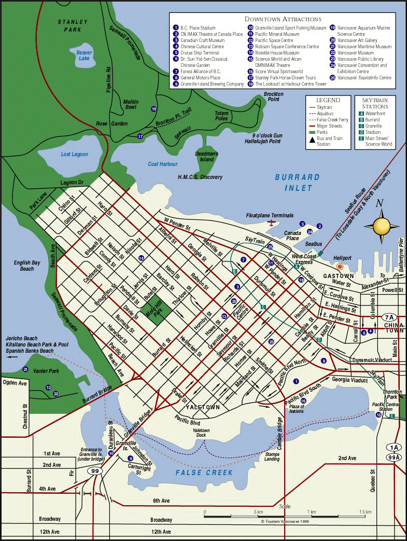

Granville Island Map

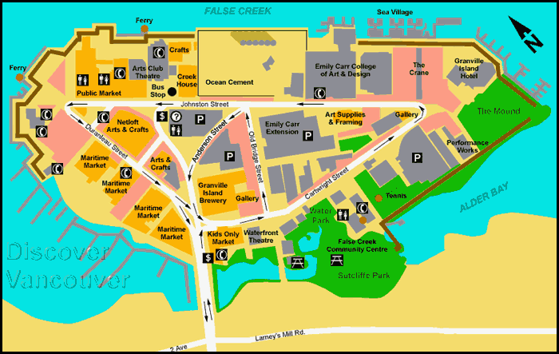

Stanley Park Map

