Software Requirements Specification
(SRS)

HEALTH AI Co-Creation & Innovation Platform

Project Name | HEALTH AI Co-Creation & Innovation Platform
Course | SENG 384 – Software Project IV, Spring 2026
Group Members | Okan Can NAZLI – 202428405  İlker BULUT – 202528201  Arda ERDEM – 202328021
Submission Date | March 2026
Version | 2.0

Revision History

Date | Version | Change Description | Author
23 March 2026 | 1.0 | Initial version | Okan Can NAZLI, İlker BULUT, Arda ERDEM
29 April 2026 | 2.0 | Add UI screen shoots & diagrams | Arda Erdem, İlker Bulut, Okan Can Nazlı

Table of Contents
1. Introduction
1.1 Purpose
1.2 Scope
1.3 Definitions and Abbreviations
1.4 Intended Audience
2. Overall Description
2.1 Product Perspective
2.2 User Roles
2.3 Assumptions and Dependencies
2.4 Constraints
3. Functional Requirements
3.1 User Registration & Access Control
3.2 Post Management
3.3 Search & Matching
3.4 Meeting Request Workflow
3.5 Administrative Dashboard
3.6 Activity Logging & Audit Trail
4. Non-Functional Requirements
5. Use Cases
6. Data Model
7. Interface Requirements
8. Requirements Traceability Matrix
9. Appendices

1. Introduction

1.1 Purpose
This Software Requirements Specification (SRS) describes the functional and non-functional requirements for the HEALTH AI Co-Creation & Innovation Platform, developed as part of SENG 384 – Software Project IV at Çankaya University, Spring 2026. The platform enables structured partner discovery between healthcare professionals and engineers. This document serves as the primary reference for the development team and course instructor throughout the development lifecycle.

1.2 Scope
The HEALTH AI platform is a secure, GDPR-compliant web application built with React (frontend), Express.js (backend), PostgreSQL (database), and Docker (containerization). It enables structured partner discovery between healthcare professionals and engineers through announcement-based posts, a controlled meeting request workflow with NDA acceptance, and a role-based admin panel.
The platform does NOT provide: financial transactions, contract management, medical advice, file repositories for technical documentation, or patient data storage.

1.3 Definitions and Abbreviations
Term | Definition
SRS | Software Requirements Specification
RBAC | Role-Based Access Control – controls access based on user role
GDPR | General Data Protection Regulation – EU data privacy regulation
NDA | Non-Disclosure Agreement – accepted before sending meeting requests
WCAG | Web Content Accessibility Guidelines
JWT | JSON Web Token – used for stateless session authentication
API | Application Programming Interface
REST | Representational State Transfer – architectural style for APIs
Docker | Containerization platform ensuring consistent deployment
ORM | Object Relational Mapping
CSV | Comma Separated Values – used for activity log export
.edu | Institutional email domain required for registration

1.4 Intended Audience
This document is intended for: the development team (3 members), the course instructor, and lab evaluators of SENG 384 – Software Project IV.

2. Overall Description

2.1 Product Perspective
Current interdisciplinary health-tech partnerships depend largely on personal networks or coincidence. The HEALTH AI platform eliminates this randomness by providing structured announcement-based partner discovery, secure first-contact initiation, controlled disclosure of ideas, transparent meeting workflow, and clear closure of partner requests. The platform runs as a containerized full-stack web application accessible via modern browsers.

2.2 User Roles
Role | Description | Key Permissions
Engineer | Technology professionals seeking clinical expertise for health-tech projects | Create/edit/close posts, browse healthcare posts, send/receive meeting requests, manage profile
Healthcare Professional | Doctors and clinicians seeking engineering partners for innovation projects | Create/edit/close posts, browse engineering posts, send/receive meeting requests, manage profile
Admin | Platform administrators responsible for moderation and oversight | View/remove all posts, manage users, view/export activity logs, access platform statistics

2.3 Assumptions and Dependencies
- Users have valid institutional .edu email addresses
- Users access the platform via modern web browsers (Chrome, Firefox, Safari, Edge)
- Meetings occur externally via Zoom, Teams, or similar platforms
- Docker Desktop is available in the deployment environment
- An external email service is available for registration verification and notifications
- The platform assumes internet connectivity for all operations

2.4 Constraints
- Registration is limited to institutional .edu email addresses only
- No patient data may be stored on the platform
- No file uploads of technical documentation are permitted
- No financial transactions or contract management
- Meeting recordings must not be stored on the platform
- The system must be containerized and runnable with a single Docker Compose command

3. Functional Requirements

3.1 User Registration & Access Control
ID | Requirement Description | Priority | Source
FR-01 | The system shall only allow registration with institutional .edu email addresses. | High | Brief 4.1
FR-02 | The system shall implement an email verification mechanism upon registration. | High | Brief 4.1
FR-03 | The user shall be able to select a role during registration: Engineer, Healthcare Professional, or Admin. | High | Brief 4.1
FR-04 | The system shall enforce Role-Based Access Control (RBAC) for all features and endpoints. | High | Brief 4.1
FR-05 | The system shall manage sessions using JWT tokens with automatic timeout. | High | Brief 5.2
FR-06 | The system shall implement rate limiting and anti-bot protection on authentication endpoints. | High | Brief 5.2
FR-07 | Attempting registration with a non-.edu email shall display an appropriate error message. | High | Demo S1

3.2 Post Management
Carefully review section 4.2 of the brief to cover all post management requirements. The post lifecycle states are: Draft, Active, Meeting Scheduled, Partner Found, Expired.
ID | Requirement Description | Priority | Source
FR-10 | Users shall be able to create a structured post containing all required fields: title, domain, explanation, expertise needed, project stage, commitment level, confidentiality level, expiry date, auto-close option, city, country. | High | Brief 4.2
FR-11 | Users shall be able to save a post as Draft before publishing. | High | Demo S2
FR-12 | Users shall be able to publish a post, changing its status to Active. | High | Brief 4.2
FR-13 | Users shall be able to edit their own posts after creation. | High | Brief 4.2
FR-14 | Posts shall follow the lifecycle: Draft → Active → Meeting Scheduled → Partner Found (Closed) / Expired. | High | Brief 4.2
FR-15 | Users shall be able to mark a post as Partner Found, closing it. | High | Brief 4.2
FR-16 | Posts with auto-close enabled shall automatically expire after the set expiry date. | Medium | Brief 4.2
FR-17 | The system shall NOT allow upload of technical documentation, patient data, or file repositories. | High | Brief 4.2
FR-18 | The dashboard shall display seed/pre-loaded data to demonstrate system functionality. | Medium | Demo S2

3.3 Search & Matching
ID | Requirement Description | Priority | Source
FR-20 | The system shall allow filtering posts by: domain, required expertise, city, country, project stage, and status. | High | Brief 4.3
FR-21 | Filter results shall update correctly when filters are applied or cleared. | High | Demo S3
FR-22 | The system shall highlight city-based matches between users. | Medium | Brief 4.3
FR-23 | The system shall provide match explanations based on shared expertise tags. | Medium | Brief 4.3

3.4 Meeting Request Workflow
ID | Requirement Description | Priority | Source
FR-30 | Users shall be able to express interest and send a meeting request with a short message. | High | Brief 4.4
FR-31 | Users must accept NDA terms before sending a meeting request. | High | Demo S4
FR-32 | Users shall be able to propose time slots for the meeting. | High | Demo S4
FR-33 | Post owners shall be able to accept or decline meeting requests. | High | Demo S4
FR-34 | Post status shall change to Meeting Scheduled upon acceptance. | High | Demo S4
FR-35 | Users shall be able to cancel a meeting request. | Medium | Brief 4.4
FR-36 | Meetings shall occur externally (Zoom/Teams). No recordings shall be stored. | High | Brief 4.4

3.5 Administrative Dashboard
ID | Requirement Description | Priority | Source
FR-40 | The admin dashboard shall be accessible only to users with the Admin role. | High | Brief 4.5
FR-41 | Admins shall be able to view all registered users and filter by role. | High | Demo S5
FR-42 | Admins shall be able to suspend or deactivate user accounts. | High | Brief 4.5
FR-43 | Admins shall be able to view, filter, and remove inappropriate posts. | High | Demo S5
FR-44 | Admins shall be able to view activity logs filtered by date, user, or action type. | High | Demo S5
FR-45 | Admins shall be able to export activity logs as CSV. | High | Demo S5
FR-46 | Admins shall be able to view platform statistics. | Medium | Brief 4.5

3.6 Activity Logging & Audit Trail
ID | Requirement Description | Priority | Source
FR-50 | The system shall log: login/logout, failed login attempts, post creation/edit/close, meeting request events, admin actions, and security events. | High | Brief 4.6
FR-51 | Each log entry shall contain: timestamp, user ID, role, action type, target entity, result status, and IP address (GDPR-compliant). | High | Brief 4.6
FR-52 | Logs shall be tamper-resistant and retained for a minimum of 24 months. | High | Brief 4.6
FR-53 | No patient data shall be included in logs. Data minimization shall be enforced. | High | Brief 4.6
FR-54 | Users shall be able to edit their profile information (name, institution, expertise, city). | High | Demo S6
FR-55 | Users shall be able to request account deletion. All personal data shall be permanently removed. | High | Demo S6
FR-56 | Account deletion shall display a warning screen before confirming. | High | Demo S6
FR-57 | Users shall be able to export their personal data (posts, profile, meeting history). | High | Demo S6
FR-58 | The platform shall send notifications for meeting request events. | Medium | Demo S6

4. Non-Functional Requirements
Requirements cover: Performance, Security, GDPR/Privacy, Usability, Accessibility, and Deployment (Brief sections 5.1–5.4 and Lab Guide).

ID | Requirement | Metric / Target | Category
NFR-01 | Search results shall be returned within a specified time. | < 1.5 seconds | Performance
NFR-02 | Page load time shall be limited. | < 3 seconds | Performance
NFR-03 | The system shall support concurrent users. | 1000 concurrent users | Performance
NFR-04 | Passwords shall be stored in encrypted form. | bcrypt hashing | Security
NFR-05 | All communication shall be encrypted. | HTTPS mandatory | Security
NFR-06 | Sessions shall be managed securely with auto-timeout. | JWT with expiry | Security
NFR-07 | Auth endpoints shall be protected against brute-force and bots. | Rate limiting implemented | Security
NFR-08 | Users shall have the right to delete their account and all personal data. | Full data deletion | GDPR/Privacy
NFR-09 | Users shall have the right to export their personal data. | Downloadable export | GDPR/Privacy
NFR-10 | Only necessary data shall be collected. No patient data stored. | Data minimization | GDPR/Privacy
NFR-11 | New users shall understand the platform's purpose quickly. | Within 20 seconds | Usability
NFR-12 | Post creation shall require minimal steps. | 3 steps maximum | Usability
NFR-13 | Creating a post shall be fast. | Under 3 minutes | Usability
NFR-14 | Sending a meeting request shall be fast. | Under 30 seconds | Usability
NFR-15 | The UI shall comply with accessibility standards. | WCAG 2.1 | Accessibility
NFR-16 | The platform shall be responsive. | Mobile and desktop support | Accessibility
NFR-17 | The system shall be containerized. | Docker Compose single command startup | Deployment

5. Use Cases
Use cases are based on the project brief (sections 3.1, 3.2) and the demo requirements. At least 6 core use cases are defined below.

5.1 UC-01: Engineer Creates a Post
Name | UC-01: Engineer Creates a Post
Actor(s) | Engineer
Precondition | The engineer must be logged in.
Main Flow | 1. Engineer clicks the '+ New Post' button. 2. Fills in ALL required fields (title, domain, expertise, city, description, etc.). 3. Saves as Draft → status shows 'Draft'. 4. Publishes the post → status changes to 'Active'. 5. Post appears in the feed with seed data visible.
Postcondition | The post is active and visible to other users.
Alternative Flow | 2a. If a required field is left blank, the system displays a validation error message.

5.2 UC-02: User Registers and Logs In
Name | UC-02: User Registers and Logs In
Actor(s) | Engineer or Healthcare Professional
Precondition | User has a valid institutional .edu email address.
Main Flow | 1. User navigates to registration page. 2. Attempts registration with a non-.edu email → error shown. 3. Registers with valid .edu email and selects a role. 4. Verifies email (or mock step demonstrated). 5. Logs in → Dashboard is displayed.
Postcondition | User is authenticated and sees the Dashboard.
Alternative Flow | 2a. Non-.edu email entered → system displays error and blocks registration.

5.3 UC-03: Healthcare Professional Sends a Meeting Request
Name | UC-03: Healthcare Professional Sends a Meeting Request
Actor(s) | Healthcare Professional, Engineer (post owner)
Precondition | User is logged in. Target post is in Active status.
Main Flow | 1. User opens a post detail page. 2. Clicks 'Express Interest' / 'Request Meeting'. 3. Accepts NDA terms. 4. Writes introduction message and proposes a time slot. 5. Post owner (different account) accepts the request. 6. Post status changes to 'Meeting Scheduled'.
Postcondition | Meeting is scheduled. Post status updated. Both parties notified.
Alternative Flow | 3a. User declines NDA → request is blocked and cannot proceed.

5.4 UC-04: User Searches and Filters Posts
Name | UC-04: User Searches and Filters Posts
Actor(s) | Engineer or Healthcare Professional
Precondition | User is logged in. Posts exist in the system.
Main Flow | 1. User applies at least 2 filters (e.g., domain, city). 2. Results update correctly based on filters. 3. User clears filters → all posts displayed again.
Postcondition | User sees filtered or complete post list.
Alternative Flow | No results match filters → empty state message shown.

5.5 UC-05: Admin Manages Platform
Name | UC-05: Admin Manages Platform
Actor(s) | Admin
Precondition | Admin is logged in with Admin role.
Main Flow | 1. Admin views user list and filters by role. 2. Admin views post list and removes an inappropriate post. 3. Admin views activity logs and filters by date/action type. 4. Admin exports logs as CSV.
Postcondition | Post removed. CSV downloaded. All admin actions logged in audit trail.
Alternative Flow | None.

5.6 UC-06: User Manages Profile and GDPR Rights
Name | UC-06: User Manages Profile and GDPR Rights
Actor(s) | Engineer or Healthcare Professional
Precondition | User is logged in.
Main Flow | 1. User edits profile information (name, institution, expertise, city). 2. User navigates to account deletion → warning shown (does NOT actually delete in demo). 3. User views data export option. 4. User sees at least one notification in the system.
Postcondition | Profile updated. GDPR options are accessible and functional.
Alternative Flow | 2a. User cancels deletion → account remains active.

6. Data Model
The following table shows the core data entities and their relationships. An ER diagram will be added in SRS V2.

Entity | Key Fields | Relationships
users | id, name, email, role, password_hash, institution, city, status, created_at | Has many: posts, meeting_requests, activity_logs, notifications
posts | id, user_id, title, domain, explanation, expertise_needed, stage, commitment, confidentiality, city, country, status, expiry_date, auto_close, created_at | Belongs to: users Has many: meeting_requests
meeting_requests | id, post_id, sender_id, message, nda_accepted, proposed_slots, status, created_at | Belongs to: posts, users (sender)
activity_logs | id, user_id, role, action_type, target_entity, result_status, ip_address, created_at | Belongs to: users
notifications | id, user_id, message, is_read, created_at | Belongs to: users

7. Interface Requirements

7.1 User Interface (UI)
The platform consists of the following main screens:
Screen | Description | Demo Scenario
Login Page | .edu email validation, password field, login button, link to register | S1
Registration Page | Role selection, .edu email, password, email verification step | S1
Dashboard | Post feed with search/filter bar, '+ New Post' button, seed data visible | S2, S3
Create / Edit Post | All required form fields, Draft and Publish buttons | S2
Post Detail Page | Full post view, 'Express Interest' / 'Request Meeting' button | S4
Meeting Request Page | NDA acceptance, message input, time slot proposal | S4
Admin Panel | User management table, post management table, activity logs with CSV export | S5
Profile Page | Edit info, GDPR account deletion flow (with warning), data export, notifications | S6

7.2 External System Interfaces
- Email Service: For registration verification emails and meeting request notifications
- External Meeting Platforms: Zoom/Teams link sharing only — the platform does not host or record meetings

8. Requirements Traceability Matrix
Req. ID | Requirement Summary | Source (Brief) | Related Use Case
FR-01 to FR-07 | User Registration & Access Control | Brief 4.1 | UC-02
FR-10 to FR-18 | Post Management | Brief 4.2 | UC-01
FR-20 to FR-23 | Search & Matching | Brief 4.3 | UC-04
FR-30 to FR-36 | Meeting Request Workflow | Brief 4.4 | UC-03
FR-40 to FR-46 | Administrative Dashboard | Brief 4.5 | UC-05
FR-50 to FR-53 | Activity Logging & Audit Trail | Brief 4.6 | UC-05
FR-54 to FR-58 | Profile Management & GDPR | Brief 5.1 | UC-06
NFR-01 to NFR-03 | Performance Requirements | Brief 5.1 | –
NFR-04 to NFR-07 | Security Requirements | Brief 5.2 | –
NFR-08 to NFR-10 | GDPR / Privacy Requirements | Brief 5.1 | UC-06
NFR-11 to NFR-14 | Usability Requirements | Brief 5.4 | –
NFR-15 to NFR-16 | Accessibility Requirements | Brief 5.4 | –
NFR-17 | Docker Containerization | Lab Guide | –

9. Appendices

9.1 AI Tool Usage
During the development of this project and document, the following AI tools were used:

AI Tool | Usage
Claude (Anthropic) | Code generation, React component structure, SRS document drafting, debugging
GitHub Copilot / Cursor | Code autocomplete and AI-assisted editing during development

All AI-generated content was reviewed and understood by the team before integration. All team members are able to explain the code and decisions documented in this SRS.

9.2 Use Case Diagram
Use Case Diagram – HEALTH AI Platform
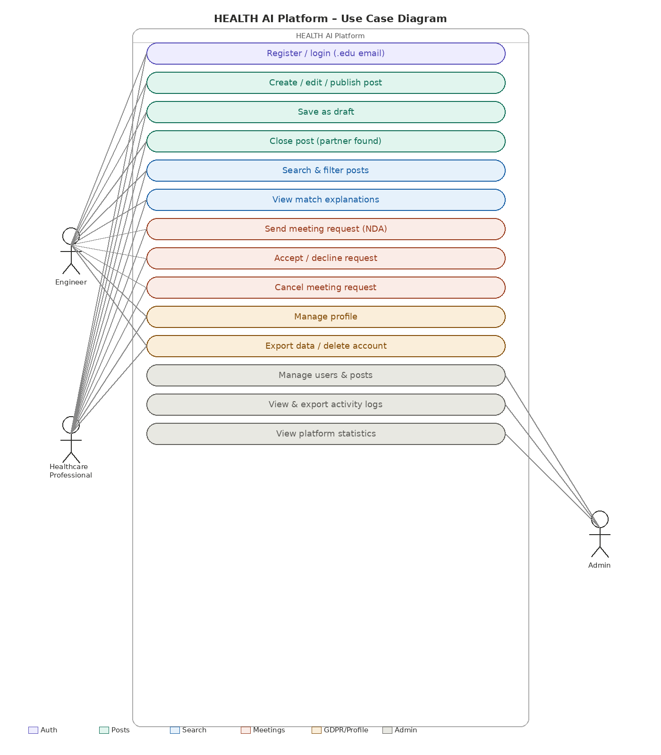

9.3 Wireframes / Mockups

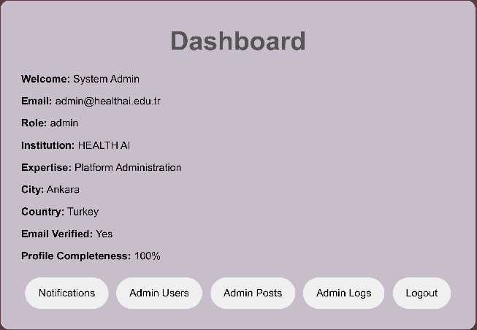
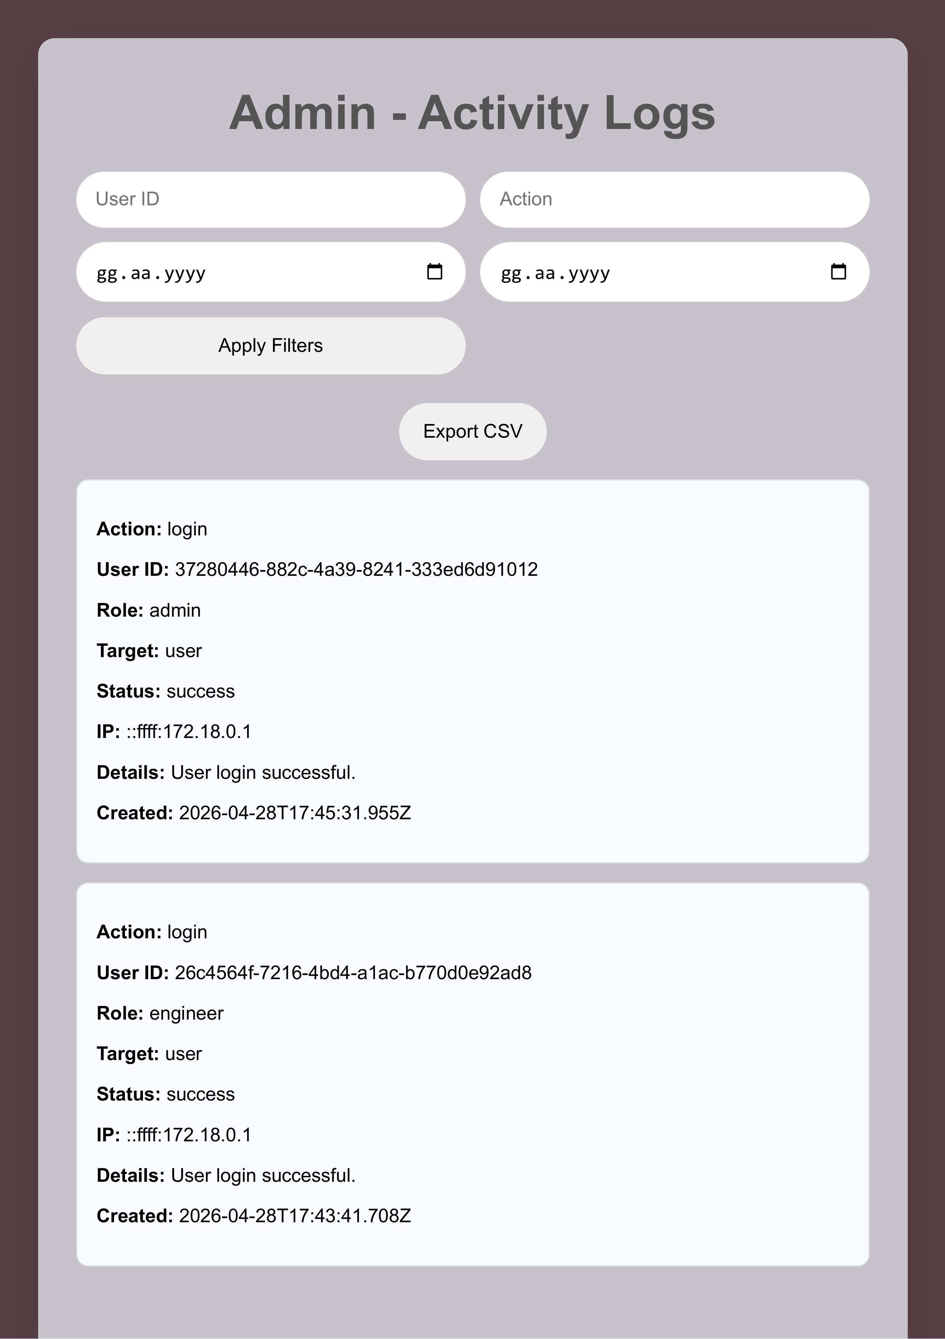

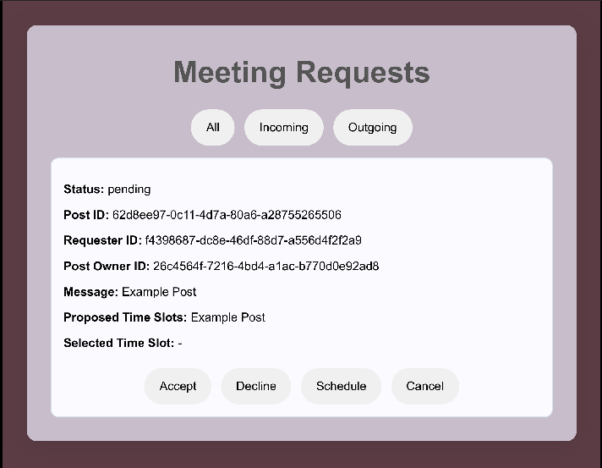

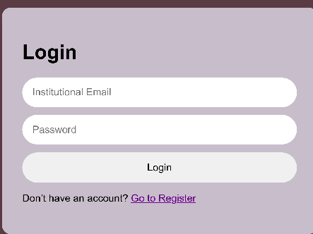
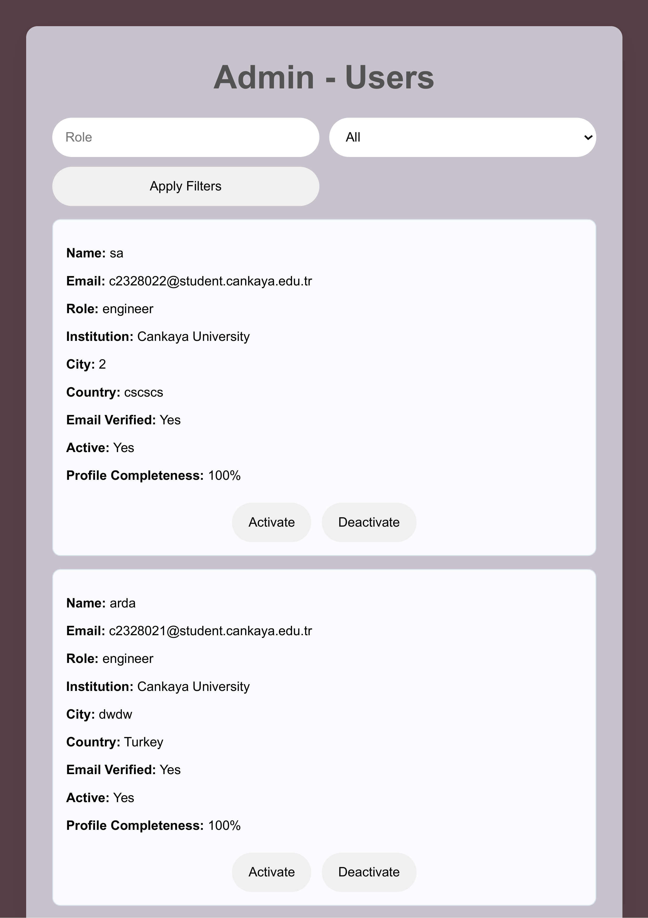
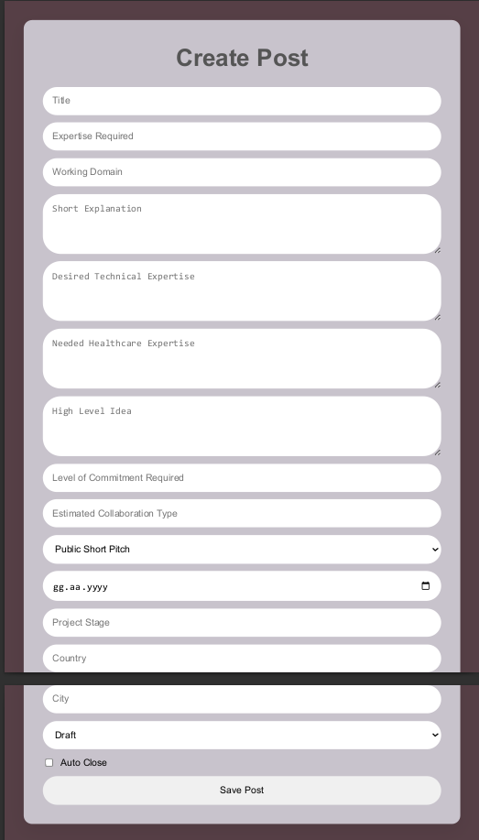



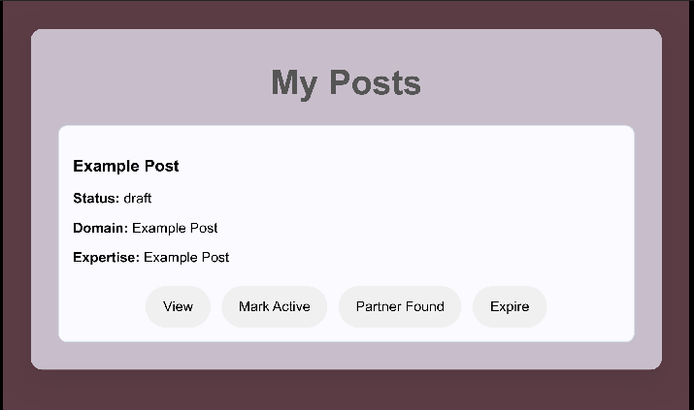

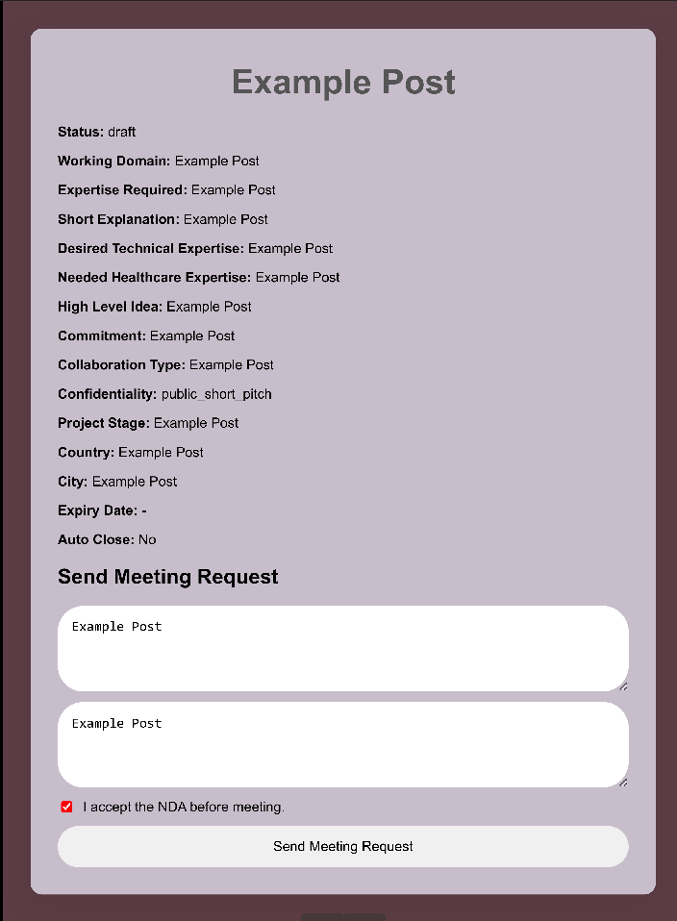

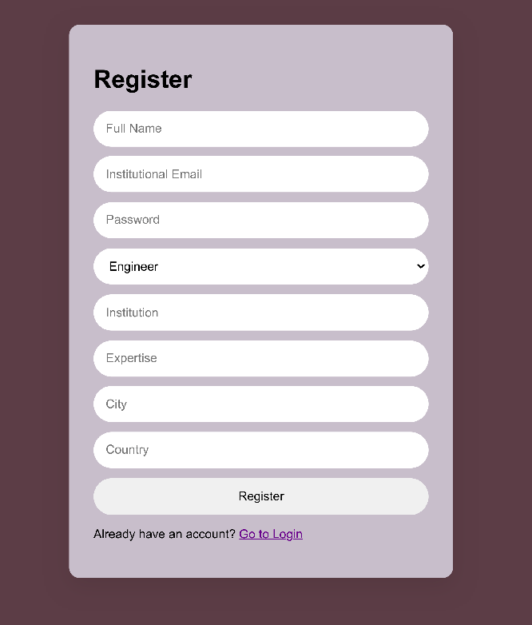

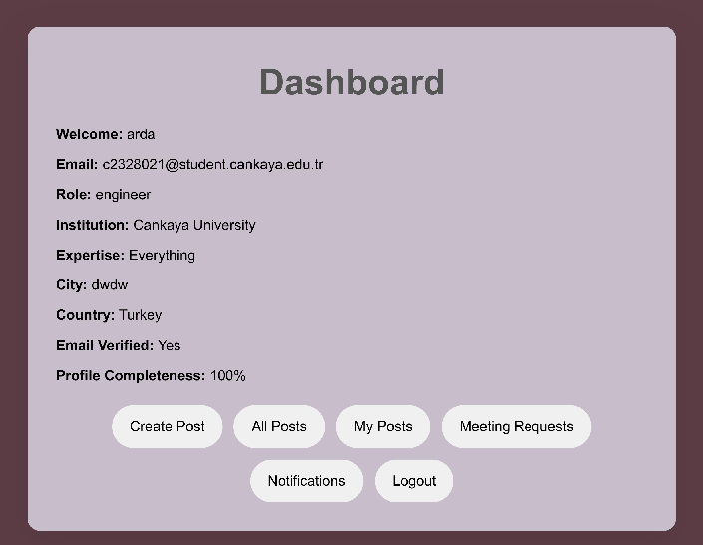

9.4 ER Diagram
ER Diagram – HEALTH AI Platform
