CYBERSECURITY INCIDENT ANALYSIS REPORT
TCP SYN Flood Indicators in a Web Server Traffic Log

Report type | Educational network security incident analysis
Primary finding | Suspected TCP SYN flood / DoS
Evidence source | HTTP-log.xlsx — TCP log worksheet
Assessment status | Indicative finding; raw PCAP not provided

Traffic snapshot
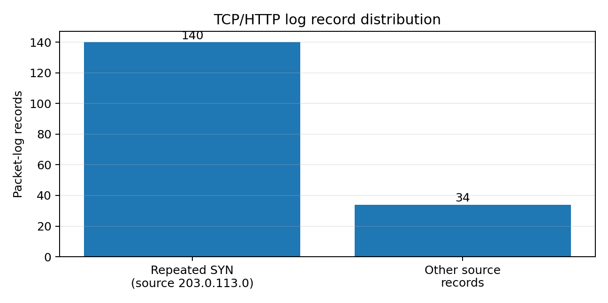
Figure 1. Spreadsheet records by source category; this is a record-count summary, not a reconstruction of packet rates.

1. Executive Summary
This report analyzes the supplied educational TCP/HTTP log in the context of a travel agency website experiencing connection timeouts. The dominant suspicious pattern is a high concentration of repeated TCP SYN requests from the source address 203.0.113.0 toward the web server address 192.0.2.1, targeting TCP port 443. The pattern is consistent with a TCP SYN flood, a denial-of-service (DoS) technique that can exhaust server or network resources used to track incomplete TCP handshakes.
The log contains 174 records across approximately 48.68 seconds (from 3.144521 s to 51.823018 s). Of these, 140 records list 203.0.113.0 as the source. The log also contains repeated SYN flags and reset responses, while only a small number of HTTP records appear. These observations support a suspected service-availability attack in the supplied scenario, but the spreadsheet is a summarized log rather than a raw packet capture; it cannot independently prove the real-world origin, intent, or full impact of an attack.

2. Incident Classification
Likely attack: TCP SYN Flood (DoS).
A TCP connection normally begins with a three-way handshake: the client sends SYN, the server replies SYN/ACK, and the client completes the handshake with ACK. In a SYN flood, a target receives an excessive volume of SYN requests and may reserve resources for connections that are never completed. If the backlog or related resources become saturated, legitimate clients may experience slow responses, failed connections, or timeouts.
DoS versus DDoS: a DoS attack overwhelms a service from one source or a limited origin set; a distributed denial-of-service (DDoS) attack uses multiple distributed sources. This log shows a dominant source address, so the observed records alone do not establish a DDoS attack. Source-address spoofing is possible in SYN floods, but it cannot be confirmed from this spreadsheet.

3. Evidence and Traffic Observations
The TCP log worksheet contains 174 records. The recorded time range is 3.144521–51.823018 seconds, a span of 48.678 seconds. The dominant source 203.0.113.0 appears in 140 records (80.5% of all records) and repeatedly sends SYN packets to destination 192.0.2.1 on destination port 443. The log contains 146 records whose Info field includes SYN, 5 SYN/ACK records, 13 RST/ACK records, and 0 HTTP records.
The sequence is consistent with repeated connection initiation and connection failures during the interval. The low number of HTTP-layer records relative to TCP records is compatible with a connection-establishment problem, but the spreadsheet alone does not provide enough packet-level detail to calculate a definitive SYN-to-completed-handshake ratio or server resource utilization.

4. Impact on the Organization
- Website availability: users may receive connection timeouts or be unable to load the sales and promotions page.
- Employee productivity: staff may be unable to search for travel packages while serving customers.
- Business impact: interrupted customer journeys can reduce trust, lead to lost bookings or sales, and increase support workload.
- Operational impact: incident response may require time from IT/security staff and temporary service restrictions.
- Scope limitation: the supplied log does not quantify actual lost revenue, the number of affected users, or the duration of a real outage; those values should not be claimed without additional evidence.

5. Containment and Remediation Recommendations
Immediate response
1. Preserve relevant logs and the original evidence before making changes; record timestamps and actions taken.
2. Confirm the traffic pattern with server, firewall, load balancer, and monitoring telemetry.
3. Apply upstream DDoS/SYN-flood protections where available, such as a hosting-provider mitigation service, network ACLs, rate limiting, and SYN proxy/SYN cookies supported by the platform.
4. Avoid relying only on a single source-IP block. Source addresses can change or be spoofed, and blocking may affect legitimate traffic.
5. Restore service only after verifying health and monitoring connection success, latency, CPU/memory, and TCP connection/backlog metrics.
Longer-term prevention
• Enable and tune SYN cookies or equivalent TCP-stack protections where appropriate.
• Use a WAF/CDN or DDoS-protection provider with network-level mitigation capacity.
• Set alert thresholds for SYN rate, incomplete handshakes, connection backlog, error rates, and latency.
• Maintain an incident response runbook, escalation contacts, and a post-incident review.
• Validate firewall and server configuration changes in a controlled manner and document outcomes.

6. Conclusion
The most likely classification for the scenario is a TCP SYN flood causing denial of service. The strongest indicator in the supplied log is the repeated SYN traffic from one dominant source toward the web server, alongside records consistent with connection disruption. The recommended response is to preserve evidence, verify impact with infrastructure telemetry, apply upstream and server-side SYN-flood defenses, and monitor recovery. The evidence should be described as indicative rather than conclusive because the source material is an educational spreadsheet, not a full packet capture.

7. Scope, Assumptions, and Evidence Limitations
Source reviewed: HTTP-log.xlsx, worksheet “TCP log”; the accompanying “Color coded TCP log” worksheet was treated as explanatory context. The report uses the records as supplied and does not claim to have captured live traffic or opened a PCAP in Wireshark. The addresses 192.0.2.1 and 203.0.113.0 fall within IPv4 documentation ranges commonly used in examples; they should not be treated as attribution to real infrastructure or a real attacker. Counts are counts of spreadsheet rows/records, not guaranteed unique network packets if the source log contains duplicated or transformed rows.

Appendix A — Useful Wireshark Display Filters
If the original PCAP/PCAPNG is available, the following display filters can help validate the hypothesis:
• TCP SYN packets without ACK: tcp.flags.syn == 1 && tcp.flags.ack == 0
• Traffic to HTTPS port: tcp.dstport == 443
• Traffic involving the example server: ip.addr == 192.0.2.1
• TCP resets: tcp.flags.reset == 1
• HTTP requests: http.request
These filters operate on packet captures, not on the Excel workbook itself.

