**EE 316 - Electronic Design Project**

Project: P5

**Ultrasonic Distance Measurement Device**

**Final Project Report**

22 May 2017

**Objective**

Bats use echolocation to find and identify objects in their environment. They use sound waves for this. Ultrasonic distance measurement device operate using the same principle. Ultrasonic ranging sensors use sound waves for locating object and calculate the distance. These sensors are used in many industrial and military areas such as car parking systems, diameter measurement, level detection, military systems, counting number of units, height measurement and dynamically changing distance measurement. They are unaffected by; material, surface, light, dust, mist and vapor. The purpose of this project is to measure the distance between the sensor and the obstacle accurately. It’s required to design an ultrasonic distance measurement device that enable to measure distances between 10 cm and 100 cm with accuracy of +/-0.5 cm is aimed.

**Group Members**

**Common efforts:** Design Whole Projects

**Okan Erdoğan:** All parts

**Görkem Özüağ:** All parts

**Revision History**

Week-4: We got the necessary components and we started circuit drawings in LTspice.

Week-5: We decided to use two 555 timer for trigger oscillator and pulse oscillator part.

Week-6: We set up the transmitting part with two 555 timers and inverter then we got the serial square wave pulses at 40 kHz that is our resonant frequency. We observed each output separately.

Week-7: We first test transducers to measure voltage values from receiver because we had to decide on the gain of the amplifier circuit. Firstly we tried with Mcp602 dual op amps but we didn’t pay attention to the supply voltage, we gave the high voltage and destroyed the op amp. Then, we used LM358N is dual op amp but there was noise in the amplifier circuit due to pulse oscillator circuit and we could not get any results due to the noise from the comparator circuit. First, we tried the high pass circuit and the band pass circuit, but even though the noise was reduced, it did not decrease as much. Then we reduced the value of the capacitor between the op amps and we add 220uF capacitor to 555 timer between first and eight pin and obtained the desired signal.

Week-8: For detection of amplified signal, we set up envelope detector. Because we need a clean signal for comparator part.

Week-9: The comparator circuit set up with LM311-N is voltage comparator, but it didn’t work proper because potentiometer is broken we changed it then it worked. After that, we tested circuit with comparator output and inverter output together then we observed that we can read the value near the 100 cm.

Week-10: We determined clock frequency is 17.2 kHz and set up counter circuit with 555 timer.

Week-11: We set up the counting circuit but it didn’t work. We supposed that there was a mistake in 4553 BCD counter. Firstly, tried it with signal generator with 1 Hz square wave. We connect the signal generator to clock input of BCD counter and it didn’t work again. We realized that there was a mistake in our circuit connection, we fixed it then the circuit worked. Then, we read the value up to 100 cm from 7 segment display.

Week-12: The necessary calibrations were made for counting circuit, comparator circuit and oscillator circuit.

**1. Introduction**

We must overcome the following design challenges in designing an ultrasonic distance measurement device.

**1. Ultrasonic Pulse Oscillator:** To drive transducers, the system need to use a timer 555 in astable mode to create oscillating signals at a specific frequency range. Ultrasonic pulse oscillator created serial wave pulses at 40 kHz is resonant frequency. We can set the component values of the circuit and change the oscillation frequency by timer. In this part, using 555 timer in astable mode control sending-out time of the ultrasonic pulse.

**2. Ultrasonic Trigger Oscillator:** Using 555 timer in astable mode to generate a trigger pulse. To calculate the distance accurately, the signal is at 40 kHz must be sent at specified time intervals. In this part, trigger circuit set on-off time for our signal and our counter circuit works according to this time interval.

**3. Amplification Circuit:** The reflected signal from obstacle is received the transducer and this signal is weak during the air travel. In the receiver part, reflected signal named echo has a low amplitude. It is hard to detect the echo signal because this signal strikes the particles in the air and loses its energy. For detection and counting part, the signal has a low amplitude is amplified with the LM538N.

**4. Detection Circuit:** This circuit consists of two parts. First envelope detector other is comparator circuit. Reflected signal losses its and energy and losses its shape too. The receiver transmit the reflected signal to amplifier circuit and weak signal will have high amplitude in this process. Then envelope detector limit the signal according to reference voltage that must be set to maximum distance is 100 cm. For envelope detection part diode, capacitor and resistor are used. After that, comparator circuit compare the input signal and reference voltage, if input voltage is higher than reference, output will be 1 otherwise 0. LM311-N voltage comparator is used for comparator circuit.

**5. BCD Counter and Display:** The BCD-Counter is used to measure the driving time of the sound wave starting from the transmitter transducer and ending on the receiving transducer. In this part MC4553 3-Digit-BCD (Binary Coded Decimal) counter was used. BCD counter is triggered by trigger oscillator circuit and start to count until master reset signal is received. The important point is to determine the clock frequency correctly, according to our calculation it is 17.2 kHz. After that decoder transfers the binary counter data to available seven segment input data to display. MC4511 is used for decoder and 7-segment LED displays used for display section.

**1.1. Sound Propagation In Air**

Sound is a vibration that spreads in a series of mechanical waves. Sound passes through the air in the form of vibrations. These vibrations cause the particles to compress together and move in such a way that they will disappear in waves. Humans can hear sound waves at frequencies between 20 Hz and 20 kHz. If the frequency is at 20 kHz, sound is ultrasound. The sound is infrasound when frequency is below 20 Hz [1].

Sound propagation in air is influenced by several factors. These are;

* Temperature: Sound travels more highly at higher temperatures than lower temperatures because in higher temperatures, the particles move faster than a slower temperature [2].
* Frequency: Frequency does not affect sound speed but sound waves move at the same speed as different frequencies, although the wave lengths are different [3].
* Pressure: The speed of sound decreases at high frequency with high energy transferred.

where $ρ$ is the fluid density and P is the fluid pressure. {\displaystyle \rho }

This equation can be simplified for an ideal gas leading to

{\displaystyle c^{2}=\gamma {\frac {P_{0}}{\rho _{0}}}}

Where is the ratio of heat capacities.

For air at 0°C and 1 atm, the speed of sound is

Co= 331.5 m/s {\displaystyle c_{0}=331.5\ {\mbox{m/s}}}

For air at 20°C and 1 atm, the speed of sound is

Co= 343 m/s [4].

{\displaystyle c_{0}=343\ {\mbox{m/s}}}

Ultrasonic sound waves have some important properties, the main features can be listed as; they can travel over the frequency at 20 kHz, these waves move with the voice of a certain environment. They can produce vibrations in low viscosity fluids. Ultrasonic waves can be reflected and broken like light waves.

The following paragraphs summarize the background information required by the underlying technologies used in this project.

**1.2. Ultrasonic Transducers**

Transducers are special materials that can convert an energy type into another. Ultrasonic Transducer that converts the alternating energy into mechanical vibrations of the same frequency over 20 kHz; It is usually piezoelectric. Piezo means “pressure” and “piezoelectric” means electricity caused by pressure [5].

Piezoelectric effect is an effect of the conversion of the energy between the mechanical and electrical forms. The mechanical deformation that occurs when a pressure is applied to a polarized crystal results in an electrical charge.

Ultrasonic transducers are used in many industrial and medical applications.

Transducers generally have 20-60 kHz resonant frequency in ultrasonic sound wave.

Resonant frequency mean that transducer converts electrical signals to mechanical vibrations in this frequency most effectively.

Transducers are divided into three groups: transmitters, receivers and transceivers.

Transmitters; electrical signal ultrasound.

Receivers; ultrasound electrical signal.

Transceivers; electrical signal ultrasound (both transmit and receive ultrasound.) [6].

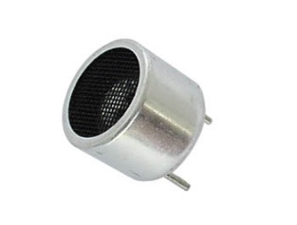

Figure 1: Ultrasonic transducer [7]

There are some important transducer parameters for our project; surface, distance, size of object and angle. Depending on the hardness or softness of the surface, there will be more reflection than other types do. If the distance is short between transducer and object, echo signal will be strong. Will reflect more echo signals as the size of the object grows. If the objects perpendicular to transducer, takes the echo signal stronger [8].

Emitted Waves

Transducer Tx

Object

Transducer Rx

  Reflected Waves

Figure 2: Transducer working principle

**1.3. Timing Circuits**

Applications of timing circuits are basically;

* Precision Timing
* Pulse Generation
* Sequential Timing
* Time Delay Generation
* Pulse Width or Position Modulation
* Linear Ramp Generator

The operating modes of common timers are bistable mode which operates as a flip-flop, monostable mode which has functions of pulse generator, and astable mode which operates as an electronic oscillator [9].

In this project, timing circuits was used when needed time delay, generating single pulse and serial wave pulses. For these operations, device 555 timer was used.

**1.4. Signal Amplification**

Amplification of a signal can be explained as increasing the signal amplitude. The purpose of signal amplification to increase the amplitude of received echo signal in form of electrical pulses. After this procedure, detection of the signal which has the losses its energy become easier. Voltage and power amplifiers can be used to obtain voltage and current gain. It was decided in this section how much amplification of the signal should be based on the distance. Distance adjusted to up to100 cm for this section.

**1.5. Detection Circuit**

Comparator circuits compare two voltages and determine which one is greater. When input voltage is higher than reference voltages its output switches to 1 otherwise 0. In this way, we can detect receiving signal. Envelope detector takes the high frequency received signal as input and takes envelope of it, and output of envelope detector is input of the comparator.

**1.6. BCD Counter and Display**

A counter can be defined as a device that stores and count number of times of a specific operation according to its clock frequency. BCD (Binary Coded Decimal) counters are 4-bit binary counters that can count from 0 to 9. We need the time data that sound travel takes to calculate distance, by multiplying output value of counter with the period of clock frequency [10]. BCD counter is trigged with trigger of transmit circuit and start to count until the Master reset signal is received. The key point is deciding to clock frequency. Our design accuracy is +/- 0.5 cm. The accuracy range is 1cm.

(**2 cm)/(343,5 m/s) = 56,2μs f = 1/(56,2x(10^-6)) = 17,2 kHz**

Also it frequency is useful for BCD counter there is no need for higher frequency because every time counter is incremented means 1cm distance. BCD counter output is a time value. However, with this criteria it is distance as well. Decoder transfers the binary counter data to available seven segment input data to display. Seven segment displays are devices that used to display binary data as decimal numerals. There are two types of 7-segment which are common cathode and common anode. 7-segment LED displays (cathode) used for display section.

**1.7. Calibration**

In this project, to design an ultrasonic distance measurement device that enable to measure distances between 10 cm and 100 cm with accuracy of +/-0.5 cm is aimed. In order for the device to work with the specified specifications, certain adjustments had to be made. For this, clock frequency and Vref adjusted with potentiometer. Firstly, clock frequency adjusted to 17.23 kHz, then Vref value set for reading value up to 100 cm. To prevent the ripple on the display, latch enable pin connected to blanking pin of decoder. When the test our circuit, we realized our circuit measured the distance with accuracy. Therefore, there was no need to set up the delay circuit.

**2. Technical Description**

Sound has a certain velocity is 343.1 m/s in the air at room temperature. With using this information, distance can be measured according to travelling time of sound between transducers and object placed without actual contact using distance ultrasonic measurement device.

Ultrasonic transducers that are used in this project. In transmitting part transducer turn the electric signal to ultrasound, in the receiver part, the opposite is the case. Transmitter circuit is built with two 555 timers and transducer. The first timer works as astable mode, second one works as astable mode like first. 555 timer in astable mode generate continuous serial square wave pulses at 40 kHz that is our resonant frequency, this part is called as pulse generation. With second 555 timer in astable mode, ultrasonic signal will be sent and then wait for specified time, this part is called as trigger pulse. Trigger pulse supply enough time for counter send start and stop commands. The generated pulses in a specific range will be input for transducer then the signal strike and reflect from object, the amplitude of the reflected signal will be weakened and transmitted to receiver part.

TH 40 kHz

Transducer

Tx

Trigger pulse

Pulse

Generation

TL

9.83 Hz

Start

Reset pin Set pin

SR Latch

Clock

Freq.

17.23 kHz

Object

Envelope

Detector

Receiver

Rx

Amplifier

BCD Counter

Object

Display

Section

High Pass

Filter

Comparator

C

R

Figure 3: Design of Ultrasonic Distance Sensor

In the receiver part, reflected signal will have a low amplitude. Firstly, weak signal goes into high pass filter which will allow passing only high frequency signals. After that, filtered signal will be amplified in amplifier part then the amplified signal will be enough for envelope detector. Envelope detector limit the signal according to the reference voltage that must be set to maximum distance is 100 cm. Then, comparator compare the input signal and reference voltage, if input signal voltage is higher than reference, output will be 1 otherwise 0. This result will be send to BCD counter that stores and count number according to its clock frequency then the results will be transferred to display section.

**2.1. Using Ultrasonic Transducers**

In transmitting part, transmitter circuit create serial wave pulses at 40 kHz is resonant frequency. With two timer 555, it is possible to generate a signal at 40 kHz. This signal will be used by transducer for detecting object and reflected signal from object be processed with other transducer. This section is divided into two, the first one is the ultrasonic pulse oscillator second is the trigger oscillator part.

**2.1.1. Ultrasonic Pulse Oscillator Circuit (Astable mode)**

In this part, with using timer 555 in astable mode control sending-out time of the ultrasonic pulse. With astable mode, circuit generate serial wave pulses at 40 kHz. According to our calculation, created 40 kHz signal with specified resistors, capacitors. 40 kHz is our resonant frequency.

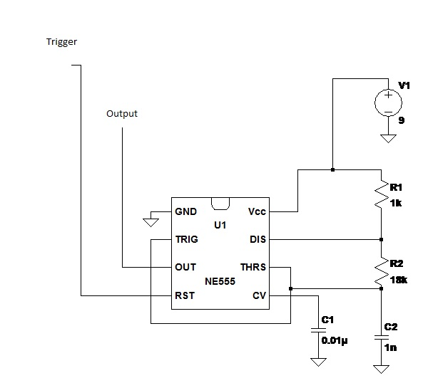

Figure 4: Ultrasonic Pulse OscillatorDiagram

That is general circuit model for astable mode with 555 timer shown figure above.

For %50 Duty cycle, RB must have higher value than RA since TL and TH must be equal or near values for equalizing the on-off cycles.

**RB >RA RB = 18k RA =1k**

**TL = 0.693* RB *C**

**TH = 0.693*(RA+ RB) *C** [11].

For generating 40 kHz signal;

f = 1/T

Tcycle = 1 /40000 = 25 µ sec

TL =TH = 12.5 µ sec for %50 duty cycle

TH

TL

Figure 5: Block diagram of on-off time

At figure 3, as you see TL and TH are equal in time.

İf we choose capacitor value 1nF, resistor of B value 18k Ω and resistor of A value 1k Ω as below;

**TL = 0.693* RB *C** and **TH = 0.693*(RA+ RB) *C**

**TL = 12.47 µ sec TH = 13.16 µ sec**

**Duty cycle = TH / (TL+ TH) * 100 = 51.34% cycles**

The frequency of oscillating is;

**FOSC = 1 / (TL+ TH) = 39.01 kHz.**

Then, we generated serial square wave signal at 39.01 kHz.

|  |  |  |  |
| --- | --- | --- | --- |
| RA : | 1kΩ | Frequency: | 39.01kHz |
| RB : | 18kΩ | Duty Cycle: | 51,34% |
| C : | 1nF | Output Voltage: | 8.8 V |
| Supply Voltage : | 9V | TL= 12,47μsec | TH=13,16μsec |

**Table 1.** Design parameters for pulse generator circuit.

**2.1.2. Ultrasonic Trigger Oscillator Circuit (Astable mode)**

In this section, use timer 555 again in astable mode to generate a trigger pulse. For this, we modify the values of components according to specified values of TL and TH. The output of trigger circuit will connect to reset pin of pulse oscillator circuit. The trigger circuit has the same structure as the circuit in figure 2 but has different values and functions. This circuit determines values of TL and TH that means set on-off time for our signal. Signal transmission can be controlled by trigger circuit, it stops in TL and it works when being TH.

First we need to be able to determine TL and TH according to the maximum and minimum distances.

**TL** : In maximum distance criteria, minimum delay duration between transmitted and received signal.

**TH** : In minimum distance criteria, maximum delay duration between transmitted and received signal.

According to distance criteria, TL and TH durations must be determined. Minimum range of our ultrasonic measurement device is 10cm, maximum is 100 cm.

For minimum range criteria;

**Vsound = 341.5 m/sec**

**(2*dmin)/ Vsound > TH**

**Dmin = 0.1 m TH < 0.582ms**

For maximum range criteria;

**dmin = 1 m**

**Vsound = 341.5 m/sec**

**(2*dmin)/ Vsound < TL TL > 5.282ms**

According to these calculations TL >TH but TL duration can’t be higher than TH duration. To prevent this situation, added inverter to between trigger and pulse oscillator circuit as you see in figure 4 below. After adding inverter our duration changed;

**TL < 0.582ms** and **TH > 5.282ms**

Then, we can determine our TL and TH values according to the above calculations.

For **RB = 3.6k RA =1400k**

**TL = 0.693* RB *C**

**TH = 0.693*(RA+ RB) *C**

İf we choose capacitor value 100nF, resistor of B value 3.6k Ω and resistor of A value 1.4MΩ as below;

**TL = 0.693* RB *C** and **TH = 0.693*(RA+ RB) *C**

**TL =0.25ms TH = 100ms**

With inverter, **TL = 100ms and TH =0.25ms,** these results provides these equations **TL < 0.582ms** and **TH > 5.282ms**

**TH** **TH**

**TL**

100ms 0.25ms

Figure 6: Trigger time delay diagram

That means, system will wait 100ms to start sending another signal, these results don’t affect the counter's operation, system will work well.

**Duty cycle = TH / (TL+ TH) * 100 = 99.75% cycles**

The frequency of oscillating is;

**FOSC = 1 / (TL+ TH) = 9.97 Hz.**

Then, we generated signal at 9.97 Hz.

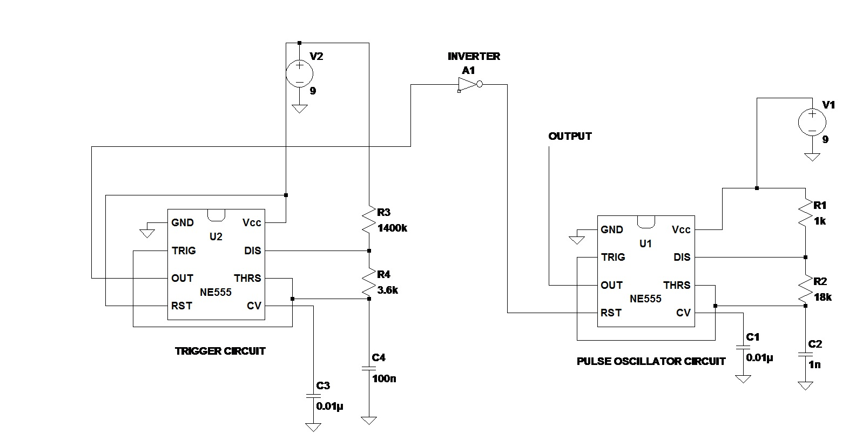

Figure 7: Transmitter Circuit diagram

In figure 7, there are trigger and pulse oscillator circuits. The two circuits together generate a signal at the frequency of 40 kHz and the desired time interval.

|  |  |  |  |
| --- | --- | --- | --- |
| RA : | 1.4 MΩ | Duty cycle : | 99.75% |
| RB : | 3.6kΩ | Frequency | 9.97Hz |
| C : | 10nF | TL = 100ms | TH =0.25ms |
| Supply Voltage : | 9V | Output voltage | 8,8V |

**Table 2.** Design parameters for trigger circuit.

**2.3. Counter Clock Circuit**

Our design criteria for accuracy is 1 cm, according to this counter timer clock period can be set as 1 cm distance from sensors to object traveling of sound waves. This means whenever counter is incremented object is away from sensor +1cm.

Sound waves speed at air is 343.1 m/s and the frequency of timer is calculated as follows;

**T = (2 cm) / (343,5 m/s) = 56,2μs f = 1/(56,2x(10^-6)) = 17,2 kHz**

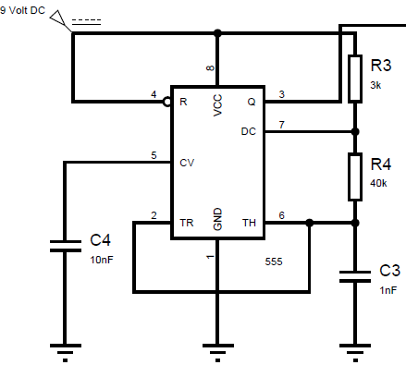

Figure 8: Counter Clock CircuitDiagram

**RB= 40 KΩ** **RA=3 KΩ and C=1nF**

**TL = 0.693* RB *C** and **TH = 0.693*(RA+ RB) *C**

**TL = 27.72 µ sec TH = 29.80 µ sec**

**Duty cycle = TH / (TL+ TH) * 100 = 51.80% cycles**

The frequency of oscillating is;

**FOSC = 1 / (TL+ TH) = 17.3 kHz.**

Then, we generated serial square wave signal at 17.3 kHz.

|  |  |  |  |
| --- | --- | --- | --- |
| RA : | 3kΩ | Duty cycle : | 51.80% |
| RB : | 40kΩ | Frequency | 17.3 kHz |
| C : | 1nF | TL = 27.72 us | TH =29.80 us |
| Supply Voltage : | 9V | Output voltage | 8,9 V |

**Table 3.** Design parameters for counter clock circuit.

**2.4. Amplifier Circuit**

Input of amplifier has high pass filter to eliminate unwanted low frequency noise. Cut-off frequency of filter calculated as below;

**Fc = 1 / (2*π*C*R)**

**By selected C = 1nF and R = 4.7 KΩ**

**Fc = 37 kHz**

There are some challenges to design amplifier. First of all using single supply voltage on circuit, it has been handled with giving half of supply voltage to one of inputs by using voltage divider to set offset voltage as 5 V, in this way our output signal has 5V offset voltage. And our receiver signal has low frequency picks with same timing with trigger, so it makes the impossible to measurements. To smooth away from picks effect, bypass capacitor at the between two op-amps selected smaller as possible. It is frequency response at 40 kHz is nearly 0.2 [12].

Gain of the circuit is as below;

**Gain1 = R3/R2 Gain2 = R5/R4**

**Gain1 = 100 Gain2 = 6.2**

**Total Gain = 620**

**Gain * frequency response of bypass capacitor = 124**

|  |  |  |  |
| --- | --- | --- | --- |
| **Amplifier Design Targets** | | | |
| **Design Target** | **First Amplifier** | **Second Amplifier** | **Unit** |
| Gain | 100 | 6.2 | **-** |
| Output  Offset voltage | 4.5 | 4.5 | V |
| Supply voltage | 9 | 9 | V |

**Table 4.** Design parameters for Amplifier circuit.

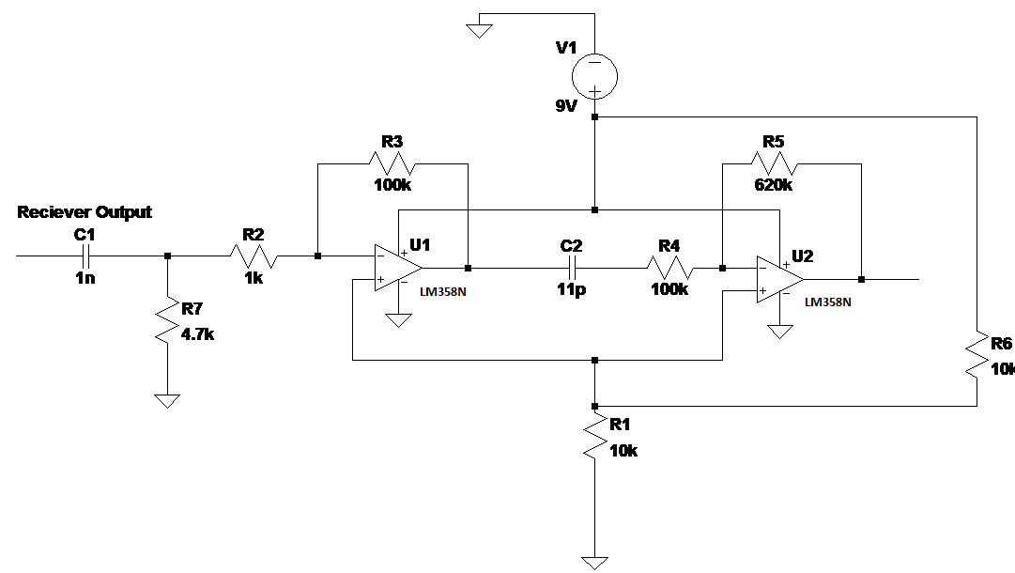Figure 9: Amplifier CircuitDiagram

**2.5. Counter Circuit and Display Section**

The purpose of 3-bit BCD counter is calculating the time between transmitted and received signals. According to this master reset connected to trigger signal output and latch enable input is connected to Q output of SR-latch which works as when set signal came output set to low and when reset signal came set to high when both of this low output is latch. To possess a convenient latch enable signal for counter connecting trigger signal as reset and comparator output as set input. Counter is starting to count when latch enable signal is low and when it is high counter stops to count. It resets to zero when master reset is high. Digit-Select pins of counter are connected to digit pins of cathode 7-segment displays.

4-bit BCD counter outputs are connected to decoder to convert them for seven segment display. Blanking pin of decoder is connected to latch enable pin of counter to get out of ripples on 7-segment display.

|  |  |  |
| --- | --- | --- |
| S | R | Q |
| 0 | 0 | NC |
| 0 | 1 | 0 |
| 1 | 0 | 1 |
| 1 | 1 | 0 |

Trigger (R)

Comparator (S)

Latch enable (Q)

Figure 10: SR LatchDiagram

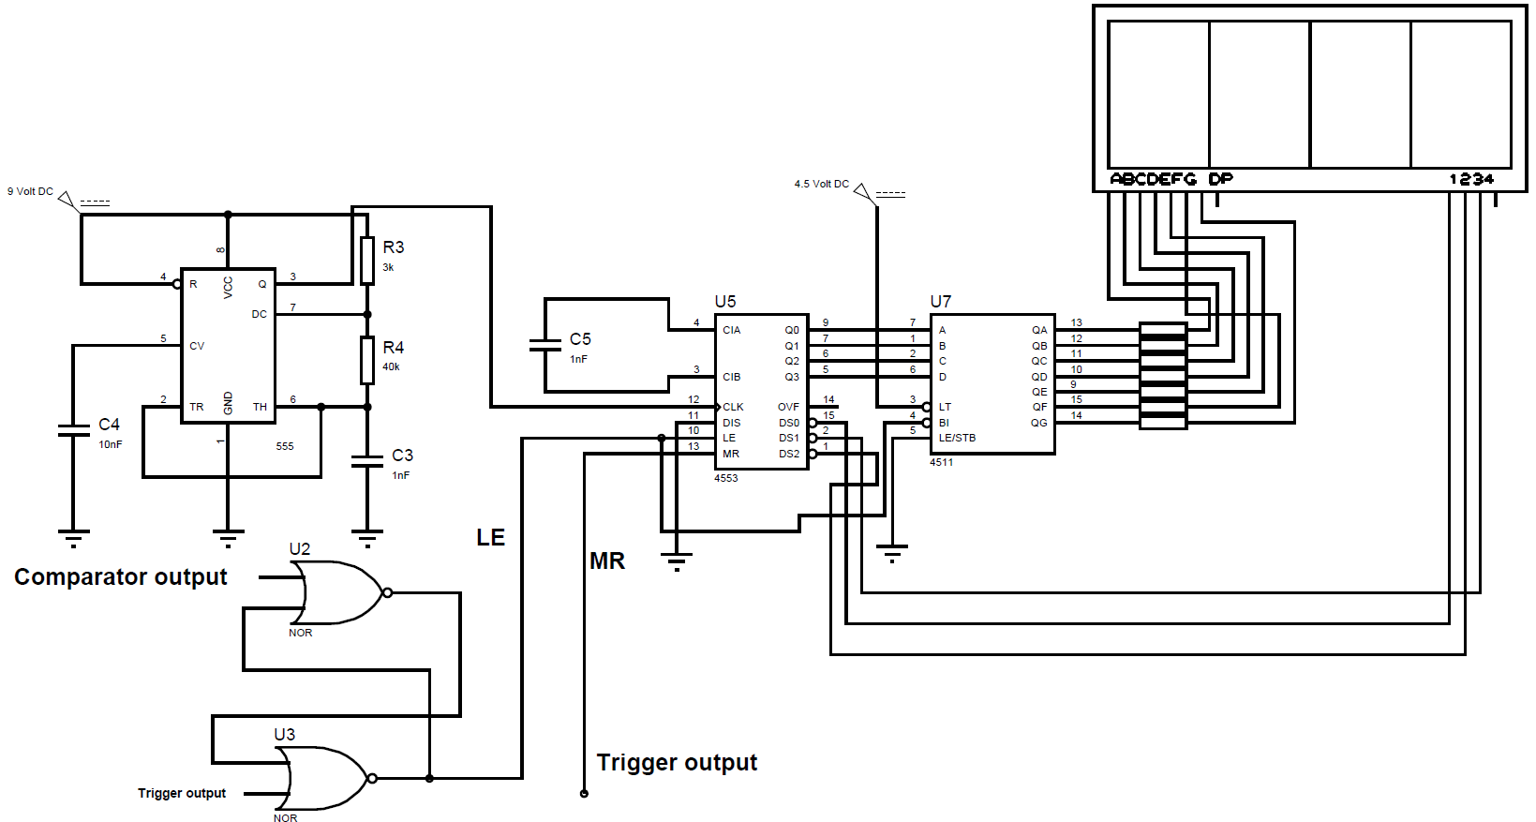

Figure 11: Counter and Display Circuit Diagram

**2.6. Detection Circuit**

Basic Envelope detector is used to uncover envelope of amplified signal for more useful to compare. The operation of this envelope detector is as follows. Capacitor is charging while diode is forward-bias, while diode is reverse-biased capacitor is slowly discharging through to resistor until the rising edge of next peak.

Cut-off frequency calculation of envelope detector as below;

**R*C = *τ* >> 1/f**

**R*C = 1 / F**

**By choosing R= 1M, C = 4.7nF Fc= 210 Hz**

detection envelope comparator output input output

Vref

Figure 12: Detection Diagram

For comparator LM311N is used. And only positive supply voltage applied with ground. So, applied reference voltage has offset because of input signal has offset voltage with amplitude the half of supply voltage. When input voltage is higher than reference voltage output is setting high otherwise low. Vref is calibrated with a 1 K trimpot for max range criteria. The output of envelope is nearly in the range of

0 mV ~ +400 mV at max range that value is our actual reference voltage and adding it with the offset voltage then Vref comes out as below [13];

**Vref = 4.5 V + 400 mV = 4.9 V**

**To set Vref 4.9 V.**

**Vref = Vsupply * (R1 / Rtrimpot)**

**R1 = 540 Ω**

**R2 = Rtrimpot – R1 = 460 Ω**

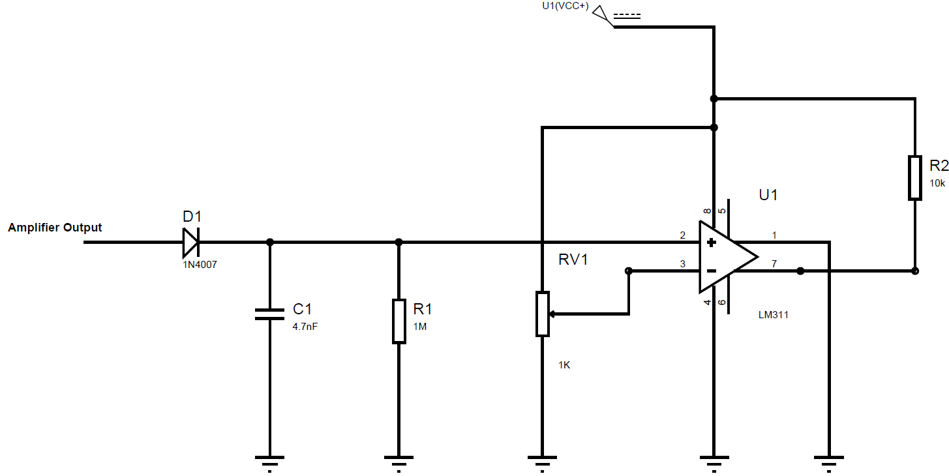

Figure 13: Detection Circuit Diagram

|  |  |  |
| --- | --- | --- |
| **Comparator Circuit Design Targets** | | |
| **Description of design target** | **Design Value** | **Unit** |
| **High to low cutoff voltage** | **4.9** | **V** |
| **Low to high cutoff voltage** | **4.9** | **V** |
| **Output Max. Voltage** | **9** | **V** |
| **Output Min. Voltage** | **0** | **V** |

**Table 5. Design targets for Comparator Circuit Design**

|  |  |  |  |
| --- | --- | --- | --- |
| **Receiver Circuit Design Targets** | | | |
| **Description of design target** | **Min.** | **Max.** | **Unit** |
| **Input voltage (transducer output)** | **4** | **40** | **mVp-p** |
| **Output voltage (amplifier output)** | **2.4** | **9** | **V** |
| **Output voltage (detector output)** | **0** | **9** | **V** |
| **Frequency range** | **37** | **-** | **kHz** |

**Table 6. Design targets for Received Circuit Design**

**3. Test Results**

**3.1. Ultrasonic Trigger Oscillator Circuit Test Results**

The measurements corresponding to the trigger oscillator circuit test results are given in the following table.

|  |  |  |
| --- | --- | --- |
| **Trigger Oscillator Test Results** | | |
| **Design target** | **Measured value** | **Unit** |
| **Input supply voltage** | **9** | **V p-p** |
| **Output voltage** | **8.8** | **V** |
| **Frequency** | **9.83** | **Hz** |
| **Output duty cycle** | **99.80** | **%** |

**Table 7. Test results for the Trigger oscillator Circuit.**

In the theoretical calculation, the trigger oscillator circuit generated a signal of 9.97 Hz and output duty cycle is 99.97 % for TH = 0.25ms and TL = 100ms. The values observed on the circuit; frequency is 9.83 Hz and duty cycle is 99.80 % and 9V peak to peak. There is a small error in the results, but not a significant amount in the operation of the circuit.

**3.2. Ultrasonic Pulse Oscillator Circuit Test Results**

The measurements corresponding to the pulse oscillator circuit test results are given in the following table.

|  |  |  |
| --- | --- | --- |
| **Pulse Oscillator Test Results** | | |
| **Design target** | **Measured value** | **Unit** |
| **Input supply voltage** | **9** | **V p-p** |
| **Output voltage** | **8.8** | **V** |
| **Frequency** | **40.6** | **kHz** |
| **Output duty cycle** | **52.93** | **%** |

**Table 8. Test results for the Pulse Oscillator Circuit.**

In the theoretical calculation, the pulse oscillator circuit generated a serial square wave signal of 39.01 kHz and output duty cycle is 51.34 % for TH = 13.16us and TL = 12.47us. The values observed on the circuit; frequency is 40.6 kHz and duty cycle is 52.93 % and 9V peak to peak. Our aim was 50 % duty cycle and generate 40 kHz signal but the results aren’t exactly the same. In transmitting part, generated serial square signal at 40.6 kHz with %52.93 duty cycle.

**3.3. Clock Frequency Circuit Test Results**

The measurements corresponding to the clock frequency circuit test results are given in the following table.

|  |  |  |
| --- | --- | --- |
| **Clock Frequency Test Results** | | |
| **Design target** | **Measured value** | **Unit** |
| **Input supply voltage** | **9** | **V p-p** |
| **Output voltage** | **8.8** | **V** |
| **Frequency** | **17.24** | **kHz** |
| **Output duty cycle** | **52.13** | **%** |

**Table 9. Test results for the Clock Frequency Circuit.**

Our design accuracy is +/- 0.5 cm. The accuracy range is 1cm. Therefore, period of clock must be less than the travel time which is (0.5 cmx2) x 2 = 2 cm.

**(2 cm)/(343,5 m/s) = 56,2μs f = 1/(56,2x(10^-6)) = 17,2 kHz**

When test the frequency of clock circuit, observed the frequency 16.3 kHz. To fix this, we changed the Rb with potentiometer. When we set it from 40k to 32.3k, the frequency value was 17.23 kHz. This value is so important because, it is our clock signal for counter circuit, this value provides counting circuit to works properly.

**3.4. Amplifier Test Results**

The receiver amplifier test results as below;

|  |  |  |
| --- | --- | --- |
| **Design Target** | **Measured values** | **Unit** |
| Amplifier supply voltage | 9.2 | V |
| Input voltage for min distance criteria | ±400 | mV |
| Input voltage for max distance criteria | ±160 | mV |
| Gain | 15 | - |
| Output voltage for min distance criteria with bypass capacitor | ±1.25 | V |
| Output voltage for max distance criteria with bypass capacitor | ±0.5 | V |
| Bypass capacitor effect at 40 KHz | 0.2 | - |
| Output voltage for min distance criteria without bypass capacitor | 6.25 | V |
| Output voltage for max distance criteria without bypass capacitor | 2.5 | V |

**Table 10. Test results for the Amplifier Circuit.**

Unwanted signal with some picks and trigger signal duration is occurs at receiver transducer output. The bypass capacitor is selected to remove this signal. At the same time, it also lessen the reflected signal but not as much as unwanted part of signal, on the other hand our overall gain is reduced.

**3.5. Detection Circuit Test Results**

The detection circuit test results as below;

|  |  |  |
| --- | --- | --- |
| **Design target** | **Measured values** | **Unit** |
| Comparator supply voltage | 9 - 0 | V |
| Min-max output of envelope  Min-max input of comparator | 1-1.25 | V |
| Output of comparator | 8.9 | V |
| Cutoff voltage for comparator | 4.7 | V |

**Table 11. Test results for the Detection Circuit.**

We calculated cutoff voltage is 4.9V. However, we set it 4.7V help of potentiometer because of unwanted picks that occur at amplifier input and also reduced effect of it at output. As you see unwanted picks at figure 14 below.

Trigger signal

Amplifier Input

VrefAmplifier Output

Unwanted Picks

Reflected signal

Figure 14: Unwanted Picks Diagram

**4. Conclusion**

Taking everything into consideration, we observed the expected results from each design block. But when we put all the circuit blocks together, we noticed that there were some minor problems in the circuit. In the process of construction of the project and in theory we have had more problems in some design blocks than in other parts.

All part of the project was constructed part by part. If it works properly, it integrated with other parts of project with accurate cabling. We have not encountered any problem in the transmitter block and designed it according to the design parameters. Transmitter transducer input signal is almost same as design specifications. At the amplifier circuit, there was so much discrepancy between calculations and implementations. Therefore, we had to change our design and do calculations several times. One of the mean reasons of this is the unwanted pick at the receiver with trigger timing, it was very difficult to handle with. It was the main challenge for us. To avoid effects of this problem, bypass capacitors are used as high pass filter that also reduces the amplifier gain. Comparator cutoff voltage range is also reduced due to this reduced gain. As an effect of this, measurements at farther distance from 85 cm are winking. Firstly we directly use comparator output signal as latch enable signal. It causes unable to read display signal that is only stop while comparator high that is very short term which we could not read, otherwise continue counting. This problem is handled with simple SR-Latch logic circuit. After this step we made calibrations in the meantime so that our device works with full accuracy.

**5. Component List**

|  |  |  |  |
| --- | --- | --- | --- |
| **Component description** | **Part Number** | **Manufacturer** | **Supplier** |
| Timer | **555** | STmicroelectronics | Electronic Lab. |
| BCD Counter | **MC14553B IC** | ----- | Zafer Elektronik |
| BCD to 7 Segment Decoder | **MC4511** | Micro Electronics | www.direnc.net |
| Operational Amplifier | **LM358N** | Texas Instruments | Zafer Elektronik |
| Voltage Comparator | **LM311N** |  | Electronics Lab. |
| 7-segment LED displays | **SP420561K** | Centenary Materials | Electronics Lab. |

**References**

**1.** Wikipedia article on "**Sound**"

<https://en.wikipedia.org/wiki/Sound#cite_note-1>

**2.** **“What is sound?”**

http://study.com/academy/lesson/what-is-sound-definition-wave-parameters-pitch-volume.html

**3. “Some Factors affecting Velocity of sound”**

https://goforaplusplus.wordpress.com/2011/04/24/some-factors-affecting-velocity-of-sound/

**4.** Wong, [*Speed of sound in standard air*](http://dx.doi.org/10.1121/1.393664), J. Acoust. Soc. Am. Volume 79, Issue 5, pp. 1359-1366, May 1986

**5.** Introduction to Piezoelectric Actuators and Transducers, Kenji Uchino, International Center for Actuators and Transducers, Penn State University Park, PA 16802

**6.** Wikipedia article on **"Ultrasonic transducer"**

https://en.wikipedia.org/wiki/Ultrasonic_transducer

**7. “Ultrasonic transducer”**

http://www.futurlec.com/Ultrasonic_Sensors.shtml

**8.** Ultrasonic Distance Measurer Implemented with the MC9RS08KA2, Freescale Semiconductor Application Note, document Number: AN3481 Rev. 0, 02/2008

**9. “LM555 Timer”**

http://www.ti.com/lit/ds/symlink/lm555.pdf

**10. “BCD COUNTER”**

http://www.electronicshub.org/decade-counterbcd-counter/

**11.** **"Timer 555 datasheet**"

http://www.ti.com/lit/ds/symlink/lm555.pdf

**12.** **"HOW TO BIAS AN OP-AMP**"

https://ocw.mit.edu/courses/media-arts-and-sciences/mas-836-sensor-technologies-for-interactive-environments-spring-2011/readings/MITMAS_836S11_read02_bias.pdf

**13.** **"Positive Feedback**"

https://www.allaboutcircuits.com/textbook/semiconductors/chpt-8/positive-feedback/