CS555/455 Fall 2015

**Assignment 4**

**Due on November 17 (by 5:59pm)**

**Author:** Okan Gul

**e-mail:** ogul1@binghamton.edu

**Part A: Questions: (50%)**

1. (12%) Use the definition of Dilation to prove “A ⊕ B = B ⊕ A”

**Answer 1:**

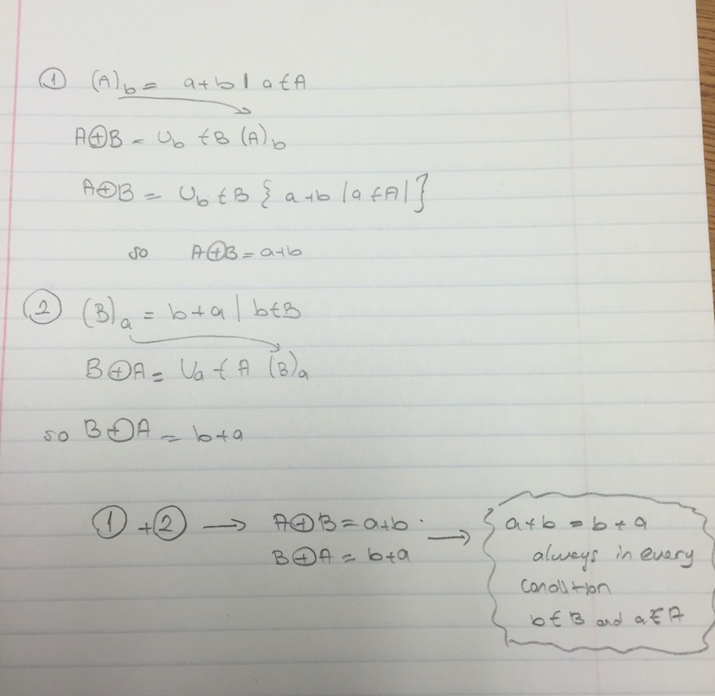

1. (12%) Binary image A and structuring element B are defined below. Show the result of opening operation (A ° B).

A

|  |  |  |  |  |  |  |  |  |  |  |  |  |  |
| --- | --- | --- | --- | --- | --- | --- | --- | --- | --- | --- | --- | --- | --- |
|  |  |  | • |  | • | • |  |  | • |  |  | • | • |
|  | • | • |  |  | • | • | • |  | • |  | • |  |  |
|  |  |  | • | • | • |  |  | • |  | • | • | • |  |
| • |  | • | • | • |  |  |  | • |  |  | • |  | • |
|  |  | • | • | • | • | • | • | • | • | • |  | • |  |
|  |  | • | • | • | • | • | • | • | • | • |  |  |  |
|  |  | • | • | • |  |  | • | • | • | • | • | • | • |
| • | • |  | • | • |  |  | • | • | • | • |  |  | • |
|  |  |  | • |  | • | • | • |  | • |  |  |  |  |
|  |  | • |  |  | • | • |  | • | • |  |  |  |  |
| • |  |  | • | • |  |  |  | • |  | • | • |  | • |
|  |  | • | • | • | • |  | • |  |  |  | • |  |  |
|  | • |  | • |  | • |  | • |  | • | • |  | • | • |
| • |  |  |  | • |  |  | • |  | • |  | • |  |  |

B

|  |  |  |
| --- | --- | --- |
| • | • | • |
| • | • | • |
| • | • | • |

**Answer 2:**

|  |  |  |  |  |  |  |  |  |  |  |  |  |  |
| --- | --- | --- | --- | --- | --- | --- | --- | --- | --- | --- | --- | --- | --- |
|  |  |  |  |  |  |  |  |  |  |  |  |  |  |
|  |  |  |  |  |  |  |  |  |  |  |  |  |  |
|  |  |  |  |  |  |  |  |  |  |  |  |  |  |
|  |  |  |  |  |  |  |  |  |  |  |  |  |  |
|  |  | * | * | * |  |  |  |  |  |  |  |  |  |
|  |  | * | * | * |  |  | * | * | * | * |  |  |  |
|  |  | * | * | * |  |  | * | * | * | * |  |  |  |
|  |  | * | * | * |  |  | * | * | * | * |  |  |  |
|  |  |  |  |  |  |  | * | * | * | * |  |  |  |
|  |  |  |  |  |  |  |  |  |  |  |  |  |  |
|  |  |  |  |  |  |  |  |  |  |  |  |  |  |
|  |  |  |  |  |  |  |  |  |  |  |  |  |  |
|  |  |  |  |  |  |  |  |  |  |  |  |  |  |
|  |  |  |  |  |  |  |  |  |  |  |  |  |  |

**(3)** (12%) Binary image C and structuring element B are defined below. Show the result of closing operation (C • B).

C

|  |  |  |  |  |  |  |  |  |  |  |
| --- | --- | --- | --- | --- | --- | --- | --- | --- | --- | --- |
|  |  |  |  |  |  |  |  |  |  |  |
|  |  |  |  |  |  |  |  |  |  |  |
|  |  |  |  |  | • |  | • |  |  |  |
|  |  |  |  | • | • | • | • |  |  |  |
|  |  |  |  | • | • | • | • |  |  |  |
|  |  | • | • | • |  |  |  |  |  |  |
|  |  |  |  | • | • | • | • |  |  |  |
|  |  |  | • | • | • | • | • |  |  |  |
|  |  |  |  | • |  |  | • |  |  |  |
|  |  |  |  |  |  |  |  |  |  |  |
|  |  |  |  |  |  |  |  |  |  |  |

B

|  |  |  |
| --- | --- | --- |
| • | • | • |
| • | • | • |
| • | • | • |

**Answer 3:**

|  |  |  |  |  |  |  |  |  |  |  |
| --- | --- | --- | --- | --- | --- | --- | --- | --- | --- | --- |
|  |  |  |  |  |  |  |  |  |  |  |
|  |  |  |  |  |  |  |  |  |  |  |
|  |  |  |  |  | **\*** | **\*** | **\*** |  |  |  |
|  |  |  |  | **\*** | **\*** | **\*** | **\*** |  |  |  |
|  |  |  |  | **\*** | **\*** | **\*** | **\*** |  |  |  |
|  |  | **\*** | **\*** | **\*** | **\*** | **\*** | **\*** |  |  |  |
|  |  |  | **\*** | **\*** | **\*** | **\*** | **\*** |  |  |  |
|  |  |  | **\*** | **\*** | **\*** | **\*** | **\*** |  |  |  |
|  |  |  |  | * | * | * | * |  |  |  |
|  |  |  |  |  |  |  |  |  |  |  |
|  |  |  |  |  |  |  |  |  |  |  |

**(4)** (14%) Use the following primitives:

a b c d e f

and use the structure relations given in class (+, −, ×, *, ~)

1. (7%) Sketch the structure whose PDL (program description language) structural description is:

[ [ b − (~c) ] + (~d) ] − [ [a – (~a) ] + d ]

**Answer 4a:**

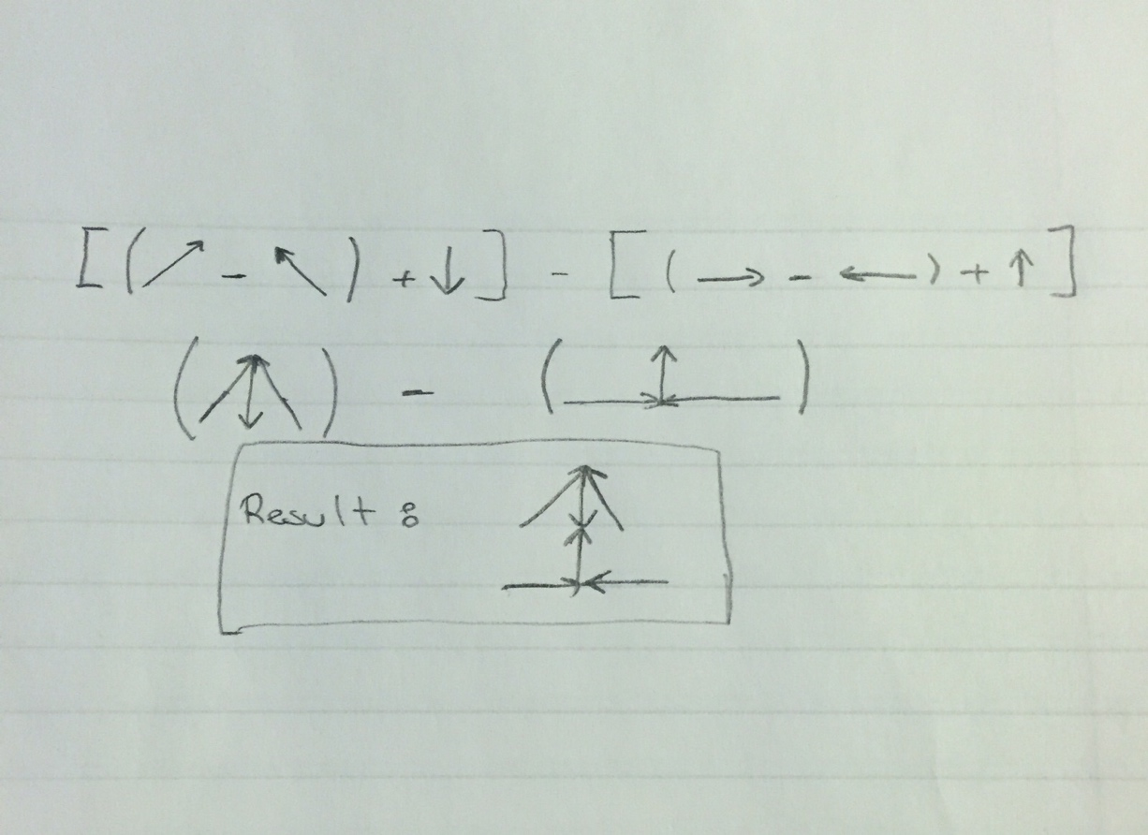

1. (7%) Give PDL structural description of the following two structures:

**Answer 4b:**

For the first one we can consider 2 ways but I choose this way.

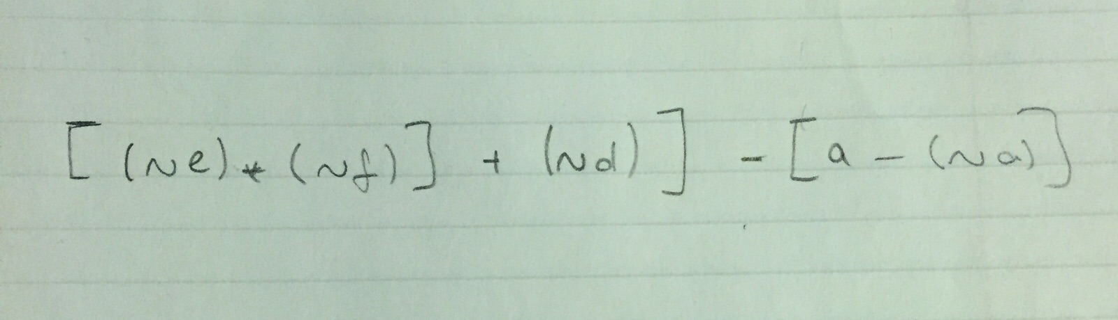

The second one should be like this.

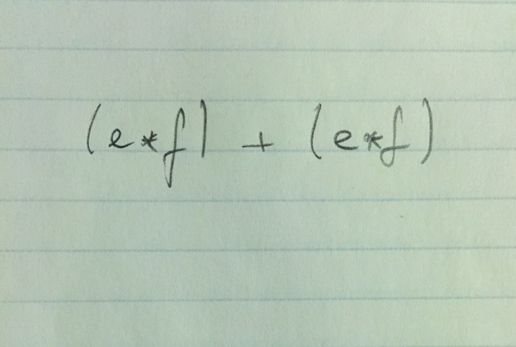

**Part B: (50%) Programming: Morphological image processing**

* **Description:** Dilation and Erosion are two basic morphological operations. Dilation is to enlarge the image, and fill the small holes within objects. Erosion is to shrink the object, and separate the objects for segmentation. In this assignment you are required to employ morphological operations to separate the multiple objects from each other and count the number of objects (e.g., pigs) in the following image (I).

## Your implementation:

1. (5%) Obtain image I, and convert it into binary image F for display.

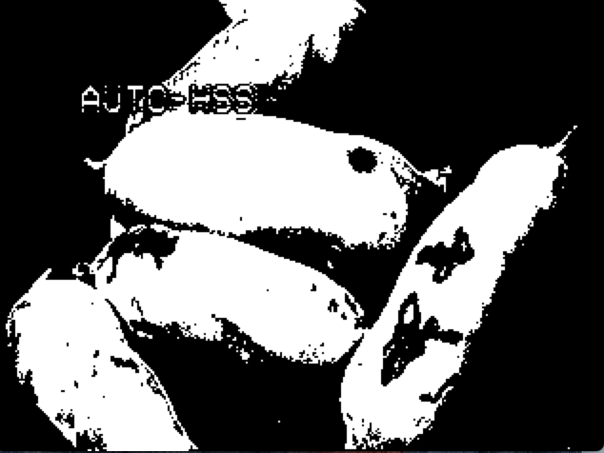

**F: BINARY IMAGE**

1. (25%) Design your algorithm to separate the objects in the given image (hint: using morphological operation)

For the binary image morphological operations, first I make my grayscale image to binary by defining a threshold value like 185 so I get my binary image by 255’s and 0’s. After that I make my structuring element below with that I simply look for pixels and if my element fits I put 255 for erosion image if it doesn’t I put 0.

For reaching my goal I want to do opening so with the same element I implement dilation after erosion so I get Image 3. Simply put the real grayscale values for 255’s and get that result image. **I found 3 pigs very separate but the other 2 are looks like one because of 1 little point.**

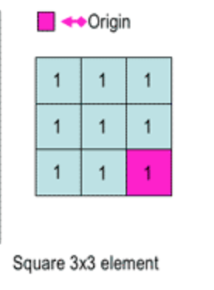



**IMAGE 2: BINARY AFTER EROSION**

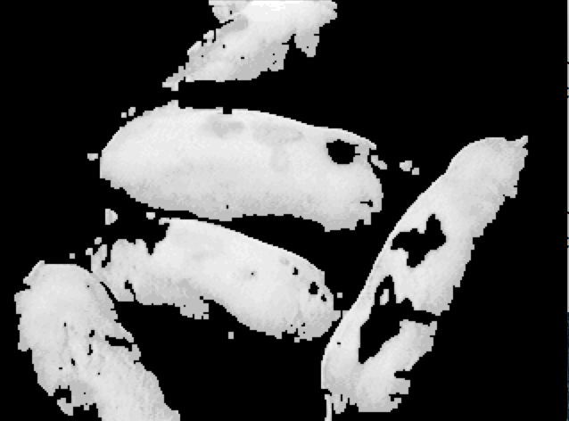

**IMAGE 3: RESULT WITH OPENING**

1. (10%) Apply the morphological operations on the original grey scale image directly, you need to report your result and explain your algorithm.

For the grayscale part I used intensity values of grayscale image. To reach my goal I make one 3x3 50’s element and 3x3 120’s element to reach my goal and make the center of them origin point. My functions works like it puts the element on pixel than it decreases the value from the center pixel after that it chooses the little one and put on the real pixel. **I don’t sure but again I found 3 pigs.**

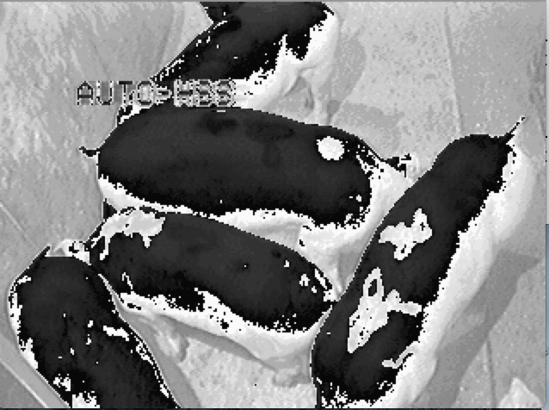

**IMAGE 4: GRAYSCALE OPENING**

**References**

<http://web.eecs.utk.edu/courses/fall2011/ece472/code/morph.cpp>