Using the variables assigned to me:

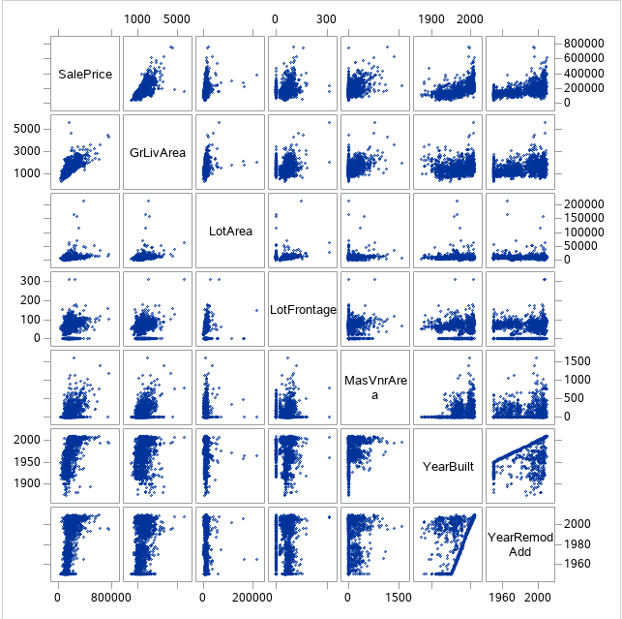

Tests multicollinearity.

Guideline: VIF>10 is a red flag

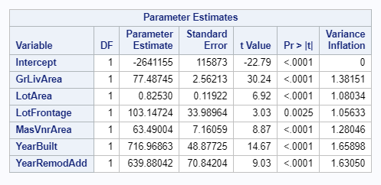

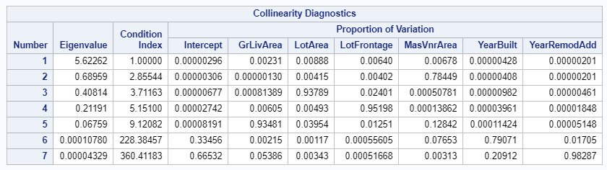

All the independent variables used show significance.

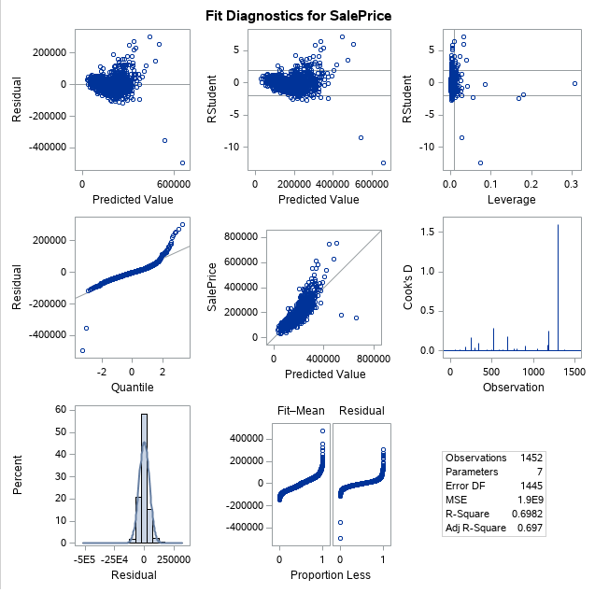

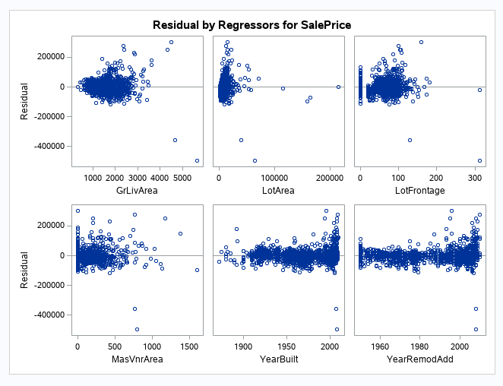

/* checking collinearity with variance inflation factor*/

proc reg data=clean_train;

model SalePrice = GrLivArea LotArea LotFrontage MasVnrArea YearBuilt YearRemodAdd / vif collin;

proc sgscatter data= clean_train;

matrix SalePrice GrLivArea LotArea LotFrontage MasVnrArea YearBuilt YearRemodAdd;