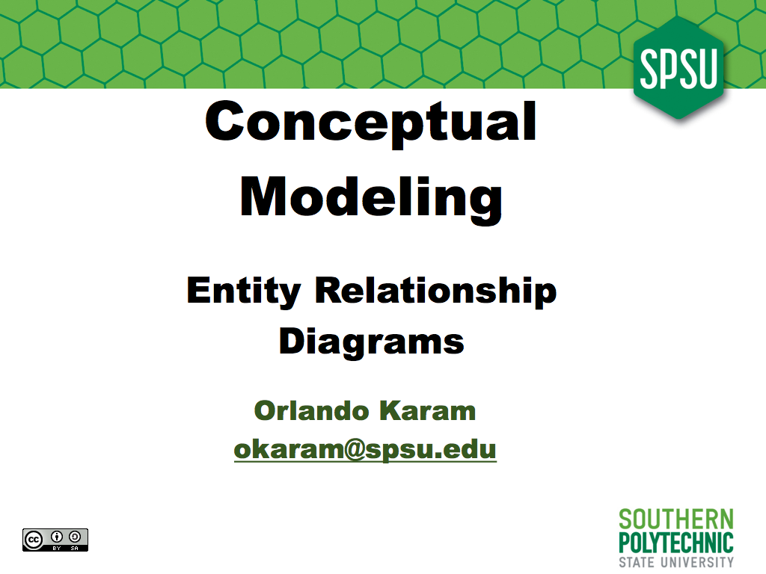
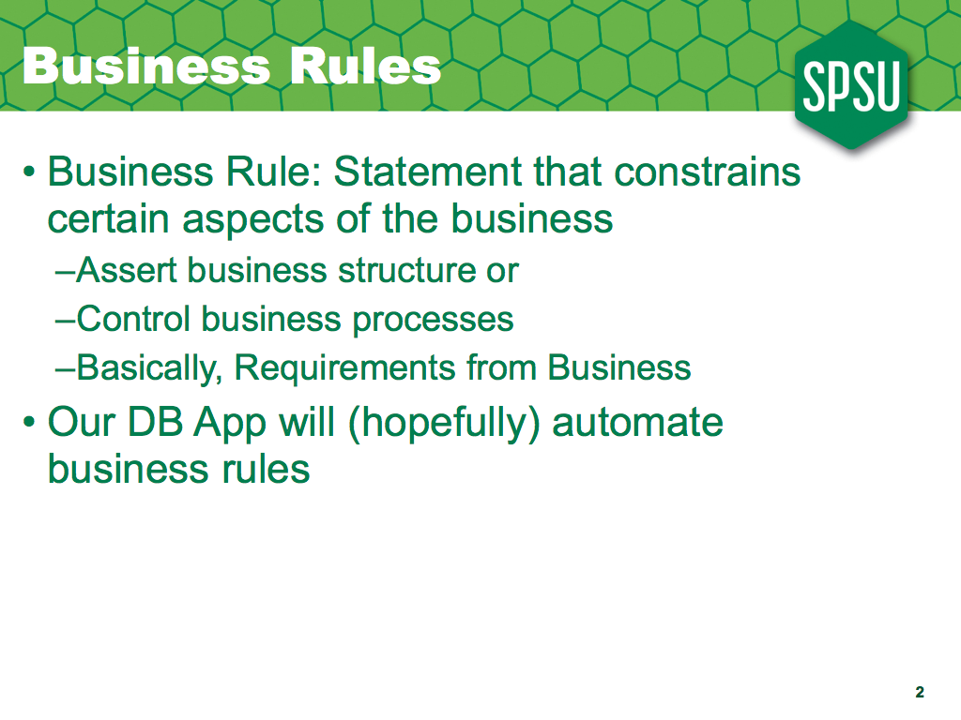
Within the database community, we tend to express requirements in terms of business rules. A business rule is a statement that constrains some aspect of the organization; in a way, business rules are the requirements for the business process, rather than just for the computer system. Business rules normally either assert business structure or somehow control business behavior. We expect most of the business rules will ultimately be automated through the DBMS and/or the computer system being built.

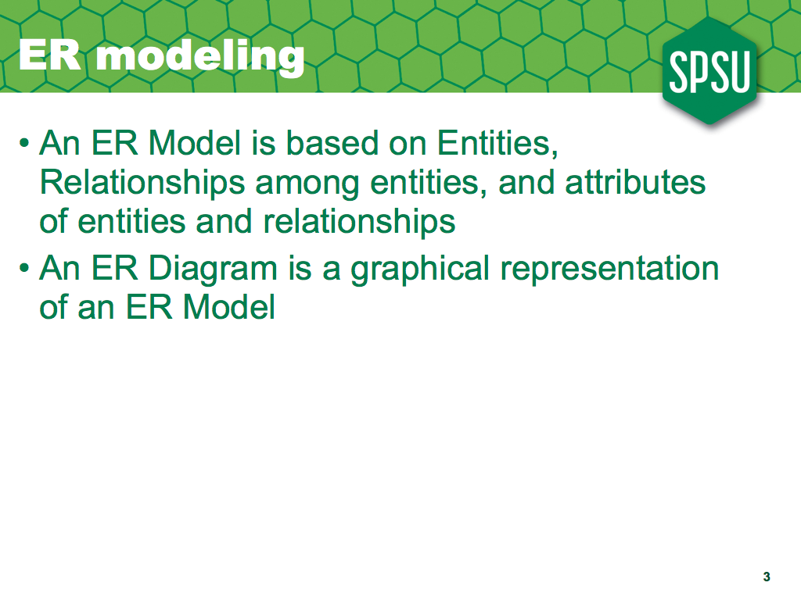
In order to create a database for an application, the most important issue is the definition of the data; what data needs to be stored in the database. In order to specify what goes in the database, we create a conceptual model of the data; this is a high-level, technology independent model of the data.
We usually represent our conceptual model by using an Entity-Relationship or ER diagram. An ER diagram is a graphical representation of an ER Model.
An ER Model represents a real-world situation by describing the Entities involved, the Relationships among those entities, and the attributes of both entities and relationships. In the following slides we define ER models in more detail.

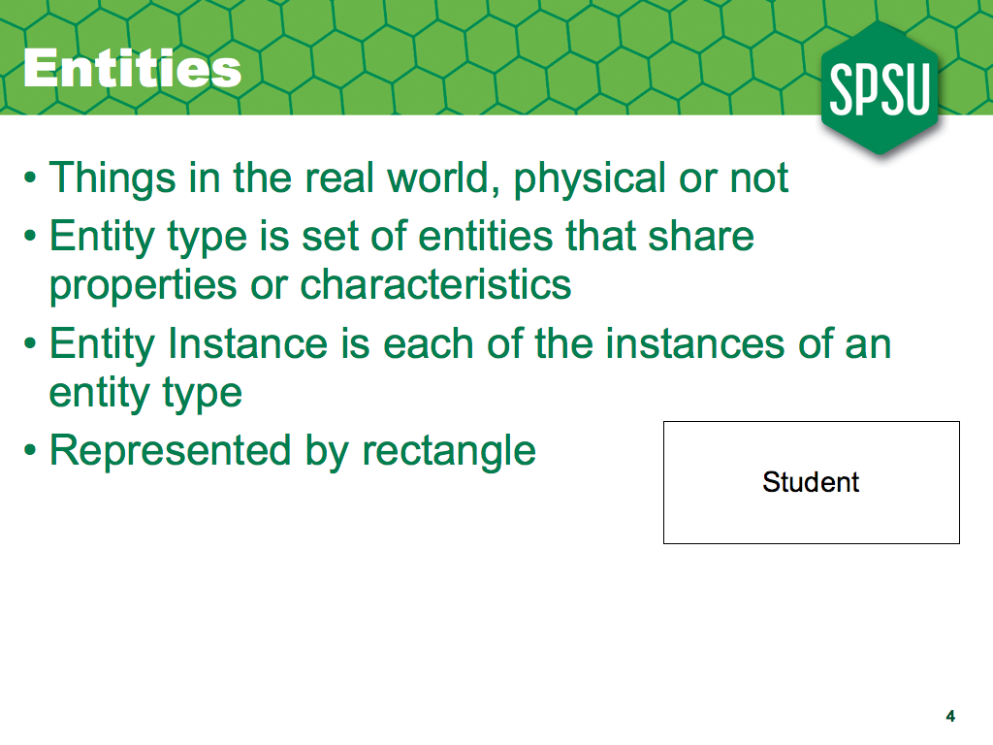
Entities represent things in the real world, whether physical things, like, say, chairs or conceptual things, like departments, or courses.
In a database, we will store many many things, so we want to reduce the number of concepts we deal with by grouping things with the same properties, so during analysis and design we can focus on just a few kinds of things, rather than on the actual million of things that will go in the database.
So, during conceptual modeling we define entity types, sets of things with common characteristics. Eventually, the database will contain many entity instances, but just from a few different types. In an ER diagram, we use rectangles to represent entity types.

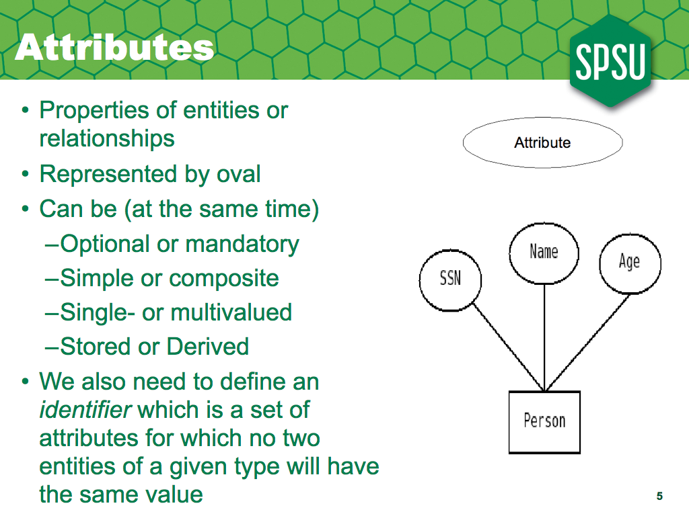
For each entity, we want to record many properties; we call those properties attributes. Later on we'll see relationships also can have attributes, but right now we'll focus on attributes of entities. In an ER diagram, we use ovals to represent attributes.
Since attributes are so important for databases, we will spend some time studying them.We classify attributes according to four independent categories. Attributes can be optional or mandatory; for mandatory attributes, every entity in the database needs to have a value.
Attributes can be simple, or composite. Composite attributes can be broken down into smaller pieces.
Most attributes can only have one value for each entity instance; however, multi-valued attributes can have more than one value for the same instance.
Most attributes will be stored in our database; however, derived attributes can be calculated from other attributes and so would not need to be stored.
Finally, we need to find a set of attributes that will uniquely identify each entity instance of the same entity type; we call this set of attributes the identifier of the entity type, and we underline the attributes that are members of the identifier.

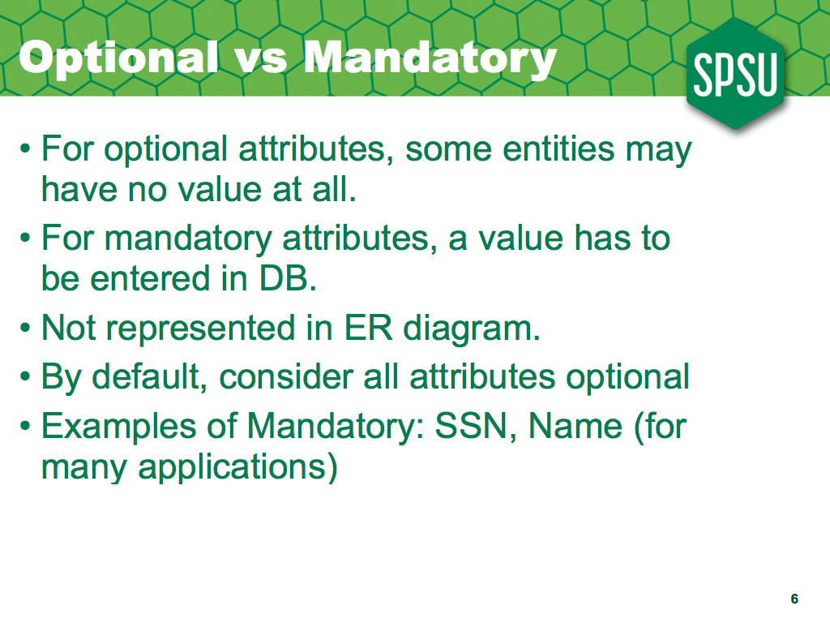
As mentioned before, some attributes are optional, that is, some entity instances may have no value for the attribute, whereas others will be mandatory, each instance in the database will have a value.
Notice this distinction is within the database, not necessarily for the real world; for example, if we're representing an Employee entity, its SSN might be mandatory, but a gender attribute could be optional; even though every employee will have a gender in the real world, we may not necessarily have it in the database for all employees.

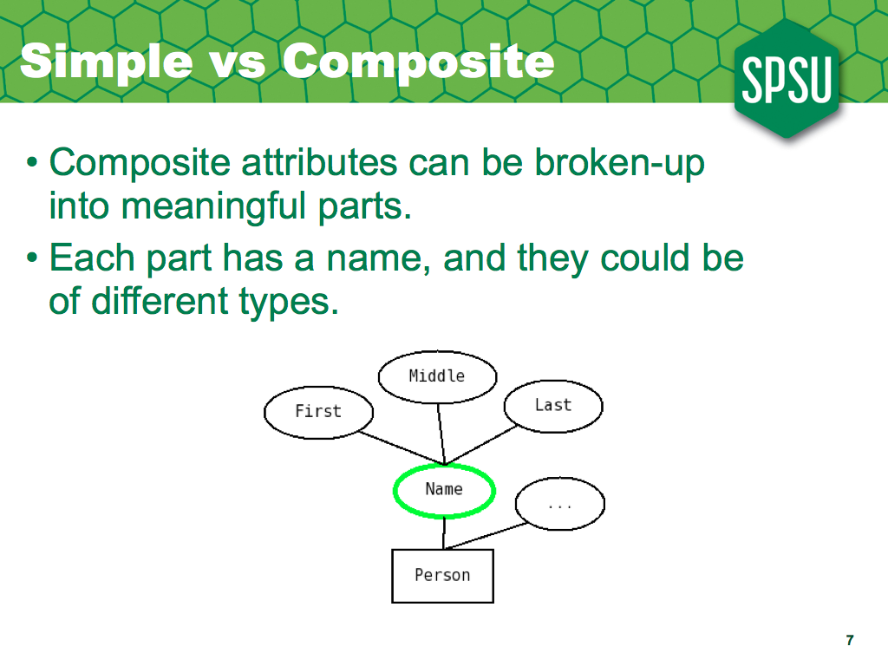
Most attributes in a database are simple; they cannot be broken up into smaller pieces without losing their meaning; however, some attributes are composite; they have meaningful pieces.
For example, in the US most people divide their full name into their first, middle and last names, which we would represent in an ER diagram by having the name attribute linked to its three pieces.

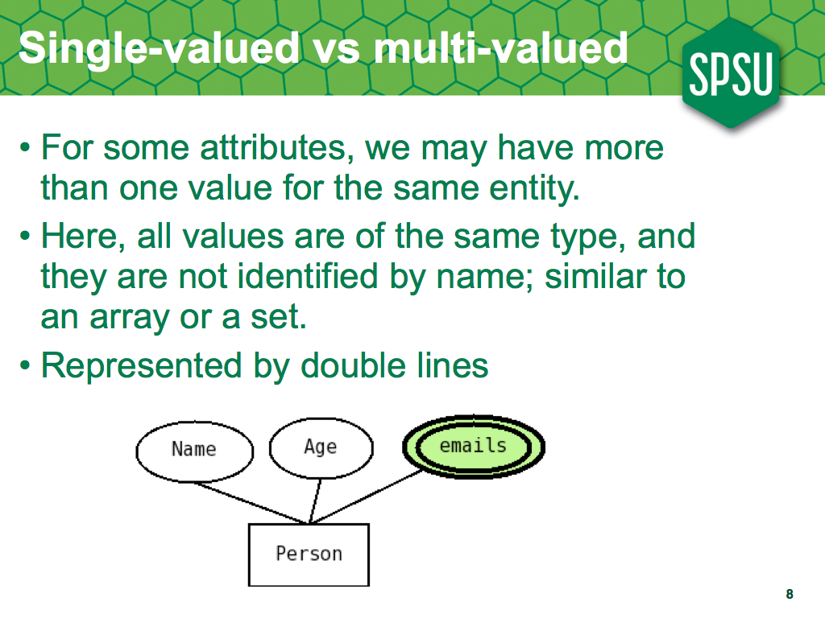
Most attributes are single-valued; each entity instance will have at most one value in the database; for example, you have one age, and one name, even though it is broken up in pieces.
However, some attributes in a database may have more than one value; for example, many people will have more than one email address, so we would say that emails is a multivalued attribute, which we represent with double lines.

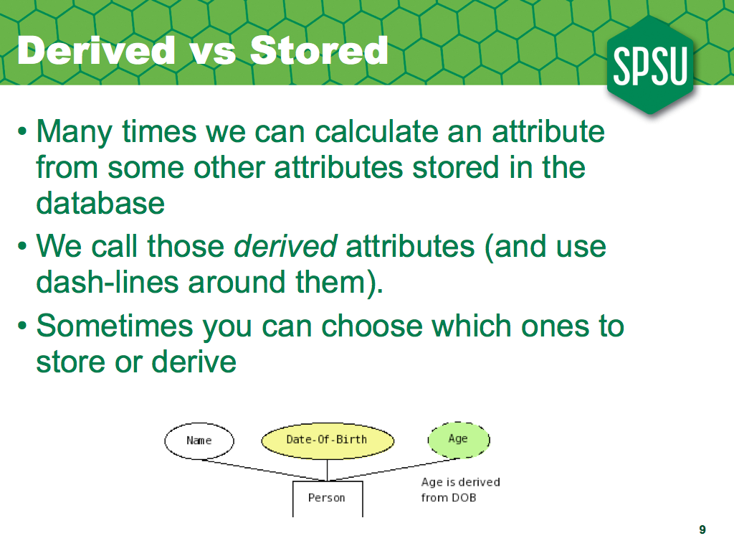
Most attributes of interest will actually be stored in the database; after all, that's why we're building it; however, there are some attributes which can be obtained from other attributes; we call those derived.
For example, although we're many times interested in knowing somebody's age, we probably wouldn't store it in the database, since it changes every day !, we would store the person's date of birth, and represent age as a derived attribute (and somewhere else we'll document how to calculate the age from the date of birth). Derived attributes are one way we get information rather than raw data from a database.
We represent derived attributes in a diagram by drawing the oval using a dashed line.
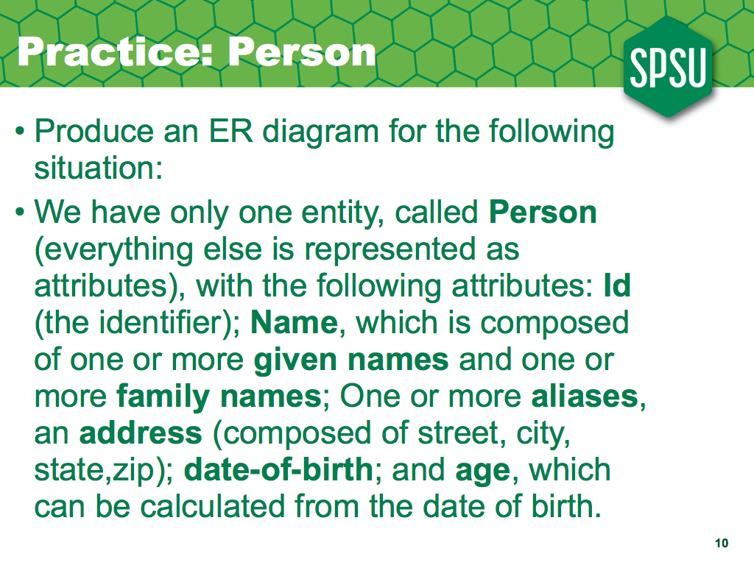
Ok, so now you try it. Don't look at the solutions yet, just get a piece of paper and try the exercise yourself. When you're done, the solution is on the next slide.

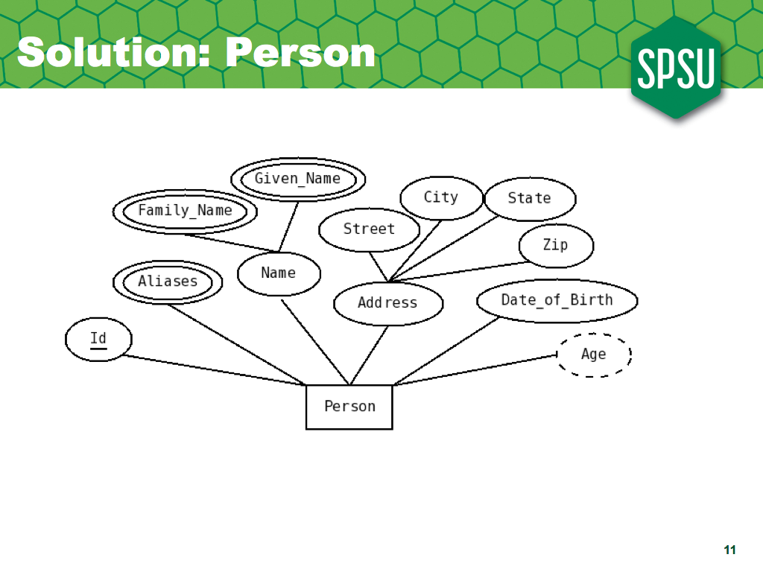
Ok, let's see. Person is the entity, so we put it in a rectangle. It has Id, the identifier, so we underline it. It has a name, which is composed of two attributes, given names and family names, and each one of these is multivalued, so they have double lines. Aliases is multivalued, so it gets double lines too. We have address, with its pieces, then date of birth, and age, which is derived and so drawn with a dashed line.

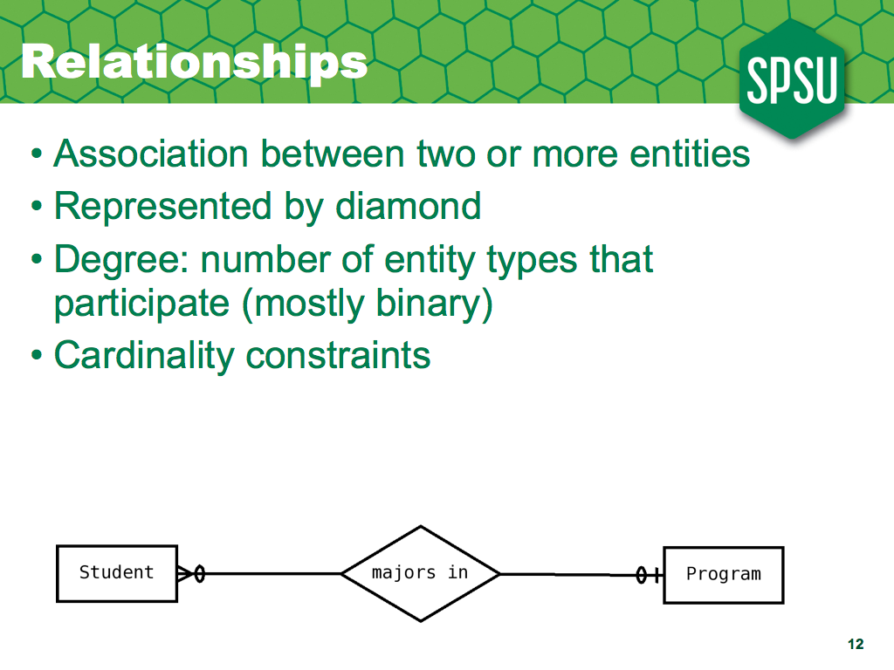
Although attributes allow us to represent many aspects of the real world, they do not allow us to represent associations between entities; to do so, we need a relationship, which appears as a diamond in an ER diagram.
Relationships themselves may have attributes, and we'll see some examples of that later; however, they cannot have an identifier, since there can only be one relationship instance for a given collection of entity instances.

We can define the Degree of a relationship as the number of entity types that relationship associates; most relationships will be binary, associating only two entities.
We also need to define, for each side of a relationship, cardinality constraints, that define the number of entities (on the other side) that an entity will be associated with. For each side, we define a minimum cardinality (that is usually either 0 or 1) and a maximum cardinality (which is usually either one or more than one, which we also call many). For the minimum cardinality, we use a circle for 0 and a vertical line for 1. For the maximum, we use a vertical line for one, and a less-than or greater-than symbol for many.

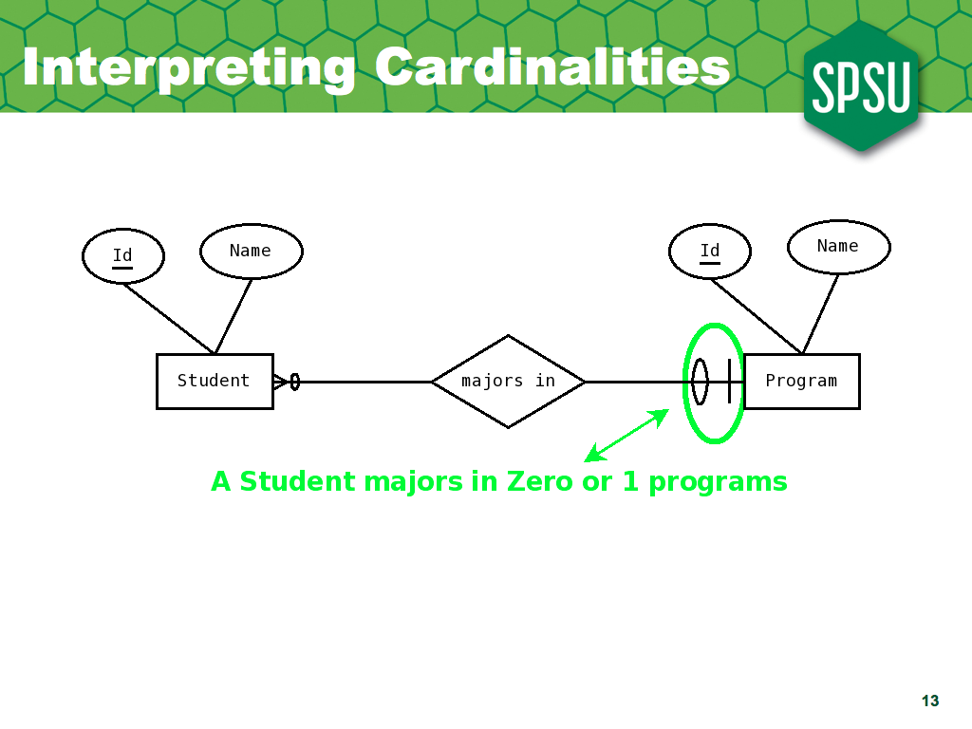
Now let's see how we interpret those cardinality constraints; We would interpret the squiggles next to the Program entity as representing constraints on how many programs can a student be related to; in this case, the diagram says that a student majors in zero or 1 programs.

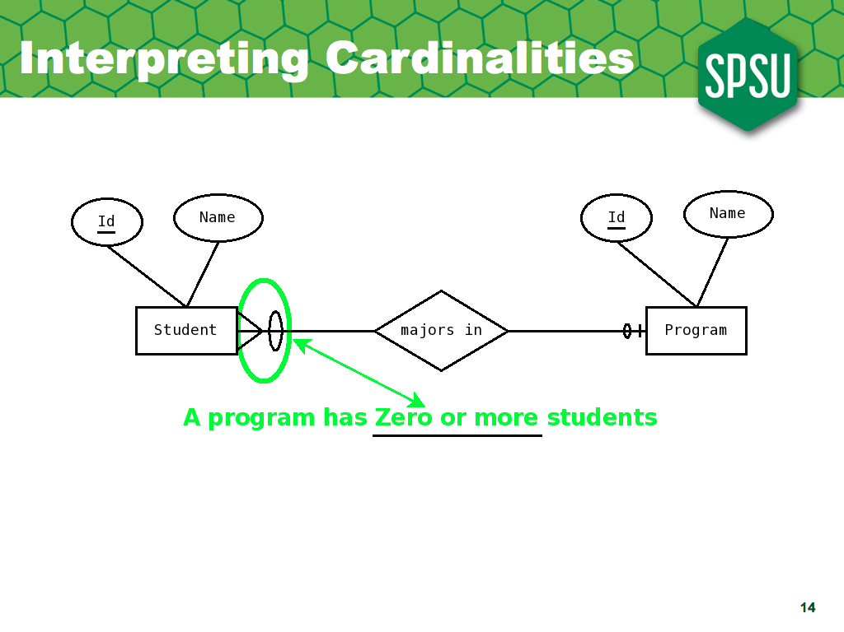
And the squiggles next to the Student entity tell us with how many students can each program be related; in this case, a program may have zero or more students majoring on it.
Notice also that the relationships are designed to be read one way, and it is expected you can understand it by the name; for example, here we assume you realize a Student majors in a program and not the other way.
Although we name the relationship in one way, when we put into the database we will be able to access the relationship either way; that is, given a student we can find its major, and given a program we can find all the students majoring in the program.

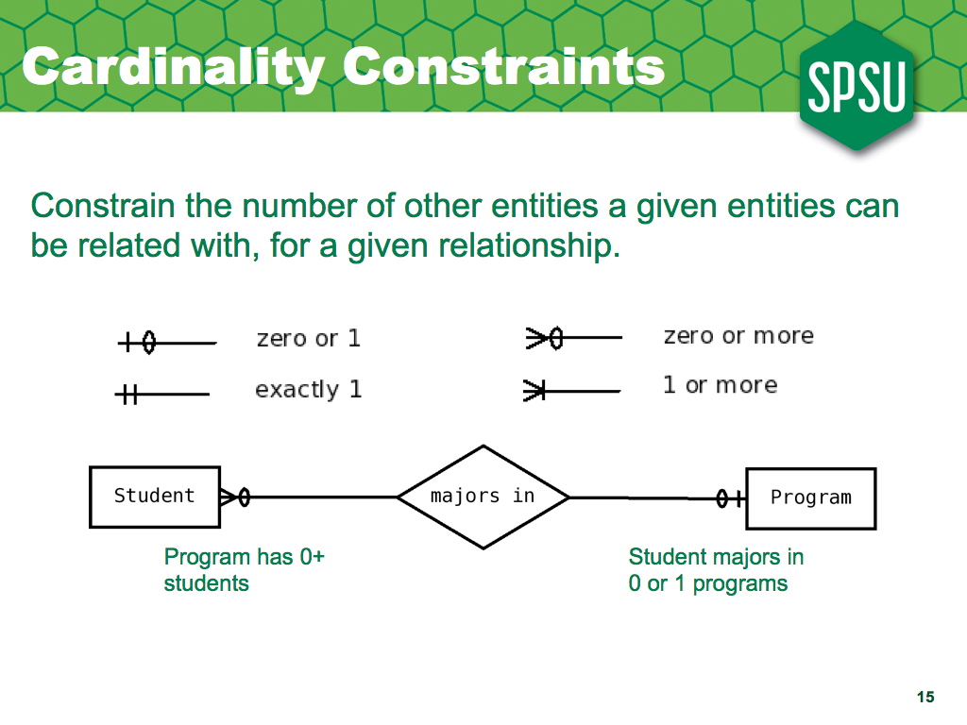
Ok, so let's review. We have four possible values for the cardinality constraints, and we put constraints on each side.
The cardinality constraints express the minimum and maximum number of entities that entities of a given type will be related to through that relationship. The minimum is either zero or 1, and the maximum is either 1 or more than one.
So, the possible combinations are:
- zero or one
- zero or more
- exactly one
- one or more
Notice that the constraints go on the side opposite the entity they constrain, so in the diagram above, the zero-or-1 constraint, which says that a student majors in zero-or-one programs is opposite the student entity, so next to the program.

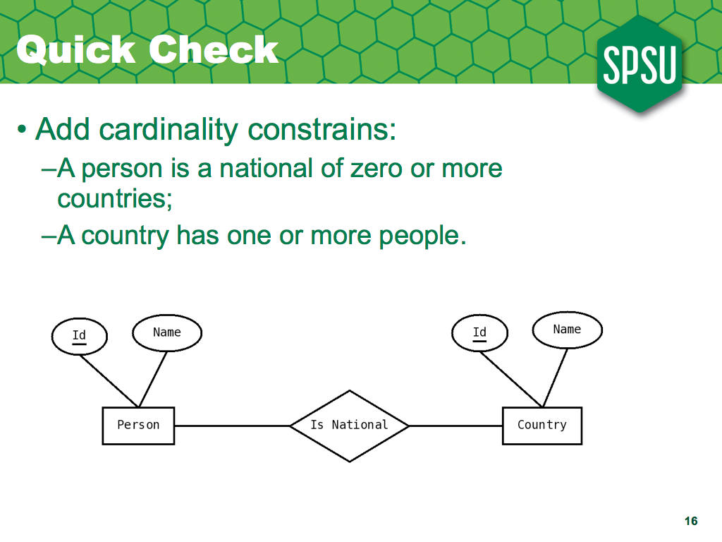
So now you try it. Add the cardinality constraints to the following diagram; a person is national of zero or more countries …...
A country has one or more people ….

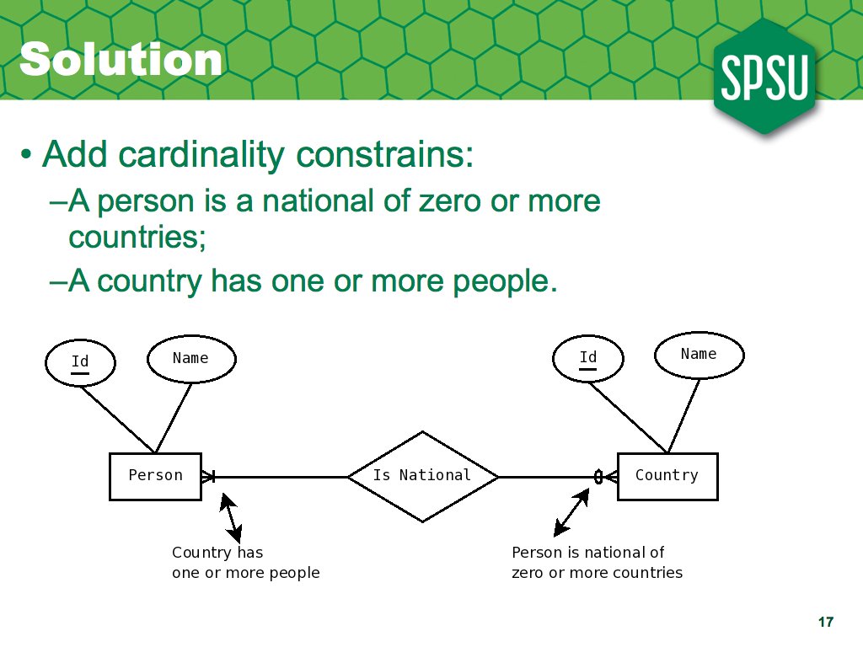
And here's the solution. Since a person is a national of zero or more countries, we write the 'zero-or-more' constraint on the side opposite to person; similarly, we write the one -or-more constraint opposite country.

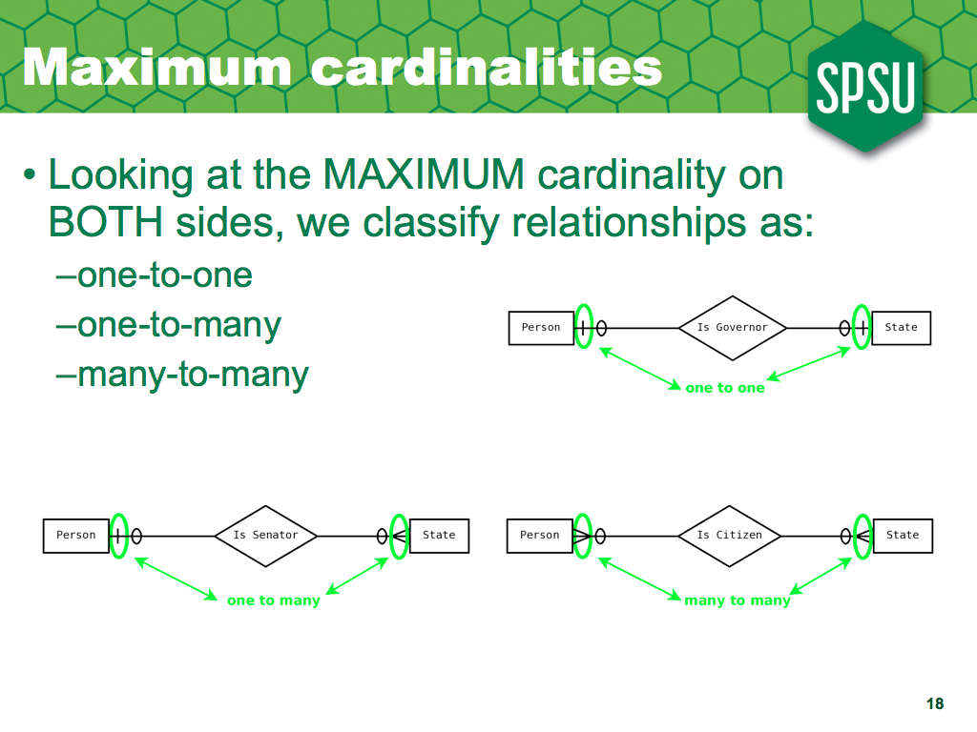
Although this is more useful when comparing the ER with the relational model, which we'll see later, it is convenient to classify binary relationships by their MAXIMUM cardinality on both sides; if the maximum is one on both sides, we call it a one-to-one relationship; if the maximum is one on one side and more-than-one on the other we call it a one-to-many relationship (or a many-to-one, depending on our viewpoint :), and if it's more-than-one on both sides we call it a many-to-many relationship.

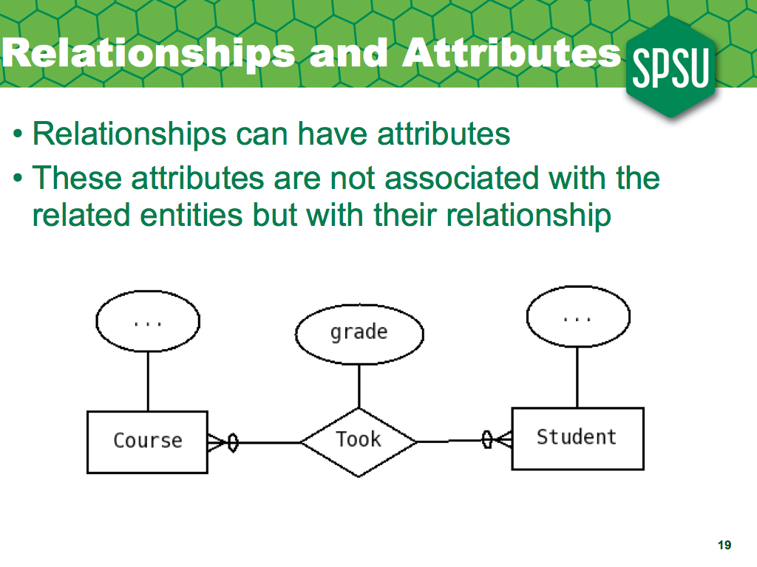
Notice that relationships may have attributes; most of the cases, if a relationship has attributes it will a many-to-many relationship.
For example, if we're representing the fact that a student takes a course, we may want to keep track of the grade a student got in that course; in this case, the grade, say A, cannot be an attribute of the student alone, since we wouldn't know on which course did the student got an A; similarly, it cannot be an attribute of the course alone; it has to be an attribute of the relationship.
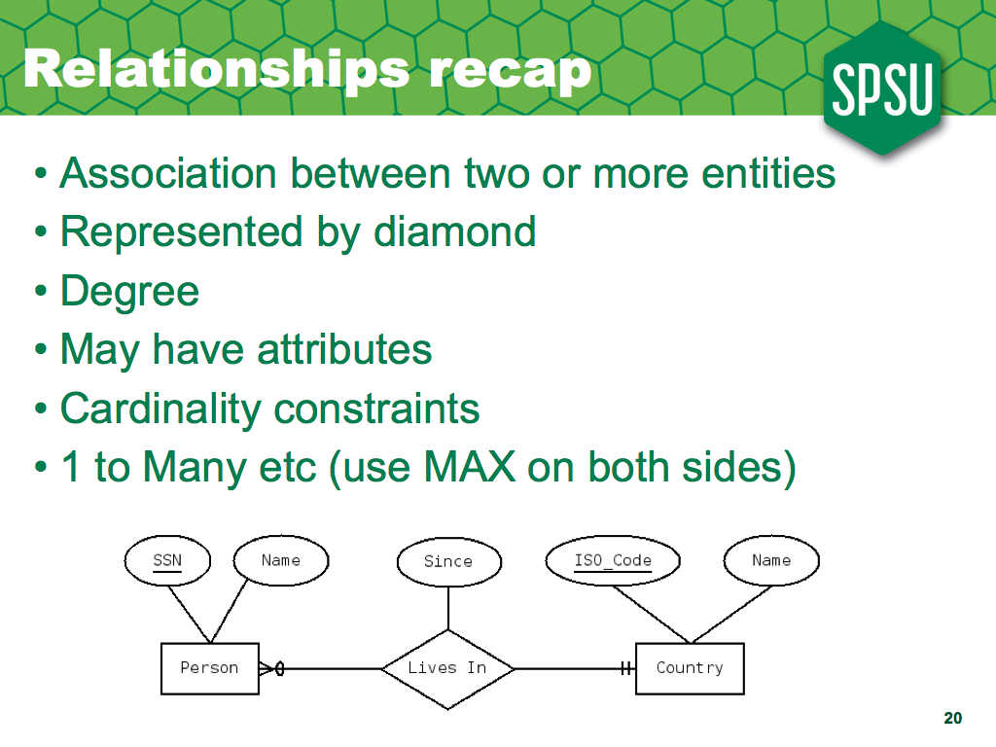
So, let's review. Relationships represent associations between entities, and we use a diamond for them. The degree of a relationship is the number of entity types it associates. Relationships may have attributes, and they do need to have cardinality constraints on both sides (these constraints are on the entity instances). Depending on the maximum cardinality on both sides, we classify relationships as one-to-one, one-to-many or many-to-many.

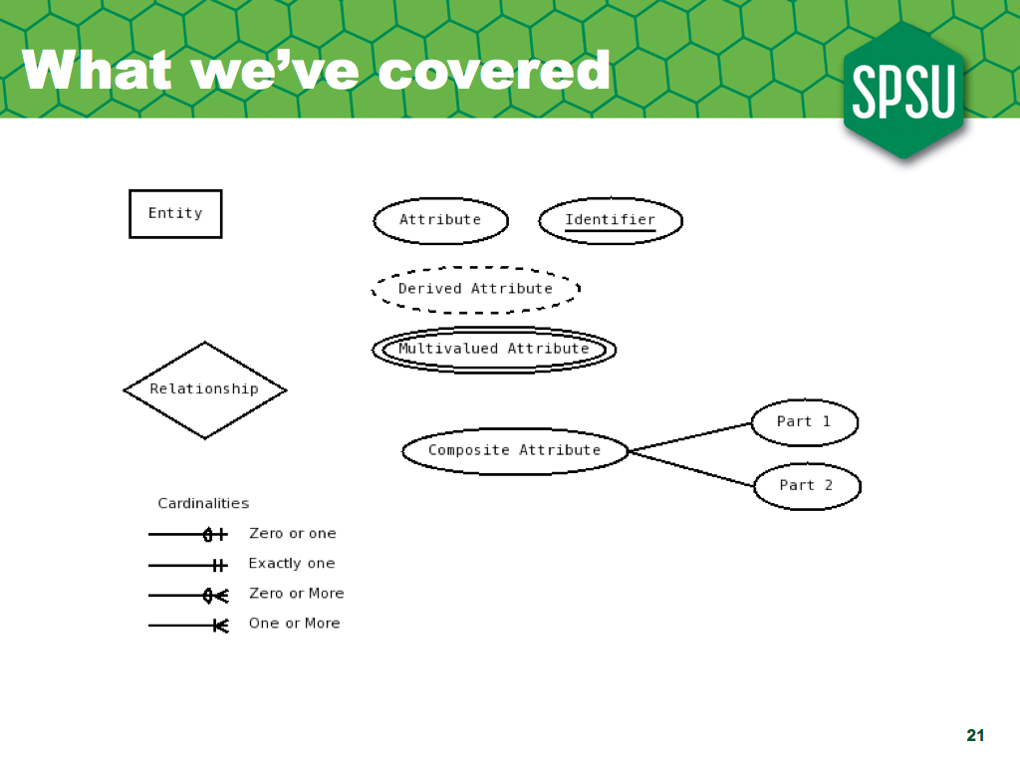
And another review of notation; we use rectangles for entities, ovals for attributes and diamonds for relationships.
We mark the identifier of an entity type by underlining it (relationships cannot have identifiers, since there can only be one relationship instances of a given type for a given collection of relationship instances).
We denote derived attributes by drawing their oval with dashed lines; we denote multivalued attributes by drawing their oval with double lines, and we denote composite attributes by linking their pieces to the composite attribute instead of to the entity of relationship.
Relationships have cardinality constraints on each side; the constraints are on the minimum and maximum number of instances of the other type that an instance can be related to. The minimum is either zero or one, and the maximum either one or more, leaving to four possible combinations; zero or one, exactly one, zero-or-more, and one-or-more.

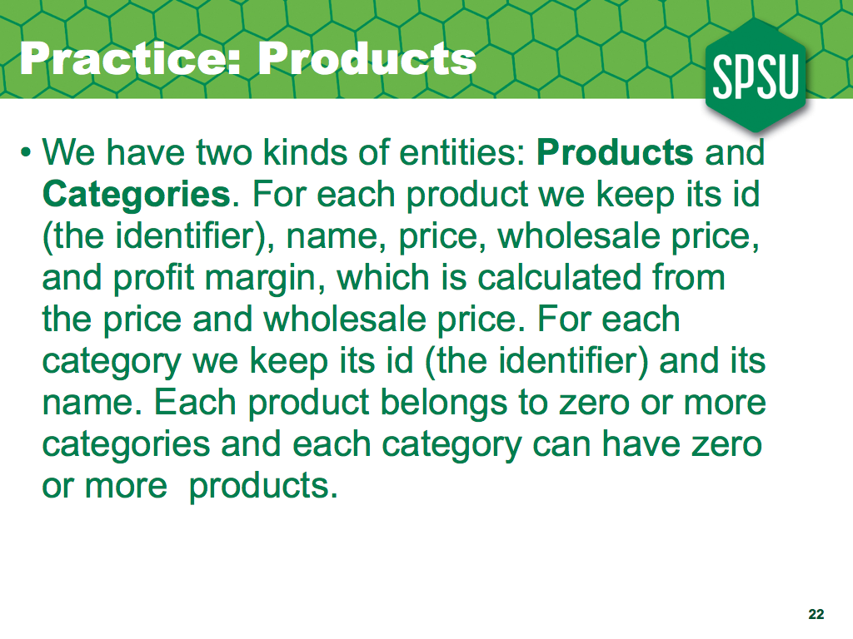
So, try this one; no peeking, try the solution first.

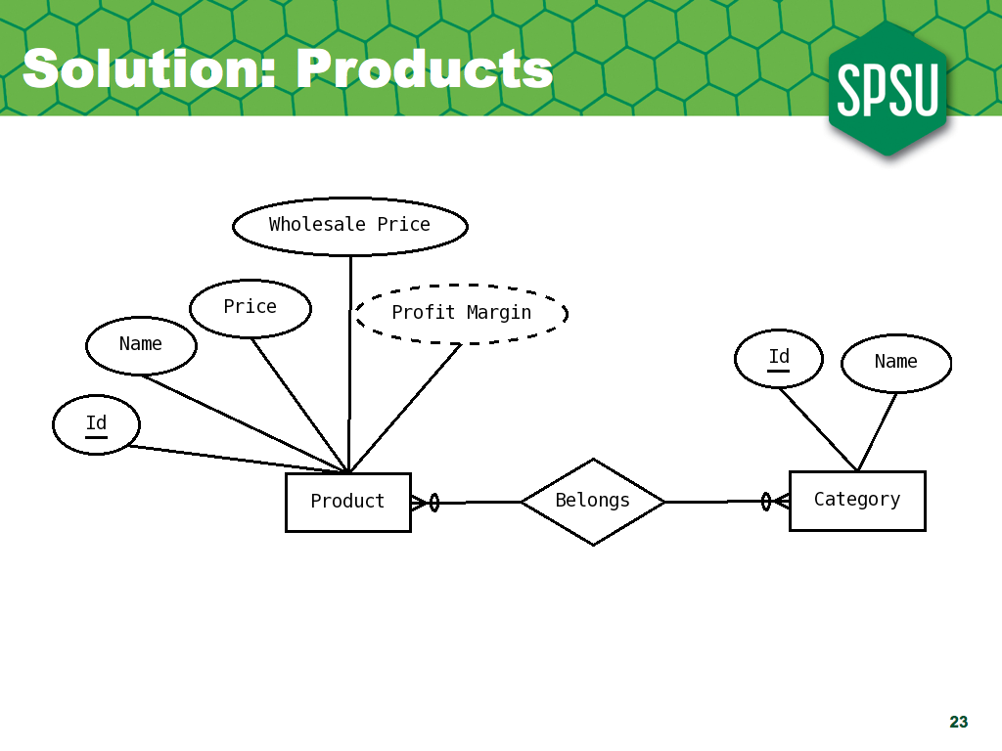
And here's the solution; we have two entity types, products and categories; for product, we underline its id, which is the identifier, add the other attributes, and use dashed lines for the profit margin, since it is derived; it can be calculated from the price and wholesale price.
Category is even simpler, since it has only id and name; once again, id, the identifier is underlined.
Now, we also need to keep track of which products belong to which categories; in order to do this, we need to use relationships; we cannot use attributes. A decent name for the relationship would be belongs, and we put cardinality constraints denoting that a product belongs to zero or more categories and that a category can have zero or more products.

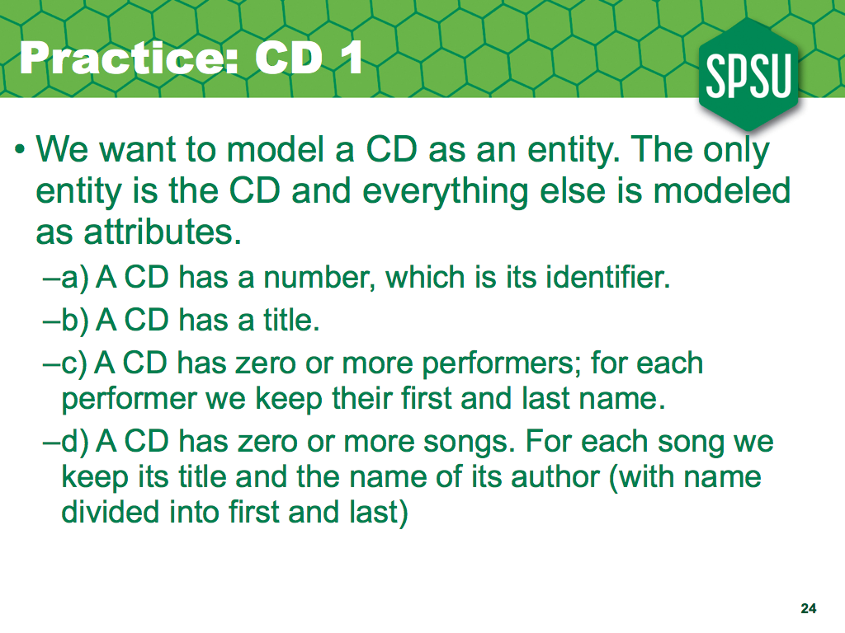
Now, lets try this one; for this example, you will model CD as an entity and you're not allowed to have other entities or relationships, just attributes.

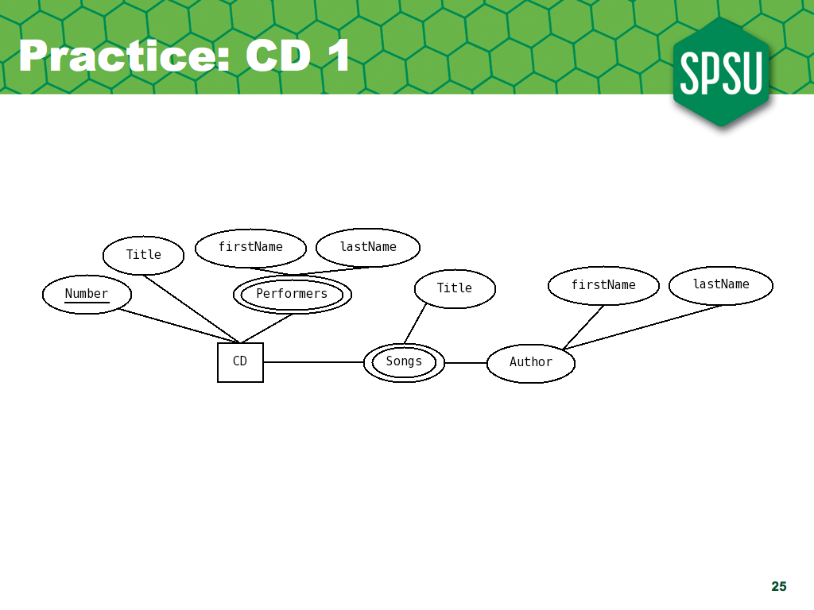
And here's the solution.

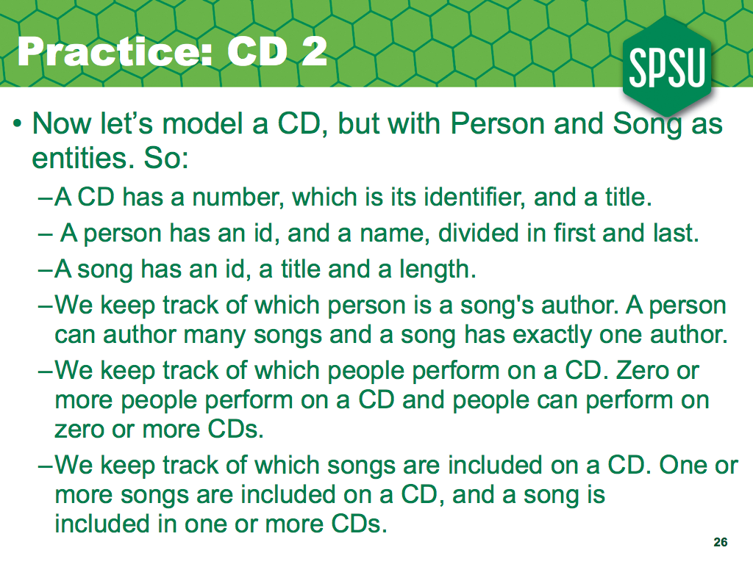
Now let's represent the same situation, but with more entities and relationships.

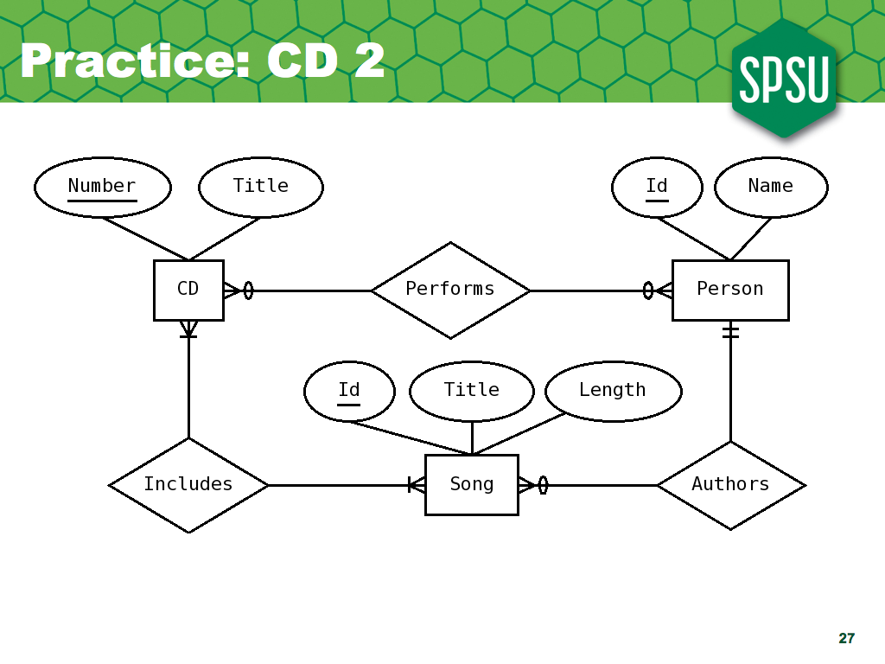
And here's the solution.

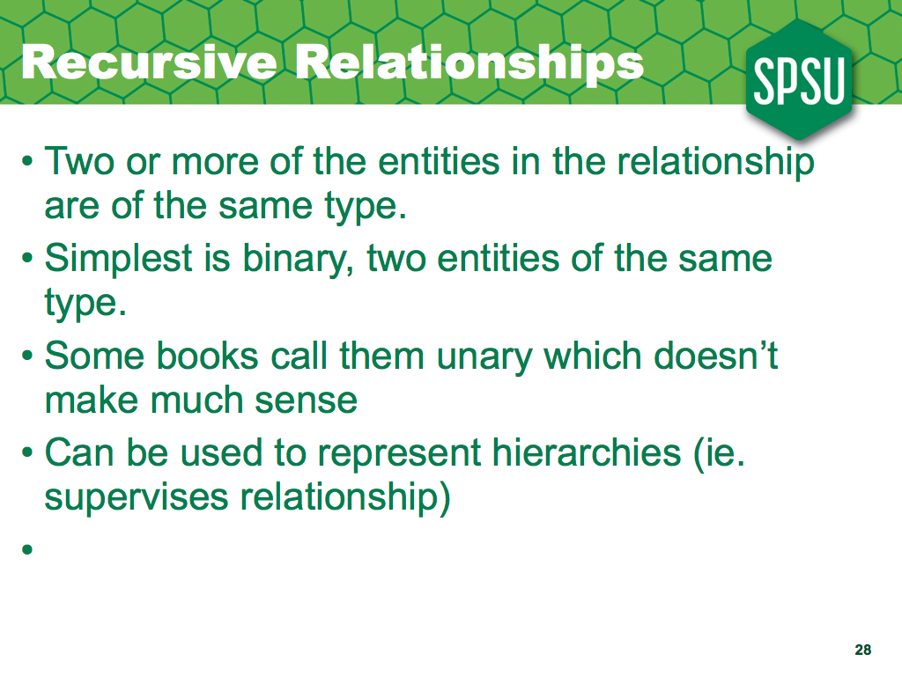
Sometimes, we need to define relationships that associate two entities of the same entity type; we call those recursive relationships. Most relationships are binary, and most recursive relationships are too; they associate two entities; recursive relationships are often used to represent hierarchies and graphs.
Although they are not that complicated, we need to make explicit the concept of a role an entity instance plays in a relationship instance, since we cannot use the entity types to distinguish.

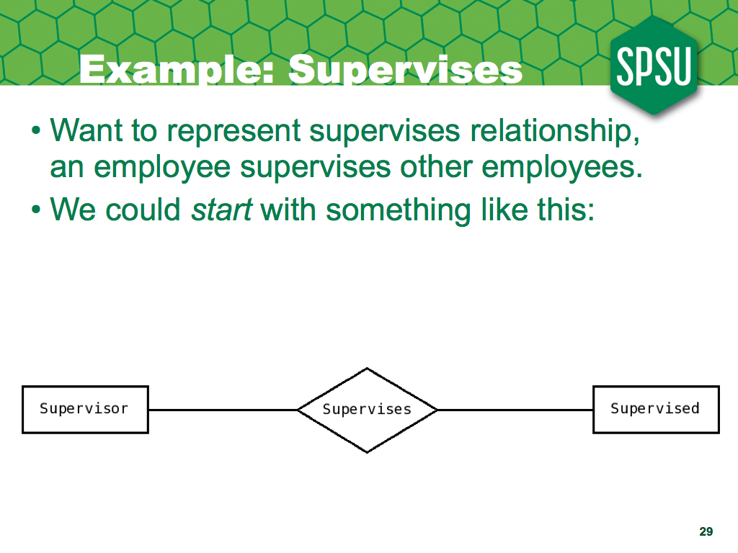
So, lets do an example. Imagine we want to represent when an employee supervises another employee; we could define a relationship called supervises; we could initially think there are two kinds of employees, supervisor and supervised, and tentatively start with a diagram like this.
However, we'll soon realize that the supervisors can also have supervisors of their own, forming a hierarchy, and we cannot use a different entity type to represent each level on the hierarchy, so we need to do something different.

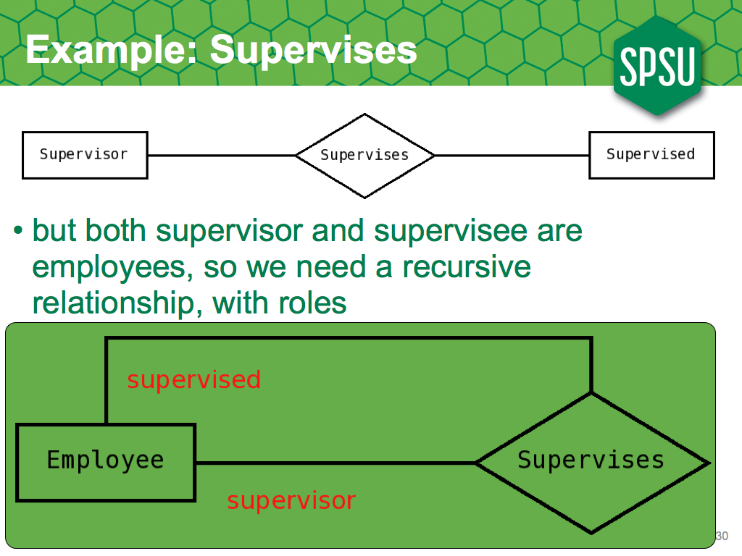
So, we need to turn the relationship onto itself, so it associates two instances of the employee entity type; now, to distinguish those instances, we need to add role names to each side of the relationship; good names would be supervisor and supervised.

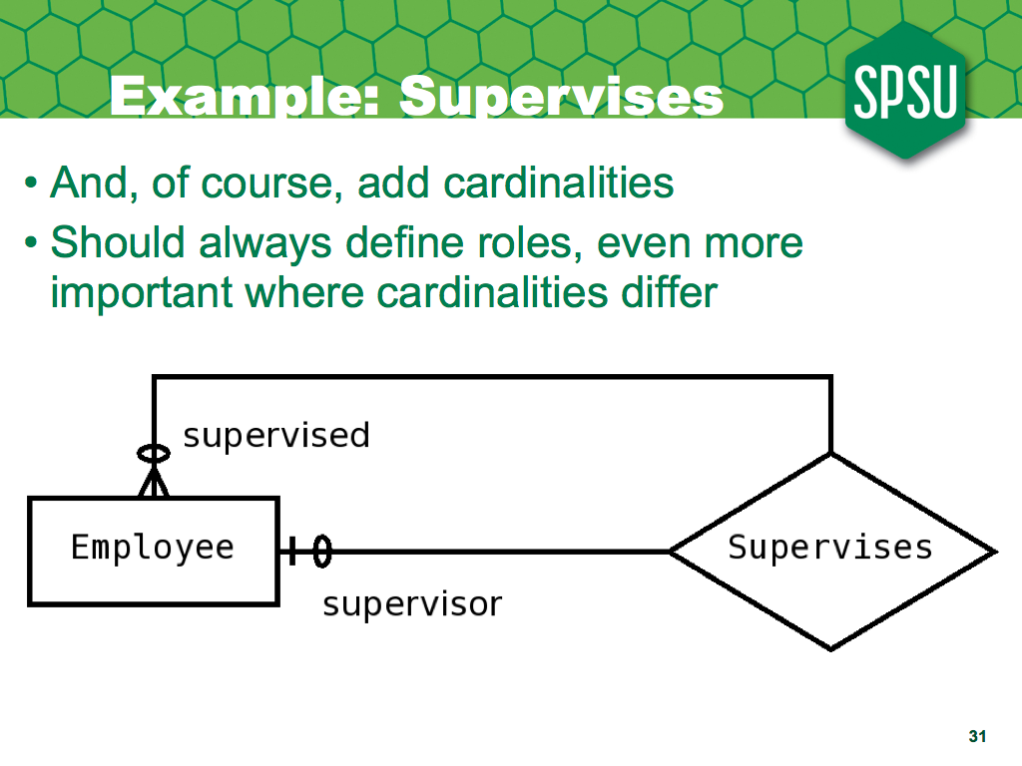
And finally we add the cardinality constraints; notice the constraints constrain employees, so in this case we would say an Employee supervises zero or more employees, and has zero or one supervisors.

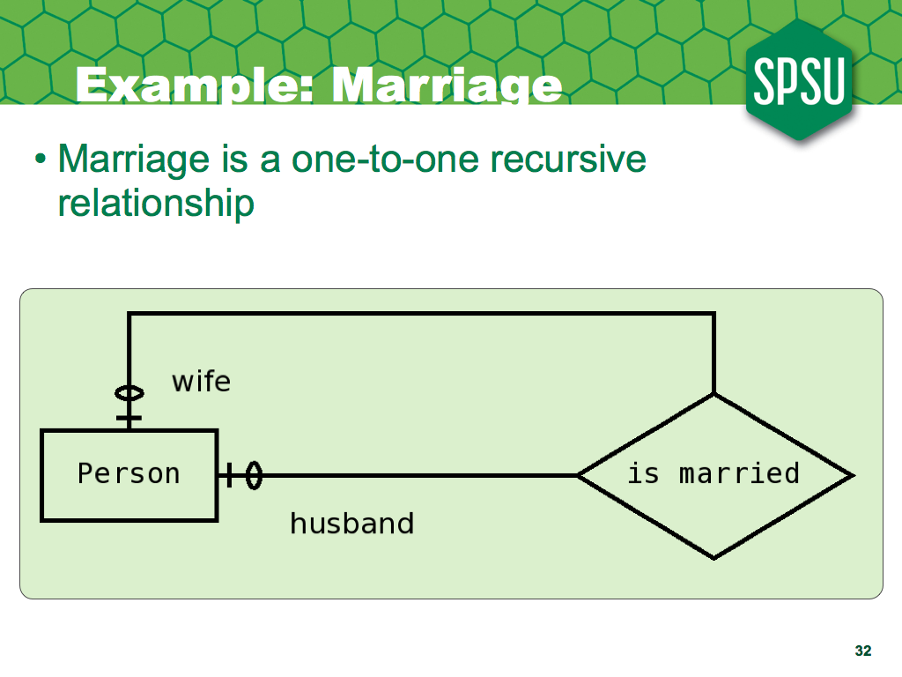
Although recursive relationships are used to represent hierarchies, not all recursive relationships represent hierarchies; for example, we could represent marriages by having a relationship, is married, associating the husband and wife; this would be a one-to-one relationship, and so does not represent a hierarchy.

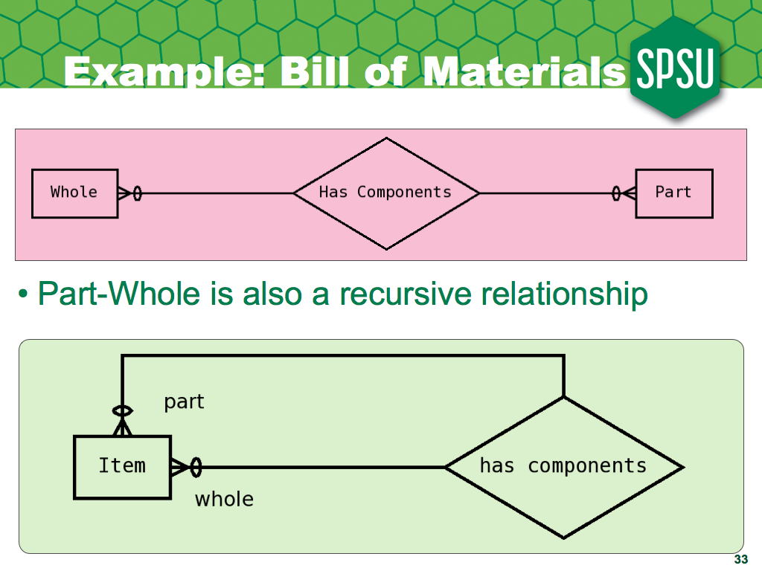
Another example, which represents a hierarchy, is the part-whole relationship, or bill of materials, commonly used in manufacturing; an item is composed of many parts, and may, in turn, be a part of many other items.

Here the term business refers to the organization that will use the software, whether it is designed to make money or not.

