The Relational Model
The most prevalent model in databases is the relational database model. It is so successful because:
- It corresponds with natural notions for modeling (the idea of writing data in tables, with rows and columns)
- It is based on set theory, and the concept of relations, which means things can be proved about its power
- We have invented efficient ways to implement it and optimize its performance.

Informal introduction
The relational model closely correspond with how we normally represent data. For example, imagine you are asked to create a class roster, containing the id, name and gender of students in a class. You'd probably come up with something like this:
Id | Name | Gender
12345 | Orlando Karam | M
34567 | Lina Colli | F
... | ... | ...

There are a few issues that are not clear from the table, but I hope you'd agree:
- We wouldn't put the same row twice; there can be no duplicates
- The order of the rows is not terribly important (although we would choose a particular order for convenience, if the rows were in a different one, we would still say it is the same table)
- The order of the columns is not terribly important either
- You'd expect the same kind of values to go in each column; that is, you wouldn't expect the value 12345 to appear in the gender column.
These issues will become important when we formally define a relation (which is our fancy name for a table). Notice that we may leave some cells blank; in the relational model we use a special value called null for blank cells.
Now, lets assume you are asked to add emails to the 'database', and we want to keep as many emails as a person would give us. We could try a couple of different modifications, that are not entirely satisfactory:
- We could add several fields, email1, email2 etc, yielding a table like this:
Id | Name | Gender | email1 | email2
12345 | Orlando Karam | M
34567 | Lina Colli | F
... | ... | ...
There are a couple of problems with this solution; first, we can only add a limited number of emails; also, we would be wasting space for people with fewer emails, and there may be data integrity issues (people filling email2 but not email1, etc)

- We could add one field, say emails, and give the field some internal structure; for example, ask people to list all their emails, separated by commas. This could yield to integrity problems again (some people separate with semicolon), and it makes the data opaque to the DBMS (and to programmers), which makes validation and use of the data harder.
- We could add one field, email and list all emails down from the person they belong to, as follows:

Id | Name | Gender | emails
12345 | Orlando Karam | M | ok@ok.com
 |  |  | ok@spsu.edu
 |  |  | ok@coldmail.com
34567 | Lina Colli | F
... | ... | ...
Here the problem is that the order of the rows becomes important ! Now if we sort the rows to view them differently, we mix up the emails of different people. Although this could work for a simple spreadsheet, it wouldn't work for a large database.
- We could add one field, emails, and copy the other data for the row, as follows:

Id | Name | Gender | emails
12345 | Orlando Karam | M | ok@ok.com
12345 | Orlando Karam | M | ok@spsu.edu
12345 | Orlando Karam | M | ok@coldmail.com
34567 | Lina Colli | F
... | ... | ...
Now the problem is that we are repeating the same information many times; if we realized we had mistyped Orlando's name, we would need to change it in 3 different places. We will later talk about normalization, which deals with solving this issue.

Now, if we think hard, we would probably come up with the idea of having two tables, one containing the person's data and another containing the emails; basically adding the following table to our original one:

Id | emails
12345 | ok@ok.com
12345 | ok@spsu.edu
12345 | ok@coldmail.com
34567 | lc@lc.com
... | ...

Notice this requires two things:
- There can be no two people in the original table with the same id (this ties with the concept of primary key)
- Any values in the id field of the emails table needs to come from the id's of the original table (this is the idea of a foreign key)
This last solution works great as long as we have an easy way to go from one table to the other; the relational model provides this through the join operation.

Formalizing the model
We define a tuple as a set of names, with a value associated with each name; we use the special value null to associate with a name when there is no other reasonable value for it (so we can get tuples with the same set of attributes). We define a relation as a set of tuples, all of the same type (that is, having the same set of names). A relation has two parts:
- a schema (or heading , or intension) a set of names, with a type or domain associated with each name (the domain is the set of all possible values the attribute could have associated in the body; basically the data type for the attribute). Notice that the special value null is, by default, a member of every basic domain.
- a body (or extension) which is a set of tuples (or rows), each of them having the same attribute names as the schema, and with values for each attribute from the corresponding domain.
Relations are associations between values, and as such, they are closely related to the mathematical concepts of relations and functions.
Remember that a set is an unordered collection with no duplicates; that is, the order is not important, and there can be no duplicates; so, from the definition of a set and that of a relation we can infer the following properties of relations:
- There are no duplicate tuples (or rows)
- Tuples are unordered; that is, the order of the rows doesn't matter
- Attributes are unordered; that is, the order of the columns doesn't matter
- The attribute names are unique within a relation; this implies there is only one value per attribute for each tuple.

Keys
Since relations are sets of tuples, they can't contain duplicates; however, we normally have stronger constraints; in many relations there are sets of attributes for which there can be no duplicates; we normally call those sets keys. More formally, we have the following definitions:
- A superkey is any set of attributes that is guaranteed to have unique values for each row in a relation.
- A candidate key is a minimal superkey; that is, a superkey that, if we take out any attribute, ceases to be a superkey.
- A prime attribute is any attribute which is part of a candidate key.
- A foreign key is a set of attributes in a relation whose values are taken from the set of values from a candidate key (usually the primary key) of some other relation.
- The primary key of a relation is a candidate key that we choose to be used for foreign keys from other relations.
Notice that in many cases a key is composed of just one attribute. Also, the set of all attributes in a relation is always a superkey, which implies that every relation has at least one candidate key. Although it is not a requirement to choose a primary key, we assume that one will always be chosen, and that all foreign key references to a given relation will be through that primary key.
Keys are used to guarantee the integrity of the data. We have the following integrity rules:
- The entity integrity rule stipulates that no prime attribute can be null; in particular, no attribute which is part of the primary key can be null.
- The referential integrity rule stipulates that for foreign keys, either the attributes match the value of some row in the corresponding relation, or the foreign key is null.

Relational Schema Diagrams
It is oftentimes convenient to represent a relational database schema in a diagram (later on, we will use SQL to actually create the database). The conventions are relatively simple:
- For each table, we write its name, and then all its fields (we usually put the borders around the field names).
- The fields that form the primary key are underlined
- All foreign key relationships among tables are marked with an arrow that goes from the foreign key to the primary key. Optionally, you can also dash-underline the foreign key, as Hoffer's oftentimes does. Notice you always have to put the arrow.
Probably the easiest way to create those diagrams is to use a modern word processor that allows you to create tables and to draw arrows on a page. In particular, recent versions of OpenOffice.org and MS Word allow you to do that (this document was typed with OpenOffice.org).
So, if we have just one table, called Person we can do:
PERSON
Id | First | Middle | Last | Age

And if we have related tables, we just draw arrows from the foreign keys to the primary keys. For example, if Person had a multi-valued emails attribute, we would need to use two tables, as follows:
PERSON
Id | First | Middle | Last | Age

EMAILS
PersonId | Email

Normalization
When creating our relational schema, we might end up with badly designed tables, if we are not careful. Normalization is a technique to validate our relational design and make sure we are not doing unnecessary duplication. Intuitively, the most important rules is that your table corresponds to only one fact, but normalization theory allows us to precisely define what we mean by that.
After we have normalized our design, we are guaranteed our relations are well-formed, that is, they do not lead to anomalies.
An anomaly would be a situation in which we cannot do a straight insert update or delete operation due to the design of our tables. For example, look at the following table:

Course Num | Course Title | Section Num | Term | DoW | Time
CS3153 | Databases | 1 | F07 | TR | 4:30p
CS3153 | Databases | 900 | F07 |  | Online
CS1301 | Intro Prog | 1 | F07 | MW | 11:00a

This table is badly designed, since it talks about two things; the courses (with their titles) and the sections for the course (with term, day of week etc). It leads to the following anomalies:
- Insertion anomalies If we insert a new section of CS3153, we also need to make sure that the title is recorded as Databases
- Update anomalies If we were to change the title of the CS3153 course, we need to change more than one row
- Deletion anomalies If we delete the CS1301 section, we are also eliminating from our database the fact that the title for CS1301 is Intro Prog
The solution of course, would be to break the table into two tables, as follows:
Figure 1: Relational schema for table 1, courses and titles
Course Num
Course Title
Section Num
Term
DoW
Time
Section
Course
Course Num

You can verify this design eliminates the anomalies mentioned above.
So, we know there are bad designs and that we can solve those problems; now we need a theory that helps us detect those bad designs and fix them. This is Normalization theory.

Functional Dependencies
Normalization theory (up to 3rd normal form, 3NF) is based on the concept of functional dependencies . A functional dependency (FD) is a particular kind of constraint on the allowed values of a relation. We represent an FD with the notation A -> B, where both A and B are sets of attributes in a relation. We say that an FD A->B holds on a relation, if for any two tuples that have the same value of A, they must necessarily have the same value of B.
Notice that at both sides of an FD we can put sets of attributes. For notational convenience, we do not use anything special to denote the sets, and just separate attributes with commas if there is more than one. If we were to use traditional set notation, FDs would look like this: {A}->{B}; we are just eliminating the braces.
The set of attributes in the left-hand side of an FD is called the determinant.
Notice that a functional dependency is a generalization of the concept of candidate key. If a set of attributes is a key for a table, then there cannot be two rows with the same value for those attributes. So on any table, all attributes are dependent on the primary key. So, on the relational schema on figure 1, Course Num -> Course Title holds for course and Course Num, Course Section -> Term, DoW, Time holds for Section.
Notice that this constraints (the FDs) are present in the real-world, and cannot be inferred just by looking at data. By looking at data we can say that an FD does not hold (if we have a pair of rows that violate the condition), but we can't be sure that it holds.

Lets try a few exercises to test our understanding of FDs. Given the following table:
Id | Name | Gender | Age
1 | Orlando | Male | 35
2 | John | Male | 35
3 | Jane | Female | 31
4 | Jane | Female | 30

Can Id -> Name hold ? Since there are no two rows with the same id, then yes (we can guess that this is true in the real world, with id being some form of identifier but it is just a guess until we verify its meaning in the real world)
Can Age -> Gender hold ? Well, we only have two rows with the same age (35), and they both have the same value for Gender, Male, so it can hold (here we would guess in the real world it doesn't hold, and at some point in time we could get a female who is 35)
Can Gender -> Age hold ? No, since for the two rows with female gender, they have a different value for age.
Can Name,Age -> Id hold ? yes, since there are no rows with the same values for both Name and Age

First Normal Form (1NF)
First normal form just requires that all attributes within a table are atomic, that is they are neither composite nor multivalued. We do not have any standard notation for tables which are NOT on 1NF, so all tables will be in 1NF by default.

Partial FDs and Second Normal Form (2NF)
We have said that the main issue with normalization is making sure that your table represents only one fact. Put in slightly more formal words, what you want is for every attribute to be dependent just on the keys of your table (remember, you may have more than one candidate key). One way in which you can break this rule is by having a partial dependency, in which some attributes are dependent on just a part of the primary key rather than the whole primary key (actually, since we may have more than one candidate key, it would be more accurate to say the determinant is a subset of a candidate key, but not a candidate key by itself). Notice this attributes would also be dependent on the PK, since the PK includes that part, but they are also dependent on just a piece of the PK.
For example, consider the table in the introductory example:

Course Num | Course Title | Section Num | Term | DoW | Time

With the following functional dependency:
CourseNum -> CourseTitle

This functional dependency is a partial dependency, since the determinant is a subset of the primary key (and not a key by itself). So, this table would be in 1NF but NOT in 2NF.
To transform this table into one in 2NF, we need to create a new table, comprised of all the fields in the offending functional dependency:
CourseNum | CourseTitle

Now, on this new table the dependency still holds, but it actually implies that CourseNum is the primary key of this new table (since it determines all other fields), so we should underline it
CourseNum | CourseTitle
Now, on the original table, we eliminate the fields determined by the offending FD (CourseTitle in this case), and add a foreign key relationship pointing to the new table, to be able to recover this information. The resulting relational schema diagram looks like this:
Figure 2: Converting to 2NF (repeat of Figure 1)
Course Num
Course Title
Section Num
Term
DoW
Time
Section
Course
Course Num
And this schema is in Second Normal Form (2NF). Notice the same functional dependencies still hold, it is just that the FD is now a full dependency on the new table.

Transitive Dependencies and Third Normal Form (3NF)
Another way in which we could have fields depending on something other than a candidate key is if we have transitive dependencies, that is, dependencies in which the determinant is neither a candidate key nor a part of any candidate key. We can have a table that is in 2NF but still has transitive dependencies.
For example, assume we have a table like this:
StudentId | Name | MajorCode | MajorName
With the following additional functional dependency:
MajorCode -> MajorName

Now, this table would be in 2NF, since it doesn't have any partial dependencies; however, it would still lead to anomalies.
Since the determinant (MajorCode) is neither a candidate key nor a piece of it, we call the dependency a transitive dependency. To eliminate it, we again create a new table, containing all fields on this dependency:
MajorCode | MajorName
And again, the dependency implies that the determinant is the primary key for this new table:

MajorCode | MajorName

And on the original table, we eliminate the fields determined on the offending FD (MajorName in this case), and add a foreign key constraint from this original table to the new table, resulting in the following relational schema:

Figure 3: Relational schema for Students and Majors
MajorCode
Major Title
Name
MajorCode
StudentId

Determining the Normal form of a Schema
Let's sumarize our definitions:
- A partial functional dependency is one in which the determinant is a proper subset of the primary key
- A transitive functional dependency is one in which the determinant is not a subset of the primary key
- A full functional dependency is one in which the determinant is the primary key
A relation is in:
- 1NF (First normal form) if it has any partial dependencies.
- 2NF (Second normal form) if it has no partial dependencies (normally, if it also has no transitiive dependencies we say it's in 3NF, which implies 2NF)
- 3NF (Third normal form) if it has no partial dependencies and no transitive dependencies.
And a relational database schema is in the lowest for of any of its relations; so it is in 1NF if any of its relations is in 1NF, 2NF if it has no relations in 1NF but some in 2NF and it is in 3NF if all its relations are in 3NF.
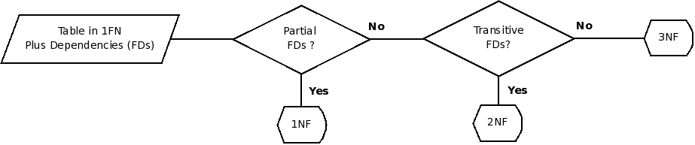Figure 4: Flow diagram for determining the normal form a relational schema is in

Multiple candidate keys
The above definitions deal only with the primary key. In many cases we have several candidate keys for a relation, and so the definitions need to be adjusted as follows:
- A partial functional dependency is one in which the determinant is a proper subset of a candidate key
- A transitive functional dependency is one in which the determinant is not a subset of the any candidate key
- A full functional dependency is one in which the determinant is a candidate key
Remember that we have the following definitions for keys:
- A superkey is any set of attributes that is guaranteed to be unique in a relation.
- A candidate key is a minimal superkey; that is a superkey that if we take any attribute out of it it is no longer a superkey
- The primary key of a relation is one of the candidate keys that is chosen to be used as foreign key in other relations.
Notice that every relation should have a primary key, and that the set of all attributes in a relation is always a superkey, since the relation is a set.

Transforming ER diagrams to Relational Schema Diagrams
Our conceptual model gets expressed as an ER diagram, but our implementation will most probably be in a relational database, so we need to transform our ER diagram to a Relational Schema diagram.
Normally you would create at least one table per entity type, but you will need to create extra tables for multivalued attributes and many-to-many relationships.
Now, what are the rules for Relational Schema diagrams ? They are simple.
- Tables are represented by their name, and attributes. A pretty representation looks like this:
SSN
FirstName
MiddleName
LastName
Employee

Whereas an ugly representation would look like this:
Employee(Ssn, FirstName, MiddleName, LastName)
- Identifier attributes (keys) should be underlined
- Foreign key references are represented by an arrow from the foreign key to the primary key.
To make reading easier, I would abbreviate Primary Key as PK and Foreign Key as FK.

Transforming entities
We will create a new table for each entity type (normally with the same name as the entity type). We will transform the attributes as follows:
- Simple attributes become simple attributes on the table.
- The identifier gets marked on the table by underlining, same as in the ER diagram
- For composite attributes, we add to the table only the atomic pieces.
- derived attributes in the ER diagram do NOT appear on the table (since they wouldn't be stored)
- For composite attributes we need to create a new table; this new table has as attributes the primary key of the entity type (as a foreign key reference to the original entity type) and the multivalued attribute. The primary key of this new table is usually composed of ALL the attributes (including the primary key of the entity type).
As an example, the following ER diagram
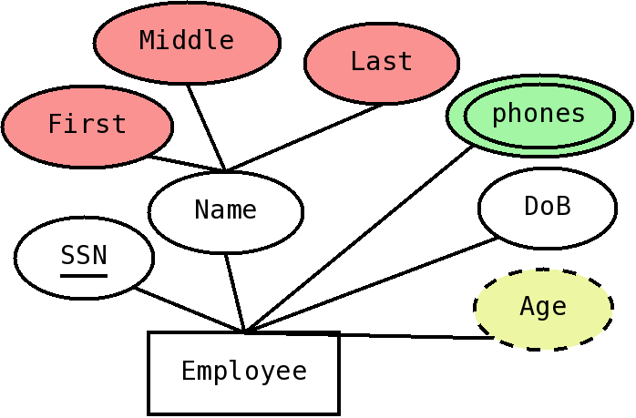
Would get transformed to the following Relational Schema Diagram:
SSN
FirstName
MiddleName
LastName
DoB
SSN
e-mail
Employee
Emails
- The two simple attributes (ssn and DoB) get mapped directly, with SSN underlined since it is the identifier (primary key).
- The composite ER attribute Name does NOT appear on the table, but instead we have only its atomic pieces, first, middle and last, with a suitable naming convention (so they become FirstName, MiddleName and LastName)
- The derived attribute, Age, does NOT appear on the able (since it wouldn't be stored)
- For the multivalued attribute, emails, we need to create a new table. We call this table Emails (another good name would be something as Employee-Emails). This table has the PK of the Employee table (the original entity) as a FK reference to the Employee table, and a field email, which would contain one value of the multivalued atribute (the email). The PK of this table is composite, and contains both attributes.

Transforming relationships
Relationships associate two entities, and in the relational model, associations are made through foreign keys (FKs); so we would need to put foreign keys in our relational schema. The transformation to be made depends on the cardinality of the relationship; we will first cover how to transform one-to-one and one-to-many relationships.
If we have a one-to-many relationship, between two entities, say A and B, where an A is related to many Bs, but a B can only be related to one A, we can put a reference to A on the table corresponding to B. If there are any attributes attached to the relationship, they would go on the same table.
For example, the following ER diagram
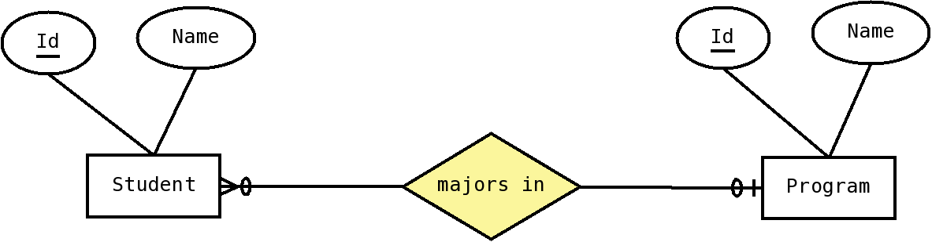Figure 5: ER diagram with one-to-many relationship
Would be transformed to the following relational schema diagram:
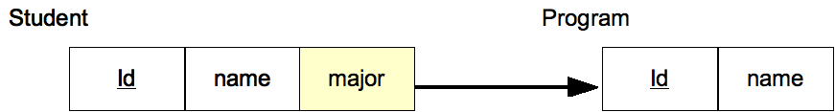Figure 6: Relational schema diagram for one-to-many relationship
For one-to-one relationships, we can choose which side to put the reference on (since either would work), we normally choose the table for which we expect to have less rows to put the reference on.
Now, for many-to-many relationships, we cannot put the reference in either table, since there is the potential to have many references per row in either side (which would be a multivalued attribute); the solution is to create a new table, that includes references to the corresponding entities. For example, the following ER diagram:
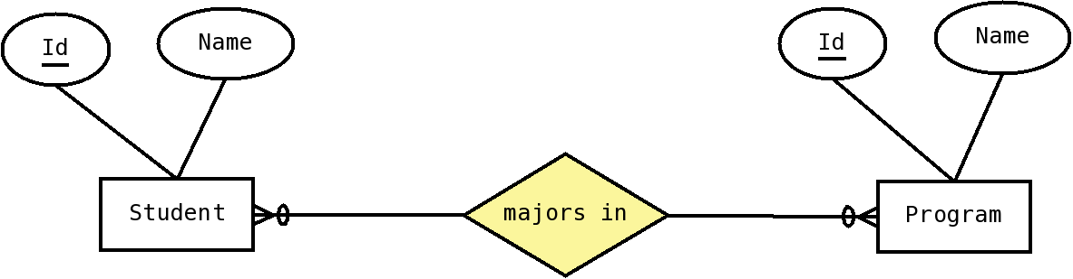
would be transformed into the following relational schema diagram:
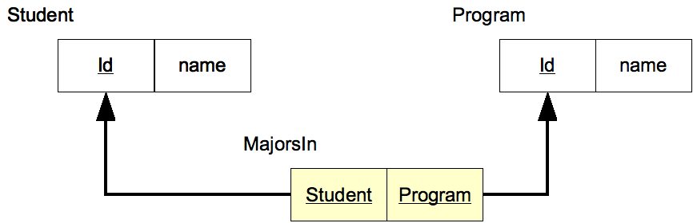
If there are attributes attached to the relationship, then we put those attributes in this new table.

Weak entities
Weak entities are those that have no identifier, and need the strong entity to be fully identified. They always have a one-to-many relationship with a strong entity, called the identifying relationship. They are transformed similarly to one-to-many relationships, except that the identifier of the strong entity becomes part of the primary key for the weak entity. Notice the weak entity would already have a reference to the strong entity, due to the transformation of the one-to-many relationship; the only change is that this reference is now part of the primary key for the weak entity's table. As an example, the following ER diagram:
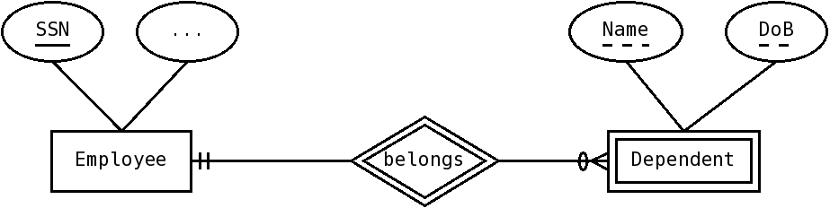
Would transform into the following relational schema diagram:
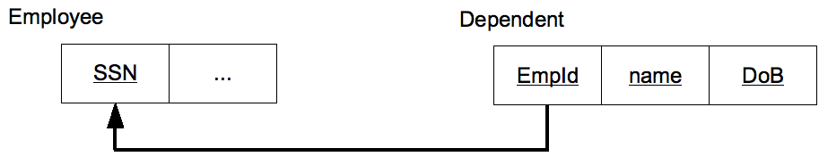

Associative entities
For an associative entity, we create a new table, with the references to the associated entities conforming the primary key. For example:
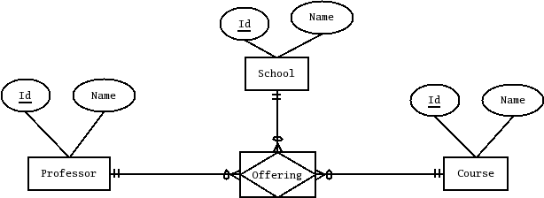
would transform into:
Name
Professor
Id
Name
Course
Id
Name
School
Id
Name
Course
Id
Course
School
Offering
Professor

Examples and Exercises (to be expanded)
- We have a relation with fields A,B,C,D,E,F and its primary key is {A,B,C}; mark whether the following dependencies would be partial, transitive, or full (OK).
Dependency | Status (partial, transitive, full)
A -> F | Partial (A is part of the PK, but not the full PK)
A,B -> E,F | Partial (A is part of the PK, but not the full PK)
E -> F | Transitive (E is not part of the PK)
A,B,C->E | Full (A,B,C is the PK)

- We have a relation with fields A,B,C,D,E,F and its primary key is {D,E}; mark whether the following dependencies would be partial, transitive, or full (OK).
Dependency | Status (partial, transitive, full)
A -> F
E-> B
E,F -> B

- For the following relation, and functional dependencies, indicate the normal form it is in (3 points). If it is not in 3NF, decompose it into 3NF relations.

Team
SportId | SportName | SchoolId | SchoolName | TeamName

Other Dependencies:
- SportId -> SportName
- SchoolId -> SchoolName

We can see that both of this dependencies are partial, because their determinants (SportId and SchoolId respectively) are pieces of the primary key. So, since there are partial dependencies, the relational schema is NOT even in 2NF (second normal form), which means it is in 1NF (first normal form)

Now, to transform this schema to 3NF, we need to eliminate the offending dependencies. Lets start with the first one, SportId -> SportName. We need to:
- Create a new table, containing both attributes, with the determinant (SportId) as the primary key (we can call this table School)
- Eliminate the determined attributes (SportName) from the original table
- Add a foreign key constraint from the original table to this new table
The resulting schema looks as follows:

Team
SportId | SportName | SchoolId | SchoolName | TeamName

School
SchoolId | SchoolName

Now, this still leaves us with one partial dependency, SchoolId -> SchoolName; after a similar transformation (and completely deleting the unneede attributes from the original table, rather than just striking through), we end up with the following relational schema diagram.

Team
SportId | SchoolId | TeamName

School
SchoolId | SchoolName
Sport
SportId | SportName

Notice that many people extend this requirement to the whole database, and require that the name of each attribute is unique across the whole database schema.

