Logging on to the Linux server (okaram.spsu.edu)

Connecting with putty
Putty works for all Windows versions, but does NOT give you an Xwindows server, which means you CANNOT run graphical programs from the Linux server; basically, you cannot run bluefish or mrxvt.
putty is a freely available (and Open Source, in case you care :) ssh client for MS Windows. It is a very small (445KB) self-contained executable. So, you:
- Download putty.exe from http://the.earth.li/~sgtatham/putty/latest/x86/putty.exe
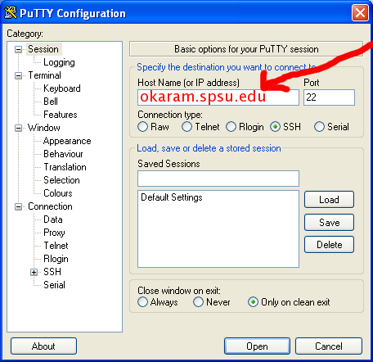
- Run putty.exe, you should see a screen like this (minus the stuff in red). Write okaram.spsu.edu as the host name and click on open
- After that you should see a screen like this:
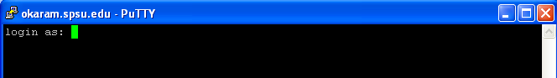
- Write your username (same as your spsu email and banner id; basically your spsu email address minus the @spsu.edu), and press enter. After that, it will ask you for your password. Enter it. The first time you log on, it may tell you something about it not being able to verify the server's authenticity; in that case, answer yes. After that, it will give you a screen like this (of course, with your name instead of pstadnic):
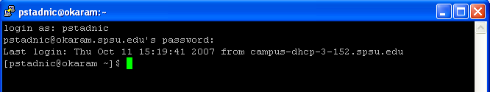
- And you can start typing commands. The ones you probably will use the most are:
- psql which is the client for connecting to our PostgreSQL server
- sqlplus which is the client for our oracle server
- nano a simple text editor (notice instructions at bottom, ^ means the control key)
- When you are done, type exit to exit putty
- Notice you can cut and paste from a Windows text editor into putty.

