Logging on to the Linux server (okaram.spsu.edu)

Connecting using XliveCD (WinXP only)
XliveCD is a version of cygwin that runs from a CD. You do NOT need to install it on your computer, although you need to have the CD with you every time you run it. It includes an ssh client plus an Xwindows server, which allows you to run graphical programs on the server (like bluefish, a decent text editor or mrxvt, a multi-tabbed terminal)

- Download the XliveCD iso image from
- http://okaram.spsu.edu/~curri/isos/xlivecd-20041201.iso
- ftp://ftp.gtlib.cc.gatech.edu/pub/XLiveCD/xlivecd-20041201.iso

- Burn the image file to a CD. Notice an image file is a special kind of file that contains the structure of the CD, so you need to burn it specially. Do NOT just add it as a file to a CD. Your CD burner program should have a way to burn as an image. Alternatively, you can download a zipped copy from ... , unzip it, and burn all files inside the created folder to a cd or copy them to a USB drive. Notice all the files and folders need to be in the root of the filesystem. For this program to work, those files need to be on the root of a letter drive (so technically, you could just put them directly on C:\ or D:\, but it would look very funny.
- Run the program from the CD (usually double click on it, but if you get a list of files double-click run.bat) and you should get a window like this (notice there will be another window in the background, ignore it):
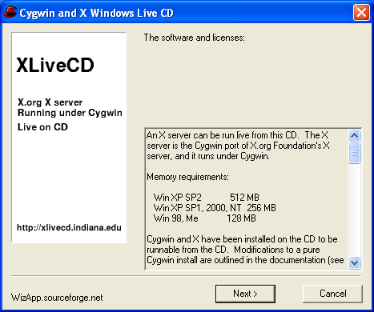
- Click on next, and you get this one:
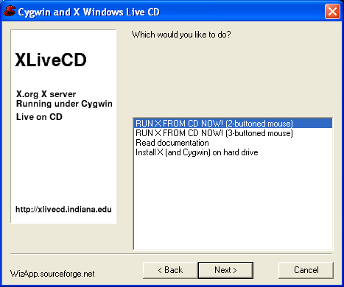
- Now select either 2 or 3 buttoned mouse and press next. This window disappears and a bunch of stuff appears on the background window. Ignore it. At the end, you will see a window like this:
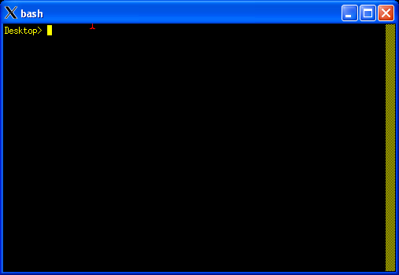
- Now type: ssh -X, then your username and then @okaram.spsu.edu. Notice spaces are important as is capitalization. Everything is lowercase, except the X; so, let me write it as if I was dictating: 'ssh space minus capital X space then your usernam and @okaram.spsu.edu. Your username is your spsu email id (just the id, minus the @spsu.edu); so for me (my id is okaram) the string would be:
ssh -X okaram@okaram.spsu.edu

- After this, it will ask you for password. The first time it will tell you that it can't authenticate the server, and it will ask you if you want to connect. Say yes, and you finally get the prompt. The screen would look like this (I'm using pstadnic as example, you need to put your username)

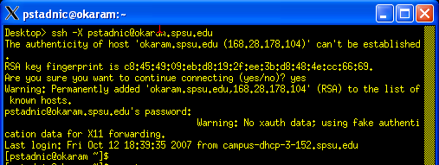

- And you can now run any command you want, including:
- mrxvt a multi-tabbed terminal
- bluefish a decent text editor
- psql the postgresql client
- sqlplus the Oracle client
For graphical programs (mrxvt, bluefish) you may want to add an extra ampersand (&) after the command, so the program runs and releases the console; if not, you need to close the program before you execute another. You do NOT want to put the ampersand (&) after text programs, like psql or sqlplus, since those are supposed to have the console.

