main.py Code compilation and execution screenshot.
This code has one endpoint “q” which stores the greeting message
Example: http://127.0.0.1:8000/greet/Arul?q=How are you?
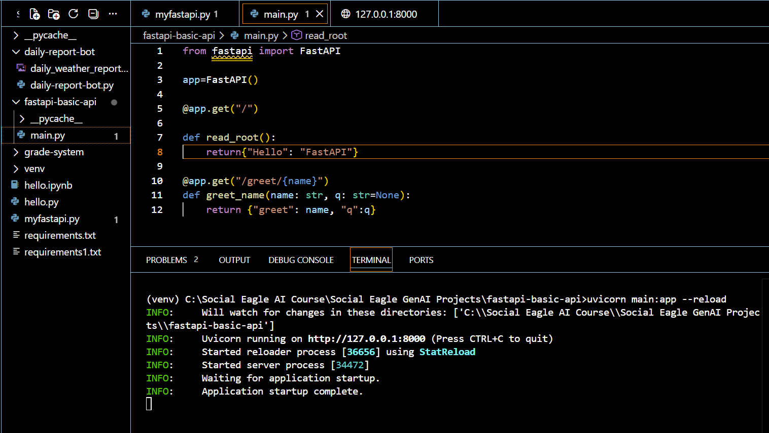

Testing the url in the Postman.
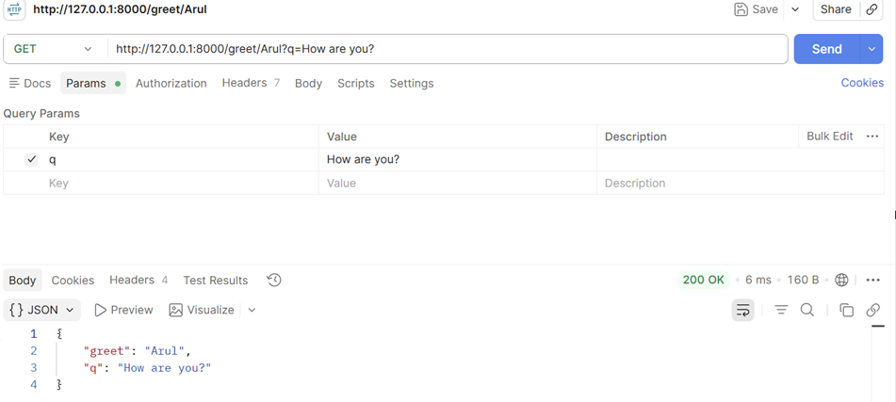
Testing the url in the browser
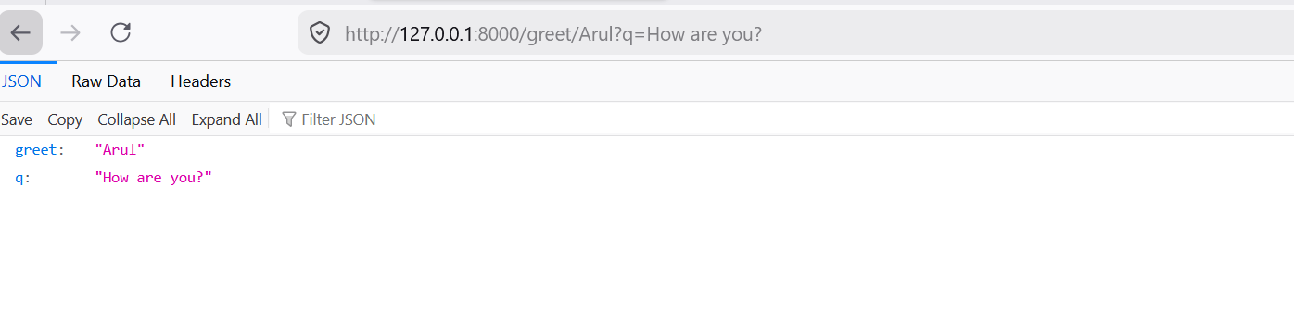
Docs
