Writing

1. Describe synopsis
2. ER Diagram
3. Module Description
4. DFD
5. Important UML Diagrams

1>>

The Project entitled “Online Class Automation” is an automation application to automatically join a scheduled zoom meeting at a specific time without manual labour. The software provides the user to log in to the class on a scheduled time having no worries about the link or which class to attend. The user can just add the information (about the timetable, start and end time of the classes) in the beginning, and the classes will automate according to the meeting scheduled. The social relevance is for the benefit of the society. The market size of the project is focusing on zoom users worldwide (ex: Education, Corporate world). The importance of this domain is the users can easily attend scheduled the meetings and there will be no manual interference required. The main objective here is lesser influence of human factor to technological process. Motivation to work on the project is suitable for school kids, disabled and elderly people, improved standard of living, high quality of software and user satisfaction, Minimizing human effort, Increased efficiency.

2>>

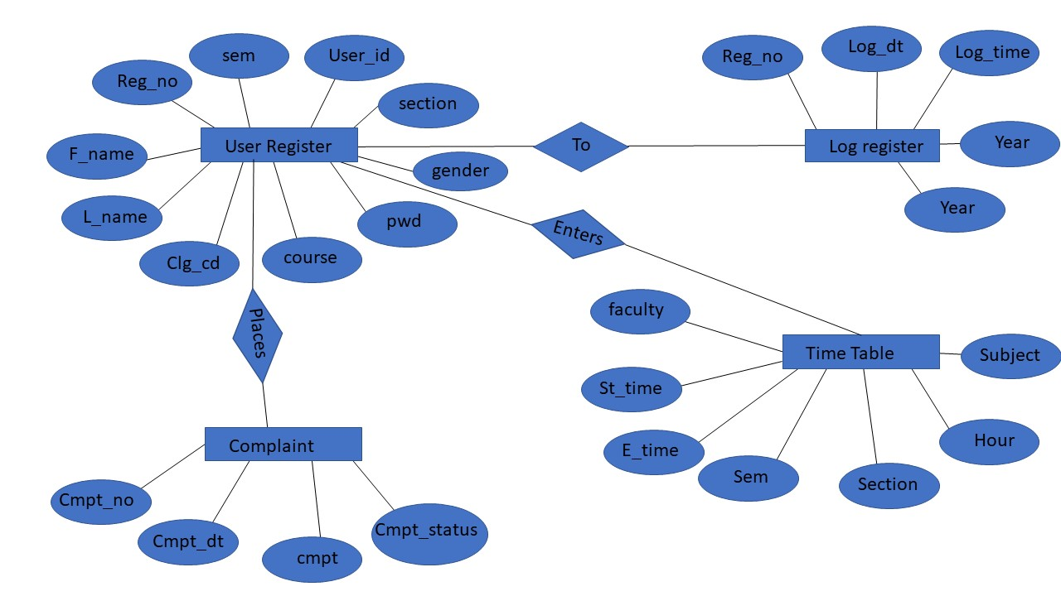

3>>

\*Registration module:

This module takes the inputs the user who are wanting to use the application stores it in the database. It is used to enroll the user to get into the application with proper verification and validation. This information is later used by the admin to keep track of the students and all other activities and for validating the user when he tries to login.

Tables read: User table

Tables updated: User table, log register

\*Login module:

This module is used to validate existing user when the user tries to access the application. This checks whether the user already exists if yes then user is granted the permission to log in to the application.

Tables read: User table

Tables updated: log register

\*Complaint module

Admin:

This module displays complaints from the users to admin. It displays the complaint and the status of it.

Tables read: complaint table

Tables updated: complaint table

4>>