Personal AI Career
Operating System
A technical and product blueprint for building an evidence-based AI career coach, skill engine, market intelligence system, job acquisition workflow, and provider-agnostic self-hosted open-source application.
Core idea
Build a continuously updated digital twin of the candidate: what they claim to know, what their work demonstrates, what they can explain and implement, what the market currently demands, and what actions should happen next.

Document version | 1.0
Version | 1.1 — Job & Company Intelligence Update
Primary model | DeepSeek API
Primary daily channel | Slack, with Gmail as a second integration

Important design principle: the AI is not the source of truth. The system of record is the evidence graph and structured candidate state; the model interprets evidence, generates tests and proposes actions.

1. Executive Summary
The proposed system is a Personal AI Career Operating System. It combines personal knowledge ingestion, GitHub/code intelligence, continuous technical assessment, market intelligence from jobs and technology news, personalized learning, job matching, resume tailoring, application tracking, and daily assistance through Slack and Gmail.
The most important addition from the latest requirements is a continuous learning state. Every meaningful interaction becomes evidence. A correct answer can raise confidence in a topic; a weak answer can reduce it; a successful coding task can strengthen implementation proficiency; a repeated mistake can create a learning gap. The system should maintain historical evidence instead of simply overwriting a single score.
Architecture / workflow diagram
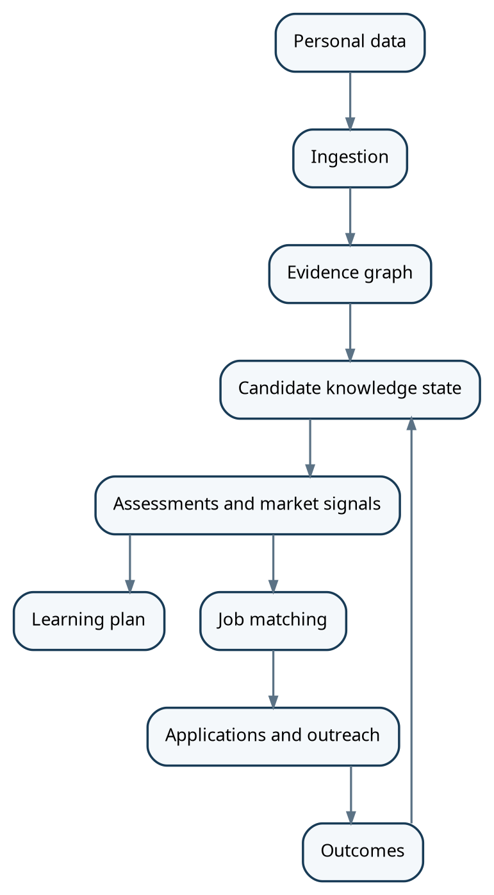

• Personal Intelligence: resume, projects, GitHub repositories, commits, documentation, certifications, and user-entered knowledge are ingested into one candidate model.
• Skill Intelligence: a skill graph stores topics, subtopics, proficiency, confidence, evidence, recency, and market demand.
• Assessment Engine: DSA, coding, debugging, system design, technical questions, code review, and verbal explanations continually update the skill state.
• Market Intelligence: job descriptions, company career pages, permitted feeds/APIs, engineering blogs, and technology news are analyzed to identify current demand, emerging stacks, and role patterns.
• Career Execution: jobs are matched to the candidate, tailored resumes and cover letters are generated from verified facts, applications are tracked, and approved outreach is prepared and sent.
• Daily Assistant: Slack is the recommended primary daily channel because it supports events, app interactions, and message delivery. Gmail is recommended as a secondary channel for email ingestion and job/interview follow-up tracking.

2. Product Vision and Goals
The product should feel like a personal progression system, but the underlying mechanics should be serious and evidence-based. The Solo Leveling inspiration should be in the progression model: levels, XP, quests, streaks, boss fights, unlocks, and clear visual progress. The evaluation engine should remain grounded in measurable evidence.
Goal | System behavior | Success measure
Know the candidate | Build a living profile from resume, GitHub, projects, tests, answers and outcomes. | The profile can explain why it believes a skill exists.
Measure technical depth | Separate recognition, explanation, implementation, debugging and architecture. | Scores become more accurate as evidence accumulates.
Understand the market | Track repeated skill signals across jobs and credible technology news. | Market recommendations are traceable to observed sources and time windows.
Train the candidate | Turn gaps into personalized tasks and assessments. | Skill confidence and task performance improve over time.
Acquire opportunities | Find, analyze, tailor, track and assist with applications. | The pipeline moves from discovery to approved action with measurable outcomes.
Create a daily habit | Deliver one useful briefing and one useful action through a familiar channel. | High daily engagement without requiring constant dashboard usage.

3. Functional Requirements

A. Candidate Data
• Resume and CV versions
• Project descriptions and case studies
• GitHub repositories and commit history
• Certificates, learning notes and technical documents
• User-entered claims such as "I know Redis but need deeper production experience"
• Target roles, locations, compensation range, work preferences and skill priorities

B. Continuous Learning
• Record every assessment attempt and answer
• Map questions and tasks to one or more skills
• Update proficiency and confidence using evidence-weighted rules
• Store the reason for every score change
• Allow knowledge to decay or become stale when not practiced
• Generate the next best task based on weakness, market value and prerequisite structure

C. Market Intelligence
• Collect job descriptions continuously
• Collect technology news, engineering announcements, release notes and credible technical analysis
• Extract normalized skills, role requirements, seniority and recurring technology patterns
• Track trends by week/month/quarter instead of using a timeless ranking
• Separate job-volume signals from news/technology signals
• Produce a market brief with evidence and source links

D. Career Execution
• Tailor resume variants from a verified fact base
• Generate cover letters and application answers
• Track applications and outcomes
• Prepare cold outreach based on company/hiring signals
• Provide human approval before sending or submitting initially
• Learn from interview feedback, rejection reasons and successful applications

4. Core Mental Model: Evidence, Not Just Scores
The most important data-model decision is to distinguish between claims and evidence. A resume claim such as "Kubernetes" is not equivalent to demonstrated ability. The system should maintain evidence records and derive a current skill state from them.
Skill: Kubernetes
Claim evidence
- Resume lists Kubernetes
Work evidence
- Deployment manifests detected
- Services / ingress configuration detected
- Containerized applications detected
Assessment evidence
- Architecture question: 62/100
- Troubleshooting task: 48/100
Current state
- Proficiency: 57
- Confidence: 74%
- Last assessed: 2026-09-18
- Learning priority: High

5. Candidate Knowledge Engine

5.1 Knowledge state per skill
Each skill should be represented as a state that is updated over time rather than a static field.
Field | Meaning | Example | Update trigger
Proficiency | Current demonstrated ability from 0-100. | 72 | Assessment or observed work
Confidence | How confident the system is that the proficiency estimate is accurate. | 81% | New independent evidence or conflicting evidence
Knowledge state | Qualitative state derived from evidence. | Strong but rusty | Recent performance + recency
Evidence count | Number of meaningful supporting observations. | 19 | Every evidence event
Recency | How recently the skill was used/tested. | 12 days | Task, code or assessment
Market demand | Current normalized demand signal for the skill in target roles. | High | Market refresh
Gap | Difference between current state and target role threshold. | 18 points | Role selection or market refresh
Priority | How urgently the skill should be trained. | P1 | Gap + market demand + prerequisites

5.2 Evidence types
• Self-reported evidence: what the candidate says they know.
• Document evidence: resume, portfolio, design documents and certificates.
• Code evidence: repository contents, commits, tests, architecture and implementation patterns.
• Assessment evidence: quizzes, explanations, coding tasks, debugging tasks and system-design exercises.
• Behavioral evidence: consistency, time to complete, hint usage, repeated mistakes and ability to explain decisions.
• Outcome evidence: interview performance, job application feedback and task results.

5.3 Updating knowledge from every interaction
The system should not update all skills after every response. First, the Assessment/Observation layer maps the interaction to affected skills, assigns an evidence type and estimates evidence strength. The Knowledge Aggregator then updates the state.
Architecture / workflow diagram
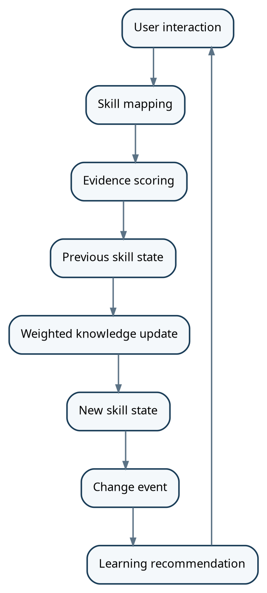

5.4 Recommended update rules
• Correct independent solution: strong positive update.
• Correct answer with heavy hints: smaller positive update.
• Partially correct answer: small positive or neutral update depending on reasoning quality.
• Incorrect answer with a good correction explanation: knowledge of the correction is recorded, but independent proficiency should not jump much.
• Repeated failure on the same concept: reduce confidence in mastery and create a focused remediation task.
• Repeated successful application over several weeks: increase both proficiency and confidence.
• Long inactivity: slowly reduce confidence or mark the skill as rusty rather than arbitrarily reducing historical proficiency.
• Contradictory evidence: lower confidence first; do not immediately swing the proficiency score.
Recommended principle
Keep two values: "historical demonstrated proficiency" and "current readiness." A developer can have demonstrated Kubernetes ability in the past but still be rusty today. The system should reflect both facts.

6. Skill Graph and Progression System
Skills should be modeled as a graph rather than a flat list. This allows prerequisites and clusters to drive learning plans.
Architecture / workflow diagram
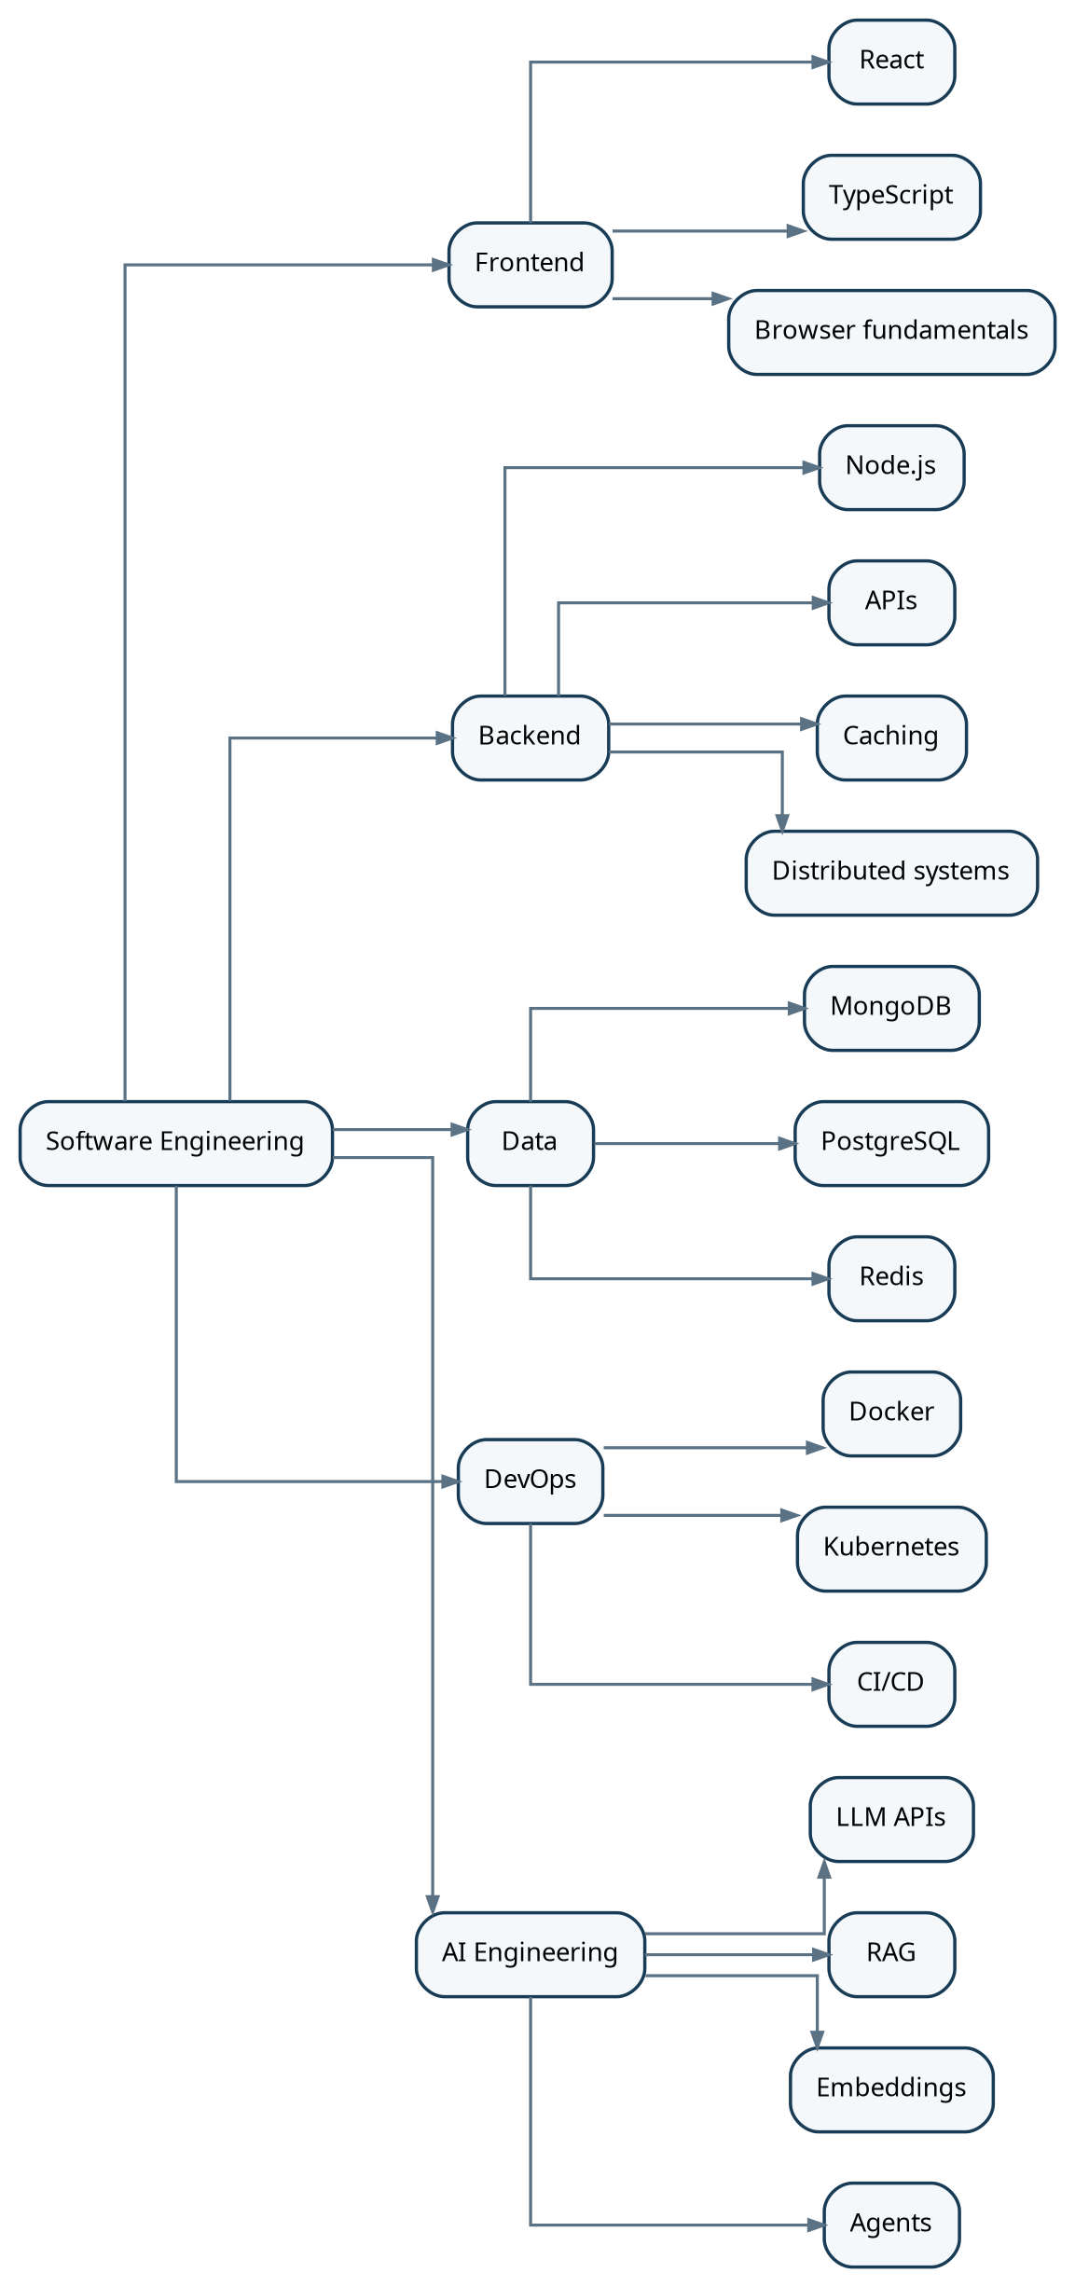

6.1 Level model
• Level 1-20: fundamentals and recognition.
• Level 21-40: working developer; can implement with support.
• Level 41-60: independent implementation and debugging.
• Level 61-80: production depth and architectural reasoning.
• Level 81-90: advanced design, tradeoffs, mentoring and difficult problems.
• Level 91-100: demonstrated mastery in multiple independent situations.
These labels are product mechanics, not claims about employability. A role-specific readiness score should remain separate from a generic level.

7. GitHub and AI-Assistance Intelligence
The GitHub subsystem should analyze repositories at repository, file, function and commit levels. The system should distinguish observed code facts from inferred AI-assistance likelihood.

7.1 Repository analysis pipeline
Architecture / workflow diagram
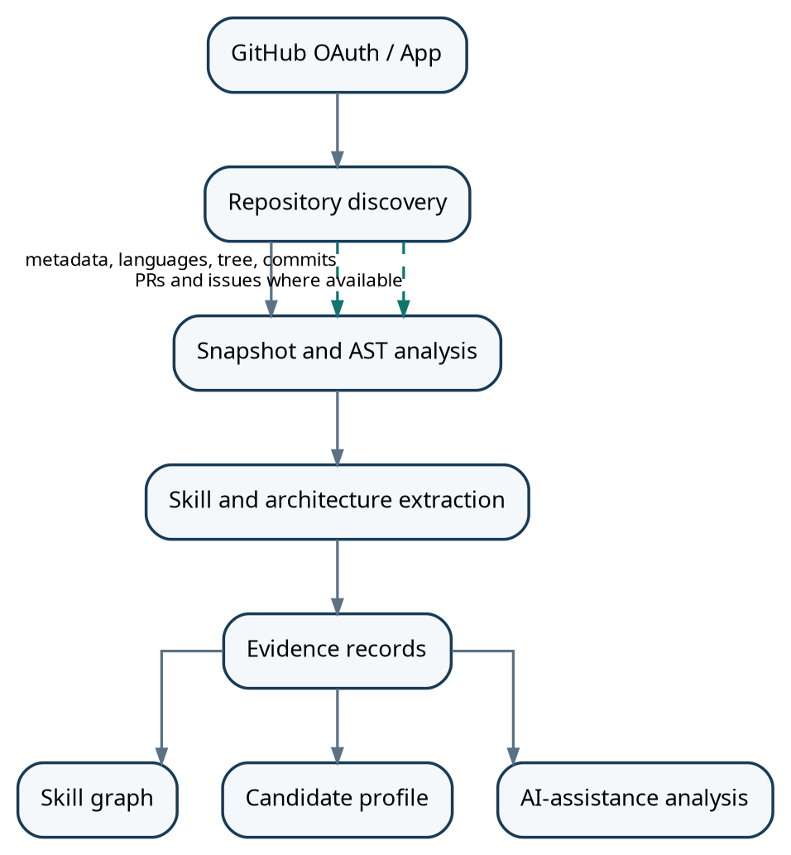

7.2 AI-assistance estimation
Source code alone cannot prove that code was written by an AI model. Therefore, the product should use the label "AI assistance likelihood" and provide confidence and evidence instead of claiming certainty.
Signal | What it can indicate | Confidence
Imported AI chat history | Direct linkage between prompt/output and code | Very high
Commit-level change patterns | Abrupt style/structure changes or large generated-looking additions | Medium
Style discontinuity | Major changes in naming, comments, abstraction style | Medium
Generated-code patterns | Patterns often seen in generated code | Low to medium
Self-report | Candidate declares AI usage | Medium to high
More valuable metric
Add "AI dependency risk" alongside AI assistance likelihood. The question is not only how much AI was used, but whether the candidate can explain, modify, debug and reproduce the result independently.

8. Technical Assessment and Training Engine
The assessment engine is the main mechanism that converts the system from a passive profile analyzer into an active coach.

8.1 Assessment types
Assessment | What it measures | Typical output | Skill effect
Knowledge question | Concept understanding | 82/100 + reasoning quality | Knowledge / confidence
Coding problem | Algorithmic implementation | Correctness + complexity | DSA / coding
Debugging task | Troubleshooting | Root cause + fix | Debugging / systems
Build task | Independent implementation | Test result + code review | Implementation
System design | Architecture and tradeoffs | Design rubric | System design
Code review | Ability to spot defects and tradeoffs | Review findings | Architecture / quality
Verbal defense | Can explain own work | Technical + communication score | Depth / interview readiness
Mock interview | Integrated performance | Panel-style report | Role readiness

8.2 XP and quests
Every completed task can award XP, but XP should not be the same thing as skill score. XP measures progression behavior; proficiency measures demonstrated capability.
Quest example
Build: Redis-backed rate limiter
Requirements: Node.js, Redis, sliding window, concurrency safety, tests
Rewards
+300 XP
Backend +3
Redis +6
Distributed systems +4
System design +5

8.3 Boss battles
At milestones, combine multiple skills into a timed project. Boss battles should test real-world tradeoffs, not merely trivia. Examples include a notification service, a scalable test execution system, an API gateway, an event-driven order system, or a real-time analytics service.

9. Market Intelligence Engine
The market engine must combine two different signals: job-market demand and technology/ecosystem signals. News alone is not demand; a job posting alone does not establish a technology trend. The system should keep them as separate evidence streams and then correlate them.

9.1 Source layers
Layer | Examples | Refresh | Use
Jobs | Company careers, ATS feeds/APIs, permitted job sources | Daily / hourly where practical | Demand by role and skill
Company engineering | Engineering blogs, release notes, architecture announcements | Daily | Technology adoption signals
Technology news | Credible technology publications and news search feeds | Daily | Emerging areas and ecosystem shifts
Open source | GitHub releases, project activity and official documentation | Daily / weekly | Maturity and ecosystem activity
Candidate outcomes | Applications, interviews, assessments, rejection feedback | Continuous | Personal response to market

9.2 Market analysis pipeline
• Every job record stores source, source job ID where available, canonical URL, application URL, first-seen time, last-seen time, source update time, last verification time, status and verification state.
• Search engines and other web discovery sources are secondary discovery mechanisms. A discovered job should be traced to an original employer/ATS posting and verified before being marked as a trusted active job.
• Company-review sources such as Glassdoor and Indeed Reviews are treated as company-intelligence evidence, not as canonical job truth. Access must follow each platform's API, licensing and usage rules.
• Primary job truth should remain the employer's official career page or ATS posting whenever it can be identified. Examples include Greenhouse, Lever, Ashby and other permitted ATS/job feeds.
• Job platforms are included as discovery and, where authorized access exists, direct ingestion sources. LinkedIn and Indeed should be supported through approved APIs/partner access where available; the system must not depend on unauthorized scraping.
Architecture / workflow diagram
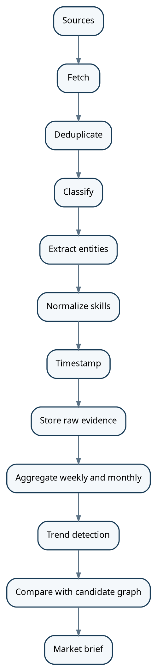

9.3 What the market engine should produce
• Skill demand by role and geography.
• Top recurring skills in the selected target roles.
• Emerging technologies with increasing mention frequency.
• Skills declining or becoming less important in the selected role family.
• Common combinations such as React + TypeScript + Node.js + AWS.
• Salary and seniority signals where reliable structured data is available.
• Company-level hiring signals and technology stack clues.
• A weekly "Market Brief" explaining what changed and why it matters to the candidate.
Time window rule
Never present market status as timeless. Store observations with dates and compare 7-day, 30-day and 90-day windows. A skill may be hot for one role family but less important for another.

10. Job Discovery, Matching and Acquisition

10.1 Job discovery
• Start with company career pages and ATS sources where postings are machine-readable or have official APIs.
• Use permitted search/news sources to discover startup and company career pages.
• Normalize all postings into one job schema.
• Deduplicate using canonical URL, company, role, location and content fingerprint.
• Record first-seen and last-seen timestamps so stale jobs can be removed.

10.2 Job matching

10.3 Match output
Area | Candidate evidence | Gap | Action
React | Production projects + code evidence | None | Highlight
AWS | Limited direct evidence | High | Learning quest + honest resume wording
System design | Some project evidence, weak assessment | Medium | Boss battle
PostgreSQL | Minimal evidence | High | Do not claim production depth

10.4 Resume and cover-letter engine
The system should maintain a master fact base and generate role-specific variants. The model may prioritize, reorganize and rephrase verified evidence, but it must not invent technologies, responsibilities, metrics or employment history.

10.5 Application automation
Application automation should be progressive. Start with preparation and human approval. Add direct ATS API integrations where an official application endpoint is available. Use browser automation for supported workflows only, with explicit controls and audit logs.

10.6 Company Intelligence Engine
• When a job is shortlisted or the user requests deeper analysis, create a company dossier covering company identity, founding/history, products, business model, locations, size where sourced, funding/public-market context where relevant, leadership changes, acquisitions, layoffs, major launches and recent company developments.
• Collect engineering signals from the company's official site, engineering blog, documentation, release notes, GitHub activity where public, technical talks and job descriptions to understand the actual technology environment.
• Collect employee and interview sentiment from permitted sources such as Glassdoor, Indeed Reviews, AmbitionBox, Comparably and public discussions where legally and technically accessible. Never treat a single review as representative.
• Summarize review themes by dimension: compensation, work-life balance, management, career growth, engineering culture, interview process and recurring concerns. Preserve source dates and sample sizes.
• Track company signals over time so recent information is distinguished from older reviews or historical events.
• Use DeepSeek to synthesize evidence into a concise company brief, but keep factual claims linked to their source and date and clearly distinguish sourced facts from model-derived themes.
• Connect company intelligence back to the candidate graph: company stack → required skills → candidate evidence → gaps → interview preparation → learning quests.
Company intelligence area | Evidence sources | Output
Identity & history | Official company site, filings, credible business/news sources | Founded, HQ, products, milestones, ownership/public status
Business & products | Official product pages, company announcements, credible reporting | Business model, customers/markets, major products
Technology | Job descriptions, engineering blogs, docs, public GitHub, technical talks | Stack, architecture signals, engineering focus
Employee sentiment | Glassdoor, Indeed Reviews, AmbitionBox, Comparably, public discussions | Themes, dated sentiment, sample size and caveats
Recent events | Company announcements, credible news, filings | Funding, layoffs, acquisitions, launches, leadership changes
Interview signals | Permitted interview reports and public candidate discussions | Likely interview topics and process signals

10.7 Job source trust and verification
• A job is VERIFIED only when the source is authoritative or an authorized feed confirms that the posting is active and traceable to a legitimate employer/ATS.
• A secondary listing can remain DISCOVERED when it is useful but cannot yet be independently verified. It should be excluded from automatic application actions.
• Verification evidence should include the checked URL, HTTP/API result where applicable, source timestamp, posting status, and the last successful verification time.
• Conflicting sources should be preserved rather than overwritten. The system should record the conflict and prefer the most authoritative, most recent source.
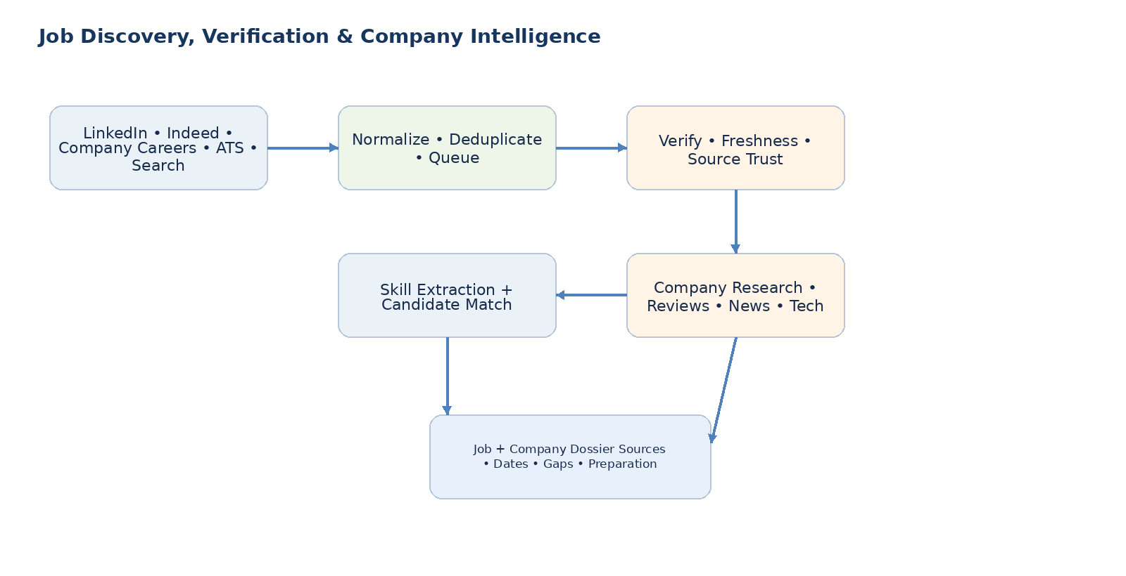
• Keep a direct original application URL whenever possible so the user can verify and apply through the employer or authorized ATS.
• Use deterministic code for source validation, timestamps, deduplication and status. Use DeepSeek for semantic extraction such as skills, responsibilities, seniority and role interpretation.
• Deduplicate across LinkedIn, Indeed, Glassdoor, company pages and ATS sources using canonical URLs, source job IDs, company/role/location similarity and content fingerprints.
• Run freshness checks through background workers. Revalidate active jobs periodically and mark stale/closed jobs rather than silently leaving them in the active pool.
• Store a verification state: VERIFIED, DISCOVERED, STALE, CLOSED or UNVERIFIED. Only VERIFIED jobs should normally enter the high-confidence application shortlist.
• Do not treat a search-engine result, LinkedIn result, Indeed result or aggregator listing as canonical merely because it exists. Resolve it to an original employer/ATS posting whenever possible.
• Use a tiered source model: (1) official employer career pages and ATS feeds/APIs, (2) authorized job-platform feeds/APIs such as LinkedIn or Indeed when available, (3) permitted job aggregators, and (4) search/web discovery as a fallback.
Architecture / workflow diagram
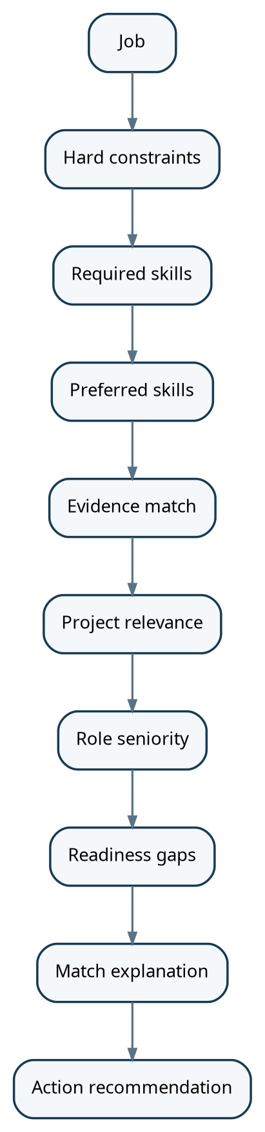

11. Daily Integration: Slack and Gmail
A daily channel is not an optional add-on. It is what turns the platform into a habit. The web dashboard should remain the deep-work interface, while Slack or Gmail should deliver a concise daily operating loop.

11.1 Slack as primary
Slack is the recommended primary daily channel for the first integration. Slack supports the Events API, HTTP or Socket Mode event delivery, interactive app behavior, and message posting. This makes it suitable for a personal bot that sends the daily briefing, receives commands, and posts task results. See the official Slack developer documentation referenced at the end of this document.
Daily interaction | Example | System action
Morning brief | "Good morning - here is today's quest" | Read candidate state + market state
Quick test | "Quiz me on Redis" | Generate assessment and record result
Progress | "What changed yesterday?" | Summarize XP, skill and market deltas
Job digest | "Show new jobs" | Return filtered matches
Approval | "Approve resume for Job 123" | Move item into execution queue
End-of-day | "Daily review" | Summarize completed work and next step

11.2 Gmail as secondary
Gmail is useful for a different reason: it is where recruiter messages, interview invitations, assessments, rejection emails and scheduling information arrive. The Gmail API supports mailbox watch notifications through Google Cloud Pub/Sub, allowing the system to react to mailbox changes rather than continuously poll. The watch must be renewed at least every 7 days; Google recommends renewing it daily.

11.3 Suggested integration model
Architecture / workflow diagram
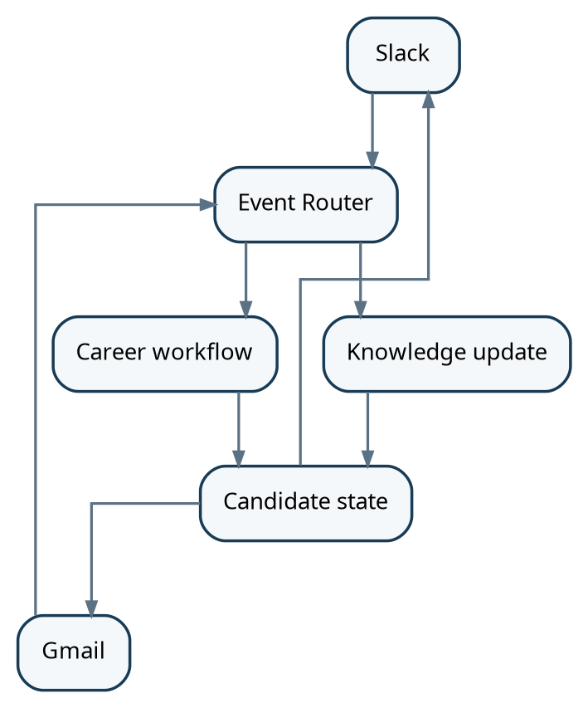

11.4 WhatsApp decision
WhatsApp can be considered later as an additional notification channel. For the first production version, Slack is simpler for interactive developer workflows, while Gmail covers the actual communication stream that contains job/interview signals. The application should therefore use a channel abstraction so WhatsApp can be added without changing the core agent architecture.

12. Agent Architecture
Use specialized agents with strict tool boundaries and a central orchestrator. Avoid a single autonomous agent that owns the entire application.
Architecture / workflow diagram

12.1 Agent rules
• Agents return structured JSON, not arbitrary prose, whenever their output is consumed by another component.
• Every conclusion contains evidence references and confidence where appropriate.
• Irreversible actions require approval unless explicitly enabled by the user.
• The orchestrator owns workflow state; agents should be stateless with respect to long-lived process state.
• Tool access should be allowlisted per agent.
• Agent prompts should never receive more personal or proprietary data than necessary.

13. AI Provider and Model Strategy
The application is provider-agnostic. DeepSeek is one supported provider, not the architecture. Users can configure OpenAI, DeepSeek, Azure OpenAI, OpenRouter, Ollama or another OpenAI-compatible endpoint. The application owns long-lived conversation, evidence, workflow and candidate state; model APIs are inference dependencies.
Task class | Recommended model | Why | Frequency
Bulk extraction | deepseek-flash | Lower-cost, high-volume work | High
Job parsing | deepseek-flash | Structured extraction | High
Resume analysis | deepseek-flash | Repeatable classification | Medium
Skill evaluation | deepseek-flash | Structured scoring + rationale | High
Complex system design | deepseek-v4-pro | Deeper reasoning | Low
Difficult code review | deepseek-v4-pro | Architecture / tradeoffs | Low
Agent orchestration | deepseek-flash | Routine tool selection | High
Implementation note
Use the DeepSeek API key only from the backend. Store conversation state, evidence state and workflow state in your own database. DeepSeek Responses are stateless, so they should not be treated as your system of record.

14. Data Architecture
Architecture / workflow diagram
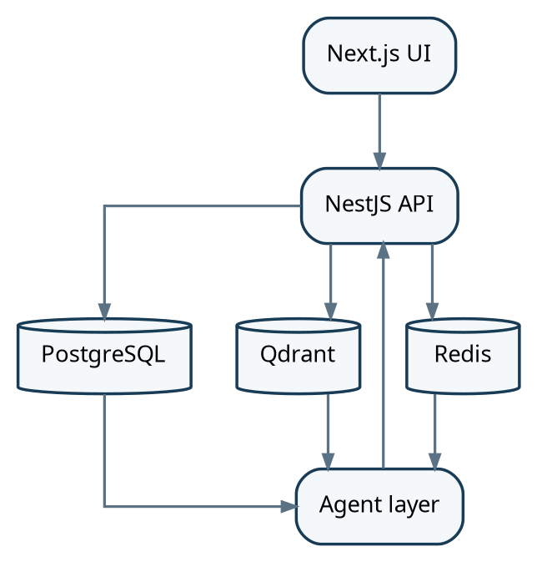

14.1 Storage responsibilities
Store | Use | Examples
PostgreSQL | Canonical structured state | skills, evidence, jobs, applications, tasks, scores
Qdrant | Semantic retrieval | resume chunks, project docs, job descriptions, learning content
Redis | Fast state and queues | BullMQ jobs, locks, rate limits, session cache
Object storage | Binary content | PDFs, DOCX, source snapshots, generated resumes
Encrypted credentials | API keys and OAuth tokens | Encrypted in PostgreSQL; master key remains in deployment secrets

14.2 Core PostgreSQL entities

14.3 Queues, workers and asynchronous processing
• Redis + BullMQ is the background job system. PostgreSQL remains the system of record; Redis/BullMQ handles transient work and execution state.
• Use queues for GitHub synchronization, repository analysis, resume parsing, job ingestion, job verification, deduplication, skill extraction, company research, market refreshes, embedding generation, scheduled briefs and outbound preparation.
• Workers should support retries, exponential backoff, concurrency limits, priorities, delayed/scheduled jobs, idempotency keys and failed-job/dead-letter handling.
• Separate high-priority user-triggered work from low-priority maintenance. Interview preparation and user-requested job analysis should outrank historical repository re-analysis.
• Long-running AI and web research tasks should never block normal API requests. The API creates a job, returns a job ID/status, and workers complete the task asynchronously.
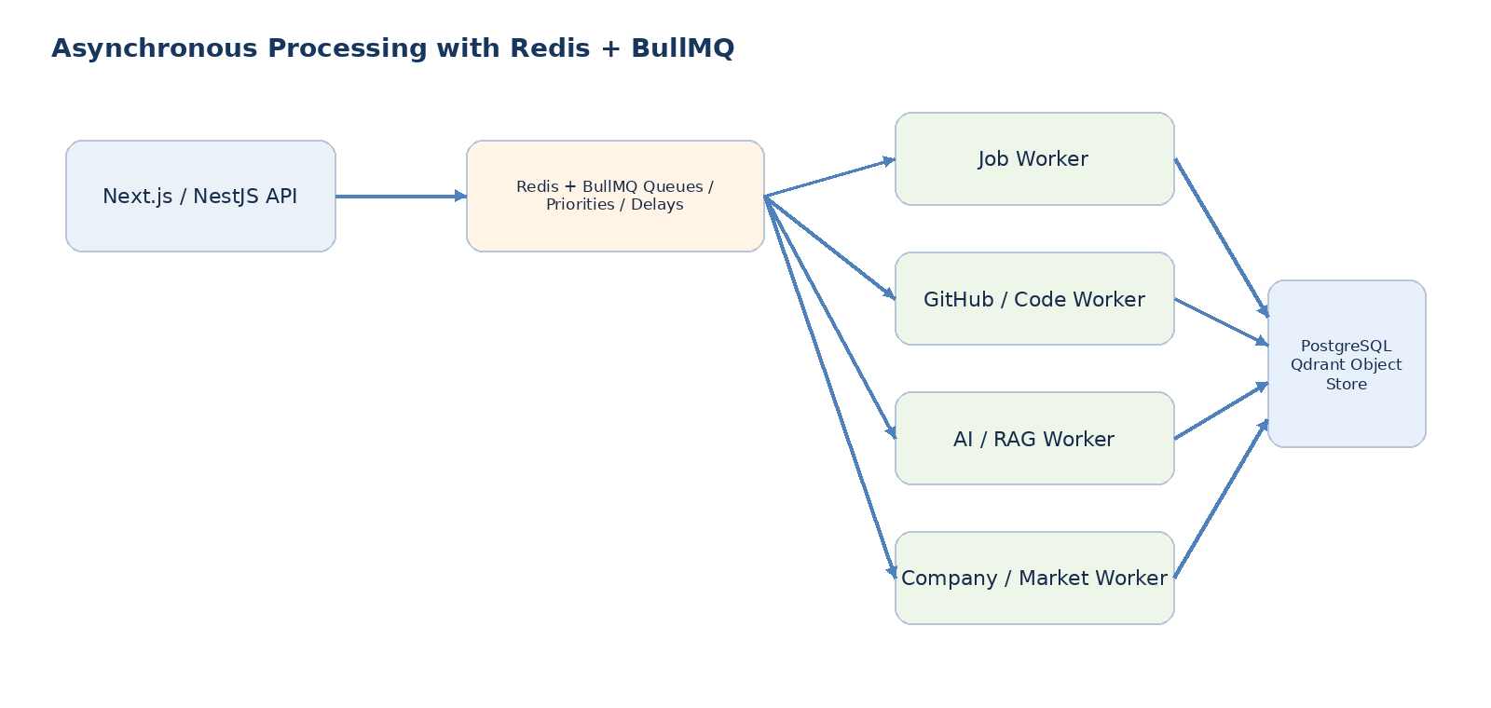
Architecture / workflow diagram
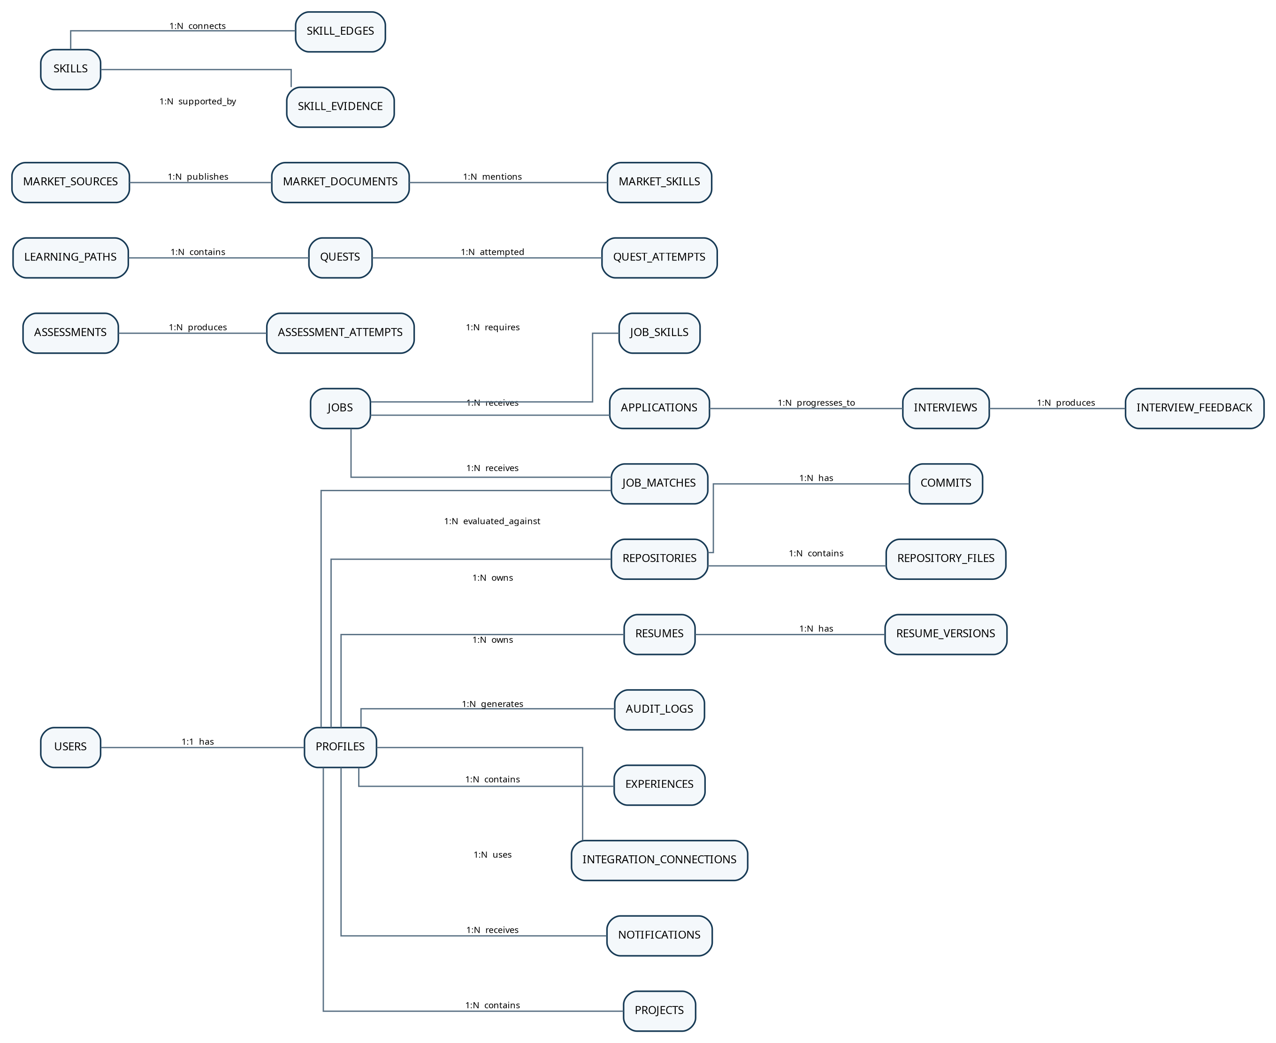

15. RAG and Personal Knowledge Retrieval
Do not put everything into the vector database. Structured facts belong in PostgreSQL, semantic content belongs in Qdrant, files belong in object storage, and transient state belongs in Redis. Job source records, verification state, company profiles, review evidence, research snapshots and application audit records remain structured and queryable in PostgreSQL.
Question | Retrieve | Reasoning input | Output
"Am I ready for this job?" | Profile + skill evidence + job requirements + recent assessments | Match + gap analysis | Readiness report
"Why is my Node.js score low?" | Recent backend assessments + code evidence + failure history | Trend analysis | Explanation + remediation
"What should I learn this week?" | Market trends + target role + current gaps + prerequisites | Prioritization | Weekly learning plan
"Prepare for this interview" | Job description + resume + project evidence + prior interview feedback | Question selection | Mock interview plan

16. Security, Privacy and Data Boundaries
The system may eventually hold private GitHub code, employer-confidential material, personal email and sensitive career data. Data boundaries must therefore be explicit from the beginning.
• Store API keys and OAuth tokens encrypted at rest; never expose DeepSeek credentials to the browser.
• Use per-integration scopes and least privilege.
• Tag every data object with sensitivity: public, personal, confidential, employer-confidential.
• Do not send employer-confidential code to an external model by default. Analyze locally where possible and send only the minimum required context or derived summaries.
• Maintain an audit log of model-generated edits, application submissions and outbound messages.
• Provide data deletion controls and retention policies.
• Require human approval before irreversible external actions in early versions.
• Redact secrets, API keys, passwords and tokens before code/documents are indexed.
Operational safety
The job system should optimize for evidence quality and truthful representation, not for maximum application volume. A lower-volume, higher-quality pipeline is easier to audit and learn from.
Job ingestion
Job verification
Company intelligence
Research / search
Messaging

17. Recommended Technology Stack
Layer | Choice | Reason
Frontend | Next.js + TypeScript + Tailwind + shadcn/ui | Fits existing skills and dashboard-heavy UX
Backend | NestJS + TypeScript | Strong structure for modules, integrations and APIs
Workers | Node.js + BullMQ | Fits Redis and background jobs well
Primary DB | PostgreSQL | Structured, relational and audit-friendly
Vector DB | Qdrant | Semantic retrieval and metadata filtering
Cache / queue | Redis | Fast state, rate limiting and jobs
File storage | S3-compatible storage / MinIO | Document and artifact storage
LLM | DeepSeek API | Tool calling + structured output + current models
Code analysis | Tree-sitter / language-aware AST tools + Git | Structural code evidence
Browser automation | Playwright | Controlled browser workflows
Deployment | Docker; single host first | Simple initial operations
AI provider layer | Provider-agnostic AIProvider abstraction | OpenAI, DeepSeek, Azure OpenAI, OpenRouter, Ollama and custom OpenAI-compatible endpoints
Embedding layer | Local embedding model or external provider | Local recommended for self-hosting; external embeddings optional
Authentication | Local account + Argon2id + secure session | Simple single-user setup; schema remains multi-user ready

18. Suggested Repository Structure
• packages/research — web-search adapters, source extraction and provenance
• packages/queue — BullMQ job definitions, priorities, retries and worker helpers
• packages/market — job/news ingestion and trend aggregation
• packages/company-intelligence — company identity, research, reviews, news and engineering signals
• packages/jobs — source adapters, normalization, deduplication, verification and matching
Architecture / workflow diagram
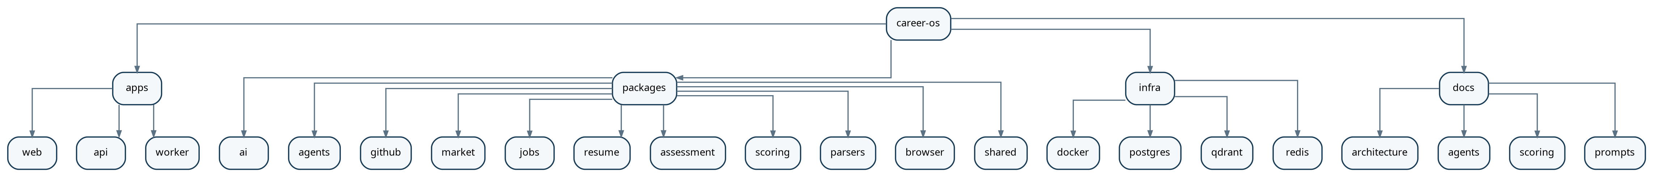

19. End-to-End Workflows

19.1 Daily learning workflow
Architecture / workflow diagram
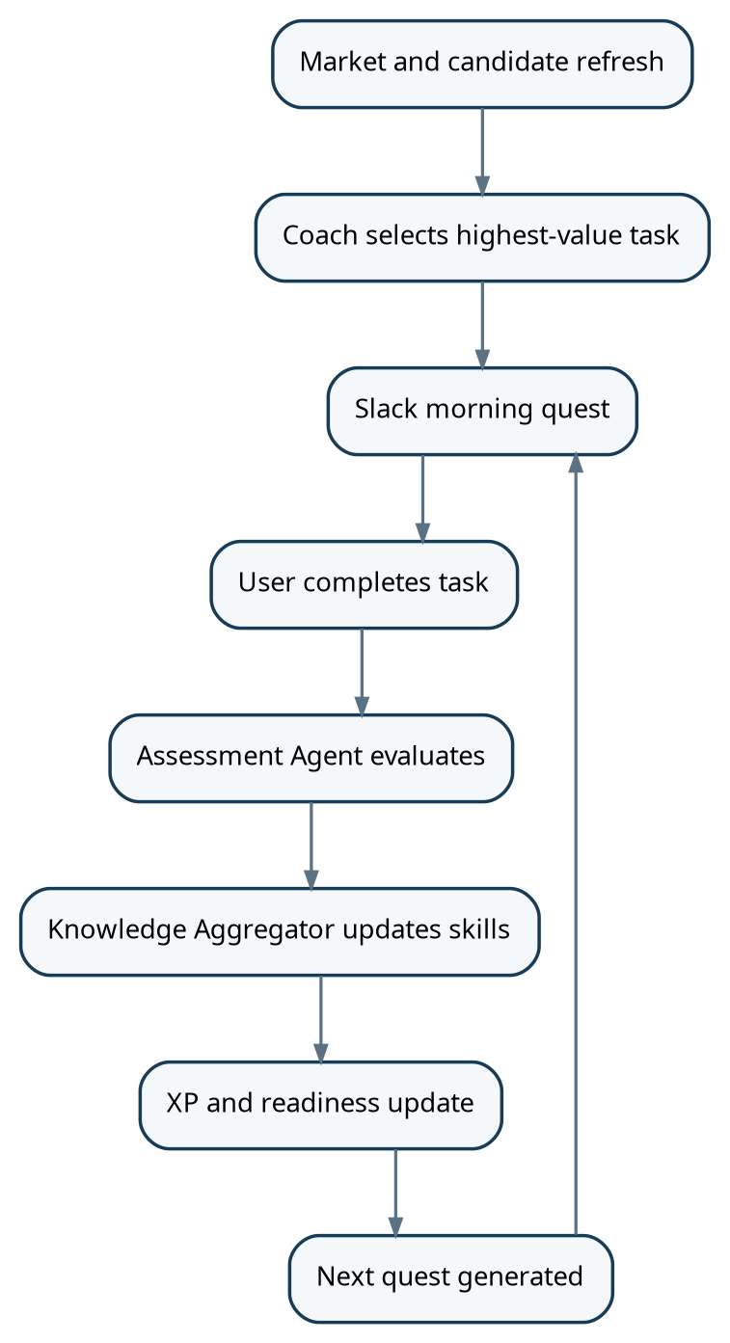

19.2 Job workflow
• Human approval moves the opportunity into the application queue; automated submission is allowed only for supported, audited workflows.
• Generate a Job + Company dossier with source links, dates, verification state, matched skills, gaps and recommended preparation.
• For shortlisted jobs, run company intelligence asynchronously: company history, business/product context, technology signals, employee reviews, interview signals and recent news.
• Normalize → deduplicate → verify → timestamp → extract skills → match against the candidate graph.
• Discover jobs from official employer/ATS sources first, then authorized job-platform feeds and permitted discovery sources.
Architecture / workflow diagram

19.3 Email workflow
Architecture / workflow diagram
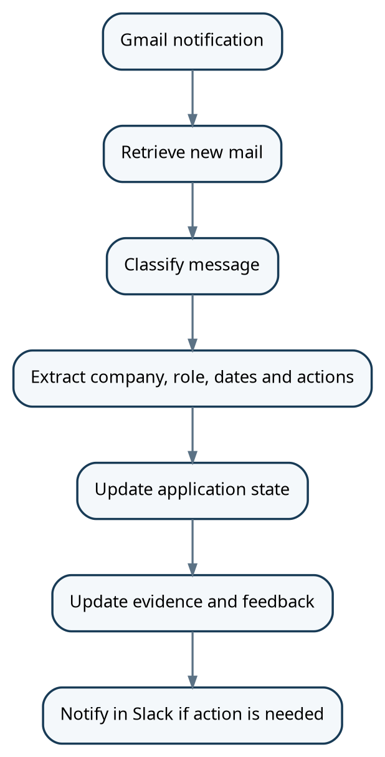

20. Implementation Roadmap
A staged roadmap prevents the system from becoming an unmanageable multi-agent science project. The order below is deliberate: build the knowledge foundation first, then assessment, then market intelligence, then execution.
Phase | Weeks | Deliverable | Key components | Exit criteria
Phase 0 - Foundation | 1 | Project skeleton + infra | Next.js, NestJS, PostgreSQL, Redis, Qdrant, auth, secrets | Local stack runs and data model is migrated
Phase 1 - Personal Intelligence | 2-4 | Candidate digital twin | Resume ingest, GitHub ingest, project model, evidence graph, skill graph | System can produce an evidence-backed technical profile
Phase 2 - Assessment Arena | 5-7 | Continuous evaluation | Question engine, coding tasks, system design rubric, knowledge updates, XP | A completed task changes the right skills with explainable evidence
Phase 3 - Market Engine | 8-10 | Market intelligence | Job ingestion, news ingestion, normalization, trend snapshots, market brief | System can explain current role/stack signals with dates and sources
Phase 4 - Hunt | 11-13 | Job matching | Job match engine, resume variants, cover letters, application tracker | New jobs produce useful, evidence-backed match reports
Phase 5 - Daily Assistant | 14-15 | Slack + Gmail | Events, daily brief, mail classification, notifications, approvals | User can operate most daily tasks from Slack
Phase 6 - Automation | 16+ | Controlled execution | ATS APIs, Playwright workflows, outreach, feedback loops | Approved actions execute with auditability

21. MVP Backlog in Build Order
- Create authentication and candidate profile schema.
- Add resume upload and parsing pipeline.
- Connect GitHub and select repositories.
- Clone/analyze selected repositories and commit history.
- Create skill taxonomy and normalized skill IDs.
- Persist skill evidence with provenance.
- Build initial skill score computation and confidence model.
- Build profile dashboard and skill tree.
- Create question generator and assessment attempt model.
- Implement knowledge update pipeline from assessment results.
- Create DSA and technical knowledge task bank.
- Create system-design assessment rubric.
- Add XP, levels, quests and daily plan.
- Add job source adapters and normalized job schema.
- Build job skill extraction and candidate matching.
- Add market snapshots and trend aggregation.
- Add company dossier generation and connect company technology signals to the candidate skill graph.
- Add company intelligence pipeline for company profiles, history, technology signals, reviews, interview signals and recent news.
- Add job verification, freshness checks, canonical URLs, deduplication and source trust states.
- Add job-source registry and adapters for official company/ATS sources plus authorized platform integrations where available.
- Build Slack daily brief and quick commands.
- Add Gmail watch and email classification.
- Add resume tailoring with a strict fact-check stage.
- Add application tracker and human approval queue.
- Only then add automated submission/outreach where supported and appropriate.

22. Scoring Framework
The system should expose several scores rather than one universal score. Example dimensions:
Score | Meaning | Use
Proficiency | What the evidence says the candidate can currently do | Skill tree
Confidence | How reliable the proficiency estimate is | Decision quality
Readiness | How close the candidate is to a selected role threshold | Job matching
Market relevance | How much the skill matters to target roles now | Learning prioritization
Interview readiness | Recent performance across interview-like tasks | Preparation
AI dependency risk | How much independent performance lags AI-assisted output | Learning design

22.1 Recommended prioritization formula
learning_priority =
market_relevance
* role_gap
* confidence_adjustment
* prerequisite_weight
* interview_importance

The exact coefficients should be calibrated with your own outcomes. The system should log why a task was prioritized so that the recommendation can be audited.

23. Daily User Experience
SLACK - 8:00 AM
GOOD MORNING
Level 37 -> 38
Today
1. DSA: LRU Cache +150 XP
2. System Design: URL Shortener +200 XP
3. Market: Learn AWS IAM basics +100 XP
Market signal
TypeScript + AWS + PostgreSQL appeared frequently in your target roles this week.
Jobs
4 new roles match your current evidence profile.
Reply:
[Start Quest] [Show Jobs] [Market Brief] [Review Progress]
Platform/API access changes
Review bias and sample size
Conflicting job sources

The dashboard remains the place for deep work: skill tree, code analysis, full assessments, market graphs, resume editing and application review. Slack should handle quick interactions, reminders, approvals and progress updates.

24. Definition of Done for the First Production Version
• A new repository can be connected and analyzed without manually copying code into prompts.
• The system can show evidence for why it believes a skill exists.
• An assessment attempt can update one or more skills and explain the change.
• The system remembers past attempts and does not reset knowledge between sessions.
• A market brief contains dates, source links and a clear distinction between job demand and technology/news signals.
• A job match explains both matched requirements and gaps.
• Background job processing uses Redis/BullMQ for ingestion, verification, research, AI processing and scheduled refreshes with retry and audit behavior.
• Company-review summaries preserve sample size, recency and source context and do not treat individual reviews as representative facts.
• A shortlisted job can trigger a company dossier covering company history, business, technology, reviews, interview signals and recent developments with source dates.
• LinkedIn/Indeed and other major platforms can be represented through authorized integrations when access is available, without relying on unauthorized scraping.
• Jobs can be traced to an authoritative or explicitly identified secondary source, with verification state and last-verified timestamp.
• Resume variants contain only verified candidate facts.
• Slack can deliver the daily plan and receive basic commands.
• Gmail can surface relevant recruiter/interview messages into the application timeline.
• All outbound applications and messages have audit records and an approval state.
• The system can be backed up and all external API tokens can be revoked.

25. Major Risks and Mitigations
Risk | Why it matters | Mitigation
LLM overconfidence | Wrong skill scores or invented resume facts | Evidence references, confidence, deterministic checks, human review
False AI-code detection | Misleading claims about candidate work | Use likelihood language; seek direct AI history when available
Market noise | One article or one job distorts recommendation | Use source weighting + rolling windows + volume thresholds
Job scraping fragility | Websites change and may prohibit automation | Prefer official ATS/API/public career pages; keep adapters modular
Privacy leakage | Employer code or private mail may be exposed | Sensitivity labels, redaction, local analysis, least privilege
Automation mistakes | Wrong applications or emails can harm reputation | Approval queue + audit log + dry-run mode
Gamification over optimization | User may chase XP instead of meaningful skills | Keep XP separate from proficiency and market readiness

26. Current External Integration Notes (verified 20 September 2026)
The following notes are included because integration capabilities and platform rules change over time. These should be rechecked before implementation is finalized.
• DeepSeek currently documents the Responses API with deepseek-flash and deepseek-v4-pro, structured JSON/JSON Schema output, and function tools. DeepSeek states that the Responses API is stateless, so application-side persistence is required.
• Slack currently documents the Events API, HTTP and Socket Mode delivery, interactive app behavior, and message posting via webhooks/Web API.
• Gmail currently supports mailbox push notifications through Google Cloud Pub/Sub, so the system can react to mailbox changes instead of polling continuously. Google notes that Gmail watches must be renewed at least every 7 days and recommends daily renewal.
• Lever currently exposes published job postings and documents application endpoints for supported use cases, including retrieving application questions and applying to a posting. This makes ATS-specific adapters attractive for the job engine.
• LinkedIn currently prohibits unauthorized scraping and automated methods in its User Agreement. The job system should not depend on unauthorized LinkedIn scraping or automated LinkedIn engagement. Use approved APIs, user-driven flows, or alternative permitted job sources instead.
• For all external job/review platforms, integration capability must be rechecked at implementation time because partner programs, permissions, rate limits and terms can change.
• Ashby currently documents a public Job Postings API for published job postings and an authenticated API for job synchronization. This makes Ashby a useful ATS adapter alongside Greenhouse/Lever where applicable.
• Glassdoor documents an API that can provide employer reviews, interview reviews, salaries, jobs and related content under its API terms. Any integration must use approved access and preserve required attribution/usage constraints.
• Indeed currently documents partner APIs for jobs, employers and candidates. Access is governed by Indeed's partner/API terms, so the system should use approved access where available rather than assume unrestricted job-search access.

27. Official References
DeepSeek Responses API - Current Responses API, models and stateless behavior.
https://api-docs.deepseek.com/api/create-response/
DeepSeek Tool Calls - Function tool calling and strict structured tool outputs.
https://api-docs.deepseek.com/guides/tool_calls/
DeepSeek JSON Output - Structured JSON output guidance.
https://api-docs.deepseek.com/guides/json_mode/
DeepSeek Change Log - Current 2026 model/API changes including V4.1 Flash.
https://api-docs.deepseek.com/updates/
Slack Event Delivery - HTTP vs Socket Mode and Events API delivery.
https://api.slack.com/apis/event-delivery
Slack Event Types - Event payload model.
https://api.slack.com/types/event
Slack Incoming Webhooks - Posting messages to Slack from apps.
https://api.slack.com/messaging/webhooks
Gmail Push Notifications - Mailbox watch notifications through Pub/Sub and renewal behavior.
https://developers.google.com/gmail/api/guides/push
Gmail API Guide - Gmail messages, labels and push notifications.
https://developers.google.com/workspace/gmail/api/guides
Lever Developer Documentation - Job posting and application endpoints.
https://hire.lever.co/developer/documentation
LinkedIn User Agreement - Current restrictions on scraping and unauthorized automation.
https://www.linkedin.com/legal/user-agreement
LinkedIn Crawling Terms - Automated crawling terms and permission requirements.
https://www.linkedin.com/legal/crawling-terms

28. Recommended Next Build Step
Ashby Job Postings API — https://developers.ashbyhq.com/docs/public-job-posting-api
Glassdoor Reviews / Company pages — https://api.glassdoor.com/Reviews/index.htm
Glassdoor API Terms of Use — https://www.glassdoor.com/crs/api/glassdoor-public-api-terms.pdf
Indeed Job Update API — https://docs.indeed.com/job-update-api/
Indeed Partner Documentation — https://docs.indeed.com/getstarted/
Do not start by building the job scraper or a fleet of agents. Start with the Personal Intelligence Engine because every later feature depends on the quality of the candidate state.
Architecture / workflow diagram
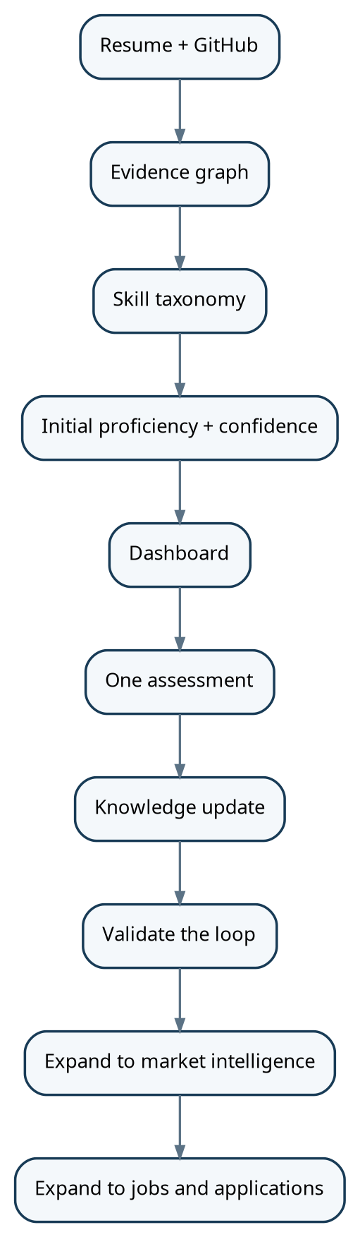

29. Open-Source Self-Hosted Architecture
Career OS should be installable on a laptop, VPS or other Docker-capable server without requiring a project-owned cloud account. The user owns the deployment, persistent data, AI credentials and integrations.
Core principle
Docker Compose installs infrastructure; the web setup wizard configures the application. A user should be able to clone the repository, start the stack, enter their own AI key, optionally choose local embeddings, connect integrations and reach a working dashboard without editing source code.
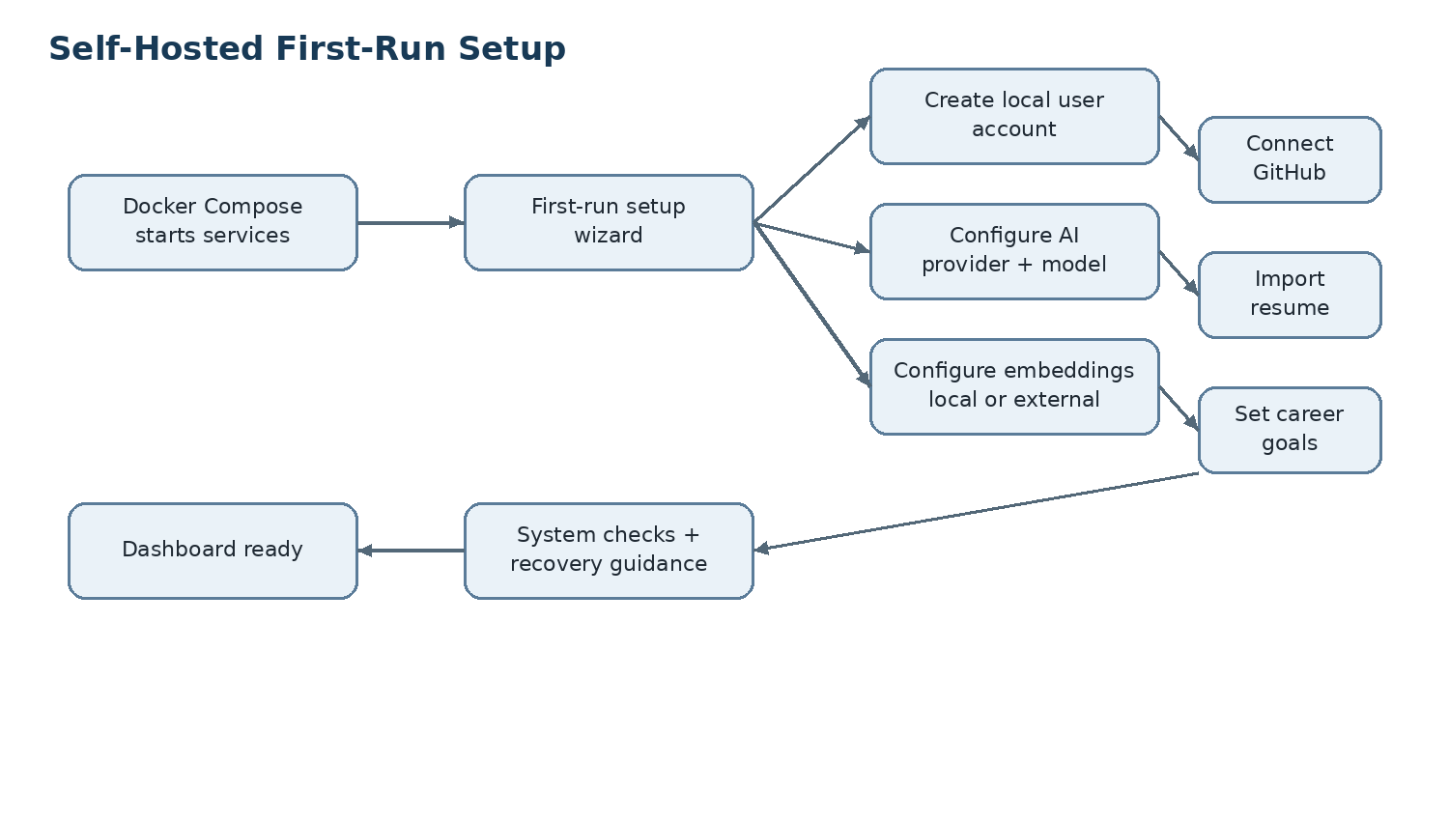

29.1 First-run setup flow
- Start Docker Compose and verify PostgreSQL, Redis, Qdrant, API, worker and web services.
- Detect an uninitialized database and redirect to the setup wizard.
- Create the local account; store only an Argon2id password hash.
- Select an AI provider and configure the chat/reasoning model, API key and optional base URL.
- Test chat, structured output, tool calling and streaming capabilities.
- Choose local or external embeddings and test vector generation.
- Connect GitHub and optionally Gmail, Slack and other integrations.
- Import the resume and review extracted facts before they become trusted evidence.
- Set target roles, locations, compensation range and career goals.
- Run final system checks and generate recovery guidance for the master encryption secret.
- Mark setup complete and enter the dashboard.

29.2 Setup modes
Mode | Purpose | Required inputs
Quick Setup | Fastest path to a working instance | Account, AI provider/key, embedding choice
Standard Setup | Recommended complete setup | Quick Setup + GitHub + resume + career goals
Advanced Setup | Power users | Storage, search, job sources, Slack, Gmail, schedules, security and worker settings

29.3 AI provider architecture
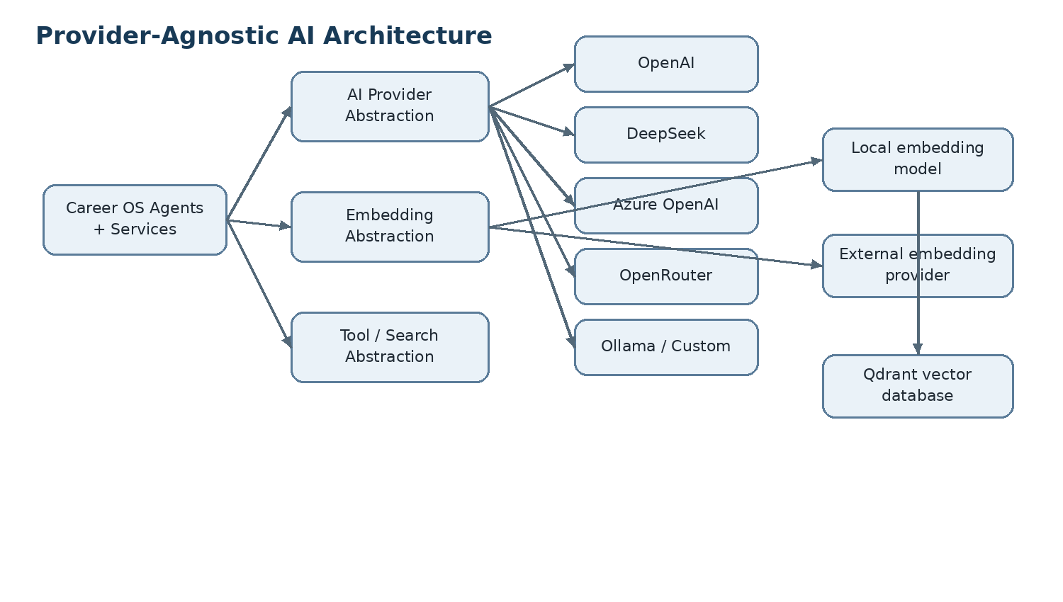
- Agents call the internal AIProvider abstraction instead of a provider SDK directly.
- Provider configuration is stored as data, so switching providers does not require a code deployment.
- DeepSeek can be used for chat while embeddings run locally, so one external API key can be sufficient.
- External embeddings remain supported for users who prefer managed embeddings.
- Custom OpenAI-compatible base URLs are supported where required capabilities are available.
- Capability checks prevent unsupported features from silently failing.

29.4 Embedding architecture
Qdrant is the vector database. An embedding model is still required to convert text/code into vectors.
Option | Credential | Where it runs | Use
Local embedding | None | Same Docker host | Default self-hosted path
External embedding | Provider API key | External API | Optional managed path
Important distinction
Embedding model = text/code → vector. Qdrant = vector storage + similarity search. PostgreSQL remains the source of truth for structured facts.

29.5 Authentication and user storage
- The first user is created by the setup wizard when the database has no users.
- Passwords are never stored in plaintext; use Argon2id.
- Sessions use secure HttpOnly cookies.
- The initial release can enforce one user per installation while retaining user_id relationships for future multi-user support.
- After setup, /setup redirects to the dashboard or settings.
Data | Storage | Protection
User identity | PostgreSQL | Relational data + authorization
Password | PostgreSQL | Argon2id hash only
Session | Backend/session mechanism | HttpOnly, Secure, SameSite
AI API keys | PostgreSQL | Encrypted at rest
OAuth tokens | PostgreSQL | Encrypted at rest + least privilege
Career profile/skills/evidence | PostgreSQL | Canonical source of truth

29.6 Configuration and secret storage
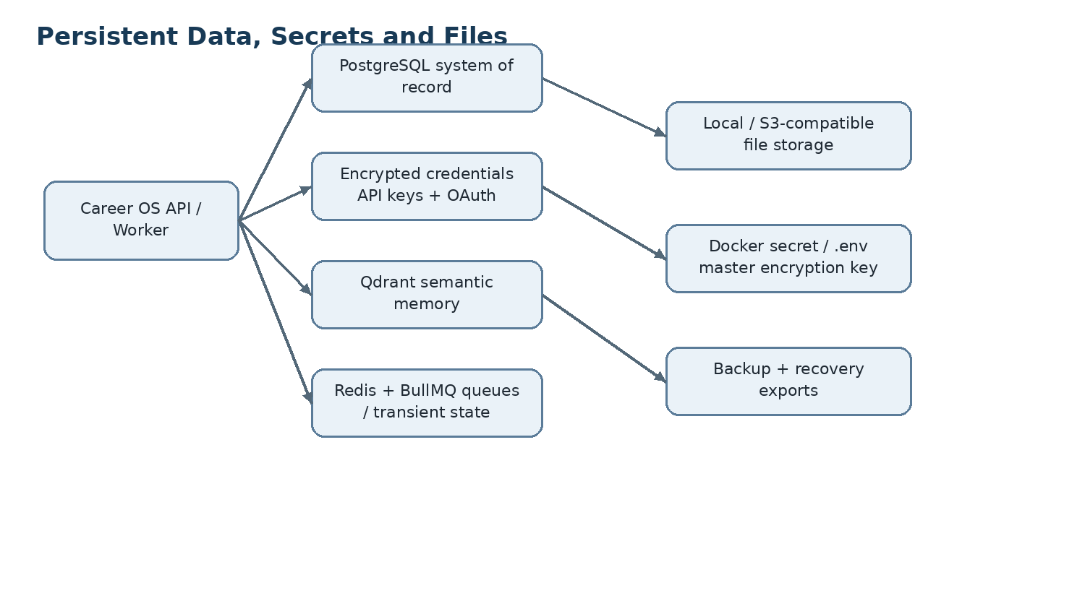
Non-sensitive configuration can be stored in PostgreSQL. Secrets must be encrypted and the master encryption key must live outside the database.
Configuration | Example | Storage
Application secret | ENCRYPTION_KEY / SESSION_SECRET | Docker secret or protected .env
Database connection | DATABASE_URL | Protected deployment configuration
Redis connection | REDIS_URL | Protected deployment configuration
Qdrant endpoint | QDRANT_URL | Normal config; credentials protected if enabled
AI provider settings | provider, base URL, model | PostgreSQL
AI API key | DeepSeek/OpenAI key | Encrypted in PostgreSQL
OAuth tokens | GitHub/Gmail/Slack tokens | Encrypted in PostgreSQL
Career preferences | role, locations, goals | PostgreSQL
Recovery requirement
If the master encryption key is lost, encrypted provider credentials and OAuth tokens may be unrecoverable. The setup wizard must clearly instruct the user to back up the recovery secret/configuration.

29.7 Persistent storage model
Component | Role | Persistence
PostgreSQL | System of record | Persistent volume + backups
Qdrant | Semantic memory/vector search | Persistent volume + snapshots/rebuild procedure
Redis | Queues, locks, rate limits, short-lived state | Not canonical; persistence only where queue recovery matters
File storage | Resumes, PDFs, DOCX, source snapshots, generated artifacts | Persistent local volume or S3-compatible storage

29.8 Single-user resource profile
Resource | Recommended | Minimum practical | Notes
CPU | 4 vCPU | 2 vCPU | More CPU helps local embeddings and workers
RAM | 8 GB | 4 GB | 8 GB provides safer headroom
Storage | 120 GB NVMe | 80 GB SSD | Repositories and documents grow over time
GPU | Not required | Not required | External LLM inference; CPU embeddings are sufficient for small models
OS | Ubuntu 24.04 LTS | Supported Linux | Docker Engine + Compose
A single-user deployment does not require Kubernetes, Kafka, RabbitMQ, Elasticsearch or a dedicated GPU server.

29.9 Suggested Docker Compose services
nginx
web
api
worker
scheduler
postgres
redis
qdrant
embedding # optional when local embeddings are selected
Only Nginx should be publicly exposed on a server. PostgreSQL, Redis, Qdrant and internal application ports remain on the private Docker network.

29.10 Environment and secret model
# .env.example
DATABASE_URL=
REDIS_URL=redis://redis:6379
QDRANT_URL=http://qdrant:6333
ENCRYPTION_KEY=
SESSION_SECRET=
FILES_PATH=/data/files
EMBEDDING_MODE=local
- Never commit .env.
- Ship .env.example with blank values.
- Prefer Docker secrets for production deployments.
- Never expose user AI keys through public frontend environment variables or browser local storage.
- Never log decrypted credentials.

29.11 Data lifecycle
Data | Canonical store | Vectorized? | External model by default?
Candidate facts | PostgreSQL | Optional | Minimum necessary context only
GitHub metadata | PostgreSQL | Sometimes | No by default for employer-confidential code
Code/document chunks | Object storage + Qdrant | Yes when needed | Configurable
Job records | PostgreSQL | Often | Research can be summarized
Company research | PostgreSQL + source snapshots | Optional | According to provider configuration
Assessment answers | PostgreSQL | Optional | Yes for evaluation when configured

29.12 Repository implications
apps/
web/
api/
worker/
packages/
ai/
embeddings/
auth/
secrets/
storage/
github/
jobs/
company-intelligence/
market/
assessment/
scoring/
search/
queue/
shared/
infra/
docker/
nginx/
postgres/
redis/
qdrant/
embedding/
docs/
setup/
deployment/
providers/
- Provider adapters are isolated from domain logic.
- Embedding adapters are isolated from Qdrant storage logic.
- Secret management is isolated from UI and integration modules.
- Setup state is explicit and testable so deployments can be upgraded safely.

29.13 Setup Definition of Done
- Fresh Docker Compose deployment starts without source-code edits.
- First-run wizard creates the first user.
- Password uses Argon2id hashing.
- At least one AI provider can be configured and capability-tested.
- Local embeddings work without a second API key.
- External embeddings can be configured.
- Qdrant stores and retrieves vectors from the selected embedding engine.
- AI and OAuth credentials are encrypted at rest and never exposed to the browser.
- GitHub connection and repository selection work.
- Resume import and fact review work.
- Career goals persist.
- Health screen covers PostgreSQL, Redis, Qdrant, AI and embedding services.
- Recovery guidance is displayed before setup completion.
- Settings allow provider and integration changes after setup.
Blueprint update: v1.2 — provider-agnostic self-hosted setup, embeddings, authentication and secrets

