
ANALYSIS OF DESIGN AND ALGORITHMS LAB

LAB REPORT

Submitted by: MANYA YADAV
Course : B.Tech CSE Data Science
Semester : IV
Roll No : 2401420012
Submitted To: Aarti Sangwan

Understanding Algorithm Efficiency through Analysis, Recurrences, and Sorting
- TASK 1: Algorithm Growth Observation
- Constant Time {O(1)}:
CODE AND OUTPUT:
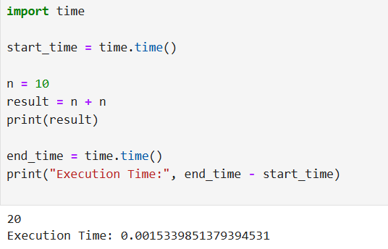
2.Linear Time {O(n)}:
CODE AND OUTPUT:
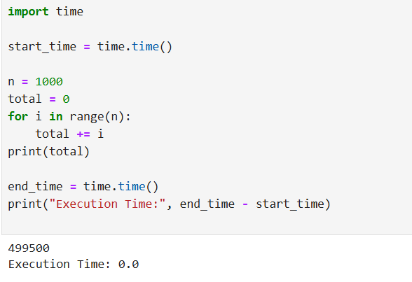

3.Quadratic Time{ O(n^2)}:
CODE AND OUTPUT:
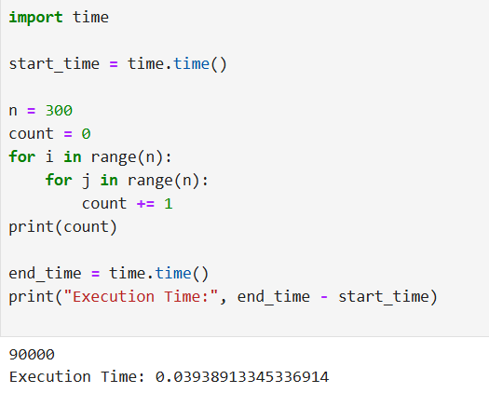
4.Logarithmic Time{ O(logn)}:
CODE AND OUTPUT:
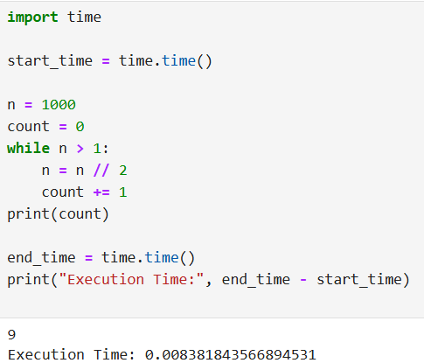

GRAPH OF INPUT SIZE VS EXCECUTION TIME:
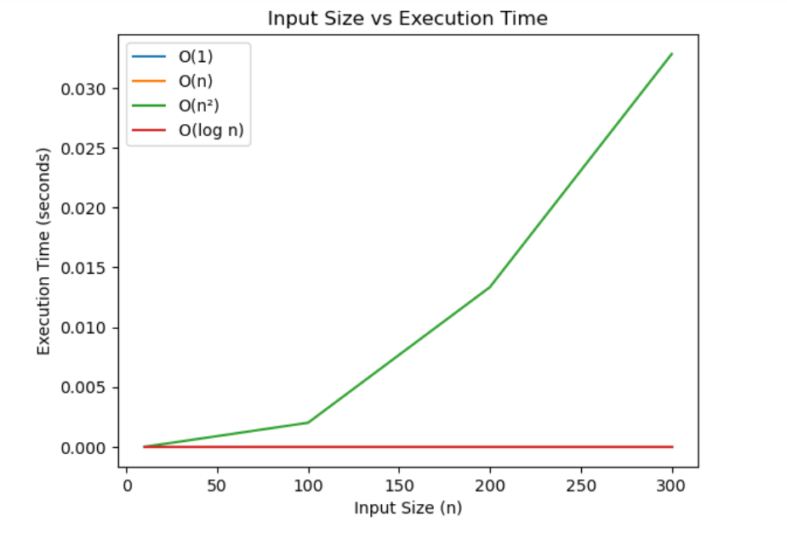
Observation:
- O(1) remains almost constant
- O(log n) increases slowly
- O(n) increases linearly
- O(n²) increases rapidly
Conclusion:
Execution time increases with input size depending on algorithm complexity.

TASK 2: Best, Average, and Worst Case Analysis
Linear Search:
- Best Case:
CODE AND OUTPUT:
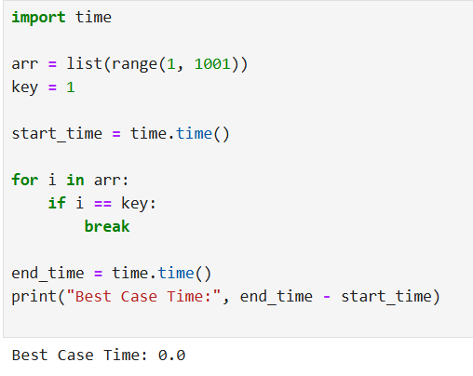
- Average Case:
CODE AND OUTPUT:
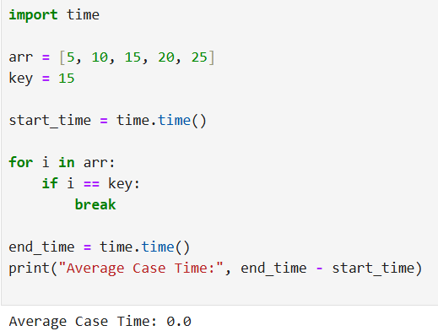

Worst Case:
CODE AND OUTPUT:
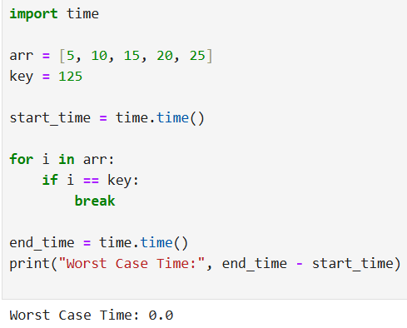

COMPARISION PLOT:
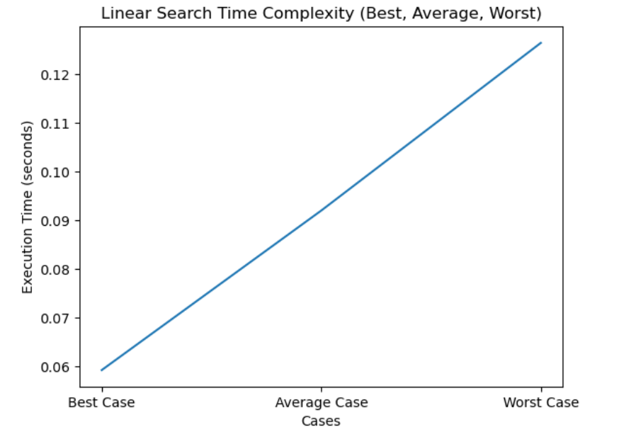
*The plot shows that worst case takes maximum time and best case takes minimum time for linear search.
TASK 3: Recursion and Recurrence Validation
- FACTORIAL:
CODE AND OUTPUT
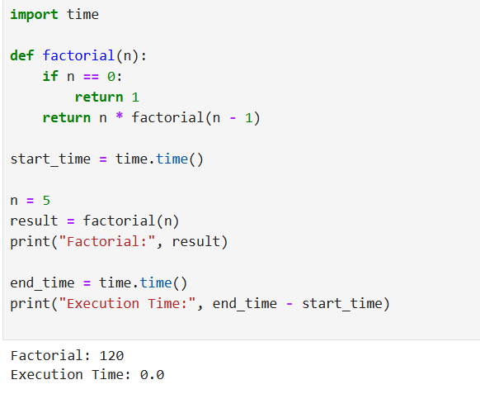
- FIBONACCI(RECURSIVE):
CODE AND OUTPUT:
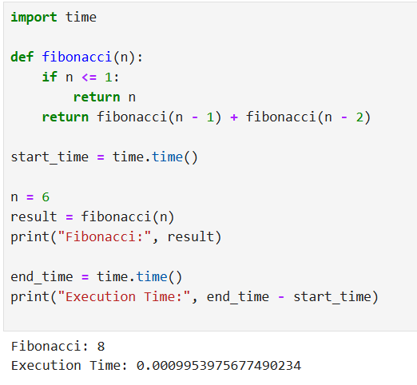

- FIBONACCI(ITERATIVE):
CODE AND OUTPUT:
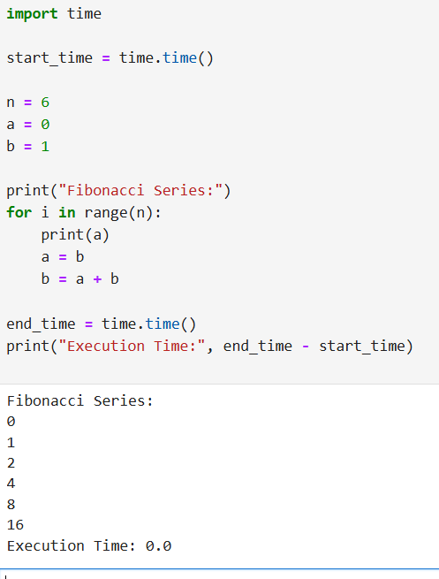
Observation:
Recursive Fibonacci takes more time compared to iterative approach.
Conclusion:
Recursion increases execution time due to repeated function calls.

TASK 4: SOLVING RECURRENCES THROUGH CODE
- T(n) = T(n/2) + n
CODE AND OUTPUT:
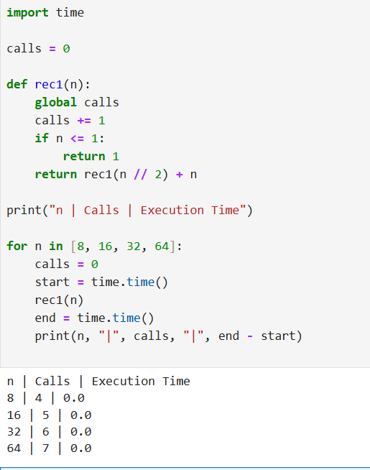

- T(n) = 2T(n/2) + n
CODE AND OUTPUT:
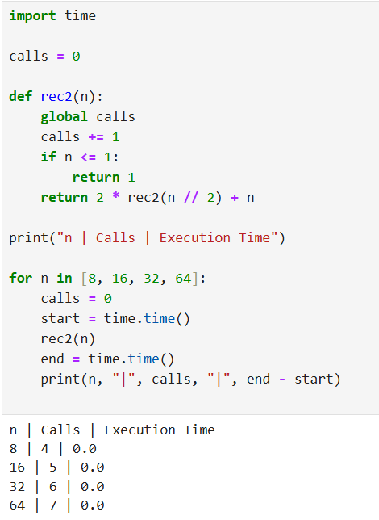

For T(n) = T(n/2) + n
- Number of recursive calls increases logarithmically
- Execution time grows linearly
- Asymptotic Complexity: O(n)
For T(n) = 2T(n/2) + n
- Number of recursive calls increases rapidly
- Execution time grows faster than linear
- Asymptotic Complexity: O(n log n)
GITHUB LINK- https://github.com/okayyymy15/MANYA_YADAV_ADA_ASSIGNMENTS

Implementation and Performance Analysis of Divide & Conquer, Greedy, and Dynamic Programming Algorithms

TASK 1: DIVIDE AND CONQUER ALGORITHMS
CODE:
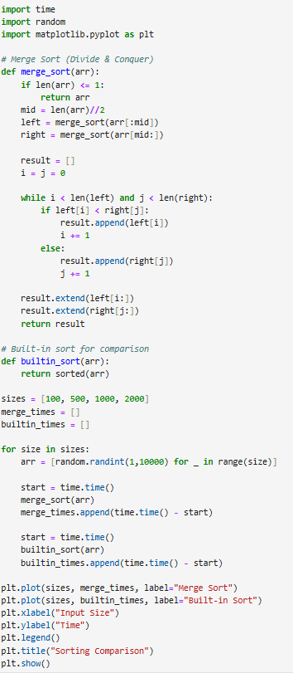
OUTPUT:
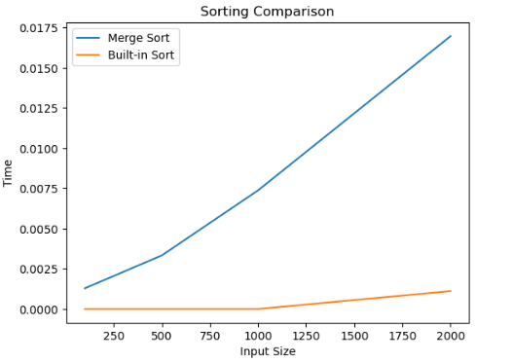

Observation
Merge Sort follows Divide & Conquer strategy
Time Complexity = O(n log n)
Built-in sort is faster due to optimization
As input increases, time increases gradually

TASKK 2:SORTING PERFORMANCE COMPARISON
CODE:

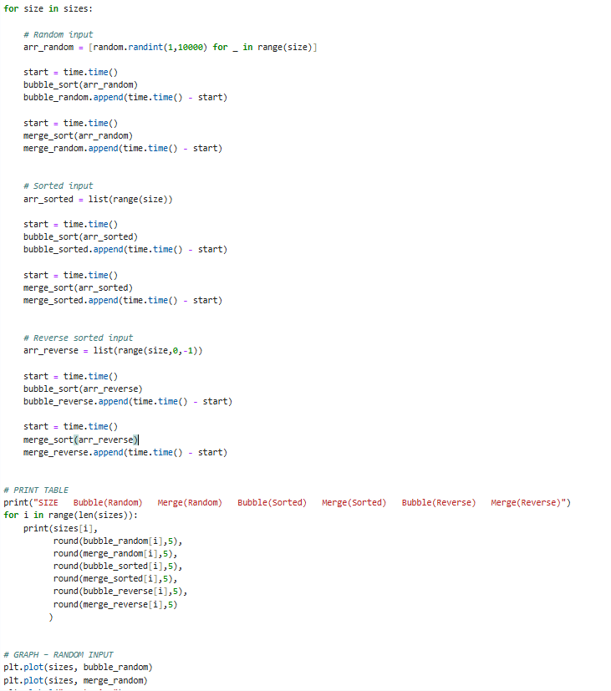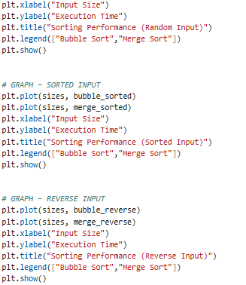
OUTPUT:

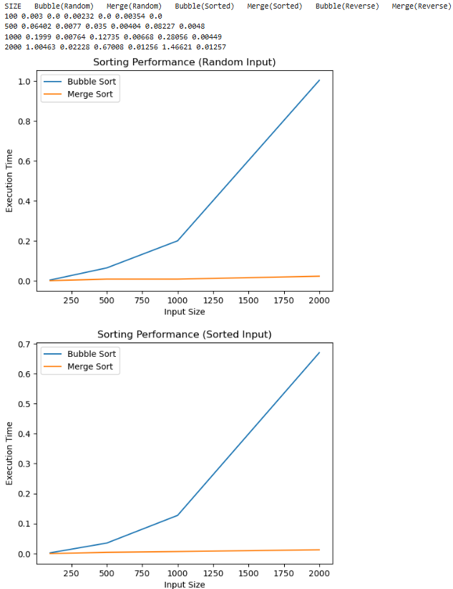
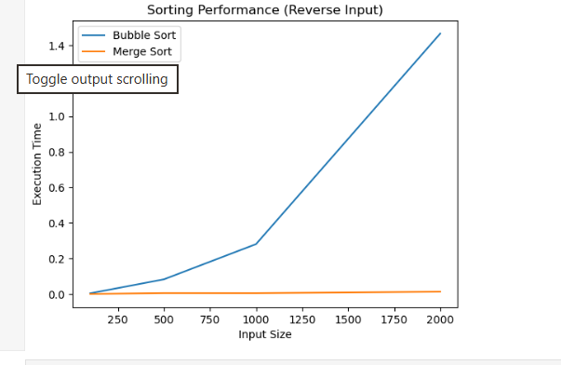
Observation:
- Bubble Sort performs well only for small input sizes.
- Its execution time increases very rapidly for large inputs.
- Merge Sort performs consistently for all types of input.
- Bubble Sort performs faster for sorted input compared to random input.
- Merge Sort execution time remains almost the same for sorted, random, and reverse input.
- Therefore, Merge Sort is more efficient for large datasets.

TASK 3: GREEDY ALGORITHMS
CODE:
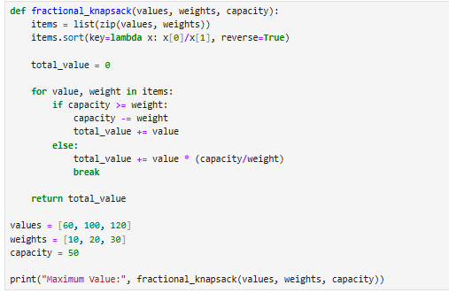
OUTPUT:

Observation
- Greedy chooses locally optimal solution
- Works efficiently for Fractional Knapsack
- Time Complexity: O(n log n) (due to sorting)

TASK 4:DYNAMIC PROGRAMMING FUNDAMENTALS
CODE:
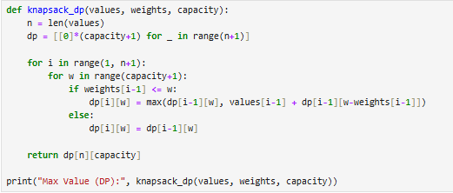
OUTPUT:

Observation
- Uses optimal substructure + overlapping subproblems
- More accurate than greedy for 0/1 case
- Time Complexity: O(n × capacity)

TASK 5:TRAVELLING SALESMAN PROBLEM
CODE:
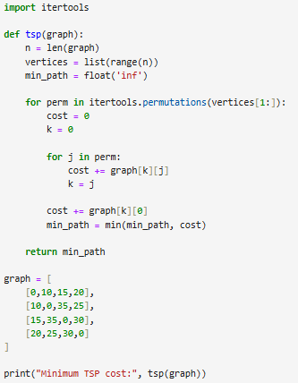
OUTPUT:

Observation
- Time Complexity = O(n!)
- Shows exponential growth
- Not practical for large inputs
GITHUB LINK: https://github.com/okayyymy15/MANYA_YADAV_ADA_ASSIGNMENTS
GRAPH PROBLEM IMPLEMENTATION

1. Graph Representation:-
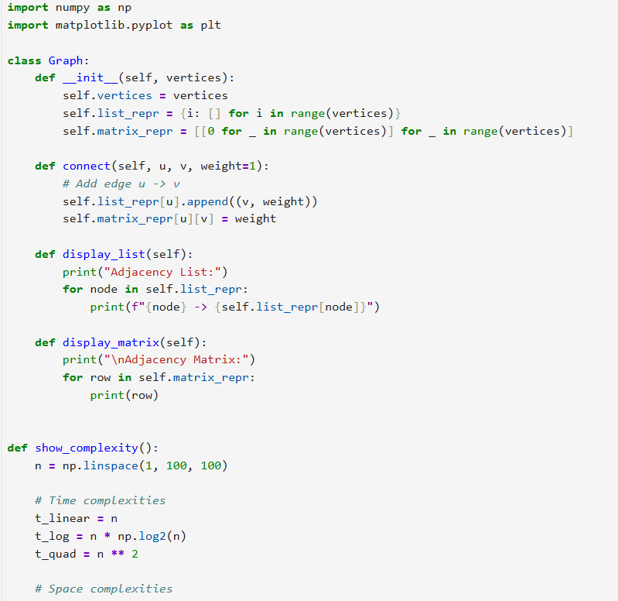
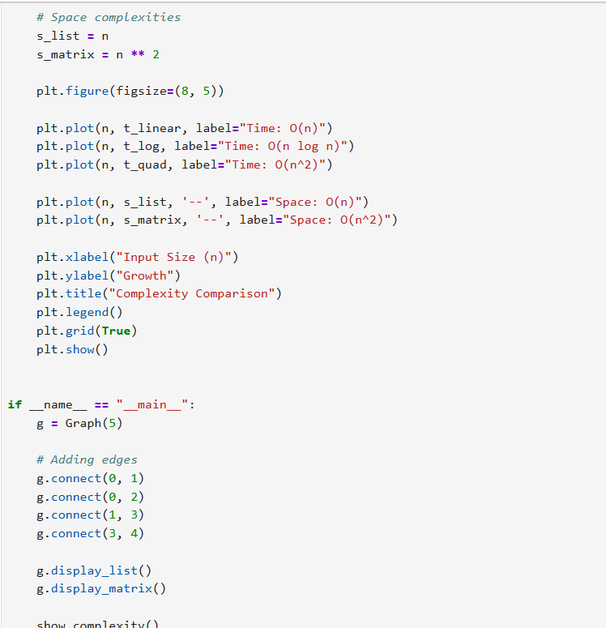

OUTPUT:-
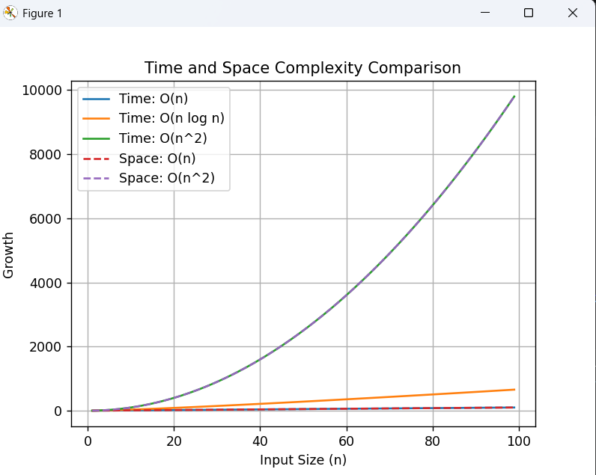

2. Depth First Search (DFS):-
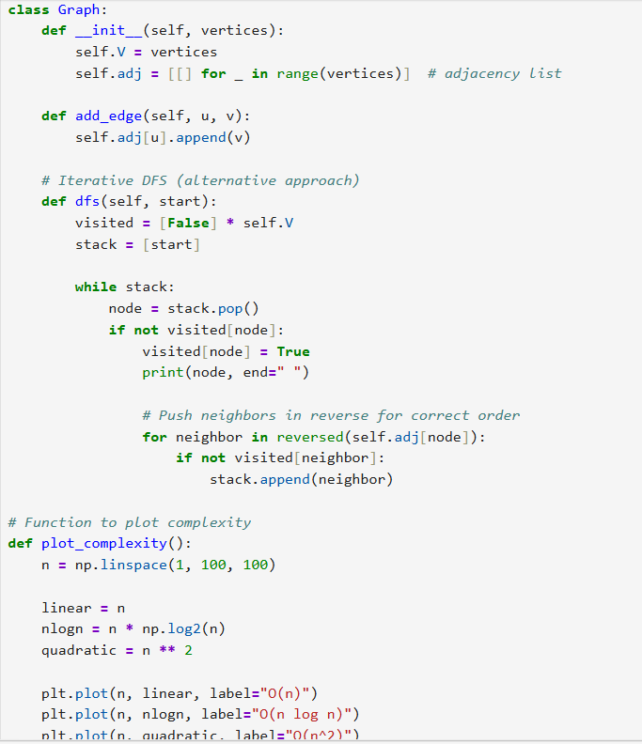
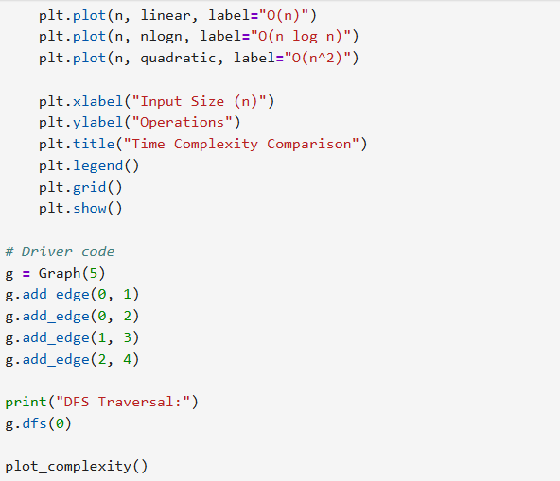

OUTPUT:-
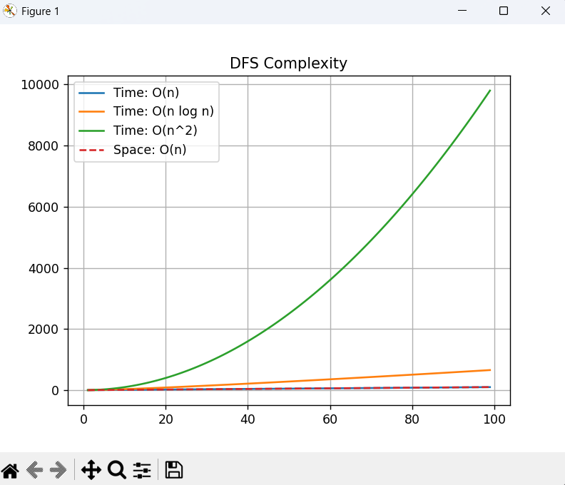

3. Breadth First Search (BFS):-
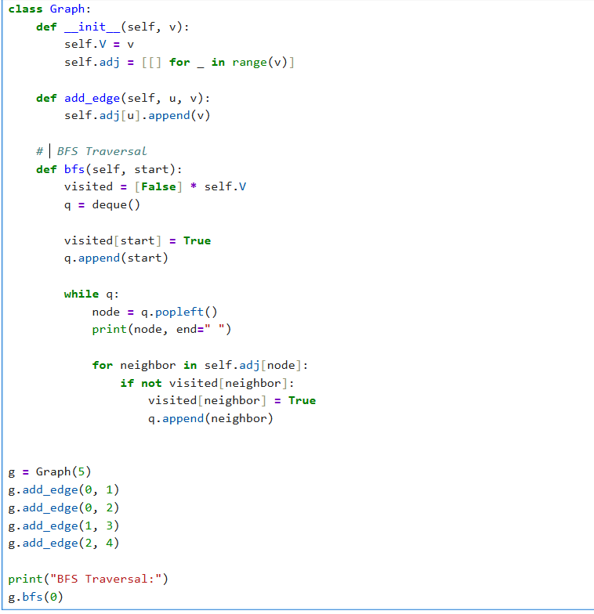
OUTPUT:- 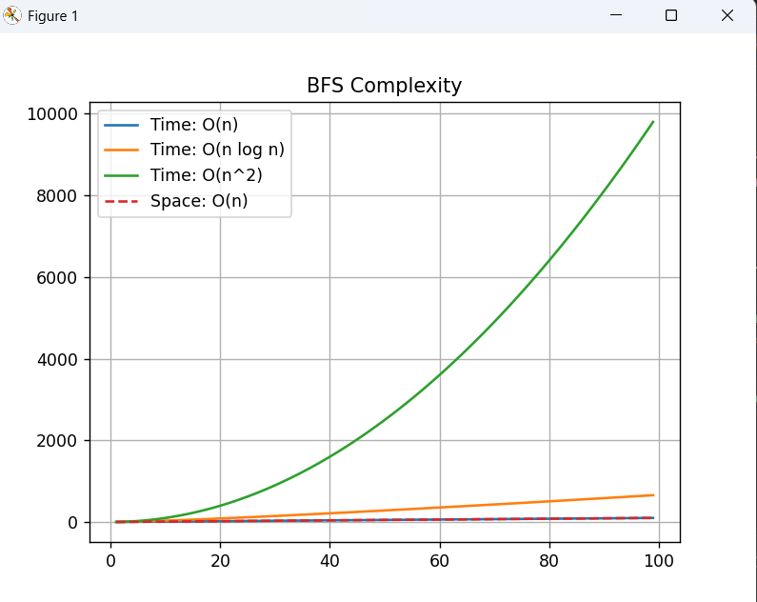
4. Topological sort :-
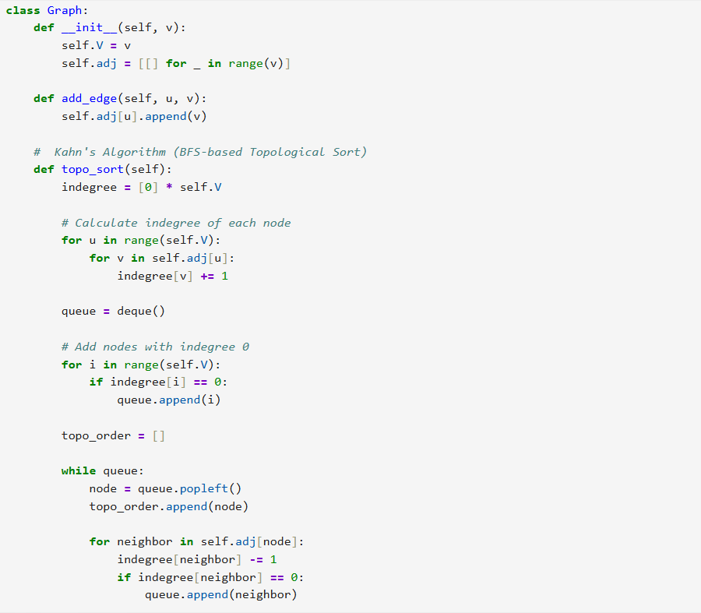
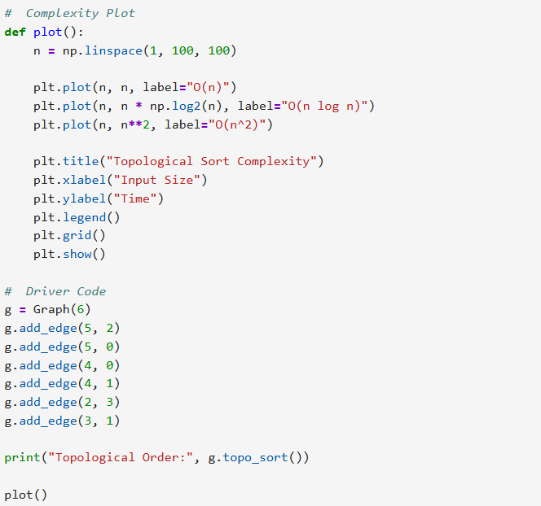

OUTPUT:-
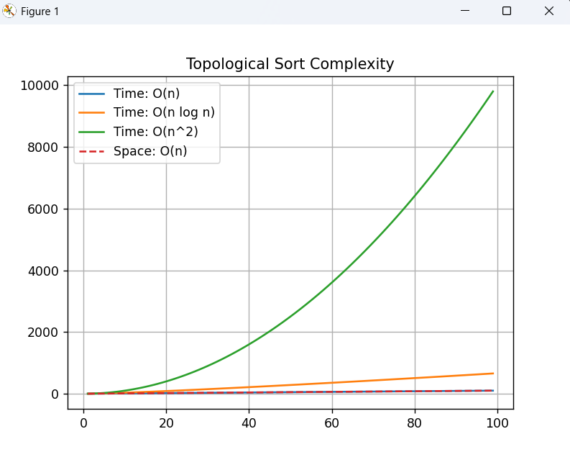

5. Topological Sort:-
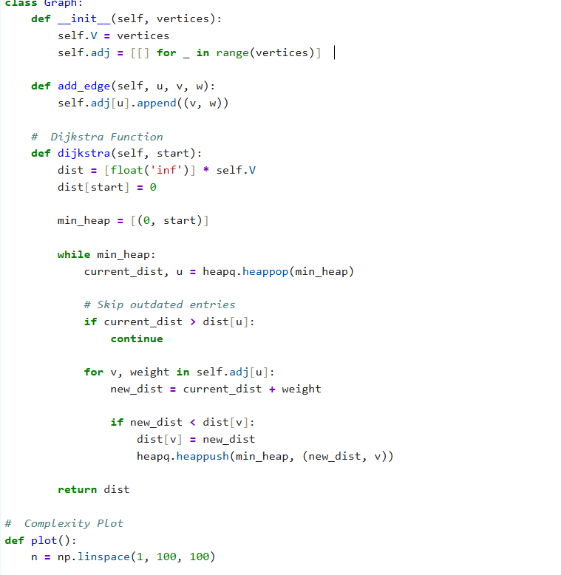
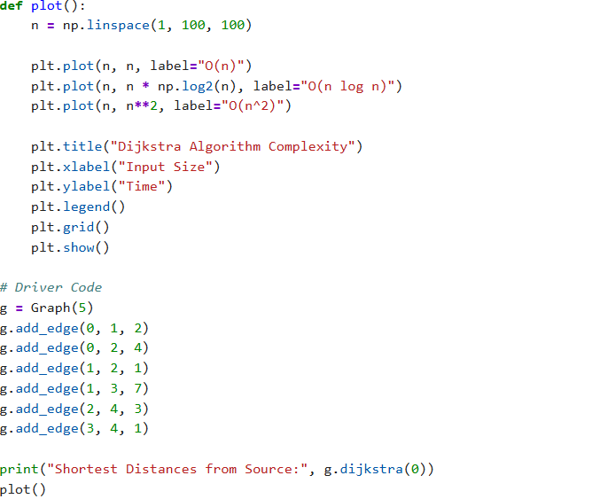

OUTPUT:-
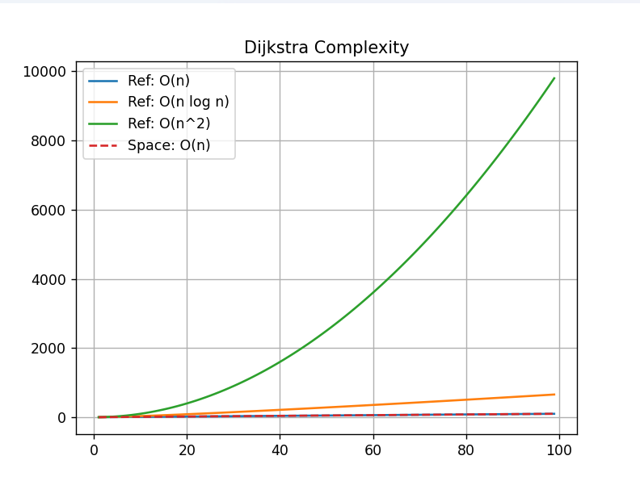
6. Bellman-Ford Algorithm:-
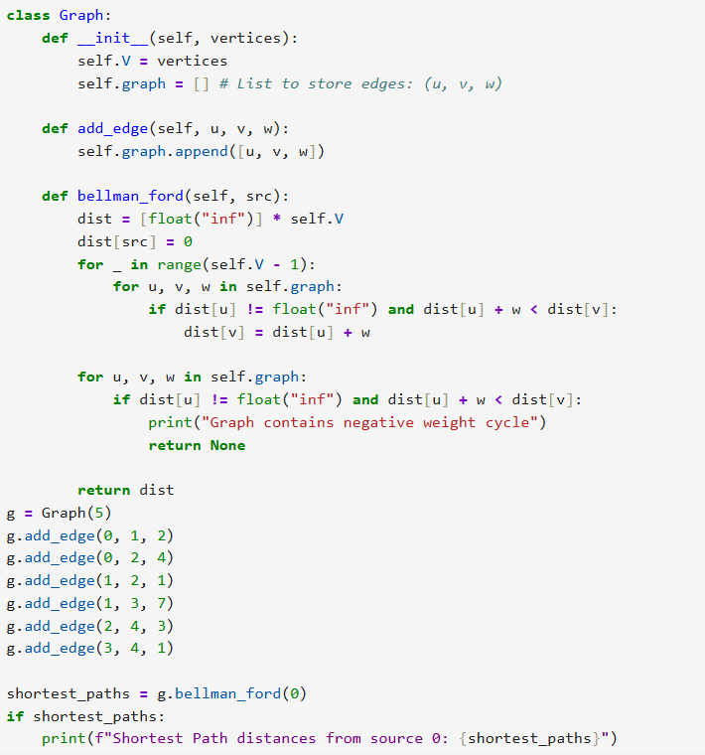

OUTPUT:-
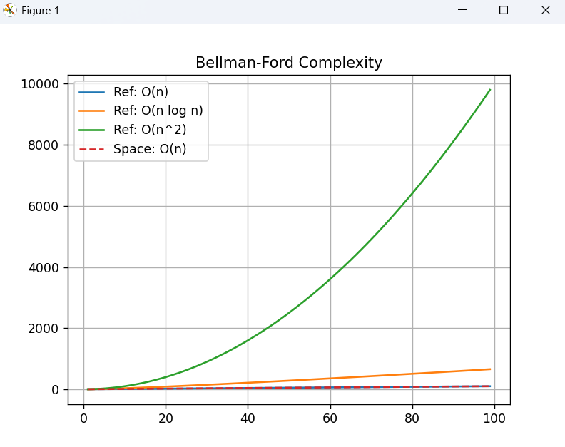
Github Link:- https://github.com/okayyymy15/MANYA_YADAV_ADA_ASSIGNMENTS

BACKTRACKING IMPLEMENTATION

1.Backtracking Algorithms:-
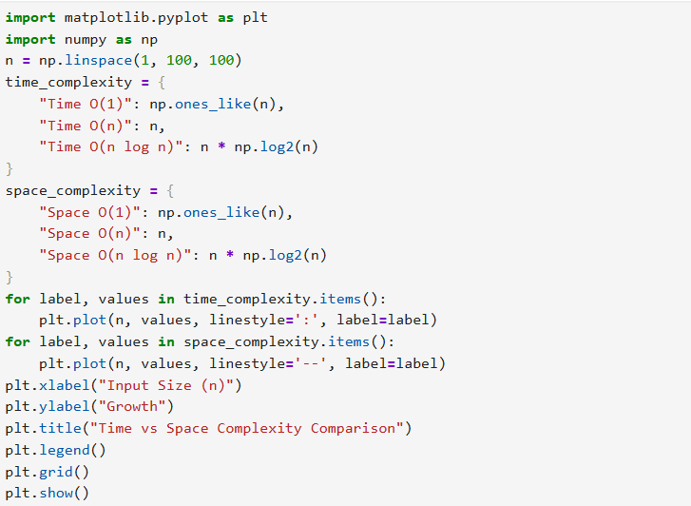
Output:-
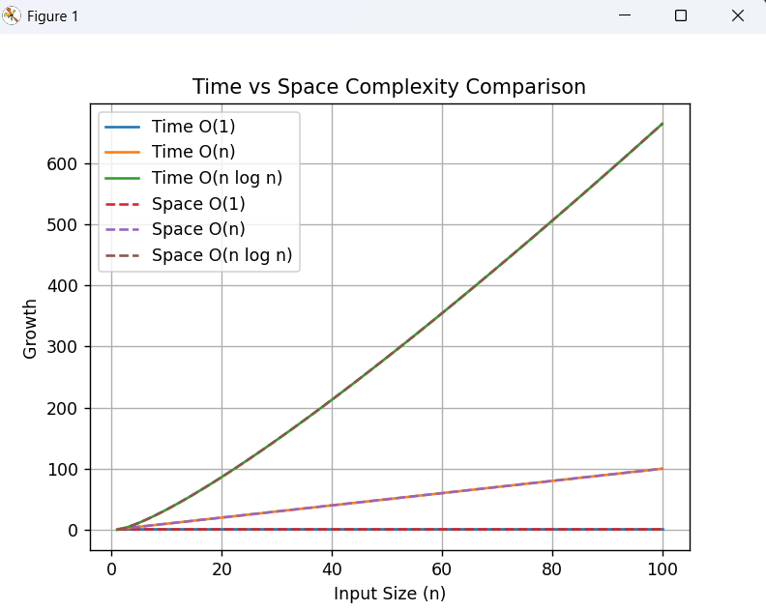

2.Branch and bound algorithms:-
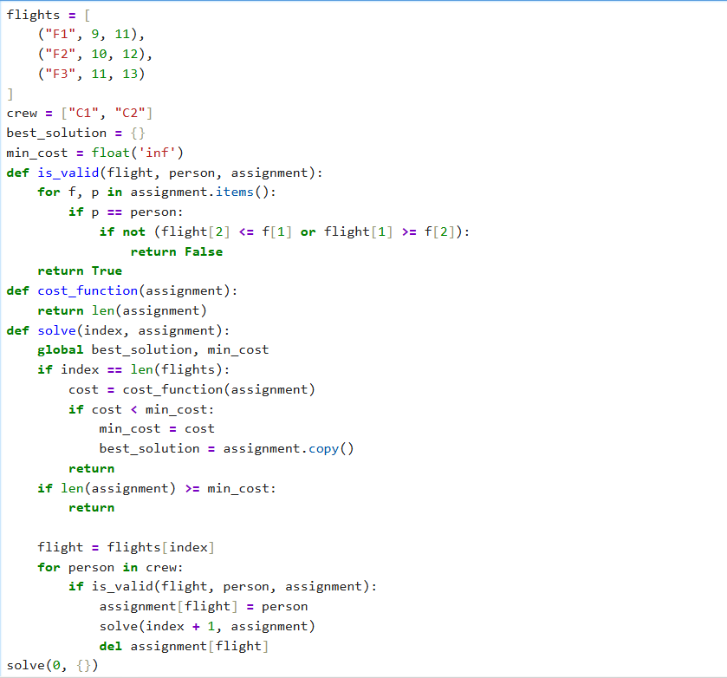

Output:-
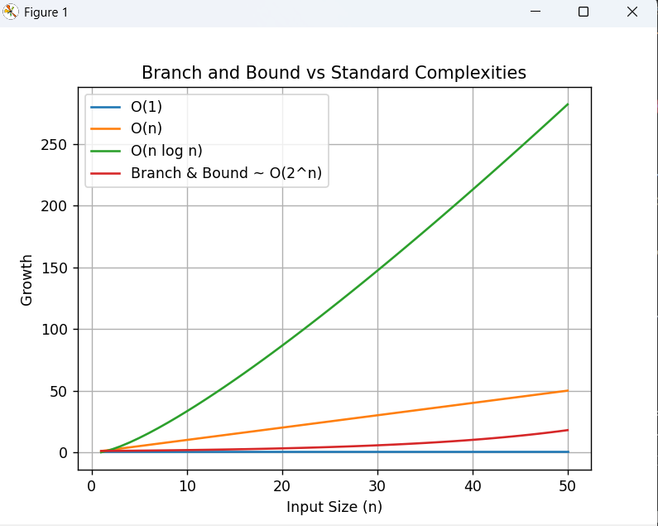

3. String Matching Algorithms:-
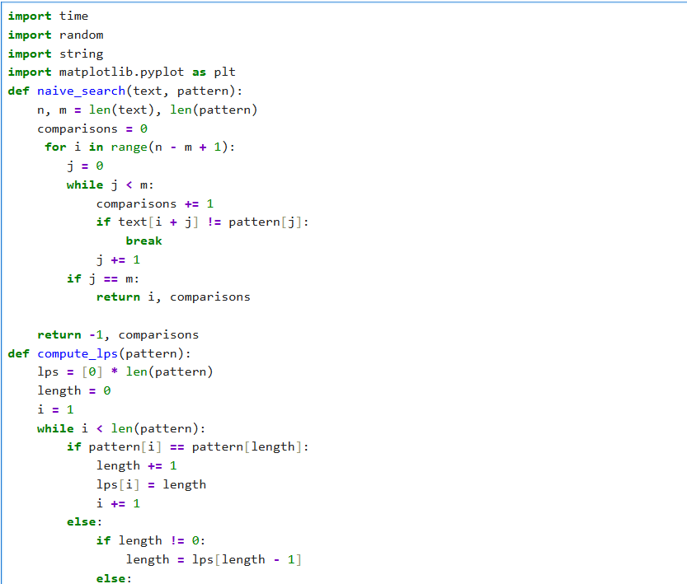
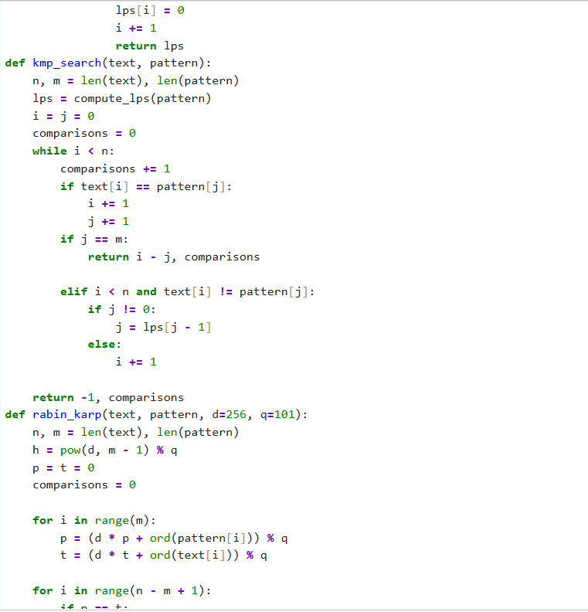
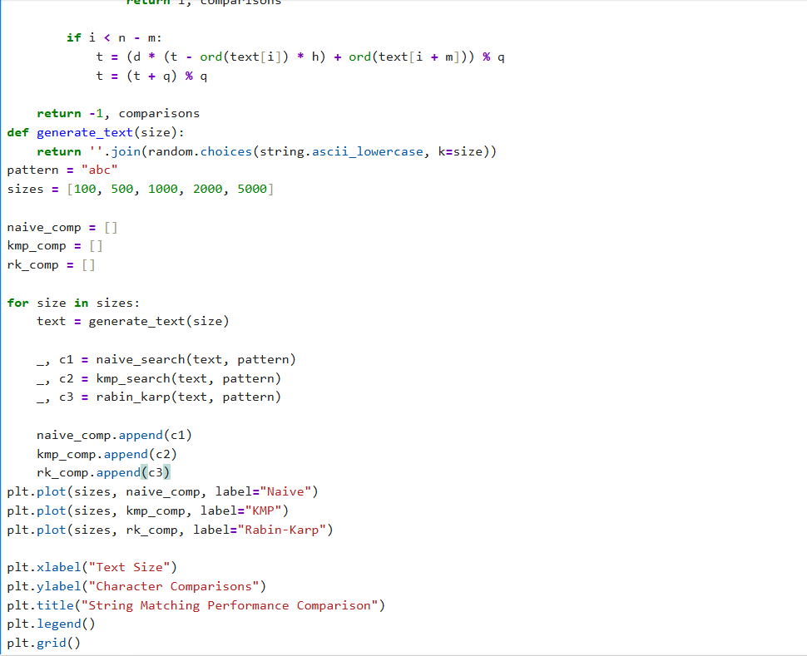
Output:-
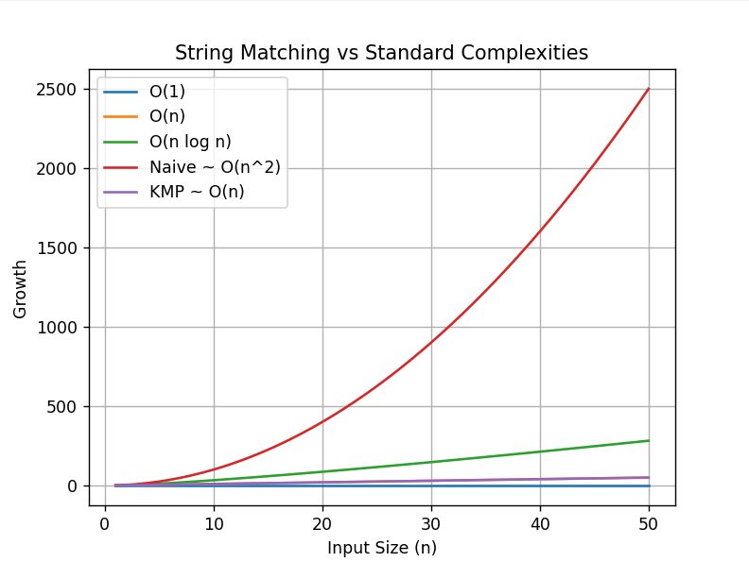

4. Experimental Comparison of String Matching :-
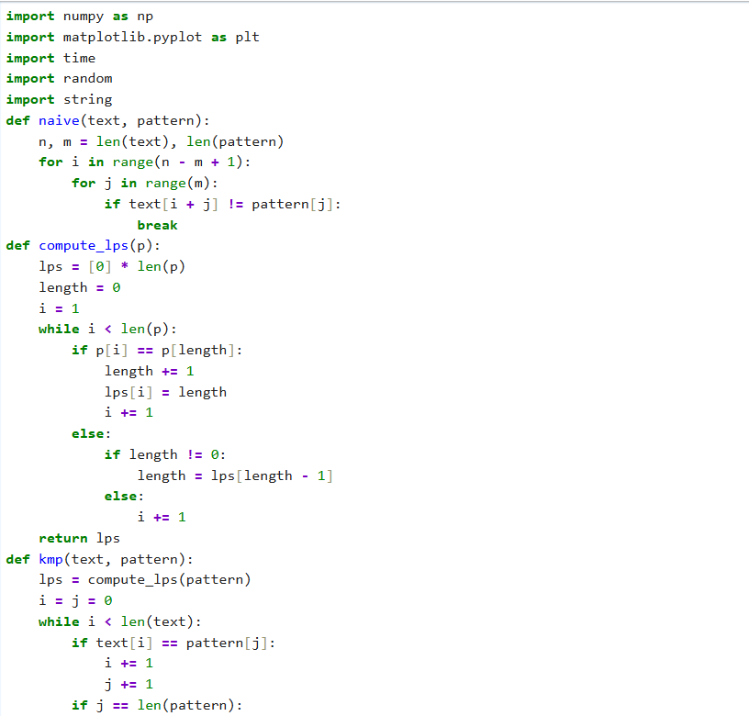
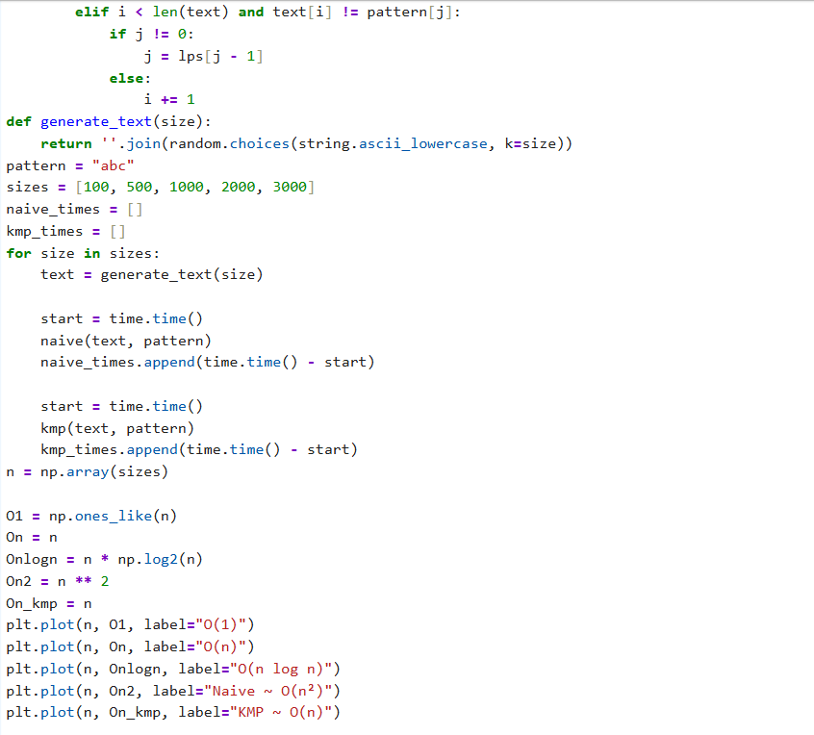
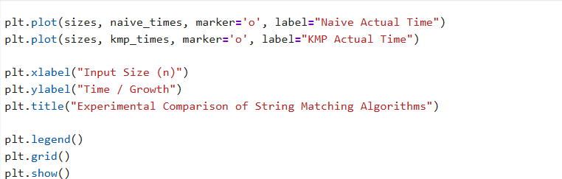

Output:-
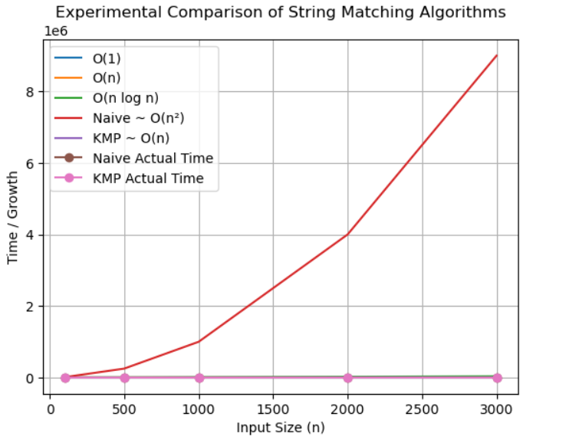

5. Conceptual Programming Tasks:-
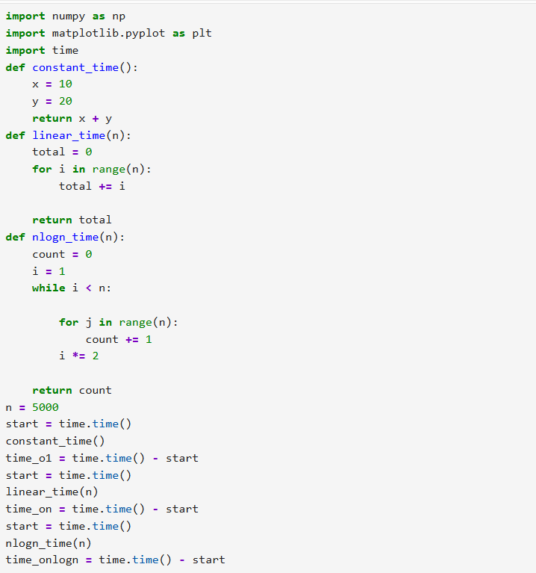
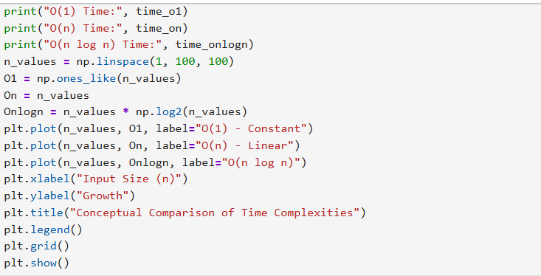

Output:-
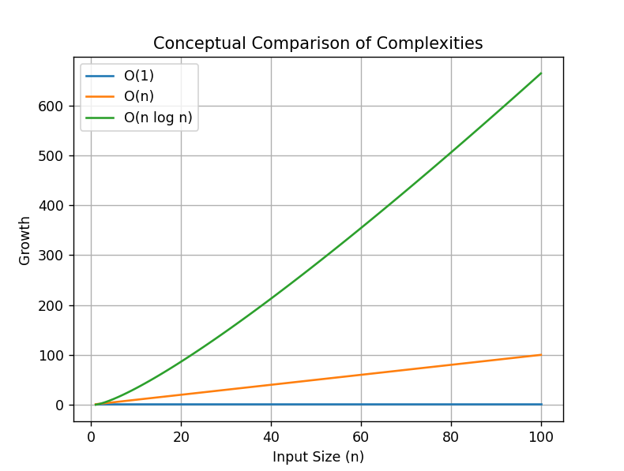
Github Link:- :- https://github.com/okayyymy15/M

CAPSTONE

INPUT MODELLING:
CODE:
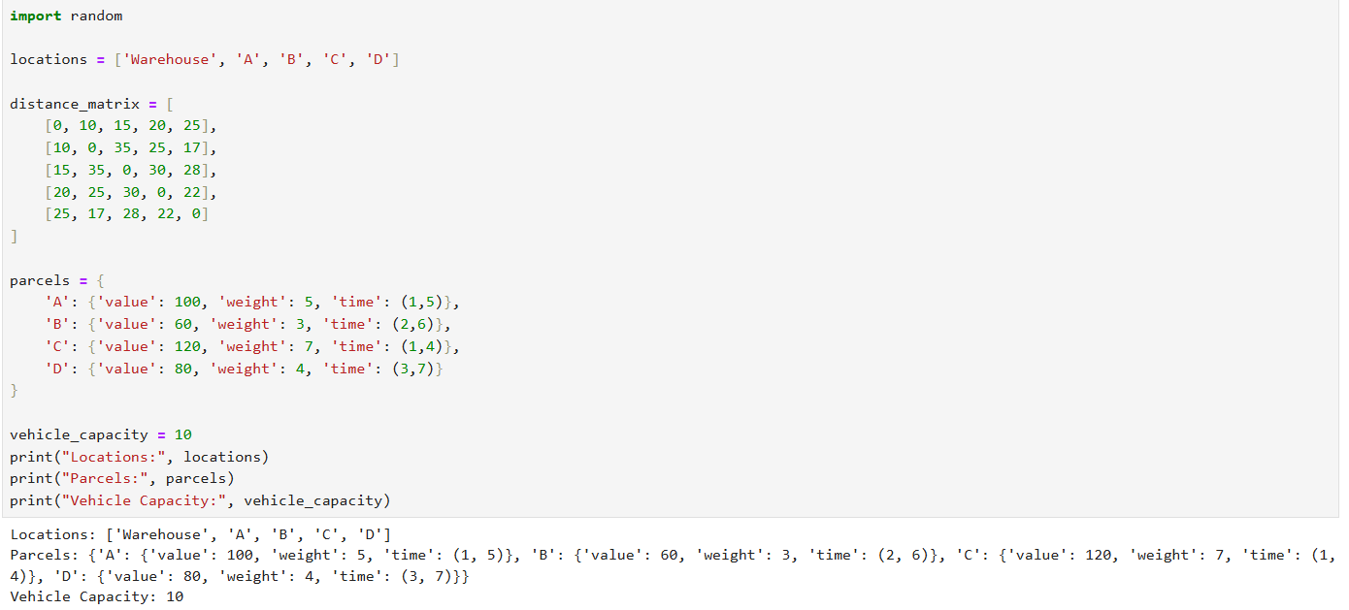
OUTPUT:

- ROUTE COST:
- CODE:- 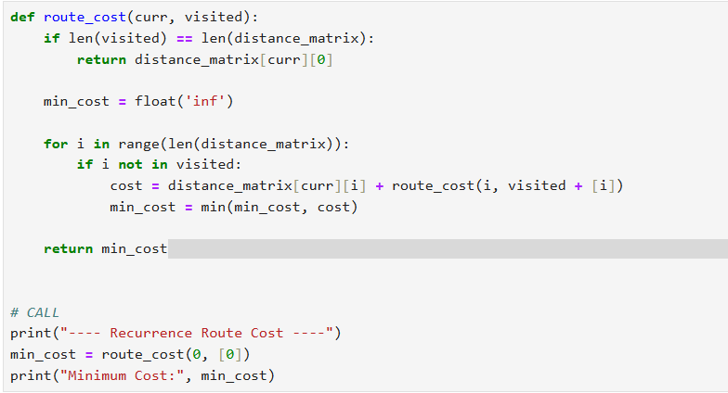

OUTPUT:
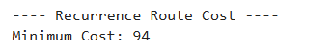

- This recursive approach explores all possible routes, ensuring optimal cost calculation. However, its exponential time complexity (O(n!)) makes it impractical for large inputs. It highlights the limitation of brute-force methods in real logistics systems.

- GREEDY FOR DELIVERY PLANNING
CODE:
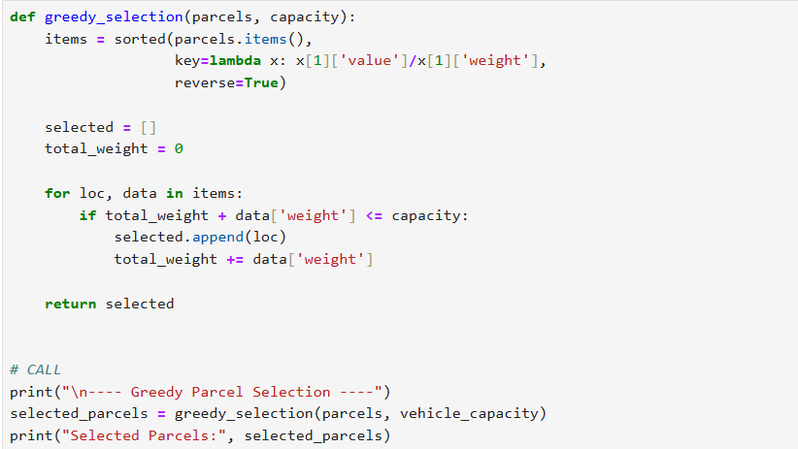

OUTPUT:
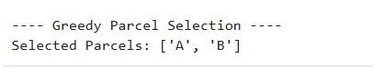

- The greedy strategy selects parcels based on maximum value-to-weight ratio, ensuring quick decision-making. While efficient (O(n log n)), it does not always guarantee a globally optimal solution, demonstrating the trade-off between speed and optimality.

- TIME WINDOW VALIDATION:
CODE:
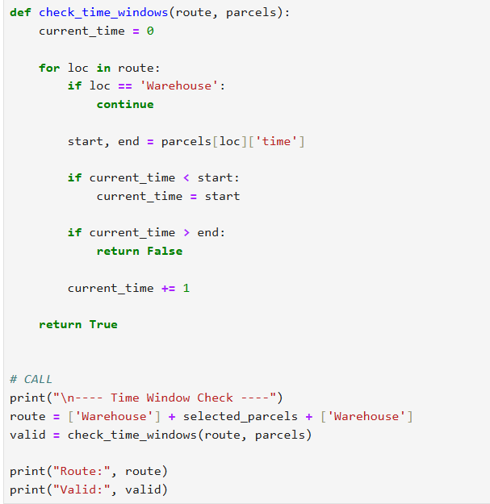
OUTPUT:
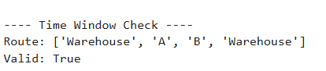

- This step ensures deliveries respect time constraints, making the solution realistic. It efficiently validates feasibility in linear time, showing how dynamic programming principles help in constraint satisfaction.

- DIJKSTRAS:
CODE:
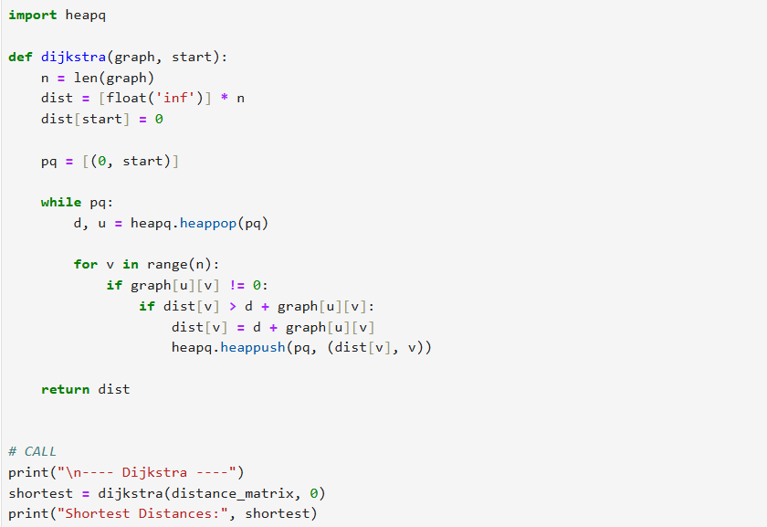
OUTPUT:
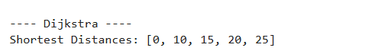

- Dijkstra’s algorithm efficiently computes shortest paths from the warehouse to all locations. It significantly reduces computation compared to brute force and is widely used in real-world navigation systems.

- MST:
CODE:
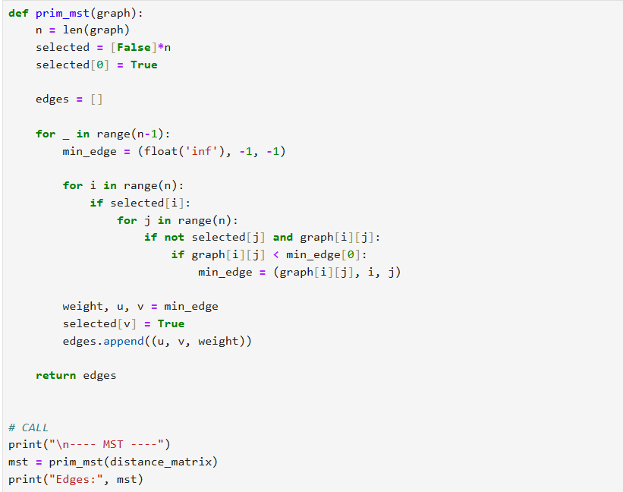
OUTPUT:
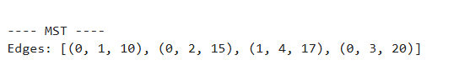

- The MST approach minimizes total connection cost between locations without forming cycles. It is useful for network design and clustering deliveries, though it does not guarantee an optimal travel route like TSP.

- TSP IMPLEMENTATION:
CODE:
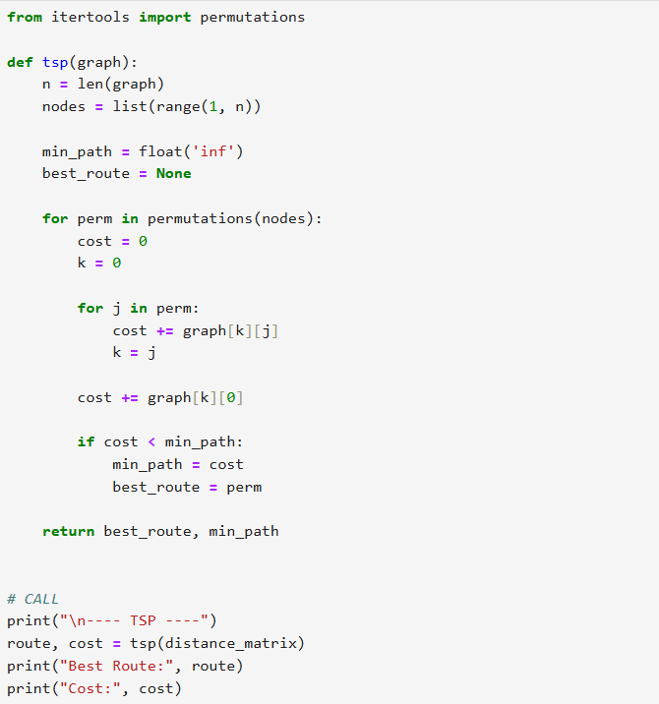
OUTPUT:
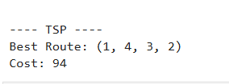

- TSP guarantees the optimal delivery route, but its factorial complexity makes it NP-hard. It becomes infeasible beyond ~10 locations, clearly demonstrating scalability limitations in real-world logistics.

- PROFILING:
CODE:
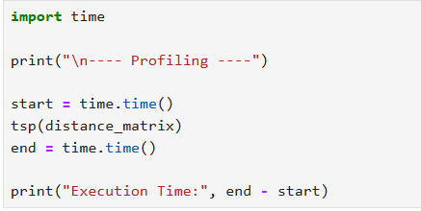
OUTPUT:
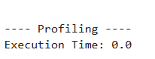

- Profiling highlights performance bottlenecks, especially for computationally expensive algorithms like TSP. It helps justify why more efficient or approximate methods are needed in practice.

- VISUALISATION:
CODE:
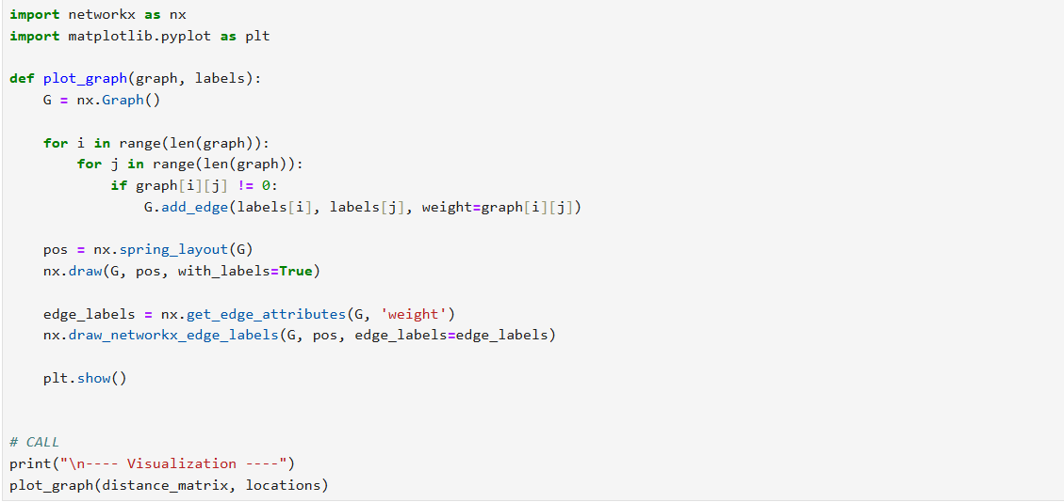
OUTPUT:
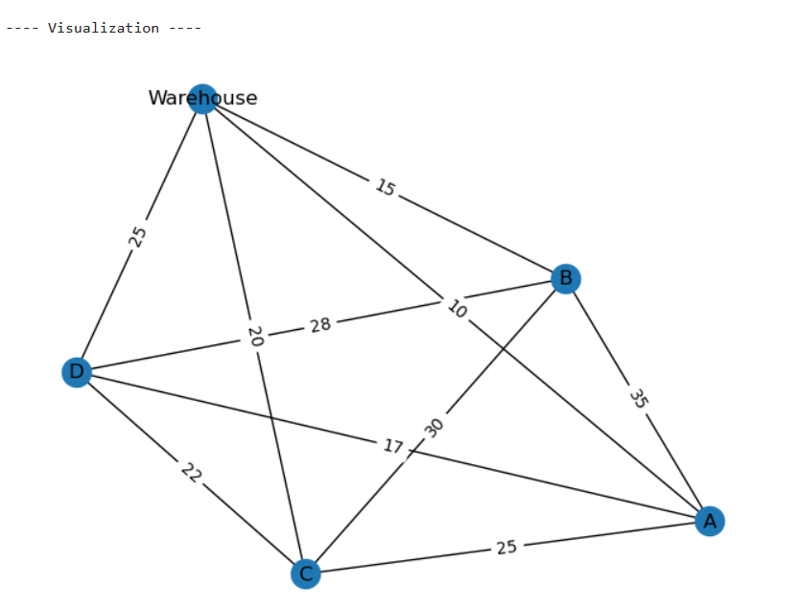

CONCLUSION:
This project demonstrates how multiple algorithmic paradigms—recursion, greedy, dynamic programming, graph algorithms, and NP-hard problem solving—can be integrated to solve a real-world logistics problem. While optimal solutions like TSP provide accuracy, practical systems rely on faster approximations due to scalability constraints

