
ANALYSIS OF DESIGN AND ALGORITHMS

CAPSTONE PROJECT

Submitted by: MANYA YADAV
Course : B.Tech CSE Data Science
Semester : IV
Roll No : 2401420012
Submitted To: Aarti Sangwan

- INPUT MODELLING:
CODE:
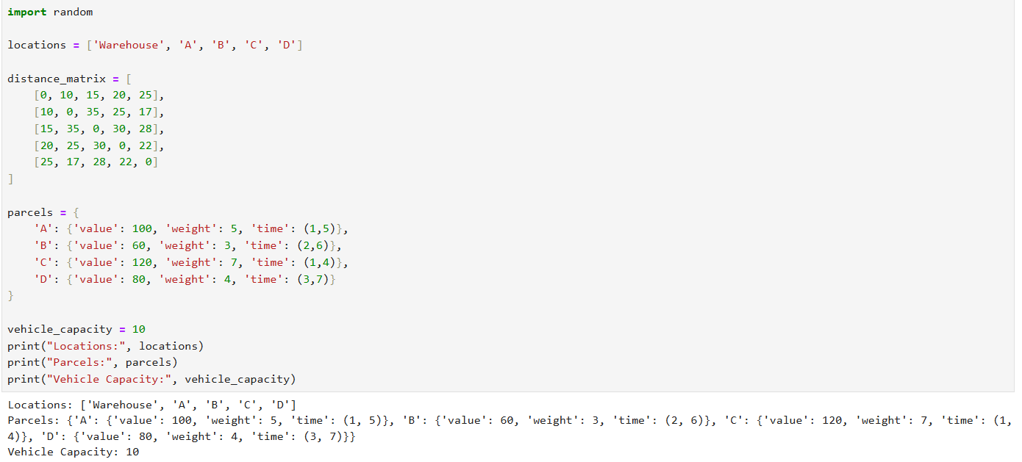
OUTPUT:

- ROUTE COST FUNCTION:
CODE:- 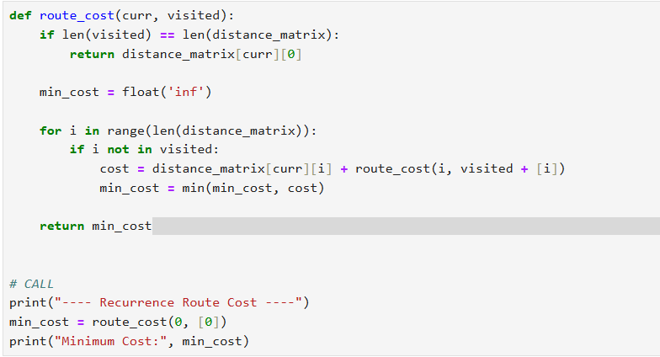

OUTPUT:
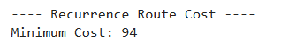

- This recursive approach explores all possible routes, ensuring optimal cost calculation. However, its exponential time complexity (O(n!)) makes it impractical for large inputs. It highlights the limitation of brute-force methods in real logistics systems.

- GREEDY FOR DELIVERY PLANNING
CODE:
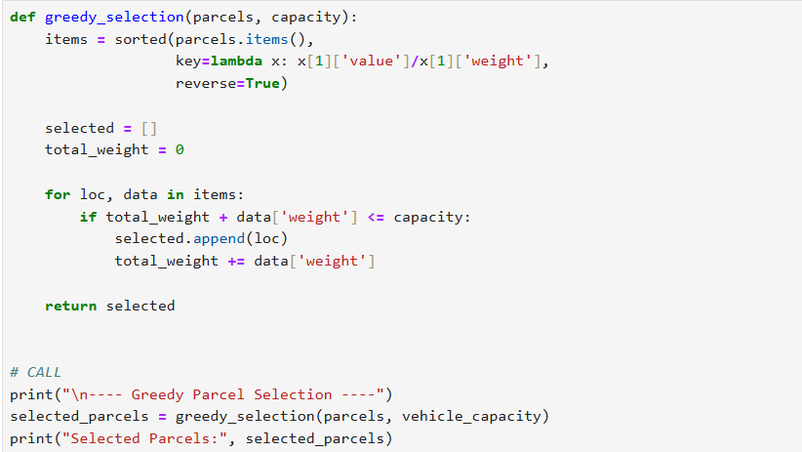

OUTPUT:
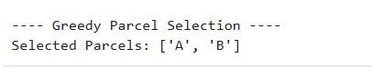

- The greedy strategy selects parcels based on maximum value-to-weight ratio, ensuring quick decision-making. While efficient (O(n log n)), it does not always guarantee a globally optimal solution, demonstrating the trade-off between speed and optimality.

- TIME WINDOW VALIDATION:
CODE:
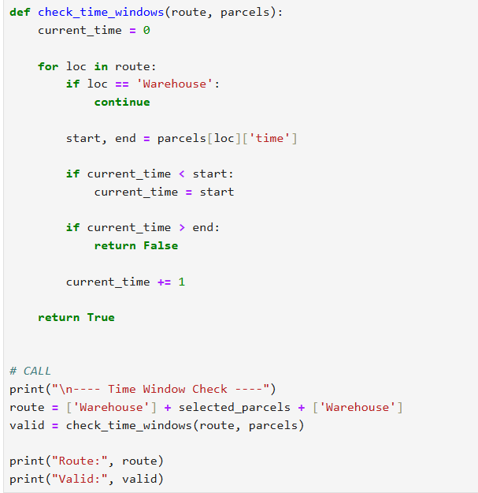
OUTPUT:
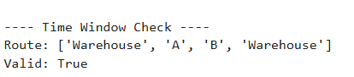

- This step ensures deliveries respect time constraints, making the solution realistic. It efficiently validates feasibility in linear time, showing how dynamic programming principles help in constraint satisfaction.

- DIJKSTRAS:
CODE:
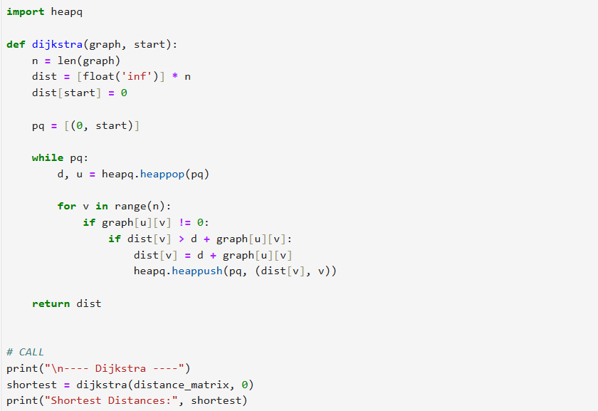
OUTPUT:
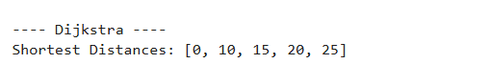

- Dijkstra’s algorithm efficiently computes shortest paths from the warehouse to all locations. It significantly reduces computation compared to brute force and is widely used in real-world navigation systems.

- MST:
CODE:
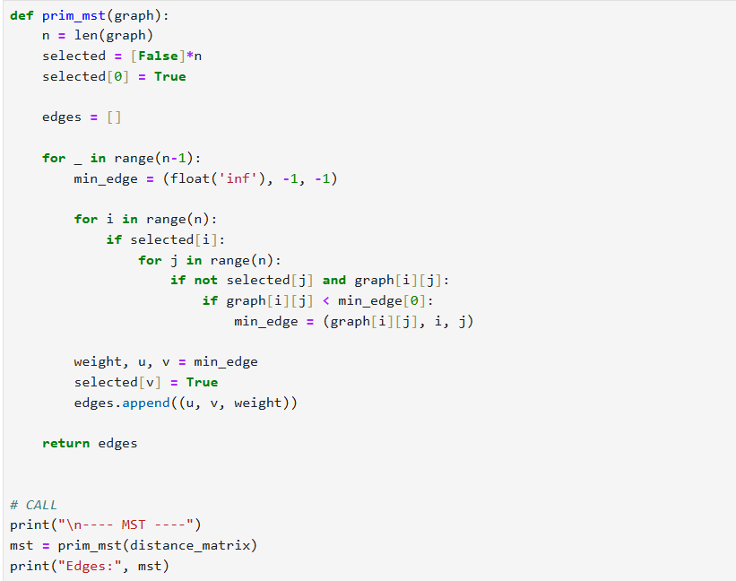
OUTPUT:
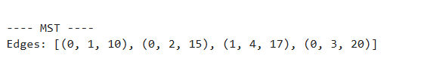

- The MST approach minimizes total connection cost between locations without forming cycles. It is useful for network design and clustering deliveries, though it does not guarantee an optimal travel route like TSP.

- TSP IMPLEMENTATION:
CODE:
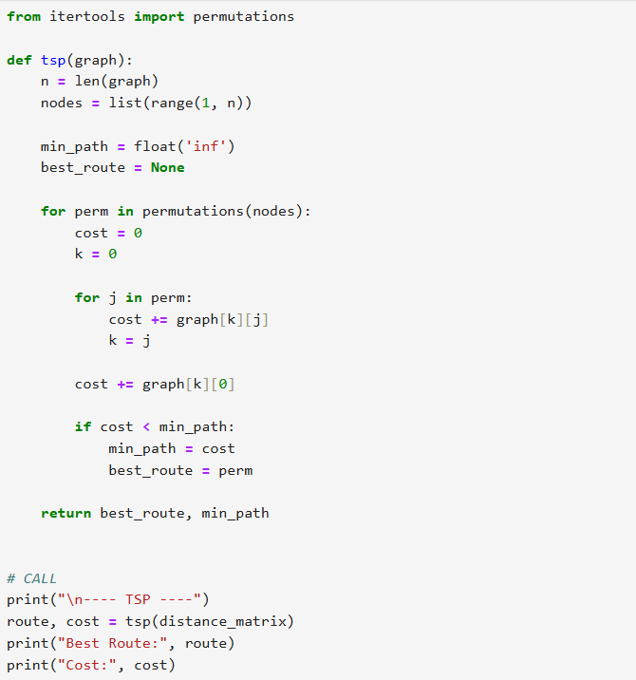
OUTPUT:
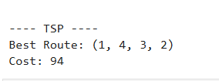

- TSP guarantees the optimal delivery route, but its factorial complexity makes it NP-hard. It becomes infeasible beyond ~10 locations, clearly demonstrating scalability limitations in real-world logistics.

- PROFILING:
CODE:
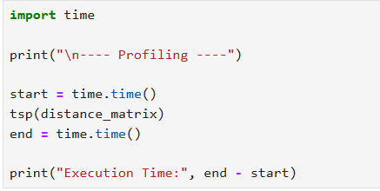
OUTPUT:
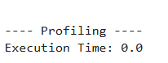

- Profiling highlights performance bottlenecks, especially for computationally expensive algorithms like TSP. It helps justify why more efficient or approximate methods are needed in practice.

- VISUALISATION:
CODE:
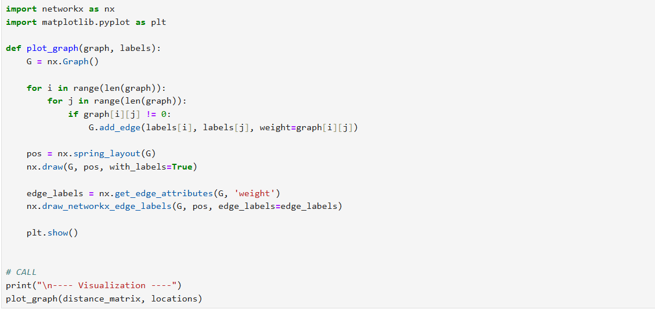
OUTPUT:
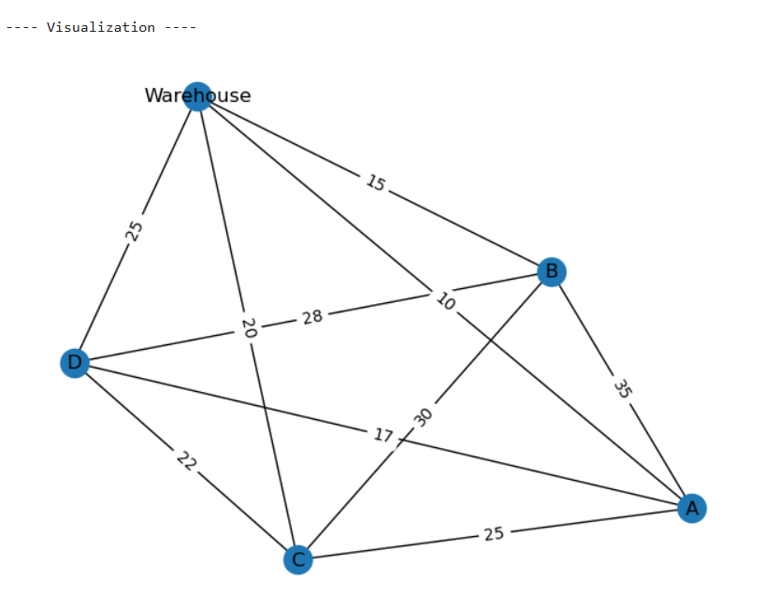

CONCLUSION:
This project demonstrates how multiple algorithmic paradigms—recursion, greedy, dynamic programming, graph algorithms, and NP-hard problem solving—can be integrated to solve a real-world logistics problem. While optimal solutions like TSP provide accuracy, practical systems rely on faster approximations due to scalability constraints.
GITHUB: https://github.com/okayyymy15/MANYA_YADAV_ADA_ASSIGNMENTS

