1. In Experiment 1, estimate the probability of winning $80 within 1000 sequential bets. Explain your reasoning.

In the first experiment, each time we win the bet we earn $1 considering the losses happened before the winning trial. So, to earn $80 it is required to win 80 of 1000 bets. The possibility of winning each bet is around 0.47 and therefore the possibility of winning $80 with the strategy defined is very close to 1. Exact number can be calculated using binomial distribution or the normal approximation to binomial distribution.

2. In Experiment 1, what is the expected value of our winnings after 1000 sequential bets? Explain your reasoning.

We can start calculating the expected amount of biddings. For each of the bets, the expected amount of winning is around $-0.05*bet_amount$. It is quite complicated to calculate the total bidding amount because it doubles each time we lose. So, I ran a simulation of 100.000 trials of 1000 sequential bets. $The mean of total bet_amount is \$753$. So, we can say the expected result is around -$39.63.

3. In Experiment 1, does the standard deviation reach a maximum value then converge or stabilize as the number of sequential bets increases?

Yes, as we can see at Figure below, the standard deviation has some peak points at the first 200 episodes but as the winning reaches to $80, the standard deviation converges to 0. The underlying reason of the peak points is that, using Martingale strategy a better can lose money exponentially. It converges to 0 because all of the trials end up at $80 in the first experiment.

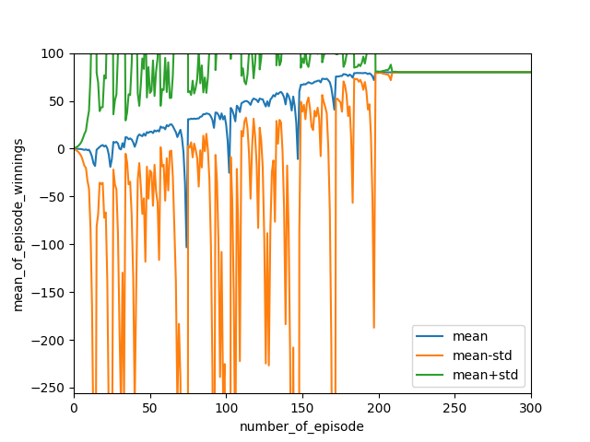

Figure 1: Mean of episode winnings and standard deviation

4. In Experiment 2, estimate the probability of winning $80 within 1000 sequential bets.

Except the experiments that end up -$256, almost all trials will end at $80. As we can see at the figure and the numpy array, the mean of 1000 trials end up at -$38. This is the result of $80*number of winnings-256*number of losings=-38.$ We can calculate the ratio of number of losses to number of winnings. It can be found that 238 of 1000 trials end up losing $256 and 762 of them end up winning $80. So, it can be estimated that the probability of winning $80 is 0.762.

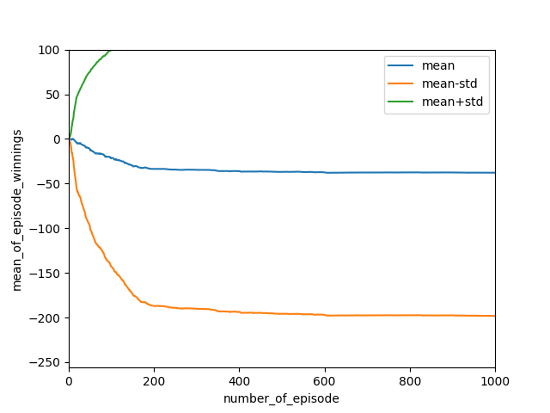

Figure 2: Mean of episode winnings and standard deviation ($256 limit)

5. In Experiment 2, what is the expected value of our winnings after 1000 sequential bets? Explain your reasoning.

The expected value of winnings after 1000 is around -$38. This is already calculated using Monte Carlo simulation and shown above at Figure 2.