Markov Decision Processes

Mehmet Oguz Kazkayasi
CS7641 – Assignment 4
mkazkayasi3@gatech.edu

Abstract

Two different MDP problems (Frozen Lake and Forest Management) in different sizes are solved using Value Iteration, Policy Iteration, and Q-Learning algorithms and the parameters of these algorithms are optimized for the best result in the given environment. The results and the behaviors of the algorithms on different environments are observed and analyzed.

1. Introduction to Environments

1.1. Frozen Lake

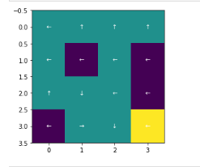
Frozen Lake [1] is a grid-world environment, where the agent tries to go from left-up grid to right-down grid. The environment has Holes, where episode ends with 0 reward and if the agent successfully goes to the right-down grid, the episode ends with 1 reward.
The purple color indicates holes and yellow color indicates the goal.
The agent can take actions (UP, LEFT, DOWN, RIGHT) but since the environment is stochastic, the resulting grid changes with probabilities. The agent ends up in the action’s direction with 0.33 probability and ends up either side of itself w.p. 0.33 each. For example, if the agent takes action UP, it goes UP w.p. 0.33, and LEFT w.p. 0.33 and RIGHT w.p. 0.33.
I have used two different sizes for this environment to observe the effect of the state size in different algorithms. The first one is 4x4, where there’s 16 states. And the second one is 16x16, where there’s 256 states.

1.2. Forest Management

These data are the results of a chemical analysis of wines grown in the same region in Italy but derived from three different cultivars. The analysis determined the quantities of 13 constituents found in each of the three types of wines. It is gathered from OpenML.org datasets [3].
All 13 features are continuous and the classification is multi-class classification consists of 3 different classes. This dataset has 1M entries and it is reduced to 5000 entries to make classification and optimization process faster and to reveal the differences among classifiers. (first 5000 is selected)
Using the features, the algorithms are used to predict the cultivar of each wine. The dataset is reasonably balanced and no class dominates any other.
This dataset presents four significant difference comparing to the UFC Fight Dataset. The first one is the Wine Dataset is balanced, unlike the UFC Dataset. The second is the number of features are much less
(13 vs. 156). And the third one is the Wine Dataset is multi-class classification, whereas the UFC Dataset is binary. The last difference is that UFC Dataset is very difficult to predict, unlike The Wine Dataset which is easier to get over 90% accuracy.
As the metric during hyper-parameter optimization process, f1_score (weighted) is used in the Wine dataset. f1_score (weighted) calculates f1_score for all classes (1 – 2 – 3). Then, it takes their weighted average according to their data count.

2. Frozen Lake 4x4

2.1. Value Iteration

I have used Value Iteration with different discount-rates, which affects the final values of non-terminal episodes as well as the epsilon value that is used to decide on the convergence of the algorithm.
For different discount-rates, I have used 0.5, 0.75, 0.9, 0.95, 0.99, 0.9999 values and for different epsilon values, I have used 1e-3, 1e-6, 1e-9, 1e-12, 1e-15 values. After convergence, I have tested the resulting policies in 1000 episodes and get the average reward they collect.

2.1.1 Discount-Rate and Its Effects on Algorithm and Policy

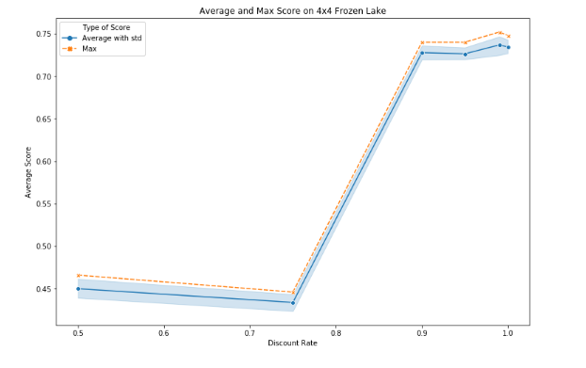
The first thing I’ve realized is the discount-rate has a very significant effect on the reward. Higher discount-rates results in better policies with better rewards.

The standard deviation is caused by different epsilon values, and the orange line shows the max of those.
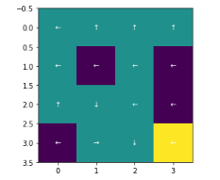
As it can be seen, the discount-rates over 0.9 results in over 0.7 average reward. It can be seen that since the goal far from some of the states, lower discount-rates can’t assign the optimal Values for those. Over 0.9 sigma, the Value Iteration does a good job on assigning optimal values and creating a good policy.
As it can be seen, in stochastic environment, the policy always tries to stay away from the holes and manages to arrive the goal at 75% of the time.
When compare the time and iterations spent with different discount-rates
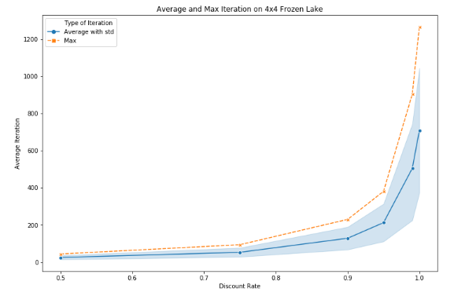
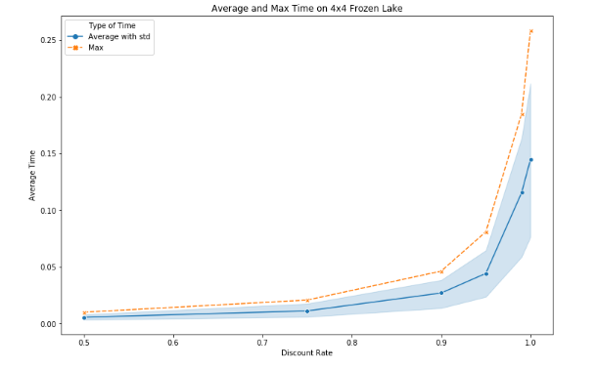
As it can be seen, the increasing discount-rate affects the iteration and time spent to create the policy exponentially. Considering the positive effect on rewards on this particular experiment, it seems viable to use a higher discount-rate for better results. Also, the maximum time spent is still 0.25 seconds with around 1200 iterations. So, for a 16 state environment, it makes sense to use a high discount-rate.

2.1.2 Epsilon Value and Its Effects on Algorithm and Policy

After observing the effects of the epsilon-value, it can be seen that for Value Iteration, discount-values dominates the reward of testing so that the effect of Epsilon value is difficult to observe.
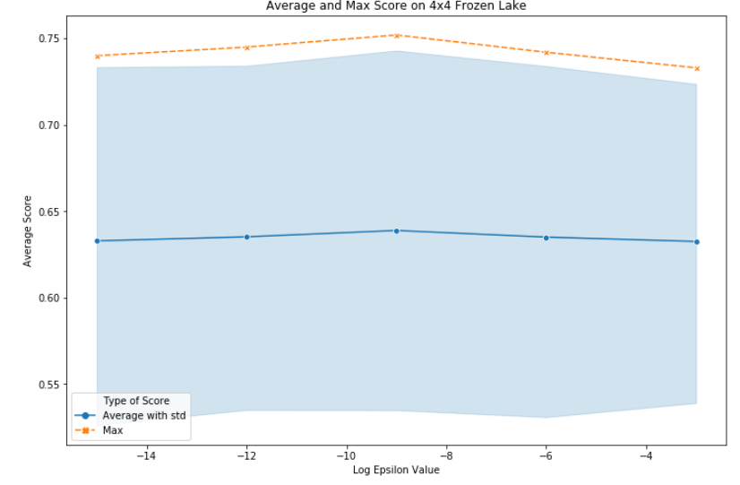
At x-axis log-values are used for epsilon

As it can be seen, different discount-rate causes a large standard deviation and 1e-0 epsilon value gets the max (seems the effect of randomization) reward. So, it can be observed that if a small enough epsilon value is used, it will be enough to get a good policy.
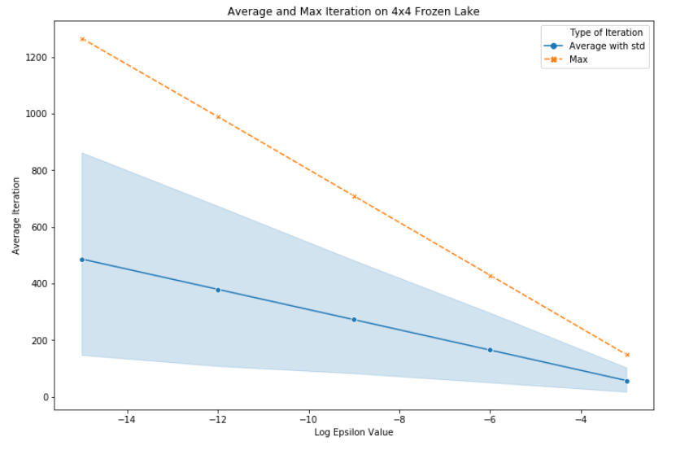
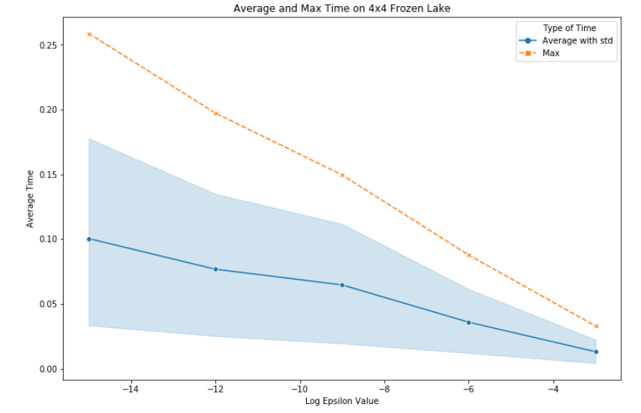
As it can be seen from iterations and time spent graphs for convergence in different epsilon values, the log(epsilon) value affects the time significantly. 1e-9, which gets the max reward, has a mean time close to 0.5, whereas 1e-15 takes twice as long time. For iterations, it is the similar case. Even though these time values (0.5sec vs 0.1sec) are so low to discuss. This would make difference in larger MDPs.

2.2. Policy Iteration

I have used the Policy Iteration from Sutton’s Reinforcement Learning [2] and I have used different epsilon values for the 2nd step (Policy Iteration). So, I had two different hyper-parameter: Discount-rate and Epsilon. I have used the same values as I used in Value Iteration and as a result I get the exact same policy in the better end of hyper-parameters.
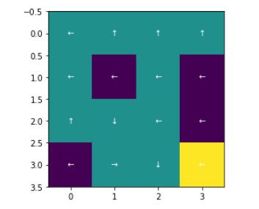
2.2.1 Discount-Rate and Its Effects on Algorithm and Policy

As the resulting policy is the same, the reward is similar to Value Iteration.
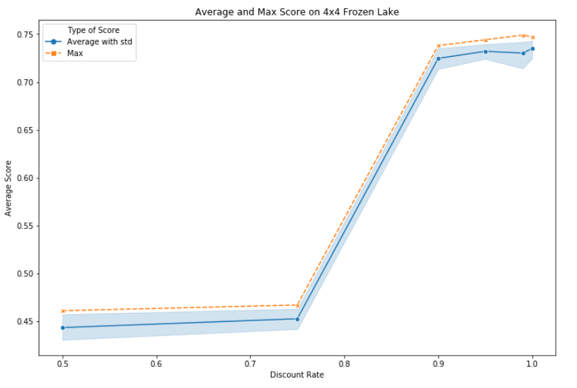
Over 0.9 discount-rate gets over 0.7 average reward, whereas under 0.75 is around 0.45. I have checked the time spent and iterations to compare with VI.
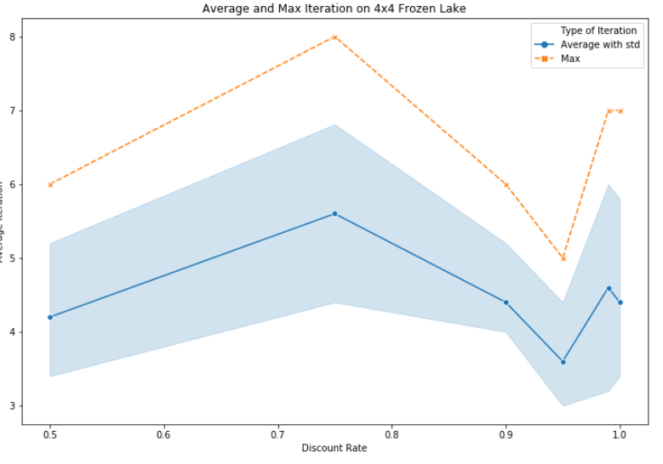
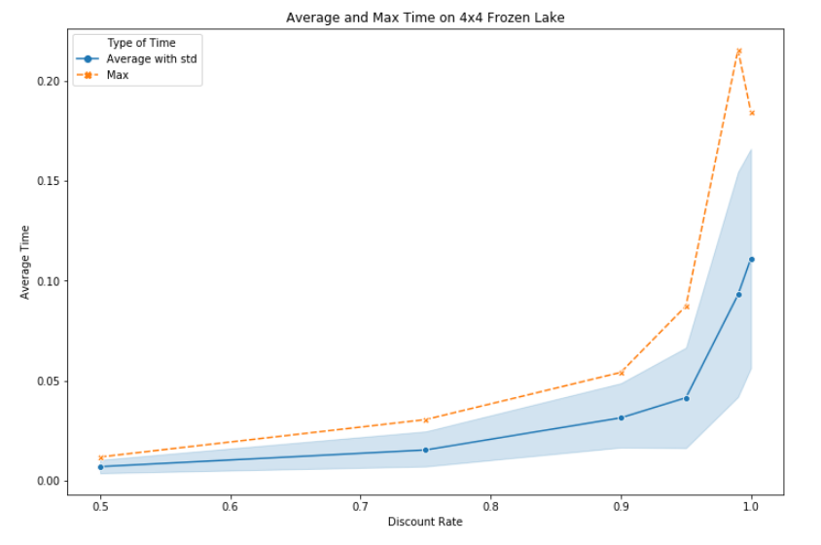
As it can be seen in the left-graph, the number of iterations for PI is much lower comparing to VI. And the discount-rate doesn’t affect it significantly. The max of iterations is 8, whereas VI converges over 1200 at its max.
On the other hand, it can be seen that discount-rate affects the time spent exponentially. But the time spent in general is below (close to it) VI, too. The max of VI takes 0.25 sec, and max of PI take around 0.22. In general, PI takes close but a little less time than VI.

2.2.2 Epsilon Value and Its Effects on Algorithm and Policy

The epsilon value, similar to VI, has less effect on the policy, but some more effect on time-spent. As they don’t indicate anything but randomness caused by discount-rate (and for space-efficiency), I am not adding the graphs for epsilon value. As long as a small enough epsilon value is used, it can be said that the only significant effect of epsilon value is on the time spent. Lower epsilon values makes PI longer to converge, but this doesn’t affect the iteration number (because the iteration is count when policy is improved) or the average reward the resulting policy gets.

3. Frozen Lake 16x16

Since the effects of different hyper-parameters are discussed in 2nd section, the differences in the larger grid-world environment will be analyzed in this section.
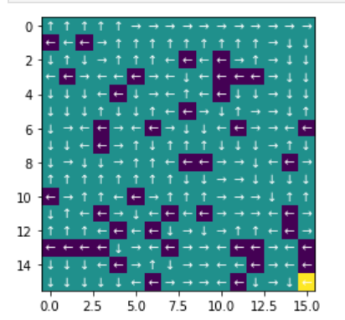
First of all, it can be said that, because a longer path should be taken by the agent, it is expected to have a lower reward on average.

3.1. Value Iteration
The first metric, I have analyzed is the average reward, which indicates how good the policy produced is.
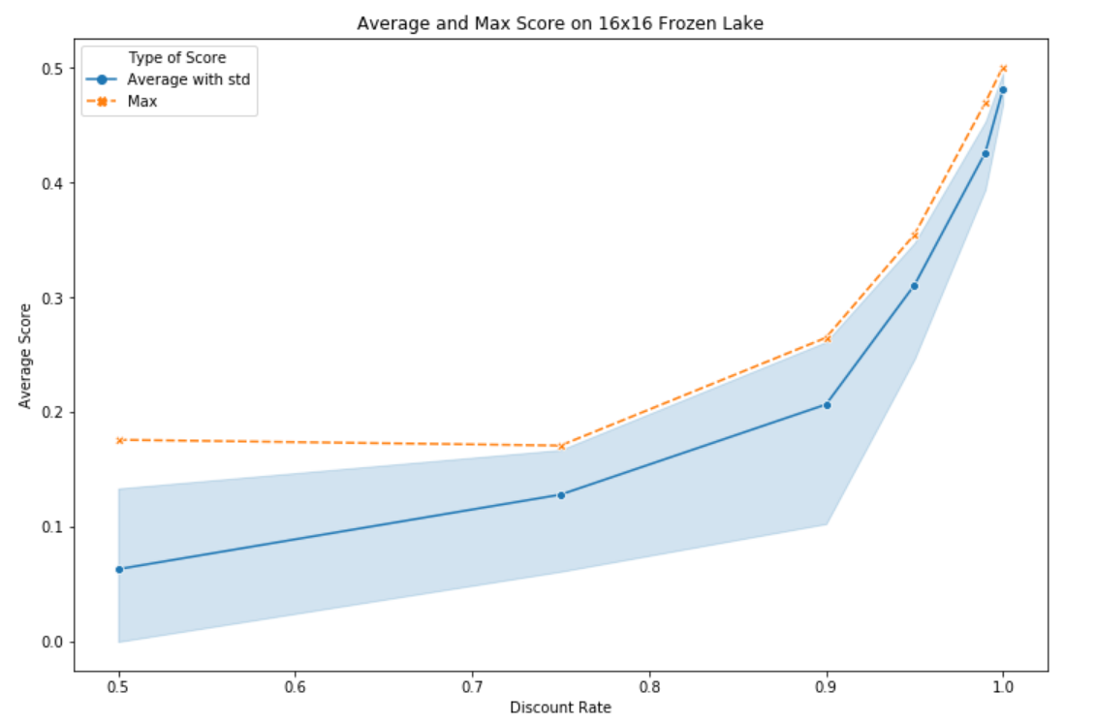
As it can be seen, the average reward is now around 0.5 at max. A significant difference between 4x4 and 16x16 is that now 0.9 discount-rate is not among the optimum values. In 4x4, over 0.9 discount-rate was enough to get the best policy. Now, it can be seen that 0.9999 makes a big difference comparing to 0.99.
This proves that larger discount-rates results in better Values for states and as the environment gets larger, we need larger values.
Here I took a step and tried discount-rate=1 at 16x16 Frozen-Lake.

As the time-spent and iterations for 16x16, it can be seen that higher discount-rate affects more than it does 4x4.
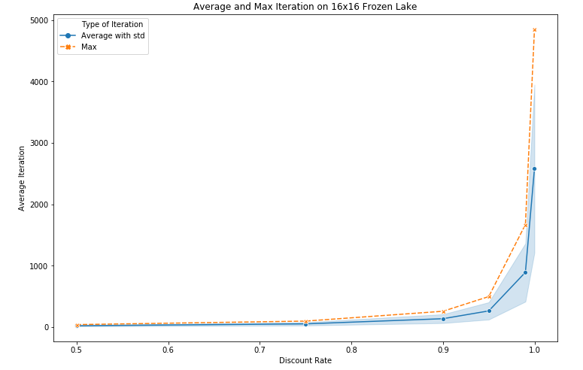
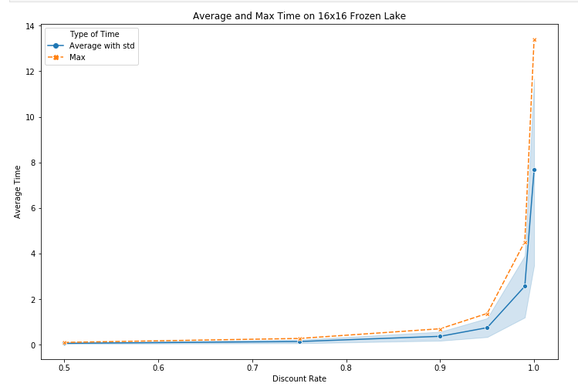
As it can be seen, even though the graphs have similar shapes, the values are quite different. The max time spent for 16x16 is 14 seconds, where it was 0.25 seconds for 4x4. This shows that larger environments needs much larger convergence time. Also, the iterations needed increases from 1200 to 5000 (at max) as well.

Since the dataset consists of so many floating point data fields, I have directly used Euclidean distance to make the clustering.
First, I have tried to come up with the best k on clustering using Error Sum of Squares (SSE). I have tried k=2 to 30 and got this graph.
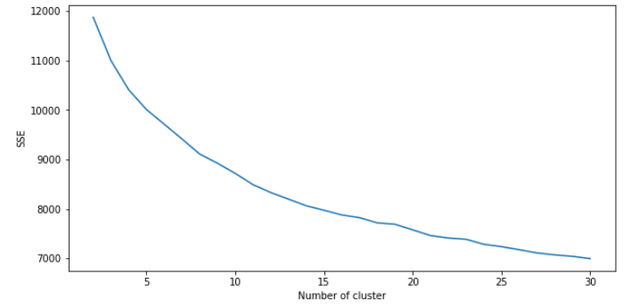
As it can be seen from the graph, it is difficult to come up with an elbow point so that I have proceeded to other methods. I have used Silhouette and Homogeneity Scores
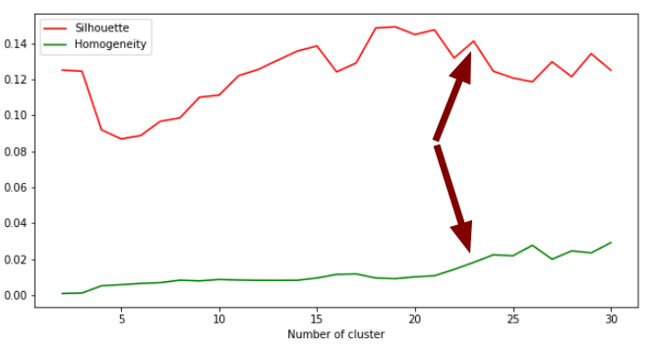
The homogeneity score is almost monotonously increasing as expected and the silhouette score has some peaks that indicates a good clustering. It can be seen between 18 and 21 seems to be good for Silhouette scores. But k=23 is better for the combination of Silhouette and Homogeneity scores. So I have chosen k=23.
This dataset includes information about two different fighters in a row, mainly. So, it can be expected to have clusters that describes the fighters with different styles of fighting and some types might have advantage on others. So, n=23 seems to be a good number of clusters since it includes both fighters and some information regarding the match (such as if it is a title-decider or not).

Comparing Clusters with Classes

I have made 2 clusters with K-Means to check if they corresponds to the classes of the dataset.
The accuracy score of K-Means labels to the real classes was only 0.57, which means it didn’t make a good representation on the classes. This is because the dataset was so complex with over 100 columns.

2.1.2 EM Algorithm

The EM algorithm might result in different numbers of clusters because of the Gaussian Mixtures’ variances. It can capture data in different shapes so it is expected to have a different optimal number of clusters comparing K-Means algorithm.
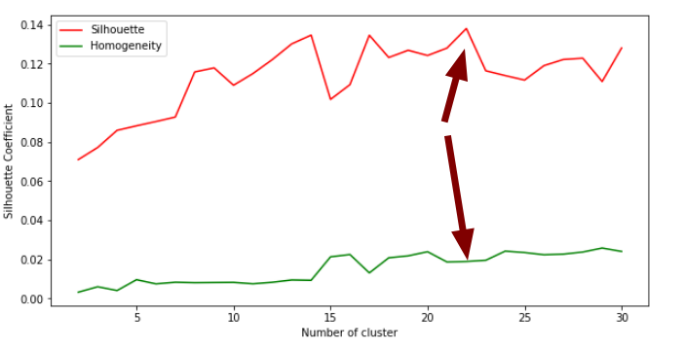
I have directly used the used Silhouette and Homogeneity Scores on EM Algorithm because SSE doesn’t make a lot of sense because of different covariance matrices.

k=22 seems to be a candidate on EM Algorithm because we have a peak on Silhouette score on 22 and its homogeneity score is on the higher side. Interestingly, EM and K-Means bring so similar number of clusters. Even the Silhouette scores are close to 0.14 on both. I believe Since EM gives labels in the end (according to instances probabilities), it brought similar results with K-Means.

Comparing Clusters with Classes

I have made 2 clusters with EM to check if they corresponds to the classes of the dataset.
The accuracy score of EM labels to the real classes was only 0.5019. This means EM labels didn’t fit, too. Its accuracy is lower but this is probably because of the randomness.

2.2. The Wine Dataset

Comparing to the UFC Dataset, the Wine Dataset was easier to discover using simpler algorithms. So, I have higher expectation from clustering algorithms in the beginning such as discovering the classes.

2.2.1 K-Means Clustering

The Wine Dataset consists of floating point fields so I have used Euclidean distance metric on this dataset, as well.
First I have tried the elbow method on SSE.
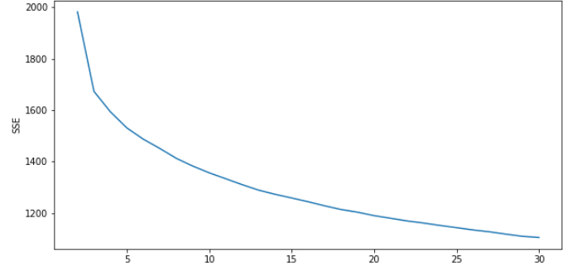
Again this method was not so helpful e on deciding the number of clusters but k=3 seems to be a candidate so I have used Silhouette and Homogeneity Scores for more help.

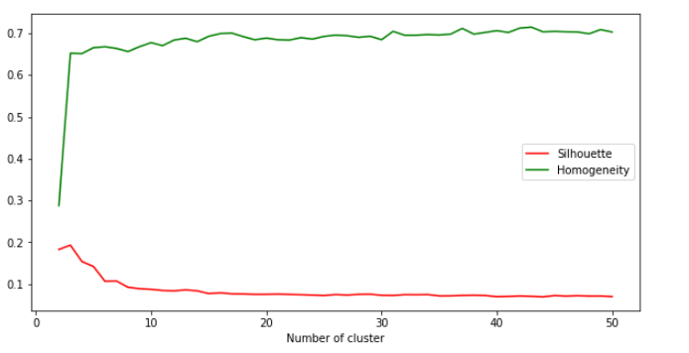
This graph also points at k=3, clearly. So, I have used k=3 on K-Means.

Comparing Clusters with Classes

The wine dataset has 3 classes and K-Means also got 3 clusters as optimum. When checked the accuracy score between clusters and labels, it got a very interesting 0.9034 accuracy, which means the clusters captured the label, amazingly almost as good as a supervised learning algorithm.
I think this is mainly because the dataset consists of only 13 columns and probably all of them affects the labels closely to each other.

2.2.2 EM Algorithm

I have directly used the used Silhouette and Homogeneity Scores on EM Algorithm because SSE doesn’t make a lot of sense because of different covariance matrices.
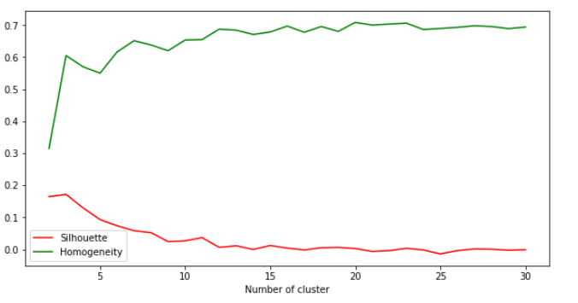
This graph also points out k=3, which was expected after the K-Means has a optimum k=3. This means the dataset is distributed into three different clusters.

Comparing Clusters with Classes

Unexpectedly, the EM didn’t give a good result when compared with labels even though its Homogeneity score was almost as high as K-Means. It captured only 0.5648 of the labels correctly and when analyzed manually, I have realized that one of the labels are detected quite good but two others are not and this is probably because EM has more flexibility and it captured some different clusters that doesn’t fit the labels.

3. Dimensionality Reduction Algorithms

3.1. PCA Algorithm

3.1.1. UFC Dataset

UFC Dataset has 156 features, so a dimensionality reduction could get rid of a great deal of them and still capture most of the information in the dataset.

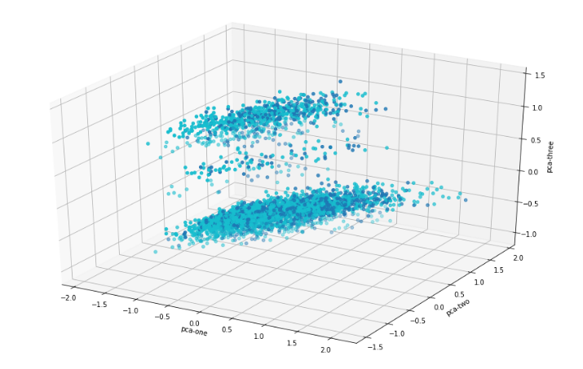
I have tried from 2 to 150 dimensions on PCA and captured the reconstruction errors along with the explained variance ratio. PCA could get 0.9 of the explained variance with 30 dimensions and 0.98 of it using 72 dimensions. I have used the 72 dimensions, which reduces the feature numbers by half and capturing 98% of the explained variance.

When drawn first 3 components of PCA, it can be seen that the points are not separated in 3 dimensions.

3.1.2. Wine Dataset

The Wine Dataset has only 13 features and I have tried from 2 to 13 dimensions in PCA and captured the reconstruction errors along with the explained variance ratio.
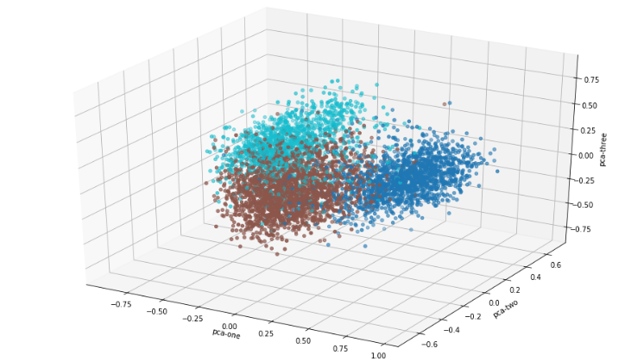
8 dimensions could get the 0.93 of the explained variance ratio and it uses almost half as many features.
As it can be seen, the first three components of the PCA makes a quite good separation among the labels.

3.2. ICA Algorithm

3.2.1. UFC Dataset

For ICA algorithm, I have used the reconstruction error to determine on the number of dimensions. After testing 1 to 150 dimensions on UFC Dataset, I got this graph of reconstruction error.
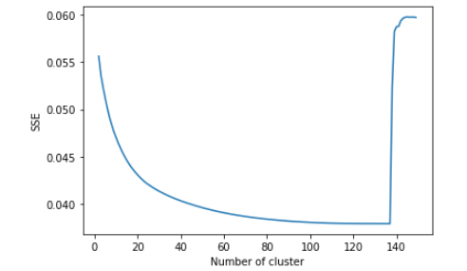
I have chosen 80 components because it gets flat after there and it uses quite less features comparing to the original dataset.

3.2.2. Wine Dataset

I have checked 1 to 13 (all) features on Wine Dataset and got this graph on reconstruction error.
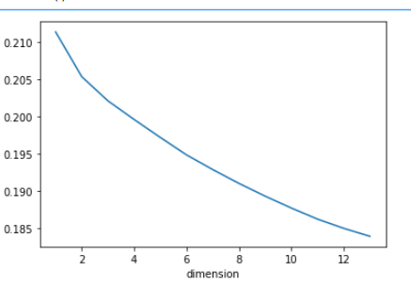
It seems like a linear line that goes down but 3 seems like a good candidate and the reconstruction error seems like not changing a lot. So, I wanted to try 3 dimensions to see the ability of ICA when it comes to compress the information to such a low number of dimensions.

3.3. Randomized Projection

3.3.1. UFC Dataset

The reconstruction error of randomized projection was quite linear. So I made an arbitrary choice of 40 dimensions on this dataset.
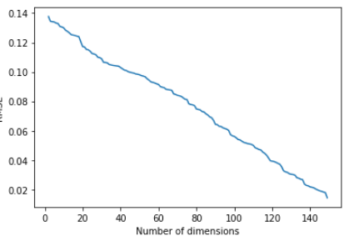
3.3.2. Wine Dataset

I have checked 1 to 13 (all) features on Wine Dataset and got this graph on reconstruction error.

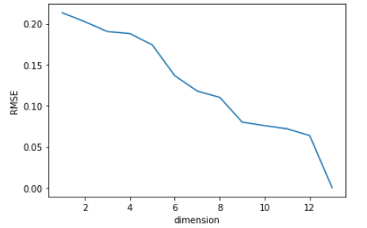
After 9 dimensions, the RMSE doesn't drop down until 13, so I have chosen 9 dimensions on randomized projection.

3.4. Feature Selection

As last, I have used SelectKBest from the model and selected 40 best from UFC Dataset and only 5 from Wine Dataset to observe in next steps.

Using the best parameters (ccp_alpha=0.003 and criterion=`gini`), it can be seen that both the training

4. Clustering on Dimensionality Reduction Algorithms

I have done all 16 clustering algorithms on Dimensionality Reduction algorithms and will write here the interesting results instead of analyzing one by one because there are 16 of them and they can be found in the code.

First of all, in general the clustering algorithms had similar results on processed (dimensionality reduction) data, comparing to the original data.

When I ran K-Means on PCA algorithm, I have realized that, it got a better result on Silhouette score comparing to the original data at 16 clusters, which was unexpected.

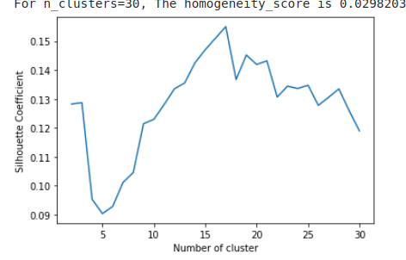
I think this is because the data became easier to cluster after projected by PCA algorithm.

But the largest Silhouette score is obtained by select K Best algorithms processed data.
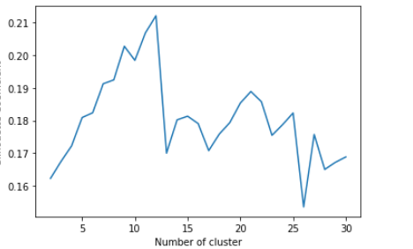

It resulted in over 0.21 Silhouette score, which is the highest for the UFC Dataset. I think this is because the less important features are not interfering with the clustering algorithms so that it makes a better job. So that, we can say that feature selection can increase the performance of Clustering if done correctly.

The resulting clusters differ a bit comparing to the original clusters and this is because some of the information is lost and the data is simply projected to some other dimension. But, the difference is not so much because most of the information is kept in the dataset.

5. Neural Networks on Wine Dataset after Dimensionality Reduction

I have chosen the wine dataset because it was very promising with clustering vs label and it has over 0.9 accuracy with original dataset Neural Network setup. So, it will be better to make comparisons.

5.1. PCA Algorithm

As stated in 3rd section I have used 8 dimension in the PCA algorithm, which covered 93% of explained variance ratio.

First I have used the sklearn’s built-in Neural Network setup and got a 0.92 f1-weighted score.
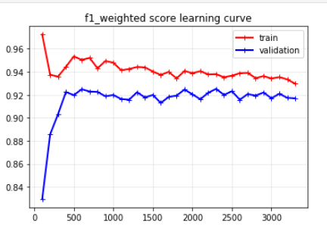
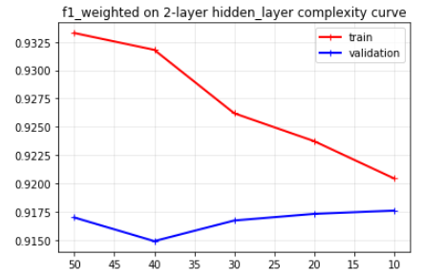
After plotting the learning curve, it can be seen that the bias and variance are relatively balanced. I have used 2 hidden layers with 60 nodes each in Assignment 1. So, I wanted to explore the number of nodes using complexity analysis.
As it can be seen in the graph, less number of nodes (10 in this case) worked better for the validation set. This is probably because less features caused a simpler state space that can be captured with less nodes.
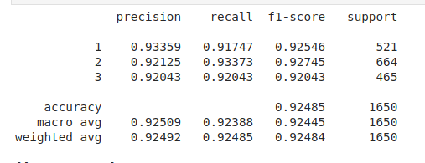
After this step, I have tested on the test set to see the results.
8 features created by PCA algorithm could get 0.9248 weighted f1 score, comparing to original dataset’s 0.9439 weighted f1-score.
Considering using almost half as many features, this seems to be a good result but it is still a significant lose for a supervised learning algorithm.

5.2. ICA Algorithm

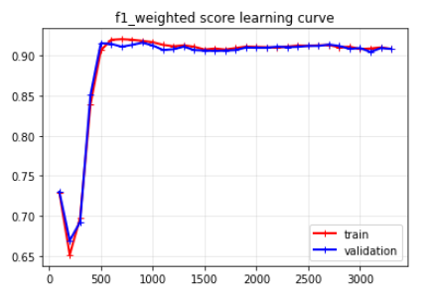
Comparing to PCA’s 8 features, I have used only 3 features in ICA Algorithm. The best neural network of Assignment 1 (with 60,60 hidden-layers) resulted in a high bias – low variance model on 3 features of ICA
So, I have made a complexity analysis with more nodes in hidden layers (up to 100) but it didn’t help in a great deal. Using only 3 features from ICA caused a model that under-fits the data.
In the end, when tested against the test data:
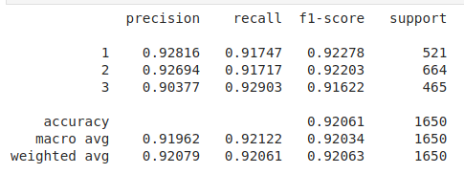
3 features of ICA gave a 0.92063 f1-weighted score, which is pretty close to PCA’s 8 features. This means ICA has done an exceptional job at capturing the information out of original data only using 3 features.

5.3. Randomized Projections

I have used Gaussian Random Projection because the data I have used is a dense dataset, where there’s no null or empty fields.

Since the performance of Randomized Projection was lower comparing to other algorithms, I have used 9 dimensions on this algorithm.

The built-in neural network’s cross-validation only gave 0.86 f1-weighted score, which is super low.
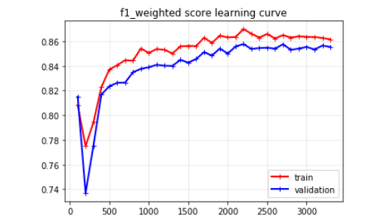
After exploring different hidden layers, the Randomized Projection didn’t give a very good result and couldn’t go over 0.86 on cross-validation data.

When used against testing dataset:
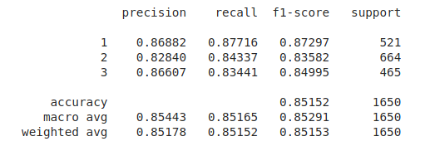
Random Projection could only get 0.85 f1-weighted score, which means it couldn’t capture enough information out of the original dataset even though I have used 9 dimensions.

5.4. Select K Best Using Lasso

For the last one, I wanted to use Feature Selection (which is allowed by Prof.Isbell on Piazza). I have used only 5 features out of 13 in the wine dataset.
Using Lasso classifier, I have selected the most important features out of the dataset and used Neural Networks on them.
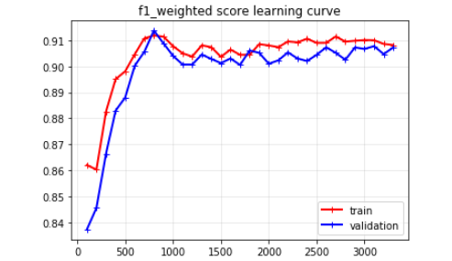
I have used the best neural network from Assignment 1 and the learning curve of this network was:

It can be seen that this algorithm suffers from high-bias, as well. So, I have made a complexity analysis on number of nodes in hidden layers and even 100 nodes didn’t make a significant increase in cross-validation score.
I have used this neural network against the testing dataset and got 0.9 f1-weighted score
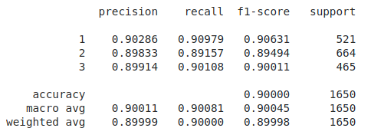
Even though the result is not so bad, it can be seen that the model under-fits the dataset. This means some valuable information is left out.

6. Neural Networks on Wine Dataset after Clustering

I have only used the clusters instead of adding them to the original dataset because I think it won’t make a real difference when added to the original dataset because neural networks are already complex enough to discover clusters etc. before making their final decisions.

In this setup, there is only 1 feature (the cluster) to decide on the labels.

6.1. K-Means Clustering

I have used 15 clusters out of K-Means (since it gave a better Homogeneity score than optimum k=3 and it will make more sense to put more clusters in to the neural dataset) and put this inputs in the neural network. The built-in configuration of Neural Network gave 0.63 f1-weighted score on cross-validation.
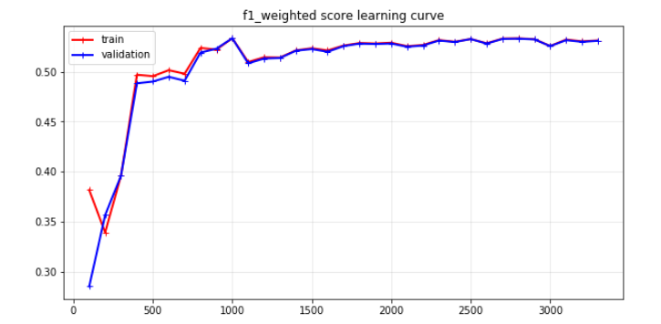
When draw the learning curve, it can be seen that the model suffers from high-bias and this is because there is not enough data to make the discovery.

To reduce bias, I have used two hidden layers with 60 nodes each and as a result the bias is reduced.
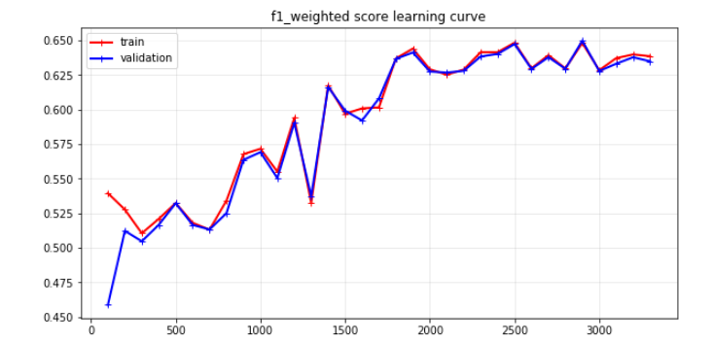

To furthermore reduce the bias, I have used two 100 nodes hidden layer and the bias didn’t reduce more.

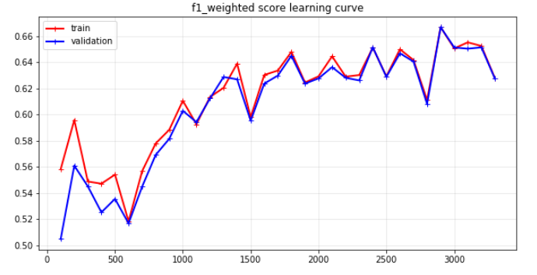
So, I have used this setup on the testing set and

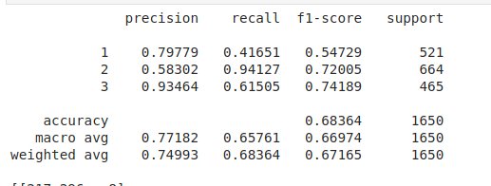

The model performed 0,67 f1-weighted score on the testing set. Only using clusters, the neural network guessed 2/3 (accuracy 0.68) of the testing set. Even though this seems good, the clustering (k=3 K Means) could get 0.9 accuracy score. So, we can say using multiple clusters in a neural network itself doesn’t work well comparing to using only clusters and using the dataset in the neural network.

6.2. Expectation Maximization

For Expectation Maximization algorithm, I have used 15 clusters, as well to make healthy comparisons between K-Means. The built-in configuration of Neural Network gave 0.75 f1-weighted score on cross-validation. Even this one is higher than K-Means’s best result itself.
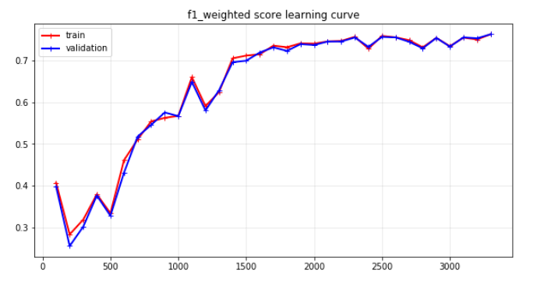

This model has high-bias as well. So, I use two hidden layers with 60 nodes each and draw another learning curve.

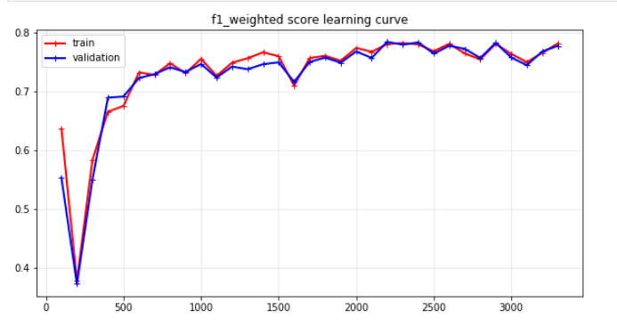

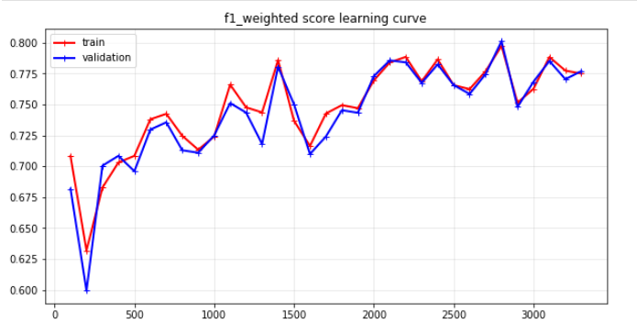
It can be seen that the model reduced its bias in a great deal by adding more complexity to the neural network. Now, I have increased the number of nodes from 60 to 100 in each hidden layer to increase the complexity more.

As it can be seen, the bias isn’t reduced significantly in this step. The model again can’t explain the dataset only using its clusters and it under-fits as expected.

I have used this neural network setup on testing dataset:

The weighted-f1 score is 0.80. Comparing to K-Means’ neural network, this is a much better result and as I have mentioned in the Clustering section, this is because EM acts more flexible and captures clusters. Even though these clusters don’t correspond to the classes, they can be used by the neural network to make better predictions.

7. Conclusion

I had two datasets; UFC Dataset was very complex with a over 150 features. Dimension Reduction algorithms bring out more performance on this dataset, even using less than half PCA explained 0.98 of the variance, which is great.

On the other hand, less complex Wine Dataset was clustered in correspondence to the labels such that K-Means got 0.9 accuracy score with the true labels.

Neural Network on dimension reduced datasets worked really good except for the RP algorithm and the selectKBest. I think ICA worked really well on this section such that it bring over 0.9 f1-weighted score using only 3 features.

8. Clock Time

Neural network algorithms were much faster when run on clusters or even reduced dimensions. This is because they run on lower space state.

8. References

[1] Gym: A toolkit for developing and comparing reinforcement learning algorithms. (2020). Retrieved 11 April 2020, from https://gym.openai.com/envs/FrozenLake-v0/

[2] Sutton, R., & Barto, A. (2018). Reinforcement learning (2nd ed.). London, England.

