**Functional Specifications Document**

**for**

**Buffet Restaurant - Mobile Application**

**Release 1.0**

**Version 1.0 draft 1**

**Prepared by Ngo Hoan Tam Huy**

**Ngo Nguyen Hong Hai Long**

**Tran Hoang Qui**

**Tran Ngoc Man Huy**

**July 19, 2021**

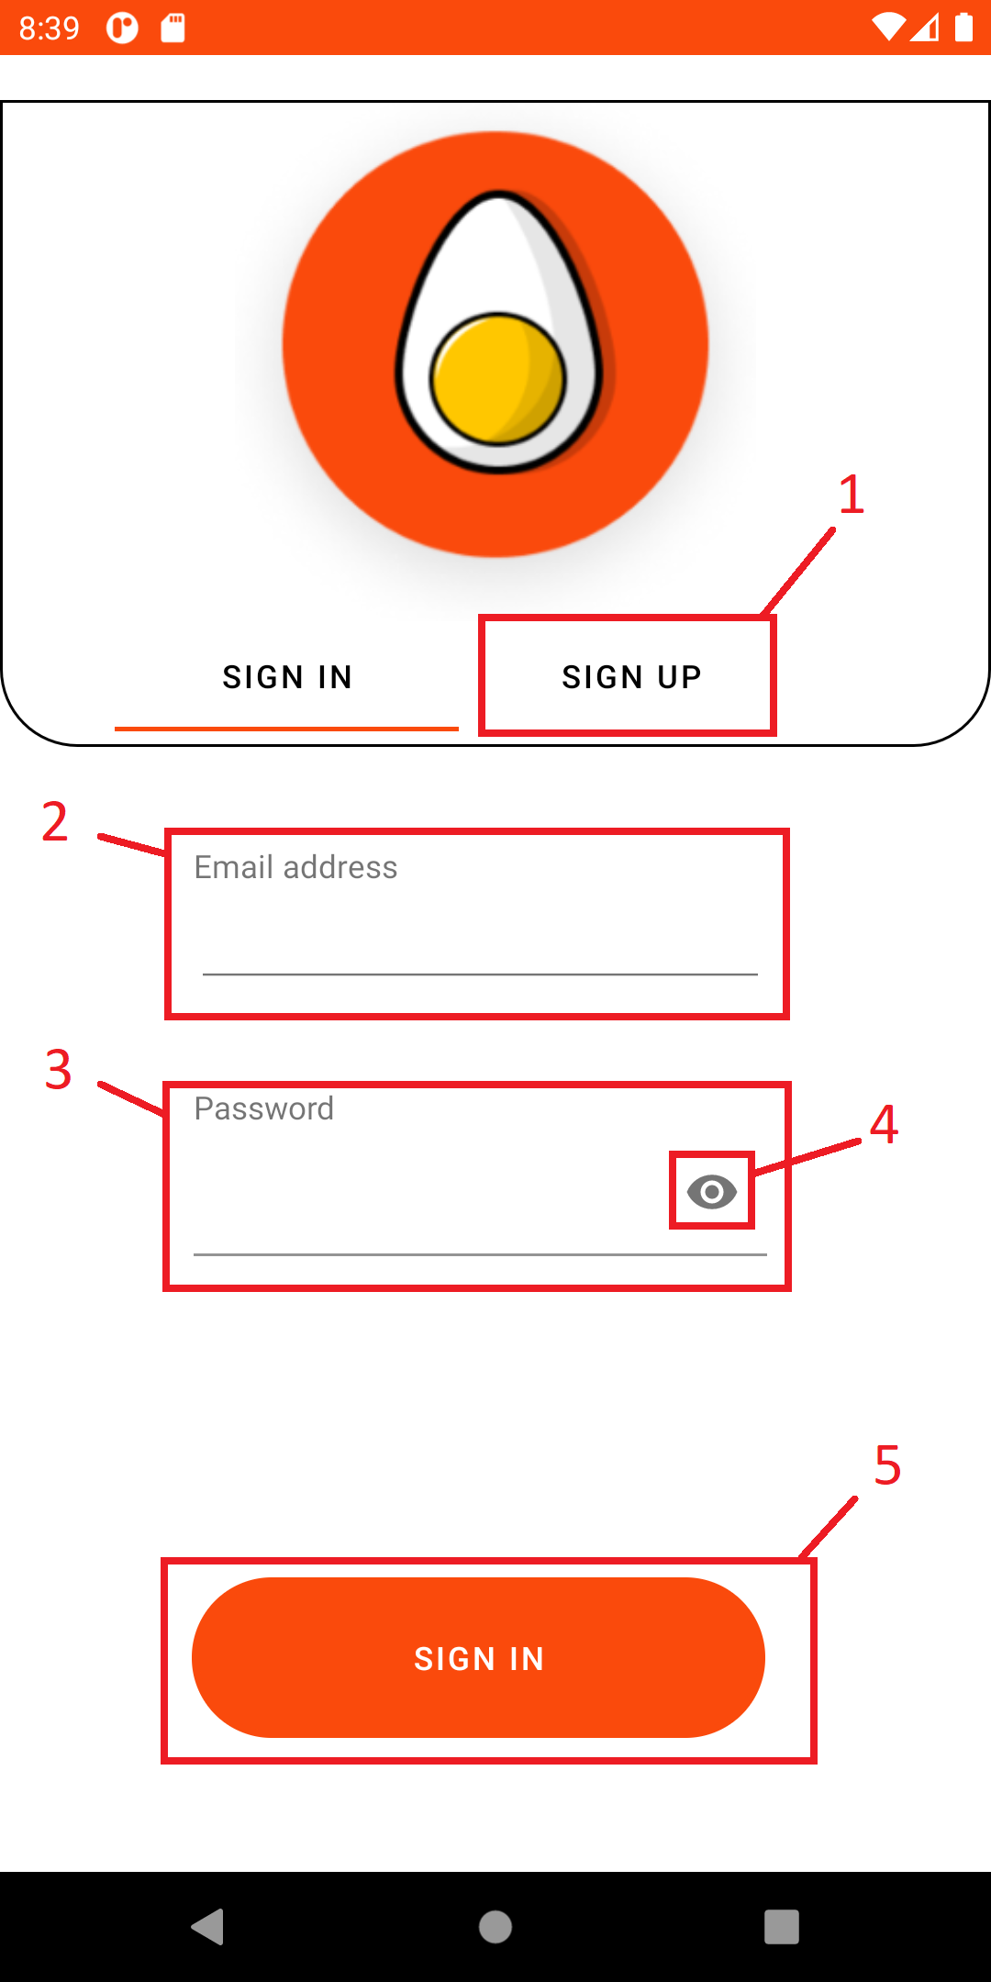

**1.Login page**

* **Frame function:** Login frame when user input email and password after check it if correct system will transfer user to home page of customer or staff base on account

|  |  |  |
| --- | --- | --- |
| **No.** | **Component** | **Function** |
| 1 | Sign Up button | Button change to sign up frame |
| 2 | Text box Email | Text box for user to input email |
| 3 | Text box Password | Text box for user to input password |
| 4 | Visible Password button | Button to show hidden password |
| 5 | Button sign in | Button check email and password to login |

**2.Customer Home page**

- **Frame function:** Home page of customer has bottom, side menu to go to other frame. Frame show all food of store base on food type

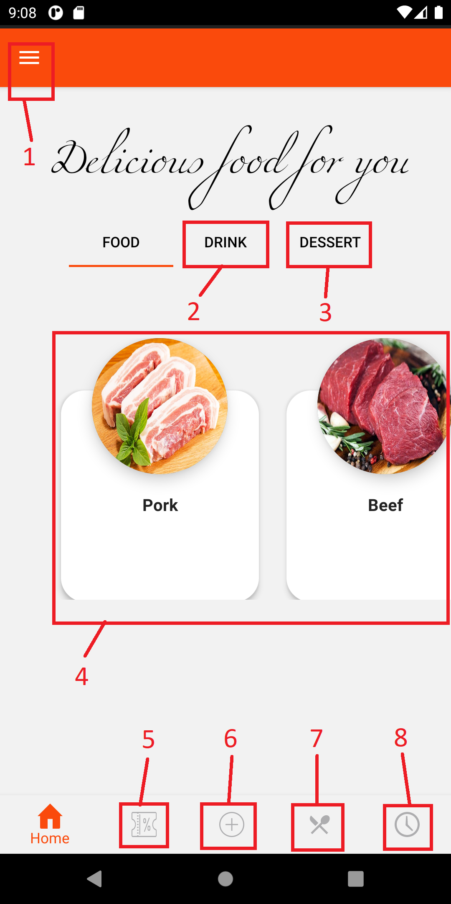

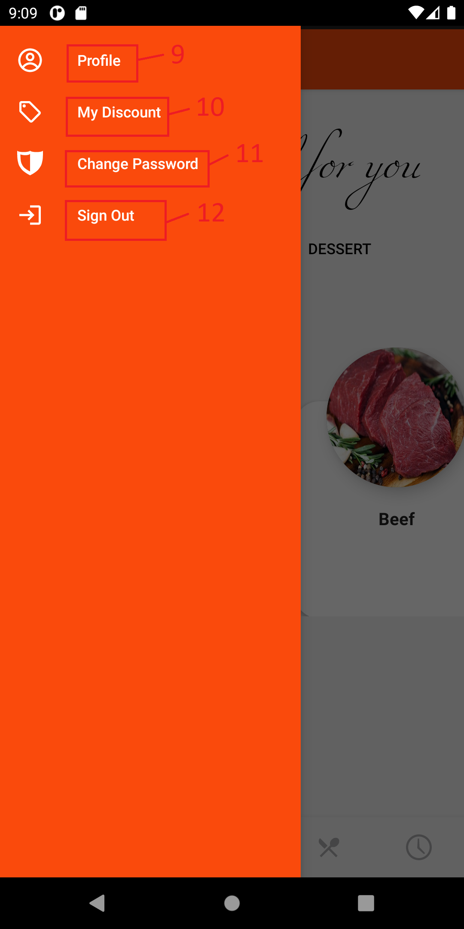

|  |  |  |
| --- | --- | --- |
| **No.** | **Component** | **Function** |
| 1 | Side menu button | Button to show side menu |
| 2 | Tab button | Button to view all drink in store |
| 3 | Tab button | Button to view all dessert in store |
| 4 | List food | List of food in store change base on Tab button |
| 5 | Bottom menu Discount button | Button to go to Buy Discount page |
| 6 | Bottom menu Reservation button | Button to go to Reservation page |
| 7 | Bottom menu View Menu button | Button to go to View Menu page |
| 8 | Bottom menu Reservation History button | Button to go to Reservation History page |
| 9 | Side menu Profile button | Button to go to Profile page |
| 10 | Side menu My Discount button | Button to go to My Discount page |
| 11 | Side menu Change Pass button | Button to go to Change Pass page |
| 12 | Side menu Sign out button | Button to sign out |

**3.Customer profile**

- Frame function: Frame for user to view and update personal account information

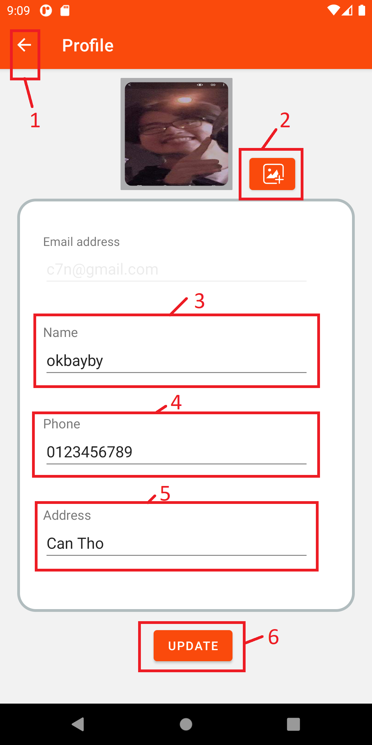

|  |  |  |
| --- | --- | --- |
| **No.** | **Component** | **Function** |
| 1 | Back button | Return to previous page |
| 2 | Change image button | Button for user to choose image for avatar |
| 3 | Text box Name | Text box for user input Name |
| 4 | Text box Phone | Text box for user input Phone |
| 5 | Text box Address | Text box for user input Address |
| 6 | Button Update | Button update user information base on above text box and image |

**4. Customer My discount**

- **Frame function:** Frame Show all customer’s discount. Customer can copy discount code to use

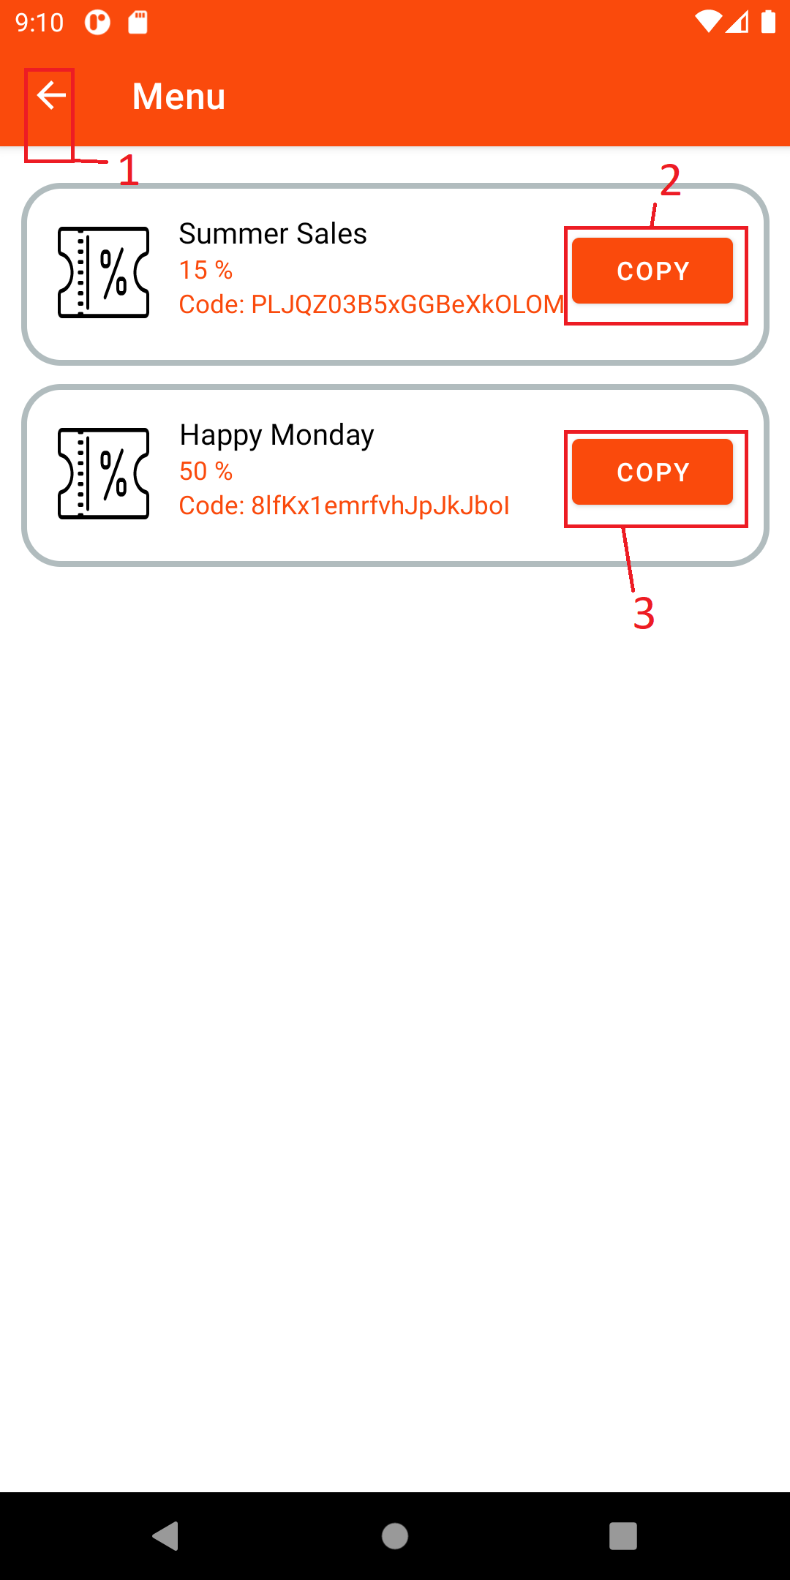

|  |  |  |
| --- | --- | --- |
| **No.** | **Component** | **Function** |
| 1 | Back button | Return to previous page |
| 2,3 | Copy button | Button to copy discount code |

**5. Customer ChangePassword**

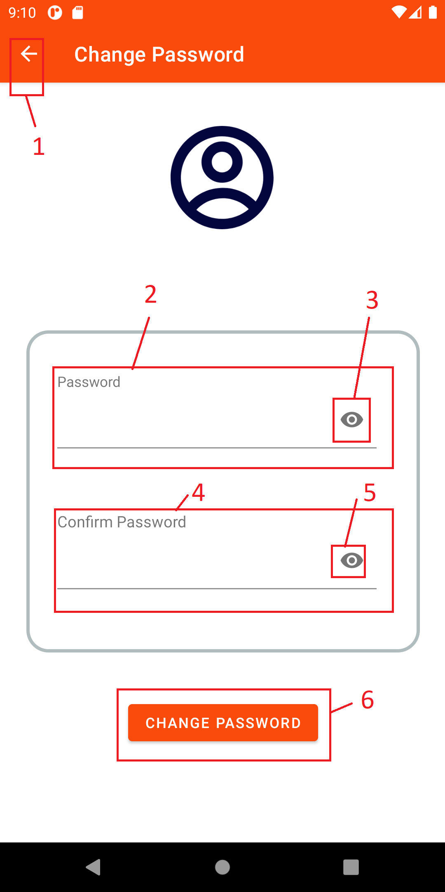

|  |  |  |
| --- | --- | --- |
| **No.** | **Component** | **Function** |
| 1 | Back button | Return to previous page |
| 2 | Text box New Password | Text box for user to input New password |
| 3 | Visible pass button | Button make hidden password visible |
| 4 | Text box Confirm Password | Text box for user to input Re-password |
| 5 | Visible pass button | Button make hidden password visible |
| 6 | Button Change password | Button check, change password to new password |

**6. Customer Buy discount**

- **Frame function:** Frame for user to buy discount

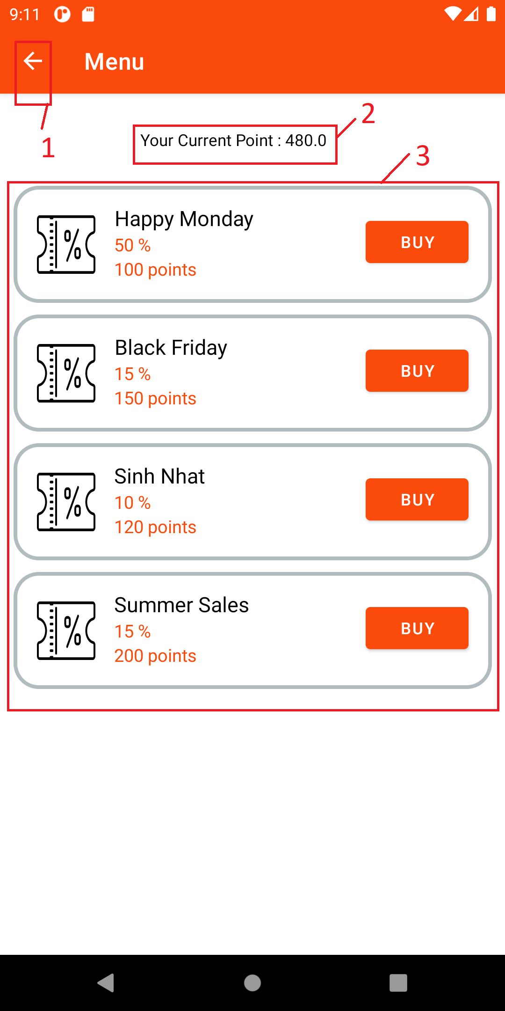

|  |  |  |
| --- | --- | --- |
| **No.** | **Component** | **Function** |
| 1 | Back button | Return to previous page |
| 2 | Text current point | Text show user current point |
| 3 | List store discount | List all store discount. User can click Buy to buy discount they want |

**7.Customer Reservation**

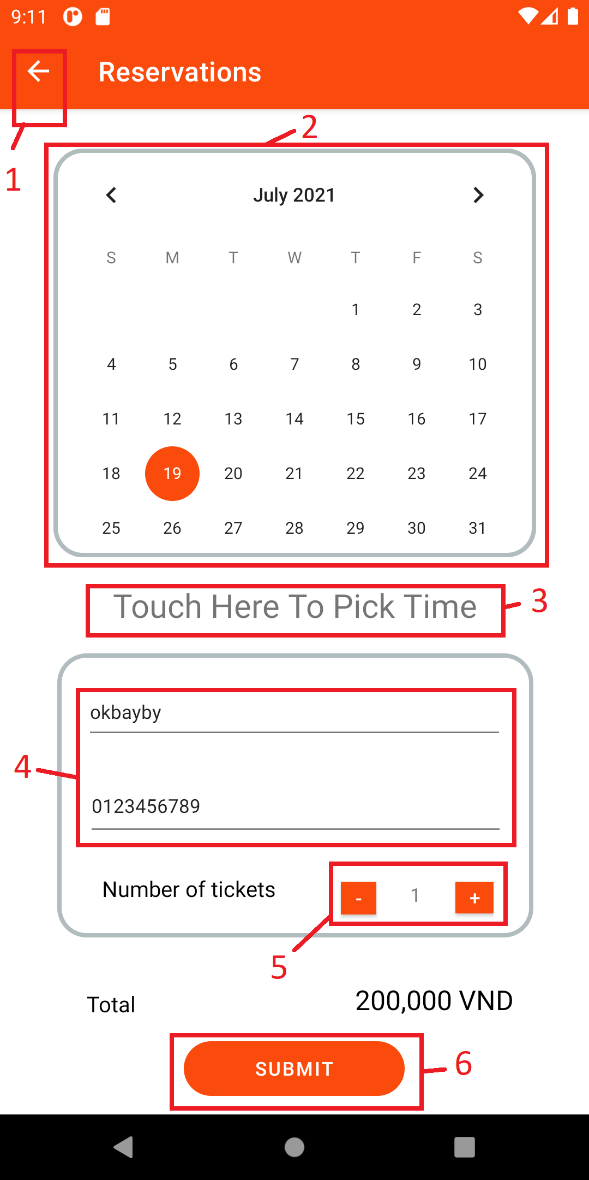

|  |  |  |
| --- | --- | --- |
|  |  |  |
|  |  |  |
|  |  |  |
|  |  |  |
|  |  |  |
|  |  |  |
|  |  |  |

**8. Customer Checkout**

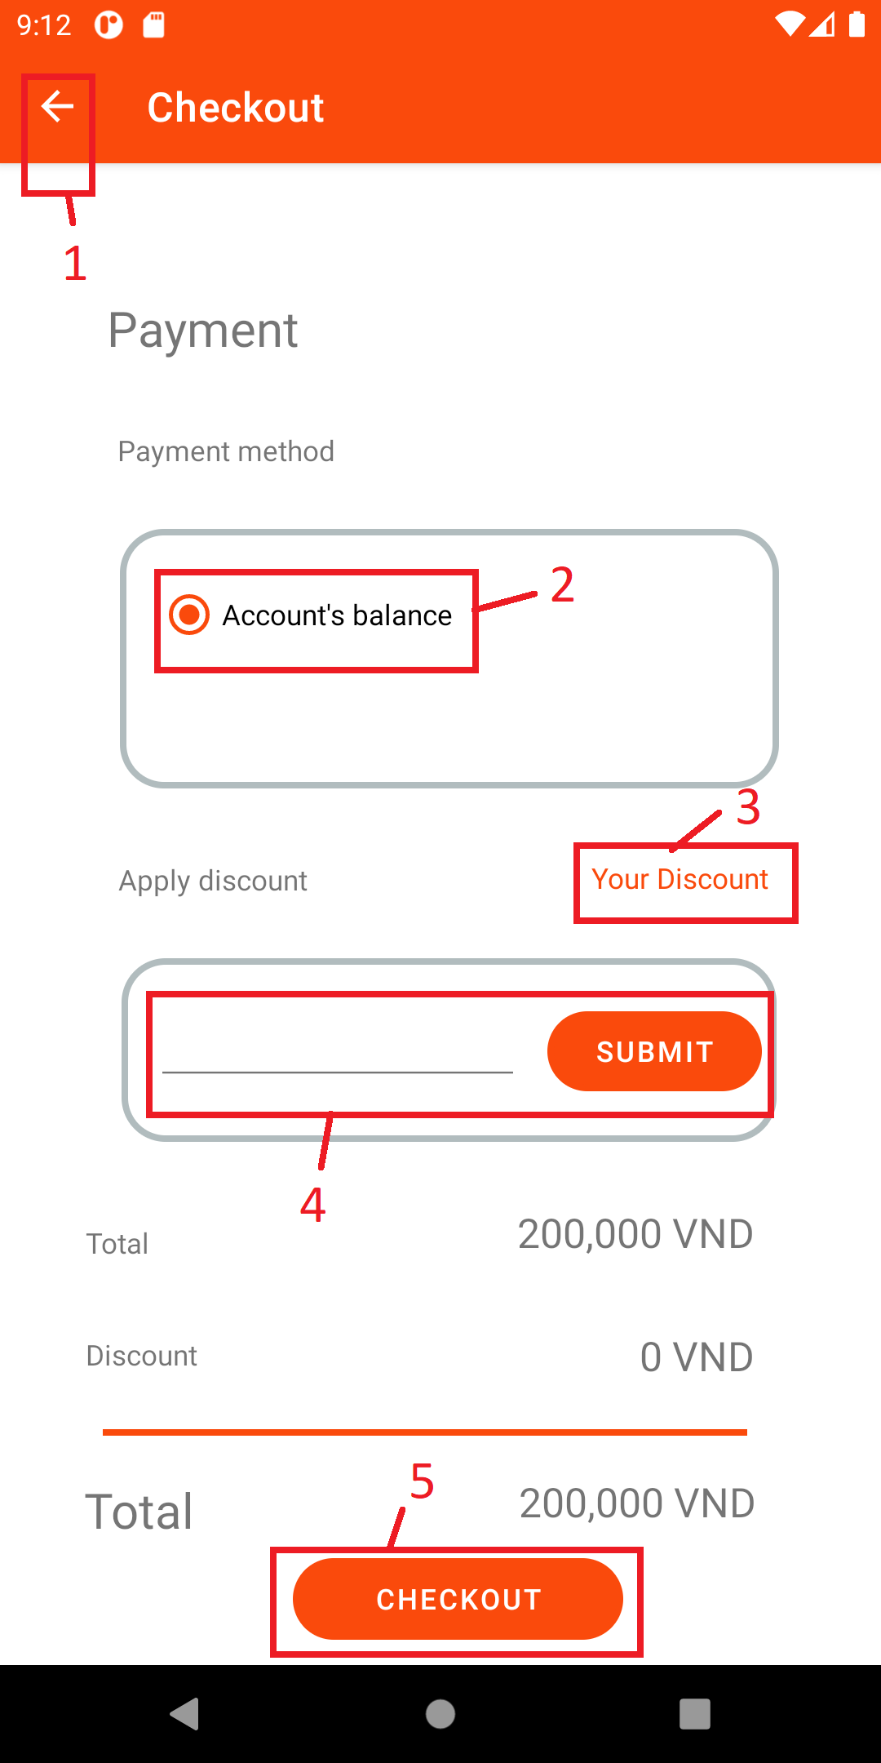

|  |  |  |
| --- | --- | --- |
|  |  |  |
|  |  |  |
|  |  |  |
|  |  |  |
|  |  |  |
|  |  |  |

**9.Customer view menu**

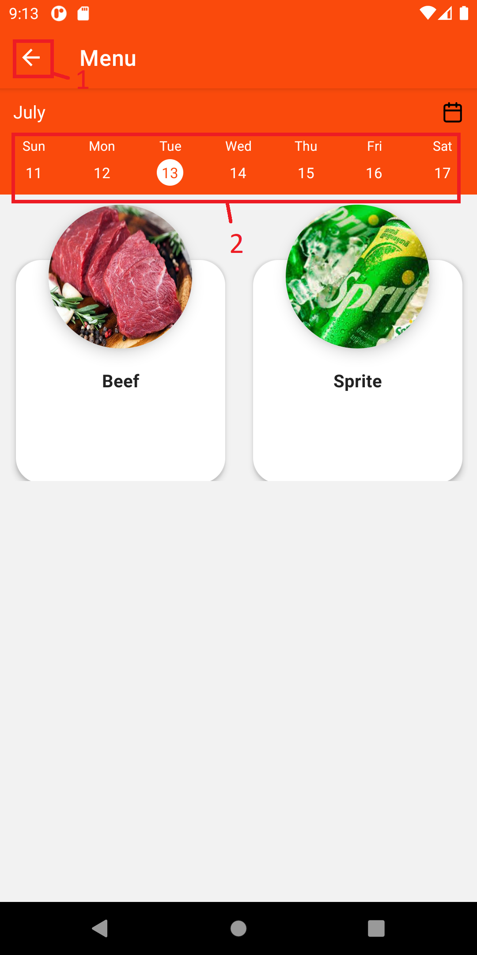

|  |  |  |
| --- | --- | --- |
|  |  |  |
|  |  |  |
|  |  |  |

**10. Customer Reservation history**



      
      
      
      
      