**Functional Specifications Document**

**for**

**Buffet Restaurant - Mobile Application**

**Release 1.0**

**Version 1.0 draft 1**

**Prepared by Ngo Hoan Tam Huy**

**Ngo Nguyen Hong Hai Long**

**Tran Hoang Qui**

**Tran Ngoc Man Huy**

**July 19, 2021**

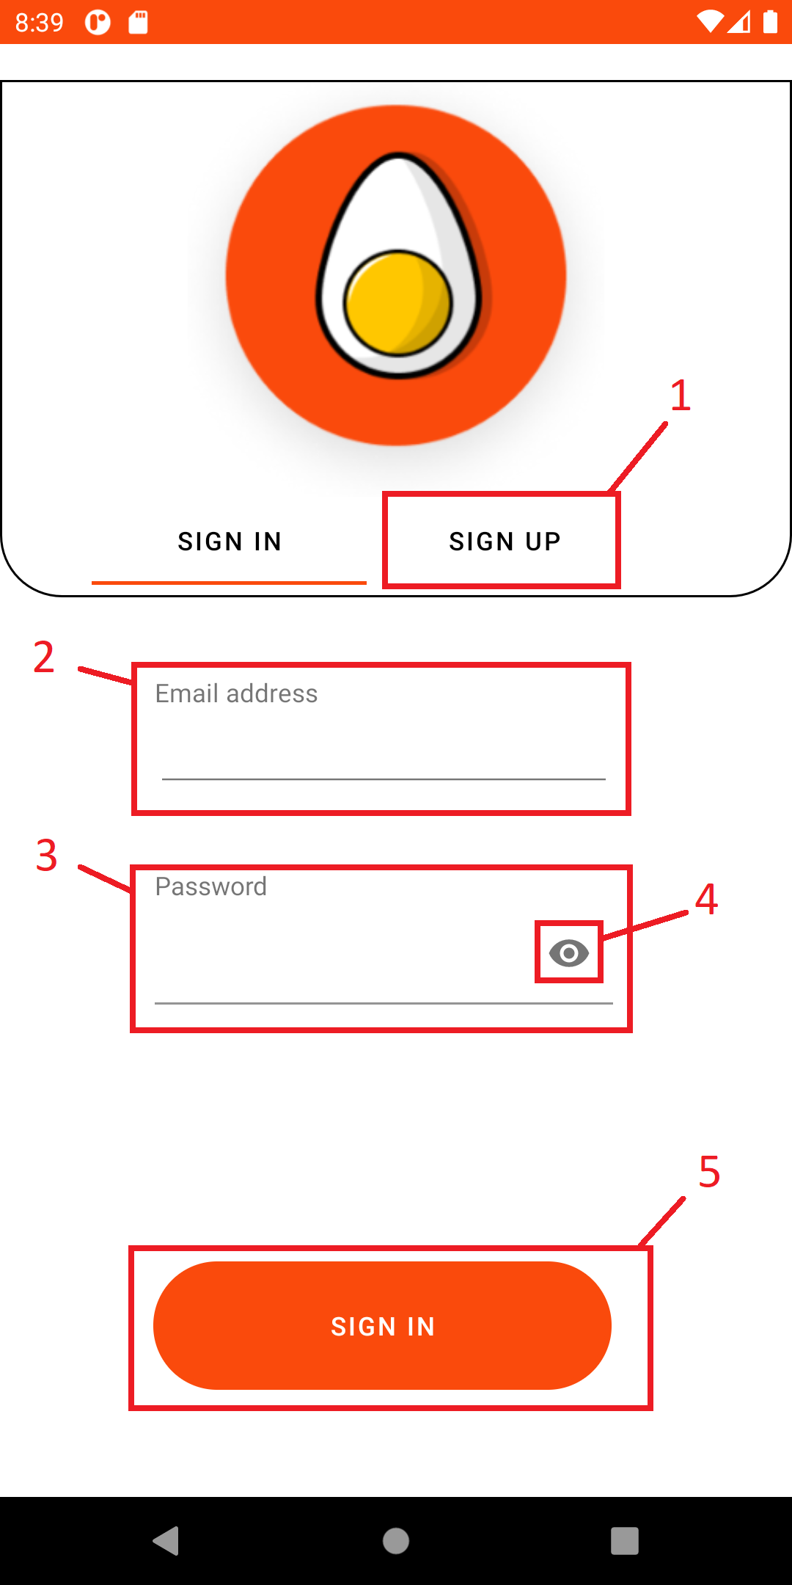

**1.Login page**

* **Frame function:** Login frame when user input email and password after check it if correct system will transfer user to home page of customer or staff base on account

|  |  |  |
| --- | --- | --- |
| **No.** | **Component** | **Function** |
| 1 | Sign Up button | Button change to sign up frame |
| 2 | Text box Email | Text box for user to input email |
| 3 | Text box Password | Text box for user to input password |
| 4 | Visible Password button | Button to show hidden password |
| 5 | Button sign in | Button check email and password to login |

**2.Customer Home page**

- **Frame function:** Home page of customer has bottom, side menu to go to other frame. Frame show all food of store base on food type

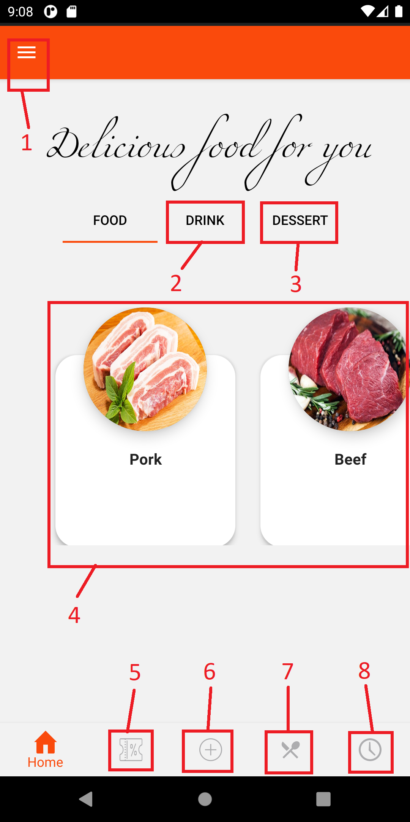

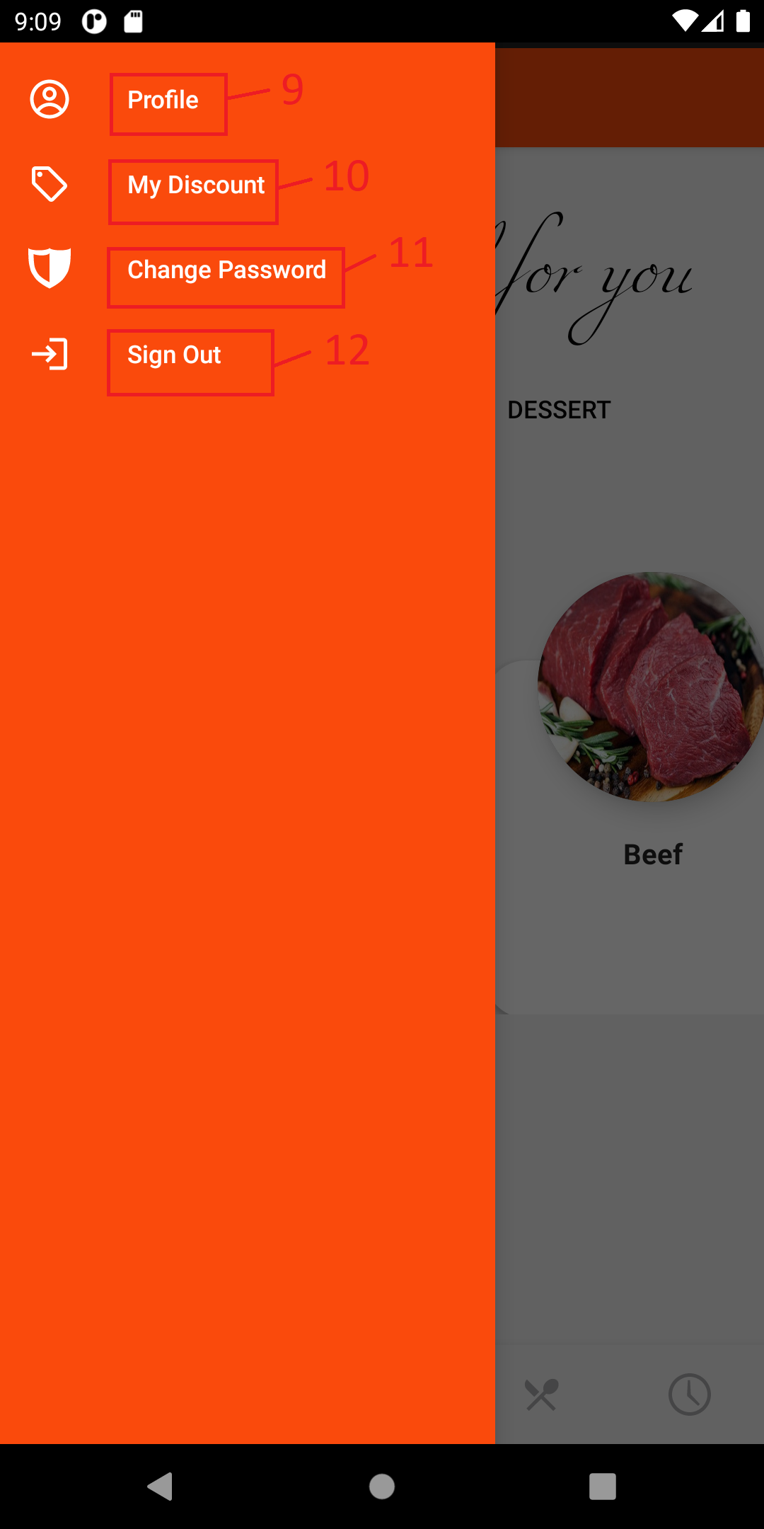

|  |  |  |
| --- | --- | --- |
| **No.** | **Component** | **Function** |
| 1 | Side menu button | Button to show side menu |
| 2 | Tab button | Button to view all drink in store |
| 3 | Tab button | Button to view all dessert in store |
| 4 | List food | List of food in store change base on Tab button |
| 5 | Bottom menu Discount button | Button to go to Buy Discount page |
| 6 | Bottom menu Reservation button | Button to go to Reservation page |
| 7 | Bottom menu View Menu button | Button to go to View Menu page |
| 8 | Bottom menu Reservation History button | Button to go to Reservation History page |
| 9 | Side menu Profile button | Button to go to Profile page |
| 10 | Side menu My Discount button | Button to go to My Discount page |
| 11 | Side menu Change Pass button | Button to go to Change Pass page |
| 12 | Side menu Sign out button | Button to sign out |

**3.Customer profile**

- Frame function: Frame for user to view and update personal account information

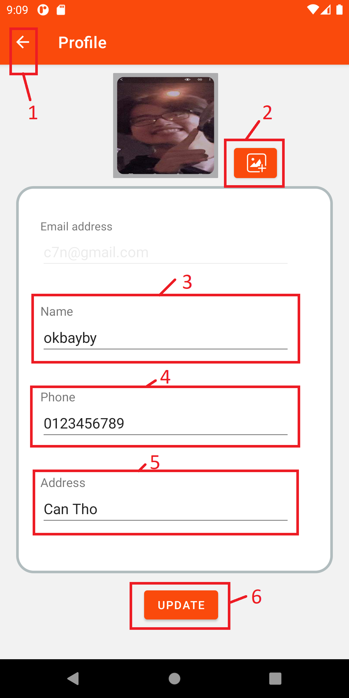

|  |  |  |
| --- | --- | --- |
| **No.** | **Component** | **Function** |
| 1 | Back button | Return to previous page |
| 2 | Change image button | Button for user to choose image for avatar |
| 3 | Text box Name | Text box for user input Name |
| 4 | Text box Phone | Text box for user input Phone |
| 5 | Text box Address | Text box for user input Address |
| 6 | Button Update | Button update user information base on above text box and image |

**4. Customer My discount**

- **Frame function:** Frame Show all customer’s discount. Customer can copy discount code to use

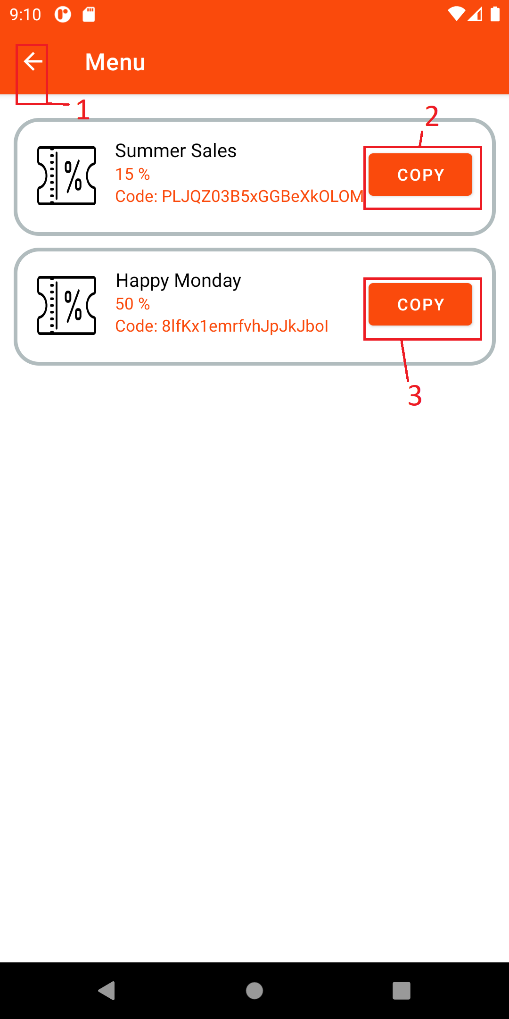

|  |  |  |
| --- | --- | --- |
| **No.** | **Component** | **Function** |
| 1 | Back button | Return to previous page |
| 2,3 | Copy button | Button to copy discount code |

**5. Customer ChangePassword**

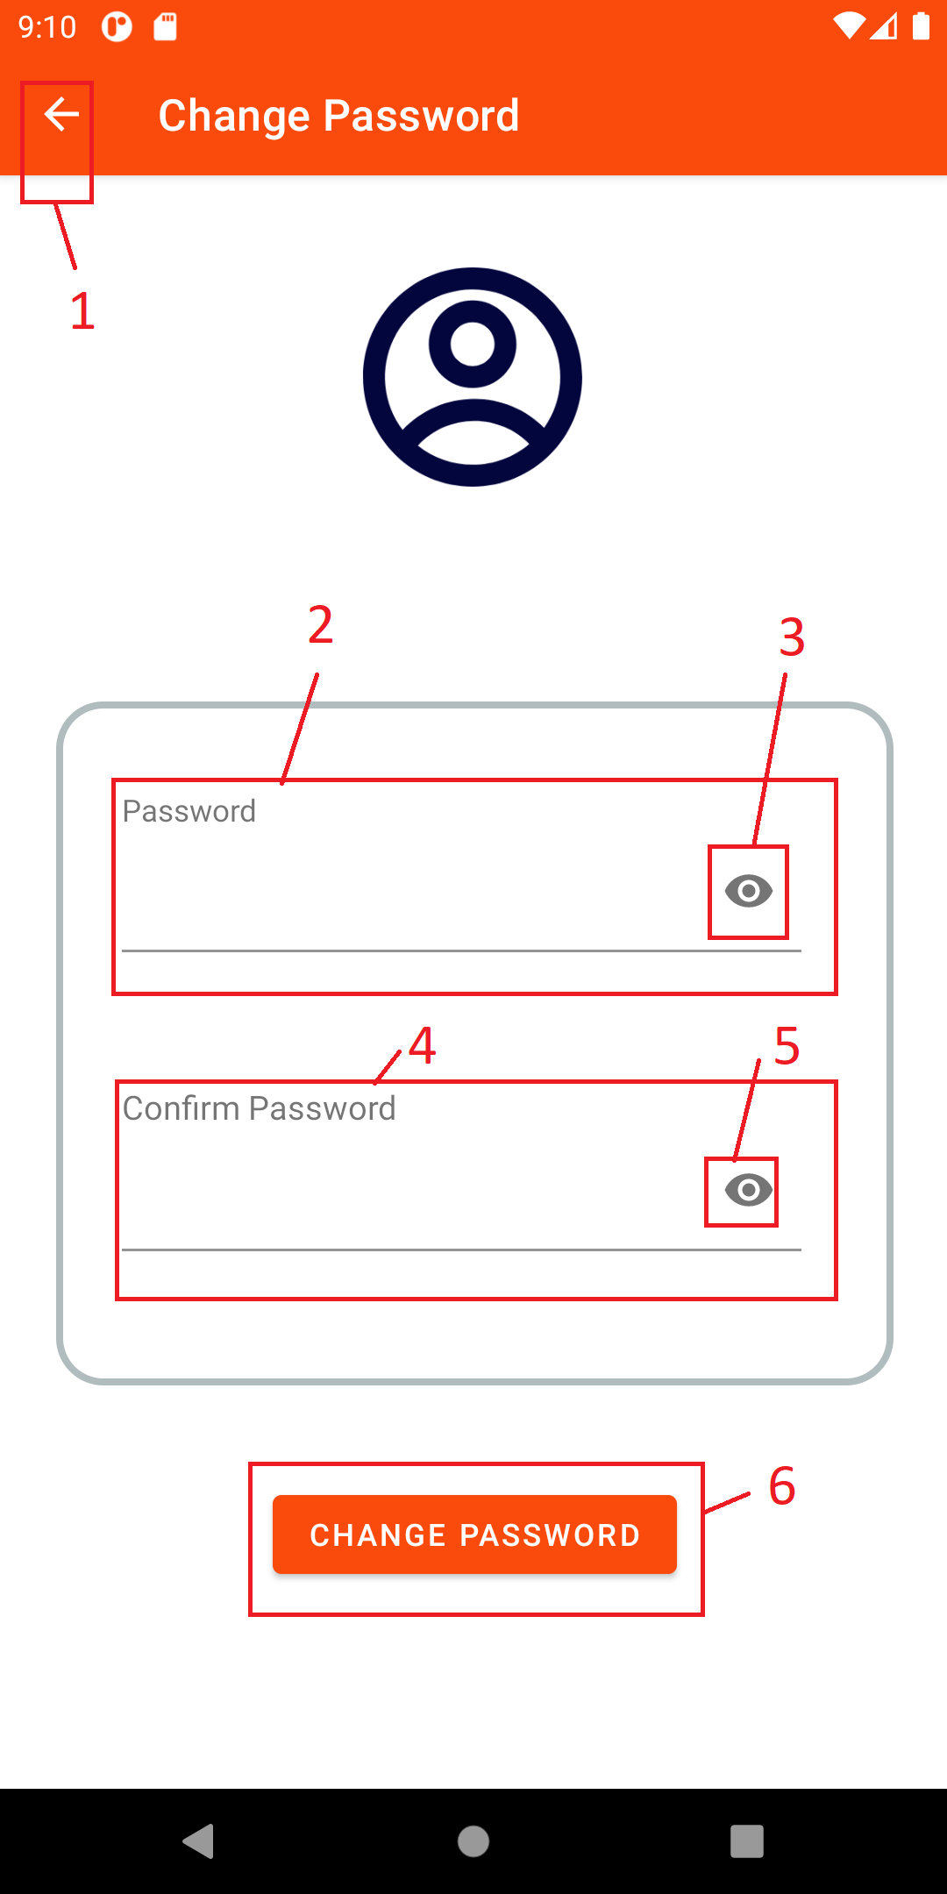

|  |  |  |
| --- | --- | --- |
| **No.** | **Component** | **Function** |
| 1 | Back button | Return to previous page |
| 2 | Text box New Password | Text box for user to input New password |
| 3 | Visible pass button | Button make hidden password visible |
| 4 | Text box Confirm Password | Text box for user to input Re-password |
| 5 | Visible pass button | Button make hidden password visible |
| 6 | Button Change password | Button check, change password to new password |

**6. Customer Buy discount**

- **Frame function:** Frame for user to buy discount

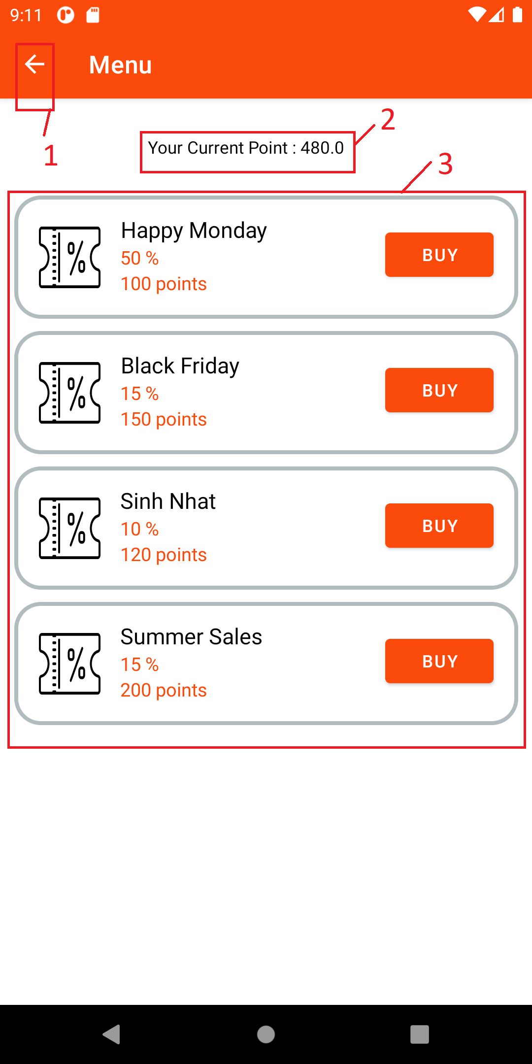

|  |  |  |
| --- | --- | --- |
| **No.** | **Component** | **Function** |
| 1 | Back button | Return to previous page |
| 2 | Text current point | Text show user current point |
| 3 | List store discount | List all store discount. User can click Buy to buy discount they want |

**7.Customer Reservation**

- **Frame function:** Customer Reservation has calendar which has been set this day when it first starts, clickable textbox to user choose time to do reservation. There is text table to display information of customer and the number of ticket of this reservation. At last, customer could press submit to confirm their reservation, or they can back to previous page by pressing back button on left corner.

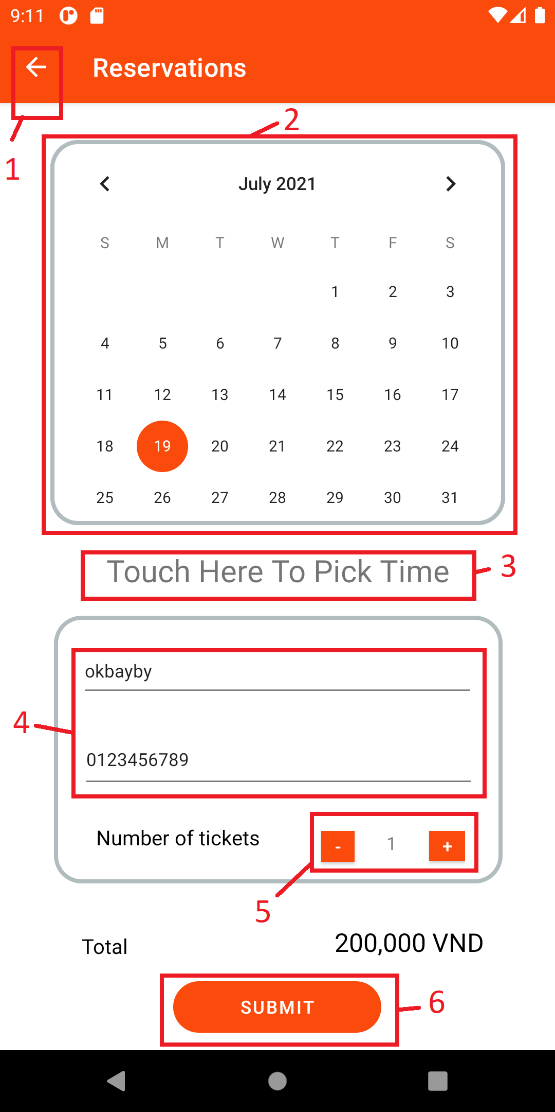

|  |  |  |
| --- | --- | --- |
| **No** | **Component** | **Function** |
| 1 | Back Button | Back to the previous page |
| 2 | Calendar | Show the date |
| 3 | Clickable Textbox | Pick the date to reserve |
| 4 | Information Table | Show information of customer |
| 5 | Plus or Minus | Increase or decrease the number of ticket |
| 6 | Button | Submit the reservation |

**8. Customer Checkout**

- **Frame function:** Customer Checkout help customers to pay their reservation, it has the payment method to let customer choose, in first version there is not more except account balance. Also, this is text to show the discount to apply for this check out. After choosing discount, you can apply by copying then pasting it onto below edit text then press submit button nearby to apply it. Finally, their also checkout button to complete customer checkout.

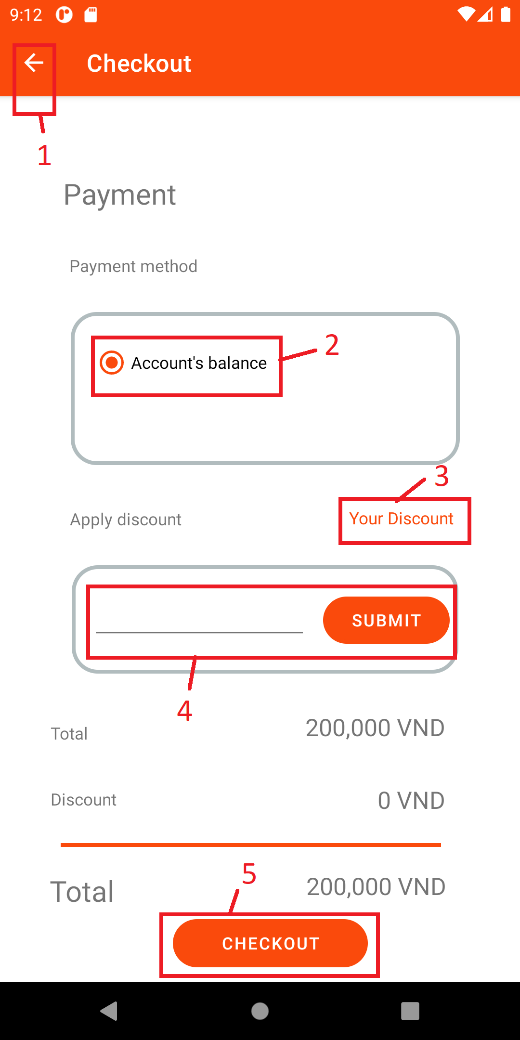

|  |  |  |
| --- | --- | --- |
| **No** | **Component** | **Function** |
| 1 | Back Button | Back to the previous page |
| 2 | Selected Text | Select payment method |
| 3 | Clickable Text | Show customer discounts |
| 4 | Applying Table | Apply customer discount |
| 5 | Checkout Button | Complete the checkout |

**9.Customer view menu**

- **Frame function:** Customer view menu has horizontal calendar to let customer choose the date. Upon on the selected date, the below list would show exactly the menu has been created by staff. This would help customer could know which date they can get their favorite food.

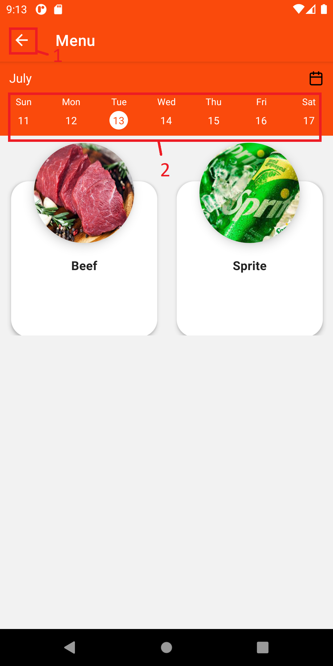

|  |  |  |
| --- | --- | --- |
| **No** | **Component** | **Function** |
| 1 | Back Button | Back to the previous page |
| 2 | Horizontal Calendar | Choose the day |

**10. Customer Reservation history**

- **Frame function:** Customer Reservation history would show a history of apply discount, or they can back to previous page by pressing back button on left corner.

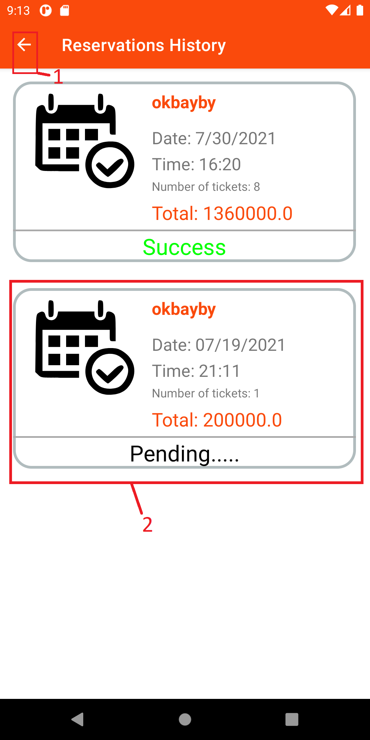

|  |  |  |
| --- | --- | --- |
| **No** | **Component** | **Function** |
| 1 | Back Button | Back to the previous page |
| 2 | Text Table | Show status and day apply that discount |