高管增持事件，去重后共990个事件

|  |  |  |  |  |  |  |
| --- | --- | --- | --- | --- | --- | --- |
| 窗口期 | AAR | T值 | P值 | CAR | T值 | P值 |
| -10 | -0.001633 | -1.717012 | 0.043149 | -0.001633 | -1.717012 | 0.043149 |
| -9 | -0.001123 | -1.016613 | 0.154796 | -0.002755 | -1.814532 | 0.069907- |
| -8 | -3.051230 | -0.026576 | 0.489402 | -0.002785 | -1.391166 | 0.082248 |
| -7 | 2.904511 | 0.035709 | 0.485760 | -0.002756 | -1.221814 | 0.111038 |
| -6 | 0.000476 | 0.524843 | 0.299906 | -0.002280 | -0.895852 | 0.185277 |
| -5 | -0.001063 | -1.145903 | 0.126059 | -0.003344 | -1.194230 | 0.116340 |
| -4 | 0.000482 | 0.528788 | 0.298536 | -0.002861 | -0.923128 | 0.178085 |
| -3 | 0.000642 | 0.698069 | 0.349034 | -0.002219 | -0.659378 | 0.254905 |
| -2 | 0.002550** | 2.391266 | 0.008490 | 0.000330 | 0.090224 | 0.464063 |
| -1 | 0.004137** | 3.457612 | 0.000284 | 0.004467 | 1.107316 | 0.134216 |
| 0 | 0.003049** | 2.810182 | 0.002525 | 0.007517** | 1.814487 | 0.034956 |
| 1 | 0.001506 | 1.417815 | 0.078283 | 0.009024** | 2.094149 | 0.018253 |
| 2 | -0.000311 | -0.347769 | 0.364044 | 0.008712** | 1.943061 | 0.026149 |
| 3 | -0.000115 | -0.110994 | 0.455821 | 0.008597** | 1.844928 | 0.032677 |
| 4 | -0.000545 | -0.519486 | 0.301770 | 0.008051** | 1.659240 | 0.048696 |
| 5 | -0.003428 | -2.845523 | 0.002263 | 0.004623 | 0.923658 | 0.177947 |
| 6 | 9.361e-05 | 0.905721 | 0.452860 | 0.004717 | 0.927845 | 0.176860 |
| 7 | -0.000172 | -0.222857 | 0.411846 | 0.004544 | 0.875789 | 0.190681 |
| 8 | -0.000445 | -0.573265 | 0.283299 | 0.004099 | 0.780979 | 0.217503 |
| 9 | -0.000675 | -0.763807 | 0.222584 | 0.003424 | 0.643024 | 0.260180 |
| 10 | 0.000699 | 0.941161 | 0.173429 | 0.004123 | 0.757528 | 0.224459 |
| 11 | 0.000344 | 0.426919 | 0.334766 | 0.004467 | 0.800478 | 0.211815 |
| 12 | 0.000771 | 1.026229 | 0.152520 | 0.005239 | 0.921999 | 0.178379 |
| 13 | 0.001408 | 1.808257 | 0.035438 | 0.006648 | 1.148056 | 0.125615 |
| 14 | -3.594272 | -0.046599 | 0.481420 | 0.006612 | 1.134339 | 0.128467 |

**表示在5%的显著性水平上拒绝原假设

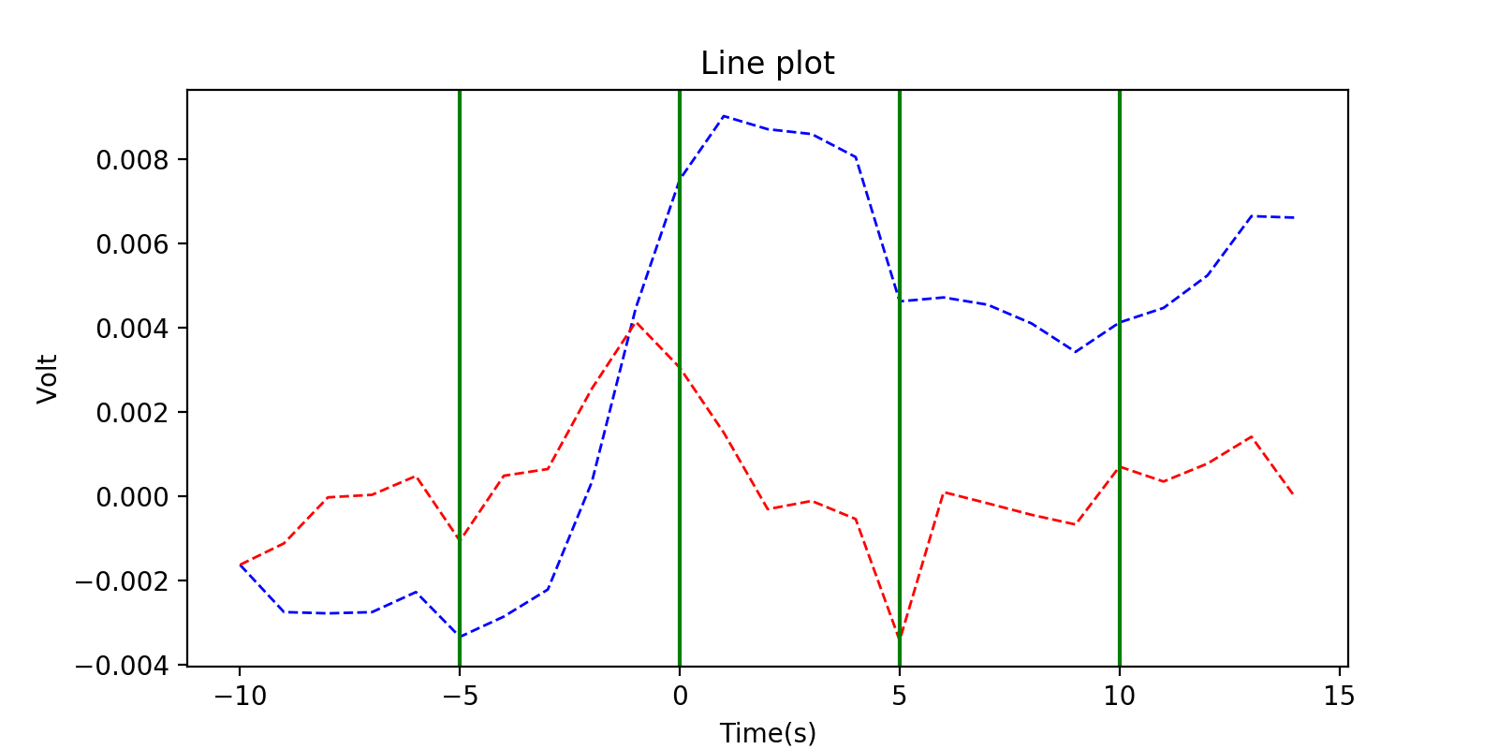

其中红色线段代表AAR平均异常收益的变化，蓝色线段代表CAR累计异常收益的变化