
Fall 2010

Oklahoma Council of Teachers of English

OCTE EXCHANGE



PLACE PHOTO HERE,
OTHERWISE DELETE BOX

Jim Burke to Speak at 2010 Fall Conference
Houghton Mifflin Harcourt will partner with OCTE to bring Jim Burke, respected author and educator, to the 2010 OCTE Fall Conference. Burke is the author of The English Teacher’s Companion and other books related to teaching English. Burke teaches at Burlingame High School, where he has taught since 1992. He has spent more than 20 years in education, and his writings include practical information and strategies for teachers.

Because Burke works as a classroom teacher and needs to be with his students during the week, OCTE will hold this year’s Fall Conference on Saturday, September 25 at Oklahoma City University in the Meinders School of Business.

In addition to Burke’s presentation, “Revising Our Work: New Perspectives on Teaching English,” and the discussion that follows, participants will be able to attend break-out sessions for middle, high school, and college teachers of English.

Randy Baker is coordinating the conference. Check out the OCTE website for more information: http://octe.ecok.edu.
Spring Conference a Success
The 2010 Spring Conference, April 7, 2010, featured Pulitzer Prize-winning poet, Natasha Trethewey, who moved attendees to tears with her reading. OCTE thanks Dr. Harbour Winn and the Center for Interpersonal Studies through Film and Literature for helping to make the conference possible.

The conference included recognition of Oklahoma Young Writers. Cathy Hume coordinated the Young Writers Contest this year, and Dr. Laura Bolf-Beliveau and Dr. Randy Baker edited the Anthology, Signs of the Times. Geraldine Burns winners were presented with one year free membership. Dr. Deborah Brown was honored with an OCTE lifetime membership because of her tireless service and dedication to the organization. newsletter text here. Continue newsletter text here. Continue newsletter text here. Continue newsletter text here. Continue newsletter text here.

Continue newsletter text here. Continue newsletter text here. Continue newsletter text here. Continue newsletter text here. Continue newsletter text here. Continue newsletter text here. Continue newsletter text here. Continue newsletter text here. Continue newsletter text here.

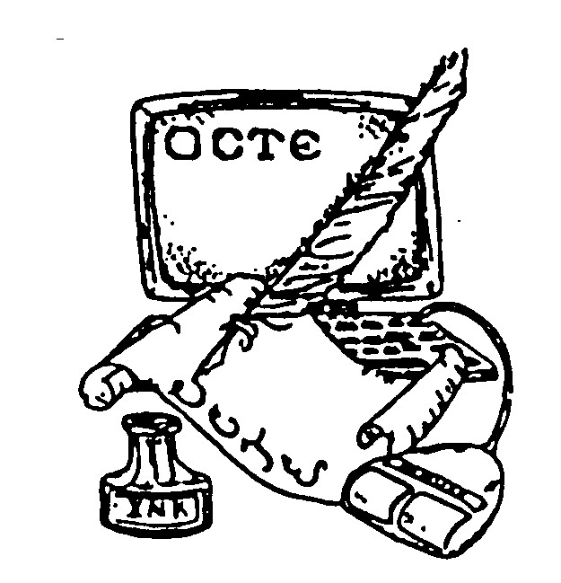
PLACE LOGO OR
COMPANY NAME HERE

Congratulations to the 2010 Geraldine Burns Award Winners
Each year, English departments from Oklahoma colleges and universities are asked to select one student who has an outstanding record of scholarship and extracurricular activities to receive the Geraldine Burns Award. Geraldine Burns was a longtime secretary/treasurer of OCTE and an honorary lifetime member. She taught English for forty-four years and served as Oklahoma Teacher of the Year in 1986. Recipients of this award are selected because they are expected to become outstanding members of the professional community. See the following pages for winners.
Continue newsletter text here. Continue newsletter text here. Continue newsletter text here. Continue newsletter text here. Continue newsletter text here. Continue newsletter text here. Continue newsletter text here. Continue newsletter text here. Continue newsletter text here. Continue newsletter text here. Continue newsletter text here.

Continue newsletter text here. Continue newsletter text here. Continue newsletter text here. Continue newsletter text here. Continue newsletter text here.



PLACE PHOTO HERE,
OTHERWISE DELETE BOX

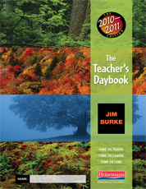

PLACE PHOTO HERE,
OTHERWISE DELETE BOX

OCTE Exchange

Fall 2010

Carleigh Coker Burroughs, Oklahoma Baptist University
In the midst of many extra-curricular demands on her, Carleigh has demonstrated both her abilities as an English student and her commitment to her intended profession. She is an intelligent, capable, and hardworking future teacher.
Christi Carruth, East Central University
Christi is a parent of four and a commuting student but manages to maintain an impressive g. p. a. in English Education and is involved in various organizations, such as Literati, an English club, and Sigma Tau Delta, an English honor society. Ms. Carruth is currently completing her student-teaching in Asher, Oklahoma, and will graduate from East Central University in May 2010. She has also been admitted to the Master’s program for Library Media, which she starts in June.
Megan Cole, Southern Nazarene
Megan has been one of our most outstanding majors. She is currently in her professional semester and is distinguishing herself in the classroom. She has also received acceptance notices from a number of graduate schools to continue her education. She has been in our McNair program and has been chosen to read scholarly papers at places like U.C. Berkeley. Her cooperating teacher has described her as someone with a “heart for teaching.” That is indeed true.
Loren Derrico, Cameron University
Loren is a junior English major with a cumulative GPA of 3.76. She came to Cameron from the US Coast Guard Academy where she was awarded the military star for three straight semesters, and she has made the dean’s list every semester since starting at Cameron.
Jane Fisher, Rose State College
Jane has been an exceptional student in her English and Education coursework during her time in our program. She has consistently exhibited a sharp mind, and an eagerness to delve into the work of classrooms. Her performances in field experiences and coursework have marked her as someone who will not only be successful during her student teaching, but well beyond. I consider her an outstanding candidate for the Geraldine Burns Award.

Register early to hear Jim Burke discuss
“Revising Our Work: New Perspectives on Teaching English”

Hanna Elledge, Rose State College
Hanna is an outstanding student in every way with her professors remarking on and noting her intellectual curiosity, perfect attendance, literary skills, and great insight. She makes extremely perceptive comments in class, showcasing not only her knowledge of the primary source but also revealing the rich literary tradition her voracious appetite for great books has afforded her. One of
her goals is to teach, and we are certain she will bring great honor to the profession.

2010 Fall Conference
Saturday, September 25, 2010
Oklahoma City University

Geraldine Burns Winners
Consider attending the NCTE Annual Convention in Orlando, Florida, November 18-21!
Use the new OCTE website to stay informed! www.octe.ecok.edu

Check out OCTE on facebook!

OCTE Exchange

fall 2010

Cynthia Hines, Murray State College
Cynthia has won the Academic Excellence in English Award at Murray State College. Additionally, she has been on the President’s honor roll for three semesters and is in the Phi Theta Kappa International Honor Society.
Emma Mercer Johnson, Oklahoma City University
Emma has demonstrated repeatedly her dedication to her learning. With a 4.0 GPA in her major and an overall GPA of 3.77, the numbers certainly attest to her excellent work as an English Education student. More than that, though, Emma has been a valuable member of our academic community, bringing her knowledge and her curiosity to our classes. We are very happy to honor Emma with this award. She will be a superb English teacher.
Randi Renee Jones, Oklahoma Panhandle State University
Randi received her AA degree in 2007 from Seward County Community College in Liberal, Kansas, and will graduate with the BA degree in English from Oklahoma Panhandle State University in May 2010. She has a 3.7 GPA and is a member of the Oklahoma Zeta Chapter of the national honor society Alpha Chi. Randi is currently student teaching at Liberal Junior High School.
Hilario Trejo Leal, Cameron University
Hilario is a senior who holds an overall GPA of 4.0. Currently, he serves as President of Lamda Iota Tau, an English honor society that recognizes and promotes excellence in the study of literature. He is also an officer in Sigma Tau Delta, an international English honor society. His academic success in English is admirable since his native language is Spanish. This success is due, in large part, to his hard work and dedication to English and its literatures.
Krystle Griffiths Lindsey, Northeastern State University
Krystle consistently exceeds expectations in her coursework and dedication to professional organizations. She is the president of Kappa Delta Pi and attended their 2009 conference. Krystle frequently contributes to the Northeastern, the student newspaper and helps fund raise to benefit English students presenting at conferences. Krystle is also a dedicated tutor at the university’s writing center.
Micah Miza, Cameron University
Micah is an excellent student, creative and inventive, and loves being in the classroom. She is one of our premier English education majors.

Kayla Saffell, Oklahoma Christian University
The Department of Language and Literature has completed their voting for the Geraldine Burns Award, and we are pleased to name Senior English Education major Ms. Kayla Saffell. Kayla has excelled both in her work in the discipline of English and in her work with the Education department. She recently had the highest score in the university on her ed. exams, and is completing her student teaching this semester. Kayla served as an officer in our chapter of the English honors society Sigma Tau Delta and has been a leader and model for her peers in her time at Oklahoma Christian.
Kelly Sehon, University of Central Oklahoma
Kelly is a senior at UCO and is currently student teaching at Belle Isle Enterprise Middle School. An incredible teacher candidate, Kelly demonstrates the highest of standards in his academic work. With great exuberance, he applies the theory of English/language artsby not only asking what and how but why something should be part of any curriculum. He will, no doubt, be one of Oklahoma’s finest teachers.
Sheena Williams, Southwestern Oklahoma State University
An honor student with a 3.98 GPA, Sheena has served as president in 2009 and secretary in 2008 of the Southwestern Oklahoma State University Women's honor society, Gamma Delta Kappa. As a member of the Student Oklahoma Education Association, she participated in OEA's Outreach to Teach. She has also been a member of NCTE since 2008. She creatively combines her ability in art with her English lessons and shows great potential toward becoming a future teacher leader in Oklahoma.


OCTE Exchange

Fall 2010

Thanks to everyone who presented at the 2010 Spring Conference! Thanks also to all who gathered door prizes, helped with registration, and put out fires as needed!
Katy Peercy
Put the website to work for you!

Go to http://octe.ecok.edu/ to do any of these things:
- Register for the 2010 Fall Conference
- Renew your membership
- Contact executive board members
- Link to NCTE’s website
- Find out about important events
Oklahoma Council of Teachers of English
NONPROFIT
ORG
U.S. POSTAGE
PAID
PERMIT NO. 1957
TULSA, OK

c/o Laura Bolf-Beliveau, Treasurer
2301 Regis Court
Norman, OK 73071

