2013 OCTE Spring Conference
Career, College, and Citizenship Readiness

Featuring Keynote Speaker
Terrance Hayes

Registration
Registration is exclusively online this year. To register for the conference, simply log on to the OCTE website and follow the registration link. Please register by Monday,
March 25. Contact Laura Bolf-Beliveau, OCTE treasurer, with any registration questions at octetreasurer@gmail.com.

Location & Time
The spring conference, sponsored by the OCU Petree College of Arts and Science, will be held on the Oklahoma City University campus at the Meinders School of Business, on Wednesday, April 3, from 8:00am—3:30pm including an awards luncheon for our Young Writers Competition winners and Geraldine Burns winners. You must prepay in order to attend the awards dinner for our Young Writers contest winners and our recognition of the Geraldine Burns award winners. Our luncheon speaker will be Ben Myers, Oklahoma author.

OCU Campus map
http://www.okcu.edu/visitors/map/map-2012.pdf

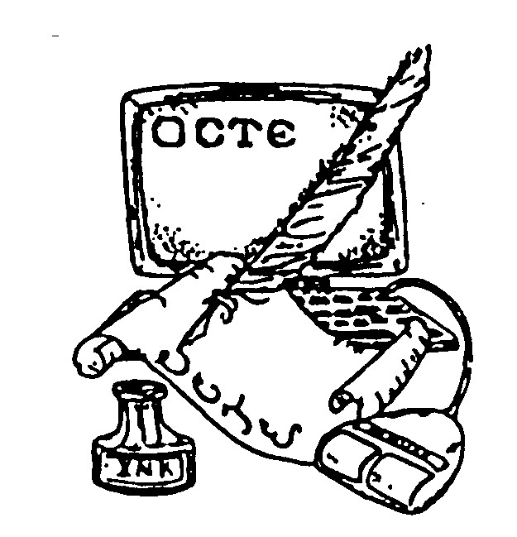
OCU Meinders School of Business
2501 N. Blackwelder
Oklahoma City, OK 73106- 1493

OCTE web address: http://octe.ecok.edu

