
Winter 2010

Oklahoma Council of Teachers of English

OCTE EXCHANGE

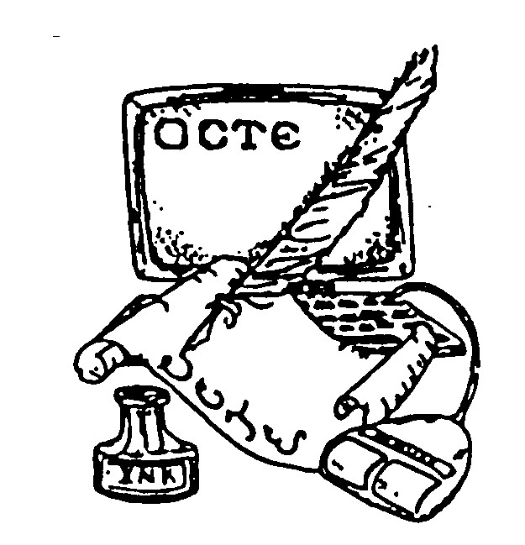

PLACE PHOTO HERE,
OTHERWISE DELETE BOX

Fall Conference a Success
Thanks to Randy Baker and his crew for a wonderful 2010 Fall Conference of OCTE. The conference inspired attendees to focus on preparing students for futures full of opportunities and challenges that did not exist only a few years ago. Presenters provided strategies for helping students to succeed in an evolving world.

The 2011 Spring Conference will be Wednesday, April 13, 2011 at Oklahoma City University. Please make plans to attend. Contact Darla Tresner with questions. You may find her contact information on the OCTE website.
The Young Writers Contest Deadline is Approaching
One of the benefits of membership in OCTE is the privilege of allowing our students to participate in the Oklahoma Young Writers Contest. Winning students are honored at the OCTE Spring Conference, where they are also given the opportunity to meet with judges about their writing.

Winning entries are also published in the Oklahoma Anthology.

Please use the attached forms or go to http://octe.ecok.edu to enter. Click on EVENTS and scroll to the bottom of the page. The deadline for entry is January 14, 2011.

Make Plans to Attend the 2011 Spring Conference!

April 13, 2011 at OCU

Follow OCTE on facebook!
Search “O.C.T.E.” for the group page.

Use the website to renew your membership!

New membership options are available.

http://octe.ecok.edu
octe

Winter 2010

2011 Oklahoma Young Writers Contest

CATEGORIES: Short Story (maximum 1,500 words)
Essay (Expository, no narrative essays, maximum 500 words)
Personal Narrative (first person, maximum 500 words)
Descriptive Paragraph
Poetry
($2 entry fee per entry)

Fillers: Descriptive sentences may be submitted as “fillers.”
($1 entry fee) Note: Writers of descriptive sentences that are
used in the anthology are welcome to attend the Young Writers
Conference and luncheon for the discounted price of $10 per
person and to purchase a copy of the 2011 Anthology for the
discounted rate of $3.00.

Age Groups: K-6
7-9
10-12
College

Entries: Each teacher (OCTE members only) may enter up to 10 original manuscripts for his/her students with a fee of $2 per entry. Also, each teacher may enter up to 10 “filler” descriptive sentences for his/her students with a fee of $1 per sentence. Make checks payable to OCTE. No student may enter more than one entry per category. Entries must be typed and double-spaced. Poems may be single-spaced. Teachers should submit the original entry plus one copy of each manuscript and in addition send an electronic copy to contest coordinator at clhume@cox.net.

Contest rules: All contest rules, such as maximum word length, entry deadline, OCTE membership for teachers, numbers of copies, cover sheets, no names on entries, etc., must be strictly observed. Failure to do so will disqualify entries. No entry fees will be refunded.

Cover Sheet: After duplicating, fill out the enclosed cover sheet completely. Use only one cover sheet per entry. The student’s name should appear on the cover sheet only. Please be sure all letters are legible to ensure names are accurate.

Winners will have their work published in the 2011 Oklahoma Anthology and will be invited, along with their teachers and parents, to attend the Young Writers Conference and luncheon April 13, 2011, to meet with the judges and receive a copy of the anthology.

Sponsored by:
Oklahoma Council for Teachers of English
The Center for Interpersonal
Studies through Film and Literature at Oklahoma City University.

Continue newsletter text here. Continue newsletter text here. Continue newsletter text here. Continue newsletter text here. Continue newsletter text here. Continue newsletter text here. Continue newsletter text here. Continue newsletter text here. Continue newsletter text here. Continue newsletter text here. Continue newsletter text here. Continue newsletter text here. Continue newsletter text here. Continue newsletter text here.
Subhead. Subhead.
Continue newsletter text here. Continue newsletter text here. Continue newsletter text here. Continue newsletter text here. Continue newsletter text here. Continue newsletter text here. Continue newsletter text here. Continue newsletter text here.

Continue newsletter text here. Continue newsletter text here. Continue newsletter text here. Continue newsletter text here. Continue newsletter text here. Continue newsletter text here. Continue newsletter text here.

Continue newsletter text here. Continue newsletter text here. Continue newsletter text here. Continue newsletter text here. Continue newsletter text here. Continue newsletter text here. Continue newsletter text here. Continue newsletter text here. Continue newsletter text here. Continue newsletter text here.

COVER SHEET
2011 OCTE Young Writers Competition
(Please type information.)

Title:__________________________________________________ Grade Level:______

Category: Number of words in entry:

Student’s Name (Please Print): ______________________________________________

Student’s Address:________________________________________________________

Teacher’s Name: ________________________________________________________

Teacher’s Address: _______________________________________________________

Teacher’s Email:__________________________________________________________

School Name: Phone:_____________

School Address: __________________________________________________________

SIGNATURES:
I hereby attest to the originality and length of this piece.

_______________________________ _________________________
Student Signature Parent Signature

I verify that the above is my student, the number of words is correct, and I am a current member
of OCTE.

________________________________________
Teacher Signature

Postmark Deadline: January 14, 2011
Please send submissions with cover sheets and electronic submission to:
Cathy L. Hume
9821 N. McKinley Avenue
Oklahoma City, OK 7311
clhume@cox.net


OCTE

Winter 2010

Put the website to work for you!

- Go
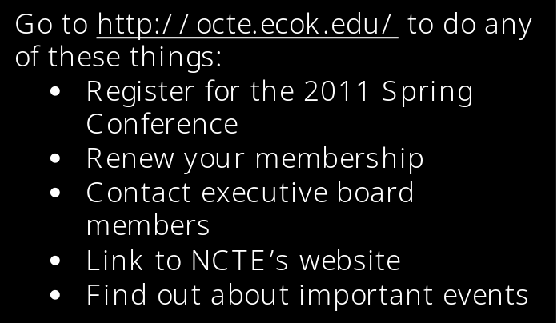
Nonprofit
Org
U.S. Postage
Paid
Permit No. 1957
Tulsa, OK

Oklahoma Council of Teachers of English
c/o Laura Bolf-Beliveau, Treasurer
2301 Regis Court
Norman, OK 73071

