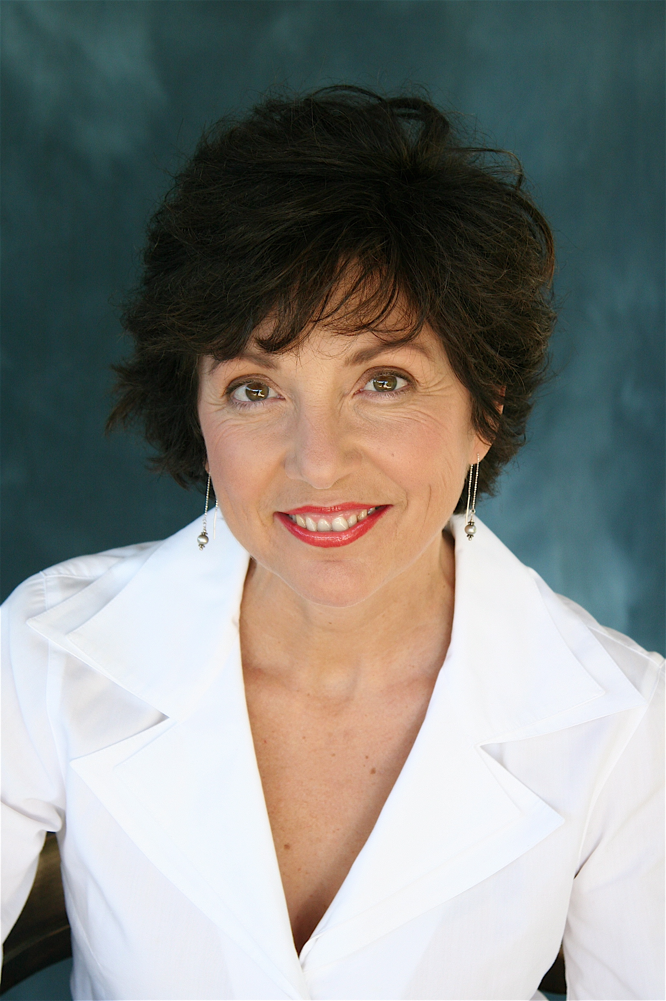

Oklahoma Council of Teachers of English, c/o Dianna Just, 440758 E. 230 Rd., Vinita, OK 74301

http://octe.ecok.edu
OCTE EXCHANGE

Carol Jago – Keynote Speaker
8:00 - 9:00 a.m. - Registration, Breakfast & Exhibits
9:00 - 10:00 a.m. - Keynote Speaker: Carol Jago, Sponsored by Holt McDougal
10:20 - 11:10 a.m. Sessions:
A - “Sight and Sound! Using the Art and Music of an Era to Build Context for Novel Study” - Beta Noel
B - Preparing NCATE Program Reviews - Tracy Fredman, Oklahoma Technical Assistance Center
C - “Poetry: The News that Stays News” - Shaun Perkins, Pryor High School
1:30 - 2:20 p.m. Sessions:
A - Nathan Brown, Oklahoma poet and musician, The University of Oklahoma
B -“The ABC’s of Surviving the First-Year” - Shawn Elmore, Cheyenne Middle School and Chelsea Agee, Ida Freeman Elementary School, Edmond Public Schools
C - “Connecting Literature to History: Using the Tulsa Race Riots” - Laura Bolf-Beliveau, The University of Central Oklahoma
D - “Gallery Walk: Literacy and Learning in the Content Areas” – Jo Stafford, the Oklahoma State University Writing Project
2:30 - 3:20 p.m. Sessions:
A - Grow Our Own: Resident and Student Teachers forum - Teresa Rothrock, ECU, and Mark Letcher, OU
B - “Teaching Technical Writing Creatively” - Linda Steele, University of Central Oklahoma
C - “Visual Journaling” - Kyle Peaden, Patrick Henry Elementary School, Tulsa Public Schools and a Teacher Consultant from the OSUUWP

The 2009 OCTE Spring Conference
Will be April 1, 2009
At Oklahoma City Univ.

Oklahoma Council of
Teachers of English
Fall Conference Theme:
Teaching Creatively;
Writing Creatively
July 2008
Please see Schedule on page 2 for afternoon sessions
NCTE President

Carol Jago is a teacher with thirty-two
years experience in middle and high school in Santa Monica, California. The author of ten books on education, she is in demand as a speaker for conferences and seminars across the country. Carol served on the planning committee for the 2009 NAEP Reading Framework and the 2011 NAEP Writing years of years of teaching experience and she directs the California Reading and Literature Project at UCLA. Her long-time work with the National Council of Teachers of English (NCTE).

conferences and seminars. Carol is also active with the California Association of Teachers of English and edits CATE’s award-winning journal California English. In 2006 Carol was awarded the National Council of Teachers of English classroom excellence award. Her most recent book is Come to Class: Lessons for High School Writers (2008). Holt McDougal is the sponsor of our keynote speaker.

2008 Fall Conference Tentative Schedule

OCTE FALL CONFERENCE SEPTEMBER 19TH AT OCU MMMEINDERS’ BLDG
“Writing is an exploration. You start from nothing and learn as you go.”
D - “Mini Theme-Park Units” - Roxann Grissom, Chouteau High School
11:20 - 12: 20 - Feature Poet Presentation: Gerald Locklin, Professional Writing Program at the University of Southern California
12: 25 - 1:25 - Lunch

Schedule from page 1
Feature Poet: Gerald Locklin
Dr. Locklin is a Professor Emeritus of English at California State University, Long Beach and a Lecturer in the Master of Professional Writing Program at the University of Southern California. He has written over 3000 poems essays, articles and reviews in periodicals that include New York Quarterly, Poetry International, and American Scholar. Dr. Locklin’s poetry readings have entertained audiences across America for many years. He is “a master of the music of spoken language” and “his candid poems focus upon literary accessibility and common sense. His is truly poetry of the people and for the people” (Basinski, 2006).

Dr

A special thanks to :
Phyllis Hartfiel for her work on this newsletter
Dr. Vince Orza for allowing us to use the beautiful Meinders building for our conferences.
Dr. Harbour Winn for his continued collaboration on our conferences
Brett Wheat-Simms for his wonderful food services
The exhibitors and presenters who will help make this conference a success!

OCTE MEMBERSHIP FORM
Annual Dues
Please make checks payable to OCTE

Single Membership $25 Retired $10
1st Year Teacher $12 Joint (2 people, one address) $30
Teacher Candidate $8
Send to: OCTE, c/o Dianna Just, 440758 E 230 Road, Vinita, OK 74301
(918) 256-5654 djust@junct.com

Name:____________________________________________________________

Home Address:_____________________________________________________

_________________________________________________________________

Home Phone:_______________________Work Phone:___________________

Fax:________________ E-mail:______________________________________

School Name:____________________________________________________

School Address:__________________________________________________

_______________________________________________________________

Teaching level:_____________________

Please mail correspondence to: ____Home ____School

If you do not belong – join today; if you are a member – is it time for renewal? Come and become part of the state professional organization for English teachers!

A caption is a sentence describing a picture or graphic.
OCTE 2008 Fall Conference Registration

Member Registration

______$20 Registration for members (includes Continental breakfast and lunch)

______$15 Teacher candidates/students (includes Continental breakfast and
lunch)

Non-member Registration:

______$25 (includes Continental breakfast and lunch)

$ _____Total amount included (Please make checks payable to OCTE.)
If paying by purchase order, please give PO# __________.

Name (for name tag): ______________________________________

School or Institution: ______________________________________

Department: _____________________________________________

Mailing Address: _____________________________________________

City, State, Zip:_______________________________________________

Telephone: __________________E-mail: __________________________

Mail Registration form to: Deborah Brown
2841 Huntleigh Drive
Oklahoma City, OK 73120

Registrations must be received by September 17 so that we can order the correct number of lunches. If you need to register on-line and then pay the day of the conference, please contact Deb Brown at djbrown6@cox.net or dbrown@ucok.edu . Thanks.
“Creative Teaching – Creative Writing”
Fall Conference
September 19, 2008
OCU- Meinders School of Business
Oklahoma City, Oklahoma

2009 Oklahoma Young Writers Competition
2008- 2009 Oklahoma Council of Teachers of English Officers

Felicia Godwin.........President, feliciag@cameron.edu
Deborah Brown ...... First Vice President (Conference Coordinator), djbrown6@cox.net
Cathy Hume ........... Second Vice President (Young Writers Contest), clhume@okcps.org
RandyBaker & Laura Bolf-Beliveau............ Third Vice Presidents (Anthology Editors) rbaker@punamcityschols.org; lbolfbeliveau@ucok.edu
Dianna Just ........... Treasurer/Executive Secretary, djust@junct.com
Claudia Garde…………Recording Secretary, claudiagarde@yahoo.com
Teresa Rothrock……Oklahoma English Journal Editor, trothrock@mailclerk.ecok.edu
Deborah Brown ……..NCTE Liaison, djbrown6@cox.net
Mark Letcher..........SLATE Representative
Claudia Garde.......... NCTE Promising Young Writers
Mark Letcher...........NCTE Program to Recognize Excellence in Literary Magazines
Susan Al-Jarrah......Geraldine Burns Award Chair, Susan.aljarrah@swosu.edu
OCTE Webmaster...Robin Murphy, rmurphy@ecok.edu

Categories: Short Story (max. 1500 words)
Essay (expository, max 500 words)
Personal Narrative (max. 500 words
Descriptive Paragraph
Poetry
Age Groups: K-6
7 -9
10 – 12
College

Entries: Each OCTE member may enter up to 10 original manuscripts for his/her students with a fee of $2 per entry. Make checks payable to OCTE. No student may enter more than one entry per category. Entries must be typed and double-spaced. Poems may be single-spaced. Teachers should submit the original entry plus two copies of each manuscript. No electronic submissions will be accepted.

Rules: All contest rules, such as maximum word length, entry deadline, OCTE membership for teachers, numbers of copies, cover sheets, no names on entries, etc., must be strictly observed. No entry fees will be refunded.

Cover Sheet: After duplicating, fill out the cover sheet completely. Use only one cover sheet per entry. The student’s name should appear on the cover sheet only.

Approximately thirty-five winners will have their work published in the 2009 Oklahoma Anthology and will be invited, along with their teachers and parents, to attend the Young Writers Conference as part of the OCTE Spring Conference April 1, 2009, and to meet with the judges and
Receive a copy of the anthology.

Sponsored by Oklahoma Council for Teachers of English and the Petree
College of Arts & Sciences Center for Interpersonal Studies Through Film and Literature, Oklahoma City University

COVER SHEET

2009 Oklahoma Young Writers Competition
(Please type information.)

Title:_____________________________________________ Grade Level:______

Category: Number of words in entry:______

Student’s Name (Please Print): ______________________________________

Student’s Address:_________________________________________________

Teacher’s Name: ________________________________________________

Teacher’s Address: ________________________________________________

Teacher’s Email:_____________________________________________________

School Name Phone: _____________

School Address: ___________________________________________________

SIGNATURES:
I hereby attest to the originality and length of this piece.

_________________________ _________________________
Student Signature Parent Signature

I verify that the above is my student, the number of words is correct, and I am a current member of OCTE.

________________________________________
Teacher Signature

Postmark Deadline: January 16, 2009

Please send submissions and cover sheets to:
Cathy L. Hume
9821 N. McKinley Avenue
Oklahoma City, OK 73114
clhume@cox.net

We’re on the Web!
Visit us at:
http://octe.ecok.edu
OCTE
c/o D. Just
440758 E. 230 Rd.
Vinita, OK 74301

The National Council of Teachers of English Annual Convention is in San Antonio, Texas, November 20 –

For details, see the link at http://octe.ecok.edu

