**COVER SHEET**

**2013 OCTE Young Writers Competition**

**(Please TYPE or PRINT information.)**

Student’s Name: Grade Level:

Category: Number of words in entry:

Title of Entry:

Student’s Address:

Teacher’s Name:

Teacher’s Address:

Teacher’s Email:

School Name:

School Address and Phone:

**SIGNATURES:**

**I hereby attest to the originality and length of this piece.**

Student Signature Date Parent Signature Date

*I verify that the above is my student, the number of words is correct, and I am a current member of OCTE.*

Teacher Signature Date

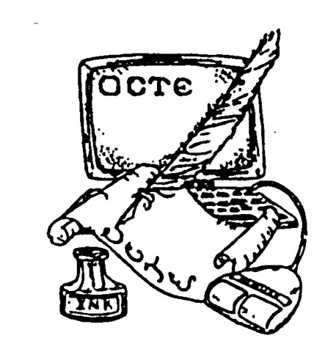

**Electronic Entry Deadline: Sunday, December 9, 2012**

**ENTRY Email: OklahomaYoungWriters@gmail.com**

**Cover Sheets and Payment Deadline: Thursday, December 13, 2012**

Dr. Teresa Rothrock

c/o East Central University

1100 E. 14th St.

PMB N-6

Ada, OK 74820-6999

Contact: trothrock@ecok.edu