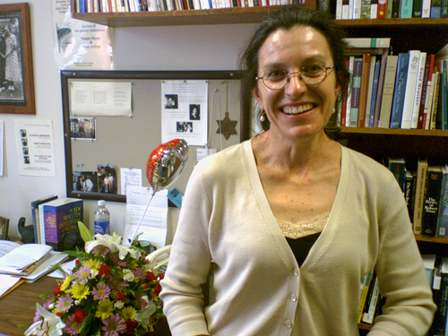

OCTE 2012 Spring Conference to Feature Pulitzer-prize winning poet Claudia Emerson

The OCTE Spring Conference is right around the corner. This year OCU and *The Petree College of Arts and Sciences Center for Interpersonal Studies through Film and Literature* is sponsoring Pulitzer Prize winning poet Claudia Emerson to deliver the keynote address at 10:00 a.m. on Wednesday, April 4th, in the Kerr McGee Auditorium at OCU.

Emerson won the Pulitzer Prize for her book “Late Wife,” seemingly a collection of letters to a former husband, her current husband and to herself. Emerson is known for her poetry that looks back on her first marriage. She believes this pursuit brings value to her life.

Claudia Emerson, a native of Chatham, Virginia, studied writing at the University of North Carolina, Greensboro. Her poetry is steeped in the Southern Narrative tradition and bears the influences of [Ellen Bryant Voigt](http://www.poetryfoundation.org/archive/poet.html?id=7110), [Betty Adcock](http://www.poetryfoundation.org/archive/poet.html?id=98635), and William Faulkner. Poet Deborah Pope writes of *Late Wife* (2005), “Like the estranged lover in one of her poems who pitches horseshoes in the dark with preternatural precision, so Emerson sends her words into a different kind of darkness with steely exactness, their arc of perception over and over striking true.” Her honors include two additional Pulitzer Prize nominations as well as fellowships from the Library of Congress, the Virginia Commission for the Arts, and the National Endowment for the Arts.

In 2008 she was appointed poet laureate of Virginia, a two-year role. Emerson has been poetry editor for the *Greensboro Review* and a contributing editor for *Shenandoah*. She has taught at Washington and Lee University, Randolph-Macon Women’s College, and the University of Mary Washington.