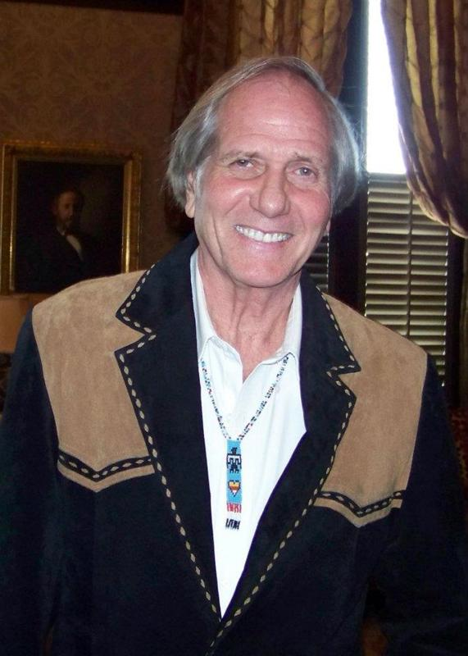

**Oklahoma Poet Laureate Eddie Wilcoxen to Entertain during Young Writer’s Luncheon**

**Eddie D. Wilcoxen** will provide entertainment at our OCTE luncheon which honors our Young Writer’s Contest winners and the Geraldine Burns honorees. Wilcoxen is well known for his accomplishments in poetry, speech, debate, landscape artistry, broadcasting, and teaching. He hosts the top rated daily morning show in Southwest Oklahoma where his poetry reaches an audience of fifty thousand on KWHW Radio in Altus, Oklahoma. His published works include: “Oklahoma Proud, A Centennial Book of Poems”; “Reflections of a Wandering mind”; “More Reflections” “Songbook in My Head,” “Riding’! Rodeo and Range,” Chautauqua—The Wounds of War, A Tale of two Americans,” and many others.

**Eddie Wilcoxen** performs across the state as featured speaker at Oklahoma Humanities Council’s Poetry Out Loud, the Oklahoma Poetry Society’s Annual Awards; the English Speaking Union in Tulsa, and the Altus Chamber of Commerce Annual Farm City Week Banquet celebrating the Legend of Agriculture Award. He was keynote speaker at the Oklahoma Literacy Coalition Conference of 2010 sponsored by the Oklahoma Literacy Coalition, Oklahoma Dept of Libraries, and State Department of Education, and his book, “Animal ABCs” was showcased as a literacy teaching tool. The author of numerous books of poetry, his acclaimed “Oklahoma Proud, A Centennial Book of Poems” was lauded for its historical accuracy, and excerpts were serialized in celebration of the Centennial over several months in the Altus Times Newspaper, and presented at the Shortgrass Arts and Humanities Council’s 2007 Oklahoma Centennial Chautauqua funded by the Oklahoma Humanities Council.

We are honored to have Eddie Wilcoxen as the OCTE luncheon speaker.