**EXHIBITOR RESERVATION FORM**

**Oklahoma Council of Teachers of English**

***Fall Conference with Derrick Cameron***

**Saturday, October 6, 2012**

**University of Central Oklahoma | Liberal Arts Building | Edmond, OK**

Please print and return this form by October 3, 2012, with check made out to **OCTE** and mailed to the address below.

Company Name: _______________________________________________________________

Address: ______________________________________________________________________

Representative(s) attending: _______________________________________________________

Address: ______________________________________________________________________

City: __________________________________________ State: _______ Zip:_______________

Telephone: _____________________________ Fax: ______________________________

E-mail: _______________________________________________________________________

Tables Needed: _____1 table $100.00

_____2 tables $150.00

Participant Registration begins at 8:30 am on October 6. **Set up will begin at 7:30 am.**

Please make check payable to **OCTE** and remit to:

Jason Stephenson

10 Coventry Ct.

Edmond, OK 73012

Please e-mail me at stephensonj@deercreek.k12.ok.us if you have any questions or comments.

Thank you so much for your support!

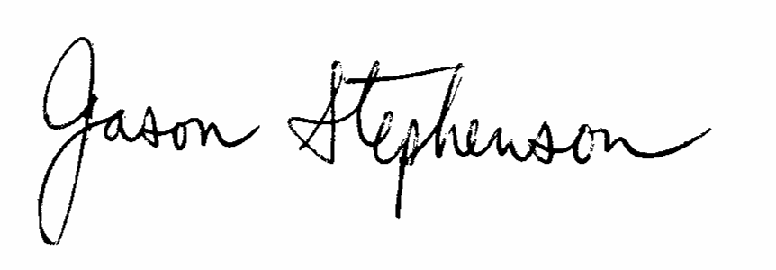

Jason Stephenson

**OCTE looks forward to seeing you at our fall conference on October 6, 2012.**