# OCTE MEMBERSHIP FORM 2010-2011

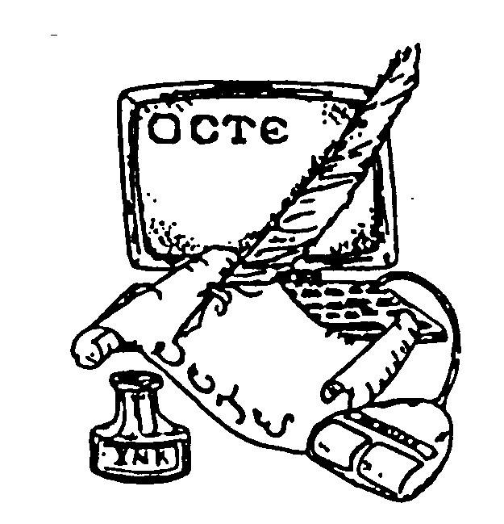

|  |  |
| --- | --- |
| Contact Information | |
|  | |
| Name |  |
| Street Address |  |
| City ST ZIP Code |  |
| Name of School |  |
| Teaching Level |  |
| E-Mail Address |  |

|  |
| --- |
| Type of Membership |
| Select a type of membership: |
|  |
| Teacher Candidate - FREE |
| First Year Teacher - FREE |
| Geraldine Burns Award Winner, one year - FREE |
| Single Membership, one year - $25 |
| Retired, one year - $10 |
| Joint, 2 people, one address, one year - $30 |
| Two or more years @ $20 a year (I would like ___________ years @ $20 = _____________) |

|  |
| --- |
| Directions |
| Return this completed form via email to <octetreasurer@gmail.com> if you do not need to send a check.  Otherwise, please print, complete, and send to:  Laura Bolf-Beliveau  OCTE Treasurer  2301 Regis Court  Norman, OK 73071  Verification of membership will be sent via email. |
|  |
| Visit our website at:  <http://octe.ecok.edu/index.htm>  Look for us on Facebook. |