**2012 OCTE Young Writers Contest**

**CATEGORIES:** Short Story (maximum 1,500 words)

($2 entry fee per entry) Essay (Expository only, no narrative essays, maximum 500 words)

Personal Narrative (first person, maximum 500 words)

Descriptive Paragraph

Poetry

**Fillers:** Descriptive sentences may be submitted as “fillers.”

($1 entry fee)

**Age Groups:** K-6th / 7th-9th / 10th-12th / College

**Entry Guidelines:**

* Each teacher (OCTE members ONLY) may enter up to **10** original manuscripts for his/her students with a fee of $2 per entry.
* Each teacher may enter up to 10 “filler” descriptive sentences for his/her students with a fee of $1 per sentence.
* No student may enter more than one entry per category.
* Entries must be **TYPED**, double-spaced. Poems should be **TYPED**, single-spaced.
* ALL ENTRIES MUST BE ELECTRONICALLY submitted via email attachment (.rtf, .doc, .docx, or .pdf accepted). Please put your last name, school, and Young Writers in the **Subject Line** of the email (e. g., Murphy, ECU, Young Writers). Student names and corresponding titles of work should be included **in the message** of the email. However, only titles should be included on the actual entry - no author or teacher names, please.
* EACH entry must have a signed cover sheet. Send these via mail with payment to: Dr. Robin Murphy, c/o East Central University, PMB N-6, Ada, OK. 74820. **Make checks payable to OCTE.**
* A confirmation email will be sent when entries, coversheets, and payment are ALL received.

**Contest rules:** All contest guidelines, such as maximum word length, entry deadline, entry format, OCTE membership for teachers, cover sheets, no names on entries, etc., must be strictly observed. Failure to do so will disqualify entries. **No entry fees will be refunded or entries returned.**

**Cover Sheet:** After duplicating, fill out the enclosed cover sheet completely, including all three signatures. Use only one cover sheet per entry. Please be sure all handwriting is legible to ensure names are accurate. **We are not responsible for lost entries or inaccurate information.**

Winners will have their work published in the 2012 Anthologyand will be invited, along with their teachers and parents, to attend the Young Writers Conference and Banquet April 4, 2011, to meet with the judges, engage in creative activities, and receive a free copy of the anthology. **Please note this year winners and guests must purchase a banquet ticket.** More information about the Banquet and Conference will follow in the Winner’s Letter. Additional copies of the anthology will be available for $5 each.

**COVER SHEET**

**2012 OCTE Young Writers Competition**

**(Please TYPE or PRINT information.)**

Student’s Name: Grade Level:

Category: Number of words in entry:

Title of Entry:

Student’s Address:

Teacher’s Name:

Teacher’s Address:

Teacher’s Email:

School Name:

School Address and Phone:

**SIGNATURES:**

**I hereby attest to the originality and length of this piece.**

Student Signature Date Parent Signature Date

*I verify that the above is my student, the number of words is correct, and I am a current member of OCTE.*

Teacher Signature Date

**Electronic Entry Deadline: Sunday, December 11, 2011**

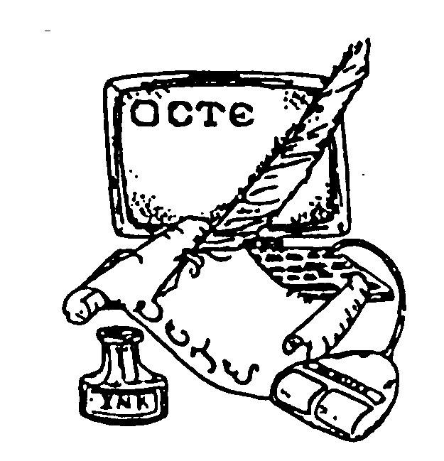

**ENTRY Email: OklaYoungWriters@gmail.com**

**Cover Sheets and Payment Deadline: Thursday, December 15, 2011**

Dr. Robin Murphy

c/o East Central University

PMB N-6

Ada, OK 74820

Contacts: [rmurphy@ecok.edu](mailto:rmurphy@ecok.edu) OR [trothrock@ecok.edu](mailto:trothrock@ecok.edu)