1. Download Python 3.6.x from http://www.python.org

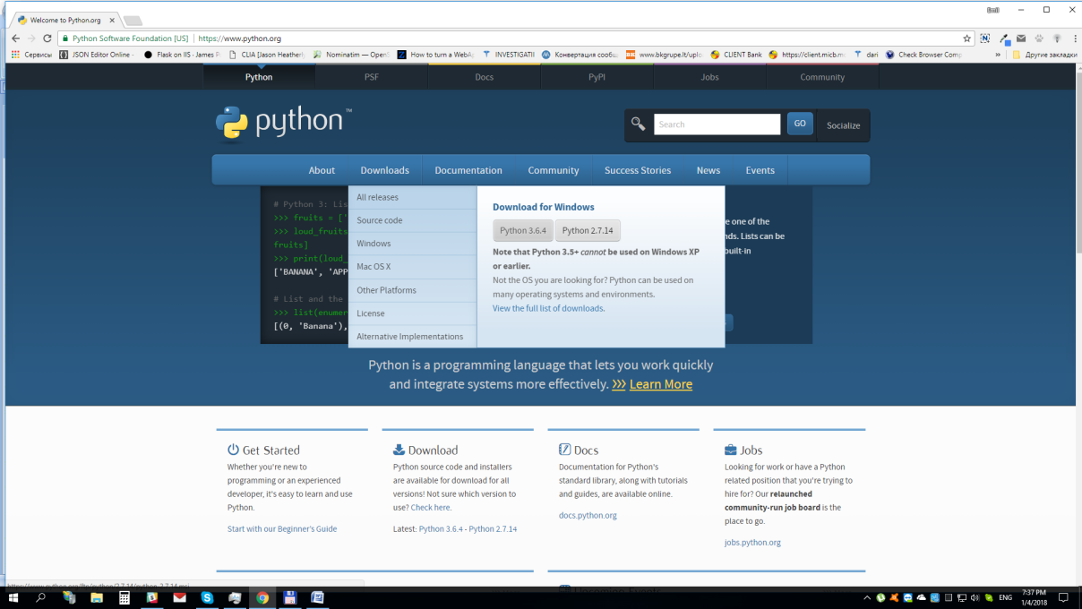

1. Install downloaded package. When installing please select for ”add python.exe to path ”

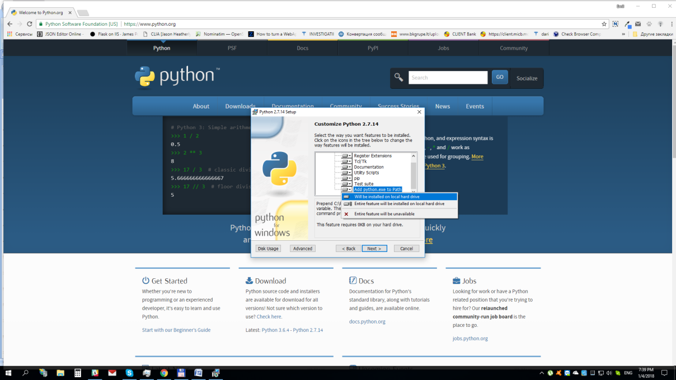

1. After python is installed, open the command console **CMD**

Enter in prompt command line following commands:

**pip install requests**

**pip install lxml**

**pip install pyodbc**

1. Open in command line the folder where is located the script (main.py)
2. Run the script with command:

**python main36.py**