**2. Using Matlab**

a) x is a vector of a random permutation of the integers from 1 to 200. Its size is 1*200, namely, 200 columns.

b) b = [4 5 6]. b is a vector that contains the second row of matrix a. a stays the same.

c)b is a 9x1 column vector by stacking up columns of a.

d) Find indices of positive elements in f and copy into g only the elements of f that are >0.

e) z is a row vector containing eight columns of 1. x and y are both row vectors containing eight columns of 0.5.

f) a is a row vector of range 1 to 5. b is the the reverse of a. [end:-1:1] means going from the last element to the first element in vector a in step of 1.

3.Write a few lines of code to do each of the following.

a)

function y = dice()

y = round(1+rand(1)*5);

end

b)

Z = reshape(y,[2,3])

c)

[x, inds] = min(Z(:))

[r, c] = find(Z == x);

r = Z(r, :);

c = Z(:, c);

d)

x = sum(v == 8)

**4.**

1. **Intensity**

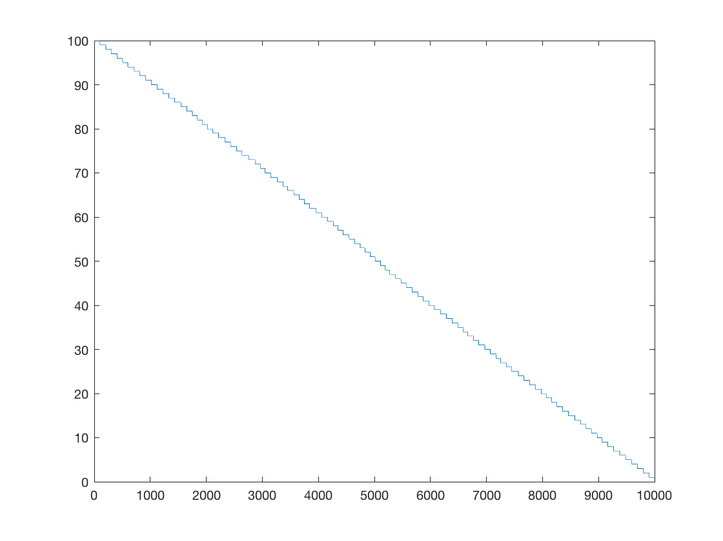

**b). Histogram**

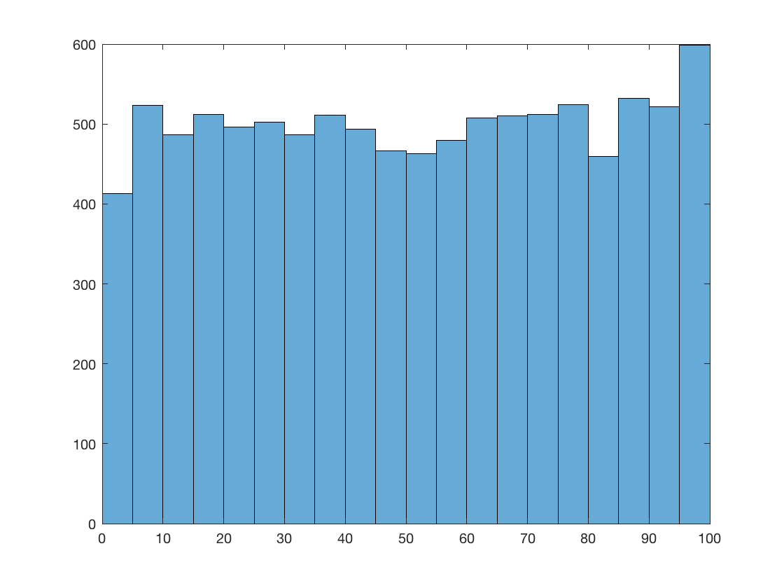

**c) Z: left quadrant of A**

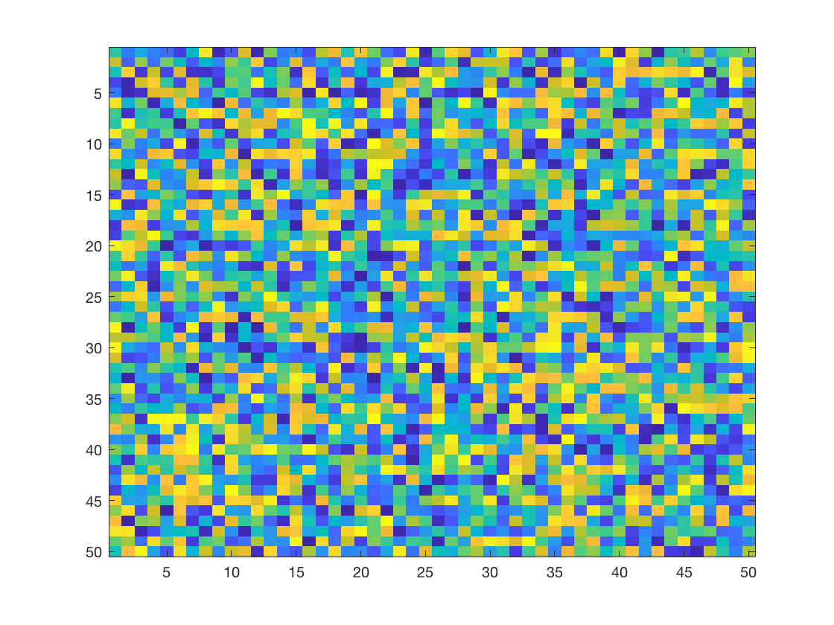

**d) W**

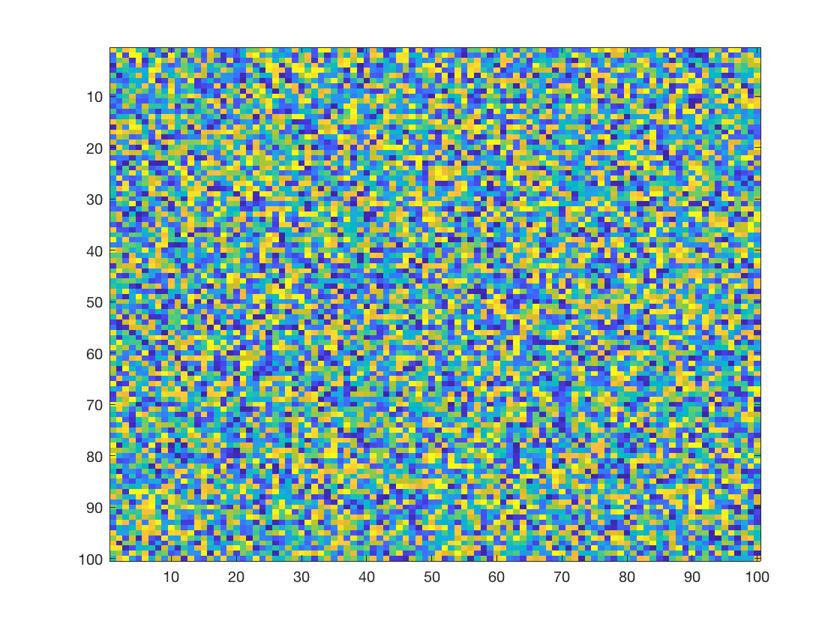



II

Original Image

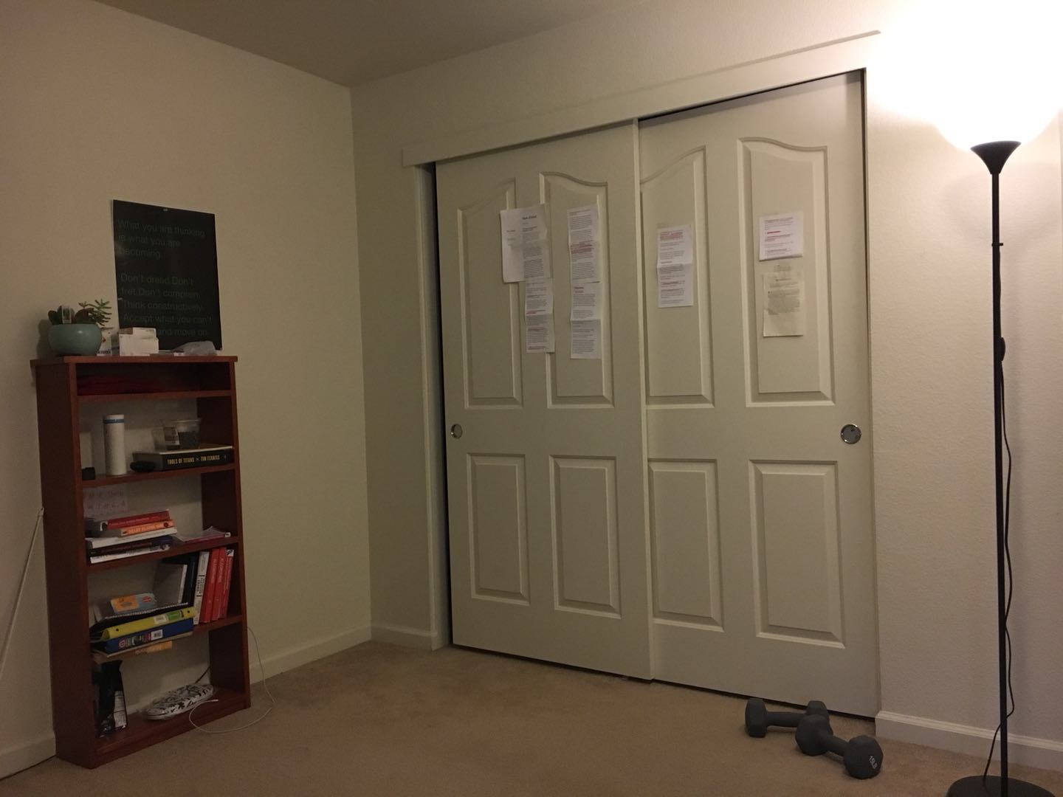

Output image

