DRAFT Education Management Information System (EMIS) Data Warehouse
Data Dictionary
This data dictionary describes the entities, attributes, data types, keys and descriptions for the EMIS data warehouse dimensional model. It is separated into sections called data marts that address specific areas of reporting.

Contents
SCHOOLS DATA MART 3
ENROLLMENT DATA MART 14
Schools Dimension 14
Learner Dimension 15
Date Dimension 15
Grade Dimension 16
Enrollment Type Dimension 16
Location Dimension 16
Enrollment Fact 17
INDICATORS DATA MART 19
TEACHER DATA MART 23
NON-TEACHING STAFF DATA MART 28
TEACHER TRANSFERS MART 33
dw.teacher_transfer_fact 33
Design Decisions and Notes 34
INFRASTRUCTURE DATA MART 34
dw.infrastructure_type_dim 35
dw.infrastructure_fact 35
Design Decisions and Notes 36
TEACHING SUBJECTS DATA MART 37
dw.subject_dim 37
dw.teaching_subject_fact 38
Design Decisions and Notes 38

SCHOOLS DATA MART
This data dictionary lists entities, attributes, data types, nullability, keys and descriptions for the Date, School Fact and Location objects in the EMIS dimensional model provided.
SCD 2 will be tracked for admin unit change, school name change, ownership status change, legal ownership status change, sex composition change, boarding status change,
TYPES OF DW REPORTS ON SCHOOLS:
1. TOTAL NUMBER OF SCHOOLS BY SEX COMPOSITION
2. TOTAL NUMBER OF SCHOOLS BY LEGAL OWNERSHIP (SOLE PROP, PARTNERSHIP, COMPANIES, NGOS ETC.)
3. TOTAL NUMBER OF SCHOOLS BY FUNDING TYPE - OWNERSHIP STATUS (GOVERNMENT AIDED, PRIVATE)
4. TOTAL NUMBER OF SCHOOLS BY BOARDING STATUS (BOARDING, DAY, BOTH)
5. TOTAL NUMBER OF SCHOOLS BY FOUNDING BODY (CATHOLIC, MUSLIM, COMMUNITY, GOVT)
6. TOTAL NUMBER OF SCHOOLS BY OPERATIONAL STATUS (ACTIVE, SUSPENDED, CLOSED)

All of these have date dimension to categorize the school fact table. The Schools Dimension is denormalized so as not to have FK lookups. The Admin Units Dimension has SCD 2 tracking for cases where admin units change over time.

Schools Dimension
Attribute | Type | Null? | Key | Description / Business Rules
id | SERIAL | No | PK | Serial surrogate key.
source_id | INT | No | FK | The source id (primary key) from the transactional database table
name | VARCHAR(100) | No |  | name of the school
admin_unit_id | INTEGER | No | FK | admin_unit_id at parish/ward level for the school
emis_number | VARCHAR(50) | No |  | The EMIS number is a unique code for each education institution. It is formatted with a level code character, alphabet character, except I&O, and ends with a 6 digit- generated-number.
school_type | VARCHAR(30) | No |  | PREPRIMARY, PRIMARY, SECONDARY, CERTIFICATE, DIPLOMA, DEGREE, INTERNATIONAL
operational_status | VARCHAR(20) | No |  | Operational status: ACTIVE, SUSPENDED, CLOSED
ownership_status | VARCHAR(60) | No |  | SOLE PROPRIETOR, LEGAL PARTNERSHIP, PUBLIC LIMITED COMPANY etc.
funding_type | VARCHAR(20) | No |  | GOVT AIDED, PRIVATE
sex_composition | VARCHAR(20) | No |  | FEMALES ONLY, MALES ONLY, MIXED
boarding_status | VARCHAR(20) | No |  | School boarding status: DAY SCHOOL, FULLY BOARDING, DAY AND BOARDING, RESIDENTIAL, NON RESIDENTIAL
founding_body_type | VARCHAR(60) | No |  | GOVERNMENT, ANGLICAN, ROMAN CATHOLIC, ISLAMIC, SEVENTH DAY ADVENTIST, ORTHODOX, COMMUNITY, ENTREPRENUERS, CBO/NGO
effective_date | date | No |  | The date the school went into effect
expiration_date | date | Yes |  | The effective end date
is_current | Boolean | No |  | Boolean that indicates if this is the current record
change_hash | TEXT | No |  | Used to implement SCD 2. If exists but change hash is different expire the old row
change_reason | TEXT | Yes |  | Optional use to explain changes
changed_fields | TEXT | Yes |  | Optional, helps to identify which fields changed.

Date Dimension
Attribute | Type | Null? | Key | Description / Business Rules
id | INT | No | PK | Surrogate key.
day | INT | No |  | Two digit day (01-31)
month | INT | No |  | Two-digit month (01–12).
month_name | VARCHAR(9) | No |  | e.g. January, February, September etc.
short_month_name | VARCHAR(3) | No |  | JAN, FEB, MAR, APR, etc.
year | INT | No |  | Four-digit year.
system_date | DATE | No |  | System date (YYYY-MM-DD).
FY | INT | No |  | Fiscal year. 4 digit
Quarter | VARCHAR(2) | No |  | Quarter (Q1–Q4).

This table should be pre-populated with all calendar days for the DW
Admin Unit Dimension
Attribute | Type | Null? | Key | Description / Business Rules
id | SERIAL | No | PK | Surrogate key.
source_id | INT | No | FK | The source id (primary key) from the transactional database table
parent_id | INT | No | FK | A foreign key indicating the parent admin_unit
admin_unit_type | VARCHAR(60) | No | UK | The admin unit type of the admin unit e.g. CITY, MUNICIPALITY, DLG, TOWN COUNCIL, REGION, SUB REGION, CITY DIVISION, MUNICIPALITY, WARD, VILLAGE, ZONE, COUNTY, DISTRICT, SUB COUNTY, PARISH, MUNICIPALITY DIVISION, CELL etc.
tier_type | VARCHAR(60) | Yes | UK | e.g. HLG, LLG etc.
admin_unit_code | VARCHAR(10) | No | UK | Every admin unit is uniquely coded by local government
voting_code | VARCHAR(10) | No | UK | A vote code is a financial id for admin units, as defined by ministry of finance. Used for payments.
effective_date | DATE | No |  | The date the admin unit went into effect
expiration_date | DATE | Yes |  | Date the admin unit was ended
is_current | boolean | No |  | status of whether the admin unit is current or not.
change_hash | TEXT | No |  | Used to implement SCD 2. If exists but change hash is different expire the old row
change_reason | TEXT | Yes |  | Optional use to explain changes
changed_fields | TEXT | Yes |  | Optional, helps to identify which fields changed.

School Location Details Dimension
Attribute | Type | Null? | Key | Description / Business Rules
id | SERIAL | No | PK | Surrogate key.
source_id | INT | No | FK | The source id (primary key) from the transactional database table
school_id | INT | No | FK | A foreign key from the schools dimension
physical_address | VARCHAR(200) | Yes |  | The physical address e.g., Plot 10 Lumumba road
postal_address | VARCHAR(100) | Yes |  | The postal address of the school
admin_unit_id | INT | No | FK | Foreign key from the admin_units table at parish level
latitude | DECIMAL(10,7) | Yes |  | Latitude coordinates of institution’s location
longitude | DECIMAL(10,7) | Yes |  | Longitude coordinates of institution’s location
date_created | TIMESTAMP | No |  | Date-time timestamp assigned at creation of the record
effective_date | DATE | No |  | Effective date of the school location
expiration_date | DATE | Yes |  | Expiration_date of the school location
is_current | boolean | No |  | status of whether the school location is current or not.
change_hash | TEXT | No |  | Used to implement SCD 2. If exists but change hash is different expire the old row
change_reason | TEXT | Yes |  | Optional use to explain changes
changed_fields | TEXT | Yes |  | Optional, helps to identify which fields changed.

School Fact
Attribute | Type | Null? | Key | Description / Business Rules
id | SERIAL | No | PK | Surrogate key for the fact row.
school_id | INTEGER | No | FK | FK → Schools Dimension(id).
date_id | INTEGER | No | FK | FK → Date Dimension(id). The grain will be daily
load_time | timestamp without timezone | No |  | ETL load date/time

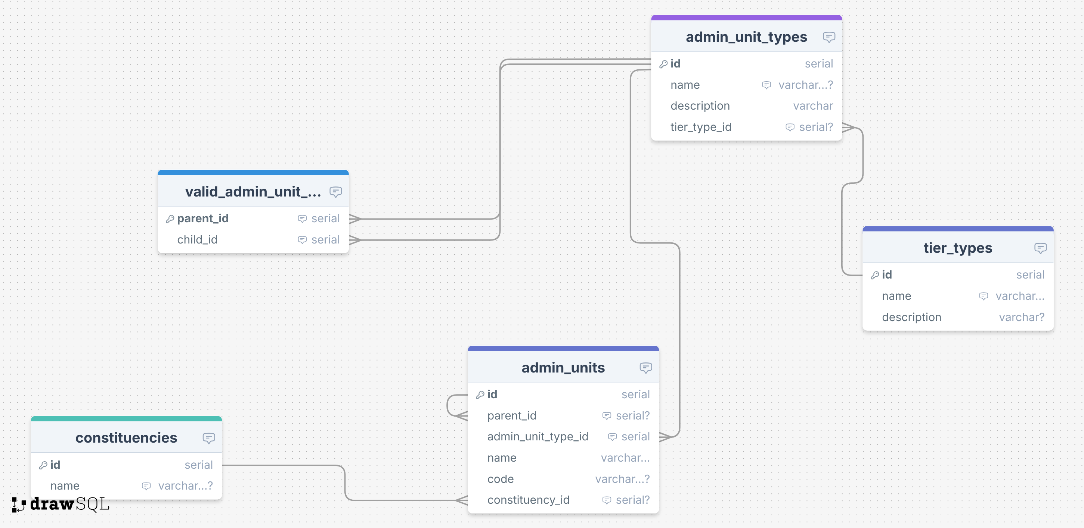

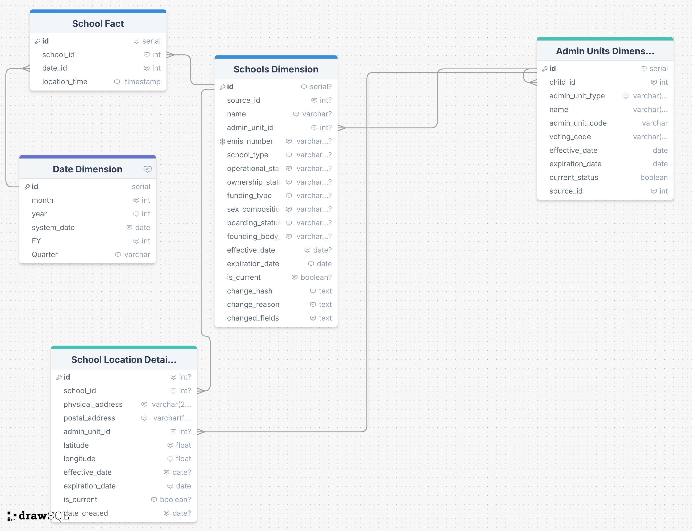

ENROLLMENT DATA MART
The enrollment data mart encompasses School, Learner, Date, Grade, Enrollment Type, Location dimensions and the Enrollment Fact table.

Schools Dimension
Attribute | Type | Null Allowed? | Key | Description
id | SERIAL |  | PK | Surrogate key for the school record.
school_id | INTEGER |  | BK | Business key from DEMIS school table.
school_level | VARCHAR(255) |  |  | Pre-primary / Primary / Secondary etc.
registration_status | VARCHAR(255) |  |  | Registered / Licensed / Not licensed.
level_category | VARCHAR(255) |  |  | Non-tertiary grouping if applicable.
local_government | VARCHAR(255) |  |  | Local government name from DEMIS.
sex_composition | VARCHAR(255) |  |  | Mixed / Boys only / Girls only.
non_tertiary_category | VARCHAR(255) |  |  | Additional classification if used nationally.
ownership | VARCHAR(255) |  |  | Government / Private.
founding_body | VARCHAR(255) |  |  | Government, Catholic, CoU, Islamic, SDA, etc.
boarding_status | VARCHAR(255) |  |  | Day / Boarding / Both.
name | VARCHAR(255) |  |  | School name (length 200 recommended).
dist_to_primary | DECIMAL(6,1) |  |  | Distance to nearest primary school (km).
dist_to_secondary | DECIMAL(6,1) |  |  | Distance to nearest secondary school (km).
dist_to_deo | DECIMAL(6,1) |  |  | Distance to DEO office (km).

Learner Dimension
Attribute | Type | Key | Null Allowed? | Description
id | INTEGER | PK |  | Surrogate key.
learner_id | INTEGER | BK |  | Business key from DEMIS learner table.
age | INTEGER |  |  | Computed in ETL from DOB.
nationality | VARCHAR(255) |  |  | Denormalized nationality/country name or ISO3.
gender | VARCHAR(255) |  |  | Male / Female.
orphan_status | VARCHAR(255) |  |  | Mother, Father or both parents deceased, or Not Applicable.
NIN | VARCHAR(14) | Yes |  | National ID (14 chars) – PII, consider masking.
PASSPORT_NO | VARCHAR(20) | Yes |  | Passport number. Consider tracking changes.
STUDENT_PASS_NO | VARCHAR(20) | Yes |  | Student pass number. Consider tracking history
WORK_PERMIT_NO | VARCHAR(20) | Yes |  | Working Permit Number
REFUGEE_ID | VARCHAR(20) | Yes |  | Refugee ID from OPM
VISUAL | BOOLEAN |  |  | Visual impairment flag.
HEARING | BOOLEAN |  |  | Hearing impairment flag.
WALKING | BOOLEAN |  |  | Walking/mobility difficulty flag.
SELF_CARE | BOOLEAN |  |  | Self-care difficulty flag.
REMEMBERING | BOOLEAN |  |  | Remembering/concentration difficulty flag.
COMMUNICATION | BOOLEAN |  |  | Communication difficulty flag.
MULTIPLE_DISABILITIES | BOOLEAN |  |  | True if more than one impairment is present.

Date Dimension
Attribute | Type | Key | NULL Allowed? | Description
id | INTEGER | PK |  | Surrogate key.
month | INTEGER |  |  | 1–12.
year | INTEGER |  |  | Four-digit year.
system_date | DATE |  |  | Calendar date.
FY | INTEGER |  |  | Fiscal year (e.g., 2025).
Quarter | VARCHAR(255) |  |  | Quarter of the year (Q1–Q4).
Term | VARCHAR(255) |  |  | Term 1/2/3.

Grade Dimension
Attribute | Type | Key | NULL Allowed? | Description
id | INTEGER | PK |  | Surrogate key.
grade | VARCHAR(2) |  |  | Grade code e.g., P1…P7, S1…S6.

Enrollment Type Dimension
Attribute | Type | Key | NULL ALLOWED? | Description
id | INTEGER | PK |  | Surrogate key.
enrol_type_id | INTEGER | BK |  | Business key from DEMIS.
enrollment_type | VARCHAR(255) |  |  | RETURNEE, REPEATER, CONTINUING, TRANSFER, NEW ENTRANT. From enrollment types table in EMIS

Location Dimension
Attribute | Type | Key | NULL ALLOWED? | Description
id | INTEGER | PK |  | Surrogate key.
region | VARCHAR(255) |  |  | Region.
sub_region | VARCHAR(255) |  |  | Sub-region.
district | VARCHAR(255) |  |  | District.
county | VARCHAR(255) |  |  | County.
sub_county | VARCHAR(255) |  |  | Sub-county.
parish | VARCHAR(255) |  |  | Parish/Ward.

Enrollment Fact
Attribute | Type | Key | Description
id | INTEGER | PK | Surrogate key.
school_id | INTEGER | FK | References School Dimension(id).
grade_id | INTEGER | FK | References Grade Dimension(id).
date_id | INTEGER | FK | References Date Dimension(id).
learner_id | INTEGER | FK | References Learner Dimension(id) if individual grain.
enrol_type_id | INTEGER | FK | References Enrollment Type Dimension(id).
location_id | INTEGER | FK | References Location Dimension(id).

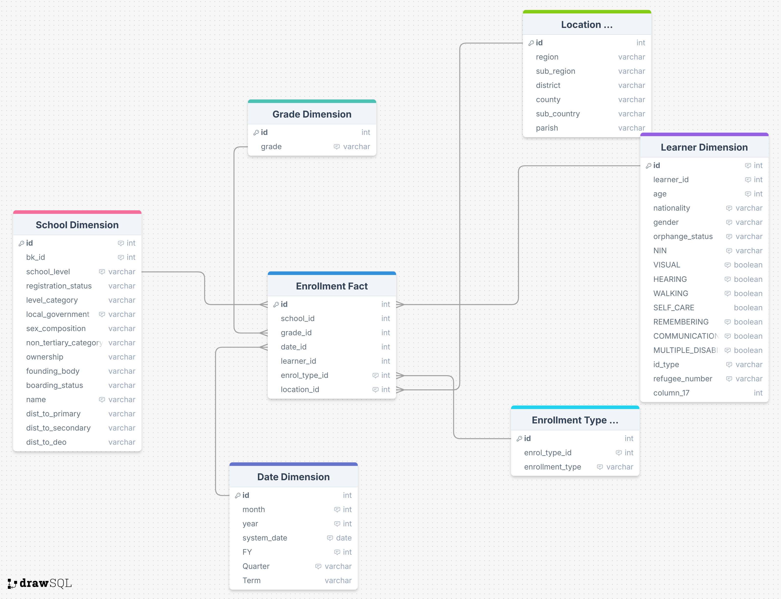

INDICATORS DATA MART
This data mart lists entities, attributes, data types, nullability, keys and descriptions for the Gender, Location, Indicator Type, Year dimensions and the Indicator Fact table in the EMIS indicators data mart.
Gender Dimension
Attribute | Type | Null? | Key | Description / Business Rules
id | INTEGER | No | PK | Serial surrogate key.
sex | VARCHAR(10) | No | AK | Male or Female (consider short codes 'M'/'F' and a UNIQUE constraint).

Location Dimension
Attribute | Type | Null? | Key | Description / Business Rules
id | INTEGER | No | PK | Serial surrogate key.
region | VARCHAR(255) | No |  | Region name.
sub_region | VARCHAR(255) | No |  | Sub-region name.
district | VARCHAR(255) | No | AK | District name (grain of this dimension; consider UNIQUE).

Indicator Type Dimension
Attribute | Type | Null? | Key | Description / Business Rules
id | INTEGER | No | PK | Serial surrogate key.
indicator_type | VARCHAR(255) | No | AK | Indicator type e.g., GER, NER, NIR, GIR, PTR (controlled list).

Year Dimension
Attribute | Type | Null? | Key | Description / Business Rules
id | INTEGER | No | PK | Serial surrogate key.
year | INTEGER | No | AK | Four-digit calendar year (e.g., 2025).

Indicator Fact
Attribute | Type | Null? | Key | Description / Business Rules
id | INTEGER | No | PK | Surrogate key for the fact row.
gender_id | INTEGER | No | FK | FK → Gender Dimension(id).
location_id | INTEGER | No | FK | FK → Location Dimension(id). Lowest level is district.
indicator_type_id | INTEGER | No | FK | FK → Indicator Type Dimension(id). (Field name has a typo in DDL; see notes.)
indicator | INTEGER | No |  | Indicator value as percentage (e.g., GIR = 88). Consider DECIMAL(5,2) if fractional values are needed.
year_id | INTEGER | No | FK | FK → Year Dimension(id).

Modeling Notes & Recommendations
• Typo: rename Indicator Fact column 'indictor_type_id' → 'indicator_type_id' to match the dimension and avoid confusion.
• Data type: 'indicator' is INTEGER in DDL; many indicators (e.g., rates/ratios) need decimals. Prefer DECIMAL(5,2).
• Controlled vocabularies: enforce allowed values for indicator_type (GER, NER, NIR, GIR, PTR, etc.) and sex ('M','F').
• Uniqueness: consider UNIQUE constraints on (year, location_id, gender_id, indicator_type_id) to prevent duplicates per slice.
• Location grain: current grain is district; if future needs require sub-county or school level, extend the dimension or add a separate location hierarchy.
• Naming: normalize table names to a consistent case/style (e.g., 'gender_dimension', 'location_dimension').
We need a local government dimension

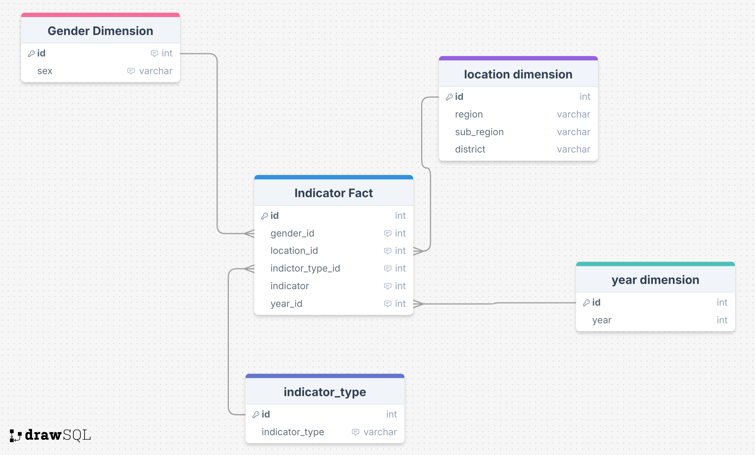

TEACHER DATA MART
This teacher data mart lists entities, attributes, data types, keys and descriptions for the School, Date, HR Fact, Location and Teacher dimensions in the EMIS dimensional model as provided.
School Dimension
Attribute | Type | Null? | Key | Description / Business Rules
id | INTEGER | No | PK | Serial surrogate key.
school_id | INTEGER | No | BK | Primary key from DEMIS schools table.
school_level | VARCHAR(255) | No |  | Pre-primary / Primary / Secondary / etc.
registration_status | VARCHAR(255) | No |  | Registered / Licensed / Not licensed / etc.
level_category | VARCHAR(255) | No |  | Non-tertiary grouping where applicable.
local_government | VARCHAR(255) | No |  | LG name (denormalized from DEMIS).
sex_composition | VARCHAR(255) | No |  | Mixed / Boys only / Girls only.
ownership | VARCHAR(255) | No |  | Government / Private.
non_tertiary_category | VARCHAR(255) | No |  | Additional classification if used nationally.
founding_body | VARCHAR(255) | No |  | Government, Catholic, CoU, Islamic, SDA, etc.
boarding_status | VARCHAR(255) | No |  | Day / Boarding / Both.
name | VARCHAR(200) | No |  | School name (comment indicates varchar(200) advisable).
dist_to_primary | DECIMAL(6,1) | No |  | Distance to nearest primary (km). Consider DECIMAL(6,1).
dist_to_secondary | DECIMAL(6,1) | No |  | Distance to nearest secondary (km). Consider DECIMAL(6,1).
dist_to_deo | DECIMAL(6,1) | No |  | Distance to DEO office (km). Consider DECIMAL(6,1).
emis_number | VARCHAR(30) | No | UK | EMIS number (comment: varchar(30)); consider unique alternate key.

Date Dimension
Attribute | Type | Null? | Key | Description / Business Rules
id | INTEGER | No | PK | Surrogate key.
month | INTEGER | No |  | Two-digit month (1–12).
year | INTEGER | No |  | Four-digit year.
system_date | DATE | No |  | System date.
FY | INTEGER | No |  | Fiscal year.
Quarter | VARCHAR(255) | No |  | Quarter of the year (Q1–Q4).
Term | VARCHAR(255) | No |  | Academic term (1/2/3).

HR Fact
Attribute | Type | Null? | Key | Description / Business Rules
id | INTEGER | No | PK | Surrogate key for the fact row.
school_id | INTEGER | No | FK* | Intended FK to School Dimension(id) – define constraint.
date_id | INTEGER | No | FK | FK to Date Dimension(id).
teacher_id | INTEGER | No | FK | FK to Teacher Dimension(id).
location_id | INTEGER | No | FK | FK to Location Dimension(id).

Location Dimension
Attribute | Type | Null? | Key | Description / Business Rules
id | INTEGER | No | PK | Surrogate key.
region | VARCHAR(255) | No |  | Region.
sub_region | VARCHAR(255) | No |  | Sub-region.
district | VARCHAR(255) | No |  | District.
county | VARCHAR(255) | No |  | County.
sub_country | VARCHAR(255) | No |  | Likely 'sub_county' in domain (typo in DDL).
parish | VARCHAR(255) | No |  | Parish/Ward.

Teacher Dimension
Attribute | Type | Null? | Key | Description / Business Rules
id | INTEGER | No | PK | Serial surrogate key.
teacher_id | INTEGER | No | BK | Business key (DEMIS teacher PK).
surname | VARCHAR(255) | No |  | Last name (suggest VARCHAR(50)).
given_name | VARCHAR(255) | No |  | First & other names (suggest VARCHAR(100)).
identity_number | VARCHAR(255) | No |  | Generic ID number; width ~30; sensitive.
identity_type | VARCHAR(255) | No |  | PASSPORT / NATIONAL ID / REFUGEE NUMBER / WORK PERMIT NUMBER.
sex | VARCHAR(255) | No |  | MALE / FEMALE (prefer short codes 'M'/'F').
discipline | VARCHAR(255) | No |  | S = Sciences; A = Arts (derived from subjects taught).
highest_teaching_qualification | VARCHAR(255) | Yes |  | Highest qualification (≤100 chars advised).
highest_education_level | VARCHAR(30) | No |  | Bachelors, Diploma, Post Graduate Diploma, Masters, PhD, O-LEVEL, A-LEVEL etc.
teacher_type | VARCHAR(255) | No |  | QUALIFIED or TRAINED.

Modeling Notes & FK Corrections
• Add missing FK on HR Fact: FOREIGN KEY (school_id) REFERENCES "School Dimension"(id).
• Remove incorrect FK in the source DDL that references "School Dimension".school_level to "HR Fact".id.
• Consider changing distance fields to DECIMAL(6,1) for numeric comparisons.
• Correct Location Dimension field name from sub_country to sub_county if applicable.
• Add a UNIQUE constraint on emis_number as a stable alternate key.

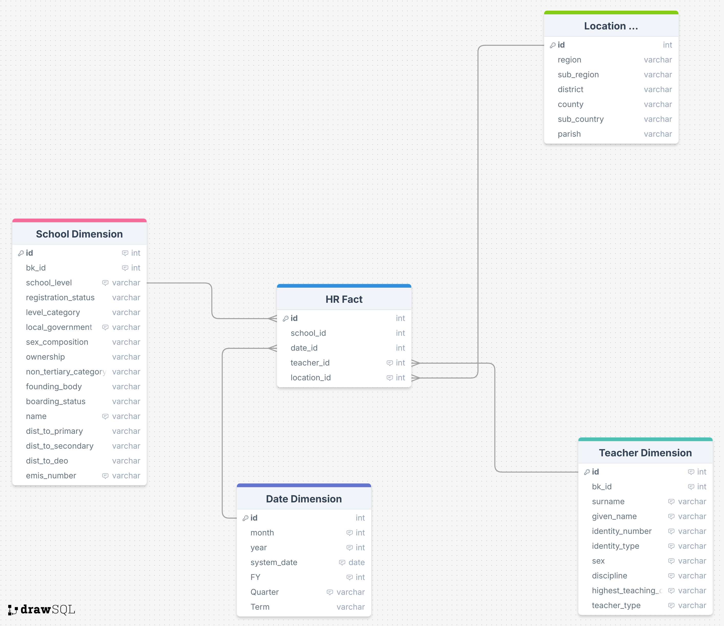

NON-TEACHING STAFF DATA MART
This data dictionary lists entities, attributes, data types, nullability, keys and descriptions for the School, Date, HR Fact, Location and Non Teacher dimensions in the EMIS dimensional model provided.
School Dimension
Attribute | Type | Null? | Key | Description / Business Rules
id | INTEGER | No | PK | Serial surrogate key.
bk_id | INTEGER | No | BK | Primary key from DEMIS schools table.
school_level | VARCHAR(255) | No |  | Pre-primary / Primary / Secondary / etc. (Use controlled vocab).
registration_status | VARCHAR(255) | No |  | Registered / Licensed / Not licensed / etc.
level_category | VARCHAR(255) | No |  | Non-tertiary grouping where applicable.
local_government | VARCHAR(255) | No |  | Local Government (denormalized name).
sex_composition | VARCHAR(255) | No |  | Mixed / Boys only / Girls only.
ownership | VARCHAR(255) | No |  | Government / Private.
non_tertiary_category | VARCHAR(255) | No |  | Additional classification if used nationally.
founding_body | VARCHAR(255) | No |  | Government, Catholic, CoU, Islamic, SDA, etc.
boarding_status | VARCHAR(255) | No |  | Day / Boarding / Both.
name | VARCHAR(255) | No |  | School name (comment suggests max 200).
dist_to_primary | VARCHAR(255) | No |  | Distance to nearest primary (km). Recommend DECIMAL(6,1).
dist_to_secondary | VARCHAR(255) | No |  | Distance to nearest secondary (km). Recommend DECIMAL(6,1).
dist_to_deo | VARCHAR(255) | No |  | Distance to DEO office (km). Recommend DECIMAL(6,1).
emis_number | VARCHAR(255) | No | AK | EMIS number (comment suggests VARCHAR(30)). Consider UNIQUE constraint.

Date Dimension
Attribute | Type | Null? | Key | Description / Business Rules
id | INTEGER | No | PK | Surrogate key.
month | INTEGER | No |  | Two-digit month (1–12).
year | INTEGER | No |  | Four-digit year.
system_date | DATE | No |  | System date (YYYY-MM-DD).
FY | INTEGER | No |  | Fiscal year.
Quarter | VARCHAR(255) | No |  | Quarter (Q1–Q4).
Term | VARCHAR(255) | No |  | Academic term (1/2/3) if applicable.

HR Fact
Attribute | Type | Null? | Key | Description / Business Rules
id | INTEGER | No | PK | Surrogate key for the fact row.
school_id | INTEGER | No | FK* | Intended FK to School Dimension(id) – add constraint.
date_id | INTEGER | No | FK | FK to Date Dimension(id).
non_teacher_id | INTEGER | No | FK | FK to Non Teacher Dimension(id).
location_id | INTEGER | No | FK | FK to Location Dimension(id).

Location Dimension
Attribute | Type | Null? | Key | Description / Business Rules
id | INTEGER | No | PK | Surrogate key.
region | VARCHAR(255) | No |  | Region.
sub_region | VARCHAR(255) | No |  | Sub-region.
district | VARCHAR(255) | No |  | District.
county | VARCHAR(255) | No |  | County.
sub_country | VARCHAR(255) | No |  | Likely intended 'sub_county' (typo in DDL).
parish | VARCHAR(255) | No |  | Parish/Ward.

Non Teacher Dimension
Attribute | Type | Null? | Key | Description / Business Rules
id | INTEGER | No | PK | Serial surrogate key.
non_teacher_id | INTEGER | No | BK | Business key (DEMIS non-teacher PK).
surname | VARCHAR(255) | No |  | Last name (suggest VARCHAR(50)).
given_name | VARCHAR(255) | No |  | First and other names (suggest VARCHAR(100)).
identity_number | VARCHAR(30) | No |  | Generic ID number (~30 chars). Sensitive; consider masking.
identity_type | VARCHAR(255) | No |  | PASSPORT / NATIONAL ID / REFUGEE NUMBER / WORK PERMIT NUMBER.
sex | VARCHAR(6) | No |  | MALE or FEMALE (prefer codes 'M'/'F').
category | VARCHAR(255) | No |  | SUPPORT or ADMINISTRATIVE.
sub_category | VARCHAR(255) | No |  | Specific role e.g., BURSAR, COOK, ASKARI, LIBRARIAN, NURSE, etc.
highest_education_level | VARCHAR(255) | No |  | BACHELORS, MASTERS, PHD, UNDERGRADUATE DIPLOMA, POSTGRADUATE DIPLOMA, UCE/UACE/PLE CERTIFICATES.

Modeling Notes & FK Corrections
• Add missing FK on HR Fact: FOREIGN KEY (school_id) REFERENCES "School Dimension"(id).
• Remove incorrect FK in source DDL that references "School Dimension".school_level to "HR Fact".id.
• Consider changing distance fields in School Dimension to DECIMAL(6,1) for numeric comparisons.
• Correct Location field name from sub_country to sub_county if applicable.
• Add UNIQUE constraint on emis_number if it is a stable alternate key.
• Treat identity_number as sensitive; mask in analytics environments.

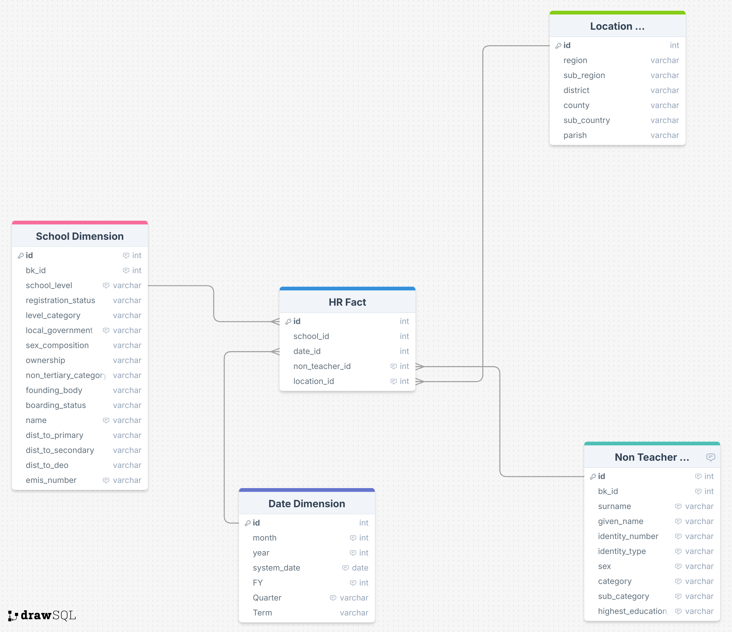

TEACHER TRANSFERS MART
THIS IS NOT YET READY IN THE TRANSACTIONAL DATABASE.
This data mart records teacher transfer events and enables analysis of teacher movement patterns by district, school type, and year. The mart answers: how many teachers were transferred per district per year? What proportion were inter-district vs intra-district? How long did teachers serve before being transferred? Which teachers have exceeded the MoES deployment duration limit?
The mart has one fact table: dw.teacher_transfer_fact (1 row per approved transfer event). It reuses dw.teacher_dim, dw.schools_dim, dw.admin_units_dim and dw.date_dim from other marts — no new dimension tables are required. Only APPROVED transfers (status=2) are loaded to the fact table. Source: public.teacher_transfers. Time-at-station is computed from public.teacher_postings.

dw.teacher_transfer_fact
Grain: 1 row per approved transfer event. Natural key: (person_id, transfer_source_id). Measures: days_at_outgoing_station and days_to_report. The is_inter_district flag enables fast filtering between cross-district and within-district transfers.
Attribute | Type | Null? | Key | Description / Business Rules
id | SERIAL | No | PK | Surrogate key.
teacher_id | INTEGER | No | FK | FK → dw.teacher_dim(id). Current SCD2 version of the teacher at transfer date.
out_school_id | INTEGER | Yes | FK | FK → dw.schools_dim(id). School transferring FROM. Nullable — school may not be in DW.
in_school_id | INTEGER | Yes | FK | FK → dw.schools_dim(id). School transferring TO.
out_district_id | INTEGER | Yes | FK | FK → dw.admin_units_dim(id) at District level. District of outgoing school. Resolved via admin_unit_upper_local_governments.district_id.
in_district_id | INTEGER | Yes | FK | FK → dw.admin_units_dim(id) at District level. District of incoming school.
date_id | INTEGER | No | FK | FK → dw.date_dim(id). Set to posting_date of the transfer.
transfer_source_id | BIGINT | Yes | NK | teacher_transfers.id from OLTP. Natural key with person_id.
is_inter_district | BOOLEAN | Yes | DD | TRUE when out_district_id ≠ in_district_id. FALSE for within-district transfer. Degenerate dimension for fast filtering.
days_at_outgoing_station | INTEGER | Yes | M | MEASURE. Days from last posting date at outgoing school to transfer posting_date. Computed from teacher_postings. NULL if no prior posting found. MoES deployment norm is 3 years (≈1095 days).
days_to_report | INTEGER | Yes | M | MEASURE. Days between posting_date and reporting_date. Measures how promptly the teacher reported to the new school. NULL if reporting_date is missing.
posting_date | DATE | Yes | DD | Official transfer date. Also stored on date_dim via date_id. Denormalized for convenience.
reporting_date | DATE | Yes | DD | Date teacher actually reported to incoming school. Used with posting_date to compute days_to_report.

Design Decisions and Notes
No new dimension tables are created. The mart reuses dw.teacher_dim (from Teachers mart), dw.schools_dim (from Schools mart), dw.admin_units_dim (from Schools mart) and dw.date_dim. This avoids duplication and ensures all location-based filtering uses the same hierarchy as other marts.
Status filter: only APPROVED transfers (teacher_transfers.status = 2) are loaded to the fact table. PENDING (1) and REJECTED (3) remain in stg.teacher_transfers_raw for audit purposes but do not represent completed movements. The original design used a flat Location Dimension and Teacher Dimension that duplicated data already in the DW — these have been removed in favour of existing dimensions.
District resolution: teacher_transfers stores incoming_local_government_id and outgoing_local_government_id which reference admin_unit_upper_local_governments (not admin_unit_districts directly). The ETL walks admin_unit_upper_local_governments.district_id → admin_unit_districts to get the district, then resolves to dw.admin_units_dim.source_id for the surrogate key.
ETL scripts: sql/02_staging/create_teacher_transfers_staging_tables.sql, sql/03_dw/create_teacher_transfers_dw_tables.sql, sql/05_etl/teacher_transfers/00_extract_teacher_transfers.sql, 01_load_transfer_fact.sql, 02_dq_checks_teacher_transfers.sql.

INFRASTRUCTURE DATA MART
This data mart records school infrastructure status captured during the annual EMIS school survey. It enables analysis of classroom availability, sanitation coverage, laboratory provision, and structure condition by school, district, and education level. The mart answers: how many classrooms does each school have? What proportion of structures are in good condition? Which schools lack latrines or laboratories?
The mart has two tables: dw.infrastructure_type_dim (building/structure type lookup) and dw.infrastructure_fact (1 row per school per type per academic year per term). It reuses dw.schools_dim and dw.date_dim. No separate Location, Completion Status, Gender Usage or User Category dimensions are needed — these are stored as decoded VARCHAR columns on the fact table. Source: public.school_building_status_updates.

dw.infrastructure_type_dim
Grain: 1 row per building/structure type. Seeded from setting_school_building_types joined with setting_school_infrastructure_types. Not SCD2 — full upsert on each ETL run.
Attribute | Type | Null? | Key | Description
id | SERIAL | No | PK | Surrogate key.
source_id | BIGINT | No | NK | setting_school_building_types.id from OLTP.
type_name | VARCHAR(200) | No |  | Structure name (e.g. Classroom, Latrine, Laboratory, Office).
is_lab_yn | BOOLEAN | No |  | TRUE for laboratory structures. Used to measure science lab coverage per school.
is_sanitation_yn | BOOLEAN | No |  | TRUE for sanitation structures (latrines, hand-washing). gender_usage and user_category are meaningful for these types only.
is_for_primary | BOOLEAN | No |  | TRUE if this structure type applies to primary schools. Similarly is_for_secondary and is_for_pre_primary.

dw.infrastructure_fact
Grain: 1 row per school per infrastructure type per academic year per term. Measures: total_number (count of structures) and area (floor area in sq metres). Status fields stored as decoded VARCHAR columns rather than separate dimension tables.
Attribute | Type | Null? | Key | Description / Business Rules
id | SERIAL | No | PK | Surrogate key.
school_id | INTEGER | No | FK | FK → dw.schools_dim(id). Join schools_dim → admin_units_dim for district/region slicing.
infra_type_id | INTEGER | No | FK | FK → dw.infrastructure_type_dim(id).
date_id | INTEGER | No | FK | FK → dw.date_dim(id). Term start date for the survey period.
academic_year | INTEGER | Yes | NK | Four-digit academic year. Part of natural key.
term | VARCHAR(100) | Yes | NK | TERM 1, TERM 2, or TERM 3. Part of natural key.
total_number | INTEGER | Yes | M | MEASURE. Count of this structure type at the school for this survey period.
area | DECIMAL(10,2) | Yes | M | MEASURE. Floor area in square metres. NULL when is_area_captured_yn = FALSE for this infrastructure type.
completion_status | VARCHAR(100) | Yes | DD | COMPLETE, INCOMPLETE, UNDER CONSTRUCTION, or PLANNED. Decoded from smallint 1–4.
structure_condition | VARCHAR(100) | Yes | DD | GOOD, FAIR, POOR, or DILAPIDATED. Decoded from smallint 1–4.
gender_usage | VARCHAR(100) | Yes | DD | MALE, FEMALE, BOTH, or NONE. Decoded from smallint. Meaningful for sanitation structures only (is_sanitation_yn = TRUE).
user_category | VARCHAR(100) | Yes | DD | TEACHERS ONLY, LEARNERS ONLY, or BOTH. Decoded from smallint. Meaningful for sanitation structures only.

Design Decisions and Notes
The original design had four separate dimension tables for Completion Status, Gender Usage, User Category, and Location. These have been removed. Completion Status, Gender Usage and User Category each have only 3–4 possible values — storing them as decoded VARCHAR columns on the fact table is simpler, avoids unnecessary joins, and makes BI queries more readable. Location uses the existing dw.admin_units_dim via dw.schools_dim, the single source of truth for all location hierarchy in the DW.
Smallint decoding: school_building_status_updates stores completion_status, usage_mode, condition, gender_usage and user_category as smallint values. These are decoded to readable strings in Step 0 of the ETL and stored as VARCHAR on both stg.infrastructure_raw and dw.infrastructure_fact. The mappings are: completion_status (1=COMPLETE, 2=INCOMPLETE, 3=UNDER CONSTRUCTION, 4=PLANNED), condition (1=GOOD, 2=FAIR, 3=POOR, 4=DILAPIDATED), gender_usage (1=MALE, 2=FEMALE, 3=BOTH, 4=NONE), user_category (1=TEACHERS ONLY, 2=LEARNERS ONLY, 3=BOTH).
ETL scripts: sql/02_staging/create_infrastructure_staging_tables.sql, sql/03_dw/create_infrastructure_dw_tables.sql, sql/05_etl/infrastructure/00_extract_infrastructure.sql, 01_load_infrastructure_fact.sql, 02_dq_checks_infrastructure.sql.

TEACHING SUBJECTS DATA MART
This data mart records the subjects taught by each teacher and enables subject coverage analysis by school, district, and education level. The mart answers: how many teachers teach each subject? What is the science vs arts balance per district? Which schools lack sufficient subject teachers?
The mart has two tables: dw.subject_dim (one row per subject) and dw.teaching_subject_fact (one row per teacher per subject). It reuses dw.teacher_dim and dw.schools_dim from the Teachers Mart. Subject data comes from public.teacher_subjects (secondary subjects) and public.teachers.trained_subject_1_id / trained_subject_2_id (primary subjects).

dw.subject_dim
Grain: 1 row per subject. Covers both primary and secondary school subjects. Not SCD2 — full upsert on each ETL run. The subject_category column is computed: LANGUAGE if is_language_subject, SCIENCE if is_science_subject, else ARTS.
Attribute | Type | Null? | Key | Description / Business Rules
id | SERIAL | No | PK | Surrogate key.
source_id | BIGINT | No | NK | setting_secondary_school_subjects.id or setting_primary_school_subjects.id. Natural key with subject_level.
subject_level | VARCHAR(50) | No | NK | PRIMARY or SECONDARY. Needed because source_id is not unique across both subject tables.
subject_name | VARCHAR(200) | No |  | Full subject name as registered in EMIS (e.g. Mathematics, English Language, Biology).
is_language_subject | BOOLEAN | No |  | TRUE for language subjects (English, Luganda etc.). Available for both levels.
is_science_subject | BOOLEAN | No |  | TRUE for science subjects. Secondary level only. Always FALSE for primary subjects.
is_olevel_subject | BOOLEAN | No |  | TRUE if subject is offered at O-level (S1–S4). Secondary only.
is_alevel_subject | BOOLEAN | No |  | TRUE if subject is offered at A-level (S5–S6). Secondary only.
is_examinable | BOOLEAN | No |  | TRUE if subject appears in UNEB national examinations. Secondary only.
subject_category | VARCHAR(50) | No |  | Generated column. LANGUAGE if is_language_subject, SCIENCE if is_science_subject, else ARTS. Use for teacher discipline analysis.

dw.teaching_subject_fact
Grain: 1 row per teacher per subject. No measures — this is a coverage fact. Aggregate rows to count teachers per subject. Join to subject_dim for subject attributes, teacher_dim for teacher gender and qualification, schools_dim → admin_units_dim for location slicing.
Attribute | Type | Null? | Key | Description / Business Rules
id | SERIAL | No | PK | Surrogate key.
teacher_id | INTEGER | No | FK | FK → dw.teacher_dim(id). Current version of the teacher at load time.
school_id | INTEGER | No | FK | FK → dw.schools_dim(id). Teacher’s current school deployment. Join schools_dim → admin_units_dim for district/region.
subject_id | INTEGER | No | FK | FK → dw.subject_dim(id).
date_id | INTEGER | No | FK | FK → dw.date_dim(id). ETL load date — not a teaching period.
person_id | BIGINT | Yes | NK | teachers.person_id from OLTP. Retained for deduplication and debugging.
subject_source_id | BIGINT | Yes | NK | setting_*_school_subjects.id from OLTP. Natural key with subject_level.
subject_level | VARCHAR(50) | Yes | DD | PRIMARY or SECONDARY. Degenerate dimension retained for fast filtering.

Design Decisions and Notes
No term dimension is included. Subject assignments in EMIS (teacher_subjects table) are not term-specific — a teacher is registered for a subject across the academic year. Adding a term dimension would require assumptions about when the registration applies and would inflate the row count unnecessarily.
Secondary subjects come from public.teacher_subjects → setting_secondary_school_subjects. Primary subjects come from public.teachers.trained_subject_1_id and trained_subject_2_id → setting_primary_school_subjects. The subject_level column (PRIMARY / SECONDARY) disambiguates source IDs since both subject tables use independent auto-increment IDs that may overlap.
The subject_category computed column on subject_dim (LANGUAGE / SCIENCE / ARTS) replaces the discipline derivation that was previously done on teacher_dim. BI queries can now group by subject_category directly from subject_dim without joining to teacher attributes.
ETL scripts: sql/02_staging/create_teaching_subjects_staging_tables.sql, sql/03_dw/create_teaching_subjects_dw_tables.sql, sql/05_etl/teaching_subjects/00_extract_subjects.sql, 01_load_teaching_subject_facts.sql, 02_dq_checks_teaching_subjects.sql.

