CA357 HCI Deliverable 2 Report

Donal Fitzpatrick

Jacob O'Keeffe 13356691
Sean Quinn 13330146
Ryan Earley 13301871
Michael Wall 13522003

Introduction

This application addresses the need for a better online version of the online DCU student timetable. The current system available to students falls short in a number of areas, mainly usability. The current timetable is a basic html page which is structured inappropriately using a table. It is generated using a web form which is also very confusing to use as it is located at the very bottom of the page, on first glance at this webpage you would think the form is not present. The text on the generated timetable is not user friendly, disproportionate in size, hard to read and not screen reader friendly. As this application is aimed at all university students it must be equally accessible to everyone as set out in our usability considerations, expected problems, requirements and functionality in the initial stages of the project. Our application seeks to be concise, usable and most importantly, simple. We achieved this to a satisfactory degree by utilising paper mock ups as our low fidelity mock-up, progressing to high fidelity mock-ups. Employing cognitive walkthroughs and user testing helped us to verify that this prototype is in fact what is required.

Design an Initial Prototype

Our design involves a login and course select page. You then progress to the main timetable page where you can see the five current week days and the schedule for those days. We colour coded the items in accordance to their type (lecture, lab, tutorial) so that they can be quickly distinguished. Labs are red, tutorials are yellow and lectures are blue. We would have liked to give the user the choice to instead colour code the items in accordance to the module but we ommited this for simplicity in our final prototype. We felt only the most imortant information should be displayed; what it is, when it is and where it is. This is represented by the module code and title, the items type, the start and finish times and the location code. We decided to leave in the GLA prefix of the location code due to the ongoing integration of ST.Pats and DCU. We decided to have fixed length activity blocks of 1 hour, therefore a 2 hour activity will appear as two separate activities in the timetable. This is to help avoid sizing issues such as those apparent with the existing DCU timetable system. Our approach may seem slightly disjoint but we feel it is more accurate in subconsciously informing the user what their day or week will look like.

Low-Fidelity Mock-Ups
We each drew out a paper mockup and then compared our different design ideas. Some were discarded as being too elaborate while others left some things to be desired. We used these mock-ups to collaboratively come up with a happy medium with which we later used to design our prototype. The initial prototypes are all shown below.

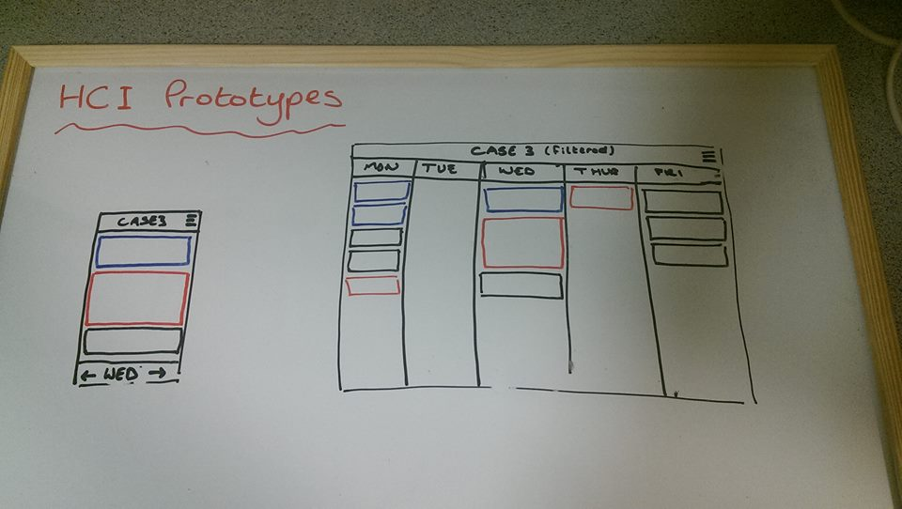

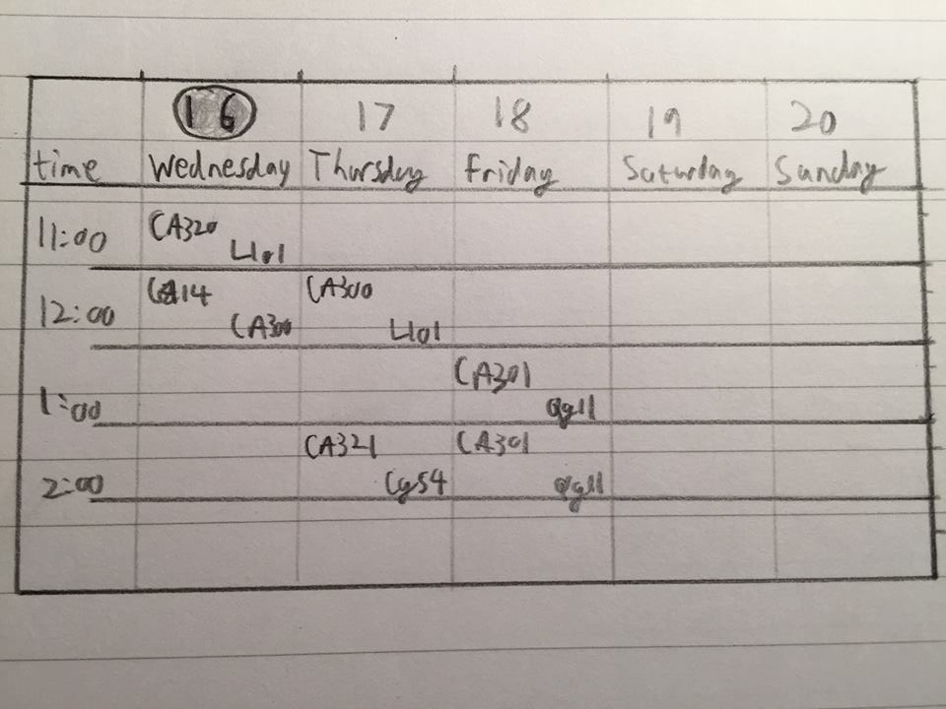

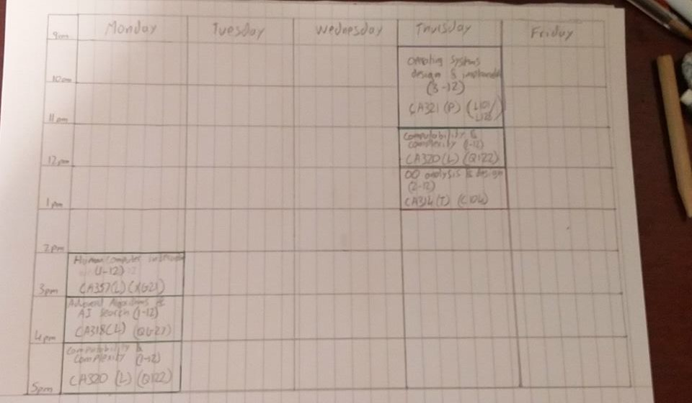

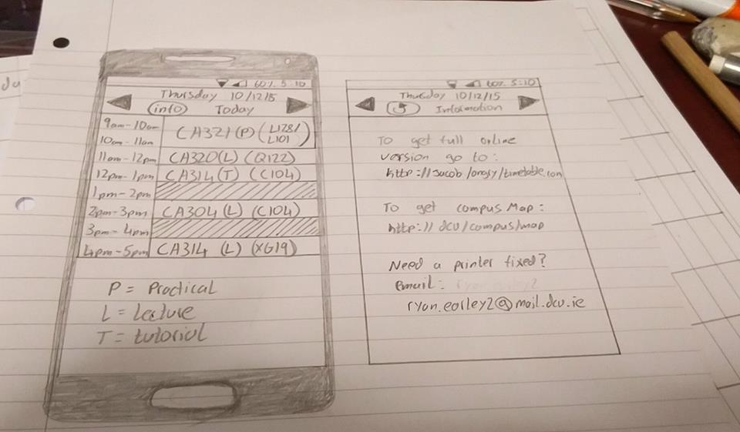

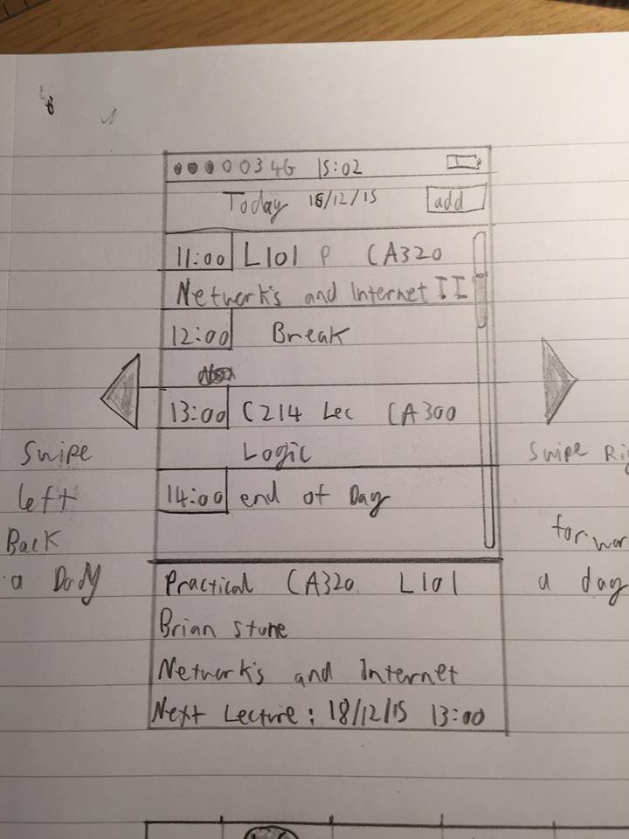

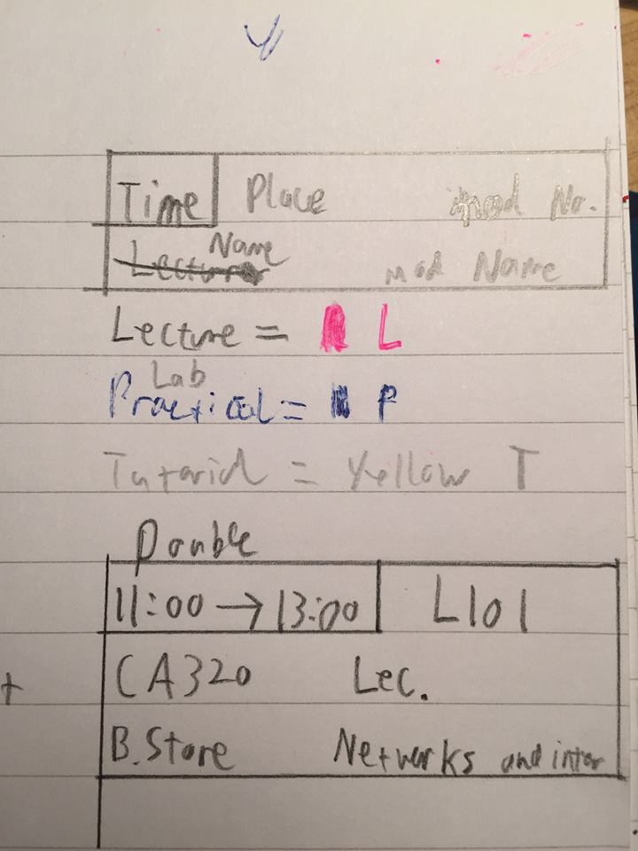

High-Fidelity Mock-Up
Once we had agreed upon a design, we began creating our high-fidelity mock-up using Justinmind. We followed the guidelines we had set ourselves and made sure we kept our design simple enough so that we could code the html for it from scratch. We created a landing page which requests login details and a mock-up of the actual timetable.

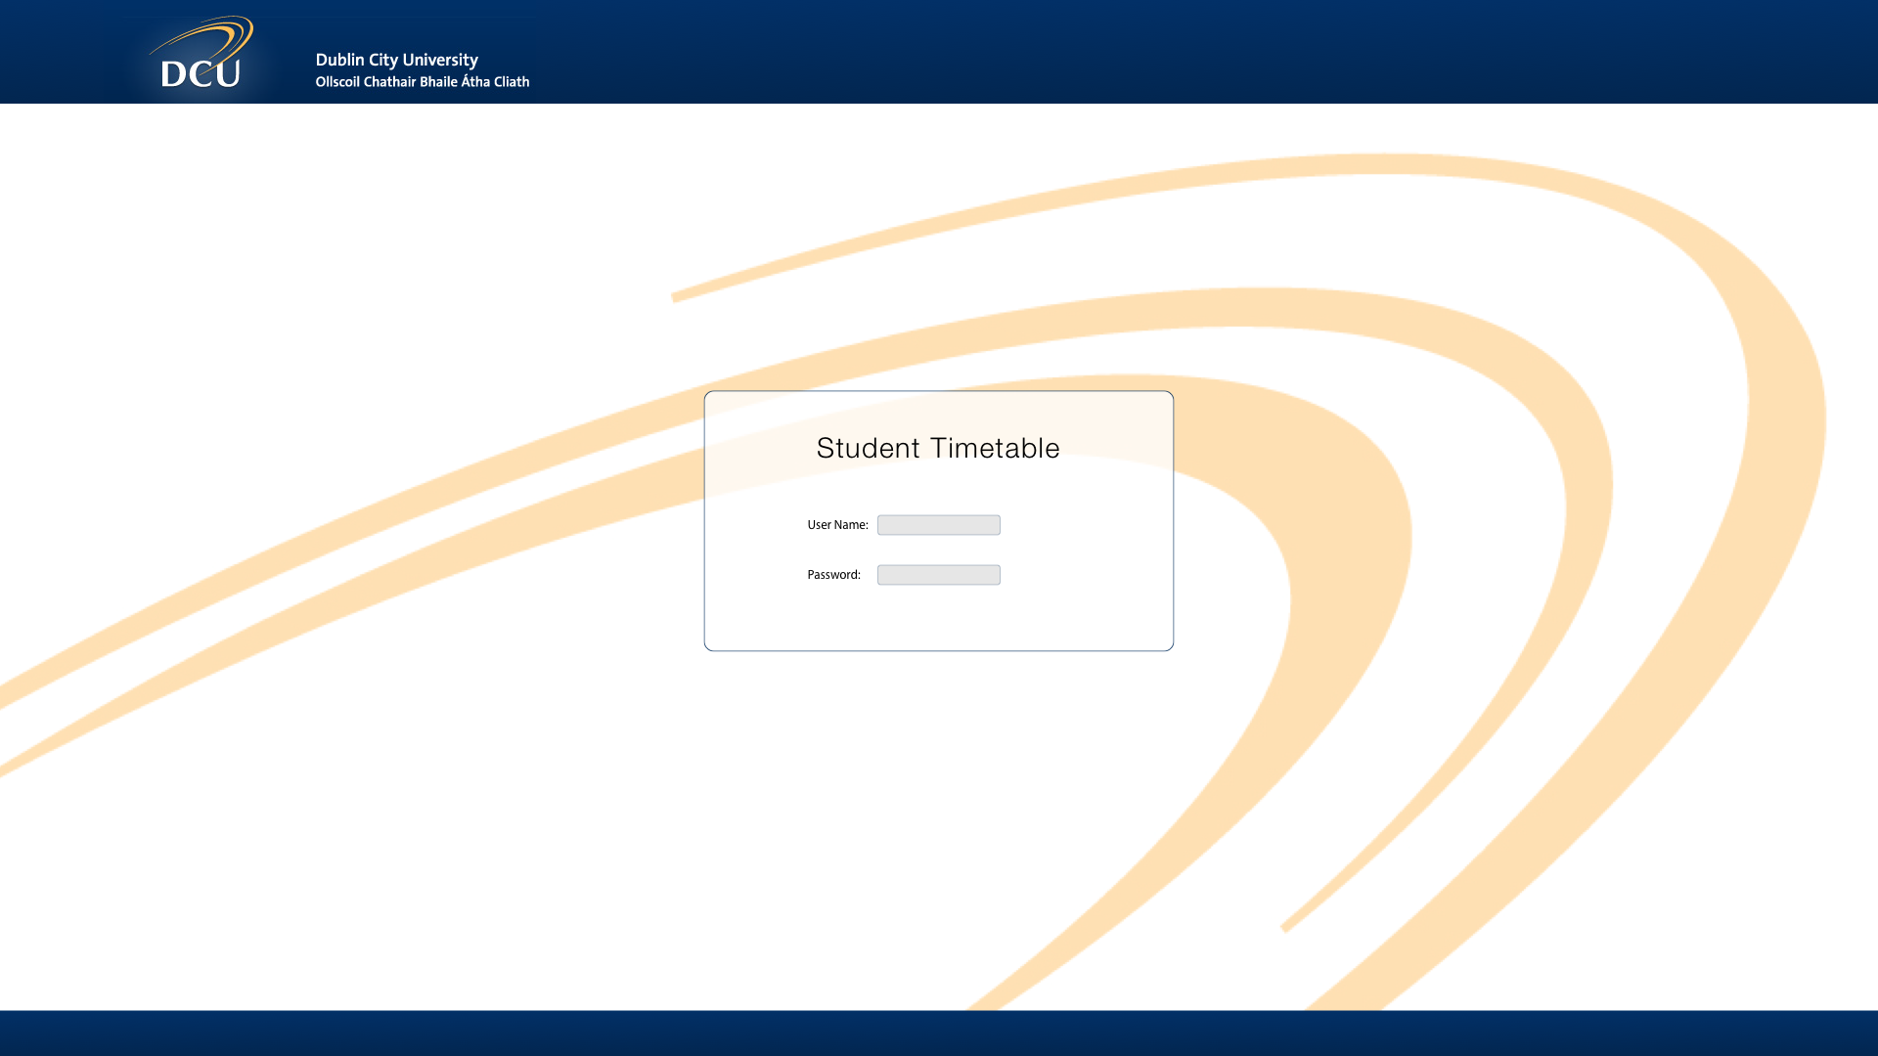

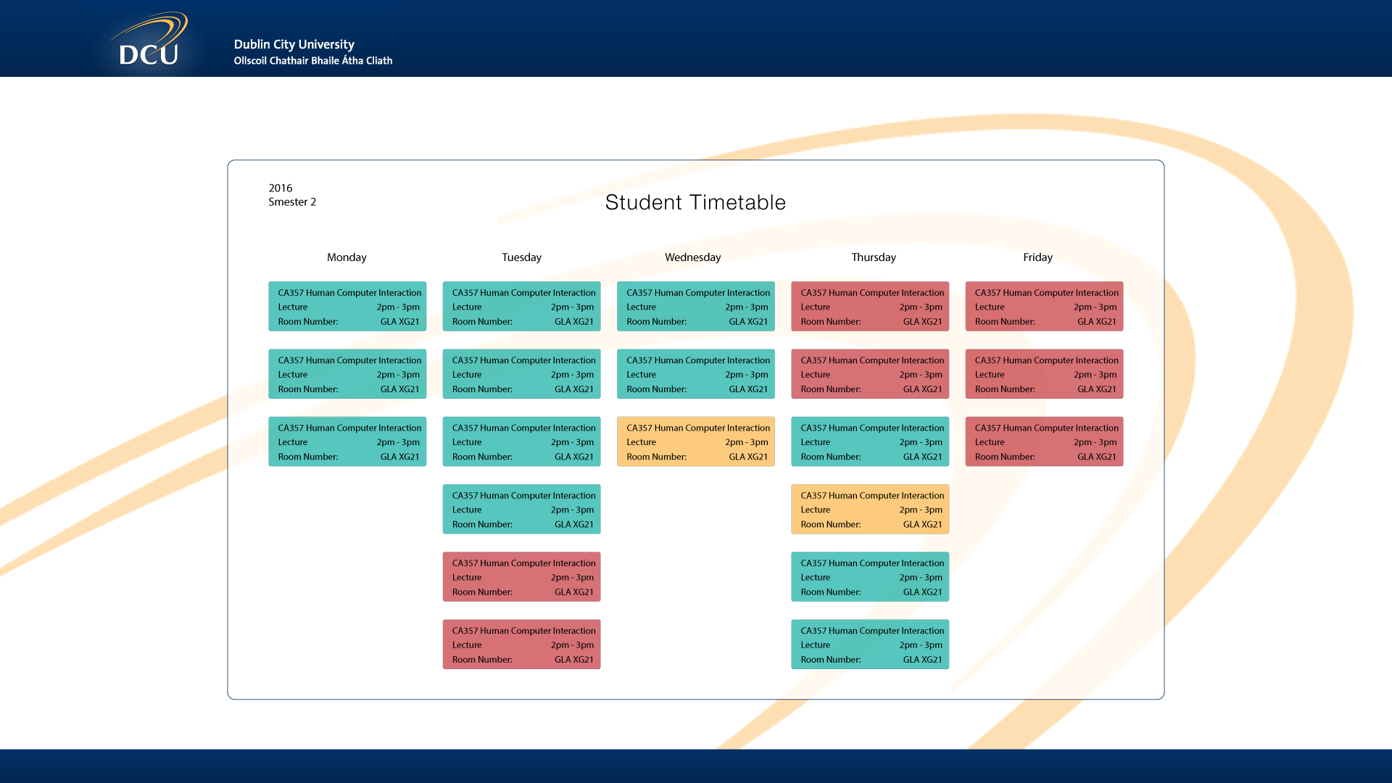

Final Prototype
Our final prototype was created using HTML5 and CSS. We all had plenty of experience creating web pages but we admitted that our web accessibility knowledge might be lacking. We read through a number of articles about accessibility on the web and read through quite a portion of the ARIA section both on Mozilla's MDN and on the W3C HTML specification. We learned that if we kept our design simple and well structured, we wouldn't need to make use of many ARIA tags.

Structure
There is a simple header at the top of the page which contains a title (“CASE3 Timetable”) and a paragraph of information which is specifically aimed at screen readers. This paragraph is visually hidden using absolute positioning in its CSS properties. It informs a screen reader that the user can select the current item in the timetable using the tab key.
The timetable itself is denoted with the landmark ARIA role “main”. Within the timetable, there are 5 columns, one for each weekday. On mobile devices, these columns are stacked on top of each other, essentially creating one long column. This is achieved using a CSS media query with a breakpoint of 480px. Within each days column, are the items, if any. There are four pieces of information available about each item; the module, the type (lecture, lab, tutorial), the time and the location. The items are represented by divs so we had to manually assign a tabindex of 0 to each div to allow it to be reached by pressing the tab button. The current item gets a tabindex of 1 so that it is the first item you reach when yo press tab.

Features
Each item is colour coded in accordance to it's type. The current item in the timetable is given a large black border to make it stand out from the other items. This is achieved by assigning a specific ID to an item.

What Next?
We manually filled our html with static data. Ideally, we would use Javascript to parse JSON from DCUTT.com and dynamically populate the timetable. Extra information such as the items lecturer should be available once a user selects an item in the timetable. A user should be able to colour code items in accordance to the module instead of the item type if they so choose. These are all features we considered implementing but we decided they were not necessary for our prototype.

Heuristic Evaluation
Before we carried out user evaluations, we decided to perform our own heuristic evaluation of the interface using Shneiderman's Eight Golden Rules.

Shneiderman's Eight Golden Rules

Strive for consistency
Our timetable interface is consistent across the week of lectures, labs and tutorials for different modules. Each item contains the same format: module, type, time and location. This makes the timetable easy to scan for specific data items as they are always located in the same location of a timetable item.

Enable frequent users to use shortcuts
For screen readers, the current/next item is always the first that is presented when tab is pressed as it is the most frequently used timetable item. This item is also highlighted with a prominent border so that it is easy to see when the page is loaded.
The following features were not implemented in the prototype but would have been if we had time. Users do not need to re-enter their course and year to get their timetable each and every time. Cookies are used to store this information on their device so that it will be remembered next time they load the webpage, improving response times.

Offer informative feedback
When navigating through the timetable using a screen reader, the module, type, time and location are all read out in one go. You do not have to actually go into the item to learn about it.
The following feature was not implemented in the prototype . When a user selects an item, more detailed information will be provided to them on a card.

Design dialogs to yield closure
This did not apply to our testing.

Offer simple error handling
There is very little room for error in our timetable interface. The user does not have options to select that allow for errors to occur.

Permit easy reversal of actions
Again, this was not implemented in the prototype. Users can always change their course and year details if they have entered them incorrectly. There is no need to fear making a choice that cannot be reversed.

Support internal locus of control
There are no pop ups, sounds or flashing lights to tell a user that they are missing a class, or that they must attend a certain lecture. They do not have to pay attention to any particular elements if they do not desire to. This means that they are always in control of their timetable and how they want to use it to structure their day or week.

Reduce short term memory load
Because our interface is simple and not cluttered, you can become accustomed to using it almost instantaneously. The user will recognise the layout upon returning, and will not require searching for a help page or an index of what means what on the timetable. It is all self-explanatory.

Conclusions
We were satisfied that our prototype adequately adhered to Schneiderman's 8 Golden Rules. A number of them did not really apply to our current prototype but we felt we had acknowledged them in our general design.

User Evaluation

The Task
We set our users 2 simple tasks to accomplish, when testing the timetable.
- Find out what is your next item
- Find out what is on at 9am on Thursday
The users were observed as they performed the tasks and were asked to give feedback on their first reactions to the visual aspects of the timetable as they went. The user was then asked the following question to get a feeling of how the user interacted with the website.
- How long did it take you to figure out the layout of the timetable?
- What aspects of the visual design stood out to you? (good or bad)
- Rate your satisfaction between 1 and 10 with each of the aspects. (1 (Awful), 10 (Very Satisfied))
- Quality of Information
- Ease of use
- Visual Design

User 1
User 1 was a 24 year old male.

Observations
It took the user a couple of seconds to become accustomed to the timetable. Once the user became accustom to the timetable he moved through the rest of the tasks with relative ease.

Users review summarised
It took me 15 seconds to become accustom to the timetable.
Highlighting the next item in the timetable was a great idea. I no longer need to waste time going through the timetable in detail to find my next lecture or lab. The colour coded design for lectures, tutorials and practical’s lets me know what I can expect at the next timeslot.
Quality of Information: 9
Ease of use: 8
Visual Design: 10

User 2
User 2 was a 20 year old male.

Observations
This user started the tasks as quick as possible and finished them very quickly. He gave us no comment as he worked.

Users review summarised
I instantly understood the timetable.
I like the simplistic layout. Only busy slots appearing in the timetable is my favourite feature of the timetable. I hate having to scroll to see all the tasks I have today. I liked the highlighted lecture slot as it instantly draws my attention to the next lecture and I need not bother with the rest of the timetable.
Quality of Information: 9
Ease of use: 9
Visual Design: 10

User 3
User 3 was a 21 year old female.

Observations
The user took the task more seriously than the previous users. The user commented about the colour coded design and how it gave her a lot of information straight away. The users also commented on how only providing basic information for lectures was easier to understand than the original DCU timetable.

Users review summarised
It took me 5 seconds to understand the timetable.
I like most aspects of the timetable but I find it a bit disorientating that they only include lecture times and there are no blank spaces. If I was to look at the timetable quickly it might seem like I have 4 lectures in a row. I think this is because I am so used to the original DCU timetable.
Quality of Information: 10
Ease of use: 7
Visual Design: 9

Conclusions
In general, the feedback we got was positive. We feel it might have been a good idea to let the user include free slots in their timetable so that an items position represented the time it started at. For our own interest we asked the users what they thought about colour coding the items in accordance to the module instead of to the items type. They unanimously felt that would be a lot better. This is one feature which we really regret not including.

Accessibility Testing
Due to us being unable to find a person accustom to the use of a screen reader we reviewed the use of the timetable using a screen reader ourselves.

Points of note
The screen reading software we used to test our prototype was Voice Over on Mac OSX Mavericks. We enabled Quick Nav to allow us to navigate through the timetable in a more intuitive fashion.

Users review summarised.
It took me about a minute to get a basic grasp on how to navigate using Voice Over. On a desktop our timetable is visually presented with the days of the week beside each other with their items underneath. You navigate through the different days using the up/down keys and through the items using the left/right keys which seemed counter-intuitive but it didn't take long to adjust. As well as using the arrow keys to navigate through the timetable, you can also use the tab key to cycle through the items. The first time you press tab you will be brought to the current item. This is a useful feature which the screen reader is informed of at the beginning of the timetable. The next time you press tab you will be brought to the first item in the timetable. Unfortunately, if you continue to navigate using the tab key, the current item will be skipped in the regular flow of the timetable.

Conclusions
We feel that the timetable is adequately accessible but we acknowledge that we are not the best people to judge. It's a shame we were not able to carry out more robust accessibility testing. We used the WAVE accessibility checker online and it returned no errors and only one alert which was in regards to the positive tabindex that was applied to the current item.

