

**E-POLICE REPORTING SYSTEM**

**A CASE STUDY OF CENTRAL POLICE STATION (Mombasa)**

**OKELLO GEORGE OKOTH**

**BSIT/149J/2016**

**SUPERVISOR: MR. RINGA**

**Research Proposal Submitted in Partial Fulfillment for the Degree in Bachelor of Science in Information Technology of Technical University of Mombasa**

**August 2020**

**DECLARATION**

This project is my original work and has not been presented for a degree in any other University or any other award.

Okello George Okoth

BSIT/149J/2016

Sign ____________________ Date ______________________

I confirm that the work reported in this project was carried out by the candidate under my supervision.

Mr. Ringa Kaingu Ringa

Lecturer,

Computer Science and Information Technology,

Technical University of Mombasa

Sign ____________________ Date ______________________

# **DEDICATION**

This project is dedicated to all the key players right from my friends, colleagues, family as a whole and so on. It’s my pleasure as well to commit this project to all the Institute of Computing and Informatics fraternity inclusive of all the lectures and other staffs who offered me support especially by providing the stable internet connectivity to facilitate this research.

**ACKNOWLEDGEMENT**

My four years of study has been a success because of friends, classmates and other people in the different surrounding outside the classroom. It’s my pleasures well to honor the people who played a bigger role in my studies until the ultimate completion of this project. I would like to greatly appreciate my supervisor Mr. Ringa, for always supporting me and guiding me from the research work until the end of completion of this great project. You will always remain a mentor to me and I will always remember the work you did at all moments. Your able guidance and supervision remain the key to the realization of this project. Let me as well give thanks especially to the lectures at the Technical University of Mombasa for their support and encouragement during my course work. Thank you for giving me a good foundation in my coursework so that I can meet the challenges in the field of Information Technology without any fear. I am grateful for teaching me the difference between management and leading hence making me a better person in this field.

# **ABSTRACT**

E-police reporting system is a web-based system that helps the public raise a complaint by reporting crimes, report missing persons and as well automate the occurrence Book(OB) enabling searching of previous records in the OB, enable the public interact with the police freely helping them find wanted person .E-police system is a system that will give residents a platform to engage the police and provide sensitive information to the police without physically reporting to the police station. This system enhances the privacy of data since users have to authenticate using the log in details before accessing the system. This system helps improve the security of the public and police, within the police station and the surroundings by the virtue of privacy of information given to residents. Interviews were used to collect data considering it as an effective method for data collection. This system enhances real-time reporting of crimes from the public to the police improving on security. This research uses Agile Methodology that is based on developing a system depending on current trends, opportunities and analyzing the risks to develop a better system. PHP, MySQL, JavaScript and CSS (cascading style sheet) were used for developing the system, CSS was used in this system to change the appearance of web pages while HTML (Hypertext Markup Language) ensured the pages are created accordingly. Since technology has been improving gradually in Kenya, as technology can be observed in various fields almost in every part of our lives. This has enhanced time and effort saving in most of the activities but in the police department, they still operate manually which is "pen and paper" work. Therefore, this research recommends developing a system that aims at helping the police in searching wanted persons, store their voluminous data and even help in improving the security of the residents.

**Table of Contents**

**DECLARATION** ii

**DEDICATION** iii

**ACKNOWLEDGEMENT** iv

**ABSTRACT** v

**LIST OF TABLES** viii

**LIST OF FIGURES** ix

**LIST OF ACRONYMS AND ABBREVIATIONS** x

**CHAPTER ONE: INTRODUCTION** 1

**1.0** **Introduction** 1

**1.1** **Background of the study** 1

**1.1.1 An overview of E-Police** 1

**1.2** **Problem Statement** 2

**1.3 Objective of the Study** 2

**1.3.1** **General Objective** 2

**1.3.2** **Specific objectives** 2

**1.4** **Research Questions** 3

**1.5 Significance of the Study** 3

**1.6** **Limitations of the Study** 3

**1.7 Scope of the Study** 3

**1.8 Organization of the Study** 4

**CHAPTER TWO: LITERATURE REVIEW** 5

**2.1 Introduction** 5

**2.2 Theoretical Literature** 5

**2.3 Similar Systems** 6

**2.3.1** **Dadra and Nagar Haveli Police** 6

**2.3.2** **Cybercrime Reporting Portal** 7

**2.3.3** **Metropolitan Police** 7

**2.3.4** **Online Crime Report** 8

**2.3.5** **Gainesville Police Department** 9

**2.4 Critical Review and Research Gap identification** 9

**2.5 Chapter Summary** 10

**CHAPTER THREE: METHODOLOGY** 11

**3.1** **Introduction** 11

**3.2** **Research Design** 11

**3.2.1** **Target Population** 11

**3.2.2** **Sample size** 11

**3.2.3** **Data collection procedure & instruments** 12

**3.3 System Development methodology** 12

**3.3.1 Methodology Justification** 14

**3.4 System Requirement Analysis** 15

**3.4.1 Functional Requirements** 15

**3.4.2 Non functional requirements** 15

**3.7 Chapter Summary** 16

**REFRENCES** 17

**APPENDICES** 18

Appendix 1. PROJECT BUDGET 18

Appendix 2. PROJECT TIMEFRAME 19

**LIST OF TABLES**

Table 1:Advantages and Disadvantages of Agile methodology. 14

Table 2:Filing Complaint Table 22

Table 3:Register/Login table 22

Table 4:User Acceptance Testing 35

Table 5:Project Budget 38

Table 6:Project Timeframe 39

**LIST OF FIGURES**

Figure 1:Dadra and Nagar Haveli Police system. 6

Figure 2:Cybercrime Reporting Portal system. 7

Figure 3:Metropolitan Police system. 8

Figure 4:Online Crime report system. 9

Figure 5: Gainesville Police Department system. 10

Figure 6: Stages of Agile SDLC life cycle. 13

Figure 7:Use Case Modelling Diagram 17

Figure 8:Activity diagram 18

Figure 9:Sequence diagram 19

Figure 10:Class diagram 20

Figure 11:Deployment diagram 21

Figure 12:Home Page 25

Figure 13:Register Form Screenshot 26

Figure 14:Login Form module 27

Figure 15:User Register Module (using existing email). 27

Figure 16:Users Dashboard File Complaint Module 28

Figure 17:Users Dashboard Missing Persons Module 28

Figure 18:Police Login Form 29

Figure 19:Police User Dashboard Module 29

Figure 20:Assign Officer Page 30

Figure 21:Add Wanted Person Page 30

Figure 22:Cell registry Form 31

Figure 23:Police User view registered users 31

Figure 24:Police user viewing assigned officers 32

Figure 25:Query output for filed complaints. 32

Figure 26:The Registration portal validation 33

Figure 27:Register page test 33

Figure 28:Login Module Test 34

**LIST OF ACRONYMS AND ABBREVIATIONS**

**OB**: Occurrence Book

**IMS**: Intelligent Management System.

**PK**: Primary Key, used in database.

**PHP**: The acronym for Hypertext Preprocessor, a programming language enable users to insert details to the database. It entails Apache Server and MySQL.

**HTML**: Hypertext Mark-up Language.

**CSS**: Cascading Style Sheet.

**FIR**: File Information Report.

**SDLC**: Software Development Life Cycle Model

**CHAPTER ONE: INTRODUCTION**

1. **Introduction**

This chapter introduction of the study covers an overview of the background study of the E-police reporting system, the problem statement, objectives of the study, research question, significance of the study, limitations of the study, scope of the study and organization of the study.

* 1. **Background of the study**

### **1.1.1 An overview of E-Police**

The present system being used by police in Kenya is Manual system that is all based in "pen and paper". To make an online computerized system that will help the police. The police department in Kenya is ranked as the most corrupt in their daily operations due to the high rate of bribery. In several cases, people who are arrested are never recorded on the OB as corrupt police officers opt to negotiate for bribes to release them This system will take a lot of time to capture all data of officers on duty in Kenya so the research will focus on developing an online system where the OB data shall be stored.

challenges that will be overcome by the use in the E-Police reporting system;

* Integrity and security issues as data may be accessed or altered in the obstruction books
* There will be privacy while using the OB to which the user will have to log in to access their respective data.
* This system will save on time needed to travel to the police station and even search data in the OB recorded by a complainant.
* Intimidation by the public to report cases in the police station. A system will increase the interactivity of the public with the security forces. The Interactivity between the police officers and residents will enhance security in the area since most residents’ fear to approach the police stations to give information.

The case study based on the central police station in Mombasa found that it is an area hard hit with insecurity, it was prudent to choose it as an area of study to develop a system that will curb insecurity challenges facing this locality.

Sarker et al. (2018) explained that the development of many models to illustrate more on the e-governance was encountered by several challenges as a result of exploiting the relevant opportunities in the Information Resource management systems. The models developed were suitable for big data processing which were missing in the e-governance systems. Information management has been a challenge managing in the public sector and when solved could improve the transparency and reduce the rate of corruption and as well speed the service delivery in public offices. This would hence provide ease access to the public services reducing the error mostly visible when people are physically handling files and documents. Whenever an IRM system is implemented it will help in saving costs since it will provide a cost-service delivery to all people while ensuring all the resources are well utilized.

On the same case, Nixon et al. (2017) argue that the people that appear the victims of crime are mostly the People with intellectual disability (PWID). However, the absence of a consistent definition makes the traces of these risks limited to find.

* 1. **Problem Statement**

The purpose of study will be to develop a system that will prevent frequent loss of data by automating the occurrence book enabling digital data storage (in the Database) as well solve difficulties people face registering a complaint at the police station and improving on the relationship between the public and the police.

**1.3 Objective of the Study**

* + 1. **General Objective**

E-police reporting system automates the use of OB whereby the police can easily search previous records about a complainant. The privacy is enhanced while using the OB to which users have to log in to access their respective data. The database is used to store the Database and this would guarantee the safety of data compared to it being stored manually. This saves on the time needed to travel to the police station and even search data in the OB recorded by a complainant. A resident can air a complaint through the platform. The Interactivity between the police officers and residents enhances security in the area since most residents’ fear to approach the police stations to give information.

* + 1. **Specific objectives**

1. To gather requirements for the proposed system.
2. To design the system using an agile methodology.
3. To develop the system using PHP and MySQL database.
4. To test the system for integration, user acceptance and unit testing
   1. **Research Questions**

The research questions below are based on the specific objectives.

1. How were the requirements of the E-police reporting system be gathered?
2. How were the E-police reporting system be designed using the agile model?
3. How were the E-police reporting system be developed using PHP and MySQL database?
4. How were the E-police reporting system be tested for user acceptance, integration, and unit testing?

**1.5 Significance of the Study**

E-police system will improve on the security of the public and the police both within the station and surrounding by the virtue of privacy of information given to both the public or residents and the police. This system will also solve difficulties people face physically registering a complaint at the police station considering the manual system that is time-consuming by automating the operations currently done manually at the police station to a digital online platform without physically altering the operations.

* 1. **Limitations of the Study**

For the system to work efficiently, it requires internet connectivity. In case of slow internet connectivity, the communication between the public and the police would be very difficult hence slow down the time for the police to act on an emergency in case it arises.

**1.7 Scope of the Study**

The aim of developing an E-police reporting system is enabling efficiency in the police department by equipping the police with a current digital online platform. This system will integrate and store information used by the police and the public. It will accommodate information that is required to run the daily activities at the police stations that will help in improving the security of regions within the country. The population sample will be the public and ranks within the police administration that is lowest ranks and their respective duties within the police station. The research will focus on small geographical areas to enable full exploitation of problems facing the police system and find an amicable solution to them by coming up with a system that will automate operations in specified areas of study.

**1.8 Organization of the Study**

Chapter one entails the objective of the study, significance, scope, and limitations to the study. This shows all the necessary background study needed to start the project whereby, chapter two focuses on literature review discussing the issues arising from several police systems focusing on how the police perform their duties to the public manually. This can be solved by building a solution system. Chapter three broadly discusses the agile methodology used and its justification is discussed. It also talks about the research design that entails the system requirements of E-police reporting system to be developed.

**CHAPTER** **TWO: LITERATURE REVIEW**

**2.1 Introduction**

This chapter will entail theoretical literature of the problem being solved, the similar systems and critical review and research gap identification. A literature review entails details of previous studies and how the current study will solve challenges that the previous studies have failed to meet. This will be as indicated below.

**2.2 Theoretical Literature**

In theoretical literature, the development life cycle of the E-police reporting system is discussed based on past literature reviews. This topic is discussed broadly as below considering user requirements and other subtopics.

E-police system focuses its study on police administration and integration of data into a central database. A good user interface designed will enable easier use of the system. It will be a real-time system. A database will be designed to store data that has been captured by the user and safely store it in the database to avoid manipulation .it will require authentication for access of data or the application at large. Being an interactive system that can be remotely accessed. It will improve service delivery at a great depth since the users can remotely use the system whenever they are to access information that can be into beneficial use improving the integrity of the public and the police.

Bevan et al. (2018) argues that users, operators, and maintenance personnel may interact with the systems in the course of the system maintenance and operation. This people may inflict some main constraints of the software. The characteristics of these people can be categorized with their language, education level and expertise. Occasionally some individuals can be using the system while others might be using the systems more frequently. The users that use the system frequently will grow to become experts while the infrequent users will remain novice. Therefore, it is of great importance to classify the users of the system in categories so as to know the relative numbers that can be useful to the system.

Kumar & Gopal (2015) explained that there is a gradual growth in the number of crime incidents being reported per day in India. This is because the technologies being used currently by criminals is improving as technology advances. Therefore, investigating crimes becomes a more complex process and therefore requiring the police officers to perform a lot of manual tasks. This study, therefore, deals with analyzing different crime information systems and automating the procedure being used during this process by the officers.

**2.3 Similar Systems**

This section indicates other projects which had been done in including the methodologies that were used. The purpose is to identify what the system does not provide. The following are a few systems among many with different functionalities considering the user's needs.

* + 1. **Dadra and Nagar Haveli police**

Dadra and Nagar Haveli's police system provides a platform for Citizens to log in, to check on citizens' feedback and just briefly describes the police department. This is a system that is used by the government of India and it does not cover various areas required by the Citizens(Dadra and Nagar Haveli Police, 2020).

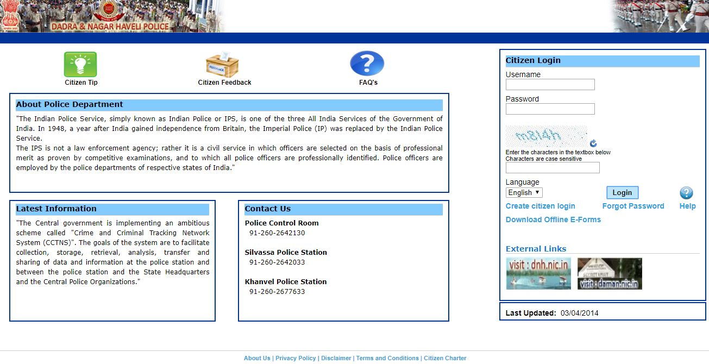

Figure 1:Dadra and Nagar Haveli Police system.

* + 1. **Cybercrime Reporting Portal**

The system provides a platform to report a complain and track a complain, also the platform provides a platform to check feedback and contact relevant authorities to do a follow up on a complaint. The problem of this system is that only it covers the complainant and not the administration which requires to do a follow-up activity on a complaint(Cybercrime Reporting Portal, 2018).

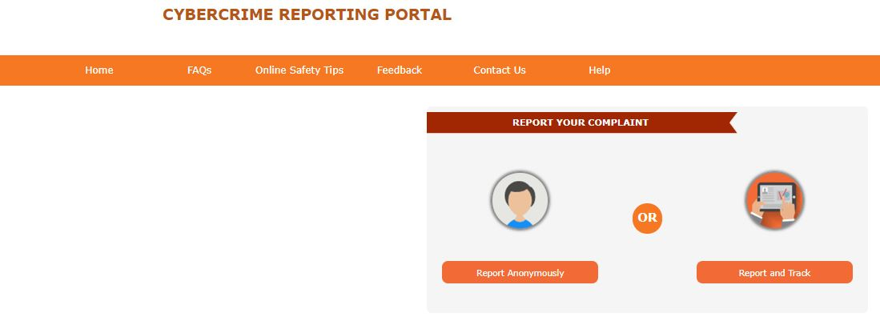

Figure 2:Cybercrime Reporting Portal system.

* + 1. **Metropolitan Police**

Metropolitan police is an online system that provides a platform to check events, experienced officers and even consults the help center to get fast help from the concerned parties. This system also provides a platform to register and log in through Facebook and link held to forward a complaint. This system does not integrate the police into their system to communicate directly with the complaints, forcing the complainants to report back to the police after sending their complaints(Metropolitan, 2018).

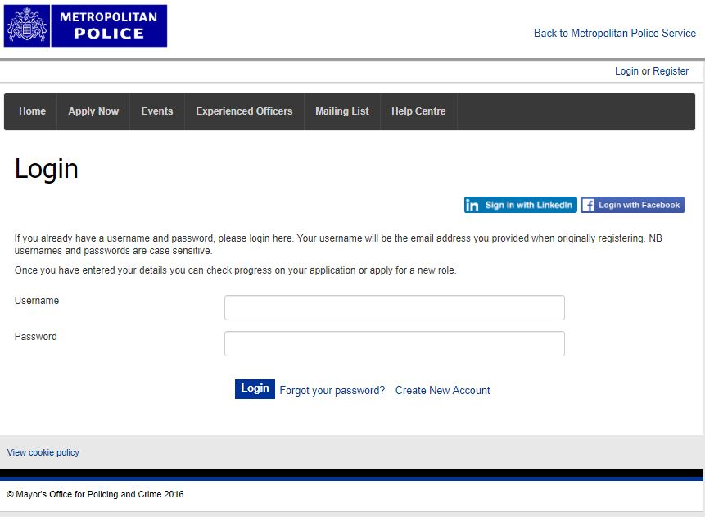

Figure 3:Metropolitan Police system.

* + 1. **Online Crime Report**

An online crime report is a system that enables the public login, access alerts and reports a crime. This system does not cover broad functionalities of the user and so does not fully satisfy user requirements. It just provides a platform for a user to report crimes and not get a reply about the reported crimes(Online crime reporting, 2019).

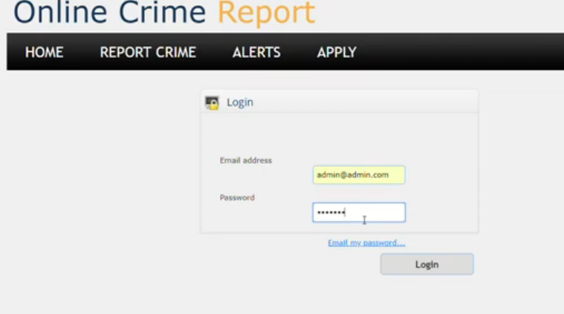

Figure 4:Online Crime report system.

* + 1. **Gainesville Police Department**

Gainesville Police department is an online police system that is used in Florida. This system enables the user to Report Incidents by answering sample questions, Crash reports, contact relevant authorities and even register Bike to reach the required standards in Florida. This system does not provide the user with the platform to consult for help and the user cannot sign in the system since the platform is not offered. This system is covering various aspects that are not very meaningful to the user(Gainesville, 2016).

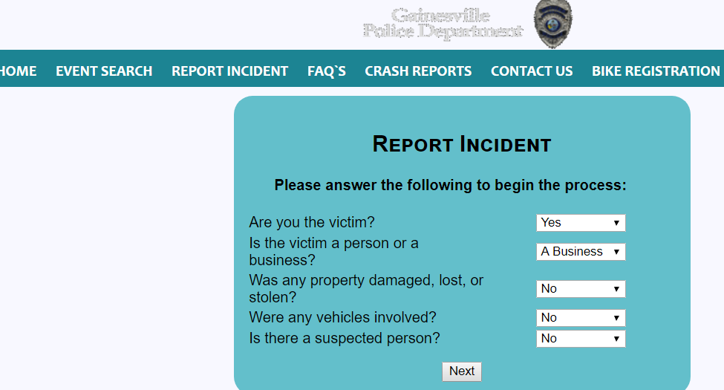

Figure 5: Gainesville Police Department system.

**2.4 Critical Review and Research Gap identification**

In the above-mentioned similar systems, they all help to understand the procedure of recording a complaint especially the Cybercrime reporting portal and online crime report. Most of the systems just define the procedures and solutions but no indications of how they will communicate with the police to get direct contact with the police and even get to report wanted criminals. These systems are well designed although some are containing a lot of information that might be confusing to the complainants or users of the systems, for example, the Gainesville Police Department system. E-police reporting system will link together both the complainant and the police, even ease administration work within the police department storing data recorded by the complainants or public, that was manually done in the Occurrence Book. This will help improve the relationship between the police and the public hence improving the security of a region.

**2.5 Chapter Summary**

This chapter, literature review focusses on the problems associated with manual and web-based systems. This chapter also focusses on comparing several similar systems and criticizing them as observed above.

# **CHAPTER THREE: METHODOLOGY**

1. **Introduction**

This chapter involves analysis of methodology technique put in place in creation of the proposed system. Due to the constrains need of a high-quality product that is User guided the best methodology that is being used is the Agile methodology. This chapter will focus on how the objectives of this study will be realized. Broadly this chapter is based on several topics such as research design method, target population, appropriate sampling techniques that will be used, data collection procedures, data collection instruments, tools and techniques that will be used to collect and analyze data.

* 1. **Research Design**

Research design provides methods chosen by the researcher in form of a framework, that combines several components of the research in an organized manner and logical way so that the problem at hand is solved efficiently. It also provides insights of “how” to conduct the research using particular methodology. The researcher also has got a list of several research questions that need to be tackled and this can be done by research design.

The types of research design that is proposed by the researcher are Descriptive research design and Experimental research design. This is because descriptive research design is theory-based research which focusses on gathering, analyzing and presenting collected data. While Experimental research design is focused on solving a problem at hand in this case the security of the public.

* + 1. **Target Population**

E-police reporting system will be a system that will focus on police officers and residents who will take part in ensuring security within a locality. Based on these criteria the system will be able to serve several regions so as to improve on the security of their localities.

* + 1. **Sample size**

Sampling involves selecting a sub-section of the population to represent the entire population. This is so as to obtain the information regarding the phenomena of interest. This is recommended since it provides easy access to the respondents. There are two approaches to sampling; random sampling and stratified sampling.

For this research, the researcher will choose random sampling as the desired method for the research.

* **Random Sampling**

This is the act of selecting a sample group from the entire population so that it will be used for research. This sampling technique has been selected because of its ability to provide accurate data that is randomly generated without any biasness. A sample number of police will be taken and research carried out.

* + 1. **Data collection procedure & instruments**

Data collection is the process of obtaining, organizing and analyzing data that is required in a particular field of study for a particular subject under research.

The researcher used the following techniques to gather information.

* **Interviews**

An interview refers to face to face interaction with the respondent in order to collect data. The researcher will gather information by interviewing the public who will be attended to at Central Police station at that time of research, and also the Police officers who will be attending to the public at that time. This will be by asking series of questions both to the public and the police. This will help the researcher know on the kind of respondents within short period of time.

* **Questionnaires**

A questionnaire is a list of questions prepared by the researcher in a piece of paper for the respondent to fill in writing either for submission or in presence of the researcher. This will be convenient in getting the very first hand information as the respondent is given time to figure out and justify the responses freely without hesitation. This is appropriate because it is cost effectiveness in collecting data over a given locality.

* **Observation**

The researcher gathered information by observing day to day activities both by the public and the police.

**3.3 System Development methodology**

The system will use the Agile Methodology.

**Agile Methodology**

Agile methodology emerged after the failure of waterfall method that was used for managing complex projects. Basically, Agile is the opposite of waterfall method since it favors a flexible and fast approach of building systems. It is also iterative and it has small iterative incremental that responds to changing requirements.

**Agile Software Development Life cycle (SDLC)**

Agile SDLC model combines both iterative and incremental process models focusing on building a working software which can offer customer satisfaction. For instance, focusing on the iterative and incremental processes to build an E-police reporting system that is fully satisfying the users requirements. Agile Methods break the product into small incremental which are provided in iterations. The stages of Agile SDLC is as shown;

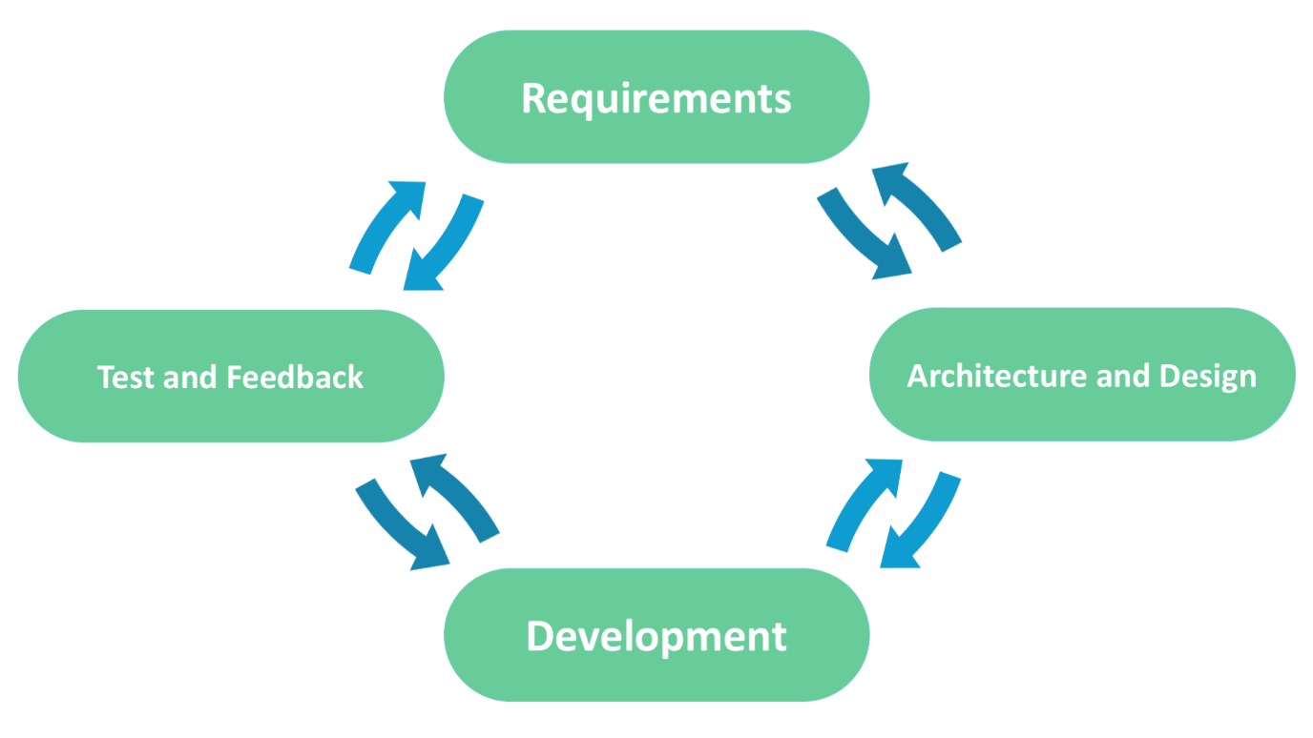

Figure 6: Stages of Agile SDLC life cycle.

**Planning and Requirement analysis:** This is whereby the requirement of the final product is discussed by defining the system requirements for the system to be built. The system requirements for E-police reporting system must be defined in accordance to the user’s requirements before building on the real system.

**Designing the project architecture:** The developers goes ahead to design the architecture of the product in accordance to the user requirements collected in the first step. E-police reporting system architecture is designed in this step and all the technical questions that may appear are discussed by stakeholders.

**Development and programming:** Focusing on the defined requirements of the users to build E-police reporting system, the designers start writing source code of the system. The programming of the system will focus on algorithm source code writing, complication debugging and testing.

**Testing and deployment:** debugging process is conducted to the E-police reporting system developed in the development and programming stage. The code flaws missed during the development is detected and documented then sent back to the developers. When the E-police reporting system developed is finalized and has got no problems, it is time to take it to users. After which the user feedback is collected as often as possible so as to know how the system works.

|  |  |
| --- | --- |
| ADVANTAGES | DISADVANTAGES |
| Correctional of functional requirements are implemented into the development process to provide the competitiveness. | Difficult with measuring final cost of because of permanent charges. |
| Project is divided by short and transparent iterations. | The team should be highly professional and client oriented. |
| Risks are minimized due to the flexible changes. | With all the corrections and changes there iss possibility that the project may exceed expected time. |
| Fast release of the first product version. |  |

Table 1:Advantages and Disadvantages of Agile methodology.

**3.3.1 Methodology Justification**

Agile methodology is a method that allows people to interact freely with a functioning software at the end of each iteration and provide feedback on it. This method allows developer to make changes if needed. It is more appropriate for developing E-police reporting system since it involves breaking down the software into smaller modules, while integrating documentation and quality testing at each and every step. The smaller modules become simple and easy to understand by the users of the system that is both the public and the police. The development and testing are performed as sequence of activities unlike the traditional Software Development Life Cycle where development and testing are separately done.

**3.4 System Requirement Analysis**

The data will be collected by the researcher from different people that is the public and the police and even from different online sites that help the police in doing their work. The system will be able to perform the following functions.

**3.4.1 Functional Requirements**

The functional requirements define the capabilities and functions of the system that it must perform successfully. Thereby specifying the software functionality that that must be built into product so as to accomplish users’ needs. User specifications are functional requirements of the system.

1. **User Specifications.**
2. Resident/User: He will be able to register into the system File a complaint, report missing persons, view assigned officers, view wanted persons details and missing persons details.
3. Police: He will be able to login to the system assign officers, view complaints and add wanted person, delete wanted person add cell registry details and view missing persons.

**3.4.2 Non functional requirements**

This are the criteria that is used to describe the operation of the system, rather than specific behaviors. They ensure the effectiveness and usability of the system and failing to meet any one of them can result to failure of systems. The nonfunctional requirements include:

1. **Security**- The system should provide authorized access to the system. Users will login to their accounts only if the password is correct. The data will be confidential and safe since all passwords will be stored in the database encrypted using the hash function.
2. **Usability**-The system will be easily used by the users. Since the System will have a user-friendly interface.
3. **Performance**-The system will have a quick response time that is the refreshing times and loading screen would be faster.
4. **Availability**-The system will be available 7days a week,24hrs a day and 365days a year. The system will always be available for access from any location from an online platform.
5. **Flexibility**-The system should be ready for expansion and changes.
6. **Backup**-The system will provide a means to backup data so as to avoid data loss.

**3.4.3 Unified Modeling Language**

This chapter entails the Unified Modelling Language which represents set of diagrams for specifying, visualizing, constructing, and documenting the artifacts of software systems, as well as for business modeling and other non-software systems. The diagrams will display how the system will function and how the users of the system will respond to various functionalities they require of the system.

* + 1. **(A)Use case Model**

The key elements in a use case model are **actors**, **use cases** themselves and the Relationship between them. A use case is a unit of functionality (a requirement), or a service, in the system. A use case is not a process, or program, or function. Because use case models are simple both in concept and appearance, it is relatively easy to discuss the correctness of a use case model with a non-technical person (such as a customer). Use case modeling effectively became a practicable analysis technique.

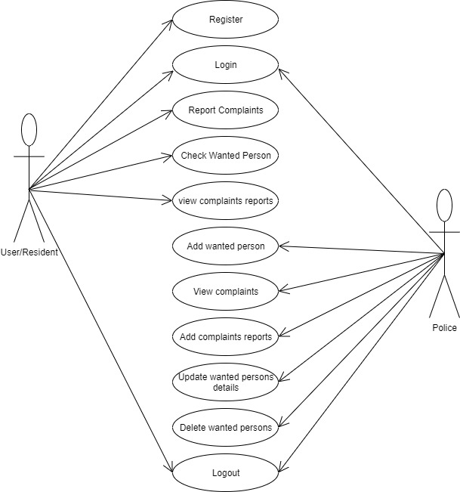

Figure 7:Use Case Modelling Diagram

* + 1. **(B)Activity Diagram**

Activity Diagram represents series of actions in a system in form of flowcharts or data flow diagram. It is often used to in business process modeling. Can also define steps in the use case diagram.

The below diagram represents the activity diagram.

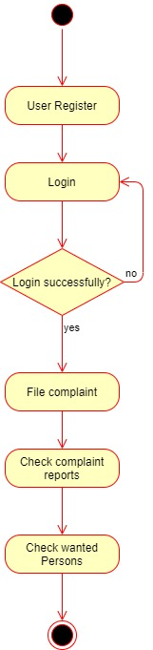

Figure 8:Activity diagram

* + 1. **(C) Sequence diagram**

In the UML context Sequence diagram represents object collaboration and is used to define event sequences between objects for a certain outcome. It is an essential component used in processes related to analysis, design and documentation.

The diagram below represents sequence diagram.

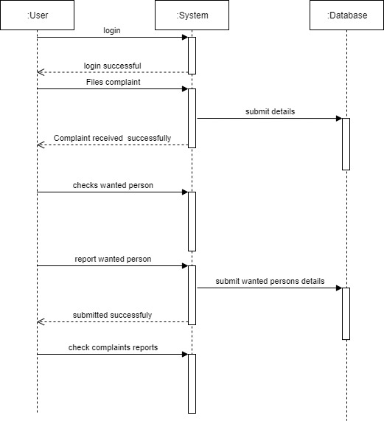

Figure 9:Sequence diagram

* + 1. **(D) Class Diagram**

Class diagram is a part of UML that describes and provides the overview and structure of a system in terms of classes, attributes and methods, and the relationships between different classes. Class diagram is used to illustrate and create a functional diagram of the system classes and serves as a system development resource within the software development life cycle. The figure 2.5 represents the activity diagram.

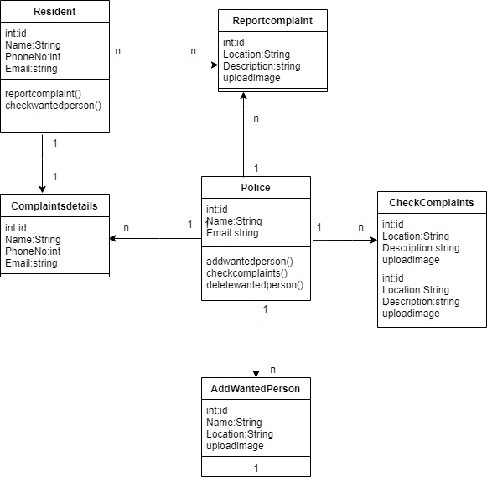

Figure 10:Class diagram

* + 1. **(E) Deployment Diagram**

The diagram below indicates the configuration of runtime processing nodes and the components that live on them. It is a diagram structure used to in modeling the physical aspects of an object-oriented system. Often used to model the static deployment view of the system, that is topology of the hardware.

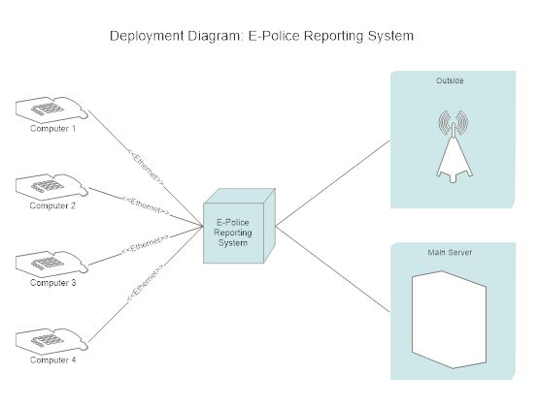

Figure 11:Deployment diagram

1. **Database Design**

**3.5.1 Table Design**

The Table 1.0, below represents the table design for the filling complaints.

|  |  |  |  |
| --- | --- | --- | --- |
| **Attribute** | **Data type** | **Primary Key** | **Constraints** |
| ID | int (11) | PK | Primary Key |
| Date | date | ___ | Not null |
| IdNo | int(15) | ___ | Not null |
| Verification Image | varchar (30) | ___ | Not null |
| First name | varchar (20) | ___ | Not null |
| Middle name | varchar (20) | ___ | Not null |
| Last name | varchar (20) | ___ | Not null |
| Email | varchar(255) | ___ | Not null |
| Phone number | int(15) | ___ | Not null |
| Complaint Description | Varchar(30) | ___ | Not null |

Table 2:Filing Complaint Table

Table 1.1 below represent the Register/Login table

|  |  |  |  |
| --- | --- | --- | --- |
| **Attribute** | **Data type** | **Primary Key** | **Constraints** |
| ID | int (11) | PK | Primary Key |
| Username | varchar (100) | ___ | Not null |
| Email | varchar (100) | ___ | Not null |
| Password | varchar (100) | ___ | Not null |

Table 3:Register/Login table

**3.7 Chapter Summary**

This chapter discussed about the agile methodology that will be used to develop the system since it enables the adjustments to be in case of changes. The research design shows the requirements that will be needed for effective data collection and to come up with a better solution system, that is the E-police reporting system.

# **CHAPTER FOUR**

# **RESEARCH FINDINGS AND DISCUSSION**

## 4.1 Introduction

In this chapter, the tools used in the development of the E-Police Reporting system are broadly described. All the technologies and requirements mentioned in the analysis and design are described.

## 4.2 System Construction

Development of the system is achieved by ensuring that both functional and non-functional requirements are achieved. This has been possible regarding the different modules in the system. The system has been developed using Hypertext Preprocessor, HTML, JavaScript and CSS. Illustration is as shown and explained in different modules in the figures below.

### **4.2.1 Objective 1**

The first objective was to design, develop and implement the web-based E-Police reporting system prototype in accordance to the user requirements. Figure 3.1 shows the developed prototype for the E-police reporting system homepage.

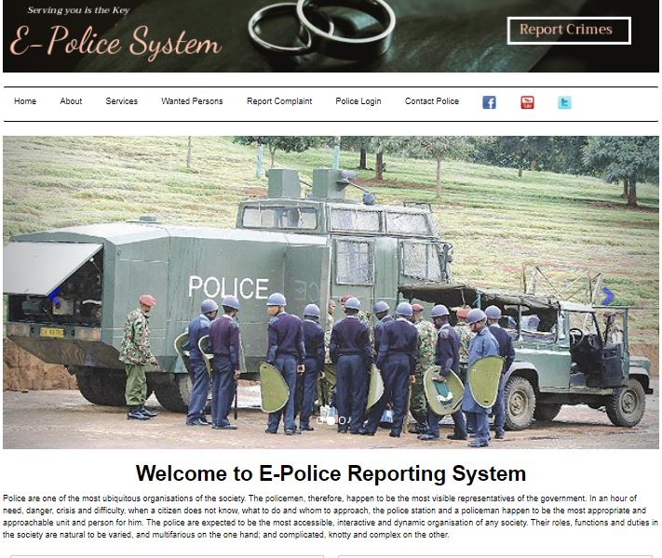

Figure 12:Home Page

### **4.2.2 Objective 2**

Here is whereby the implementation of the system is described. The results of interaction of the system with the users at different modules and levels are described using module screenshots.

#### **4.2.2 (A) Account Creation and Login Module**

When the user or resident clicks on report complaint, the resident is directed to registration page which is the first step in accessing the system. It requires user to enter their respective details. On login the user will be able to use their email and password and this will only work once the user has registered.

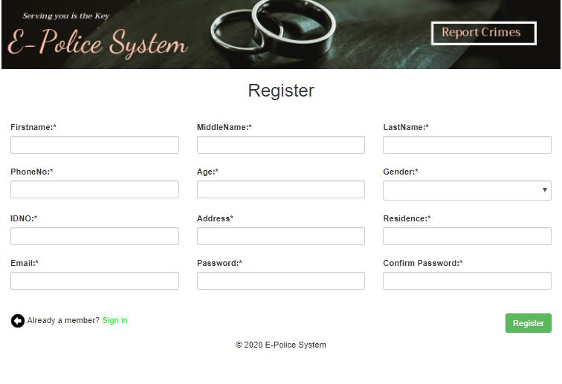

Figure 13:Register Form Screenshot

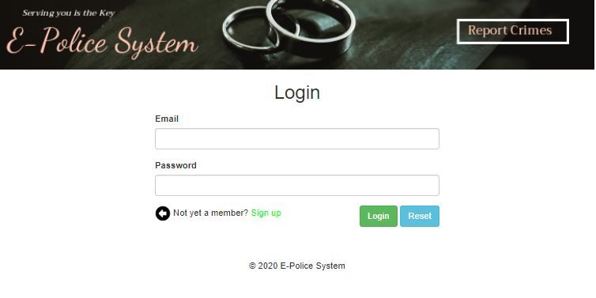

Figure 14:Login Form module

This module shows register attempts by a user using existing email.

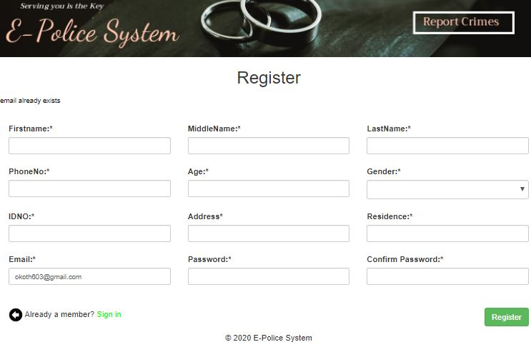

Figure 15:User Register Module (using existing email).

#### **4.2.2 (B) Data Entry Forms Screenshots**

1. **Residents Dashboard**

This page is whereby the resident will file the complaint, being that the details has already been recorded in the register Module page.

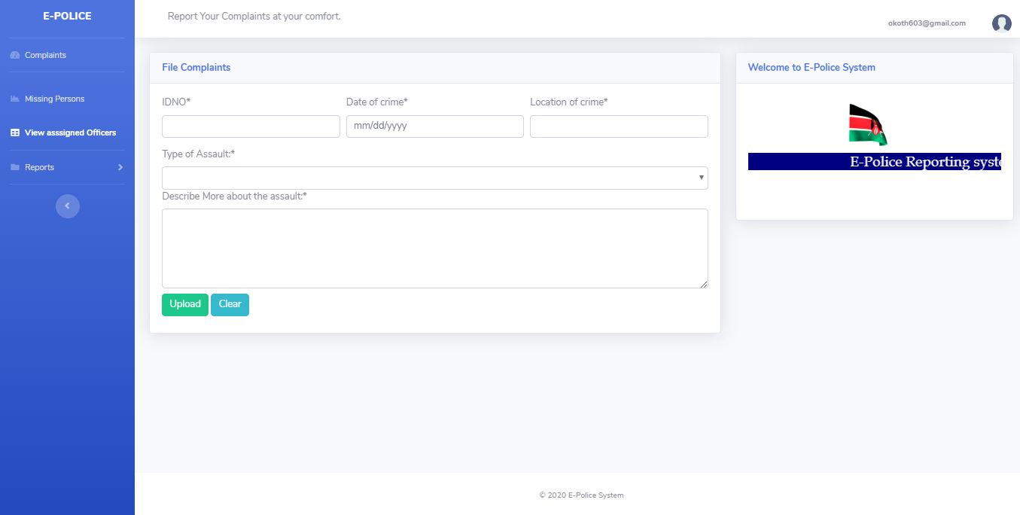

Figure 16:Users Dashboard File Complaint Module

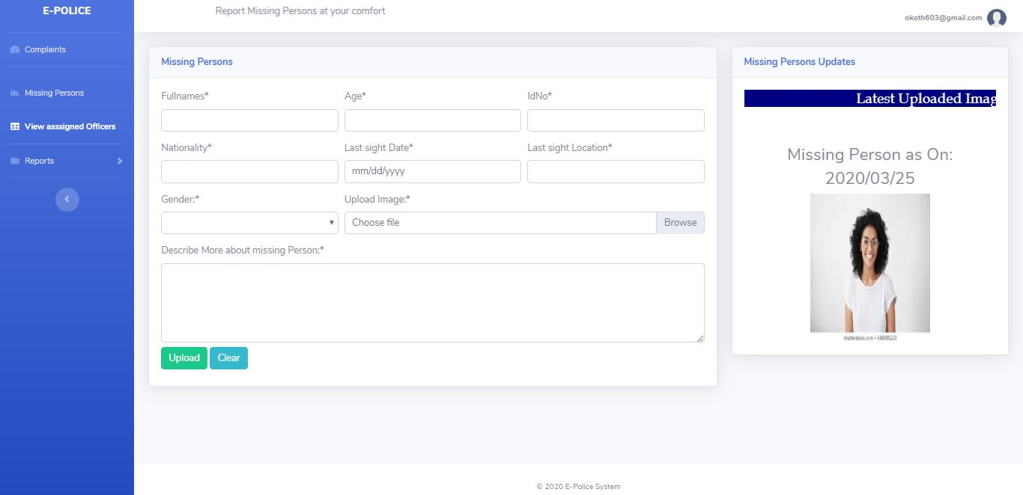

Figure 17:Users Dashboard Missing Persons Module

1. **Police User Dashboard**

The figures below represent forms that allows police to login, assign officers, add wanted persons, view missing persons and add cell registry data.

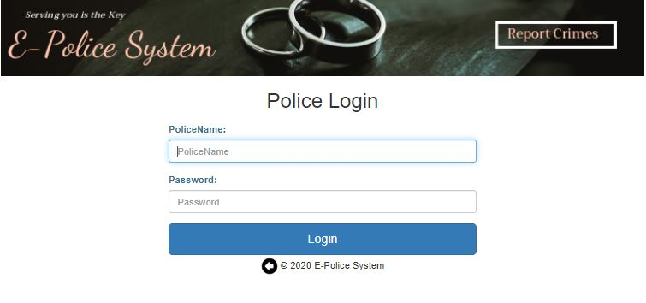

Figure 18:Police Login Form

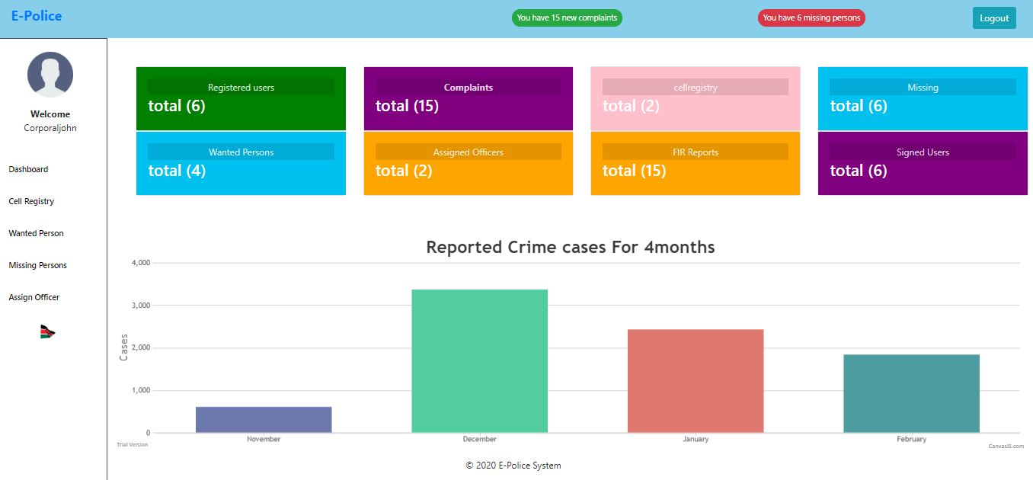

Figure 19:Police User Dashboard Module

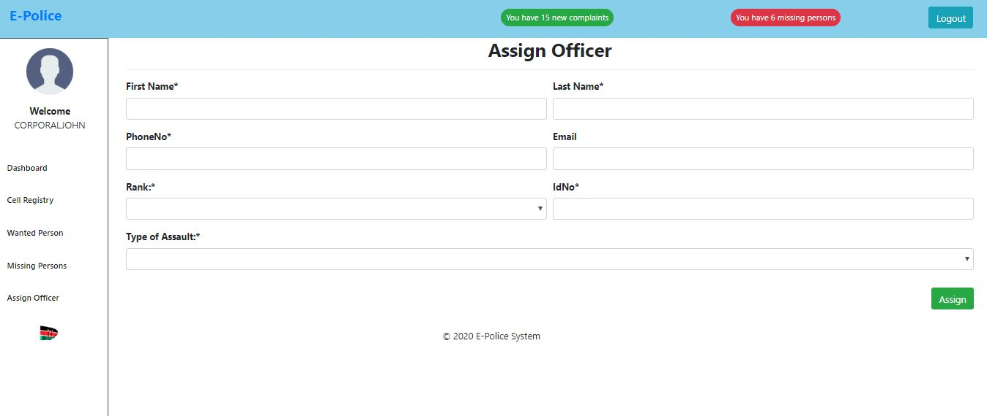

Figure 20:Assign Officer Page

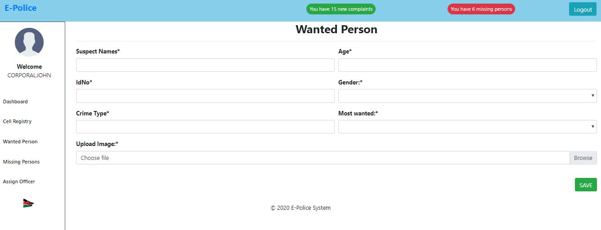

Figure 21:Add Wanted Person Page

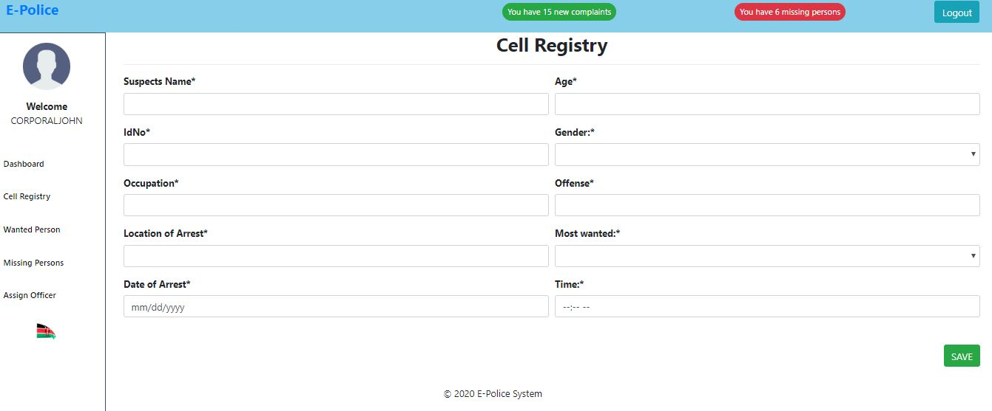

Figure 22:Cell registry Form

#### **4.2.2 (C) Query Output Results**

All the query output results are described here for both the resident and police regarding their functionality.

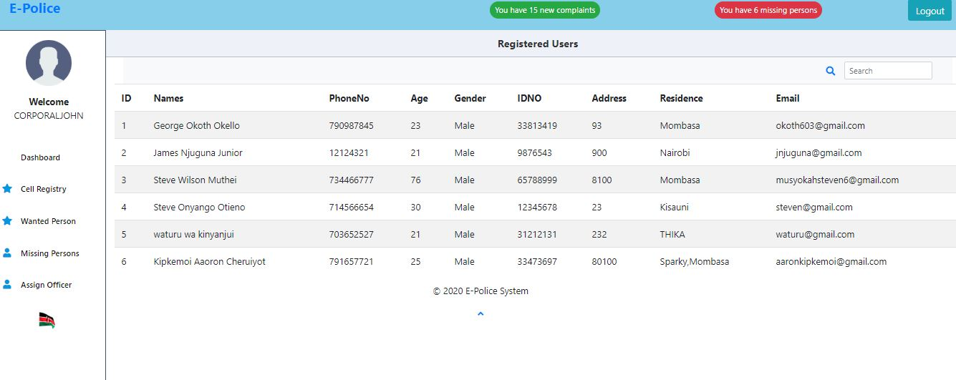

Figure 23:Police User view registered users

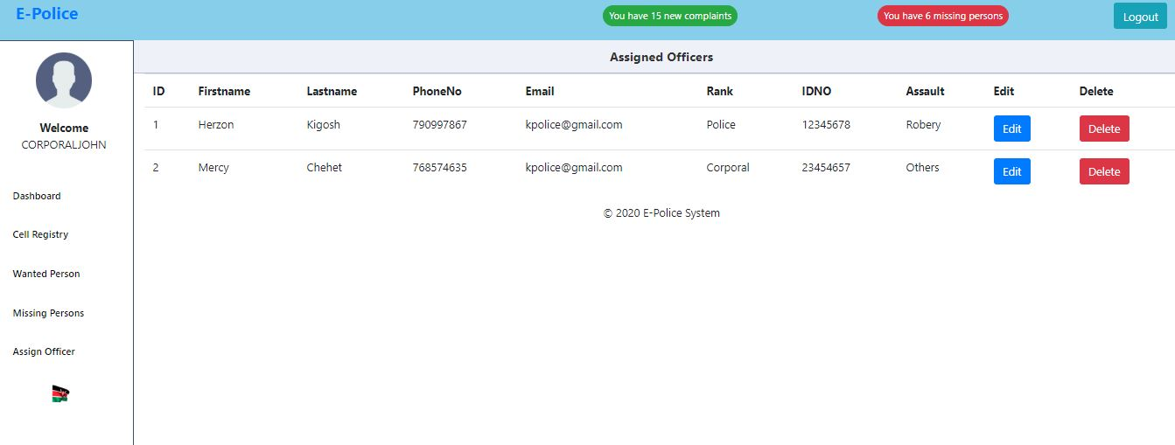

Figure 24:Police user viewing assigned officers

Figure 4.4 shows the filled profile for filing complaints

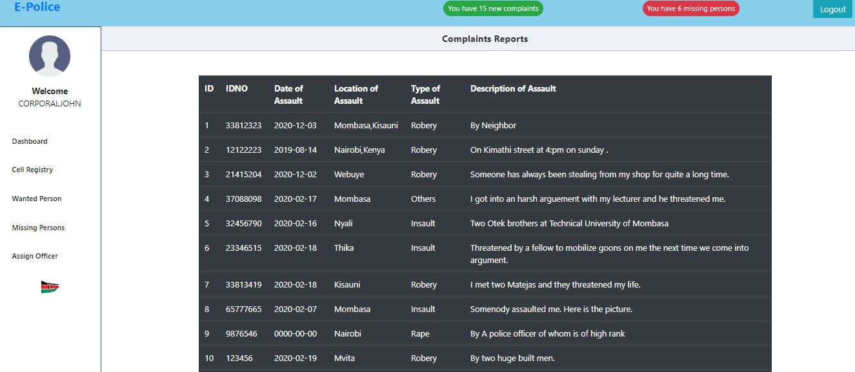

Figure 25:Query output for filed complaints.

#### **(D) Validation Screenshots**

The registration portal with an already used email and passwords that are not matching.

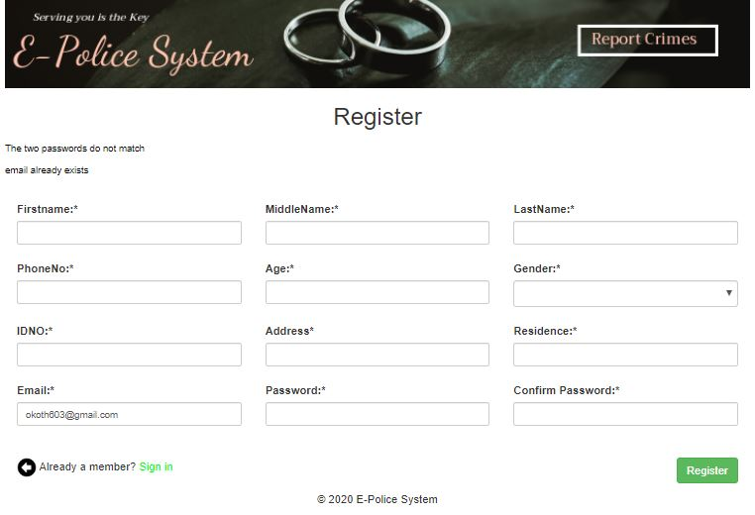

Figure 26:The Registration portal validation

The registration module validation being that all the field are required and must be filled before proceeding to another field.

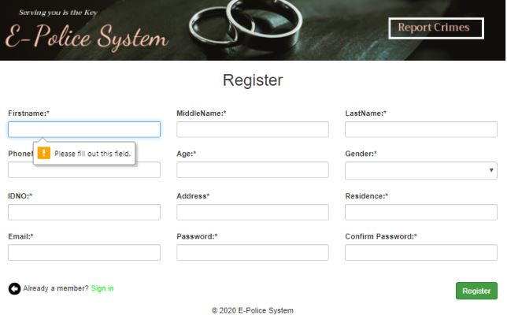

Figure 27:Register page test

The login module test using an empty email and password.

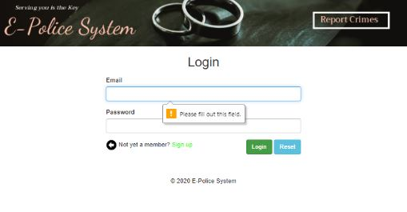

Figure 28:Login Module Test

**4.3 Testing**

Testing the system is very important to determine the success of the system. System testing determines whether the modules of the system is correct and achieving the user requirements in accordance to the objectives outlined. Testing of the system involves using the test data in the test phase.

Debugging and testing was carried out in two consecutive phases. First phase was composed of Unit testing of major modules of the system. Lastly the User Acceptance Test was conducted whereby four volunteers were chosen to conduct User Acceptance Testing.

The main purpose of test plan is to determine and build detailed test cases of each aspect of the application as provided by the users of the system.

**4.3.1 User Acceptance Testing**

Users test the system if it can handle real world scenarios. This is in accordance to the user’s specifications outlined in the objectives to ensure the expected results are met. The login module was tested and implemented using username and password. The other modules are as shown below.

|  |  |  |  |  |
| --- | --- | --- | --- | --- |
| **No** | **Data input** | **Expected output** | **Actual Output** | **Pass/Fail** |
| **1** | All field are empty | Error message: indicating compulsory field | Error message: indicating compulsory field | Pass |
| **2** | Email | Error message: indicating invalid email address | Error message: indicating invalid email address | Pass |
| **3** | Password and confirm password | Error messages: Both passwords don’t match | Error messages: Both passwords don’t match | Pass |
| **4** | Login | Log in the system should be done by the registered persons for the users and their correct passwords as well as the police users(admin) should log in with the assigned login details as provided by the administrator  The system gives an error and deny login. | Login should be successful and the user should be able to enter into the system  Log in should fail with an error message “Incorrect Username /Password” | Fail  Pass |
| **5** | User (Resident) | Log in allows the user to get to the users’ dashboard | Login successfully user gets to dashboard | Pass |
| **6** | Police User (Admin) | Log in allows police user get to admin dashboard | Log in successfully and admin gets to admin dashboard | Pass |

Table 4:User Acceptance Testing

**CHAPTER FIVE**

**SUMMARY OF FINDINGS, CONCLUSIONS AND RECOMMENDATIONS**

## 5.0 introduction

This chapter summarizes the finding of the study and makes conclusions upon which recommendations are drawn. Suggestion for further study is also captured as a way of filling the gaps identified in the study. The chapter also summarizes the findings of the current method of the system and whether to adopt the use of online platform to report or view necessary information that may help both the police and public at large to improve their security in their respective localities of jurisdiction

## 5.1Summary of the Achievements

The system developer was able to make the system in the following parts:

* Enabled save of data recorded in the police station online
* Through the system there exist an aspect of integrity of data saved online
* Saved on time used to review case files and data recorded online
* Safety of data and can be extracted for future reference

## 5.2 Constraints

* Integrating necessary upload files that the residence could download remotely e.g. P3 FORMS
* Implementing an A.I system that could easily detect the total number of cases recorded
* Feedback system to notify the user if the progress of a case they had filed

## 5.3 Conclusions

The government of Kenya should be in the forefront to spear head the innovations made in building of the systems. Currently as it stands no online system exists where locals can interact with the police remotely with no need of visiting the police stations to be served. This will improve the security and increase interactivity with the security stakeholders at the lowest levels and in the field.

## 5.4 Recommendations

There is need to invest more in security of the country thus the government through the respective stakeholders should develop adopt the use of automated system. Advancement in use of online and secure systems as such will provide the security personnel a smooth-running environment to carry out their duties in their respective jurisdiction.

An automated system will reduce workload and encourage transparency and reduce vices in the security docket of the country.

# **REFRENCES**

Bevan, N., Earthy, J.: Benefiting from ISO standards. In: Norman, K.L., Kirakowski, J. (eds.) The Wiley Handbook of Human Computer Interaction, pp. 51–69. Wiley, New York (2018)

[Cybercrime Reporting Portal]. (2018). https://cybercrime.gov.in/Webform/crmcondi.aspx

[Dadra and Nagar Haveli Police]. (2020). http://www.simadnh.org/dnh-police-administration.html

[Geneville]. (2016). http://www.gainesvillepd.org/

Kumar, A. S., & Gopal, R. K. (2015). Data mining based crime investigation systems: Taxonomy and relevance. *2015 Global Conference on Communication Technologies (GCCT)*, 850–853.

[Metropolitan]. (2018). https://www.met.police.uk/ro/report/ocr/af/how-to-report-a-crime/

Nixon, M., Thomas, S. D., Daffern, M., & Ogloff, J. R. (2017). Estimating the risk of crime and victimisation in people with intellectual disability: A data-linkage study. *Social Psychiatry and Psychiatric Epidemiology*, *52*(5), 617–626.

[Online crime reporting]. (2019). https://www.cityoflondon.police.uk/contact-city-police/reporting-a-crime/Pages/Online-crime-report.aspx

Sarker, M. N. I., Wu, M., Liu, R., & Ma, C. (2018). Challenges and opportunities for information resource management for E-governance in Bangladesh. *International Conference on Management Science and Engineering Management*, 675–688.

**APPENDICES**

## Appendix 1. PROJECT BUDGET

|  |  |  |  |  |
| --- | --- | --- | --- | --- |
| **NO** | **REQUIREMENT** | **QUALITY** | **UNIT PRICE** | **AMOUNT** |
| **1.** | Laptop | 1 | 30,000 | 30,000 |
| **2.** | Transport | ______ | 1500 | 1500 |
| **3.** | Communication (airtime) | ______ | 500 | 500 |
| **4.** | Printing (Proposal) | Laser Printing | 1500 | 1500 |
| **5.** | Miscellaneous |  | 1000 | 1000 |
|  | **TOTAL AMOUNT(Kshs.)** |  |  | **34,500** |

Table 5:Project Budget

## Appendix 2. PROJECT TIMEFRAME

|  |  |  |  |  |  |  |
| --- | --- | --- | --- | --- | --- | --- |
| Activity | October | November | December | January | February | March |
| Problem definition and literature review |  |  |  |  |  |  |
| requirement gathering |  |  |  |  |  |  |
| Project design and analysis |  |  |  |  |  |  |
| Project coding |  |  |  |  |  |  |
| Integration and Testing |  |  |  |  |  |  |
| implementation |  |  |  |  |  |  |
| Documentation |  |  |  |  |  |  |

Table 6:Project Timeframe

# **QUESTIONNAIRE**

Sample questionnaire for E-Police Reporting system.

1. Do you have access to the following:

a) Android Phone [ **Yes**] [ **No**]

b) Internet [ **Yes**] [ **No**]

2. Are you a Computer literate? [ **Yes**] [ **No**]

3. How often do you use Social Network Platforms?

**A.** Daily **B.** Once in A Week **C.** Less Often **D.** Never

4.In respect to the current police system in the police station, rate the mode at which services are offered

**A)** Slow **B.** Medium **C**. Fast

5. Please Indicate state of security in your area of residence?

**A)** Bad **B)** Fair C) **Good**

6. How are security matters handled by police in your area of residence?

a) slow c) fair b) moderate d) good

7. How often do residents report cases or give relevant information at the police station?

......................................................................................................................................................

................................................................................................................................................

8. How often do resident get relevant information from the police station?

......................................................................................................................................................

................................................................................................................................................

9. How is the relationship between police officers and residents?

**A.** Excellent **B.** Interactive **C.** Harsh **D.** Rarely Occurs

10. information given at the police stations Occurrence Book, can it be considered safe and not vulnerable to interference?

**A.** Strongly Agree **B.** Agree **C.** Neutral **D.** Disagree **E.** Strongly Disagree

11. Will the system enable residents to interact socially and enhance security in the area of locality?

**A.** Strongly Agree **B.** Agree **C.** Neutral **D.** Disagree **E.** Strongly Disagree