Table 1 Distributions used for bootstrapping functional responses. Distributions are similar to those used by Koehn et *al.* (2017)

|  |  |  |
| --- | --- | --- |
| Parameter symbol | Description | Distribution |
| *γi* | Other mortality density-dependence for group *i* | Beta(3, 12) |
| *θij* | Prey dependence of predator *j* prey *i* functional response | Beta(12,3) |
| *εij* | Predator dependence of predator *j* prey *i* functional response | Beta(2,2) |

Table 2 Ecopath model summary. TL is trophic level, PB production to biomass ratio, QB consumption to biomass ratio, EE ecotrophic efficiency, GE gross efficiency (PB/QB).

|  |  |  |  |  |  |  |  |
| --- | --- | --- | --- | --- | --- | --- | --- |
| Group | TL | Biomass | PB | QB | EE | GE | Removals |
| Juv Shark+ | 3.49 | 0.08441 | 21 | 181 | 0.00237* | 0.111 | 4.00E-041 |
| Adu Shark | 3.86 | 6.80E-07* | 0.511 | 3.91* | 0.288* | 0.13 | 1.00E-071 |
| Juv R Drum+ | 2.35 | 0.21 | 2.21 | 4.51 | 0.706* | 0.489 | 5.00E-041 |
| Adu R Drum | 3.18 | 0.00149* | 0.621 | 1.87* | 1.46E-05* | 0.332 | 0 |
| Juv Seatrout | 2.92 | 0.00275* | 3.71 | 29.1* | 0.843* | 0.127 | 0 |
| Adu Seatrout+ | 2.97 | 0.11 | 0.71 | 5.41 | 0.312* | 0.13 | 0.0041 |
| Juv B Drum+ | 2.33 | 0.1091 | 21 | 22.61 | 0.923* | 0.0883 | 0.0331 |
| Adu B Drum | 2.69 | 0.00117* | 0.51 | 6.36* | 0.741* | 0.0786 | 0.000161 |
| Juv Catfish | 2.3 | 0.0175* | 21 | 10.8* | 0.74* | 0.185 | 0 |
| Adu Catfish+ | 2.76 | 0.1561 | 0.81 | 3.31 | 0.834* | 0.242 | 0.021 |
| Juv Sm Scianids+ | 2.74 | 0.331 | 21 | 201 | 0.902* | 0.0999 | 0 |
| Adu Sm Scianids | 2.64 | 1.56* | 1.51 | 8.84* | 0.577* | 0.17 | 0.0221 |
| Juv Sheepshead | 2.73 | 0.0975* | 21 | 14.6* | 0.788* | 0.137 | 0.0011 |
| Adu Sheepshead+ | 3.11 | 0.051 | 0.421 | 5.91 | 0.838* | 0.0712 | 0.0151 |
| Juv Flounder+ | 2.67 | 0.006471 | 21 | 13.31 | 0.8691 | 0.15 | 2.00E-041 |
| Adu Flounder | 3.32 | 0.00581* | 0.421 | 4.51* | 0.792 | 0.0932 | 0.00181 |
| Juv Pinfish | 2.26 | 0.0727* | 21 | 19.8* | 0.946* | 0.101 | 0 |
| Adu Pinfish+ | 2.11 | 0.081 | 0.71 | 81 | 0.947 | 0.0875 | 0.0021 |
| Juv Menhaden+ | 3 | 0.171 | 2.31 | 19.41 | 0.254* | 0.119 | 1.00E-041 |
| Adu Menhaden | 2.02 | 0.569* | 1.91 | 8.48* | 0.909* | 0.224 | 0.681 |
| Juv Mullet | 2.71 | 0.38* | 2.41 | 33* | 0.408* | 0.0728 | 0.0021 |
| Adu Mullet+ | 2 | 1.441 | 0.81 | 12.31 | 0.16* | 0.0651 | 0 |
| Anchovy Silverside | 2.65 | 0.9521 | 2.31 | 19.41 | 0.854* | 0.119 | 0.0021 |
| Gar | 3.34 | 0.04 | 0.482 | 2.253 | 0.104* | 0.213 | 0.002 |
| Stingray | 3.17 | 0.16 | 0.484 | 15 | 0.197* | 0.48 | 0 |
| Diving Birds | 3.48 | 0.001476 | 0.16 | 50 | 0* | 0.002 | 0 |
| Pelicans | 3.45 | 0.007476 | 0.16 | 17.7 | 5.41E-05* | 0.00565 | 0 |
| Marsh Birds | 3.36 | 0.000137 | 5.487 | 87.67 | 0* | 0.0625 | 0 |
| Dolphins | 3.55 | 0.088 | 0.0518 | 25.39 | 8.24E-05* | 0.00202 | 0 |
| Killifishes | 2.72 | 0.2151 | 2.531 | 19.41 | 0.966* | 0.13 | 0 |
| Juv Panaeids+ | 2.05 | 0.2051 | 31 | 66.61 | 0.262* | 0.045 | 0 |
| Adu Panaeids | 2.16 | 15.5* | 2.41 | 19.2* | 0.0388* | 0.125 | 1.321 |
| Juv Blue Crab+ | 2.37 | 0.4431 | 31 | 171 | 0.203* | 0.176 | 0.0021 |
| Adu Blue Crab | 2.44 | 0.563* | 2.41 | 8.51 | 0.589* | 0.282 | 0.6011 |
| Carn Insects | 2.68 | 0.0171* | 610 | 3010 | 0.3 | 0.2 | 0 |
| Grass Shrimp | 2.05 | 0.4461 | 4.51 | 181 | 0.901* | 0.25 | 0 |
| Other Crabs | 2 | 11 | 4.51 | 181 | 0.991* | 0.25 | 0 |
| Herb Insects | 2 | 0.174* | 610 | 3010 | 0.3 | 0.2 | 0 |
| Zooplankton | 2 | 4.121 | 28.81 | 84.91 | 0.489* | 0.339 | 0 |
| Oyster Spat | 2 | 0.0356* | 21 | 40* | 0.032* | 0.05 | 0 |
| Seed Oyster | 2.05 | 1.2* | 1.81 | 14.6* | 0.625* | 0.123 | 0 |
| Sack Oyster+ | 2.05 | 0.6851 | 2.41 | 101 | 0.839* | 0.24 | 0.31 |
| Oyster Drill | 2.24 | 1.51 | 4.51 | 181 | 0.272* | 0.25 | 0.011 |
| Mollusks | 2 | 4.031 | 31 | 151 | 0.743* | 0.2 | 0 |
| Benthic Inverts | 2.03 | 61 | 4.51 | 221 | 0.982* | 0.205 | 0 |
| Juncus | 1 | 5 | 3 | 0 | 0.176* | 0 | 0 |
| Spartina | 1 | 5 | 2.9911 | 0 | 0.177* | 0 | 0 |
| SAV | 1 | 9.781 | 9.011 | 0 | 0.744* | 0 | 0 |
| Benthic Microalgae | 1 | 29.81 | 3.911 | 0 | 0.755* | 0 | 0 |
| Phytoplankton | 1 | 12.81 | 1021 | 0 | 0.31* | 0 | 0 |
| Detritus | 1 | 100 | 0 | 0 | 0 | 0 | 0 |
|  |  |  |  |  |  |  |  |

+ Leading stanza

* Solved by Rpath

1 De Mutsert et al. 2017

2 Murie et al. 2009

3 Pauly, 1998

4 Sage et al. 1972

5 De Mutsert et al. 2016

6 Geers, 2012 (SUNY Stony Brook MS thesis)

7 Deehr et al. 2014 (ecological modelling)

8 McDonald et al. 2017

9 Bejarano et al. 2017

10 Wolff et al. 2000 (estuarine and coastal shelf science)

11 Hill and Roberts, 2017

Fig. 1 Map



Fig. 2 Diagram of Rpath food web model



Fig. 3 Proportion of total mortality directly induced by predators and fishing on juvenile and adult stanzas of five key fish and invertebrate functional groups.



Fig. 4 Direct and indirect responses from generalized equilibrium model of fish and invertebrate biomass to changes in predator productivity and fishing effort with stanzas a) dynamically unlinked and b) combined into one homogenous functional group. Bars are at median of the Monte Carlo simulations and error lines represent 50% simulation intervals.

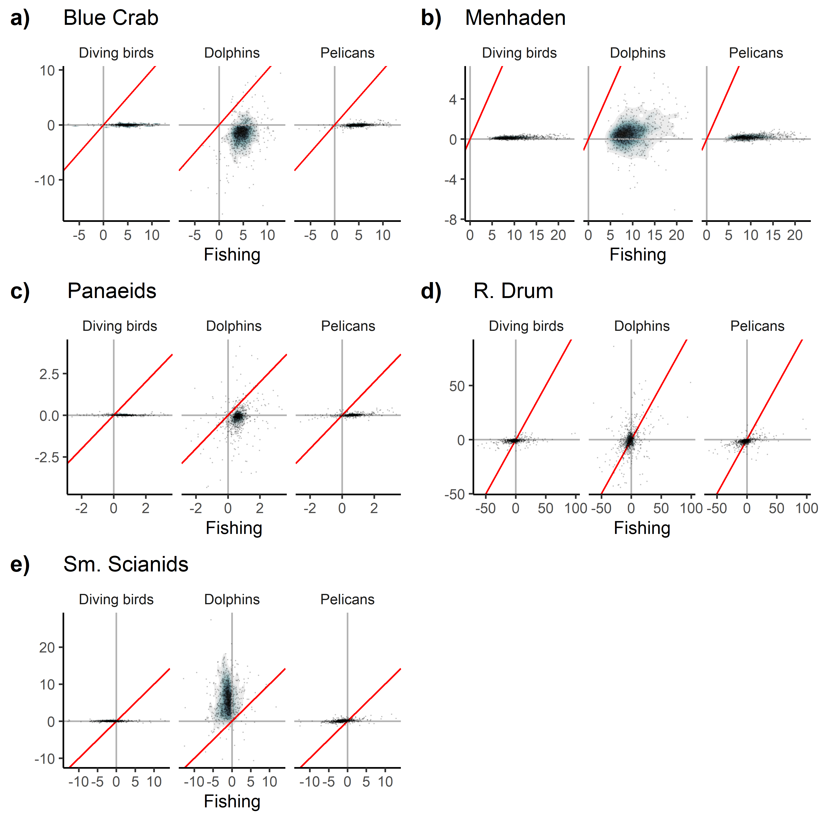

Fig. 5 Percent change in biomass in response to a 10% change in fishing effort vs 10% change in respective predator productivity for five focal functional groups, with juvenile and adult stanzas combined. Red line is 1:1. Points are overlaid on top of density plot, with bluer colors indicating higher point density and grayer/white colors indicating lower point density. Only models falling in the middle 95% of responses for all four sources for all five focal functional group are plotted (772/1000 models).