**Fishery closures, more than predator release, increased persistence of nearshore fishes and invertebrates to the Deepwater Horizon oil spill**

Kiva L. Oken1,2*, Kenneth W. Able3, Kim de Mutsert4, F. Joel Fodrie5, Paola C. López-Duarte6, Charles W. Martin7, Michael J. McCann8, Jill A. Olin9, Michael J. Polito10, Brian J. Roberts11, Olaf P. Jensen2,12

1 Fishery Resource Analysis and Monitoring Division, Northwest Fisheries Science Center, National Marine Fisheries Service, National Oceanic and Atmospheric Administration, Seattle, WA 98112, USA, ORCiD ID: 0000-0002-5627-6837

2 Department of Marine and Coastal Sciences, Rutgers University, New Brunswick, NJ, 08901

3 Rutgers University Marine Field Station, 800 c/o 132 Great Bay Boulevard, Tuckerton, New Jersey 08087, USA

4 Division of Coastal Sciences, School of Ocean Science and Engineering, University of Southern Mississippi, Ocean Springs, MS 39564.

5 Institute of Marine Sciences, University of North Carolina at Chapel Hill, 3437 Arendell Street, Morehead City, NC, USA 28557

6 Department of Biological Sciences, University of North Carolina at Charlotte, 9201 University City Blvd., Charlotte, NC, USA 28223, ORCiD ID: 0000-0003-1332-4859

7 Nature Coast Biological Station, University of Florida Institute of Food and Agricultural Sciences Cedar Key, FL, USA 32625

8 The Nature Conservancy, New York, NY 10001

9 Department of Biological Sciences, Great Lakes Research Center, Michigan Technological University, Houghton, MI, USA 49931; ORCiD ID: 0000-0002-2748-1970

10 Department of Oceanography and Coastal Sciences, Louisiana State University, Baton Rouge, LA 70803 USA, ORCiD ID: 0000-0001-8639-4431

11 Louisiana Universities Marine Consortium, Chauvin, LA USA 70364, ORCiD ID: 0000-0002-6366-3165

12 Present address: Center for Limnology, University of Wisconsin-Madison, Madison, WI 53706, USA

* kiva.oken@noaa.gov, T: (564) 225-2297, F: not available

Abstract (245/250 words)

The *Deepwater Horizon* disaster released 4.9 million barrels of oil into the Gulf of Mexico. Despite clear evidence of exposure and toxicity, there has been little evidence of population-level declines of most nearshore fish and invertebrate populations. Several hypotheses have been proposed to explain this paradox. Two possibilities include a fishing moratorium following the spill and reductions in predation pressure following predator die-offs. We tested both using mass-balance food web models to quantify direct and indirect population sensitivity to perturbations in fishing pressure and bird and dolphin mortality. In doing so, we developed a new method allowing us to quantify responses of one functional group to changes in fishing pressure across all fished groups. We inferred support for a compensatory mechanism, either release from fishing or predation, when populations modeled without any oil-induced mortality displayed large increases to negative perturbations in fishing or predation. We found the fishing moratorium to be the most likely potential mitigating mechanism, especially for penaeid shrimp, menhaden, and blue crabs. Dolphin mortality may explain the stability of small sciaenids. Increased seabird mortality did not lead to major changes in any functional group we examined. The consideration of indirect trophic pathways within the food web model produced a wide range of plausible population responses, especially responses to increases in predator mortality. Broadly, this work shows that oil spills are one driver of population dynamics within a broader socioecological system, and understanding oil spill impacts on populations requires consideration of this complexity.

Keywords (4-6)

Food web model, saltmarsh, Gulf of Mexico, predation, fishing

Introduction

Unexpected population responses after a high-intensity, short-duration stressor can arise because focal populations are embedded in a larger system of human and ecological interactions. Toxicological studies that solely focus on single species are often insufficient to predict population or community level impacts. More than a decade after the 2010 *Deepwater Horizon* Macondo well blowout, we are developing a clearer picture of the impact of the oil spill on estuarine ecosystems. For nearshore fishes and large-bodied invertebrates (i.e., crabs and shrimp), there has been a largely consistent finding of significant impacts at the individual or organismal level but, unexpectedly, minimal or even positive impacts at the population level (Fodrie et al. 2014). Several hypotheses have been proposed to explain this apparent paradox. First, even small-bodied marsh fishes are capable of detecting and dispersing away from patches of crude oil (Martin 2017). Second, short generation times of small-bodied estuarine fishes and high intrinsic rates of population increase translate to a potential for rapid recovery (Vastano et al. 2017; Jensen et al. 2019). Third, many fishes and invertebrates are caught as target species or bycatch in commercial and recreational fisheries, and temporary closure of these fisheries may have offset mortality from the oil spill (Van der Ham and De Mutsert 2014; Lewis et al. 2021). Finally, fishes and invertebrates may have experienced predatory release as some of their important predators, such as birds and dolphins, were impacted by the spill (Short et al. 2017). While the first two hypotheses have received targeted research attention, the final two have remained difficult to test across a diversity of estuarine taxa and at realistic spatiotemporal scales.

The nearshore waters of the northern Gulf of Mexico contain extremely productive fisheries, with commercial and recreational catches exceeding all other areas in the United States (Chesney et al. 2000; Adams et al. 2004; Lellis-Dibble et al. 2008). Valuable estuarine fisheries along the Gulf Coast drive local economies and are deeply embedded in local culture (Jacob et al. 2013; Savolainen et al. 2014). Commercial species such as oysters (*Crassostrea virginica*), penaeid shrimp (*Farfantepenaeus aztecus*, *Litopenaeus setiferus*), blue crab (*Callinectes sapidus*), and Gulf menhaden (*Brevoortia patronus*) are harvested and exported globally, while abundant, recreationally-important species such as red drum (*Sciaenops ocellatus*), spotted seatrout (*Cynoscion nebulosus*), and flounders (*Paralichthys* spp.) promote thriving tourism revenues for Gulf Coast residents. Harvesters and fishery managers both respond to and impact dynamics of target and bycatch populations in the northern Gulf of Mexico, and these impacts in turn affect the entire food web, making it a linked socioecological system (Liu et al. 2007; Murawski et al. 2021).

The 2010 *Deepwater Horizon* oil spill had impacts on local and regional fishing communities that may have been strong enough in turn to impact population dynamics of fished species. Two weeks following the collapse of the drilling platform, the National Oceanic and Atmospheric Administration (NOAA) initiated closures to nearshore fishing to prevent human ingestion of oil-contaminated seafood. These closures ranged from around 17,000 km2 (approximately the area of Connecticut) in May 2010 to more than 88,000 km2 later in June 2010 (approximately the area of Maine), representing over a third of Gulf of Mexico federal waters (Lubchenco et al. 2012). Initial estimates of combined commercial and recreational losses topped $8 billion (Sumaila et al. 2012). These initial estimates likely overestimated the spill’s long-term impacts on fisheries, and singling out the impact of the oil spill on fishing effort is challenging given the myriad local and global factors fishermen integrate when making decisions, but recreational catch, shrimp landings, and commercial sales all fell below long-term averages in 2010, indicating a likely short-term reduction in fishing mortality during the most acute phase of the disaster (Murawski et al. 2021; Swinea and Fodrie 2021). The indirect ecological consequences of this cessation of fishing remain uncertain and may mask any negative impact due to oil’s toxicity (Schaefer et al. 2016).

An alternative possibility for reconciling the conflicting individual- and population-level responses observed for nearshore fishes and large-bodied invertebrates is a release from predation following high predator mortality (Fodrie et al. 2014). Specifically, exposure to crude oil released from the *Deepwater Horizon* induced substantial mortalities and dispersal of piscivorous predators including bottlenose dolphin (*Tursiops truncatus*) (Venn-Watson et al. 2015), and seabirds, wading birds, and other marsh-associated shorebirds (Haney et al. 2014). In some cases, reduced survival rates of these predators were observed up to three years following the oil spill (Schwacke et al. 2013; McDonald et al. 2017). These species typically exert top-down control on coastal nekton communities and their reduced abundances potentially generated a degree of release from predatory controls (Fodrie et al. 2014). Predation release has already been attributed to the large Gulf menhaden recruitment class observed following the spill (Short et al. 2017). However, translating reductions in predator biomass to changes in predation mortality and thus abundance of prey is challenging. Measuring change in prey and predator abundance at the appropriate scales and placing any measured changes in predator abundance within the broader context of total predation mortality for a prey species presents an additional challenge. For example, even large changes in predator abundance may not result in measurable changes in the size of prey populations if predation by that predator represents a small component of overall mortality for the prey species.

Ecosystem modeling represents a powerful tool for disentangling multiple impact pathways as modeling allows us to integrate both the direct impacts of stressors and the indirect impacts of stressors that are mediated through food web interactions. In this respect, they have been used to study the impact of stressors such as oil spills (Ainsworth et al. 2018; Lewis et al. 2021), hypoxia (De Mutsert et al. 2016; De Mutsert et al. 2017), ocean acidification (Marshall et al. 2017), and fishing (Koehn et al. 2017) on populations and communities. The ability of ecosystem models to account for predator-prey interactions, population dynamics, fisheries, and, in some cases, biophysical forcing makes them valuable tools for strategic management and can give scientists and managers a high-level understanding of major risks and drivers in an ecosystem. Their ability to account for all food web interactions, including ones that may not be apparently influential, makes ecosystem models particularly useful for generating new hypotheses and ruling out implausible ones (Fulton et al. 2011). Ecosystem models that account for such indirect impacts are particularly essential to understand the potential for chemical harm from stressors such as oil spills because indirect effects may confound laboratory-based ecological risk assessment by enhancing, masking, or spuriously indicating the direct effect of chemical contaminants (Fleeger 2020).

In this study, we use mass-balance food web models coupled with a generalized equilibrium model to ask whether fishery closures, predator mortality, or both can plausibly explain patterns of stable or increasing numbers of nearshore fishes and invertebrates following the *Deepwater Horizon* oil spill. We quantify the nearshore population responses in two ways to answer this question: 1) by only including the direct impacts of fisheries or predators and 2) by including both the direct impacts and impacts mediated through food web interactions. This comparison allows us to understand the added benefit of building a whole food web model instead of a series of simpler population models.

Methods

We developed a mass-balance food web model to quantify both the direct and indirect impacts of fishery closures and predator mortality on five major fish and invertebrate groups in Barataria Bay, Louisiana, USA: penaeid shrimp; blue crabs; small-bodied sciaenids (Atlantic croaker, spot, and silver perch); red drum; and Gulf menhaden. To explore direct impacts of fishery closures and predator mortality, we asked what proportion of total mortality of these five groups (both juvenile and adult life stages) came from 1) fisheries, 2) seabirds, and 3) dolphins. We then used the food web model to parameterize a generalized equilibrium model (Essington and Munch 2014) and quantify the indirect effects of changes in fisheries, birds, and dolphins on the same five groups, but integrated across all food web interactions. The generalized equilibrium model allows us to ask two important questions of our mass-balance model. First, how much will the biomass of a prey species change from a specific percent change in the mortality of one (or several) of its predators? And second, how does this impact of changing predation mortality compare to changes in fishing mortality on the prey species? Because the generalized equilibrium model finds analytical solutions to relative changes in equilibrium biomass, it avoids some of the assumptions and pitfalls associated with fully projecting food web models through time.

All analyses were done in R version 4.1.0 (R Core Team 2021). Code is available online at http://github.com/okenk/cwc.

*Developing a mass-balance model*

We parameterized our food web model using the Rpath package (Lucey et al. 2020), an implementation of the Ecopath (Christensen and Pauly 1992) modeling framework in R (R Core Team 2021). Rpath and Ecopath models are snapshots of food webs that assume equilibrium mass balance; that is, all biomass produced from the net result of consumption and respiration equals all mortality from predation, fisheries, and other sources. We did not include migration or biomass accumulation in our model because we expect, on average, net migration and biomass accumulation will be equal to zero, and we had no data to inform other values. Food web dynamics in Rpath are governed by a master equation:



In equation (1), *Bi* is the biomass of functional group *i*, *PBi* is the production to biomass ratio of group *i* (under mass balance, this is equal to total mortality), *EEi* is the ecotrophic efficiency or proportion of total production removed by predators and fisheries within the model domain, *Ci* is the fisheries catch (including bycatch and discards), *QBj* is the consumption to biomass ratio for predator *j*, *DCji* is the diet composition, or proportion by mass of prey *i* in the diet of predator *j*, and *n* is the total number of functional groups. A functional group is a species, species life stage, or group of species, that have similar life history characteristics, diets, and predators. All biomasses are in g/m2 (equivalent to metric tons/km2) and all rates are annual. Rpath is able to solve the resulting system of *n* linear equations for *n* unknowns, which means that the user leaves one parameter undefined for each functional group. In practice, this is often the ecotrophic efficiency (*EE*).

Rpath also allows for separation of functional groups into more than one life history stage, referred to as “stanzas.” In this case, the user defines the consumption-to-biomass ratio and biomass for a single “leading” stanza where those parameters are best informed by data. The user defines the production to biomass ratio for all life stages, and the von Bertalanffy growth rate parameter for the stanza as a whole. Rpath then fills in the remaining parameters by assuming a stable age distribution and a cubic relationship between length and biomass.­

Our Rpath model contains four functional groups for primary producers, 30 functional groups for consumers, (14 of which are broken up into multiple stanzas), and one detrital group (Table 1, S1). Most parameters are based on De Mutsert et al. (2017) which described the estuarine waters around the Mississippi Delta and was, importantly, parameterized for a baseline prior to the *Deepwater Horizon* oil spill (see Table 1 for sources of all model parameters). We intentionally parameterized a model for the system before the spill to understand how the system that existed before the oil spill would react to changes in fishing and predator mortality that the spill induced. However, a new assessment of resident dolphins in Barataria Bay has since been completed indicating dolphins are over an order of magnitude more abundant than originally thought (McDonald et al. 2017). In addition, we included several more predatory species in our model than De Mutsert et al. (2017): gars, stingrays, wading birds in the families *Ardeidae* and *Charadriidae*, as well as gulls, terns, and skimmers in the family *Laridae*, the latter of which we refer to as “gulls and terns” (Table S1). Bird densities in De Mutsert et al. (2017) were based only one species of pelican (*Pelecanus occidentailis*). In our model, we included pelicans as well as taxa historically, though erroneously, included in the *Pelecaniformes* including frigatebirds, cormorants, and gannets into a single functional group (Table S1). Colloquially, we refer to this functional group (pelicans, frigatebirds, cormorants, and gannets; hereafter “pelicans”) and the functional group that contains gulls, terns, and skimmers (“gulls and terns”) as seabirds. We based survival (1-*PB*) and consumption rates on other geographically close Ecopath models and biomass on a mix of other models and expert judgement (Table 1). Changes in the species groups above unbalanced the original De Mutsert et al. (2017) model because production of some prey fish species was insufficient to meet predator demand. This mismatch is likely because the updated dolphin biomass is based on a population assessment, which is close to a full census, while fish biomasses were based on fishery-independent surveys conducted by the Louisiana Department of Wildlife and Fisheries (LDWF) with much lower catchabilities. In order to balance the model, we increased biomasses of the leading stanza for the seatrout, sheepshead, pinfish, and menhaden functional groups from De Mutsert et al. (2017). The increase necessary to balance the model varied by group and ranged from 20% (menhaden) to a factor of 9 (pinfish).

*Direct impacts of fishing and predation*

We first quantified the fraction of total mortality for each of our five functional groups (both juvenile and adult stanzas for: penaeid shrimp; blue crabs; small sciaenids; red drum; and Gulf menhaden) attributable to: 1) fishing, and predation by 2) dolphins, 3) pelicans, and 4) gulls and terns). We chose these five key prey functional groups because research has shown that the abundance of these fish and invertebrate groups was relatively steady following the oil spill and they represent some of the most important functional groups in the system, both ecologically and socially (Ward et al. 2018; Martin et al. 2020). If fishing or predation is a key component of mortality for these groups, we would expect these fish and invertebrate populations to increase in abundance following the declines in fishing effort and predator abundance that resulted from the DWH oil spill. If fishing or predation is a key component of mortality for these groups, the lack of observed population increases following the spill despite a reduction in these mortality sources is evidence that oil-induced mortality did occur, but was simply counterbalanced by temporary release from other mortality sources. Thus, the predators were selected not because of their energetic importance in the food web, but because there is evidence of major declines of these groups following the spill.

The mortality rate of group *i* from fishing is calculated as: . The mortality rate of group *i* induced exclusively by predation from group *j* is calculated as: . Because each fish and invertebrate group has a different natural productivity, we standardized these mortality rates by dividing by each group’s production to biomass ratio, *PBi*. Because *PBi* is equivalent to the total mortality rate at mass balance, this standardization provided a metric for the total proportion of annual mortality arising from each source. Throughout, we refer to this as the analysis on direct mortality, as it does not account for indirect energy pathways in the food web.

*Generalized equilibrium model*

The previous analysis provided a coarse examination of how populations may respond directly to changing fishing and predation patterns, but we also wanted to take advantage of the food web model, which allows for consideration of indirect pathways. For example, lower marine mammal abundance may benefit small-bodied fishes due to reduced predation, but if marine mammals also consume larger mesopredators of small-bodied fishes, the net result of lower marine mammal abundance becomes less clear. To account for indirect pathways, we used our Rpath food web to parameterize a generalized equilibrium model (Essington and Munch 2014, described in detail below). The generalized equilibrium model assumes that the rate of change of biomass of a given functional group is related to the group’s abundance, population growth rate, and harvest rate. The growth rate is further related to prey and predator abundances. We used the generalized equilibrium model to calculate the sensitivity of equilibrium abundances to perturbations in other model parameters. While dynamic numerical food web models (e.g., Ecosim, Rsim, Atlantis) can address similar questions, these models require extensive tuning of functional responses and then find numerical solutions via a computationally intensive process. Functional responses define how predator diets respond to changing prey abundances, and the parameters to define functional responses generally have little to no data available to inform values. We did not use any of these numerical tools and did not project our food web model through time. The strength of the generalized equilibrium model is its ability to easily simulate many different flexible functional response scenarios to better understand a range of possible results. This is possible because the approach is analytical and very fast to compute.

We quantified how biomass of our five focal functional groups would change following 10% perturbations in the per capita predator growth rate or fishing mortality rate. Specifically, we calculated the derivative of biomass of each focal functional group with respect to total fishing effort and the derivative of biomass with respect to the per capita growth rate of each predator group. The selection of 10% was somewhat arbitrary, but does not impact the relative differences among the various mortality sources or the direction (positive or negative) of the responses. We incorporated uncertainty in: 1) predator-dependence of the feeding functional response, 2) prey-dependence of the feeding functional response, and 3) density-dependence of the mortality not captured by fishing or predation within the model. One simplification of the model is that it does not include a dynamic relationship between juvenile and adult functional groups. To address this simplification, we ran a second set of simulations with juvenile and adult stanzas combined into one homogenous functional group, weighted by biomass and consumption rates of the stanzas. These two endpoint configurations bracket the true level of population connectivity among stanzas of a given functional group.

The generalized equilibrium model assumes that the per capita rate of population change of group *i*, *ri*,as a function of the vector of biomass for all functional groups, **B**,is (Essington and Munch 2014):

In equation (1), the first term describes biomass gains from consumption, the second term describes biomass loss from predators, and the third term is other mortality (not fishing or predation). *Bi* and *Bj* are elements *i* and *j*, respectively, of vector **B**. *GEi* is the gross conversion efficiency of group *i*, or the production to consumption ratio (*GEi = PBi*/*QBi*). The parameter *γi* dictates the density-dependence of the other mortality (e.g., disease, predation and fishing outside model domain, senescence) and is drawn from a random beta distribution (Table 2). *M0,i* scales the other mortality and is equal to mortality not attributed to predation or fishing: *PBi* – total predation on group *i* – harvest of group *i*.

The functional response *fij(Bi, Bj)* in equation (1) describes the per prey consumption rate of prey *i* by predator *j* and is approximated as:

where *αij* is the effective search and capture rate of predator *j* on prey *i*, *θij* describes the prey dependence (from *θij* = 1 as a linear response to 0 as a fully saturated response), and *εij* describes the predator dependence, also between 0 and 1 (Essington and Munch 2014). The parameters *θ* and *ε* are drawn randomly from distributions for each predator-prey pair (Table 2), and *α* is solved for using the values at Ecopath equilibrium for biomass and predator consumption.

Given equation (2), the rate of total population change can be described as:

where *Ci* is again catch of group *i* (Essington and Munch 2014).

In order to determine the ecosystem’s expected reaction to predator mortality and fishery closures we calculated two quantities based on new derivations from the generalized equilibrium model: 1) for *j* as the index for pelicans, gulls and terns, and dolphins, i.e., the change in equilibrium prey biomass per change in predator productivity and 2) where *E* is relative fishing effort compared to the effort at mass balance equilibrium. In other words, it is the change in equilibrium biomass per change in relative fishing effort applied proportionally to all functional groups. We calculated the derivative at *E* = 1. The first partial derivative will tell us the influence of pelicans, birds, and dolphins on focal prey group population dynamics and the second partial derivative the influence of fishing on the focal populations. To calculate these derivatives, we introduce **J***r*(**B**) as the Jacobian of the per capita production rate, or the matrix of all partial derivatives . Then, based on equations A7 and A13 in Essington & Munch (2014):

And

where ***s*** is the selectivity vector such that *siE = Fi* and *Fi* is the fishing mortality rate of group *i*. This allows us to assess the impacts of a proportional decrease in fishing across all functional groups, not just direct fishing mortality on group *i*, while still accounting for the fact that some species experience higher fishing mortality rates than others. We standardize these derivatives by biomass of the fish or invertebrate functional groups, and, in the case of the response to predator declines, with respect to predator productivity. This yields a proportional change in biomass of the prey group for a proportional change in fishing effort or predator productivity. Finally, we note that as an equilibrium model, the generalized equilibrium model does not simulate the ecosystem forward in time, but instead predicts how the equilibrium state of the system will shift with a perturbation to some component of it.

These novel derivations from the generalized equilibrium model allowed us to quantify changes in the focal nekton functional groups to 10% decreases in fishing effort applied proportionally across *all* fished functional groups simultaneously, thus measuring the effect on individual functional groups of reducing fishing effort across the entire socioecological system. We also ran a similar procedure for a 10% decrease in predator per capita growth rate applied proportionally and simultaneously across allthree predator groups. We ran 1000 simulations of the generalized equilibrium model, randomizing parameters for each pairwise functional response every iteration (Table 2). This Monte Carlo procedure accounted for the uncertainty in not knowing how diets of our functional groups responded to changes in the prey landscape.

Results

Our Rpath model indicated a wide range of trophic positions in the nearshore ecosystem, ranging from one (primary producers) to 3.86 (adult sharks; Table 1, Fig. 2). The mean trophic level across all living groups was 2.49 and the biomass-weighted mean was 1.17. Total biomass of consumers was 42.8 g/m2 and total annual consumer production was 227 g/m2.

Fishing was a major source of direct mortality for the adult stanza of the menhaden (62.9% of total mortality), blue crab (44.5%), and penaeid shrimp (3.6%) functional groups (Fig. 3). For all other groups, both juvenile and adult stanzas, fishing was less than 1% of mortality.

Only dolphins exerted a notable amount of direct predation mortality on the five prey functional groups we examined (Fig. 3). Dolphins were particularly important predators of the small sciaenids functional group, accounting for nearly half of the mortality of both the adult (44.1%) and juvenile (43.2%) life stages of these prey species. Dolphins also represented an important mortality source for adult menhaden (13.5% of mortality) and juvenile red drum (3.9% of mortality).

While the focal functional groups represent important diet items for some bird species, the total abundance of birds in the model area was insufficient to exert substantial mortality on prey populations. Seabird predation impacted menhaden most out of the five nekton functional groups we examined. Pelicans accounted for 1.5% of adult menhaden mortality and 1.8% of juvenile menhaden mortality. Gulls and terns were a slightly less influential menhaden mortality source at 1.1% (adults) and 0.9% (juveniles). Menhaden composed a similar diet fraction for both seabird groups; however, the higher biomass of pelicans and their allies in the model more than outweighed the higher consumption rate of gulls and terns.

The generalized equilibrium model that quantified responses while integrating across all food web interactions confirmed the importance of fishing as a driver of most groups, with predation by the selected subset of predators as important for only a few individual prey groups such as small sciaenids and menhaden. Adult blue crab and adult menhaden showed large (median: 11%, 14% respectively) positive responses to reductions in fishing effort, and adult penaeids showed small (median 0.6%) positive responses, all with relatively low uncertainty (middle 50% of simulations did not cross zero) (Fig. 4a). These patterns generally held when juveniles and adults were aggregated into one functional group (blue crab: 5%, menhaden: 9%, penaeids: 0.6%) (Fig. 4b). The results to fishing changes are consistent with those from the analysis on only direct mortality from the Rpath model. Adult and juvenile small sciaenids, as well as their aggregated group, showed large positive responses coincident with reductions in dolphin survival (medians 5%, 5%, 6%, respectively), though there was more uncertainty associated with functional responses (Fig. 4). This response to dolphins was also in alignment with the Rpath analysis on direct mortality. Menhaden, which experienced a larger fraction of their mortality from seabirds than other focal groups, responded positively to decreased seabird predation. Although the middle 50% simulations were all greater than zero, the responses were muted to the point of not being visually perceptible (Fig. 4). When a change in fishing was compared to a simultaneous change in mortality in all three predator groups, fishing still led to a greater response for blue crabs, menhaden, and penaeids, while predation still led to a greater response for small sciaenids (Fig. S1). The separated juvenile and adult red drum groups also displayed stronger responses to changes in fishing. However, because they responded in opposite directions, the combined red drum group experienced a stronger response to a change in predation, though the middle 50% of simulations contained zero for both predation and fishing (Fig. S1).

Uncertainty in functional responses led to high uncertainty in how groups less impacted by direct mortality would respond to oil spill-induced changes in the ecosystem. Six functional group stanzas had negative median responses to reduced fishing pressure (juvenile blue crab, juvenile menhaden, juvenile penaeids, juvenile red drum, and both stanzas of small sciaenids; Figs. 4a, S2). However, juveniles generally experienced less direct fishing pressure and more predation pressure from harvested mesopredators. In the case of blue crab, menhaden, and penaeids, when juvenile and adult functional groups were combined, the expected negative response of adults dominated. For seven functional group stanzas (all *except* juvenile menhaden and both small sciaenid groups), decreased dolphin survival actually led to median decreases in biomass, presumably due to release of mesopredators (Fig. 4a, S2). When juvenile and adult functional groups were combined, results were consistent with those of the separated stanzas, with aggregated menhaden responding positively to a decrease in dolphin survival (Fig. 4b, 5). In addition, for many of these groups (juvenile menhaden, juvenile penaeids, juvenile red drum, adult small sciaenids), the middle 50% of simulations included both positive and negative responses nekton biomass. The highest magnitude indirect impact from seabirds was a *decrease* in juvenile and combined red drum biomass.

The responses from the generalized equilibrium model were highly variable across the randomly simulated functional responses. With respect to fishing, the middle 80% of simulation (not plotted because the wide range obscures bar heights) contained only positive responses for blue crabs (adult and combined), menhaden (adult and combined), adult penaeids, and adult red drum, with all responding positively to decreases in fishing. For all other functional group stanzas and combined functional groups the middle 80% of simulations contained both positive and negative responses to fishing. The middle 80% of simulations contained both positive and negative responses for all ten functional group stanzas and all five combined functional groups across all three predators with the exception of a positive response of adult menhaden to increases in gull and tern mortality. Thus, while some parameter combinations simulated qualitatively substantial responses to changing fishing pressure or predator productivity, these responses were highly variable and depended on the particular set of functional responses.

Directly comparing the responses to fishing versus predation from the generalized equilibrium model showed fishing was more important for most functional groups, while among predators, dolphins led to responses of a greater magnitude (Fig. 5, S2). In addition, the simulated range of responses often includes both positive and negative values. For blue crab, menhaden, and penaeids, fishing was much more influential on biomass than any predator (point clouds below the 1:1 line). For small sciaenids, dolphin predation was more influential than fishing (point cloud in dolphin panel falls above red line), and the overall response to a decrease in fishing was slightly negative due to indirect pathways (point clouds centered to left of y-axis). For red drum, the point clouds were largely centered about the origin, indicating no consistent directional responses to either fishing or predation. Increases in dolphin mortality led to a wider range of responses overall, both positive and negative, than increases in mortality of either seabird group.

Discussion

Both predator release and fishery closures had potential to contribute to compensatory responses of certain nearshore fish and invertebrate populations to the *Deepwater Horizon* oil spill. Although both factors likely helped mask oil-induced mortality on these populations, our results suggest that fishery closures were the more significant factor for most focal groups we examined. Based on the direct mortality analysis, fishing and consumption by top predators both individually accounted for up to ~50% of mortality among the five prey groups that we examined. However, the generalized equilibrium model that integrates over all food web linkages demonstrated that biomass is more sensitive to small perturbations in fishing effort than small changes in predation mortality, and that the responses to changes in predation mortality are highly dependent on functional responses. Furthermore, we assessed the impact of comparable changes in fishing effort and predator mortality, but the oil spill caused dramatic changes in fishing effort, whereas the increases in predator mortality were less substantial but longer lasting. Thus, we conclude that, while both mortality sources may be responsible for some compensatory responses of fish and invertebrate populations to the *Deepwater Horizon* oil spill, fishing likely played a stronger role for more of the species that we examined.

The regional Gulf shrimp fishery has a strong impact on target and bycatch populations, as well as the ecosystem as a whole. The bulk of the fishery operates farther offshore than the domain of our model, leading to relatively low values of fishing mortality within the model domain on both shrimp and the suite of species associated with the fishery’s high bycatch rates, as compared to stock assessment fishing mortality estimates (Hart 2017; Hart 2018). However, small-scale shrimp trawling is ubiquitous in Barataria Bay, and such operations are notoriously hard to track (Quetglas et al. 2016). Thus, we consider our fishing mortality values, and as a result, the perceived impact of fishing on functional groups heavily impacted by shrimp trawling, to be highly conservative. This includes both penaeids as well as functional groups such as small sciaenids and menhaden that are subjected to the fishery’s high rates of incidental catch (Diamond et al. 2000). Indeed, due to the difficulty of quantifying recreational and subsistence fishing effort across target species, all fishing mortalities are likely to be underestimates. An empirical study that focused on shrimp over a broader geographic range also concluded that the cessation of fishing was a key component to the stability of penaeids (Van der Ham and De Mutsert 2014). The shrimp fishery also impacts species in the ecosystem beyond shrimp and bycatch targets. Trawling substantially modifies the local habitat, and thus species inhabiting the benthos may have benefited from fishery closures (Wells et al. 2008). These impacts may have indirectly impacted our focal functional groups, particularly benthic-oriented groups like small sciaenids, blue crabs, and shrimp themselves. On the other hand, other species benefit from scavenging on the high concentration of discards around boats, and these species may have lost a consumption pathway while fishing was paused (Ramsay et al. 1997; Jodice et al. 2011). Of particular note for our study, the lost food subsidies via bycatch could have exacerbated the increase in pelican, gull and tern, and dolphin mortality.

Dolphins exerted the strongest top-down control on small sciaenids, and the decrease in survival and reproduction of dolphins may have played a role in the stability of small sciaenids. These fish were the most common prey item in dolphin stomachs recovered following the oil spill, making up over one-third of all items (Bowen-Stevens et al. 2021). In our model, small sciaenids made up over two-thirds of dolphin diet by mass. The Barataria Bay dolphin population experienced a range of physiological impacts from the oil spill, many of which went on for years (Schwacke et al. 2013). Some evidence even points to either continued exposure or cross-generational impacts of maternal exposure on dolphins born after the oil spill (De Guise et al. 2021). Unfortunately, estimating the total loss of predatory biomass is hampered by the resolution of surveys and a lack of direct measurements of the mortality processes. Thus, any attempts to estimate mortality likely underestimate the total because indirect effects that may decrease lifespans and reproductive potential are difficult to quantify, but impart considerable pressures on individuals and populations (Peterson et al. 2003). For this reason, we did not rely on actual estimates of dolphin (or seabird) mortality, but instead looked at sensitivity to decreases in predator population productivity. Our results indicate that any significant dolphin mortality event may have impacted small sciaenid populations, dolphins’ principal prey resource.

Contrary to our results, one study based on population modeling concluded that release from seabird predation was key to the unusually strong recruitment of menhaden near the Mississippi River following the oil spill (Short et al. 2017). This divergence in results is likely in part because: 1) we assumed a much lower seabird diet fraction to be comprised of menhaden than did Short et al. (2017), who presumed 50% of seabird diets were menhaden; and 2) we assumed a lower seabird consumption rate relative to Short et al. (2017). Unfortunately, both of these quantities are extremely difficult to estimate reliably. Interestingly, consumption from seabirds was a larger source of mortality for menhaden than any other focal functional group we examined. For juvenile menhaden, mortality from seabird predation was greater than that from both dolphin predation and fishing. However, the importance of seabird predation was much less consequential once we accounted for indirect trophic pathways in the generalized equilibrium model, indicating an investigation at the population scale may have missed some important dynamics of the larger system.

While we explored two key pathways for stability of the nekton community following the *Deepwater Horizon* oil spill, a number of studies have employed ecosystem models to explore how the spill impacted both populations and the food web as a whole. A simpler less quantitative network model showed that blue crabs are a critical component of the food web and of intermediate oil sensitivity (McCann et al. 2017). However, other studies did not find major shifts in blue crab populations (Ward et al. 2018). We provide evidence that release from heavy fishing pressure may have been partially responsible, and thus buffered the rest of the food web. Similar network models showed that the nektonic food web in coastal waters across the northern Gulf of Mexico is resilient and likely has redundant energy pathways, which may explain some of the ecosystem resilience observed (Lewis et al. 2021). This redundancy is likely an additional pathway responsible for the resilience, on top of the two top-down pathways we explored. A much more complex spatial end-to-end ecosystem model of the whole Gulf of Mexico found very strong impacts of the oil spill on demersal and reef fish populations, and little impact from fishery closures (Ainsworth et al. 2018). This model covered a much broader domain than our study, and also attempted to directly model the oil’s impacts on growth and mortality based on toxicological studies. However, these toxicological studies have shown to be poor predictors of population impacts in real-world situations, both in response to the *Deepwater Horizon* oil spill, as well as other spills (Fodrie et al. 2014; Shelton et al. 2018). This growing body of ecosystem modeling research at varying levels of complexity indicates both pathways for stability, as we demonstrated, as well as pathways for major population scale impacts, depending on model assumptions and domain (Ainsworth et al. 2021).

The multifaceted ecological responses to the *Deepwater Horizon* catastrophe are not unique among well-studied oil spills, underscoring the complexity of interacting stressors that impact populations in coastal and estuarine ecosystems worldwide. Even early studies on oil spills found that laboratory experiments often failed to predict real-world outcomes, and that effects on fish populations and fisheries were often the hardest component of coastal ecosystems on which to quantify impacts of offshore oil spills (Teal and Howarth 1984). Salmon and groundfish displayed only muted responses to the 1989 Exxon Valdez oil spill in Prince William Sound, Alaska (Ward et al. 2017; Shelton et al. 2018). While the herring population collapsed several years after the spill and has not rebounded, the cause of the persistent low herring abundance remains unclear; several mechanisms have been proposed and are likely acting in concert (Trochta and Branch 2021). The Penglai 19-3 oil spill in China also had mixed impacts on monitored stocked fish populations (Pan et al. 2015). The fact that experiments are poor predictors of outcomes indicates that system complexity, including food webs and human dynamics which we studied, as well as other sources of complexity such as environmental variability and animal behavior, are likely key factors leading to these unexpected responses (Fodrie et al. 2014).

Three important caveats to this study relate to habitat effects, non-stationarity of populations following the spill, and the wide response intervals from the generalized equilibrium model. First, our model does not explicitly consider the impact of the oil spill on marsh habitats. The oil spill has been implicated in intense erosion of oiled marsh directly following the spill, and we did not capture these impacts on species that rely on marsh habitat for food, predator avoidance, or nesting (Silliman et al. 2012; Silliman et al. 2016). Some juvenile life stages of our five focal functional groups are found in higher densities in and around marsh edges, and for those that do not rely directly on marsh habitat, some of their food resources do (Minello and Rozas 2002; Rozas and Minello 2015). A spatially explicit ecosystem model (e.g., De Mutsert et al. 2021) would be necessary to account for marsh loss. However, while marsh loss may impact absolute change in in biomass in response to reductions in fishing and predation, we do not expect it to impact the *relative* importance of changes in fishing versus predation because neither the predators nor the fishery relies directly on marshes. Second, the generalized equilibrium model measures the change in *equilibrium* biomass to perturbations in fishing effort and predation mortality, yet the period immediately following the oil spill was an inherently non-stationary period, and the populations themselves are highly dynamic. We contend this analysis is still a good first pass at comparing the relative impacts of these two different mortality sources within a single quantitative framework that integrates across all food web linkages. Finally, the simulated ranges of responses for the generalized equilibrium model were so wide that even plotting the range of the middle 80% completely visually obscured the center of the distribution. In general, individual model configurations that had extreme results across all functional groups caused this wide range. The set of models with responses in the middle 95% for all 40 predator/fishing – focal prey combinations only excluded one third of all models (Fig. S2), whereas if extremeness had been independent across predator/fishing – focal prey combinations we would have *retained* only 13% (0.95raised to the 40th power). Thus, we attribute the wide intervals to random unrealistic model configurations, and consider the medians plotted in Fig. 4 and center of point clouds in Fig. 5 to be reasonable estimates of anticipated outcomes. These unrealistic model configurations could potentially be removed using the ecosense approach in Rpath which uses a dynamic simulation to weed out the most unrealistic parameter combinations (Whitehouse and Aydin 2020).

Conclusions

Population responses to stressors can often yield unexpected results when we do not consider linkages between the focal population and the food web in which it is embedded, as well as the dynamics of the broader socioecological system. Building a logical framework for simulating scenarios that include consistent futures of both social and ecological responses, as we did, is a powerful way to understand how complex systems may respond to stressors such as oil spills and climate change (O’Neill et al. 2014). Specifically, we evaluated evidence for two possible pathways of stability of nekton populations to the *Deepwater Horizon* oil spill. However, neither the two pathways we explored nor other potential pathways such as behavioral avoidance and high intrinsic rates of growth are mutually exclusive. Furthermore, the impacts of the oil spill itself were mediated through other stressors like oil redistribution by storms and changes in freshwater discharge to keep oil out of marshes and bays (Able et al. 2015; López-Duarte et al. 2016). For species that are targets of major fisheries (menhaden, blue crab, shrimp), fishing cessation likely played a key role in stability because it is a major component of total mortality (Van der Ham and De Mutsert 2014). Even when accounting for impacts of fishing cessation across the food web, which could, for example, lead to increases of predator biomass, the groups still exhibited strong positive responses in our models. Small sciaenids likely benefitted from negative impacts to dolphins during and following the spill. Although menhaden were more impacted by seabirds than any other group we investigated, the response was still muted. It is also notable how responses can be very different depending on the construction of the food web and how predators respond to changes in prey abundance. More food web modeling and empirical work will continue disentangling impacts of this oil spill and others on populations, ecosystems, and the broader human-natural system. Sensitivity analyses will be key, as scaling individual impacts of these stressors up to population scales remains challenging. In addition, it is crucial to explore a range of hypotheses, both within and across studies. Conducting studies at a range of scales of model complexity and ecological organization will be necessary; full integrative pictures emerge best over a large body of work employing a diversity of methods. Barataria Bay and the nearshore habitats of the northern Gulf of Mexico more broadly are complex heavily modified systems, and only through a concerted collective effort will we continue to make progress untangling their natural history, how we have impacted them to date, and how we might expect them to change in the future.

Acknowledgements

This research was made possible by a grant from The Gulf of Mexico Research Initiative to the

Coastal Waters Consortium. Data are publicly available through the Gulf of Mexico Research Initiative Information & Data Cooperative (GRIIDC) at https://data.gulfresearchinitiative.

org (doi: 10.7266/N7J10121). It is also a result of research funded by the National Oceanic and Atmospheric Administration's RESTORE Science Program under award NA17NOS4510091. The funders had no role in the design, execution, or analyses of this project. The authors thank Isaac Kaplan, the Jensen lab, the associate editor, and three anonymous reviewers for comments on earlier drafts of this manuscript.

References

Able, K. W., P. C. López-Duarte, F. J. Fodrie, O. P. Jensen, C. W. Martin, B. J. Roberts, J. Valenti, K. O’Connor, and S. C. Halbert. 2015. Fish Assemblages in Louisiana Salt Marshes: Effects of the Macondo Oil Spill. *Estuaries and Coasts* 38: 1385–1398. https://doi.org/10.1007/s12237-014-9890-6.

Adams, C. M., E. Hernandez, and J. C. Cato. 2004. The economic significance of the Gulf of Mexico related to population, income, employment, minerals, fisheries and shipping. *Ocean & Coastal Management* 47: 565–580. https://doi.org/10.1016/j.ocecoaman.2004.12.002.

Ainsworth, C. H., E. P. Chassignet, D. French-McCay, C. J. Beegle-Krause, I. Berenshtein, J. Englehardt, T. Fiddaman, H. Huang, M. Huettel, and D. Justic. 2021. Ten years of modeling the Deepwater Horizon oil spill. *Environmental Modelling & Software* 142. Elsevier: 105070. https://doi.org/10.1016/j.envsoft.2021.105070.

Ainsworth, C. H., C. B. Paris, N. Perlin, L. N. Dornberger, W. F. Patterson III, E. Chancellor, S. Murawski, D. Hollander, K. Daly, and I. C. Romero. 2018. Impacts of the Deepwater Horizon oil spill evaluated using an end-to-end ecosystem model. *PloS one* 13. Public Library of Science San Francisco, CA USA: e0190840. https://doi.org/10.1371/journal.pone.0190840.

Bowen-Stevens, S. R., D. P. Gannon, R. A. Hazelkorn, G. Lovewell, K. M. Volker, S. Smith, M. C. Tumlin, and J. Litz. 2021. Diet of Common Bottlenose Dolphins, Tursiops truncatus, that Stranded in and Near Barataria Bay, Louisiana, 2010–2012. *Southeastern Naturalist* 20. Eagle Hill Institute: 117–134. https://doi.org/10.1656/058.020.0113.

Chesney, E. J., D. M. Baltz, and R. G. Thomas. 2000. Louisiana Estuarine and Coastal Fisheries and Habitats: Perspectives from a Fish’s Eye View. *Ecological Applications* 10: 350–366. https://doi.org/10.1890/1051-0761(2000)010[0350:LEACFA]2.0.CO;2.

Christensen, V., and D. Pauly. 1992. ECOPATH II—a software for balancing steady-state ecosystem models and calculating network characteristics. *Ecological modelling* 61: 169–185. https://doi.org/10.1016/0304-3800(92)90016-8.

De Guise, S., M. Levin, L. Jasperse, J. Herrman, R. S. Wells, T. Rowles, and L. Schwacke. 2021. Long-Term Immunological Alterations in Bottlenose Dolphin a Decade after the Deepwater Horizon Oil Spill in the Northern Gulf of Mexico: Potential for Multigenerational Effects. *Environmental Toxicology and Chemistry* 40: 1308–1321. https://doi.org/10.1002/etc.4980.

De Mutsert, K., K. A. Lewis, E. D. White, and J. Buszowski. 2021. End-to-End Modeling Reveals Species-Specific Effects of Large-Scale Coastal Restoration on Living Resources Facing Climate Change. *Frontiers in Marine Science* 8. https://doi.org/10.3389/fmars.2021.624532.

De Mutsert, K., K. Lewis, S. Milroy, J. Buszowski, and J. Steenbeek. 2017. Using ecosystem modeling to evaluate trade-offs in coastal management: Effects of large-scale river diversions on fish and fisheries. *Ecological Modelling* 360: 14–26. https://doi.org/10.1016/j.ecolmodel.2017.06.029.

De Mutsert, K., J. Steenbeek, K. Lewis, J. Buszowski, J. H. Cowan, and V. Christensen. 2016. Exploring effects of hypoxia on fish and fisheries in the northern Gulf of Mexico using a dynamic spatially explicit ecosystem model. *Ecological Modelling* 331. Ecopath 30 Years – Modelling Ecosystem Dynamics: Beyond Boundaries with EwE: 142–150. https://doi.org/10.1016/j.ecolmodel.2015.10.013.

Diamond, S. L., L. G. Cowell, and L. B. Crowder. 2000. Population effects of shrimp trawl bycatch on Atlantic croaker. *Canadian Journal of Fisheries and Aquatic Sciences* 57. NRC Research Press: 2010–2021. https://doi.org/10.1139/f00-154.

Essington, T. E., and S. B. Munch. 2014. Trade-offs between supportive and provisioning ecosystem services of forage species in marine food webs. *Ecological Applications* 24: 1543–1557. https://doi.org/10.1890/13-1403.1.

Fleeger, J. W. 2020. How do indirect effects of contaminants inform ecotoxicology? A review. *Processes* 8. Multidisciplinary Digital Publishing Institute: 1659. https://doi.org/10.3390/pr8121659.

Fodrie, F. J., K. W. Able, F. Galvez, K. L. Heck, O. P. Jensen, P. C. López-Duarte, C. W. Martin, R. E. Turner, and A. Whitehead. 2014. Integrating Organismal and Population Responses of Estuarine Fishes in Macondo Spill Research. *BioScience* 64: 778–788. https://doi.org/10.1093/biosci/biu123.

Fulton, E. A., J. S. Link, I. C. Kaplan, M. Savina-Rolland, P. Johnson, C. H. Ainsworth, P. Horne, R. Gorton, R. J. Gamble, and A. D. Smith. 2011. Lessons in modelling and management of marine ecosystems: the Atlantis experience. *Fish and fisheries* 12. Wiley Online Library: 171–188. https://doi.org/10.1111/j.1467-2979.2011.00412.x.

Haney, J. C., H. J. Geiger, and J. W. Short. 2014. Bird mortality from the Deepwater Horizon oil spill. II. Carcass sampling and exposure probability in the coastal Gulf of Mexico. *Marine Ecology Progress Series* 513: 239–252. https://doi.org/10.3354/meps10839.

Hart, R. A. 2017. Stock Assessment Update for White Shrimp (Litopenaeus setiferus) in the U.S. Gulf of Mexico for the 2016 Fishing Year.

Hart, R. A. 2018. Stock Assessment Update for Brown Shrimp (Farfantepenaeus aztecus) in the U.S. Gulf of Mexico for the 2017 Fishing Year.

Jacob, S., P. Weeks, B. Blount, and M. Jepson. 2013. Development and evaluation of social indicators of vulnerability and resiliency for fishing communities in the Gulf of Mexico. *Marine Policy* 37. Social and Cultural Impacts of Marine Fisheries: 86–95. https://doi.org/10.1016/j.marpol.2012.04.014.

Jensen, O. P., C. W. Martin, K. L. Oken, F. J. Fodrie, P. C. López-Duarte, K. W. Able, and B. J. Roberts. 2019. Simultaneous estimation of dispersal and survival of the gulf killifish Fundulus grandis from a batch-tagging experiment. *Marine Ecology Progress Series* 624: 183–194. https://doi.org/10.3354/meps13040.

Jodice, P. G. R., L. C. Wickliffe, and E. B. Sachs. 2011. Seabird use of discards from a nearshore shrimp fishery in the South Atlantic Bight, USA. *Marine Biology* 158: 2289–2298. https://doi.org/10.1007/s00227-011-1733-4.

Koehn, L. E., T. E. Essington, K. N. Marshall, W. J. Sydeman, A. I. Szoboszlai, and J. A. Thayer. 2017. Trade-offs between forage fish fisheries and their predators in the California Current. *ICES Journal of Marine Science* 74: 2448–2458. https://doi.org/10.1093/icesjms/fsx072.

Lellis-Dibble, K. A., K. E. McGlynn, and T. E. Bigford. 2008. Estuarine fish and shellfish species in US commercial and recreational fisheries: economic value as an incentive to protect and restore estuarine habitat. U.S. Dep. Commerce, NOAA Tech. Memo. NMFSF/SPO-90, 94 p.

Lewis, K. A., R. R. Christian, C. W. Martin, K. L. Allen, A. M. McDonald, V. M. Roberts, M. N. Shaffer, and J. F. Valentine. 2021. Complexities of disturbance response in a marine food web. *Limnology and Oceanography*. https://doi.org/10.1002/lno.11790.

Liu, J., T. Dietz, S. R. Carpenter, C. Folke, M. Alberti, C. L. Redman, S. H. Schneider, et al. 2007. Coupled Human and Natural Systems. *AMBIO: A Journal of the Human Environment* 36. Royal Swedish Academy of Sciences: 639–649. https://doi.org/10.1579/0044-7447(2007)36[639:CHANS]2.0.CO;2.

López-Duarte, P. C., F. J. Fodrie, O. P. Jensen, A. Whitehead, F. Galvez, B. Dubansky, and K. W. Able. 2016. Is Exposure to Macondo Oil Reflected in the Otolith Chemistry of Marsh-Resident Fish? *PLOS ONE* 11. Public Library of Science: e0162699. https://doi.org/10.1371/journal.pone.0162699.

Lubchenco, J., M. K. McNutt, G. Dreyfus, S. A. Murawski, D. M. Kennedy, P. T. Anastas, S. Chu, and T. Hunter. 2012. Science in support of the Deepwater Horizon response. *Proceedings of the National Academy of Sciences* 109: 20212–20221. https://doi.org/10.1073/pnas.1204729109.

Lucey, S. M., S. K. Gaichas, and K. Y. Aydin. 2020. Conducting reproducible ecosystem modeling using the open source mass balance model Rpath. *Ecological Modelling* 427: 109057. https://doi.org/10.1016/j.ecolmodel.2020.109057.

Marshall, K. N., I. C. Kaplan, E. E. Hodgson, A. Hermann, D. S. Busch, P. McElhany, T. E. Essington, C. J. Harvey, and E. A. Fulton. 2017. Risks of ocean acidification in the California Current food web and fisheries: ecosystem model projections. *Global Change Biology* 23: 1525–1539. https://doi.org/10.1111/gcb.13594.

Martin, C. W. 2017. Avoidance of oil contaminated sediments by estuarine fishes. *Marine Ecology Progress Series* 576: 125–134. https://doi.org/10.3354/meps12084.

Martin, C. W., K. A. Lewis, A. M. McDonald, T. P. Spearman, S. B. Alford, R. C. Christian, and J. F. Valentine. 2020. Disturbance-driven changes to northern Gulf of Mexico nekton communities following the Deepwater Horizon oil spill. *Marine Pollution Bulletin* 155: 111098. https://doi.org/10.1016/j.marpolbul.2020.111098.

McCann, M. J., K. W. Able, R. R. Christian, F. J. Fodrie, O. P. Jensen, J. J. Johnson, P. C. López‐Duarte, et al. 2017. Key taxa in food web responses to stressors: the Deepwater Horizon oil spill. *Frontiers in Ecology and the Environment* 15: 142–149. https://doi.org/10.1002/fee.1474.

McDonald, T. L., F. E. Hornsby, T. R. Speakman, E. S. Zolman, K. D. Mullin, C. Sinclair, P. E. Rosel, L. Thomas, and L. H. Schwacke. 2017. Survival, density, and abundance of common bottlenose dolphins in Barataria Bay (USA) following the Deepwater Horizon oil spill. *Endangered Species Research* 33: 193–209. https://doi.org/10.3354/esr00806.

Minello, T. J., and L. P. Rozas. 2002. Nekton in Gulf Coast Wetlands: Fine-Scale Distributions, Landscape Patterns, and Restoration Implications. *Ecological Applications* 12: 441–455. https://doi.org/10.1890/1051-0761(2002)012[0441:NIGCWF]2.0.CO;2.

Murawski, S. A., C. B. Paris, T. Sutton, M. Cockrell, S. O’Farrell, J. Sanchirico, E. Chancellor, and L. Perruso. 2021. Impacts of Deepwater Horizon on Fish and Fisheries: What Have we Learned about Resilience and Vulnerability in a Coupled Human-Natural System? *International Oil Spill Conference Proceedings* 2021: 689658. https://doi.org/10.7901/2169-3358-2021.1.689658.

O’Neill, B. C., E. Kriegler, K. Riahi, K. L. Ebi, S. Hallegatte, T. R. Carter, R. Mathur, and D. P. van Vuuren. 2014. A new scenario framework for climate change research: the concept of shared socioeconomic pathways. *Climatic Change* 122: 387–400. https://doi.org/10.1007/s10584-013-0905-2.

Pan, G., S. Qiu, X. Liu, and X. Hu. 2015. Estimating the economic damages from the Penglai 19-3 oil spill to the Yantai fisheries in the Bohai Sea of northeast China. *Marine Policy* 62: 18–24. https://doi.org/10.1016/j.marpol.2015.08.007.

Peterson, C. H., S. D. Rice, J. W. Short, D. Esler, J. L. Bodkin, B. E. Ballachey, and D. B. Irons. 2003. Long-term ecosystem response to the Exxon Valdez oil spill. *Science* 302: 2082–2086. https://doi.org/10.1126/science.1084282.

Quetglas, A., G. Merino, F. Ordines, B. Guijarro, A. Garau, A. M. Grau, P. Oliver, and E. Massutí. 2016. Assessment and management of western Mediterranean small-scale fisheries. *Ocean & Coastal Management* 133: 95–104. https://doi.org/10.1016/j.ocecoaman.2016.09.013.

R Core Team. 2021. R: A language and environment for statistical computing. Vienna, Austria: R Foundation for Statistical Computing.

Ramsay, K., M. J. Kaiser, P. G. Moore, and R. N. Hughes. 1997. Consumption of Fisheries Discards by Benthic Scavengers: Utilization of Energy Subsidies in Different Marine Habitats. *Journal of Animal Ecology* 66. [Wiley, British Ecological Society]: 884–896. https://doi.org/10.2307/6004.

Rozas, L. P., and T. J. Minello. 2015. Small-Scale Nekton Density and Growth Patterns Across a Saltmarsh Landscape in Barataria Bay, Louisiana. *Estuaries and Coasts* 38: 2000–2018. https://doi.org/10.1007/s12237-015-9945-3.

Savolainen, M. A., J. M. Fannin, and R. H. Caffey. 2014. Economic Impacts of the U.S. Gulf of Mexico Recreational For-Hire Fishing Industry. *Human Dimensions of Wildlife* 19. Routledge: 72–87. https://doi.org/10.1080/10871209.2014.843220.

Schaefer, J., N. Frazier, and J. Barr. 2016. Dynamics of near-coastal fish assemblages following the Deepwater Horizon oil spill in the northern Gulf of Mexico. *Transactions of the American Fisheries Society* 145: 108–119. https://doi.org/10.1080/00028487.2015.1111253.

Schwacke, L. H., C. R. Smith, F. I. Townsend, R. S. Wells, L. B. Hart, B. C. Balmer, T. K. Collier, S. De Guise, M. M. Fry, and L. J. Guillette Jr. 2013. Health of common bottlenose dolphins (Tursiops truncatus) in Barataria Bay, Louisiana, following the Deepwater Horizon oil spill. *Environmental science & technology* 48: 93–103. https://doi.org/10.1021/es403610f.

Shelton, A. O., M. E. Hunsicker, E. J. Ward, B. E. Feist, R. Blake, C. L. Ward, B. C. Williams, et al. 2018. Spatio-temporal models reveal subtle changes to demersal communities following the Exxon Valdez oil spill. *ICES Journal of Marine Science* 75: 287–297. https://doi.org/10.1093/icesjms/fsx079.

Short, J. W., H. J. Geiger, J. C. Haney, C. M. Voss, M. L. Vozzo, V. Guillory, and C. H. Peterson. 2017. Anomalously High Recruitment of the 2010 Gulf Menhaden (Brevoortia patronus) Year Class: Evidence of Indirect Effects from the Deepwater Horizon Blowout in the Gulf of Mexico. *Archives of Environmental Contamination and Toxicology* 73: 76–92. https://doi.org/10.1007/s00244-017-0374-0.

Silliman, B. R., P. M. Dixon, C. Wobus, Q. He, P. Daleo, B. B. Hughes, M. Rissing, J. M. Willis, and M. W. Hester. 2016. Thresholds in marsh resilience to the Deepwater Horizon oil spill. *Scientific Reports* 6. Nature Publishing Group: 32520. https://doi.org/10.1038/srep32520.

Silliman, B. R., J. van de Koppel, M. W. McCoy, J. Diller, G. N. Kasozi, K. Earl, P. N. Adams, and A. R. Zimmerman. 2012. Degradation and resilience in Louisiana salt marshes after the BP–Deepwater Horizon oil spill. *Proceedings of the National Academy of Sciences* 109. Proceedings of the National Academy of Sciences: 11234–11239. https://doi.org/10.1073/pnas.1204922109.

Sumaila, U. R., A. M. Cisneros-Montemayor, A. Dyck, L. Huang, W. Cheung, J. Jacquet, K. Kleisner, V. Lam, A. McCrea-Strub, and W. Swartz. 2012. Impact of the Deepwater Horizon well blowout on the economics of US Gulf fisheries. *Canadian Journal of Fisheries and Aquatic Sciences* 69: 499–510. https://doi.org/10.1139/f2011-171.

Swinea, S. H., and F. J. Fodrie. 2021. Gulf fisheries supported resilience in the decade following unparalleled oiling. *Ecosphere* 12: e03801. https://doi.org/10.1002/ecs2.3801.

Teal, J. M., and R. W. Howarth. 1984. Oil spill studies: A review of ecological effects. *Environmental Management* 8: 27–43. https://doi.org/10.1007/BF01867871.

Trochta, J. T., and T. A. Branch. 2021. Applying Bayesian model selection to determine ecological covariates for recruitment and natural mortality in stock assessment. *ICES Journal of Marine Science* 78. Oxford University Press: 2875–2894.

Van der Ham, J. L., and K. De Mutsert. 2014. Abundance and Size of Gulf Shrimp in Louisiana’s Coastal Estuaries following the Deepwater Horizon Oil Spill. *PLOS ONE* 9: e108884. https://doi.org/10.1371/journal.pone.0108884.

Vastano, A. R., K. W. Able, O. P. Jensen, P. C. López-Duarte, C. W. Martin, and B. J. Roberts. 2017. Age validation and seasonal growth patterns of a subtropical marsh fish: The Gulf Killifish, Fundulus grandis. *Environmental Biology of Fishes* 100: 1315–1327. https://doi.org/10.1007/s10641-017-0645-7.

Venn-Watson, S., K. M. Colegrove, J. Litz, M. Kinsel, K. Terio, J. Saliki, S. Fire, R. Carmichael, C. Chevis, and W. Hatchett. 2015. Adrenal gland and lung lesions in Gulf of Mexico common bottlenose dolphins (Tursiops truncatus) found dead following the Deepwater Horizon oil spill. *PLoS One* 10: e0126538. https://doi.org/10.1371/journal.pone.0126538.

Ward, E. J., M. Adkison, J. Couture, S. C. Dressel, M. A. Litzow, S. Moffitt, T. H. Neher, J. Trochta, and R. Brenner. 2017. Evaluating signals of oil spill impacts, climate, and species interactions in Pacific herring and Pacific salmon populations in Prince William Sound and Copper River, Alaska. *PloS one* 12: e0172898.

Ward, E. J., K. L. Oken, K. A. Rose, S. Sable, K. Watkins, E. E. Holmes, and M. D. Scheuerell. 2018. Applying spatiotemporal models to monitoring data to quantify fish population responses to the Deepwater Horizon oil spill in the Gulf of Mexico. *Environmental Monitoring and Assessment* 190: 530. https://doi.org/10.1007/s10661-018-6912-z.

Wells, R. J. D., J. H. Cowan Jr., and W. F. Patterson III. 2008. Habitat use and the effect of shrimp trawling on fish and invertebrate communities over the northern Gulf of Mexico continental shelf. *ICES Journal of Marine Science* 65: 1610–1619. https://doi.org/10.1093/icesjms/fsn145.

Whitehouse, G. A., and K. Y. Aydin. 2020. Assessing the sensitivity of three Alaska marine food webs to perturbations: an example of Ecosim simulations using Rpath. *Ecological Modelling* 429. Elsevier: 109074.

Table 1 Ecopath model summary. TP is trophic position, PB production to biomass ratio, QB consumption to biomass ratio, EE ecotrophic efficiency, GE gross efficiency (PB/QB). See Table S1 for scientific names of species within functional groups.

| Group | TP | Biomass (g/m) | PB (1/yr) | QB (1/yr) | EE | GE | Removals (g/m/yr) |
| --- | --- | --- | --- | --- | --- | --- | --- |
| Juv Shark | 3.49 | 0.0844 | 2 | 18 | 0.00237 | 0.11100 | 4e-04 |
| Adu Shark | 3.86 | 6.8e-07 | 0.51 | 3.91 | 0.288 | 0.13000 | 1e-07 |
| Juv R Drum | 2.35 | 0.2 | 2.2 | 4.5 | 0.706 | 0.48900 | 5e-04 |
| Adu R Drum | 3.18 | 0.00149 | 0.62 | 1.87 | 1.46e-05 | 0.33200 | 0 |
| Juv Seatrout | 2.92 | 0.00275 | 3.7 | 29.1 | 0.843 | 0.12700 | 0 |
| Adu Seatrout | 2.97 | 0.1 | 0.7 | 5.4 | 0.312 | 0.13000 | 0.004 |
| Juv B Drum | 2.33 | 0.109 | 2 | 22.6 | 0.923 | 0.08830 | 0.033 |
| Adu B Drum | 2.69 | 0.00117 | 0.5 | 6.36 | 0.741 | 0.07860 | 0.00016 |
| Juv Catfish | 2.30 | 0.0175 | 2 | 10.8 | 0.74 | 0.18500 | 0 |
| Adu Catfish | 2.76 | 0.156 | 0.8 | 3.3 | 0.834 | 0.24200 | 0.02 |
| Juv Sm Sciaenids | 2.74 | 0.33 | 2 | 20 | 0.902 | 0.09990 | 0 |
| Adu Sm Sciaenids | 2.64 | 1.56 | 1.5 | 8.84 | 0.577 | 0.17000 | 0.022 |
| Juv Sheepshead | 2.73 | 0.0975 | 2 | 14.6 | 0.788 | 0.13700 | 0.001 |
| Adu Sheepshead | 3.11 | 0.05 | 0.42 | 5.9 | 0.838 | 0.07120 | 0.015 |
| Juv Flounder | 2.67 | 0.00647 | 2 | 13.3 | 0.869 | 0.15000 | 2e-04 |
| Adu Flounder | 3.32 | 0.00581 | 0.42 | 4.51 | 0.792 | 0.09320 | 0.0018 |
| Juv Pinfish | 2.26 | 0.0727 | 2 | 19.8 | 0.946 | 0.10100 | 0 |
| Adu Pinfish | 2.11 | 0.08 | 0.7 | 8 | 0.947 | 0.08750 | 0.002 |
| Juv Menhaden | 3.00 | 0.17 | 2.3 | 19.4 | 0.254 | 0.11900 | 1e-04 |
| Adu Menhaden | 2.02 | 0.569 | 1.9 | 8.48 | 0.909 | 0.22400 | 0.68 |
| Juv Mullet | 2.71 | 0.38 | 2.4 | 33 | 0.408 | 0.07280 | 0.002 |
| Adu Mullet | 2.00 | 1.44 | 0.8 | 12.3 | 0.16 | 0.06510 | 0 |
| Anchovy Silverside | 2.65 | 0.952 | 2.3 | 19.4 | 0.854 | 0.11900 | 0.002 |
| Gar | 3.34 | 0.04 | 0.48 | 2.25 | 0.104 | 0.21300 | 0.002 |
| Stingray | 3.17 | 0.16 | 0.48 | 1 | 0.197 | 0.48000 | 0 |
| Gulls & Terns | 3.48 | 0.00147 | 0.1 | 50 | 0 | 0.00200 | 0 |
| Pelicans | 3.45 | 0.00747 | 0.1 | 17.7 | 5.41e-05 | 0.00565 | 0 |
| Wading Birds | 3.36 | 0.00013 | 5.48 | 87.6 | 0 | 0.06250 | 0 |
| Dolphins | 3.55 | 0.08 | 0.051 | 25.3 | 8.24e-05 | 0.00202 | 0 |
| Killifishes | 2.72 | 0.215 | 2.53 | 19.4 | 0.966 | 0.13000 | 0 |
| Juv Penaeids | 2.05 | 0.205 | 3 | 66.6 | 0.262 | 0.04500 | 0 |
| Adu Penaeids | 2.16 | 15.5 | 2.4 | 19.2 | 0.0388 | 0.12500 | 1.32 |
| Juv Blue Crab | 2.37 | 0.443 | 3 | 17 | 0.203 | 0.17600 | 0.002 |
| Adu Blue Crab | 2.44 | 0.563 | 2.4 | 8.5 | 0.589 | 0.28200 | 0.601 |
| Carn Insects | 2.68 | 0.0171 | 6 | 30 | 0.3 | 0.20000 | 0 |
| Grass Shrimp | 2.05 | 0.446 | 4.5 | 18 | 0.901 | 0.25000 | 0 |
| Other Crabs | 2.00 | 1 | 4.5 | 18 | 0.991 | 0.25000 | 0 |
| Herb Insects | 2.00 | 0.174 | 6 | 30 | 0.3 | 0.20000 | 0 |
| Zooplankton | 2.00 | 4.12 | 28.8 | 84.9 | 0.489 | 0.33900 | 0 |
| Oyster Spat | 2.00 | 0.0356 | 2 | 40 | 0.032 | 0.05000 | 0 |
| Seed Oyster | 2.05 | 1.2 | 1.8 | 14.6 | 0.625 | 0.12300 | 0 |
| Sack Oyster | 2.05 | 0.685 | 2.4 | 10 | 0.839 | 0.24000 | 0.3 |
| Oyster Drill | 2.24 | 1.5 | 4.5 | 18 | 0.272 | 0.25000 | 0.01 |
| Mollusks | 2.00 | 4.03 | 3 | 15 | 0.743 | 0.20000 | 0 |
| Benthic Inverts | 2.03 | 6 | 4.5 | 22 | 0.982 | 0.20500 | 0 |
| Marsh Plants | 1.00 | 192 | 2.99 | 0 | 0.00919 | 0.00000 | 0 |
| SAV | 1.00 | 9.78 | 9.01 | 0 | 0.744 | 0.00000 | 0 |
| Benthic Microalgae | 1.00 | 29.8 | 3.91 | 0 | 0.755 | 0.00000 | 0 |
| Phytoplankton | 1.00 | 12.8 | 102 | 0 | 0.31 | 0.00000 | 0 |
| Detritus | 1.00 | 100 | 0 | 0 | 0 | 0.00000 | 0 |

|  |
| --- |
| De Mutsert et al. 2017 |
| C.W. Martin 2022, expert opinion |
| Murie et al. 2009 |
| Pauly, 1998 |
| Sage et al. 1972 |
| De Mutsert et al. 2016 |
| Geers, 2012 |
| Deehr et al. 2014 |
| McDonald et al. 2017 |
| Bejarano et al. 2017 |
| Wolff et al. 2000 |
| Lin and Mendelssohn, 2012 |
| Hill and Roberts, 2017 |
| Leading stanza |
| Solved by Rpath |
| Sensitivity of results to this parameter was minimal |

Table 2 Distributions used for bootstrapping functional responses. Distributions are similar to those used by Koehn et *al.* (2017)

|  |  |  |
| --- | --- | --- |
| Parameter symbol | Description | Distribution |
| *γi* | Other mortality density-dependence for group *i* | Beta(3, 12) |
| *θij* | Prey dependence of predator *j* prey *i* functional response | Beta(12,3) |
| *εij* | Predator dependence of predator *j* prey *i* functional response | Beta(2,2) |

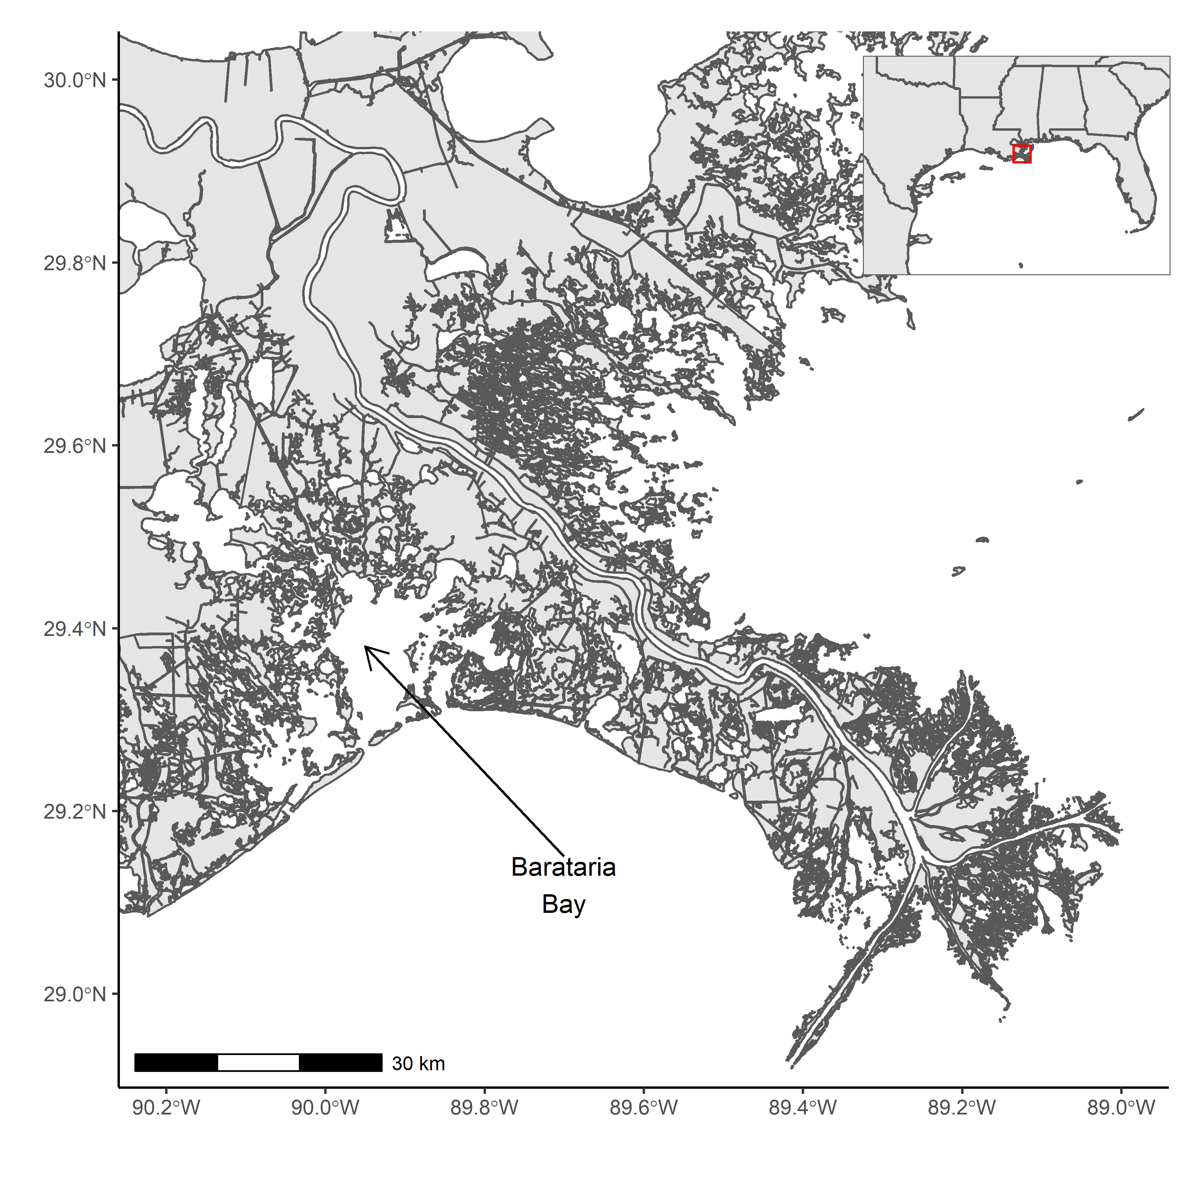

Fig. 1 Map of the region

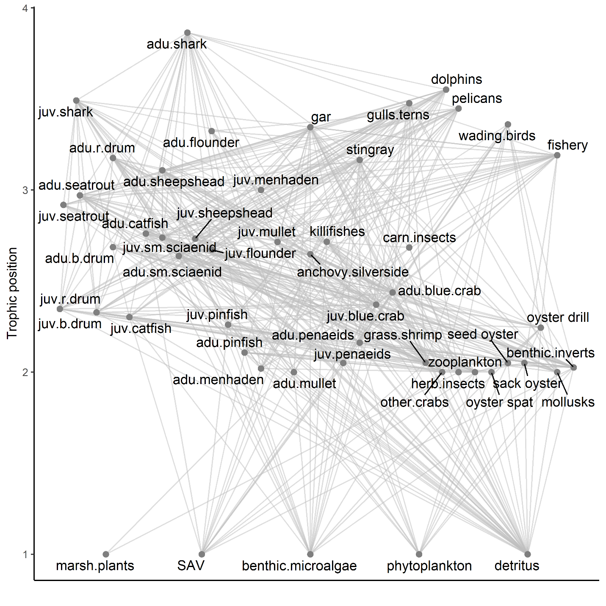

Fig. 2 Diagram of Rpath food web model



Fig. 3 Proportion of total mortality directly induced by predators and fishing on juvenile and adult stanzas of five key fish and invertebrate functional groups.



Fig. 4 Direct and indirect responses from generalized equilibrium model of fish and invertebrate biomass to changes in predator productivity and fishing effort with stanzas a) dynamically unlinked and b) combined into one homogenous functional group. Bars are at median of the Monte Carlo simulations and error lines represent the interval covering the middle 50% of simulations.

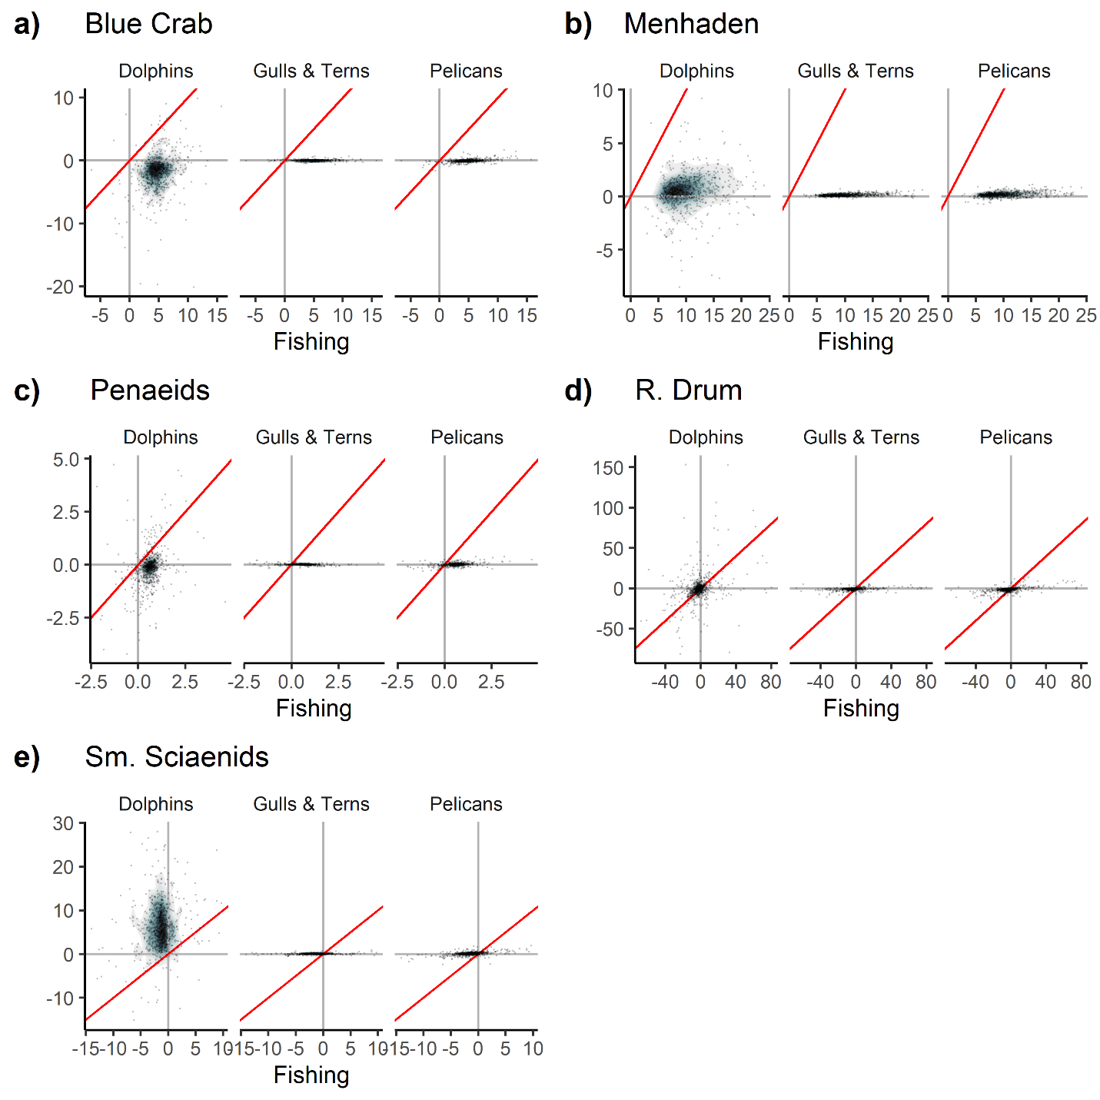

Fig. 5 Percent change in biomass in response to a 10% change in fishing effort vs 10% change in respective predator productivity for five focal functional groups, with juvenile and adult stanzas combined. Red line is 1:1. Points are overlaid on top of density plot, with bluer colors indicating higher point density and grayer/white colors indicating lower point density. Only models falling in the middle 95% of responses for all four sources for all five focal functional group are plotted (789/1000 models).

Table S1 Species included in Rpath functional groups and sources for diets

|  |  |  |
| --- | --- | --- |
| Group | Species based on | Diet based on |
| Shark | *Carcharhinus leucas* | (De Mutsert et al. 2017) |
| R Drum | *Sciaenops ocellatus* | (De Mutsert et al. 2017) |
| Seatrout | *Cynoscion arenarius, Cynoscion nebulosus* | (De Mutsert et al. 2017) |
| B Drum | *Pogonias cromis* | (De Mutsert et al. 2017) |
| Catfish | *Ariopsis felis, Bagre marinus* | (De Mutsert et al. 2017) |
| Sm Scianids | *Micropogonias undulates, Leiostomus xanthurus, Bairdiella chrysoura* | (De Mutsert et al. 2017) |
| Sheepshead | *Archosargus probatocephalus* | (De Mutsert et al. 2017) |
| Flounder | *Paralichthys lethostigma* | (De Mutsert et al. 2017) |
| Pinfish | *Lagodon rhomboides* | (De Mutsert et al. 2017) |
| Menhaden | *Brevoortia tyrannus* | (De Mutsert et al. 2017) |
| Mullet | *Mugil cephalus* | (De Mutsert et al. 2017) |
| Anchovy Silverside | *Anchoa mitchilli, Menidia beryllina, Membras martinica* | (De Mutsert et al. 2017) |
| Gar | *Atractosteus spatula* | (Goodyear 1967; Geers 2012) |
| Stingray | *Hypanus sabinus* | (Geers 2012) |
| Gulls and Terns | *Gelochelidon nilotica, Hydroprogne caspia, Larus argentatus, Leucophaeus atricilla, Larus delawarensis, Larus marinus,* *Rynchops niger, Sterna forsteri, Sterna hirundo, Sternula antillarum, Thalasseus maximus, Thalasseus sandvicensis* | (McGinnis and Emslie 2001; Geers 2012) |
| Pelicans | *Fregata magnificens, Pelecanus erythrorhynchos, Pelecanus occidentalis, Phalacrocorax auritus, Morus bassanus* | (Fogarty et al. 1981; Clapp et al. 1982; Hingtgen et al. 1985) |
| Wading Birds | *Ardea alba*, *Ardea erodias*, *Charadrius semipalmatus*, *Calidris pusilla*, *Pluvialis squatarola*, *Butorides virescens*, *Egretta tricolor* | (Boyle et al. 2012; Deehr et al. 2014) |
| Dolphins | *Tursiops truncatus* | (Barros and Odell 1990; Bowen 2011; Bowen-Stevens et al. 2021) |
| Killifishes | *Fundulus* spp. | (De Mutsert et al. 2017) |
| Panaeids | *Farfantepenaeus aztecus, Litopenaeus setiferus* | (De Mutsert et al. 2017) |
| Blue Crab | *Callinectes sapidus* | (De Mutsert et al. 2017) |
| Carn Insects |  | Expert opinion |
| Grass Shrimp | *Palaemonetes* spp. | (De Mutsert et al. 2017) |
| Other Crabs | *Rhithropanopeus harrissii* | (De Mutsert et al. 2017) |
| Herb Insects |  | Expert opinion |
| Zooplankton |  | (De Mutsert et al. 2017) |
| Oyster | *Crassostrea virginica* | (De Mutsert et al. 2017) |
| Oyster Drill | *Thais haemastoma* | (De Mutsert et al. 2017) |
| Mollusks | Clams | (De Mutsert et al. 2017) |
| Benthic Inverts | Amphipods, isopods, annelids | (De Mutsert et al. 2017) |
| Marsh Plants | *Spartina alterniflora, Juncus roemerianus* |  |
| SAV |  |  |
| Benthic Microalgae |  |  |
| Phytoplankton |  |  |
| Detritus |  |  |
|  |  |  |

Diet literature cited

Barros, N. B., and D. K. Odell. 1990. Food habits of Bottlenose Dolphins in the Southeastern United States. In *The Bottlenose Dolphin*, ed. S. Leatherwood and R. R. Reeves. San Diego, CA: Academic Press.

Bowen, S. R. 2011. Diet of bottlenose dolphins Tursiops truncatus in the northwest panhandle and foraging behavior near Savannah, Georgia. PhD Thesis, Savannah State University.

Bowen-Stevens, S. R., D. P. Gannon, R. A. Hazelkorn, G. Lovewell, K. M. Volker, S. Smith, M. C. Tumlin, and J. Litz. 2021. Diet of Common Bottlenose Dolphins, Tursiops truncatus, that Stranded in and Near Barataria Bay, Louisiana, 2010–2012. *Southeastern Naturalist* 20. Eagle Hill Institute: 117–134. https://doi.org/10.1656/058.020.0113.

Boyle, R. A., N. J. Dorn, and M. I. Cook. 2012. Nestling diet of three sympatrically nesting wading bird species in the Florida Everglades. *Waterbirds* 35. BioOne: 154–159.

Clapp, R. B., R. C. Banks, D. Morgan-Jacobs, and W. A. Hoffman. 1982. *Marine birds of the southeastern United States and Gulf of Mexico. Part I. Gaviiformes through Pelecaniformes*. National Museum of Natural History, Washington, DC (USA).

De Mutsert, K., K. Lewis, S. Milroy, J. Buszowski, and J. Steenbeek. 2017. Using ecosystem modeling to evaluate trade-offs in coastal management: Effects of large-scale river diversions on fish and fisheries. *Ecological Modelling* 360: 14–26. https://doi.org/10.1016/j.ecolmodel.2017.06.029.

Deehr, R. A., J. J. Luczkovich, K. J. Hart, L. M. Clough, B. J. Johnson, and J. C. Johnson. 2014. Using stable isotope analysis to validate effective trophic levels from Ecopath models of areas closed and open to shrimp trawling in Core Sound, NC, USA. *Ecological Modelling* 282: 1–17. https://doi.org/10.1016/j.ecolmodel.2014.03.005.

Fogarty, M. J., S. A. Nesbitt, and C. R. Gilbert. 1981. Diet of nestling brown pelicans in Florida. *Florida Field Naturalist* 9: 38–40.

Geers, T. M. 2012. *Developing an ecosystem-based approach to management of the Gulf menhaden fishery using Ecopath with Ecosim*. State University of New York at Stony Brook.

Goodyear, C. P. 1967. Feeding habits of three species of gars, Lepisosteus, along the Mississippi Gulf Coast. *Transactions of the American Fisheries Society* 96. Taylor & Francis: 297–300.

Hingtgen, T. M., R. Mulholland, and A. V. Zale. 1985. *Habitat suitability index models: eastern brown pelican*. Vol. 82. Fish and Wildlife Service, US Department of the Interior.

McGinnis, T. W., and S. D. Emslie. 2001. The foraging ecology of royal and sandwich terns in North Carolina, USA. *Waterbirds*: 361–370.



Fig. S1 Direct and indirect responses from generalized equilibrium model of fish and invertebrate biomass to changes in a simultaneous change in predator productivity across predator groups and changes fishing effort with stanzas a) dynamically unlinked and b) combined into one homogenous functional group. Bars are at median of the Monte Carlo simulations and error lines represent the interval covering the middle 50% of simulations.

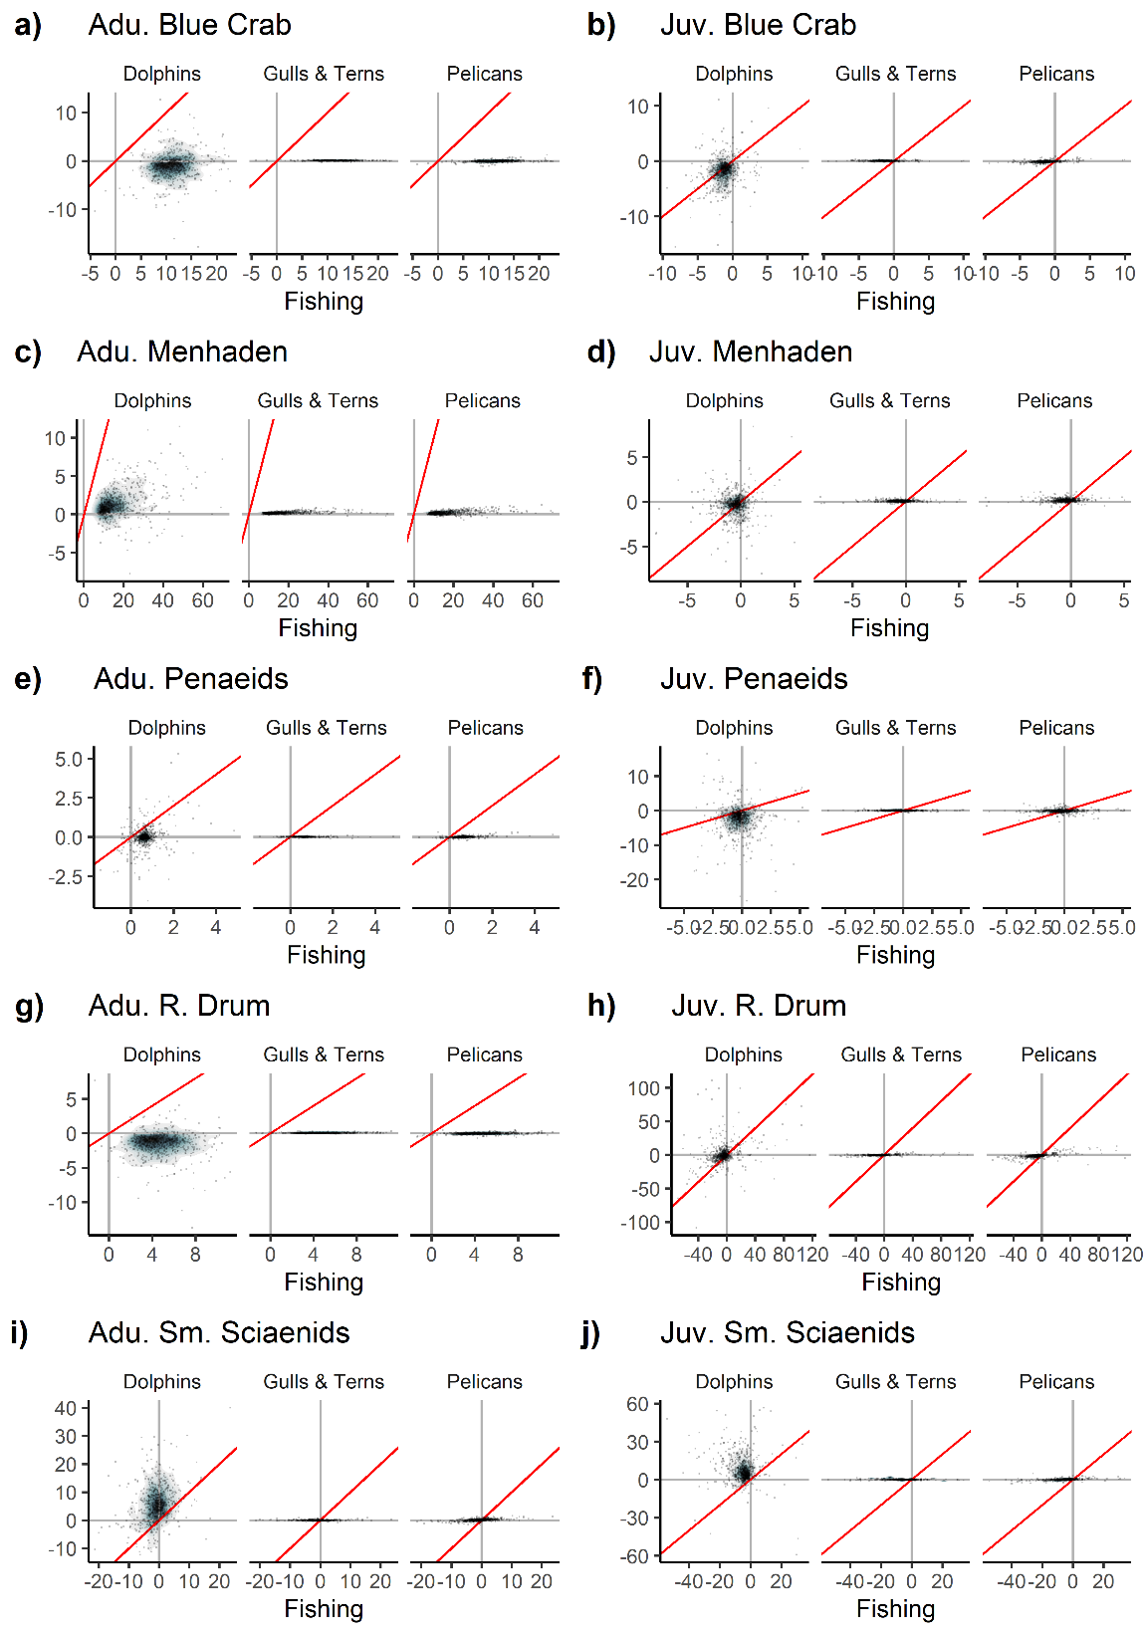

Fig. S2 Percent change in biomass in response to a 10% change in fishing effort vs 10% change in respective predator productivity for five focal functional groups. Red line is 1:1. Points are overlaid on top of density plot, with bluer colors indicating higher point density and grayer/white colors indicating lower point density. Only models falling in the middle 95% of responses for all four sources for both stanzas of all five focal functional group are plotted (667/1000 models).