The generalized equilibrium model assumes that the per capita rate of population change of group *i*, *ri*,as a function of the vector of biomass for all functional groups, **B**,is (Essington and Munch 2014):

In equation (1), the first term describes biomass gains from consumption, the second term describes biomass loss from predators, and the third term is other mortality (not fishing or predation). *Bi* and *Bj* are elements *i* and *j*, respectively, of vector **B**. *GEi* is the gross conversion efficiency of group *i*, or the production to consumption ratio (*GEi = PBi*/*QBi*). The parameter *γi* dictates the density-dependence of the other mortality (e.g., disease, predation and fishing outside model domain, senescence) and is drawn from a random distribution (Table 2). *M0,i* scales the other mortality and is equal to mortality not attributed to predation or fishing: *PBi* – total predation on group *i* – harvest of group *i*.

The functional response *fij(Bi, Bj)* in equation (1) describes the per prey consumption rate of prey *i* by predator *j* and is approximated as:

where *αij* is the effective search and capture rate of predator *j* on prey *i*, *θij* describes the prey dependence (from *θij* = 1 as a linear response to 0 as a fully saturated response), and *εij* describes the predator dependence, also between 0 and 1 (Essington and Munch 2014). The parameters *θ* and *ε* are drawn randomly from distributions for each predator-prey pair (Table 2), and *α* is solved for using the values at Ecopath equilibrium for biomass and predator consumption.

Given equation (2), the rate of total population change can be described as:

where *Ci* is again catch of group *i* (Essington and Munch 2014).

In order to determine the ecosystem’s expected reaction to predator mortality and fishery closures we calculated two quantities based on new derivations from the generalized equilibrium model: 1) for *j* as the index for pelicans, gulls and terns, and dolphins, i.e., the change in equilibrium prey biomass per change in predator productivity and 2) where *E* is relative fishing effort compared to the effort at mass balance equilibrium (we calculate the derivative at *E* = 1), i.e., change in equilibrium biomass per change in relative fishing effort applied proportionally to all functional groups. The first partial derivative will tell us the influence of pelicans, birds, and dolphins on population dynamics and the second partial derivative the influence of fishing on the populations. To calculate these derivatives, we introduce **J***r*(**B**) as the Jacobian of the per capita production rate, or the matrix of all partial derivatives . Then, based on equations A7 and A13 in Essington & Munch (2014):

And

where ***s*** is the selectivity vector such that *siE = Fi* and *Fi* is the fishing mortality rate of group *i*. This allows us to assess a proportional decrease in fishing across all functional groups, not just direct fishing mortality on group *i*, while still accounting for the fact that some species experience higher fishing mortality rates than others. We standardize these derivatives by biomass of the fish or invertebrate functional groups, and, in the case of the response to predator declines, with respect to predator productivity. This yields a proportional change in biomass of the prey group for a proportional change in fishing effort or predator productivity. Finally, we note that as an equilibrium model, the generalized equilibrium model does not simulate the ecosystem forward in time, but instead predicts how the equilibrium state of the system will shift with a perturbation to some component of it.

Table S1 Species included in Rpath functional groups and sources for diets

|  |  |  |
| --- | --- | --- |
| Group | Species based on | Diet based on |
| Shark | *Carcharhinus leucas* | (De Mutsert et al. 2017) |
| R Drum | *Sciaenops ocellatus* | (De Mutsert et al. 2017) |
| Seatrout | *Cynoscion arenarius, Cynoscion nebulosus* | (De Mutsert et al. 2017) |
| B Drum | *Pogonias cromis* | (De Mutsert et al. 2017) |
| Catfish | *Ariopsis felis, Bagre marinus* | (De Mutsert et al. 2017) |
| Sm Scianids | *Micropogonias undulates, Leiostomus xanthurus, Bairdiella chrysoura* | (De Mutsert et al. 2017) |
| Sheepshead | *Archosargus probatocephalus* | (De Mutsert et al. 2017) |
| Flounder | *Paralichthys lethostigma* | (De Mutsert et al. 2017) |
| Pinfish | *Lagodon rhomboides* | (De Mutsert et al. 2017) |
| Menhaden | *Brevoortia tyrannus* | (De Mutsert et al. 2017) |
| Mullet | *Mugil cephalus* | (De Mutsert et al. 2017) |
| Anchovy Silverside | *Anchoa mitchilli, Menidia beryllina, Membras martinica* | (De Mutsert et al. 2017) |
| Gar | *Atractosteus spatula* | (Goodyear 1967; Geers 2012) |
| Stingray | *Hypanus sabinus* | (Geers 2012) |
| Gulls and Terns | *Gelochelidon nilotica, Hydroprogne caspia, Larus argentatus, Leucophaeus atricilla, Larus delawarensis, Larus marinus,* *Rynchops niger, Sterna forsteri, Sterna hirundo, Sternula antillarum, Thalasseus maximus, Thalasseus sandvicensis* | (McGinnis and Emslie 2001; Geers 2012) |
| Pelicans | *Fregata magnificens, Pelecanus erythrorhynchos, Pelecanus occidentalis, Phalacrocorax auritus, Morus bassanus* | (Fogarty et al. 1981; Clapp et al. 1982; Hingtgen et al. 1985) |
| Wading Birds | *Ardea alba*, *Ardea erodias*, *Charadrius semipalmatus*, *Calidris pusilla*, *Pluvialis squatarola*, *Butorides virescens*, *Egretta tricolor* | (Boyle et al. 2012; Deehr et al. 2014) |
| Dolphins | *Tursiops truncatus* | (Barros and Odell 1990; Bowen 2011; Bowen-Stevens et al. 2021) |
| Killifishes | *Fundulus* spp. | (De Mutsert et al. 2017) |
| Panaeids | *Farfantepenaeus aztecus, Litopenaeus setiferus* | (De Mutsert et al. 2017) |
| Blue Crab | *Callinectes sapidus* | (De Mutsert et al. 2017) |
| Carn Insects |  | Expert opinion |
| Grass Shrimp | *Palaemonetes* spp. | (De Mutsert et al. 2017) |
| Other Crabs | *Rhithropanopeus harrissii* | (De Mutsert et al. 2017) |
| Herb Insects |  | Expert opinion |
| Zooplankton |  | (De Mutsert et al. 2017) |
| Oyster | *Crassostrea virginica* | (De Mutsert et al. 2017) |
| Oyster Drill | *Thais haemastoma* | (De Mutsert et al. 2017) |
| Mollusks | Clams | (De Mutsert et al. 2017) |
| Benthic Inverts | Amphipods, isopods, annelids | (De Mutsert et al. 2017) |
| Marsh Plants | *Spartina alterniflora, Juncus roemerianus* |  |
| SAV |  |  |
| Benthic Microalgae |  |  |
| Phytoplankton |  |  |
| Detritus |  |  |
|  |  |  |

Diet literature cited

Barros, N. B., and D. K. Odell. 1990. Food habits of Bottlenose Dolphins in the Southeastern United States. In *The Bottlenose Dolphin*, ed. S. Leatherwood and R. R. Reeves. San Diego, CA: Academic Press.

Bowen, S. R. 2011. Diet of bottlenose dolphins Tursiops truncatus in the northwest panhandle and foraging behavior near Savannah, Georgia. PhD Thesis, Savannah State University.

Bowen-Stevens, S. R., D. P. Gannon, R. A. Hazelkorn, G. Lovewell, K. M. Volker, S. Smith, M. C. Tumlin, and J. Litz. 2021. Diet of Common Bottlenose Dolphins, Tursiops truncatus, that Stranded in and Near Barataria Bay, Louisiana, 2010–2012. *Southeastern Naturalist* 20. Eagle Hill Institute: 117–134. https://doi.org/10.1656/058.020.0113.

Boyle, R. A., N. J. Dorn, and M. I. Cook. 2012. Nestling diet of three sympatrically nesting wading bird species in the Florida Everglades. *Waterbirds* 35. BioOne: 154–159.

Clapp, R. B., R. C. Banks, D. Morgan-Jacobs, and W. A. Hoffman. 1982. *Marine birds of the southeastern United States and Gulf of Mexico. Part I. Gaviiformes through Pelecaniformes*. National Museum of Natural History, Washington, DC (USA).

De Mutsert, K., K. Lewis, S. Milroy, J. Buszowski, and J. Steenbeek. 2017. Using ecosystem modeling to evaluate trade-offs in coastal management: Effects of large-scale river diversions on fish and fisheries. *Ecological Modelling* 360: 14–26. https://doi.org/10.1016/j.ecolmodel.2017.06.029.

Deehr, R. A., J. J. Luczkovich, K. J. Hart, L. M. Clough, B. J. Johnson, and J. C. Johnson. 2014. Using stable isotope analysis to validate effective trophic levels from Ecopath models of areas closed and open to shrimp trawling in Core Sound, NC, USA. *Ecological Modelling* 282: 1–17. https://doi.org/10.1016/j.ecolmodel.2014.03.005.

Essington, T. E., and S. B. Munch. 2014. Trade-offs between supportive and provisioning ecosystem services of forage species in marine food webs. *Ecological Applications* 24: 1543–1557. https://doi.org/10.1890/13-1403.1.

Fogarty, M. J., S. A. Nesbitt, and C. R. Gilbert. 1981. Diet of nestling brown pelicans in Florida. *Florida Field Naturalist* 9: 38–40.

Geers, T. M. 2012. *Developing an ecosystem-based approach to management of the Gulf menhaden fishery using Ecopath with Ecosim*. State University of New York at Stony Brook.

Goodyear, C. P. 1967. Feeding habits of three species of gars, Lepisosteus, along the Mississippi Gulf Coast. *Transactions of the American Fisheries Society* 96. Taylor & Francis: 297–300.

Hingtgen, T. M., R. Mulholland, and A. V. Zale. 1985. *Habitat suitability index models: eastern brown pelican*. Vol. 82. Fish and Wildlife Service, US Department of the Interior.

McGinnis, T. W., and S. D. Emslie. 2001. The foraging ecology of royal and sandwich terns in North Carolina, USA. *Waterbirds*: 361–370.



Fig. S2 Direct and indirect responses from generalized equilibrium model of fish and invertebrate biomass to changes in a simultaneous change in predator productivity across predator groups and changes fishing effort with stanzas a) dynamically unlinked and b) combined into one homogenous functional group. Bars are at median of the Monte Carlo simulations and error lines represent the interval covering the middle 50% of simulations.

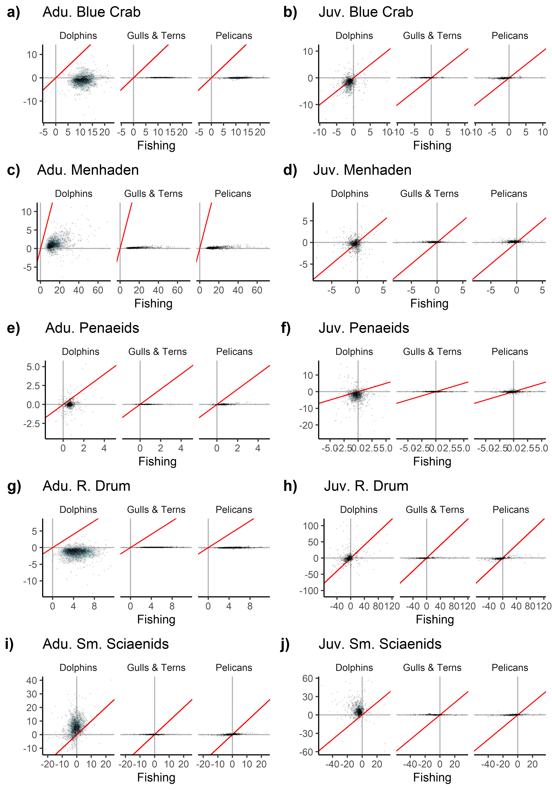

Fig. S1 Percent change in biomass in response to a 10% change in fishing effort vs 10% change in respective predator productivity for five focal functional groups. Red line is 1:1. Points are overlaid on top of density plot, with bluer colors indicating higher point density and grayer/white colors indicating lower point density. Only models falling in the middle 95% of responses for all four sources for both stanzas of all five focal functional group are plotted (667/1000 models).