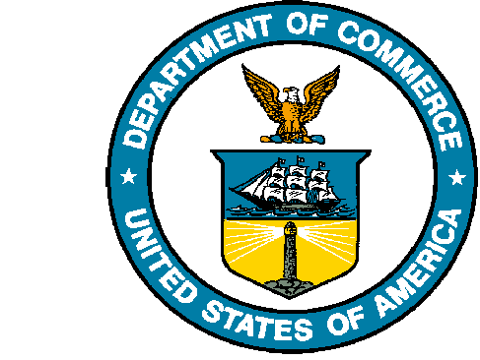
UNITED STATES DEPARTMENT OF COMMERCE

National Oceanic and Atmospheric Administration
NATIONAL MARINE FISHERIES SERVICE
Northwest Fisheries Science Center
2725 Montlake Boulevard East
Seattle, WA 98112-2097

DATE

Dear Editor,

Thank you for considering the accompanying manuscript “Fishery closures, more than predator release, increased persistence of nearshore fishes and invertebrates to the Deepwater Horizon oil spill,” for publication in Estuaries and Coasts.

In this manuscript, we used food web models to test two hypothesis that may explain the unexpected persistence and stability of nearshore nekton populations following the Deepwater Horizon oil spill: a pause in fishing mortality from regulatory closures and a reduction in predation mortality due to high mortality rates of dolphins and seabirds. Across a range of key nekton groups, we found the most evidence to support the fishing hypothesis, some evidence for release from dolphin consumption, and only very limited evidence for release from seabird consumption. This work will be of wide interest to the Estuaries and Coasts readership, as it illustrates how the complex nature of coastal food webs can lead to unexpected responses to sudden perturbations, particularly when those perturbations impact many species in the food web, and mediate the way that humans impact the food web, as well.

This work has not been published before and is not under consideration for publication elsewhere. Its publication has been approved by all coauthors and other responsible authorities (namely, NMFS internal review). All authors contributed to conceptualization and initial model groupings, provided input on various aspects of the model, and helped with revisions. K.L.O., with input from O.P.J., ran all analyses and wrote the paper. This manuscript is posted as a preprint at DOI. The authors guarantee that the manuscript has been prepared according to the ESCO Aims and Scope and the Instructions for Authors.

Sincerely,
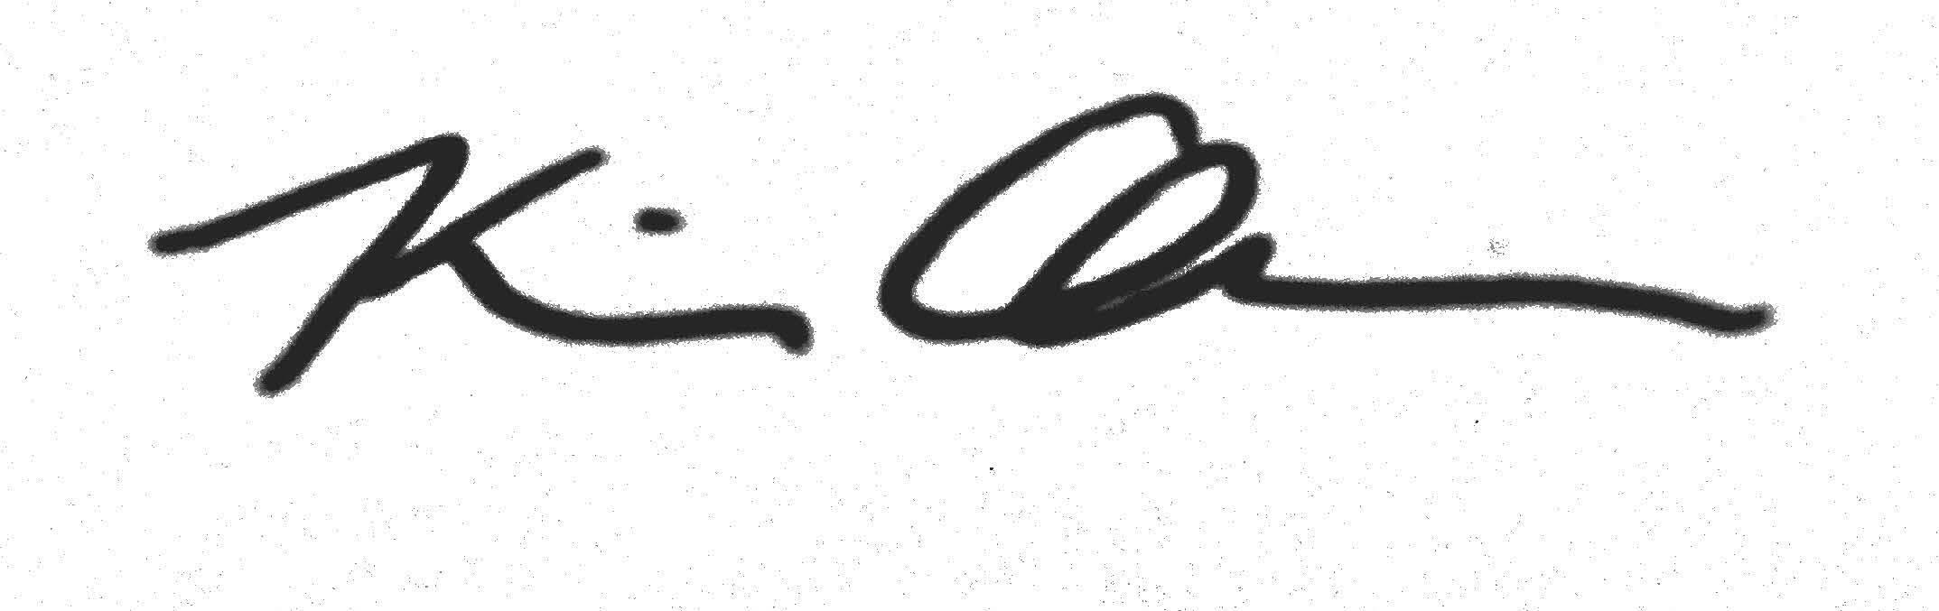
Kiva Oken, PhD
Fisheries Resource Analysis and Monitoring Division
Northwest Fisheries Science Center
kiva.oken@noaa.gov

