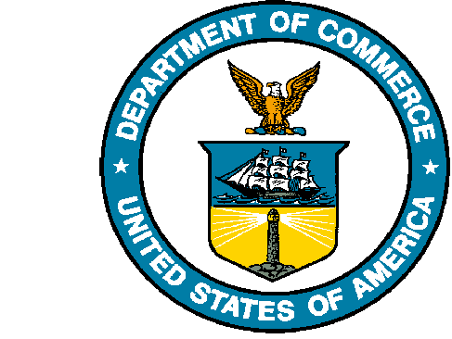
UNITED STATES DEPARTMENT OF COMMERCE

National Oceanic and Atmospheric Administration
NATIONAL MARINE FISHERIES SERVICE
Northwest Fisheries Science Center
2725 Montlake Boulevard East
Seattle, WA 98112-2097

February 15, 2023

Dear Dr. Brush,

We are grateful for the opportunity to submit our revised manuscript “Fishery closures, more than predator release, increased persistence of nearshore fishes and invertebrates to the Deepwater Horizon oil spill,” for publication in Estuaries and Coasts. We appreciate the thoughtful comments from you and the two reviewers and believe the manuscript has genuinely improved as a result of this very constructive feedback.

The most significant changes we have made to the manuscript were 1) an additional supplemental figure in response to first reviewer’s comment that comparing all fishing to individual predators essentially gave fishing a “leg up,” (this strengthened our previous findings) and 2) an additional paragraph to the discussion in response to your own request to provide a broader interpretation of the results. While the second reviewer was most negative, we found that responding to the comments resulted in relatively minor changes to the manuscript. As you noted, the model itself was in fact mostly cited, and we have added citations for the diet matrix. We have also worked to clarify the generalized equilibrium model throughout and further emphasize that, as an equilibrium model, it is not projected in time.

This manuscript is posted as a preprint with DOI 10.31219/osf.io/csfqn. The authors guarantee that the manuscript has been prepared according to the ESCO Aims and Scope and the Instructions for Authors.

Thank you for your consideration and please let us know if you have any questions.

Sincerely, on behalf of all authors,
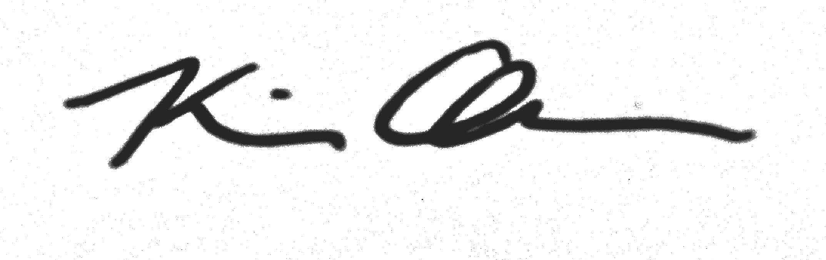
Kiva Oken, PhD
Fishery Resource Analysis and Monitoring Division
Northwest Fisheries Science Center
kiva.oken@noaa.gov

