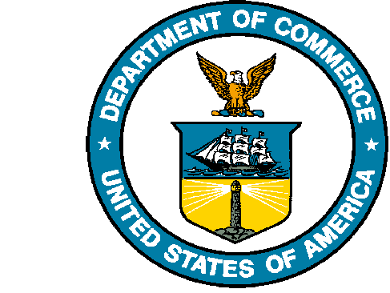
UNITED STATES DEPARTMENT OF COMMERCE

National Oceanic and Atmospheric Administration
NATIONAL MARINE FISHERIES SERVICE
Northwest Fisheries Science Center
2725 Montlake Boulevard East
Seattle, WA 98112-2097

July 5, 2023

Dear Dr. Brush,

We are grateful for the opportunity to submit our revised manuscript “Fishery closures, more than predator release, increased persistence of nearshore fishes and invertebrates to the Deepwater Horizon oil spill,” for publication in Estuaries and Coasts. We appreciate the thoughtful comments from the additional reviewer and have incorporated their constructive feedback and responded to their queries.

This manuscript is posted as a preprint with DOI 10.31219/osf.io/csfqn. The authors guarantee that the manuscript has been prepared according to the ESCO Aims and Scope and the Instructions for Authors. We look forward to hearing your response.

Sincerely, on behalf of all authors,
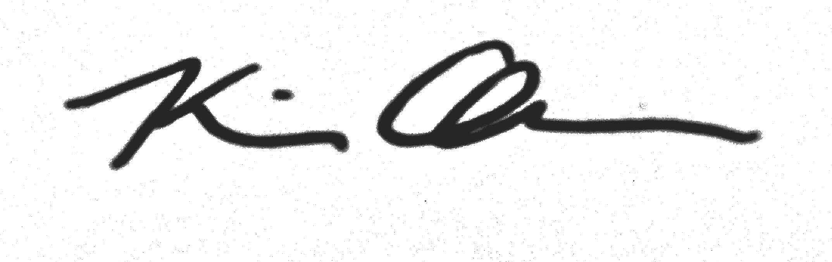
Kiva Oken, PhD
Fishery Resource Analysis and Monitoring Division
Northwest Fisheries Science Center
kiva.oken@noaa.gov

