# Questions

Initially, we wanted to know in what sort of cases do we see an influence of predation on population productivity, when looking across species and ocean basins. It turns out we often see no signal, which begs the question why.

First, one common theory is that marine food webs are complex, and predation comes from many different species. This complexity stabilizes the total amount of predation any species experiences. That is, the total portfolio of predation is less variable than each individual predator species. According to this logic, in simpler systems with single predators, such as the Baltic Sea, we should see a predation signal in prey productivity.

Second, we generally only had abundance data for commercially exploited species, particularly groundfish that are easy for surveys to capture. Therefore, perhaps we are not capturing the true time series of predation that fish are experiencing because we are missing key predator species such as birds and mammals. According to this logic, in systems where we have data that capture a larger proportion of predators, we should see a predation signal in prey productivity.

# Data

Data mainly consist of time series of trawl surveys from across the North Atlantic and North Pacific. These time series exist for a wide range of species. Surveys have already been corrected for catchability and are scaled up to total population biomasses. In some ecosystems (mainly the Pacific), we have stock assessment model output instead.

In concert with the abundance data, we also have Ecopath models that have been parameterized and balanced for many of the above ecosystems. In two cases we used Ecopath models for neighboring ecosystems: the North Gulf of St. Lawrence Ecopath model was used for South Gulf of St. Lawrence data, and the Eastern Scotian Shelf model was used for Western Scotian Shelf data.

Finally, for forage fish species for which we had productivity data (i.e., catch and abundance) and appropriate Ecopath models, we looked to see if recruitment estimates were also available in the RAM Legacy database.

The following table lists the prey stocks we have examined, and whether recruitment estimates are available in the RAM legacy database.

|  |  |  |
| --- | --- | --- |
| **Species** | **Ecosystem** | **Recruitment?** |
| Atlantic herring | Baltic Sea | Yes |
| Sprat | Baltic Sea | Yes |
| Atlantic herring | Barents Sea | No |
| Capelin | Barents Sea | Yes |
| Pacific herring | Gulf of Alaska | No |
| Pacific herring | Hecate Strait | Yes |
| Atlantic herring | North Sea | Yes |
| Lesser sandeel | North Sea | No |
| Atlantic herring | South Gulf of St. Lawrence | Yes |
| Capelin | South Gulf of St. Lawrence | No |
| Atlantic herring | Western Scotian Shelf | Yes |

# Analyses

Most marine fish are subject to predation from a variety of species, each with different diet preferences, consumption rates, and abundances. As a result, we required a metric to weight the relative importance of each predator species on a given prey species. To do so, we used Ecopath models that were parameterized for the various ecosystems of interest. Ecopath models assume the following equilibrium holds:

$\frac{dB_{i}}{dt}=Production-Fishing-\sum_{species j}{α_{i,j}B_{i}B_{j}}=0$ (1)

That is, the rate of change of biomass of each species, *i*, is zero, and is equal to production minus fishing minus predation, which is accounted for by the final summation. We used the alpha terms from that summation as the weighting for each predator species, and multiplied these weightings by the time series of abundances of the predators (from the data) in order to obtain an overall measure of the “predator field” that a prey species experiences. Alpha terms are equal to the predator consumption:biomass ratio multiplied by the fraction of the predator diet that the prey of interest makes up, divided by the equilibrium prey biomass. When Ecopath models divided the prey species into separate compartments for adults and juveniles, we examined predation on juveniles, as work from chapter 1 indicated that was where we were most likely to find a relationship.

We were also interested in simply quantifying the proportion of predation for which we had time series of abundances. In order to make that calculation, we assumed equilibrium abundances for all species.

We examined the correlation between the “predator field” and prey surplus production (change in biomass after accounting for fishery catch, where prey biomasses were first smoothed with a Kalman filter to avoid unrealistic spikes in productivity). We also fit a Schaefer model (assuming process error) with an additional linear term for predation, as was done for the simulations from my first chapter. For the latter case, the predator field was de-meaned, and we (for now) examined the p-value of the predation term’s t-value for indication of top-down effects.

Finally, we examined the relationship between recruitment and the “Predator field.”

# Preliminary results

First, we looked at the relationship between prey surplus production and the predator field. The number in the upper-right corner is the correlation between the two. A star indicates statistical significance (P<0.05), but the preliminary test did not account for temporal autocorrelation, so is quite liberal. In this case, the only two stocks for which we see a minimal impact of predation are Baltic sprat and North Sea sandeels. The former is a well-established relationship in the literature. In addition, the correlation for Gulf of Alaska herring was almost significant (P=0.057) using this very crude test.



Next, we looked at the relationship between predation and prey surplus production after accounting for a Schaefer biomass-surplus production relationship. That is, we fit the following linear model, where SP is annual surplus production, B is prey biomass, P is predator field, and estimated parameters are population growth rate r, carrying capacity K, predator effect beta, and the residual standard deviation:

$$SP_{y}=rB_{y}\left(1-\frac{B_{y}}{K}\right)+βP_{y}+ϵ_{y}$$

First, we note that for most stocks, there is minimal evidence of a biomass-surplus production relationship. In most cases, the linear and quadratic biomass terms were statistically different from zero, but not necessarily ecologically so:

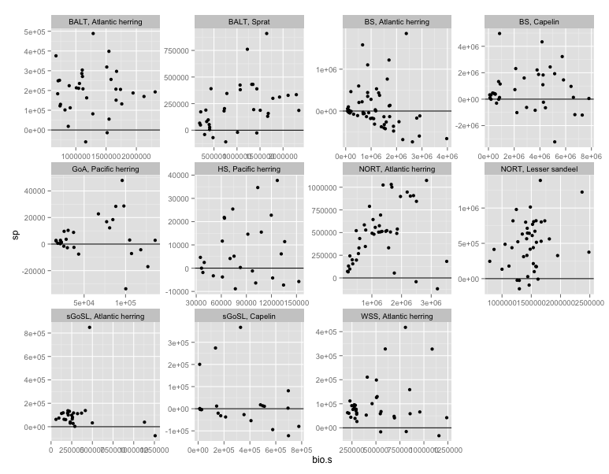

Next, we note that the conclusions regarding predation from the full surplus production model are different than those from the simpler correlation test. The third column is the p-value from the predation term of the surplus production model (i.e., <0.05 implies predators are important):

region prey.spp demean.pred

1 BALT Atlantic herring 0.6194877283

2 BALT Sprat 0.2481059681

3 BS Atlantic herring 0.8681035387

4 BS Capelin 0.1236510733

5 GoA Pacific herring 0.0675461340

6 HS Pacific herring 0.9839787731

7 NORT Atlantic herring 0.0906217671

8 NORT Lesser sandeel 0.0003708616

9 sGoSL Atlantic herring 0.8016093161

10 sGoSL Capelin 0.8363723208

11 WSS Atlantic herring 0.7127709297

We still conclude that the North Sea sandeels are impacted by predation, but not Baltic sprat. Other species of interest are North Sea and Gulf of Alaska herring (P<0.1).

Next, we examined which species were contributing to predation for each stock. In some cases, such as the Baltic Sea and Gulf of Alaska, one or two species cause the bulk of the predation. Both of these showed a relationship in one of the two analyses above. In other systems like the Scotian Shelf and North Sea, many different species contribute. North Sea species also showed a relationship between predation and prey productivity above. Here it is also notable for which predator species we have time series data. Predator species with data are outlined in gray. Missing species are outlined in black. Ecosystems in the Northwest Atlantic, the Baltic, and the Gulf of Alaska have very high coverage. Other cases like Hecate Strait and Barents Sea herring have very low coverage. Often, a single missing species would help (Barents Sea minke whales, Hecate Strait squid).



We also looked at how the overall “predator field,” and its components, change over time. This would be evidence for a sort of portfolio effect of predation. Here, we only include species for which we have time series data (i.e., those outlined in grey above). Where single species dominate the predator field (Baltic, Gulf of Alaska), we obviously see major changes over time. Where there are many species, the relationship is sometimes less variable, though the difference between trawl survey and stock assessment data is really the most notable thing here:

committee_meeting.pdf

Finally, we looked at the relationship between recruitment and the predator field. This does not account for the stock-recruit relationship though, as this analysis has not been an avenue we have really pursued.committee_meeting.pdf

# A few conclusions

There seems to be some evidence that prey species that experience predation from one or two sources (Baltic sprat, Gulf of Alaska herring) show larger responses to predation in their productivity, lending evidence to the hypothesis that simpler systems are driven from the top down, and complex systems from the bottom up. However, the fact that we single out different species as having top-down effects depending on whether we also account for standing prey biomass is odd, since the biomass-surplus production relationship doesn’t look very strong in most cases. Predation seems very important for North Sea sandeels. Having abundance time series for a large proportion of the predators seems less important. We only had predation time series that accounted for 37% of the North Sea sandeel’s total predation, yet found the strongest relationship there. Recruitment currently doesn’t seem like a very useful path to go down, particularly as it further reduces the available stocks.

# Remaining questions and input we are interested in from you:

1. Are there any particularly interesting stocks we’re missing? (Note this is limited to ecosystems with existing Ecopath models.)
2. Is there a better way to examine these data to answer our questions? A different approach to take?